Computer networks lab one
Sudarshan Rao
BL.AI.U4AID25064
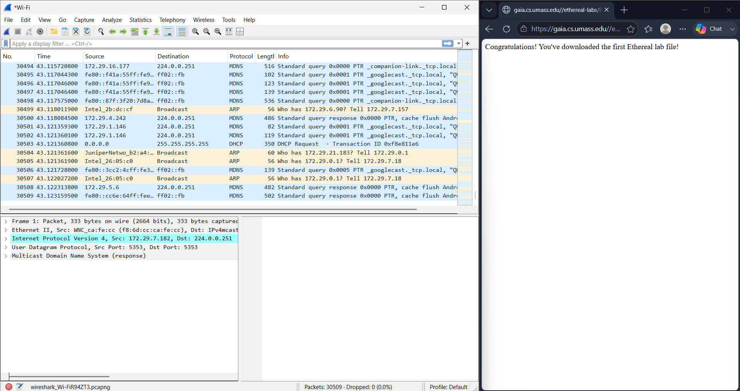
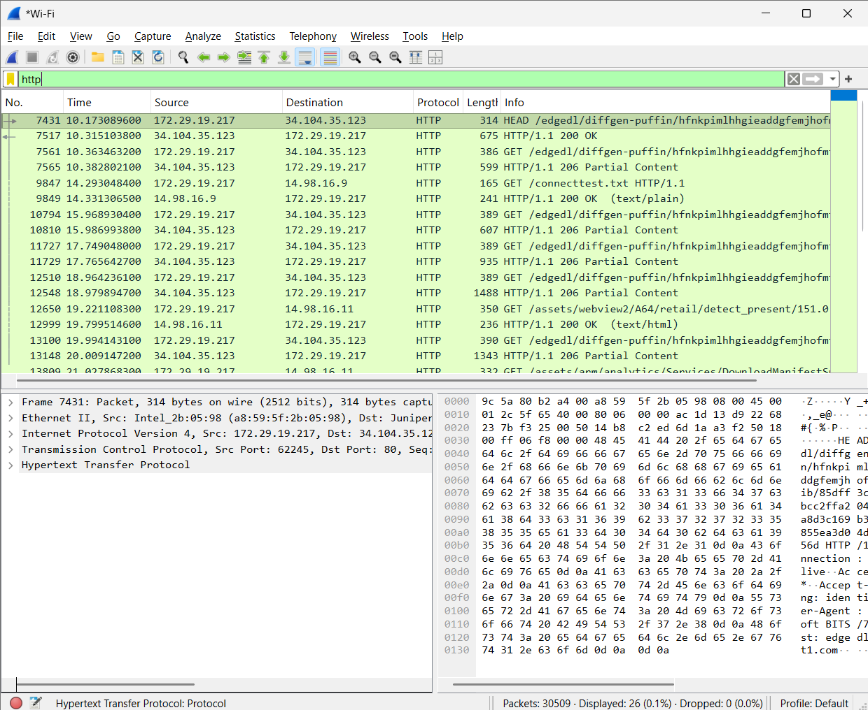
Question_1
List the different protocols that appear in the protocol column in the unfiltered packet-listing window.
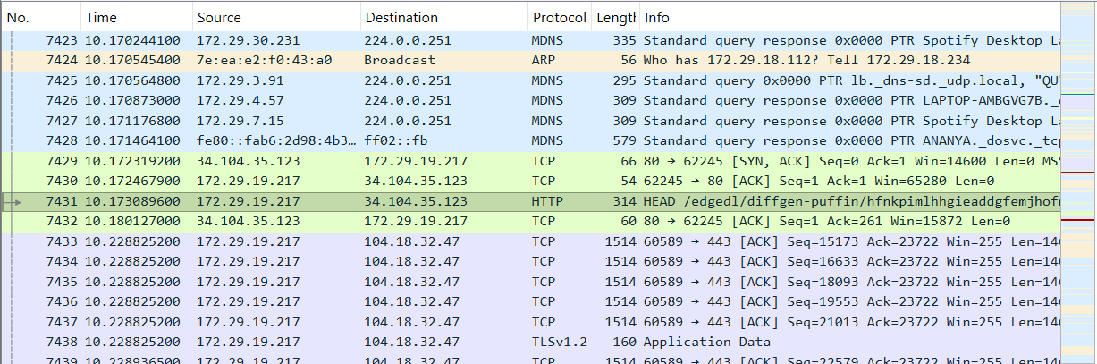
Question_2
How long did it take from when the HTTP GET message was sent until the HTTP OK reply was received?
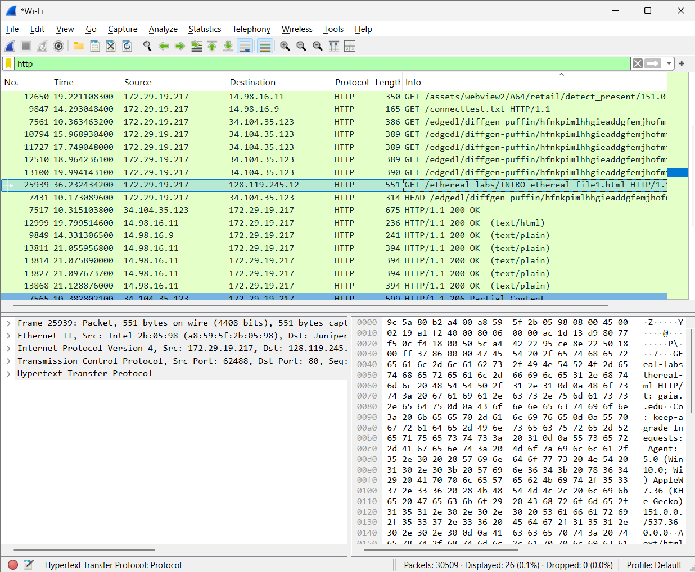
Time taken = 25.9192382
Question_3
What is the IP address of your computer? Of the gaia.cs.umass.edu server?
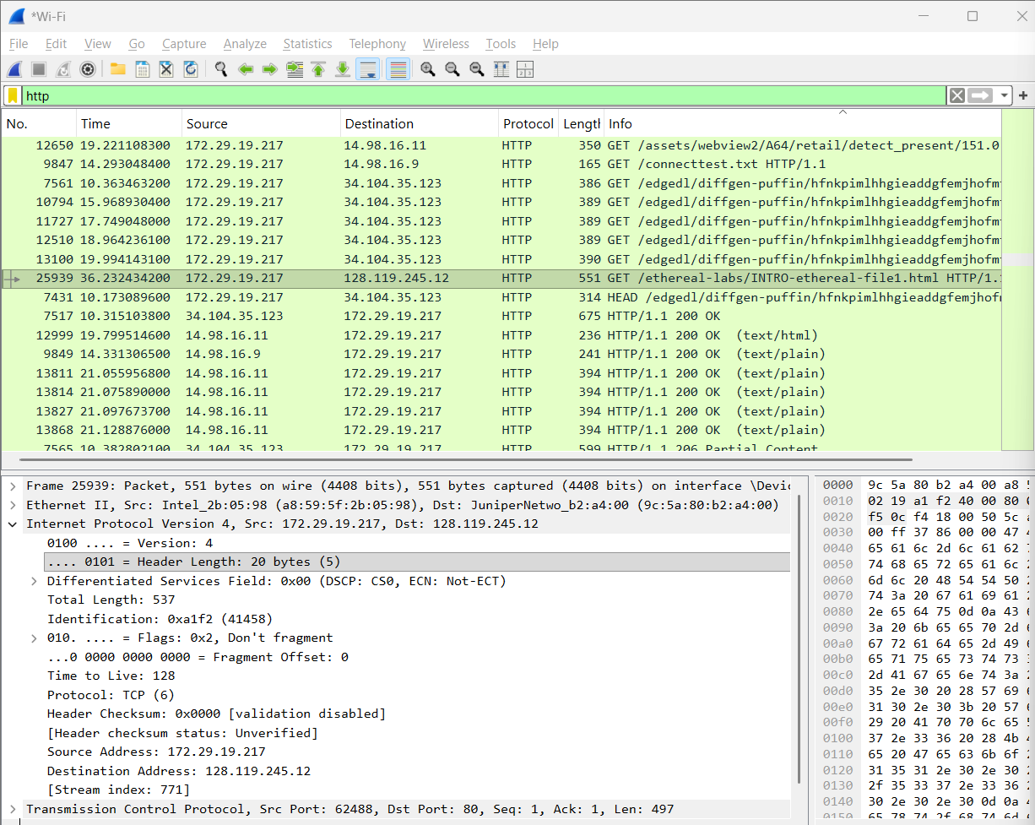
Question_4
What is the status code returned from the server?
Status code = 200
Phrase = OK
Question_5
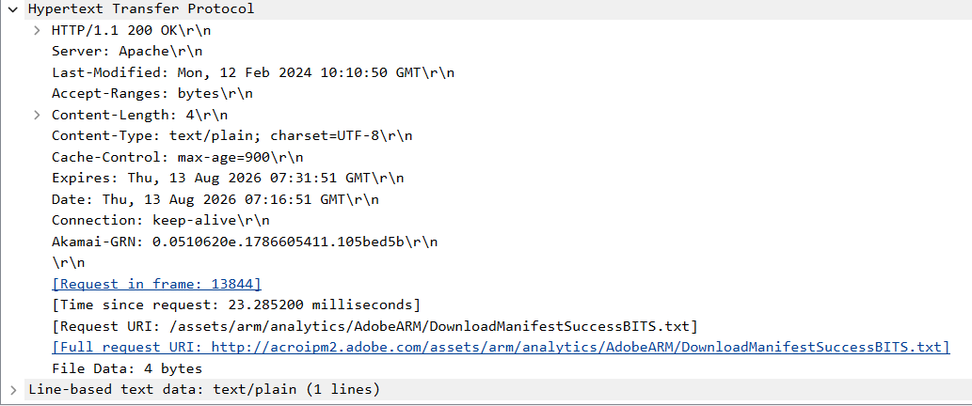
Question_6
How many bytes of content are being returned?
4\r\n
Total 4 bites
Question_7
Do you see any headers in the raw data that aren't displayed in the packet-listing window?
Yes
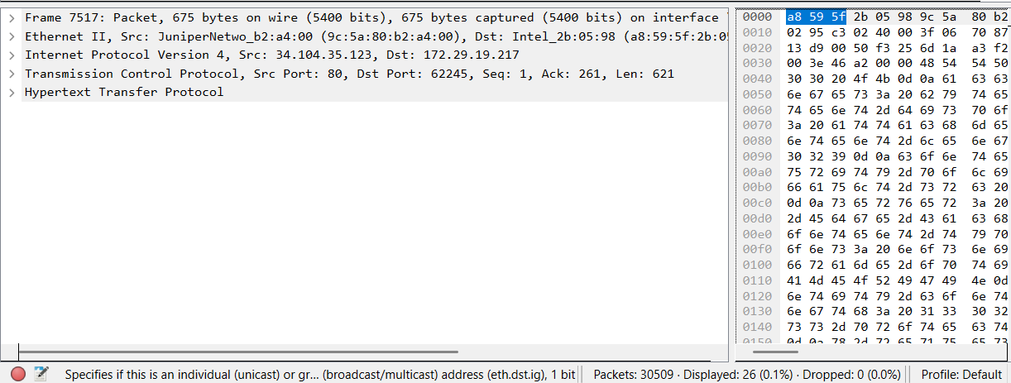
Question_8
Do you see an If-Modified-Since line?
NO
Question_9
Did the server return the file?
Yes
Question_10
Now inspect the contents of the second HTTP GET request. Do you see an “IF-MODIFIED-SINCE:” line in the HTTP GET? If so, what information follows the “IF-MODIFIED-SINCE:” header?
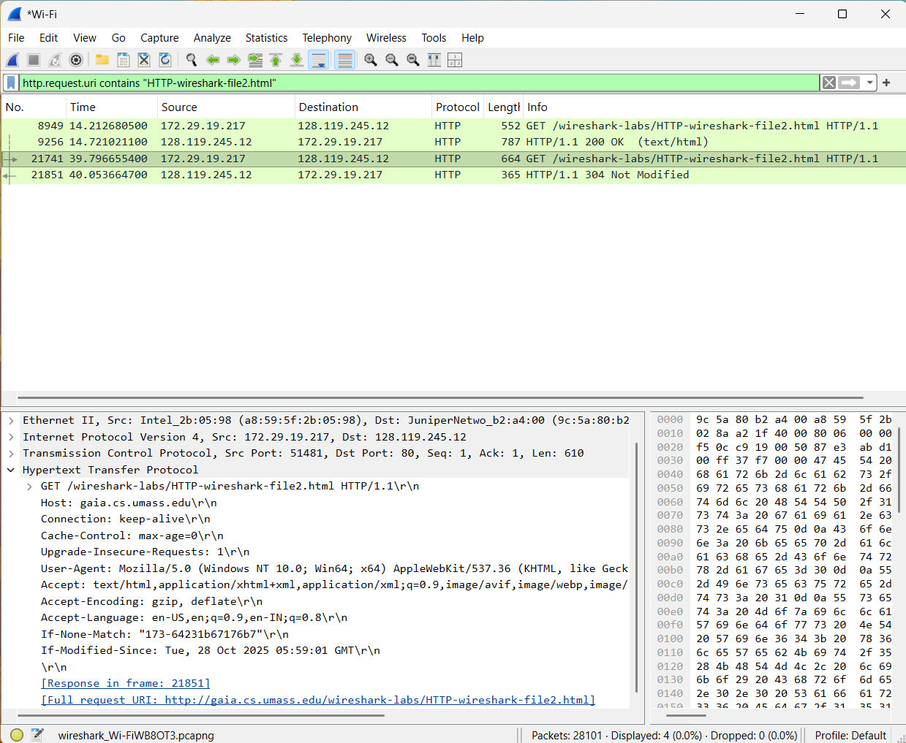
If-Modified-Since: Tue, 28 Oct 2025 05:59:01 GMT\r\n
Question_11
What is the HTTP status code and phrase returned from the server in response to
this second HTTP GET? Did the server explicitly return the contents of the file?
Explain.
The HTTP status code returned by the server is 304, with the phrase “Not Modified.” The server did not explicitly return the contents of the file. The 304 Not Modified response indicates that the requested file has not been modified since the date specified in the If-Modified-Since header. Therefore, the browser can use the copy of the file that is already stored in its cache instead of downloading the file again.
Question_12
How many HTTP GET request messages were sent by your browser?
One
Question_13
How many data-containing TCP segments were needed to carry the single HTTP
response?
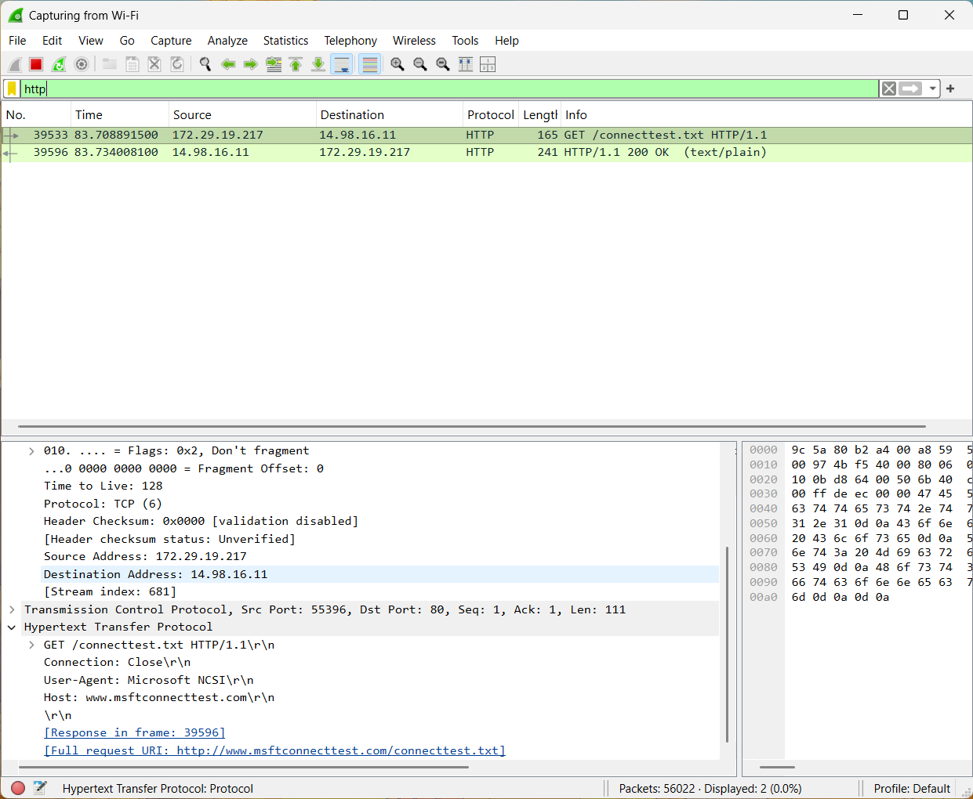

Question_14
What is the status code and phrase associated with the response to the HTTP GET
request?
The status code returned by the server is 200, and the associated phrase is “OK”. Therefore, the HTTP response status line is HTTP/1.1 200 OK.
Question_15
Are there any HTTP status lines in the transmitted data associated with a TCPinduced
“Continuation”?
No. There are no HTTP status lines associated with the TCP-induced “Continuation” packets. The HTTP response contains only one status line, HTTP/1.1 200 OK. The “Continuation” packets are simply additional TCP segments carrying portions of the same HTTP response. “Continuation” is a Wireshark indication and is not a separate HTTP message
Question_16
How many HTTP GET request messages were sent by your browser? To which Internet addresses were these GET requests sent?
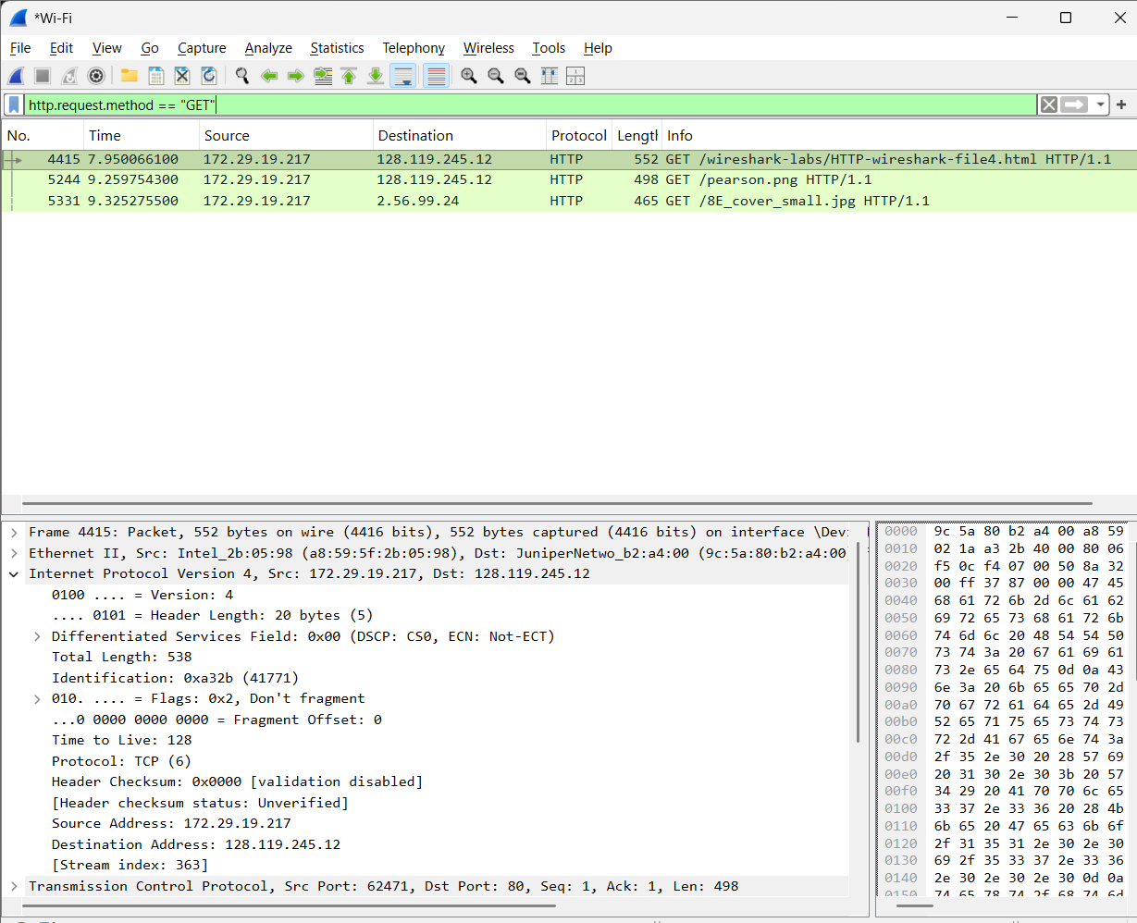
Total 3
Address - 172.29.19.217 destination - 128.119.245.12
Question_17
Can you tell whether your browser downloaded the two images serially, or whether they were downloaded from the two web sites in parallel? Explain.
The two images were downloaded in parallel. This can be determined by inspecting the timestamps of the HTTP GET requests for the two images. The GET requests occur very close together in time, indicating that the browser initiated requests to the two web servers without waiting for the first image download to complete.
Question_18
What is the server’s response (status code and phrase) in response to the initial HTTP GET message from your browser?

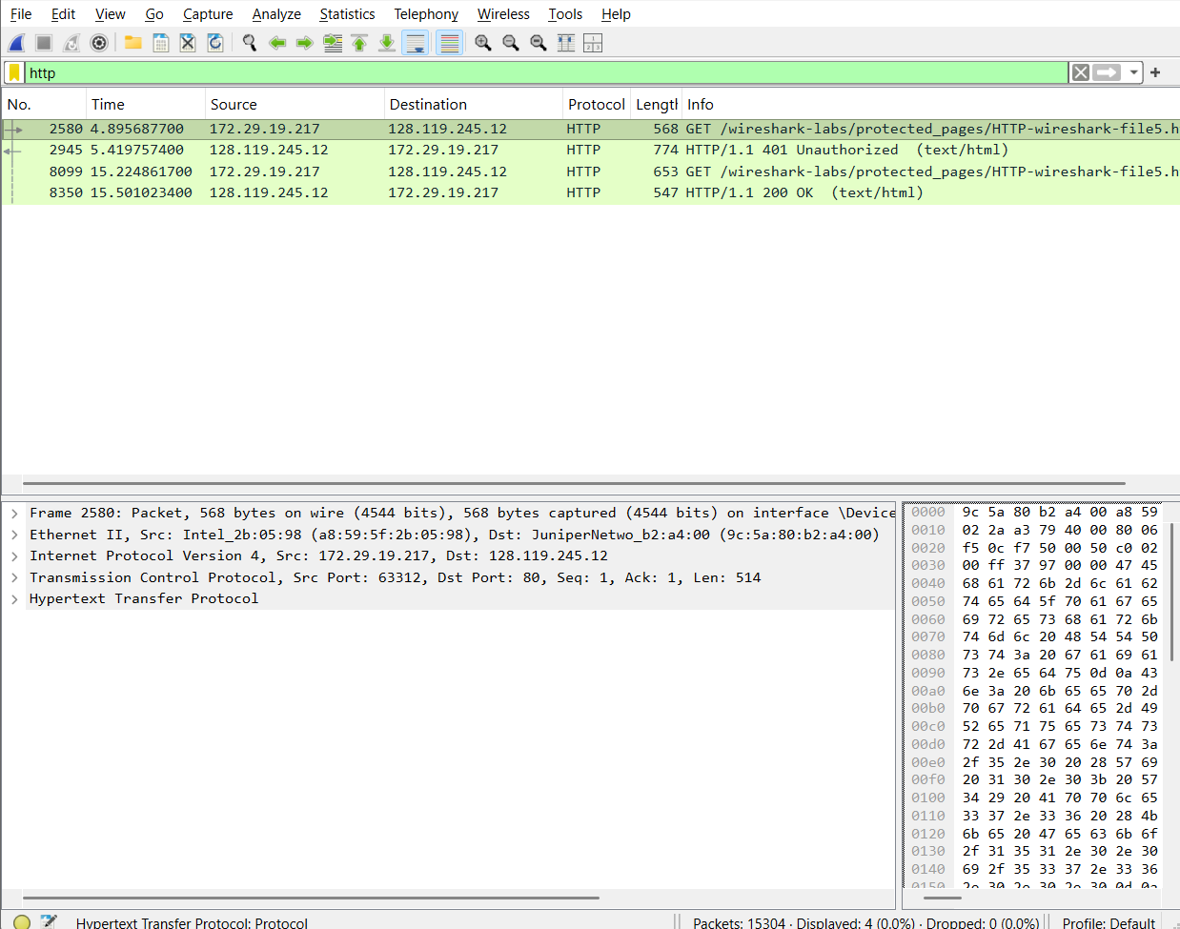The server responds to the initial HTTP GET with status code 401 and the phrase “Unauthorized.” The response is HTTP/1.1 401 Unauthorized, indicating that authentication is required before the requested resource can be accessed.
Question_19
When your browser sends the HTTP GET message for the second time, what new field is included in the HTTP GET message?
The second HTTP GET message contains a new Authorization field, specifically an Authorization: Basic header. This header contains the username and password encoded using Base64. The credentials are encoded rather than encrypted.

