Computer networks – Lab 2
BL.AI.U4AID25064
Surampudi Sudarshan Rao

Nslookup – questions
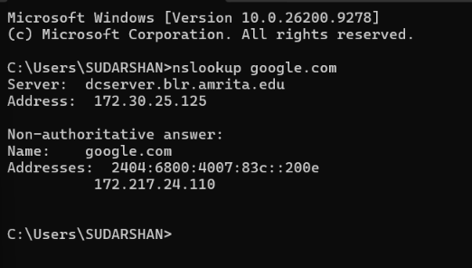
Question – 1
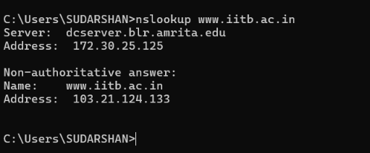
Question – 2
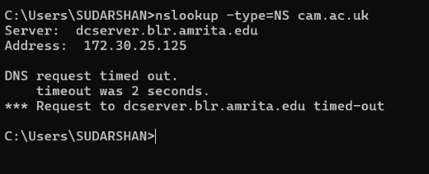
The DNS server is timed out so we are not using the given url in the pdf. We are using the google.com server.
Question – 1
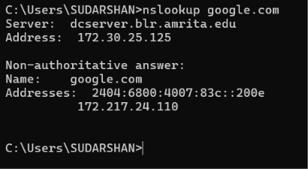
Question – 2
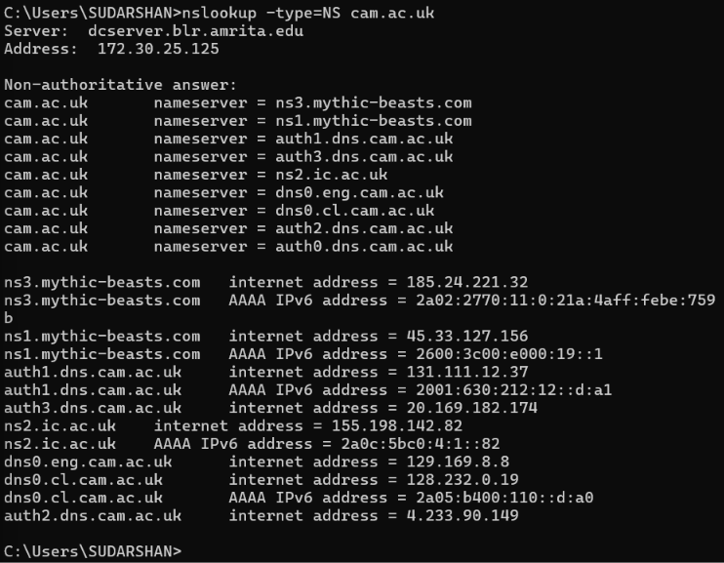
Question – 3
In this question the mythic-beasts.com we are not able to connect to the servers. And then we have tried for the Cambridge command but we got rejected but in the end the request was timed out even when the one with IP address was not able to be connected.
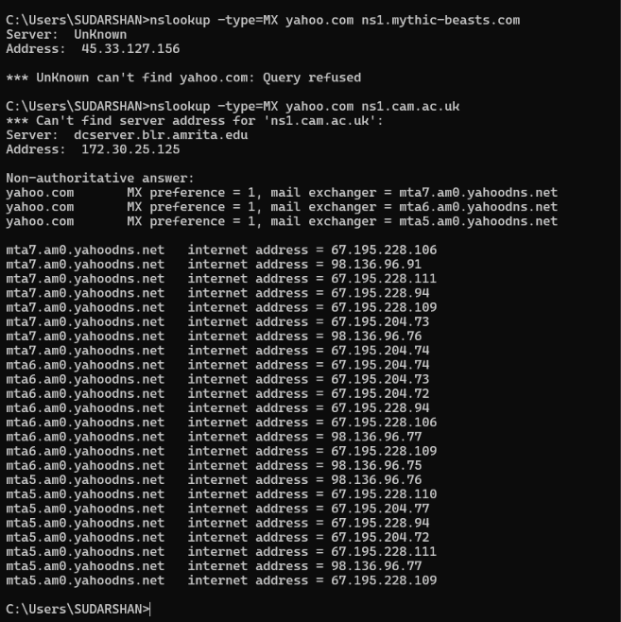
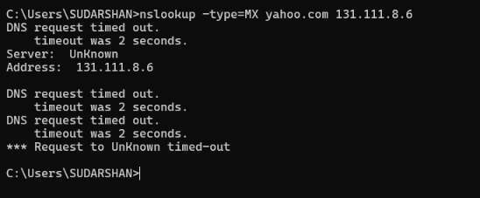
Ipconfig
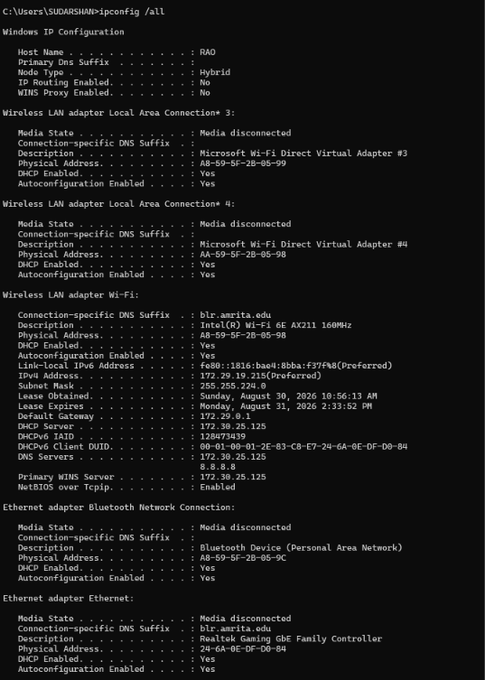
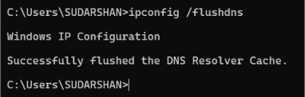
Question – 4
This is sent using UDP
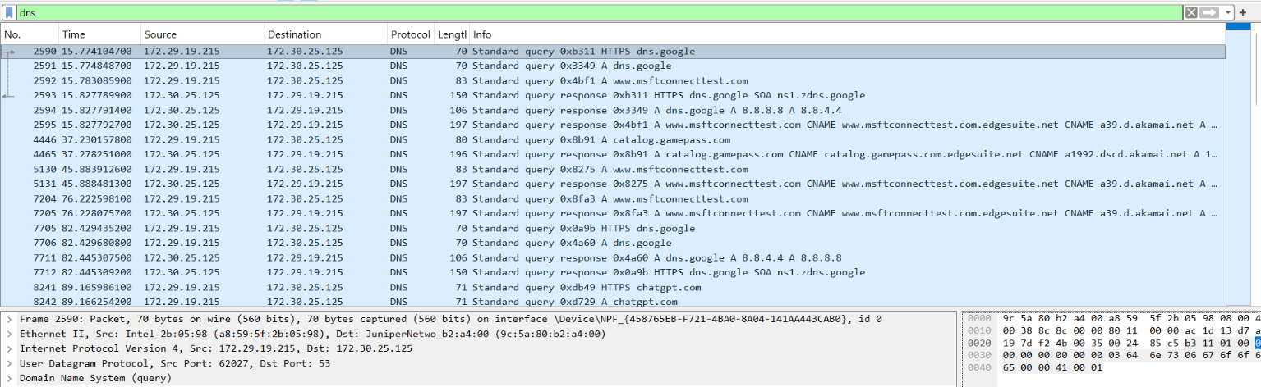
Question – 5
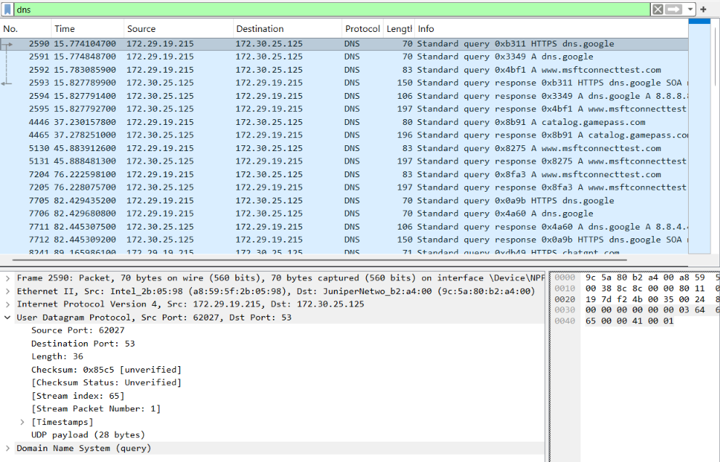
Question – 6
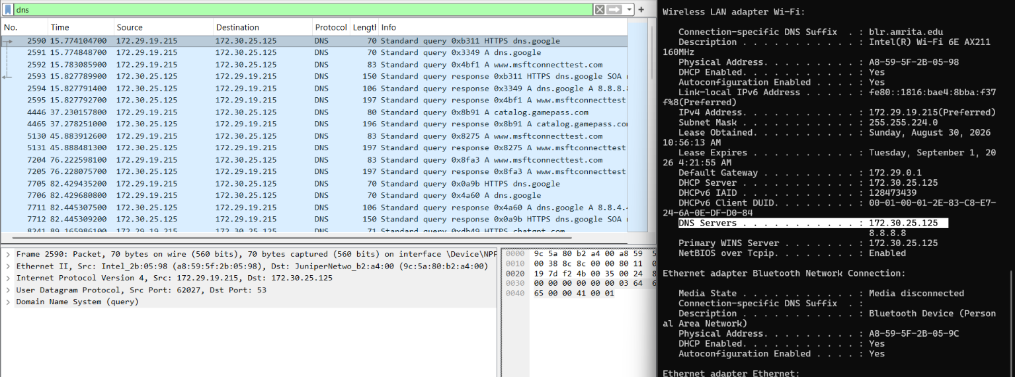
The DNS query was sent to 172.30.25.125, which is the local/default DNS server shown by ipconfig.
Question – 7
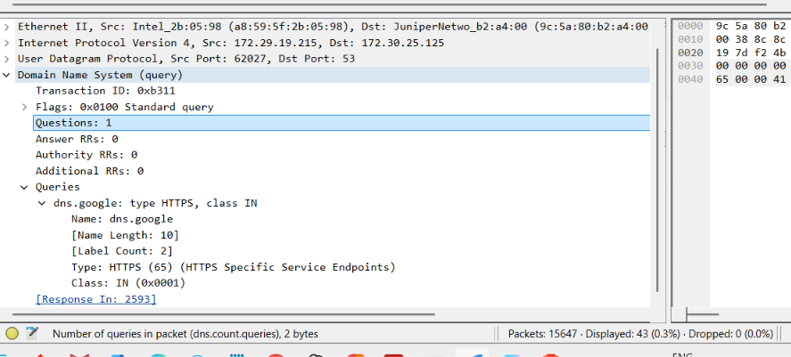
Question – 8
In my wire shark this shows answers RRs as 0.
Question – 9
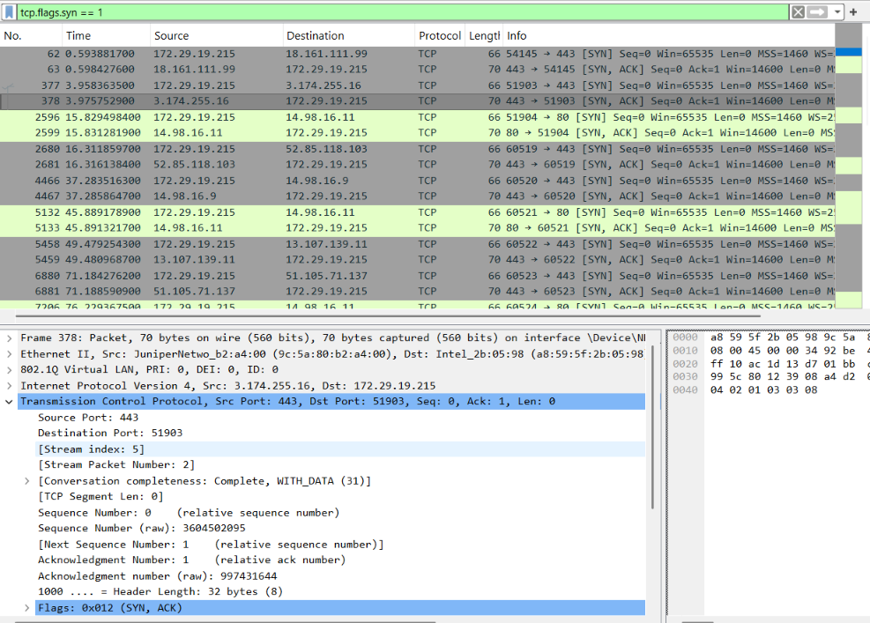
Question – 10
NO
Question – 11
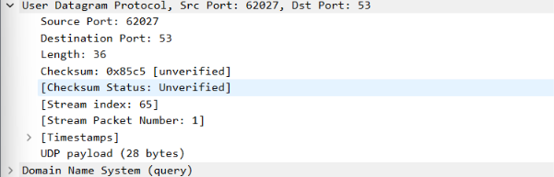
Question – 12
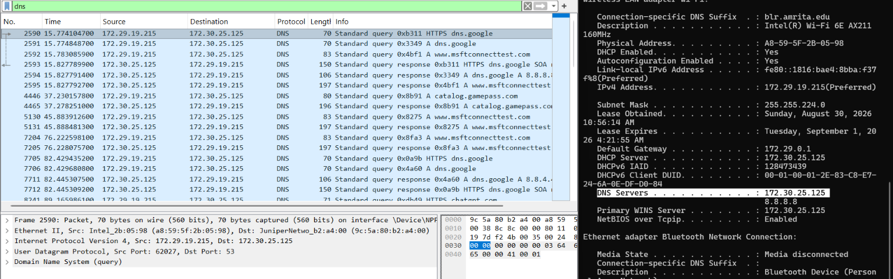
Question – 13
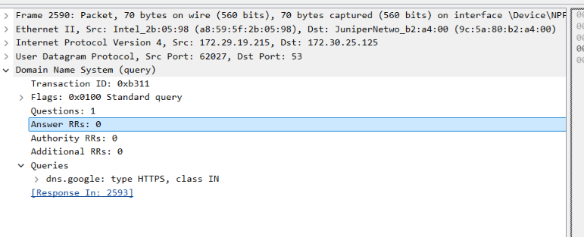
Question – 14
These are the answers
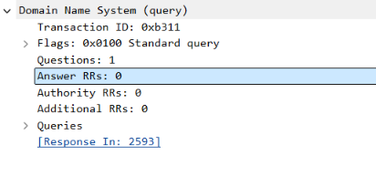
Question – 15
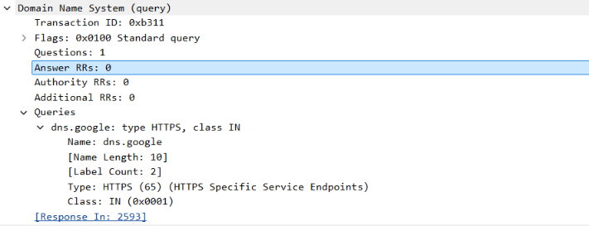
Question – 16
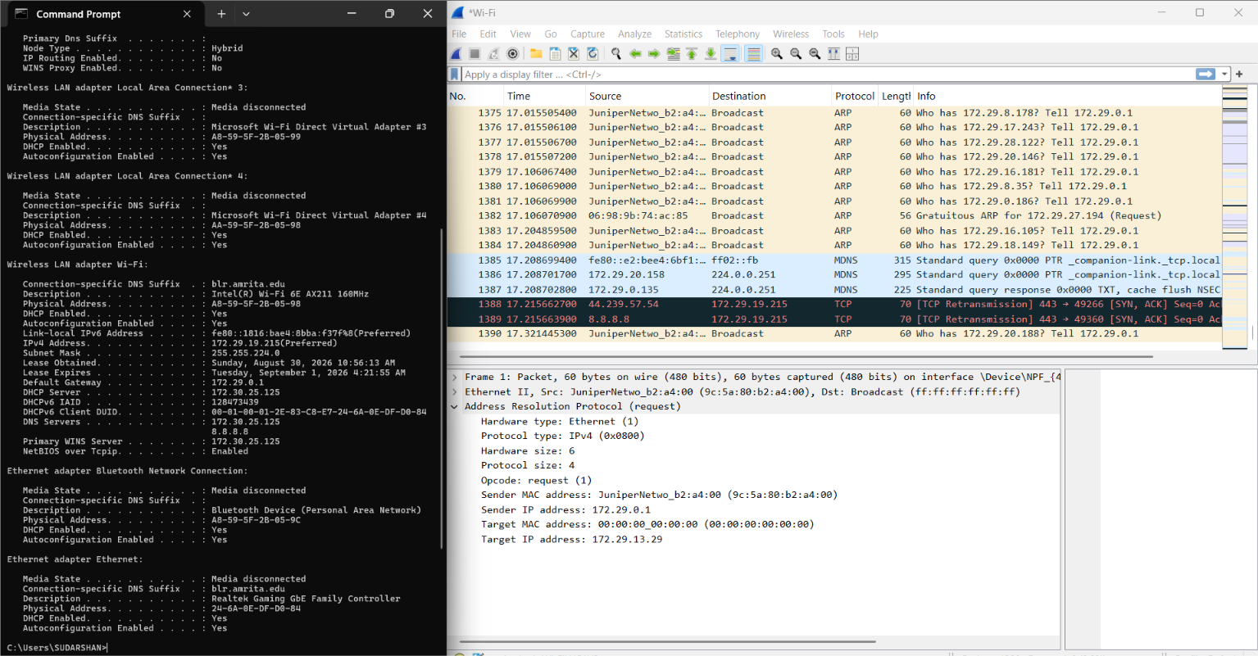
Question – 17
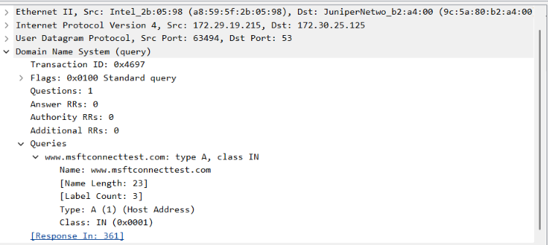
Question – 18
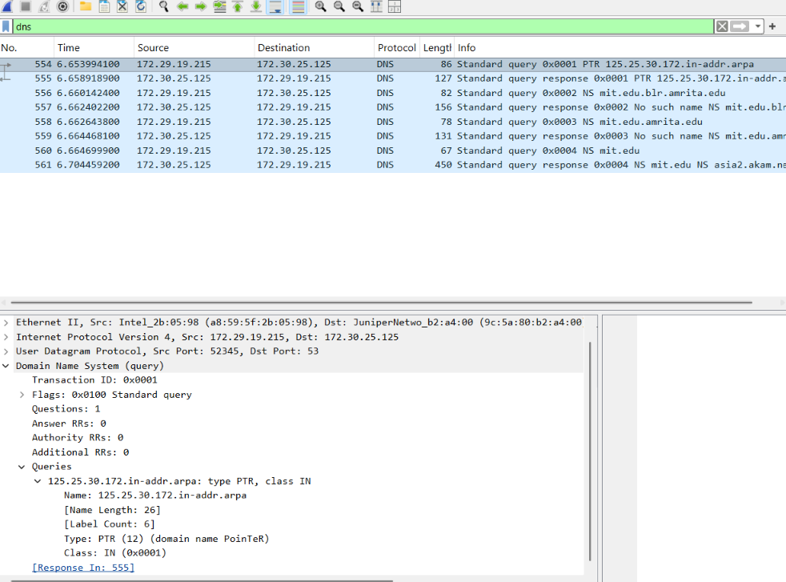
Question – 19
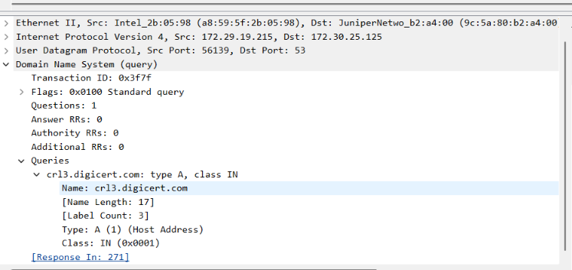
Question – 20
NO , the DNS server timed out , and if the command works
Question – 21 and 22
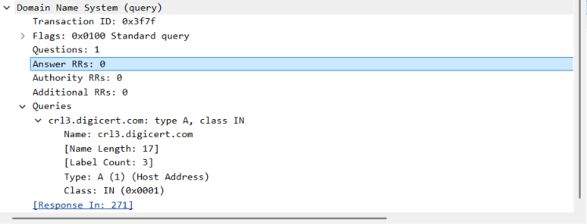
Question – 23
