CM2900 – Industry Based AI Software Project
Final Report

AI-Powered Housing, Rental, and Land Price Prediction System with Sentiment Analysis & Reinforcement Learning
Group 04

Index No | Name
235504U | Ahamed MFY
235517L | Illankoon IMHL
235534K | Samarasinghe SKAK
235545U | Wijerathna WDIS

Supervised by:
Dr. Thilini Piyathilake
Mr. Hasarindu Perera
Client:
Vega Innovations
Trace Expert City,
Tripoli Market,
Maradana, Sri Lanka
BSc (Hons) in Artificial Intelligence
Department of Computational Mathematics
Faculty of Information Technology
University of Moratuwa
Sri Lanka
2026

DECLARATION
We declare that this report is our own work and has not been submitted in any form for another degree or diploma at any university or other institution of tertiary education. Information derived from the published or unpublished work of others has been acknowledged in the text, and a list of references is given.
Student Name | Index No | Signature
Ahamed MFY | 235504U
Illankoon IMHL | 235517L
Samarasinghe SKAK | 235534K
Wijerathna WDIS | 235545U

The above candidates have carried out research for the undergraduate thesis/dissertation under our supervision. We confirm that the declaration made above by the students is true and correct.

Supervisor | Signature | Date
Dr. Thilini Piyathilake
Mr. Hasarindu Perera

ABSTRACT
Property valuation in Sri Lanka is dominated by listing-price heuristics and expert judgement, and automated valuation platforms built for data-rich markets transfer poorly: local listings are sparse, unevenly distributed across districts, quoted in inconsistent units and rapidly outdated. Reva addresses this as an industry-based decision-support system that predicts housing, rental and land prices, tracks a user's portfolio over time, aggregates market sentiment from financial news, and issues buy, hold or sell guidance through a reinforcement-learning agent.
The delivered system is a React and TypeScript client over a FastAPI service of thirteen routers and sixteen relational tables. Three supervised models are served: a CatBoost house model for house price prediction which some extracted features from free-text listing descriptions; a LightGBM land model with gazetteer geocoding and Land Valuation Indicator calibration; and a CatBoost rental model over sixty-five features on a log target. Each model price is then moved from its training anchor to the present by a matched, observed Central Bank of Sri Lanka index ratio, guarded by staleness, volatility and plausibility tests that degrade the factor to unity rather than distort the estimate. A FinBERT and MiniLM pipeline scores news into per-asset horizons, and a Deep Q-Network maps a twenty-five element state to one of twenty-seven joint actions with a distribution-health verdict attached to every response.
Evaluation uses held-out and temporal splits. The house model reaches 19.66 % validation MAPE, improving 5.34 % on a ten-feature baseline; the rental model reaches 32.05 % validation and 58.80 % temporal MAPE, a 51.85 % MAE improvement over the strongest non-learned baseline. Two negative results are published rather than suppressed: a graph-neural residual imputer lost to the tabular baseline on every variant, and the market-index LSTM lost to a naive forecast at every horizon.

Keywords: automated valuation model, gradient boosting, market-index anchoring, financial sentiment analysis, deep Q-network, real estate decision support

TABLE OF CONTENTS
Contents
INTRODUCTION 1
1.1 Introduction 1
1.2 Objectives 2
1.3 Problem in Brief 3
1.4 Background and Motivation 3
1.5 Novel Approach to Evidence-Governed Property Decision Support 4
1.6 Resource Requirements 5
1.7 Structure of the Thesis 5
1.8 Summary 6
LITERATURE REVIEW 7
2.1 Introduction 7
2.2 Chronological Review of Prior Work 7
2.2.1 Early development of automated property valuation 7
2.2.2 Current developments and future trends 7
2.2.3 Issues and research challenges 8
2.3 Comparative Analysis of Existing Technologies 9
2.4 Strengths and Limitations of Current Technologies 10
2.5 Summary of Issues 10
2.6 Discussion on Gaps in Current Research 11
2.6.1 Problem Definition 11
2.7 Summary 11
TECHNOLOGY ADOPTED 13
3.1 Introduction 13
3.2 Revisiting the Research Problem 13
3.3 Justification for the Choice of Technologies 13
3.4 Brief Overview of the Selected Technology 14
3.5 Technology Adoption for the Solution 15
3.6 Novelty of the Solution 16
3.7 Summary 16
APPROACH 17
4.1 Introduction 17
4.2 Hypothesis and Its Inspiration 17
4.3 Inputs and Outputs of the Solution 17
4.4 Process Workflow in the Solution 18
4.5 Justification for Technology Adopted 22
4.6 Target Users 22
4.7 Novelty and Features of the Solution 22
4.8 Summary 23
ANALYSIS AND DESIGN 24
5.1 Introduction 24
5.2 Rationale for Design 24
5.3 Top-Level Architecture 25
5.3.1 Preprocessing Module 26
5.3.2 ML Engine 26
5.3.3 Extended Module 26
5.4 Data Flow and Interaction Design 26
5.4.1 Use Case Model 27
5.4.2 Activity Models 28
5.4.3 Class Model 33
5.4.4 Sequence Models 33
5.4.5 Entity–Relationship Model 37
5.4.6 Administrative Design 40
5.5 Positioning the Novelty within the Design 41
5.6 Summary 41
IMPLEMENTATION 42
6.1 Introduction 42
6.2 Overall System Development 42
6.3 Hardware and Software Platforms 42
6.4 Module-wise Implementation of the Design 43
6.4.1 Valuation models 44
6.4.2 Market-index anchoring 45
6.4.3 Portfolio valuation 45
6.4.4 Sentiment pipeline 46
6.4.5 Reinforcement-learning serving 46
6.4.6 Conversational and agentic layers 47
6.5 Algorithms and Pseudocode 48
6.6 Workflow Diagrams and Flowcharts 50
6.7 Integration of Components 50
6.8 Incremental Testing During Development 51
6.9 Summary 51
EVALUATION 53
7.1 Introduction 53
7.2 Evaluation Strategy 53
7.3 Experimental Setup 53
7.4 Datasets and Test Cases 54
7.5 Participants 54
7.6 Evaluation Metrics 54
7.7 Results and Analysis 55
7.7.1 House valuation model 55
7.7.2 Graph neural network experiment (negative result) 56
7.7.3 Rental valuation model 57
7.7.4 Market-index forecasting (negative result) 60
7.7.5 Land valuation model 61
7.7.6 Reinforcement-learning component 61
7.8 Comparison of the Solution with Existing Methods 62
7.9 Discussion of Findings 63
7.10 Summary 64
CONCLUSIONS AND FURTHER WORK 65
8.1 Introduction 65
8.2 Overall Conclusion 65
8.3 Objectives-wise Achievements 66
8.4 Summary of Quantitative Performance 66
8.5 Challenges and Limitations 67
8.6 Future Work 68
8.7 Summary 69
Appendix A — Register of Corrections Applied to the Interim Report 72
Appendix B — REST API Endpoint Reference 74
Appendix C — Implemented Relational Schema 75
Appendix D — Reinforcement-Learning State Vector Specification 75
Appendix E — Individual Contributions 76

LIST OF FIGURES
Figure 1:Price prediction workflow as implemented. Sentiment is not an input to this path; the temporal correction is supplied by a guarded, observed market-index ratio. 20
Figure 2:Reinforcement-learning recommendation workflow as implemented, including the constant cash feature and the state-health verdict attached to every response. 21
Figure 3:Target reinforcement-learning recommendation workflow from the parallel research study. Steps 8 and 10 are specified for future work rather than implemented (see §8.6). 21
Figure 4:Top-level architecture of the implemented system. The application layer exposes thirteen FastAPI routers over sixteen relational tables; the intelligence layer holds three valuation models, a market-index model, the sentiment pipeline, the reinforcement 25
Figure 5:High-level use case diagram carried forward from the interim design. Three of the administrative use cases — Manage Datasets, Retrain Models and Export User Property Data 27
Figure 6:Price Prediction Module activity diagram from the interim design 28
Figure 7:Login to account — activity diagram. 28
Figure 8:Add property details — activity diagram 29
Figure 9:View dashboard — activity diagram. 30
Figure 10:Use chatbot — activity diagram. 31
Figure 11:Provide feedback — activity diagram. In the delivered system the stored record is a site review; it is not associated with a prediction and is not consumed by any model. 31
Figure 12:Admin workflow activity diagram from the interim design. The dataset-management, retraining and export branches were not implemented; training is performed offline by the scripts listed in §6.4. 32
Figure 13:Class diagram from the interim design. ReinforcementLearningModule.updatePolicy() and processFeedback() are not implemented; the deployed agent exposes inference only 33
Figure 14:Price prediction module — sequence diagram. The backend lifeline is FastAPI, not Flask, and the sentiment model does not participate in this interaction. 34
Figure 15:Login to account — sequence diagram. 34
Figure 16:Add property details — sequence diagram. 35
Figure 17:View dashboard — sequence diagram. In the implementation the dashboard path additionally applies the index anchor factor and writes a valuation snapshot. 35
Figure 18:Use chatbot — sequence diagram. Two chat paths exist in the delivered system and neither retrieves a portfolio summary as drawn; see §6.4. 36
Figure 19:Provide feedback — sequence diagram. The Reward signal and Update dashboard messages to the RL module are not implemented. 36
Figure 20:Manage datasets — sequence diagram. Not implemented; retained as design intent. 36
Figure 21:Export user property data — sequence diagram. Not implemented; retained as design intent. 37
Figure 22:Admin model retraining — sequence diagram. Not implemented as an online workflow; retraining is performed offline and the resulting artefact is registered through the model registry. 37
Figure 23:Entity–relationship diagram as proposed in the interim report. 38
Figure 24:Entity–relationship diagram of the implemented relational schema — sixteen tables across PostgreSQL, defined by SQLAlchemy models. 39
Figure 25:Target architecture for the reinforcement-learning advisory component from the parallel research study. The preprocessing module and ML engine are implemented; the extended module ships with state-health assessment only, without risk, feasibility or exp 41
Figure 26:House valuation model — held-out validation error by feature set (n = 3,354). 55
Figure 27:Every graph-neural variant lost to the tabular baseline. Logarithmic scale; the acceptance threshold was a 2 % MAE improvement. 56
Figure 28:Rental valuation model against four baselines on the validation split and the 2026 temporal hold-out. 57
Figure 29:Rental valuation model — validation MAPE by property segment, with validation row counts. Error tracks data density. 58
Figure 30:Rental valuation model — relative error calibration on the validation split. 58
Figure 31:Market-index LSTM against naive and drift benchmarks. The learned model loses at every horizon on both series. 60

LIST OF TABLES
Table 1:RESOURCE REQUIREMENTS OF THE DELIVERED SYSTEM 5
Table 2: COMPARATIVE ANALYSIS OF CANDIDATE TECHNOLOGIES FOR THE REVA PROBLEM 9
Table 3:SUMMARY OF ISSUES AND THE RESPONSE ADOPTED IN REVA 10
Table 4:JUSTIFICATION FOR THE SELECTED TECHNOLOGIES 13
Table 5:MAIN INPUTS OF THE SOLUTION 17
Table 6:MAIN OUTPUTS OF THE SOLUTION 18
Table 7:NOVEL FEATURES OF THE SOLUTION AND THEIR IMPLEMENTATION STATUS 23
Table 8:MAIN DESIGN MODULES AND THEIR RESPONSIBILITIES 25
Table 9:IMPLEMENTED RELATIONAL TABLES BY FUNCTIONAL GROUP 40
Table 10:HARDWARE AND SOFTWARE PLATFORMS 42
Table 11:MODULE-WISE IMPLEMENTATION 43
Table 12:INCREMENTAL TESTING DURING DEVELOPMENT 50
Table 13:DATASETS USED FOR TRAINING AND EVALUATION 53
Table 14:EVALUATION METRICS AND THEIR ROLE 54
Table 15:HOUSE VALUATION MODEL — RESULTS BY FEATURE SET (TARGET: CAPPED PRICE PER SQUARE FOOT) 55
Table 16:HOUSE GNN RESIDUAL EXPERIMENT — ALL VARIANTS AGAINST THE ACCEPTED BASELINE 56
Table 17:RENTAL VALUATION MODEL — ACCEPTED MODEL AGAINST FOUR BASELINES 57
Table 18:MARKET-INDEX LSTM AGAINST NON-LEARNED BENCHMARKS (WALK-FORWARD BACKTEST, MAPE %) 59
Table 19:COMPARISON OF REVA WITH EXISTING APPROACHES 61
Table 20:COMPARISON OF REVA WITH EXISTING APPROACHES 65
Table 21:SUMMARY OF QUANTITATIVE PERFORMANCE 65
Table 22:REGISTER OF CORRECTIONS APPLIED TO THE INTERIM REPORT 71
Table 23:REST API ENDPOINTS EXPOSED BY THE FASTAPI SERVICE 73
Table 24:RELATIONAL TABLES, DEFINITION SOURCE AND DELETE BEHAVIOUR 74
Table 25:STATE VECTOR LAYOUT AND PER-FEATURE NOTES 74
Table 26:INDIVIDUAL CONTRIBUTIONS 75

LIST OF ABBREVIATIONS
Abbreviation | Description
API | Application Programming Interface
AVM | Automated Valuation Model
BERT | Bidirectional Encoder Representations from Transformers
CatBoost | Categorical Boosting (gradient-boosted decision tree library)
CBSL | Central Bank of Sri Lanka
CQL | Conservative Q-Learning
CVaR | Conditional Value at Risk
DQN | Deep Q-Network
ER | Entity Relationship
GATv2 | Graph Attention Network, version 2
GNN | Graph Neural Network
IQL | Implicit Q-Learning
JWT | JSON Web Token
LKR | Sri Lankan Rupee
LightGBM | Light Gradient Boosting Machine
LLM | Large Language Model
LSTM | Long Short-Term Memory
LVI | Land Valuation Indicator
MAE | Mean Absolute Error
MAPE | Mean Absolute Percentage Error
MDP | Markov Decision Process
ML | Machine Learning
MTL | Multi-Task Learning
OAuth | Open Authorization
ORM | Object Relational Mapper
REST | Representational State Transfer
RL | Reinforcement Learning
RMSE | Root Mean Squared Error
SPA | Single Page Application
UML | Unified Modeling Language
UI / UX | User Interface / User Experience

LIST OF APPENDICES
Appendix | Description
Appendix A | Register of corrections applied to the interim report
Appendix B | REST API endpoint reference
Appendix C | Implemented relational schema
Appendix D | Reinforcement-learning state vector specification
Appendix E | Individual contributions

CHAPTER 1

INTRODUCTION

1.1 Introduction
A property is the largest single transaction most households ever make, and in Sri Lanka it is usually priced by comparison: an agent recalls what a similar plot fetched nearby, adjusts for road access and utilities, and quotes a figure. The method is fast, does not scale, and it degrades quickly outside the districts the agent knows well.
Reva, Real Estate Virtual Agent, was developed to replaces that heuristic with an auditable pipeline. The system predicts prices for three distinct asset classes — houses, rental properties and land — from structured attributes and, where available, from the free text of listing descriptions. It does not stop at a prediction. A registered user can record the properties they own, and Reva tracks the estimated value of that portfolio over time, separating what the model asserts from what the published market index actually observed. Alongside this, a sentiment pipeline reads financial and property news and reduces it to per-asset market mood, and a reinforcement-learning agent converts the combined picture into a buy, hold or sell suggestion for each asset class.
The distinguishing commitment of the system is not any single model. It is that every figure leaving the API carries its provenance: which model produced it, at what training anchor, which index observation moved it to the present, how confident the coverage is, and — for the reinforcement-learning output — whether the request even falls inside the distribution the agent was trained on. Where that chain cannot be completed, the system returns a status of unavailable or anchor_only rather than an invented default. We refer to this property throughout as evidence-governed behaviour.
This dissertation reports the completed system. An audit of that document(interim report) against the implementation found thirteen material discrepancies, ranging from the name of the backend framework to two architectural claims that the code does not support. Those corrections are integrated into the relevant chapters and catalogued in Appendix A.
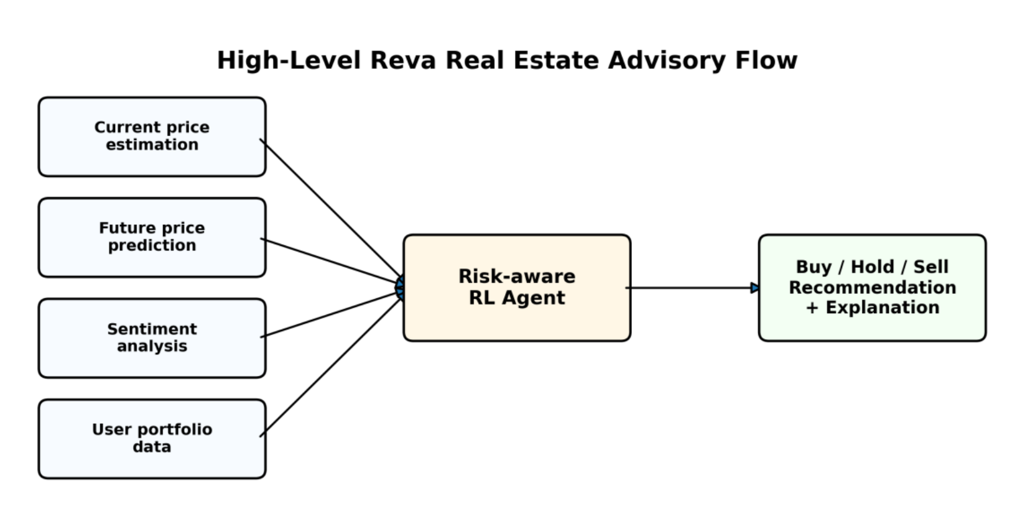
Fig. 1.1: High-level Reva decision-support flow. Current price estimation, forward price signals, sentiment aggregation and portfolio state are combined by the reinforcement-learning agent into a buy / hold / sell recommendation.

1.2 Objectives
The overall aim of the project is to design, build and evaluate an AI software system that produces defensible property valuations for the Sri Lankan market and converts them into portfolio-level decision support. Four objectives follow from that aim.
- Objective 1 — Critical literature review. Review automated valuation modelling, hedonic and machine-learned pricing, financial sentiment analysis, reinforcement learning for portfolio decisions, and the specific failure modes of transferring data-rich-market techniques to a thin, regionally biased market.
- Objective 2 — In-depth study of relevant technology. Study gradient-boosted decision trees for tabular valuation, graph neural networks for neighbourhood-aware imputation, sequence models for index forecasting, transformer-based financial sentiment classification, and value-based reinforcement learning, including the serving constraints each imposes.
- Objective 3 — Design and development of a solution. Deliver a working, deployed, multi-user web system integrating three valuation models, a market-index anchoring layer, a portfolio valuation engine, a sentiment pipeline, a reinforcement-learning recommendation service and an agentic conversational interface, with provenance carried end to end.
- Objective 4 — Evaluation of the solution. Evaluate each component on held-out and temporal splits against explicit non-learned baselines, report negative results where the learned component fails to beat its baseline, and verify the integrated system through an automated test suite.

1.3 Problem in Brief
Sri Lankan property data is thin, biased and stale. Listings cluster heavily in the Western Province; a single land model's district vocabulary in this project covers only Colombo, Gampaha and Kalutara, while the national calibration table names nine districts plus a catch-all. Prices are quoted in mixed units — land per perch, houses per square foot, rentals per month — and aggregating them naively produces figures that are not merely imprecise but dimensionally wrong. The published market index that would let a model correct for time lags real time by a quarter or more, and covers Colombo district only.
Layered on top is a decision problem. A predicted price does not tell a user what to do. Whether a household should buy, hold or sell depends on what they already own, what the market is doing, how confident the forecast is, and how illiquid and costly the transaction would be. Supervised regression is structurally incapable of answering that question, and portfolio reinforcement learning as practised on equities assumes liquidity, divisibility and dense price history that real estate does not have.
The problem this project addresses is therefore twofold: produce valuations that remain honest when the data runs out, and convert those valuations into decision support that declares its own reliability.

1.4 Background and Motivation
Vega Innovations approached the problem from the position of a practitioner rather than a researcher. Their brief was blunt: a valuation a client cannot interrogate is a valuation the client will not act on. That framing drove three decisions that shape the whole system.
First, the model that predicts a price and the mechanism that ages that price to the present were separated. A gradient-boosted tree trained on 2022–2025 listings knows the price level of its training corpus, not of today. Multiplying that level by an observed index ratio is a claim the system can show its working for; retraining monthly is not feasible with the available data volume.
Second, silence was preferred to invention. If a property is missing a district or a required physical feature, the valuation returns unavailable and asks the user to supply it. If a property sits outside the index's geographic coverage, it is labelled anchor_only and is not silently moved by Colombo's market movement.
Third, the reinforcement-learning component was scoped honestly. The literature offers risk-aware, personalised and offline reinforcement-learning formulations that are well suited to illiquid assets, and the group's parallel research study specifies such a framework in detail. What ships in this release is the foundation of that framework — a trained Deep Q-Network served as an inference endpoint with a distribution-health guard — and the report is explicit about where the boundary lies.

1.5 Novel Approach to Evidence-Governed Property Decision Support
The novelty of Reva lies in the composition rather than in any individual model. Four elements distinguish it from the platforms and academic prototypes reviewed in Chapter 2.
- Separation of price level from price movement. The automated valuation model owns the level at its own training anchor. A matched, observed CBSL index ratio owns the movement to the present. A forecast, when enabled, owns only the forward path. Each is versioned and reported independently, so a wrong number can be attributed to the component that produced it.
- Guarded degradation instead of silent defaults. Index staleness, per-series volatility bands and a plausibility clamp are evaluated before the index factor is applied. Failing any guard degrades the factor to exactly 1.0, leaving the model's own estimate untouched, and the response records that this happened.
- Description-derived features as first-class model inputs. Forty of the fifty house-model features are extracted from unstructured listing text — road width, utility availability, distances to town, school, hospital, supermarket and transport, and composite utility, access, service and quality scores. This converts prose that agents read intuitively into signal a tree can split on.
- A recommendation that declares its own competence. Every reinforcement-learning response is accompanied by a per-feature z-score assessment against the agent's training distribution. Where any feature exceeds three standard deviations the response is flagged reliable: false and names the offending features, because a Deep Q-Network queried off-distribution returns an arbitrary argmax rather than degrading gracefully.

1.6 Resource Requirements
Table 1:RESOURCE REQUIREMENTS OF THE DELIVERED SYSTEM
Resource type | Requirement | Purpose
Structured data | Scraped and cleaned house, rental and land listings (2022–2026); CBSL Real Estate Market Analysis index; Land Valuation Indicator table; Sri Lanka place-name gazetteer | Model training, temporal anchoring and offline geocoding
Textual data | Financial and property news via NewsAPI, targeted scrapers and Google Trends | Sentiment scoring and market-mood aggregation
Model artefacts | CatBoost house and rental models; LightGBM land bundle; two LSTM index models; DQN weights and StandardScaler | Serving predictions and recommendations without retraining at request time
Software | Python 3.12, FastAPI, Uvicorn, SQLAlchemy, CatBoost, LightGBM, TensorFlow/Keras, PyTorch, Hugging Face Transformers, sentence-transformers, LangGraph, React 19, TypeScript, Vite, Leaflet | Backend services, model inference, sentiment pipeline, agent and client
Storage | PostgreSQL (Azure Database for PostgreSQL), Redis, MongoDB, ChromaDB | Relational state; caches; scored sentiment documents; reference embeddings
Computing | Development workstation with 16 GB RAM; cloud application instance; GPU optional and used only for offline training | Training runs, inference and integration testing
External services | Google OAuth, Google Gemini 2.5 Flash, OpenRouter, OpenStreetMap tiles | Authentication, conversational assistance and map rendering

1.7 Structure of the Thesis
- Chapter 1 introduces the project, its objectives, the problem, the motivation, the novel approach and the resources required.
- Chapter 2 reviews prior work in automated valuation, sentiment analysis and reinforcement learning for investment decisions, and derives the research gap and problem definition.
- Chapter 3 justifies the technologies adopted and describes how they combine.
- Chapter 4 presents the approach: hypothesis, inputs and outputs, process workflow, target users and novel features.
- Chapter 5 presents the analysis and design, including the top-level architecture, the UML models and the implemented database schema.
- Chapter 6 describes the implementation module by module, with algorithms, integration and incremental testing.
- Chapter 7 evaluates the system against held-out and temporal splits and explicit baselines, and reports negative results.
- Chapter 8 concludes, states objective-wise achievement, limitations and further work.
- Appendix A records every correction applied to the interim report; Appendices B to E give the API reference, the relational schema, the reinforcement-learning state specification and individual contributions.

1.8 Summary
This chapter positioned Reva as an evidence-governed decision-support system for the Sri Lankan property market, stated the four project objectives, described the data and decision problems it addresses, and outlined the four elements that distinguish its approach. It also declared this dissertation's secondary purpose: to correct the interim report where the implementation diverged from it. The next chapter reviews the literature that motivates these choices.

CHAPTER 2

LITERATURE REVIEW

2.1 Introduction
This chapter reviews the work Reva builds on and departs from. Three strands are relevant: automated property valuation, financial sentiment analysis, and reinforcement learning applied to investment decisions. The review is oriented towards a specific question — which of these techniques survive transfer to a thin, regionally biased, slowly transacting market — because that, rather than raw accuracy, determined the design.

2.2 Chronological Review of Prior Work

2.2.1 Early development of automated property valuation
Automated valuation begins with hedonic pricing, in which a property is treated as a bundle of attributes and its price regressed on them [1]. Hedonic models are interpretable and remain the reference method in appraisal practice, but they assume additive, largely linear contributions and struggle with the interactions that dominate property value — the joint effect of location, access and size is not the sum of their separate effects.
Spatial econometrics addressed part of this by modelling spatial autocorrelation explicitly, recognising that nearby properties share unobserved value drivers [2]. Comparable-sales methods, which remain the industry standard, encode the same intuition procedurally rather than statistically. Both approaches degrade where transaction density is low, which is precisely the condition outside major Sri Lankan urban centres.

2.2.2 Current developments and future trends
Machine-learned valuation displaced hedonic regression in accuracy terms once ensemble methods matured. Random forests and gradient-boosted trees capture the interactions hedonic models cannot, and require no functional-form assumption. Modern implementations — XGBoost [3], LightGBM [4] and CatBoost [5] — differ in how they handle categorical variables and how they grow trees; CatBoost's ordered target statistics are particularly suited to high-cardinality location categories such as sub-locality, which is why it was selected for two of the three models here.
Commercial platforms operationalise this at scale. Zillow's Zestimate and Redfin's Estimate combine large transaction corpora with frequent retraining, and publish national median error figures in the low single digits. Their accuracy is a function of data density: the United States publishes near-complete transaction records, while Sri Lankan valuation must rely on asking prices from listing portals such as ikman and LankaPropertyWeb, which are biased upward and unevenly distributed. Reported error figures from these platforms are therefore not a meaningful target for this project.
Two more recent directions are relevant. First, graph neural networks have been applied to property valuation to let a listing borrow signal from its spatial and feature-space neighbours, with attention-based aggregation [6] used to weight neighbours by relevance. Second, transformer language models fine-tuned on financial text — FinBERT [7] being the widely used instance — make it practical to convert news flow into a quantitative market-mood signal. Both were implemented in this project; only one survived evaluation, as Chapter 7 reports.

2.2.3 Issues and research challenges
- Data sparsity and regional bias. Listing volume collapses outside the Western Province, so a model trained on the national corpus is effectively a Colombo model wearing a national label.
- Unit inconsistency. Land is quoted per perch, houses per square foot or in total, rentals per month. Summing these without conversion produces portfolio values that are wrong by orders of magnitude.
- Temporal drift. A model trained on a fixed corpus reports that corpus's price level. Correcting for elapsed time requires an external index, and the available index lags by a quarter or more.
- Asking price is not transaction price. Listing portals publish what sellers ask, not what buyers pay; the resulting bias is systematic rather than random.
- Illiquidity and indivisibility. Property cannot be traded frequently or fractionally, invalidating the core assumptions of portfolio reinforcement learning developed for equities.
- Unsafe exploration. A recommendation agent cannot learn by experimenting with a user's capital, which forces offline formulations and conservative evaluation [8], [9].
- Forecast uncertainty. Downstream decision layers routinely consume upstream predictions as point estimates, discarding the variance that should temper the decision.

2.3 Comparative Analysis of Existing Technologies
Table 2: COMPARATIVE ANALYSIS OF CANDIDATE TECHNOLOGIES FOR THE REVA PROBLEM
Technology / approach | Strength | Limitation in this context
Hedonic regression | Interpretable, statistically well understood, standard in appraisal | Cannot represent the interactions that dominate property value; weak on high-cardinality location
Comparable-sales heuristics | Matches practitioner reasoning; robust with few data points | Not reproducible, does not scale, and degrades where transaction density is low
Random forest / bagging | Handles non-linearity, resistant to overfitting | Weaker extrapolation than boosting; less native categorical handling
Gradient boosting (CatBoost, LightGBM, XGBoost) | State of the art on tabular data; native categorical handling; fast inference | Cannot use unstructured text without feature engineering; no notion of temporal drift outside the training corpus
Graph neural networks | Neighbourhood-aware; can impute missing attributes from spatial and feature neighbours | Requires dense, well-connected graphs; expensive to serve; failed to beat the tabular baseline in this project (§7.7.2)
LSTM / sequence forecasting | Models temporal structure directly | Needs long, dense series; the available CBSL series has 66–75 monthly observations and the model loses to a naive forecast (§7.7.4)
Lexicon sentiment (VADER and similar) | No training data required; fast | General-purpose lexicons misread financial phrasing
Transformer financial sentiment (FinBERT) | Domain-tuned; handles negation and hedging | Higher inference cost; requires relevance filtering before aggregation
Deep Q-Network | Natural fit for a small discrete action space such as buy / hold / sell | Unstable without target networks; no built-in notion of risk, feasibility or forecast uncertainty
Offline / conservative RL (CQL, IQL) | Safe for high-stakes domains; learns from historical data alone | Requires carefully constructed datasets and conservative evaluation; not implemented in this release

2.4 Strengths and Limitations of Current Technologies
Taken together the literature offers strong components and a weak seam between them. Gradient boosting reliably produces a good price estimate for the period it was trained on. Transformer sentiment models reliably produce a market-mood signal. Reinforcement learning reliably converts a state into a discrete action. What no reviewed system does well is manage the joins: how a stale price level is aged to the present without pretending the model was retrained; how sentiment enters a decision without contaminating a valuation that should depend on property attributes; and how a decision layer signals that its own input is outside the range it understands.
The commercial platforms manage the first join by brute force — they retrain often enough that drift never accumulates — which is not available at this data volume. The academic literature largely evaluates components in isolation, so the second and third joins rarely arise. The practical consequence is that a system assembled from best-in-class parts can still produce a confident, wrong, unattributable number.

2.5 Summary of Issues
Table 3:SUMMARY OF ISSUES AND THE RESPONSE ADOPTED IN REVA
Issue | Why it matters | Response adopted
Model price level is fixed at its training anchor | Estimates silently drift stale as time passes | Multiply by a matched, observed CBSL index ratio; version and report the factor separately
Index coverage is Colombo-only and lags real time | Applying Colombo movement nationally would fabricate signal | Label out-of-coverage properties anchor_only; enforce a staleness ceiling; degrade the factor to 1.0
Missing property attributes | Imputed defaults produce confident, unfounded valuations | Return status unavailable and name the missing field rather than substituting a default
Mixed quotation units | Naive aggregation yields dimensionally wrong portfolio values | Carry unit and total_value explicitly; convert per-perch land to whole-plot value in the service layer
Unstructured listing text is discarded | Discards the signal an agent actually reads | Extract forty description features and feed them to the house model
Forecast treated as a point estimate | Overstates confidence in the decision layer | Composite confidence from model coverage and index freshness; forward path disabled by default
RL queried outside its training distribution | A DQN returns an arbitrary argmax rather than degrading | Per-feature z-score assessment; reliable flag and named offending features in every response
Unsafe online exploration | An advisor cannot experiment with a user's capital | Serve a pretrained policy only; specify offline conservative learning as future work (§8.6)

2.6 Discussion on Gaps in Current Research
Three gaps follow from the review. The first is a provenance gap: valuation research reports aggregate error metrics but rarely specifies what a system should return when its inputs are insufficient, so implementations default to imputation and the failure becomes invisible. The second is a temporal-anchoring gap: the literature treats retraining as the answer to drift, which presumes a data volume that thin markets do not have, and offers little on principled index-based correction with explicit guards. The third is a competence-declaration gap: reinforcement-learning recommenders are evaluated on average return over a test distribution, and almost never report whether an individual query lay inside that distribution.
A fourth gap, addressed by the group's parallel research study rather than by this release, is the absence of a risk-aware, uncertainty-aware, personalised offline reinforcement-learning formulation for illiquid property portfolios. That study is summarised in §4.7 and its implementation roadmap appears in §8.6.

2.6.1 Problem Definition
How can a property decision-support system produce valuations and buy / hold / sell recommendations that remain honest under sparse, regionally biased and temporally stale data by separating price level from price movement, degrading in a declared and auditable way when evidence is insufficient, and reporting when a query falls outside the range its models understand?

2.7 Summary
This chapter traced automated valuation from hedonic regression to gradient boosting and graph methods, reviewed financial sentiment analysis and value-based reinforcement learning, and compared candidate technologies against the constraints of the Sri Lankan market. It identified provenance, temporal anchoring and competence declaration as the gaps this project addresses, and stated the problem definition. The next chapter justifies the technologies selected in response.

CHAPTER 3

TECHNOLOGY ADOPTED

3.1 Introduction
This chapter states which technologies were adopted and why. It supersedes Chapter 3 of the interim report, which described the backend as a Flask application. That description was incorrect at the time of writing and is incorrect now: the service is built on FastAPI and run under Uvicorn, and no Flask import exists anywhere in the repository. The correction is recorded as item A.1 in Appendix A, and it matters beyond nomenclature — the dependency-injection model, the Pydantic request and response contracts and the automatic OpenAPI schema described in §3.4 are FastAPI mechanisms with no Flask equivalent.

3.2 Revisiting the Research Problem
The problem definition in §2.6.1 imposes three technical demands. Valuation must be accurate on small, wide, categorical-heavy tabular data. Price level must be separable from price movement, which requires an independent index series and a guard mechanism, not a bigger model. And every response must carry structured provenance, which requires typed contracts rather than ad-hoc dictionaries. Technology selection follows from these demands.

3.3 Justification for the Choice of Technologies
Table 4:JUSTIFICATION FOR THE SELECTED TECHNOLOGIES
Technology | Reason for selection | Role in the solution
FastAPI + Uvicorn | Typed request/response contracts via Pydantic, dependency injection for auth and database sessions, generated OpenAPI schema, ASGI concurrency | Thirteen routers exposing prediction, portfolio, property, recommendation, sentiment, agent, admin and cache endpoints
React 19 + TypeScript + Vite | Component reuse across three prediction pages and the dashboard; compile-time checking of API response shapes; fast development builds | Single-page client with prediction forms, portfolio dashboard, admin console and chat
Leaflet + OpenStreetMap | Open licensing, no API key or usage quota | Map explorer for geographic property context
CatBoost | Ordered target statistics handle high-cardinality categoricals such as sub-locality without manual encoding; strong on small-to-medium tabular data | House model (50 features) and rental model (65 features)
LightGBM | Leaf-wise growth gives high accuracy at low latency; compact serialised bundle | Land price-per-perch model with categorical district and locality vocabularies
Scikit-learn | Standard preprocessing and metric implementations; stable serialisation | Scalers, splitting, and the metrics reported in Chapter 7 (version-pinned to 1.6.1 for scaler compatibility)
TensorFlow / Keras | Mature serving path for the pretrained Q-network and the index models | DQN inference and the two LSTM market-index models
PyTorch + PyTorch Geometric | Reference implementation of attention-based graph convolution | GATv2 residual imputation experiment for the house model (evaluated, not accepted)
Hugging Face Transformers (FinBERT) | Domain-tuned financial sentiment classification, correct on negation and hedging where general lexicons fail | Scoring news and scraped articles
sentence-transformers (all-MiniLM-L6-v2) | Fast, compact embeddings for relevance filtering | Cosine similarity of articles against land, house, rental and horizon reference vectors
LangGraph + LangChain | Explicit state machine over an LLM, so routing is inspectable rather than prompt-dependent | Agentic assistant: planner → extraction → missing-field check → prediction / investment / analysis → formatter
Google Gemini 2.5 Flash / OpenRouter | Low-latency hosted inference for conversational assistance | Ask Reva chat endpoint and the agent graph's language calls
PostgreSQL + SQLAlchemy | Referential integrity across users, properties, valuations and transactions; ORM keeps the schema in code | Sixteen relational tables; SQLite fallback for local development
Redis | Sub-millisecond reads for values recomputed on every request | Caches for current prices, sentiment snapshots, sentiment history and forecast sequences; optional, with direct recomputation as fallback
MongoDB | Schema-flexible storage for heterogeneous scored documents | Persisted news articles with predictions, similarity scores and timestamps
ChromaDB | Lightweight embedded vector store | Reference embedding collections for the semantic filter
APScheduler | In-process scheduling without an external broker | Daily sentiment cache refresh, weekly pipeline run, quarterly portfolio snapshots
JWT + Google OAuth | Stateless authentication with a familiar sign-in path | Session tokens; optional-user dependency lets guests obtain predictions

3.4 Brief Overview of the Selected Technology
FastAPI is an ASGI web framework in which every endpoint declares its input and output types. Those declarations are enforced at runtime by Pydantic and published as an OpenAPI schema, which is why a Reva prediction response is guaranteed to carry unit, confidence and details fields rather than whatever the handler happened to return. Dependency injection supplies the database session and the authenticated user; the optional-user dependency is what allows the same prediction endpoint to serve both guests and registered users.
Gradient-boosted decision trees fit an additive ensemble of shallow trees, each correcting the residual of its predecessors. They dominate tabular problems of this size because they model interactions without being told to, tolerate missing values, and are cheap to serve. CatBoost's specific advantage here is ordered target statistics for categoricals: sub-locality has hundreds of levels, and one-hot encoding it would be both sparse and leak-prone.
FinBERT is BERT fine-tuned on financial communication text and classifies each passage as positive, negative or neutral with a confidence score. Reva does not use the raw label; it converts label and score into a signed impact, weights it by source type, by semantic relevance to the asset class and to a time horizon, and applies exponential time decay before aggregation.
A Deep Q-Network approximates the action-value function with a neural network and acts greedily with respect to it. The deployed network maps a 25-element state to 27 Q-values, one per joint action over three asset classes. Only the forward pass runs in production; training was performed offline, and the reproducible training pipeline is not fully available in the current branch — a limitation this report states explicitly rather than eliding.
LangGraph expresses an LLM application as a directed graph of typed state transitions. Reva's graph classifies intent, extracts entities, checks for missing required fields, and routes to a prediction, investment or analysis node before formatting. The value is that the routing decision is code, and therefore testable, rather than an emergent property of a prompt.

3.5 Technology Adoption for the Solution
The technologies compose as a pipeline with two deliberate separations. In the valuation path, the React client posts a typed feature payload to FastAPI, which validates it against a per-model contract and resolves the active model — an environment endpoint first, then the admin model registry, then the embedded artefact — before invoking CatBoost or LightGBM. The resulting price is the model's own level. The CBSL index layer then computes a growth factor from the model's anchor period to the latest observed index value, applies staleness, volatility and plausibility guards, and multiplies. Confidence is composed from model coverage and index freshness, and the whole provenance chain is returned in details.
In the decision path, the recommendation router assembles a state vector from property counts, aggregated sentiment features and clipped price signals, scales it with the training scaler, and runs the Q-network forward. The state-health module then grades that vector against the training distribution and attaches the verdict. Sentiment enters here and only here in the decision chain; it is not an input to the valuation models, which is the substantive correction recorded as item A.2 in Appendix A.

3.6 Novelty of the Solution
None of the individual technologies is novel. What is novel is the discipline imposed on their junctions: an index ratio rather than a retrain to correct temporal drift; guards that degrade to a mathematical identity rather than to a plausible-looking default; description-derived features that convert the text an agent reads into features a tree can split on; and a recommendation that reports its own distributional competence. Chapter 7 shows that this discipline has teeth — it is what led the project to disable a learned forecast path and reject a graph model, both of which a less instrumented pipeline would have shipped.

3.7 Summary
This chapter corrected the interim report's account of the backend framework, justified each adopted technology against the constraints derived in Chapter 2, and described how the components compose into a valuation path and a decision path that share data but not inputs. The next chapter sets out the approach in terms of hypothesis, inputs, outputs and workflow.

CHAPTER 4

APPROACH

4.1 Introduction
This chapter states the hypothesis the system tests, the inputs it consumes and the outputs it produces, the workflow that connects them, the users it targets, and the features that distinguish it. Where the interim report described intended behaviour that the implementation does not exhibit, the corrected behaviour is given here and cross-referenced to Appendix A.

4.2 Hypothesis and Its Inspiration
Hypothesis. A property decision-support system that (i) separates a model's price level from an index-derived price movement, (ii) refuses to substitute defaults for missing evidence, and (iii) reports when a query lies outside its models' competence, will produce estimates and recommendations that are more defensible than a monolithic predictor of equal or better aggregate accuracy — and the instrumentation required to do so will itself surface modelling failures that aggregate metrics conceal.
The inspiration is practitioner scepticism rather than a paper. In review sessions the client repeatedly asked not what is the number but where did the number come from, and a valuation that could not answer was discarded regardless of its error metric. The second clause of the hypothesis — that instrumentation surfaces failures — was not anticipated at proposal time. It emerged when the guards described in §6.4 revealed that two of the reinforcement-learning agent's three price features were being computed as a ratio of index points to rupees, and were consequently pinned to their clipping floors at roughly −7.5 and −4.2 standard deviations from the training distribution.

4.3 Inputs and Outputs of the Solution
Table 5:MAIN INPUTS OF THE SOLUTION
Input group | Examples | Consumed by
House attributes | House and land area, bedrooms, bathrooms, district, sub-locality, latitude, longitude, posting period, free-text description | House AVM
Land attributes | Land size in perches, district, location text, main-road access, electricity, water, clear deed, bank-loan eligibility, distance to town | Land AVM
Rental attributes | Property type, location, district, bedrooms, bathrooms, floor area, furnishing, parking, deposit and advance months, lease term | Rental AVM
Portfolio records | Purchase price and date, acquisition costs, capital improvements, lease periods, transaction ledger entries | Portfolio valuation engine; property counts for the RL state
Market index | CBSL Real Estate Market Analysis quarterly index for houses and land, interpolated monthly (2019 = 100, Colombo district) | Anchor adjustment, forward path, RL price signals
News and web text | NewsAPI articles, scraped property and financial news, Google Trends series | Sentiment pipeline
Reference vectors | Embedded reference passages for land, house, rental and short / medium / long horizons | Semantic relevance filter

Table 6:MAIN OUTPUTS OF THE SOLUTION
Output | Description
predicted_value + unit | Price in the model's native unit: LKR per perch for land, total LKR for houses, LKR per month for rentals
total_value | Whole-plot value for land, so callers never perform the multiplication themselves
predicted_sequence | Five-step forward path; flat when the index forecast is disabled or fails its guards
confidence | High / medium / low, composed from model coverage and index freshness
details | Provenance: anchor adjustment factor and applicability, index version, source and observation, model coverage verdict, sequence source
Portfolio summary | Estimated value, unrealised gain, total return including net rental cash flow, property mix, per-property valuation status and reasons
Market sentiment | Per-asset short, medium and long-horizon scores with bullish / neutral / bearish labels, plus an overall verdict
RL recommendation | action_index, action_vector, action_labels over land, rental and housing; the full state_vector; state_health; and a reliable flag
Conversational response | Typed chat payload: plain text, a pre-filled prediction form, a prediction result, or a trend chart trigger

4.4 Process Workflow in the Solution
Two workflows carry the system. The valuation workflow (Fig. 4.1) answers what is this worth now. The recommendation workflow (Fig. 4.2) answers what should I do about it. They share cached market data but not inputs, and this separation is the single most important correction to the interim report.
The interim report asserted in three places — functional requirement 3, the price-prediction activity diagram and §5.2.3 — that sentiment analysis is a mandatory step in the price prediction pipeline. It is not. The prediction service contains no reference to sentiment of any kind. Sentiment is consumed by the reinforcement-learning state vector, is surfaced as a standalone market view, and contributes a descriptive label to the portfolio dashboard. Treating it as a valuation input would in fact be undesirable: it would make the estimated value of an unchanged property move with the news cycle, which is precisely the behaviour the anchoring layer exists to prevent.
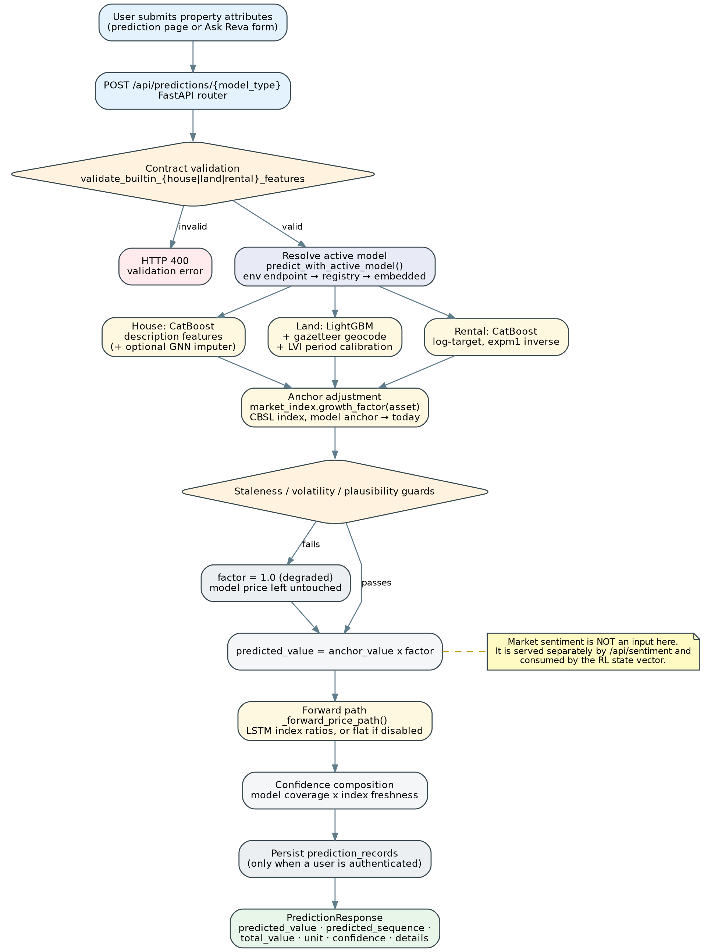
Figure 1:Price prediction workflow as implemented. Sentiment is not an input to this path; the temporal correction is supplied by a guarded, observed market-index ratio.
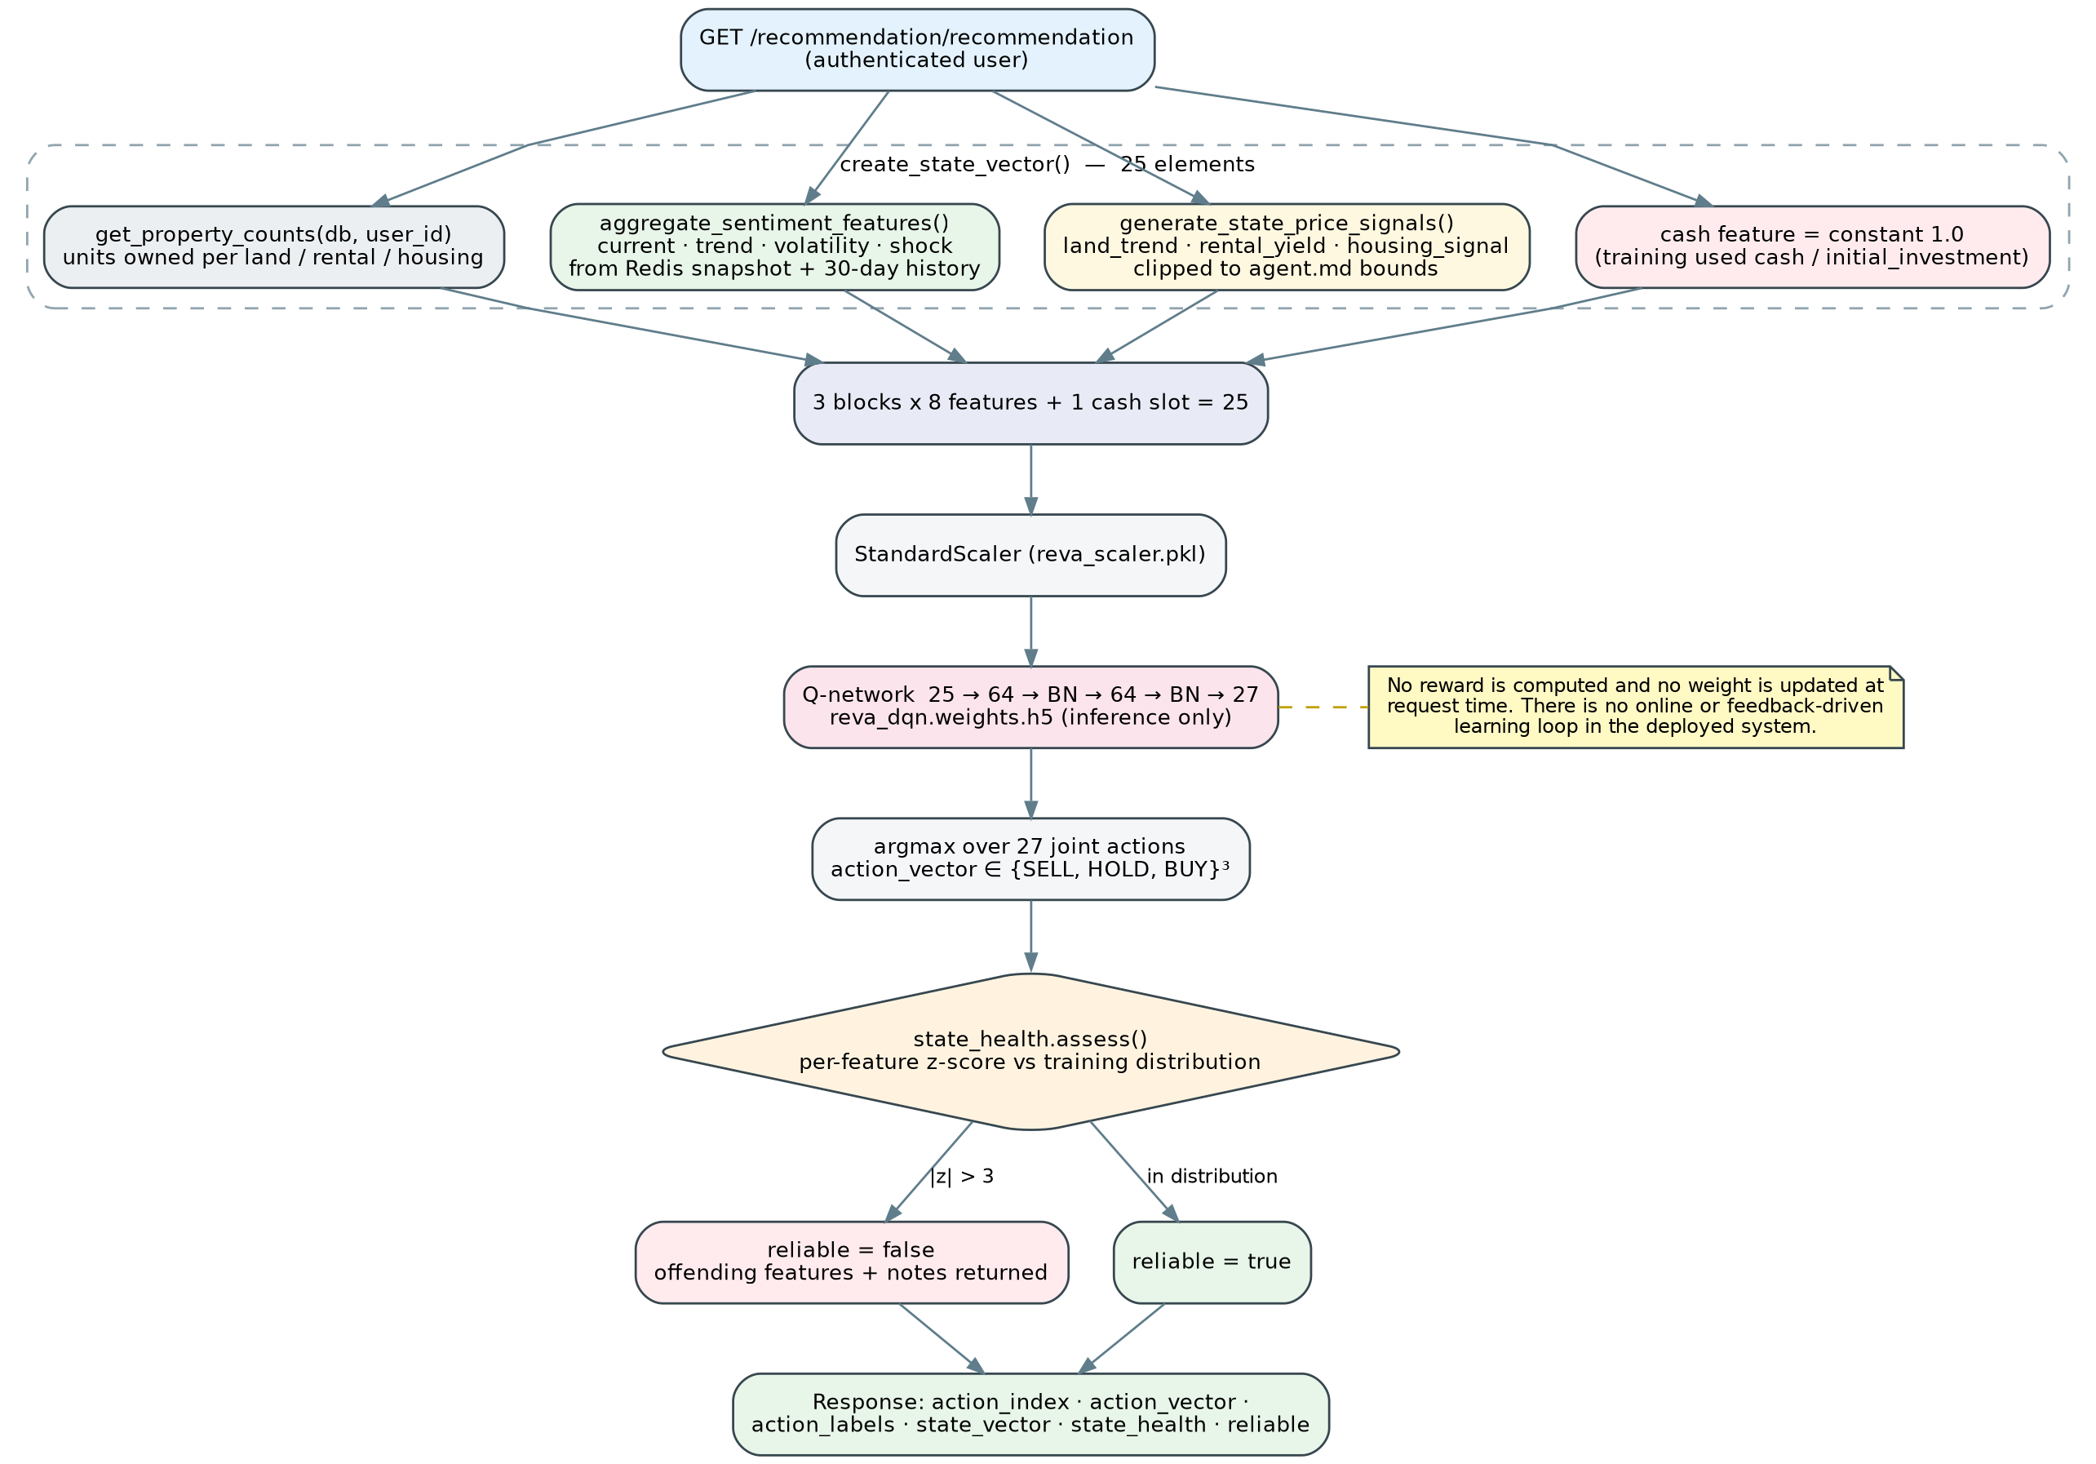
Figure 2:Reinforcement-learning recommendation workflow as implemented, including the constant cash feature and the state-health verdict attached to every response.
Fig. 4.3 reproduces the idealised workflow from the group's parallel reinforcement-learning study. Steps 1 to 7 and step 9 correspond to implemented behaviour. Step 8, the risk and feasibility check, and step 10, explanation delivery, are specified but not implemented; the state-health verdict is the partial substitute that ships in this release.
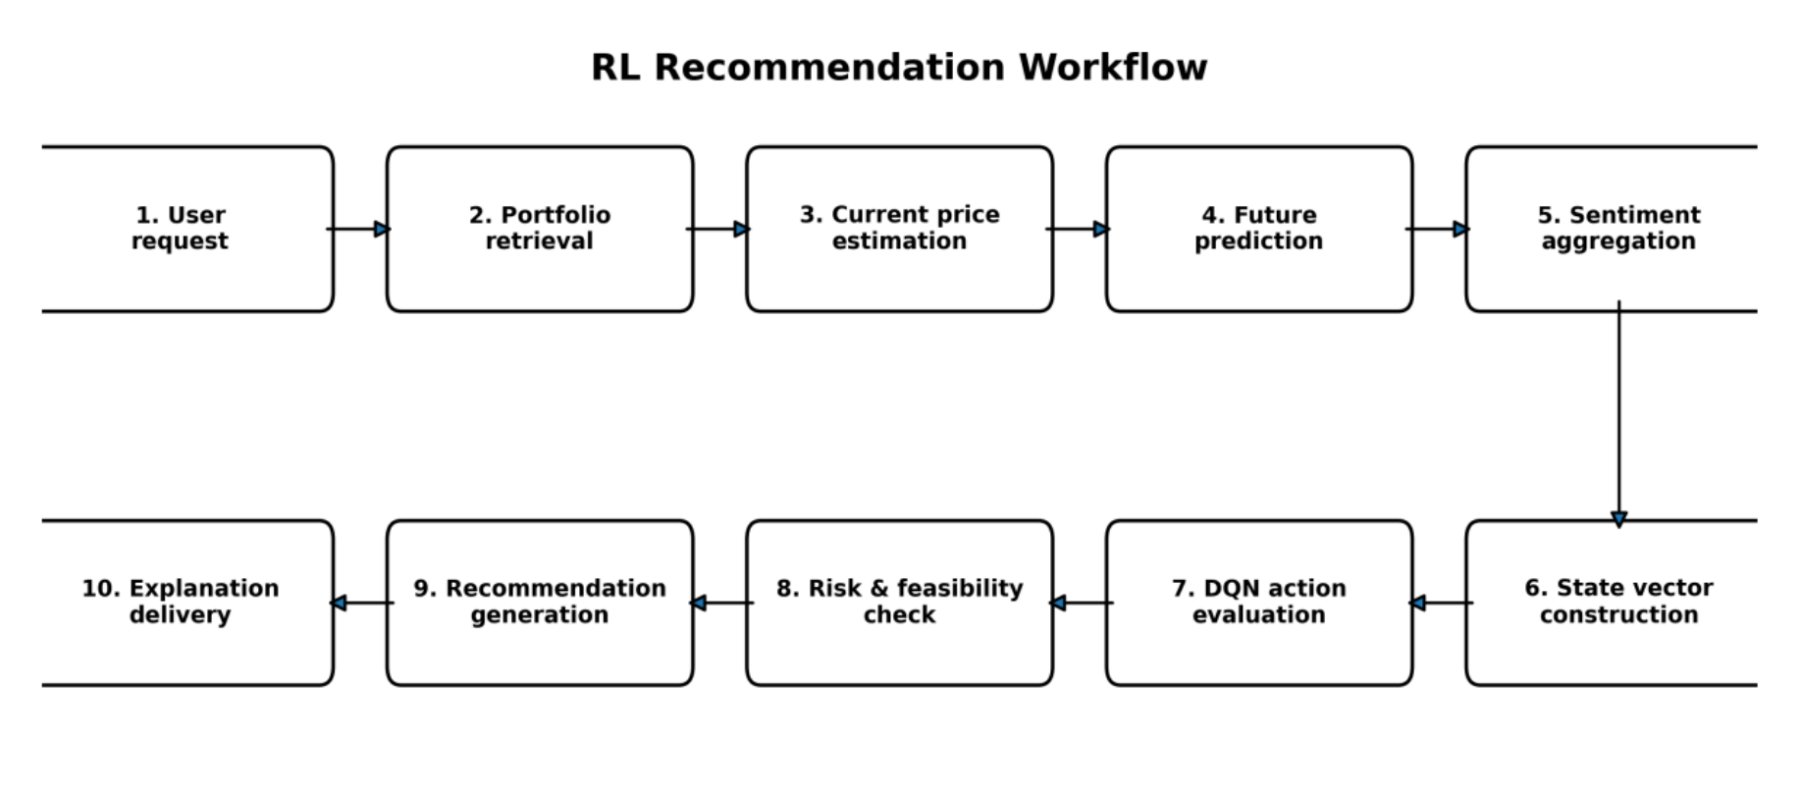
Figure 3:Target reinforcement-learning recommendation workflow from the parallel research study. Steps 8 and 10 are specified for future work rather than implemented (see §8.6).

4.5 Justification for Technology Adopted
Each workflow stage justifies its technology by the constraint it must satisfy. Validation must reject an incomplete payload before a model sees it, so contracts are typed and per-model rather than generic. Model resolution must work on a fresh clone with no configuration, so embedded artefacts are the default and an HTTP endpoint is an override that falls back to embedded on failure. Anchoring must be auditable, so it uses a published index with a documented base period rather than a learned correction. Sentiment must survive noisy scrapes, so relevance filtering by embedding similarity precedes classification. Recommendation must be safe, so the policy is pretrained and read-only, and the response carries a competence verdict.

4.6 Target Users
- Guest users who want a single valuation without creating an account. They may call the prediction endpoints and submit a site review. They cannot reach the sentiment, portfolio or recommendation endpoints, all of which require authentication — a narrower surface than the interim report described (Appendix A, item A.8).
- Registered individual investors who record the properties they own and track estimated value, unrealised gain and net rental cash flow over time.
- First-time buyers and sellers who need a defensible reference figure and an explanation of how confident it is.
- Property professionals using the system as a second opinion alongside comparable-sales judgement.
- Administrators who curate feature definitions, manage users and maintain the model registry.

4.7 Novelty and Features of the Solution

Table 7:NOVEL FEATURES OF THE SOLUTION AND THEIR IMPLEMENTATION STATUS
Feature | Contribution | Status
Anchor / movement separation | Model owns the price level at its training anchor; a matched observed index ratio owns the movement to today | Implemented
Guarded degradation | Staleness, volatility and plausibility guards degrade the index factor to exactly 1.0 and say so | Implemented
Explicit unavailability | unavailable and anchor_only statuses instead of imputed defaults | Implemented
Description feature extraction | Forty features mined from listing prose feed the house model | Implemented
Three-tier land coverage verdict | High / medium / low confidence by model vocabulary and calibration table membership | Implemented
Mixed-frequency sentiment | Daily news aggregated into monthly decision features with time decay and shock detection | Implemented
Distribution-health reporting | Per-feature z-scores against the training distribution; reliable flag | Implemented
Quarterly portfolio snapshots | Versioned valuation history with provenance for longitudinal tracking | Implemented
Agentic conversational layer | LangGraph state machine with intent routing and missing-field handling | Implemented
Risk-adjusted reward and action feasibility masking | Penalise drawdown, concentration, liquidity and affordability; mask infeasible actions | Specified; future work (§8.6)
Uncertainty-aware state | Propagate forecast variance and confidence intervals into the RL state | Specified; future work (§8.6)
Personalised offline RL | Condition on user cash, debt, horizon and risk tolerance; train with CQL / IQL | Specified; future work (§8.6)

4.8 Summary
This chapter stated the hypothesis, catalogued inputs and outputs, and presented the two workflows the system runs. It corrected the interim report's claim that sentiment is a mandatory input to price prediction, and separated implemented novelty from specified-but-future novelty in the reinforcement-learning component. The next chapter presents the analysis and design.

CHAPTER 5

ANALYSIS AND DESIGN

5.1 Introduction
This chapter presents the analysis and design of Reva: the reasoning behind the structure, the top-level architecture, the UML models that describe behaviour and structure, the data flow, and the placement of the system's novelty within that design. The behavioural diagrams carried forward from the interim report are reproduced unchanged where they remain accurate, and are annotated where the implementation diverged.

5.2 Rationale for Design
Five requirements drove the structure. Each asset class needed its own model, because houses, land and rentals differ in target unit, feature set and data quality, and a single multi-task model would have hidden those differences behind an average. Price level and temporal movement needed to be independently replaceable, because they fail for different reasons and on different schedules. Provenance needed to travel with the value rather than be reconstructable from logs, because the client's first question about any number is where it came from. The sentiment pipeline needed to be asynchronous, because scraping and transformer inference cannot run inside a request. And the reinforcement-learning component needed to be strictly read-only in production, because an advisory agent must not learn from live users' capital.
The resulting design is layered with narrow interfaces: the presentation layer knows only HTTP contracts; the application layer owns orchestration, authorisation and provenance assembly; the intelligence layer holds models that accept a feature dictionary and return a value with metadata; and the data layer is split by access pattern rather than by convenience — relational for state requiring integrity, key-value for values recomputed on every request, document for heterogeneous scored text, and vector for similarity search.

5.3 Top-Level Architecture
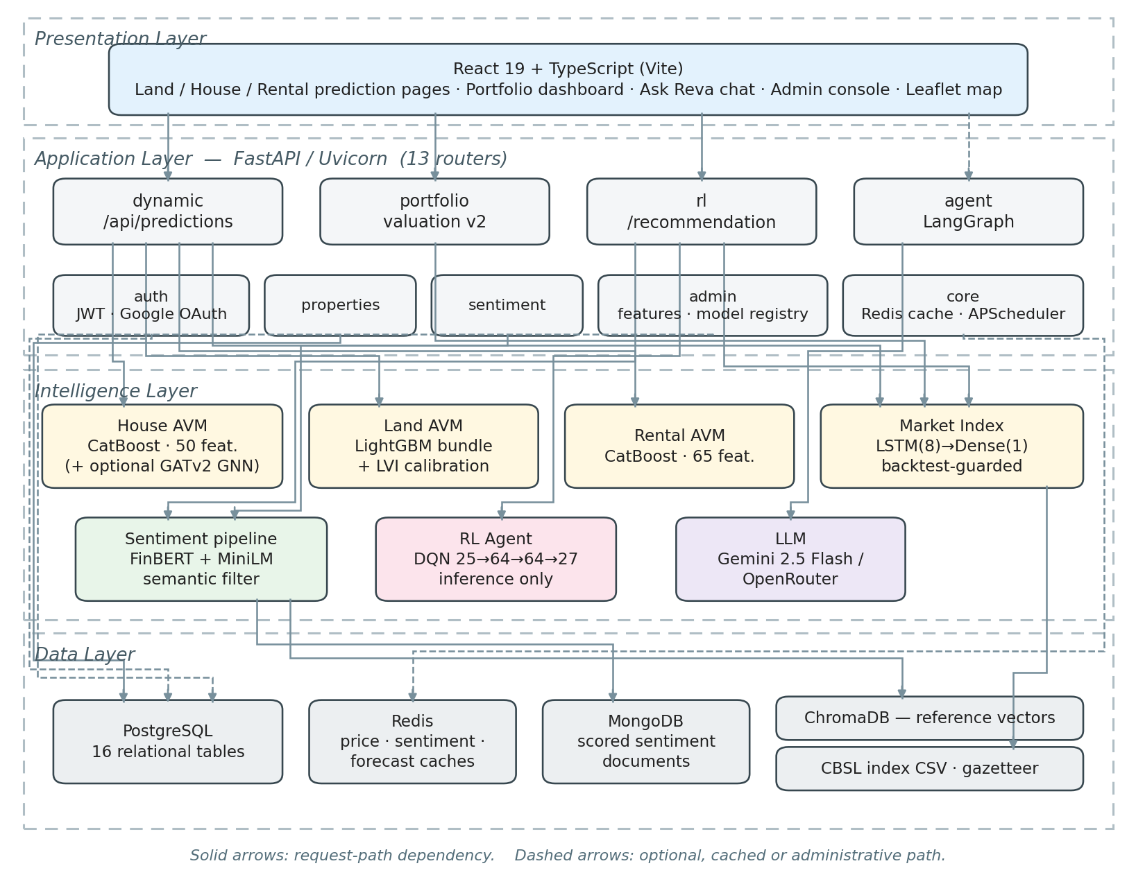
Figure 4:Top-level architecture of the implemented system. The application layer exposes thirteen FastAPI routers over sixteen relational tables; the intelligence layer holds three valuation models, a market-index model, the sentiment pipeline, the reinforcement
Table 8:MAIN DESIGN MODULES AND THEIR RESPONSIBILITIES
Module | Responsibility | Key outputs
Preprocessing | Validate typed payloads, derive geographic and description features, resolve locations from the gazetteer, assemble the RL state vector | Model-ready feature dictionary; 25-element scaled state vector
ML engine | Serve the three valuation models, the market-index model and the Q-network; resolve the active model artefact | Price at model anchor; index growth factor; 27 Q-values
Extended module | Apply index guards, compose confidence, assemble provenance, grade state health, persist valuation snapshots | Final value with status and reasons; reliable verdict

5.3.1 Preprocessing Module
Preprocessing converts a user payload into model-ready features. For houses this includes extracting forty description features — road width, road type mentions, utility and amenity flags, parking, five distance-to-service measures with explicit missingness indicators, and four composite scores — under a versioned extraction scheme. For land it resolves the location text against a shipped Sri Lankan gazetteer rather than a live geocoder, computes distance to Colombo and a city-gravity term, and records whether resolution was exact or fell back to district centroid. For the recommendation path it assembles the state vector described in Appendix D.

5.3.2 ML Engine
The ML engine resolves and invokes the active model for a request. Resolution order is an environment endpoint, then an active entry in the admin model registry, then the embedded artefact shipped in the repository; a remote call that fails degrades to the embedded model rather than failing the request. The engine also owns the market-index model and the Q-network. It performs inference only: no gradient computation, optimiser step or weight write occurs in the deployed service.

5.3.3 Extended Module
The extended module is where evidence governance lives. It evaluates the index guards, composes the confidence level from model coverage and index freshness, assembles the provenance block, writes quarterly valuation snapshots with model and index versions, and grades the reinforcement-learning state against the training distribution. In the target architecture from the parallel research study (Fig. 5.22) this module also performs risk and feasibility checking and generates natural-language explanations; those functions are specified but not implemented.

5.4 Data Flow and Interaction Design
The behavioural design is expressed through UML use case, activity, sequence and class models, and the structural design through an entity–relationship model. This section presents them and, where the delivered system differs from the interim design, states the difference.

5.4.1 Use Case Model
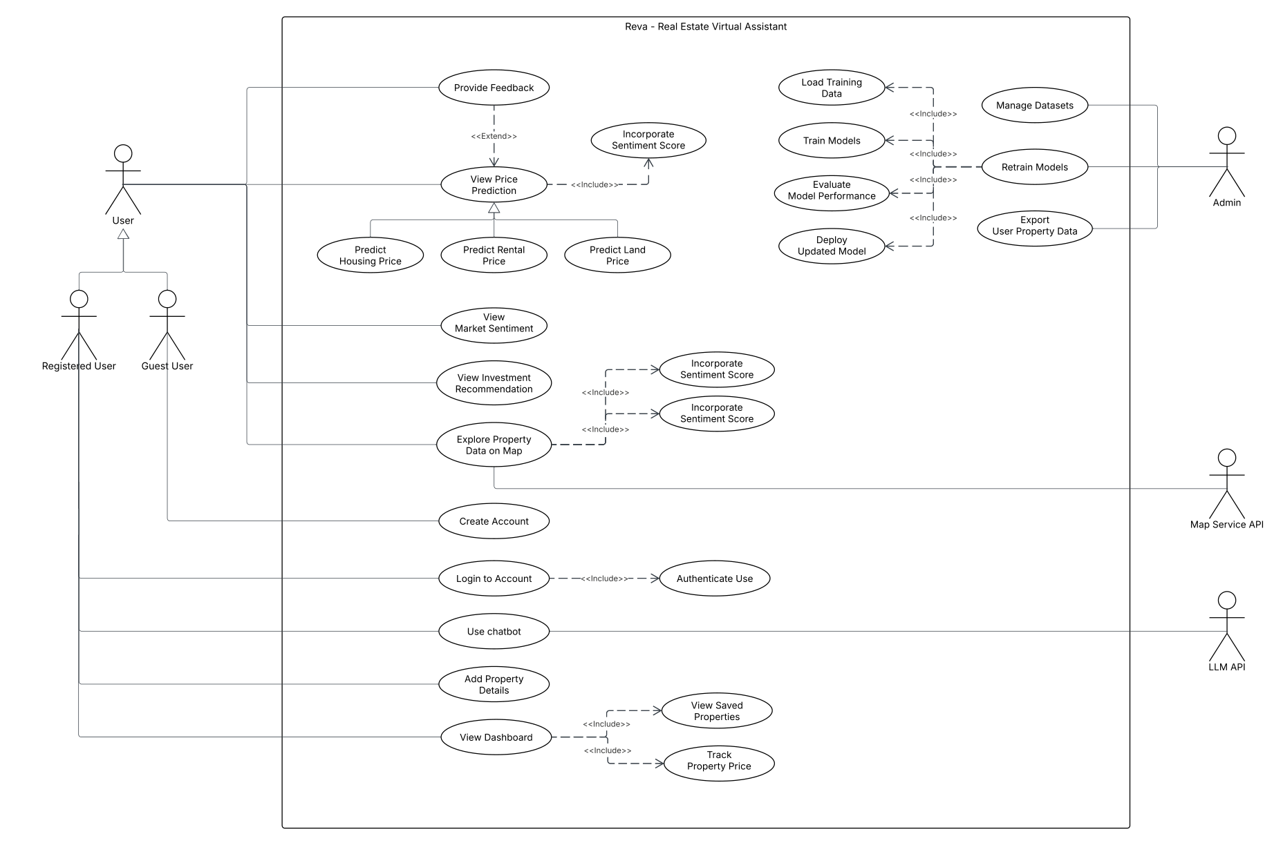
Figure 5:High-level use case diagram carried forward from the interim design. Three of the administrative use cases — Manage Datasets, Retrain Models and Export User Property Data
Two qualifications apply to Fig. 5.2. First, the <<include>> relationship from View Price Prediction to Incorporate Sentiment Score does not exist in the implementation; sentiment is included by View Investment Recommendation alone. Second, the administrative branch overstates delivered capability: the admin console manages feature definitions, users and a model registry, but does not upload datasets, trigger retraining or export user property data.

5.4.2 Activity Models
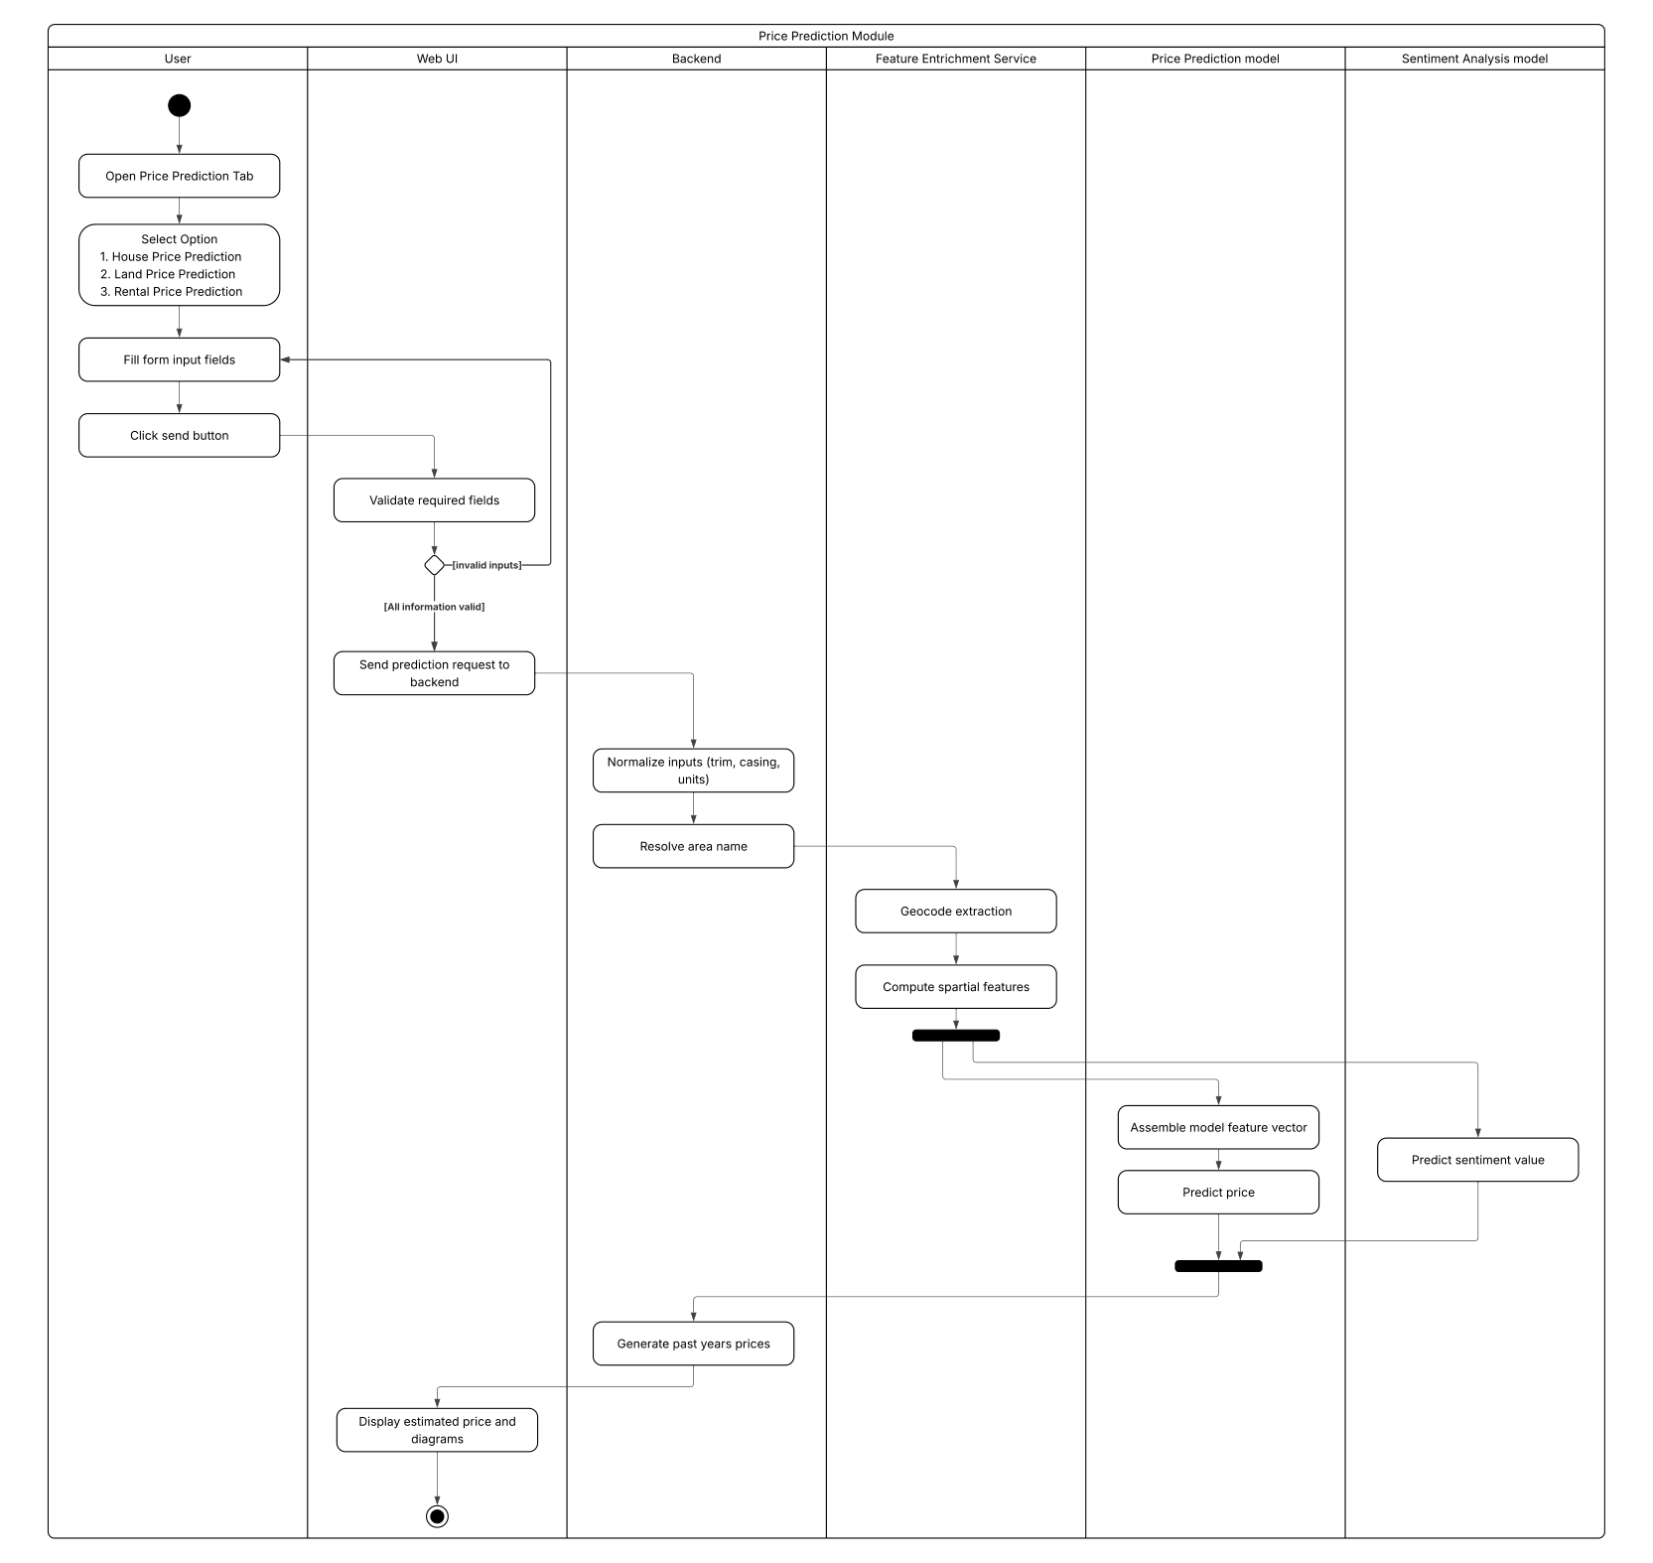
Figure 6:Price Prediction Module activity diagram from the interim design
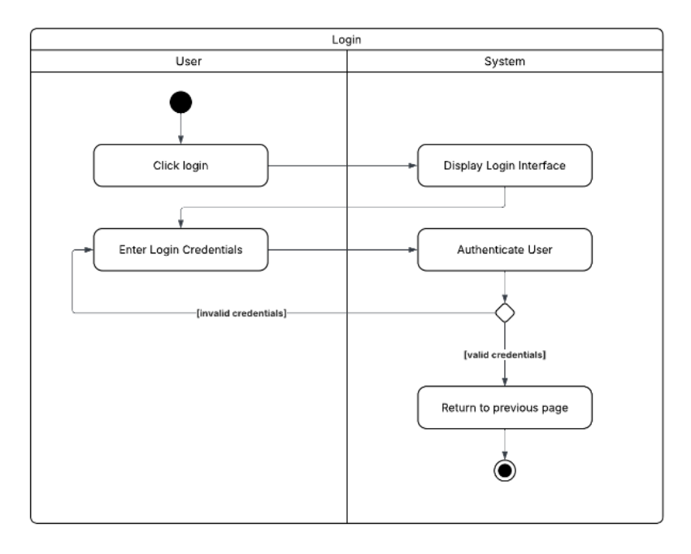
Figure 7:Login to account — activity diagram.
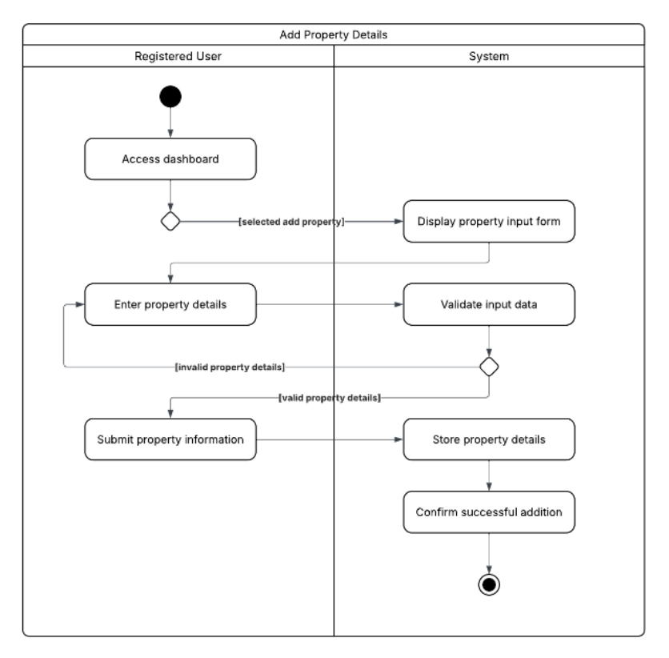
Figure 8:Add property details — activity diagram
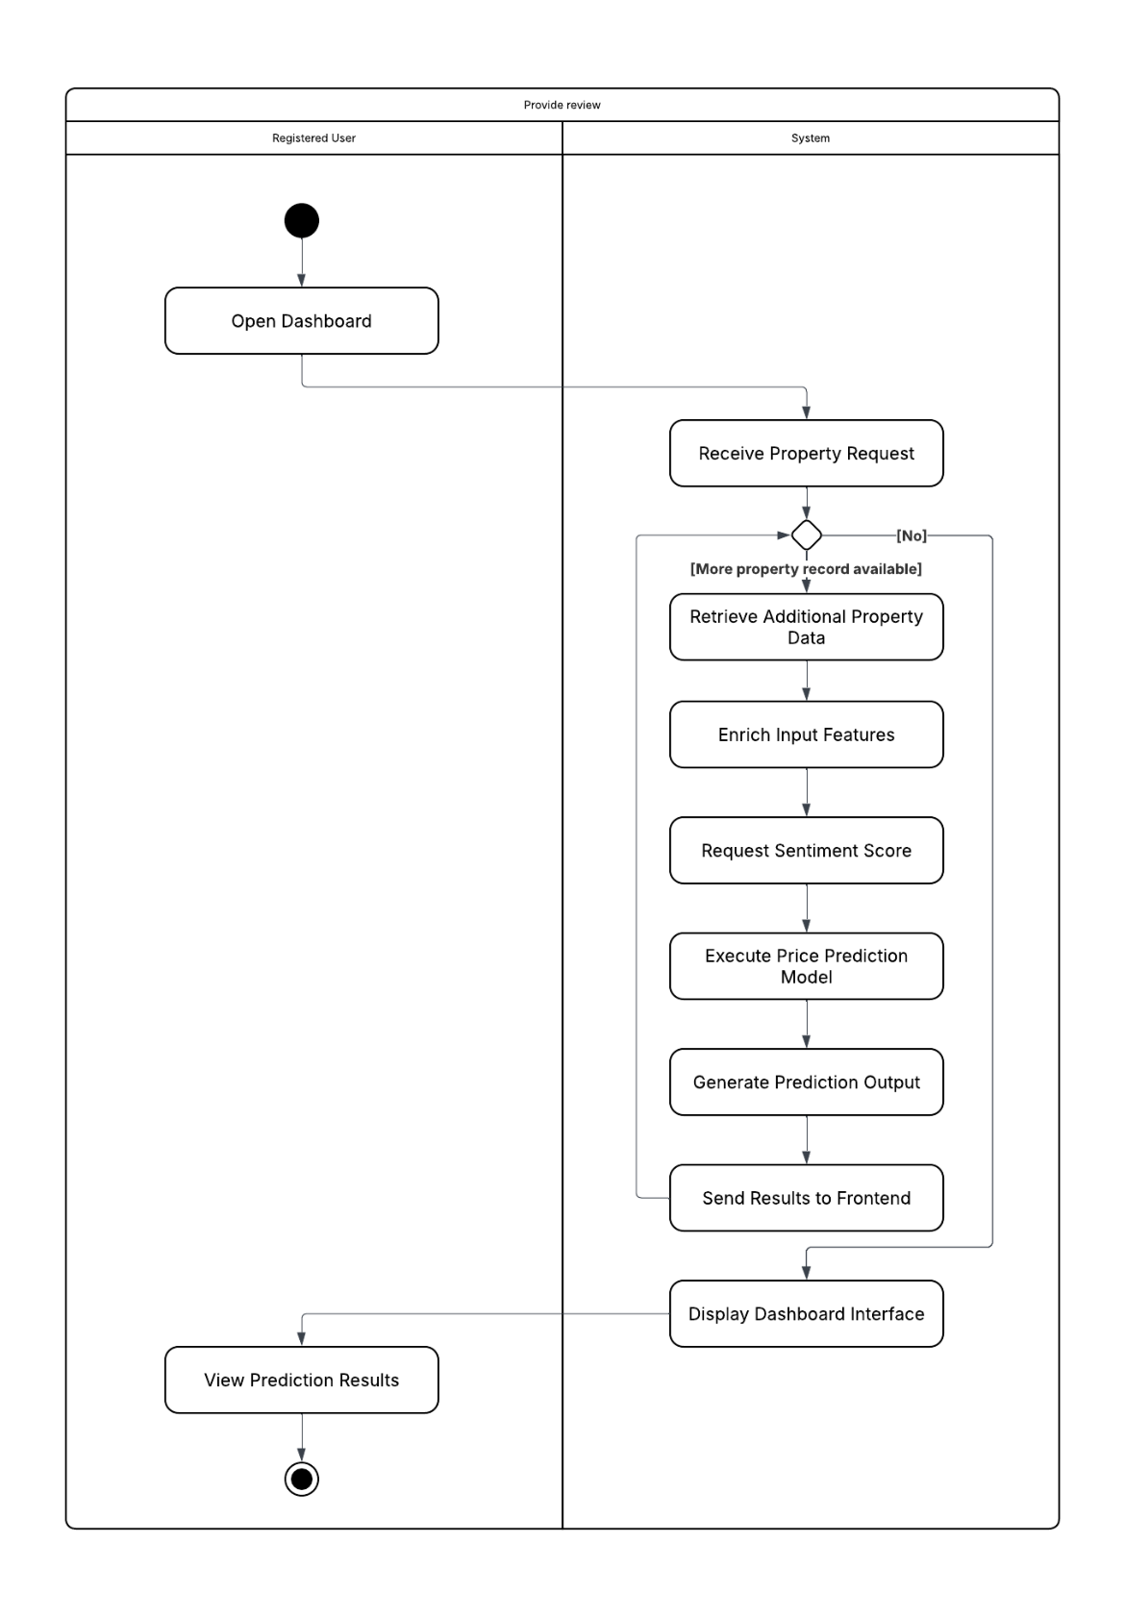
Figure 9:View dashboard — activity diagram.
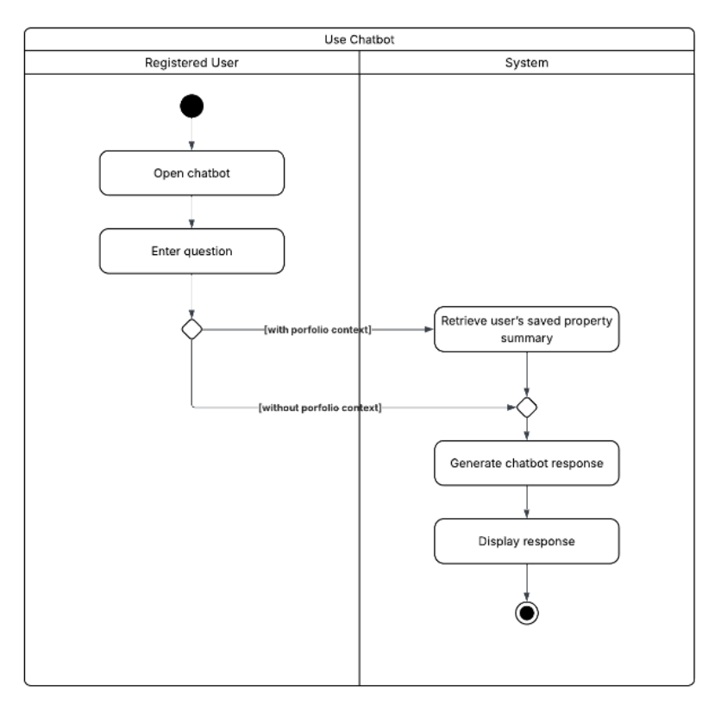
Figure 10:Use chatbot — activity diagram.
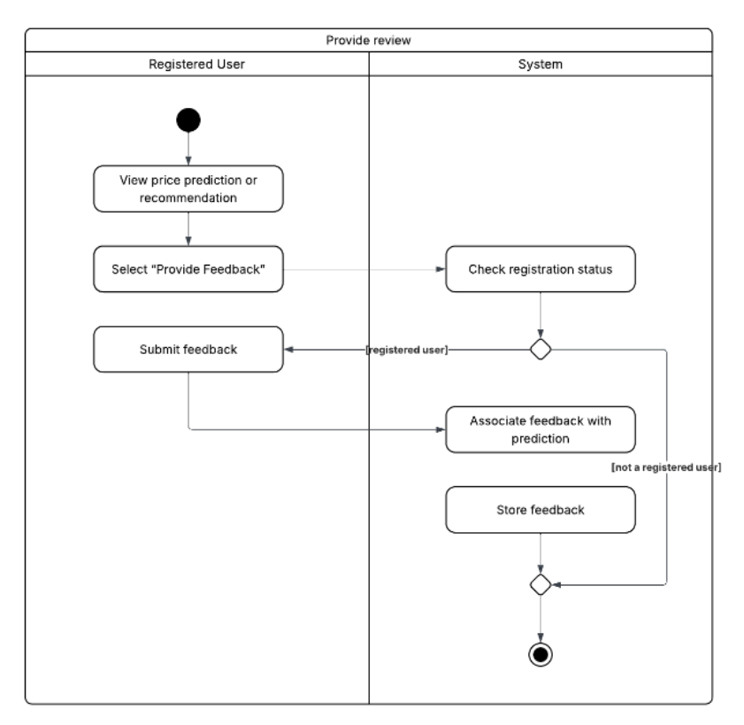
Figure 11:Provide feedback — activity diagram. In the delivered system the stored record is a site review; it is not associated with a prediction and is not consumed by any model.
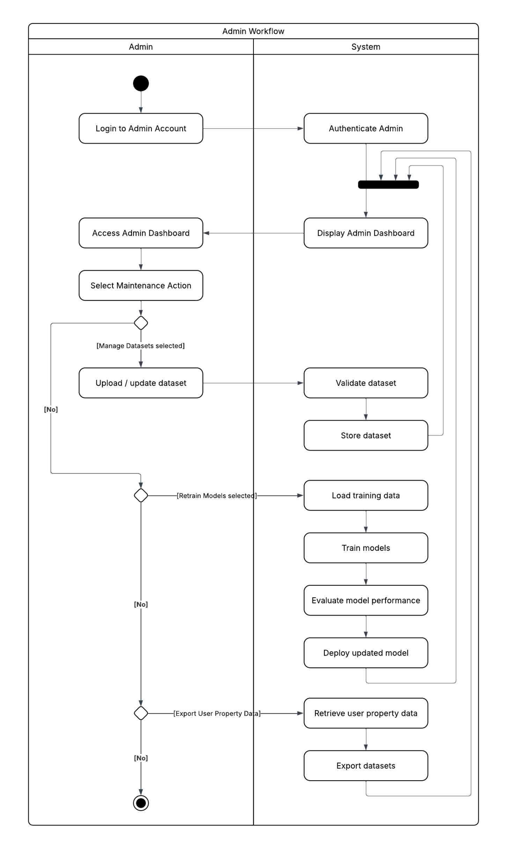
Figure 12:Admin workflow activity diagram from the interim design. The dataset-management, retraining and export branches were not implemented; training is performed offline by the scripts listed in §6.4.

5.4.3 Class Model
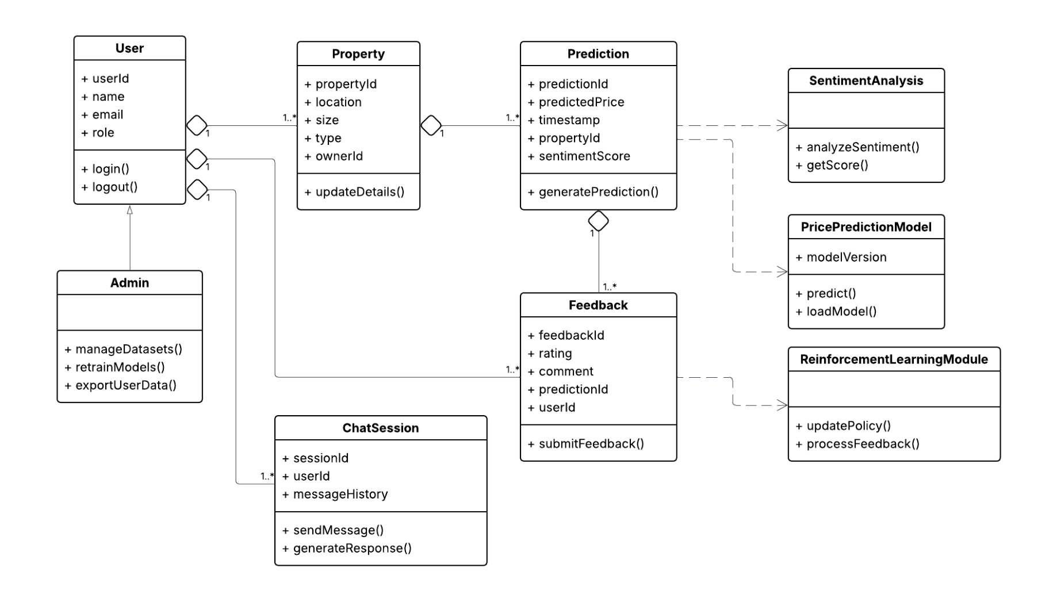
Figure 13:Class diagram from the interim design. ReinforcementLearningModule.updatePolicy() and processFeedback() are not implemented; the deployed agent exposes inference only
The class model remains a reasonable conceptual view of the domain, but two of its operations must be withdrawn. updatePolicy() and processFeedback() describe an online learning loop that does not exist: backend/rl/agent_services.py rebuilds the Q-network, loads saved weights and a pickled scaler, and calls predict(). There is no optimiser, no replay buffer, no reward computation and no weight write-back anywhere in the backend. Similarly, the Feedback class's association with Prediction is not realised: the reviews table stores name, e-mail, rating and comment, and carries no foreign key to any prediction.

5.4.4 Sequence Models
The sequence diagrams carried forward from the interim design remain structurally accurate for the interaction order, with one systematic correction: every lifeline labelled Backend (Flask) is in fact a FastAPI service (Appendix A, item A.1). Where a diagram shows a sentiment lifeline participating in price prediction, that participation does not occur.
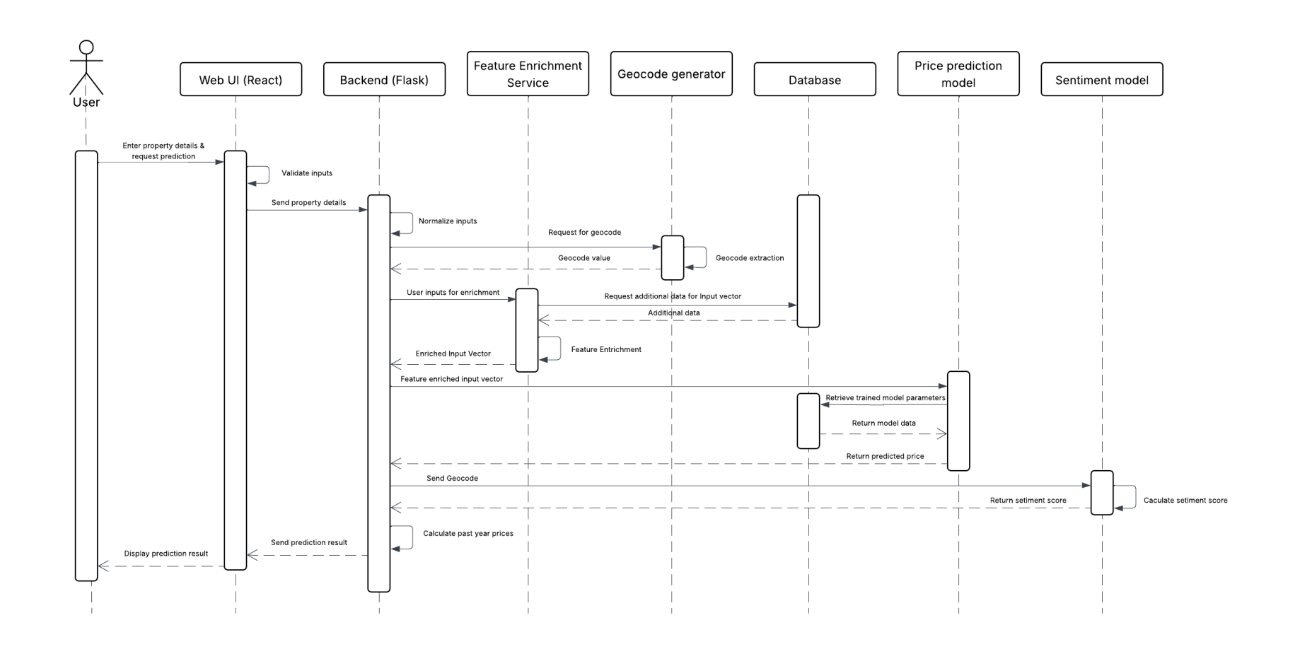
Figure 14:Price prediction module — sequence diagram. The backend lifeline is FastAPI, not Flask, and the sentiment model does not participate in this interaction.
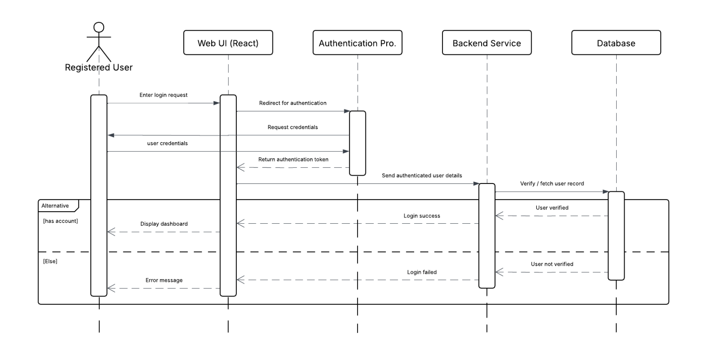
Figure 15:Login to account — sequence diagram.
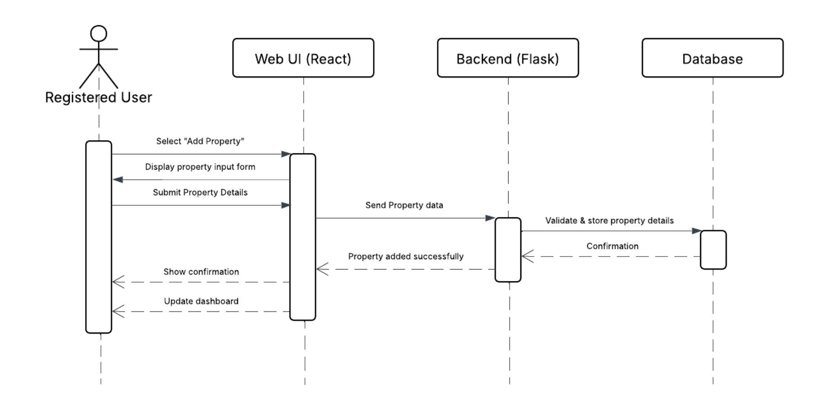
Figure 16:Add property details — sequence diagram.
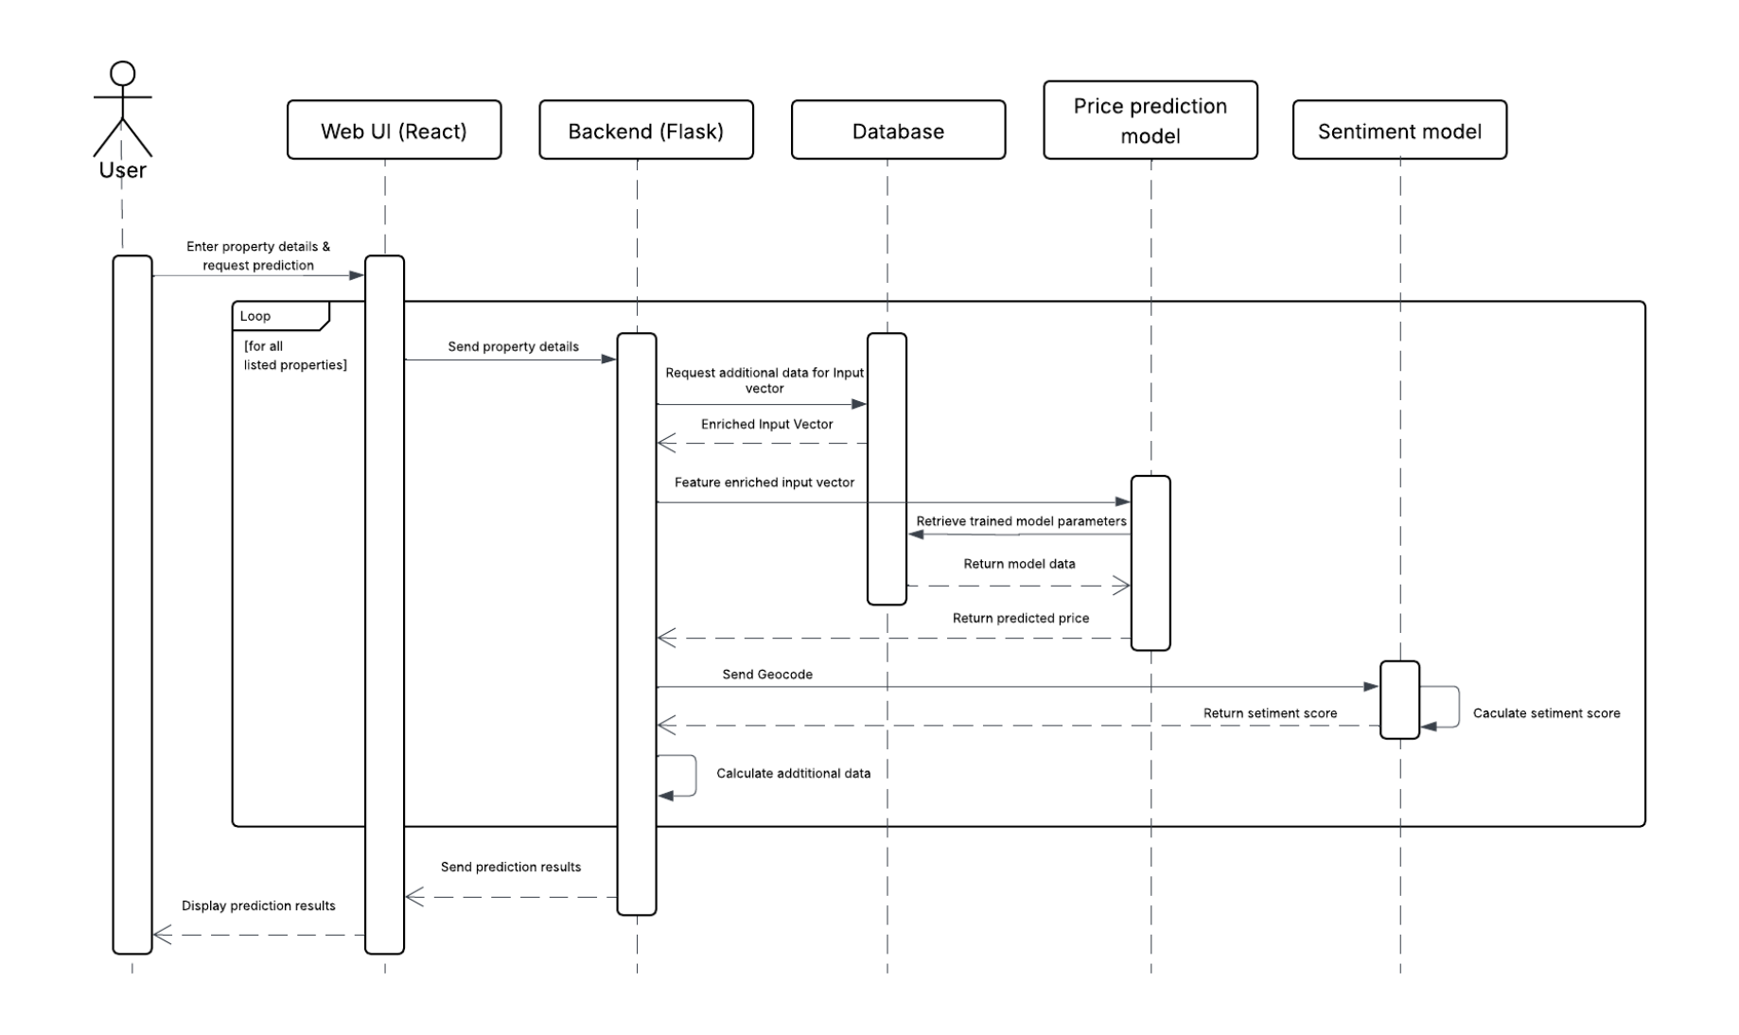
Figure 17:View dashboard — sequence diagram. In the implementation the dashboard path additionally applies the index anchor factor and writes a valuation snapshot.
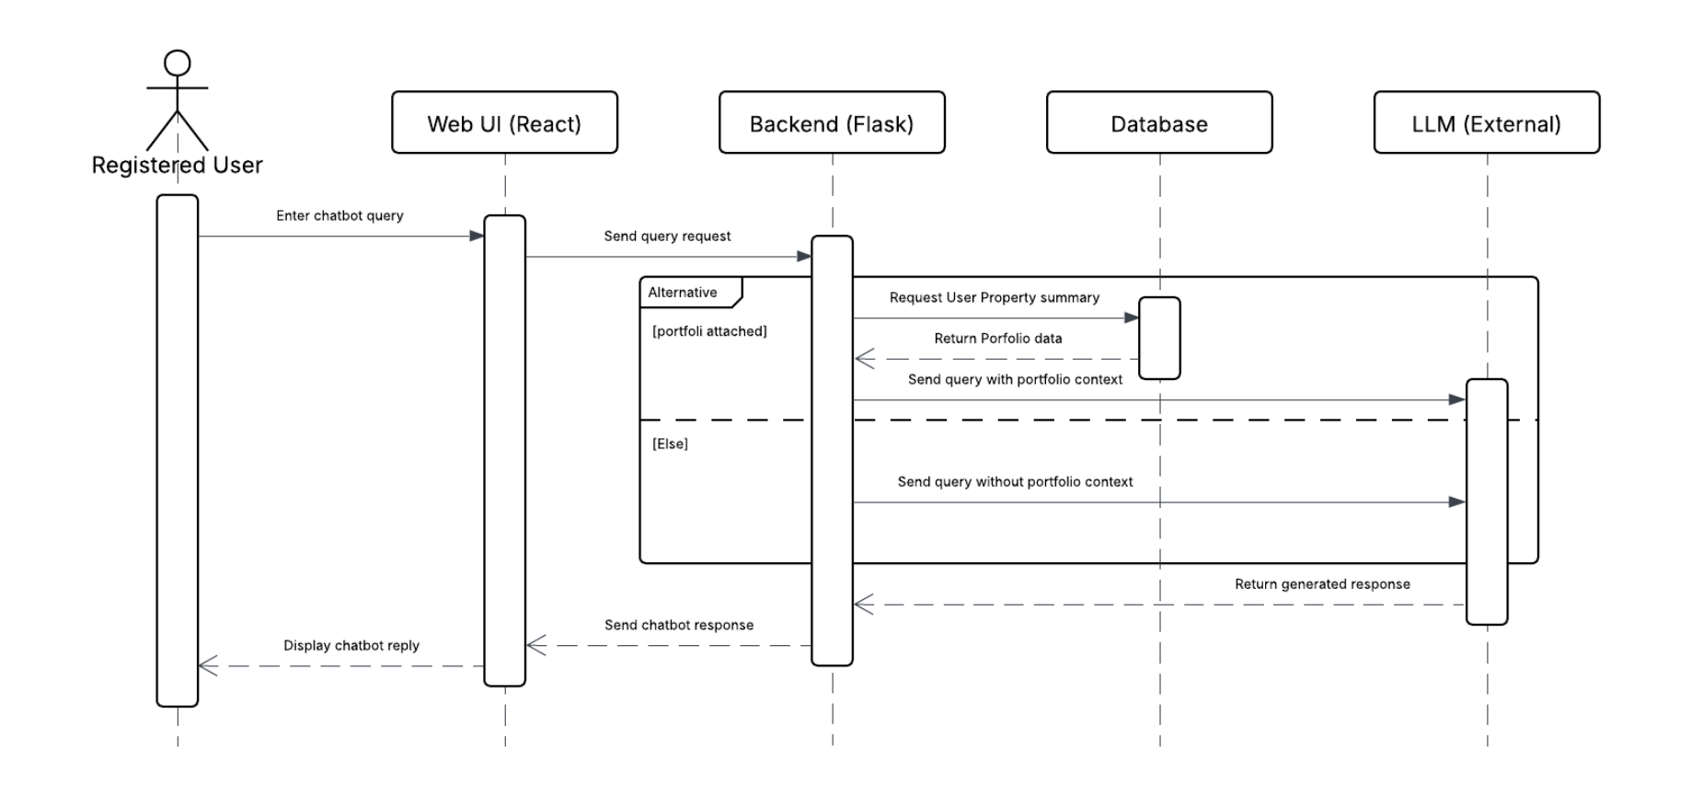
Figure 18:Use chatbot — sequence diagram. Two chat paths exist in the delivered system and neither retrieves a portfolio summary as drawn; see §6.4.
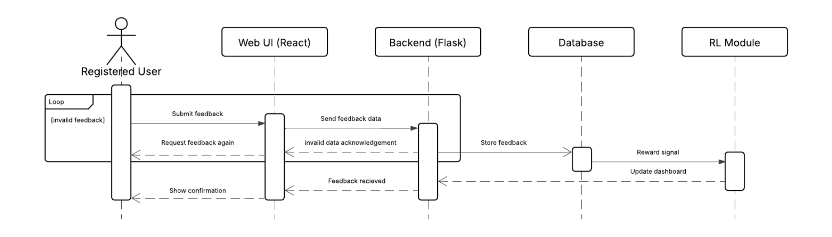
Figure 19:Provide feedback — sequence diagram. The Reward signal and Update dashboard messages to the RL module are not implemented.
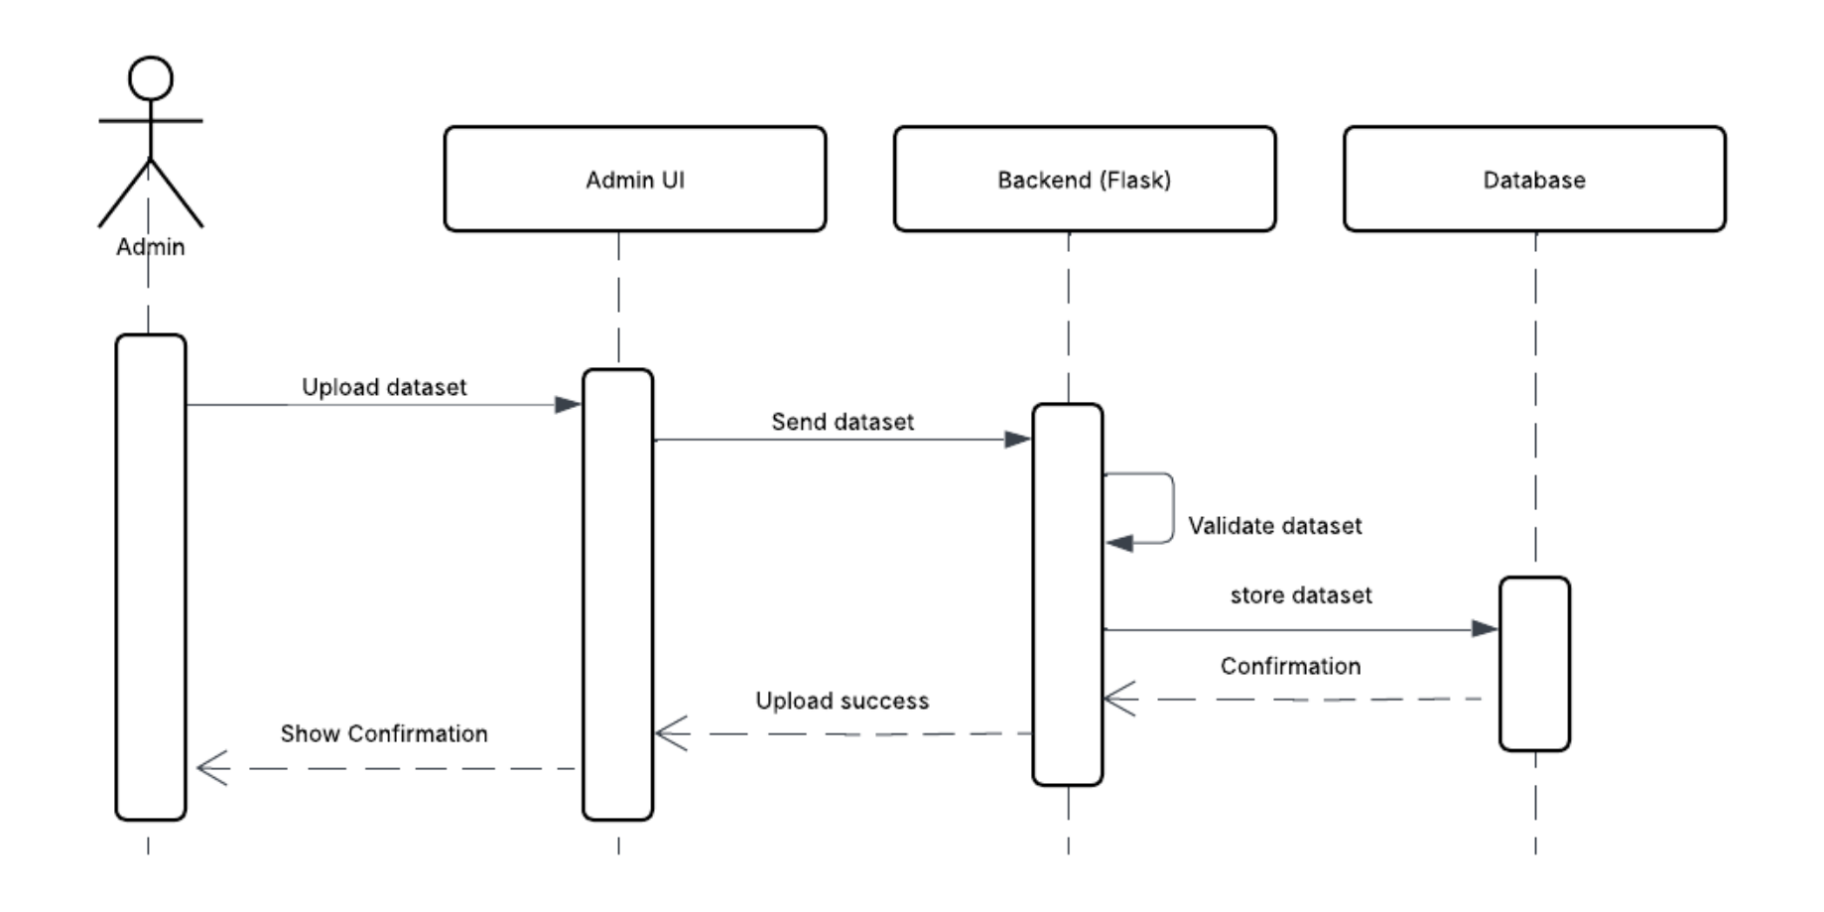
Figure 20:Manage datasets — sequence diagram. Not implemented; retained as design intent.
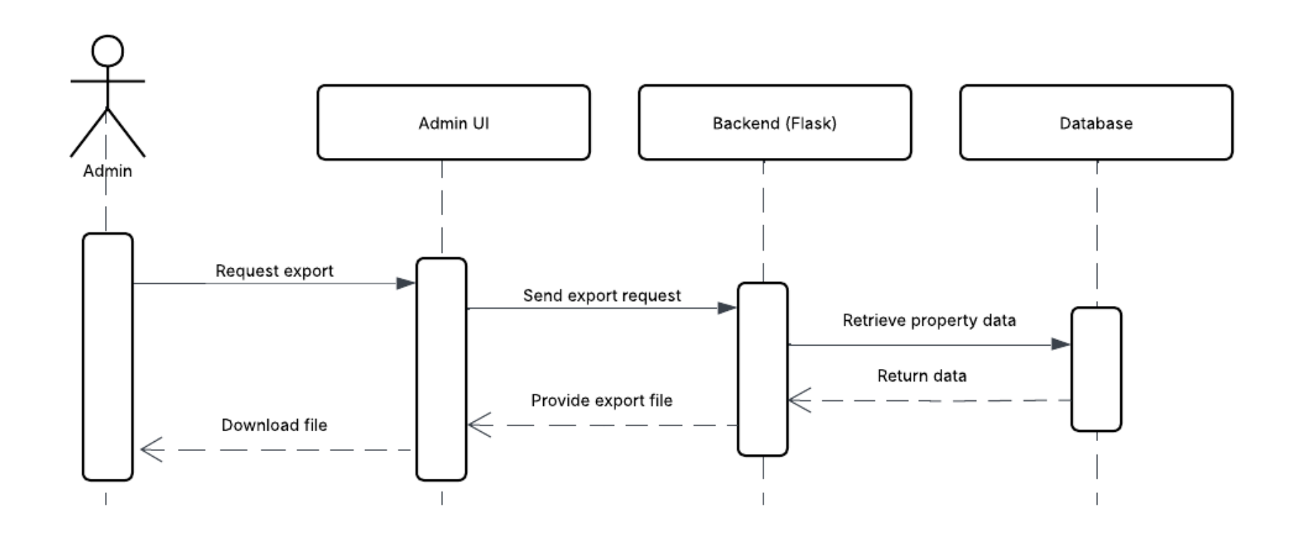
Figure 21:Export user property data — sequence diagram. Not implemented; retained as design intent.
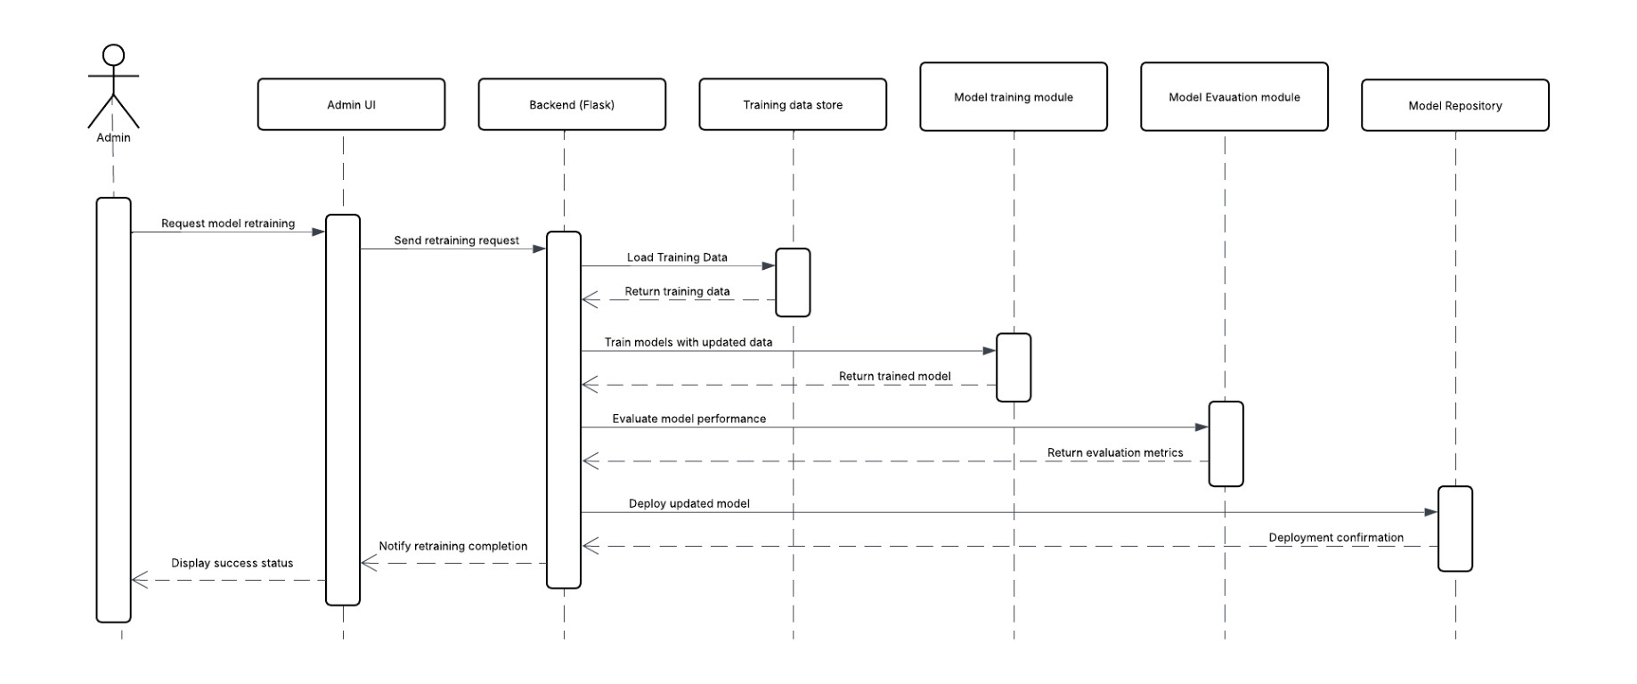
Figure 22:Admin model retraining — sequence diagram. Not implemented as an online workflow; retraining is performed offline and the resulting artefact is registered through the model registry.

5.4.5 Entity–Relationship Model
The interim entity–relationship diagram (Fig. 5.20) proposed entities for Location, ListingSnapshot, Prediction, Sentiment, Model and RL. The delivered schema differs substantially, and Fig. 5.21 records what was actually built.
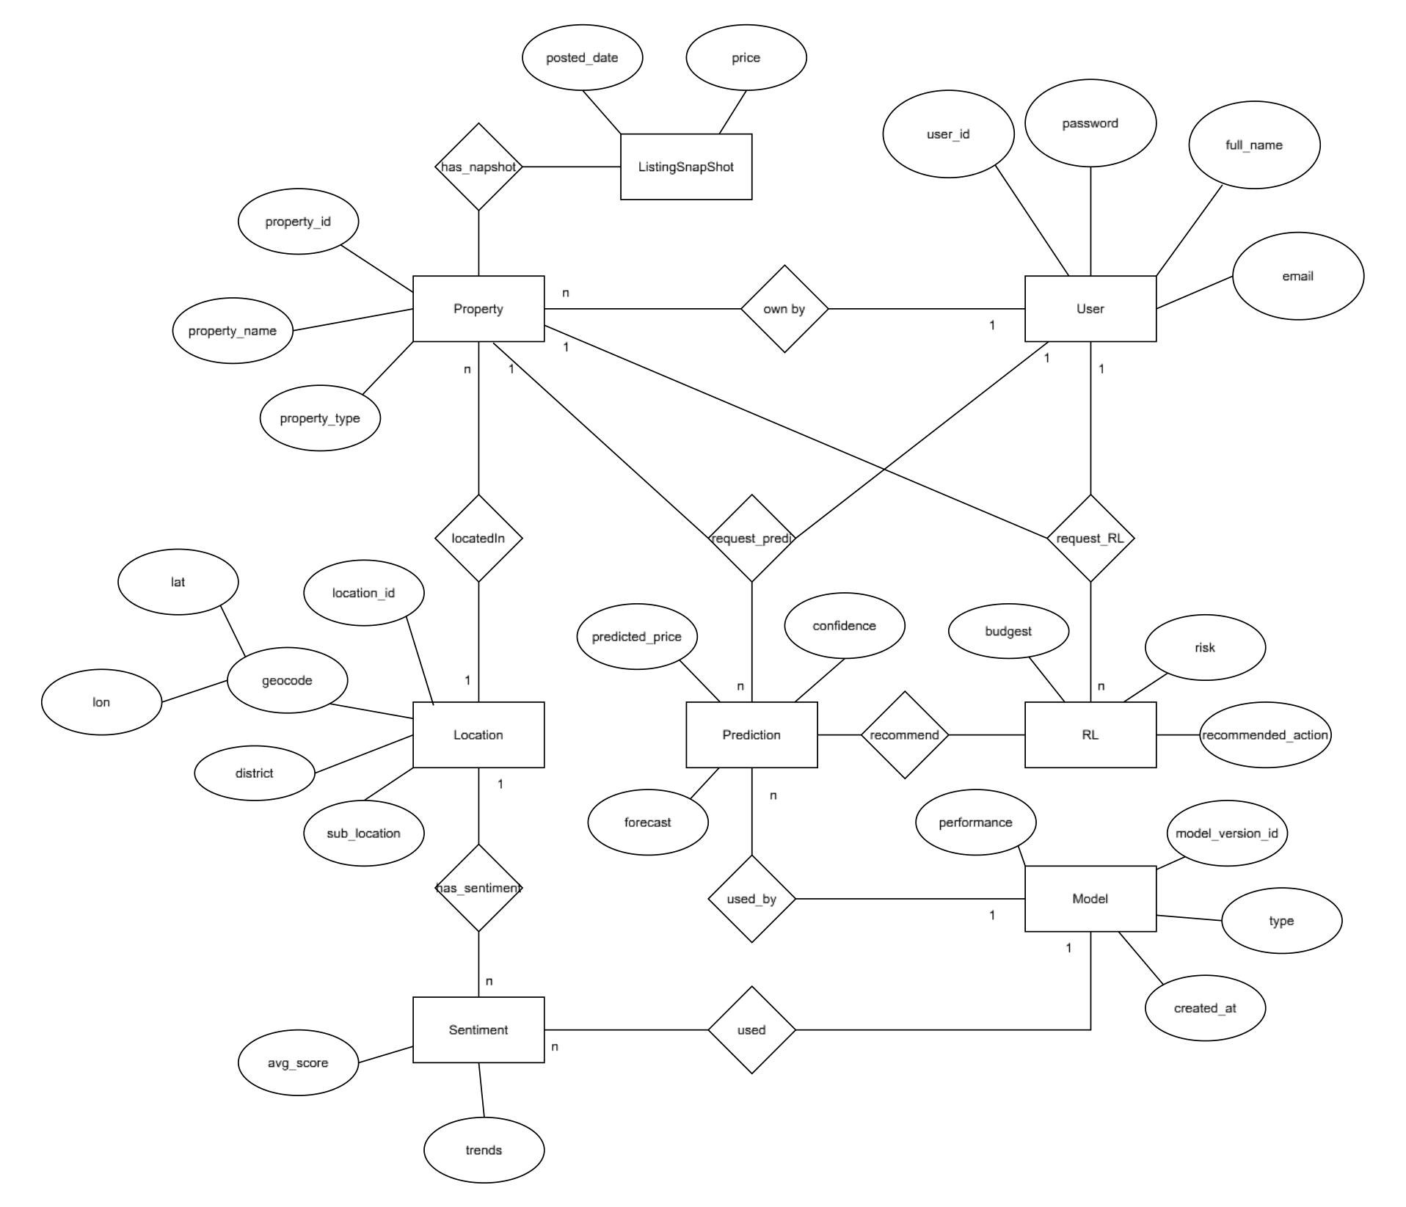
Figure 23:Entity–relationship diagram as proposed in the interim report.
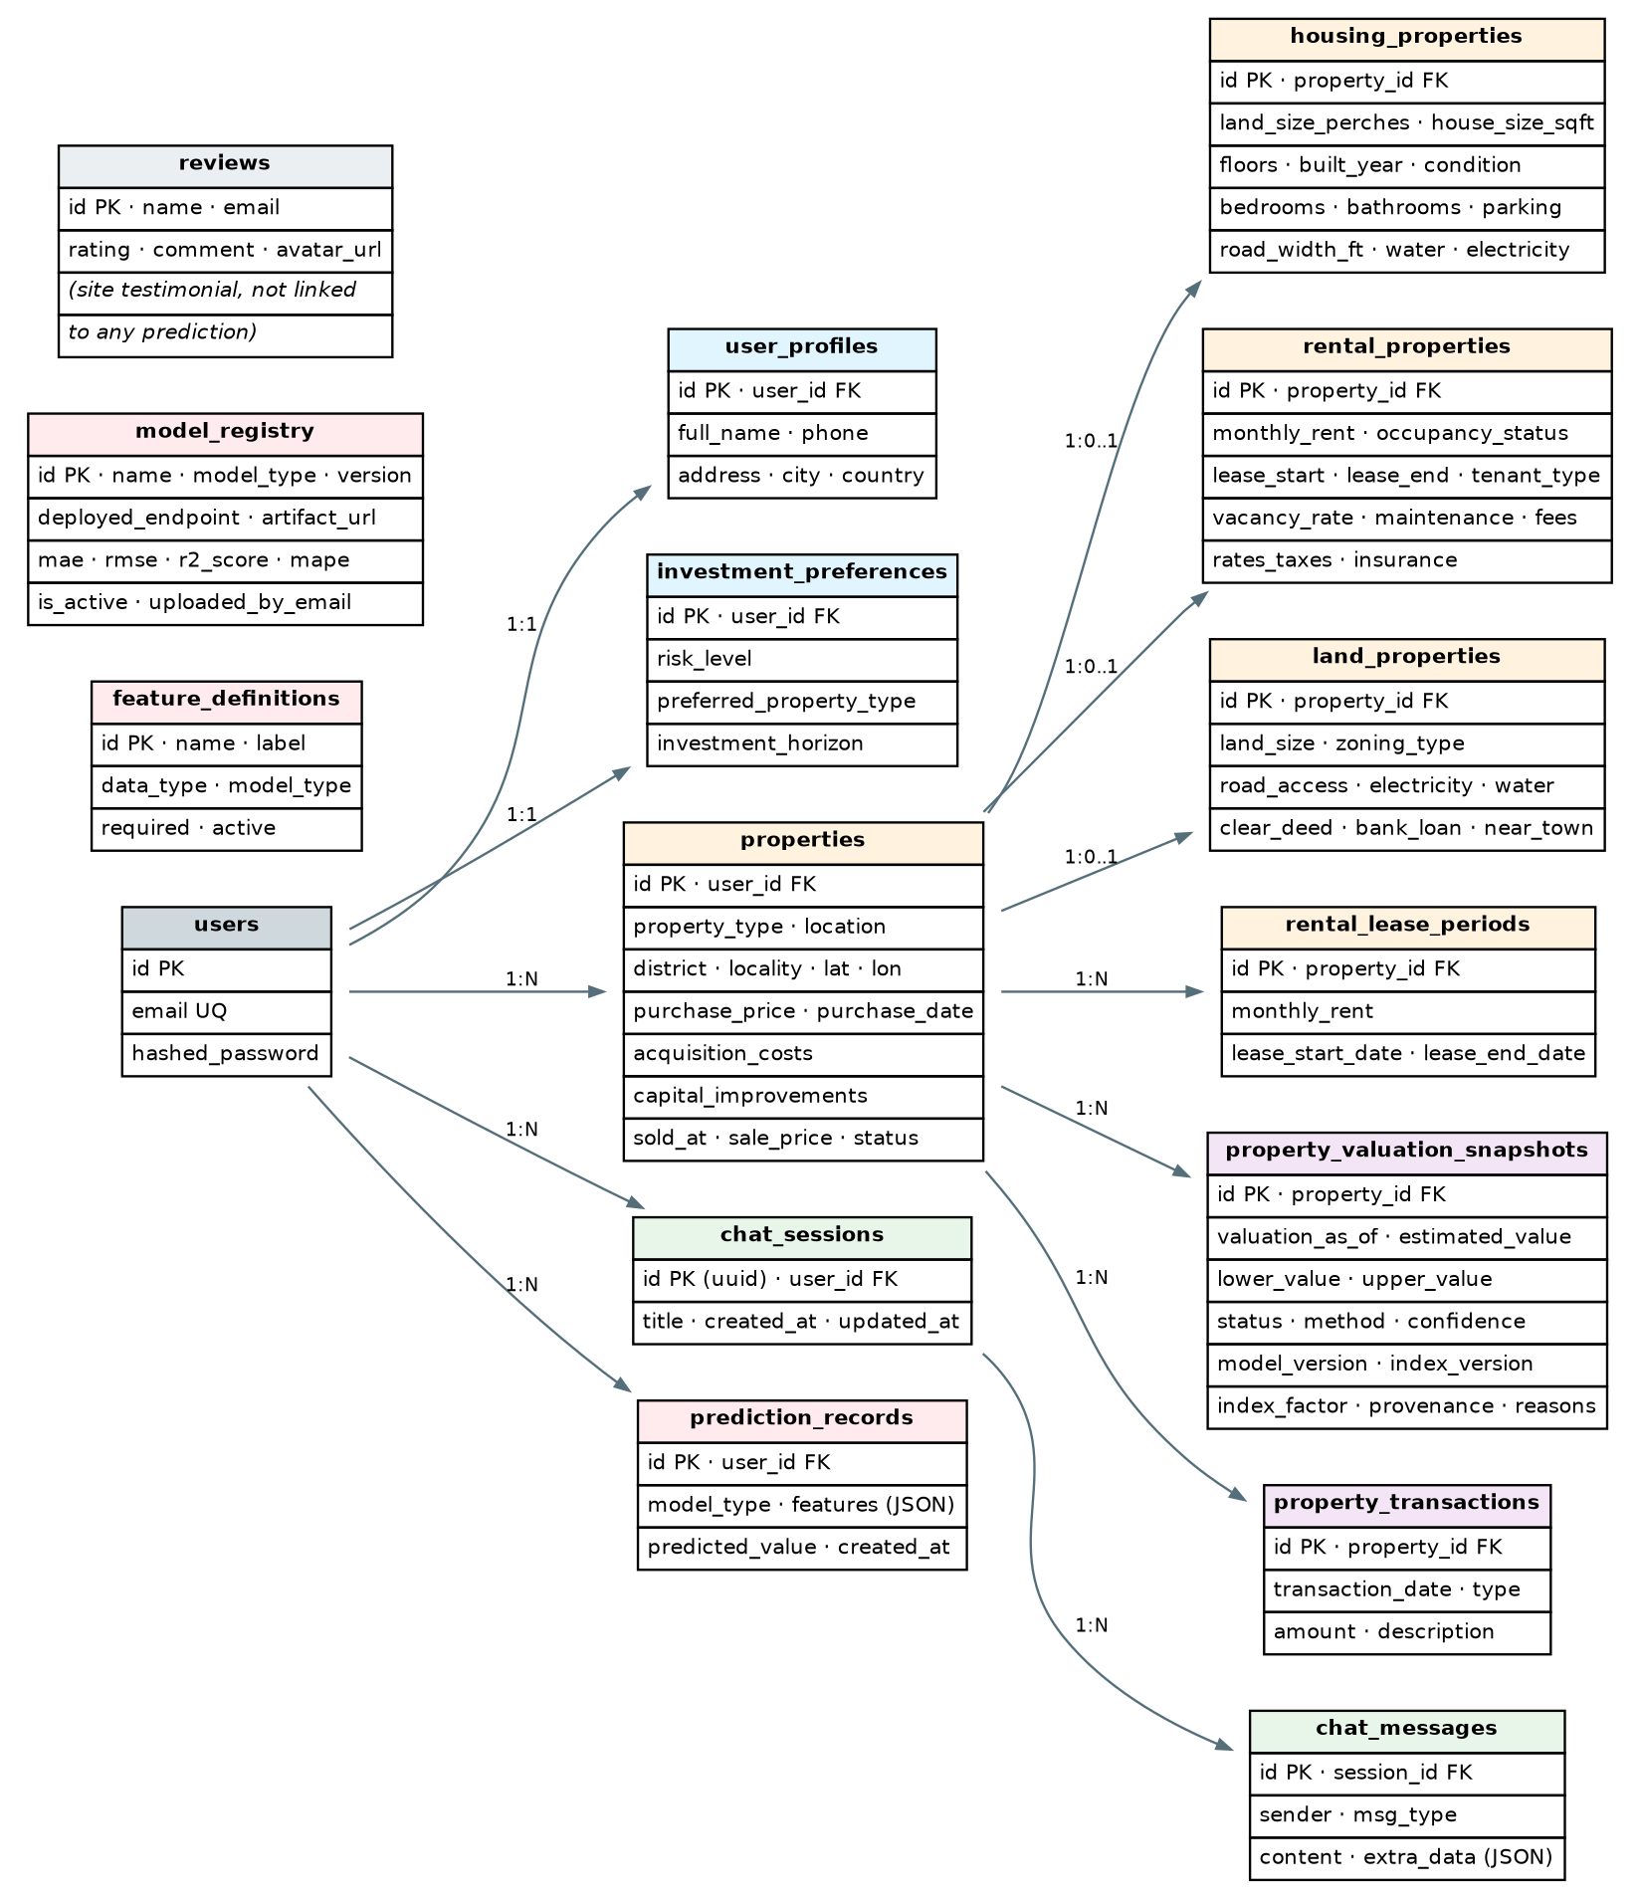
Figure 24:Entity–relationship diagram of the implemented relational schema — sixteen tables across PostgreSQL, defined by SQLAlchemy models.
The principal differences are these. Location is not an entity; district, locality, latitude and longitude are columns on properties. ListingSnapshot does not exist; historical valuation is captured instead by property_valuation_snapshots, which stores an estimated value with a lower and upper bound, a status, a method, a confidence level, model and index versions, the index factor applied, a feature hash and a JSON provenance block. Sentiment is not relational at all: scored documents live in MongoDB and aggregated snapshots in Redis. Model corresponds to model_registry, which stores endpoint and metric metadata rather than model artefacts. RL has no relational representation whatsoever — no state, action, reward or recommendation is persisted. A Prediction entity does exist, as prediction_records, but it is written only when the requester is authenticated.
The delivered schema also contains six tables the interim design did not anticipate: rental_lease_periods, which preserves historical agreed rents so cumulative rental income remains correct when a lease is renegotiated; property_transactions, a ledger of acquisition, improvement and disposal amounts; investment_preferences, holding risk level, preferred property type and investment horizon; chat_sessions and chat_messages, which persist conversations; and feature_definitions, which lets administrators declare model input contracts without a code change.
Table 9:IMPLEMENTED RELATIONAL TABLES BY FUNCTIONAL GROUP
Group | Tables
Identity and preference | users, user_profiles, investment_preferences
Property portfolio | properties, housing_properties, rental_properties, land_properties, rental_lease_periods
Valuation history | property_valuation_snapshots, property_transactions
Conversation | chat_sessions, chat_messages
Model operations | feature_definitions, prediction_records, model_registry
Site feedback | reviews

5.4.6 Administrative Design
The delivered administrative surface is narrower than Fig. 5.2 and Fig. 5.9 imply. It provides dashboard statistics, full CRUD over feature definitions, user listing and deletion, and a model registry supporting registration, update, activation and deletion, where activation deactivates all other models of the same type. It does not provide dataset upload, model retraining or data export. Administrative identity is established by comparing the authenticated user's e-mail against a configured administrator address; there is no role column in the schema. Both limitations are recorded in Appendix A and revisited as future work in §8.6.

5.5 Positioning the Novelty within the Design
The novelty sits in the extended module, not in the ML engine. The engine is conventional: gradient-boosted trees for tabular valuation, a small recurrent network for an index series, a feed-forward Q-network for discrete actions. What is unconventional is that no value leaves the system without passing through a layer whose job is to decide whether the evidence supports it, to degrade it in a declared way when it does not, and to attach the reasoning to the response.
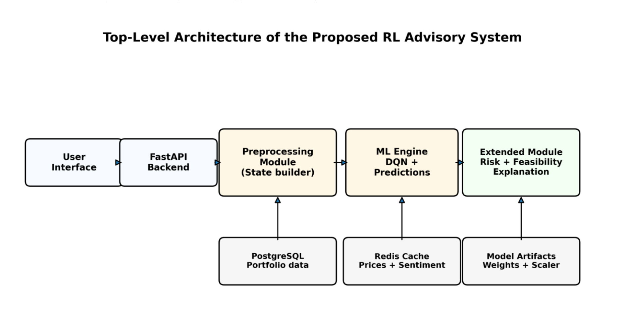
Figure 25:Target architecture for the reinforcement-learning advisory component from the parallel research study. The preprocessing module and ML engine are implemented; the extended module ships with state-health assessment only, without risk, feasibility or exp

5.6 Summary
This chapter presented the design rationale, the top-level architecture and the UML and entity–relationship models. It reproduced the interim behavioural models, annotated the points at which the implementation diverged, and replaced the interim entity–relationship diagram with the schema actually built. The next chapter describes how each module was implemented.

CHAPTER 6

IMPLEMENTATION

6.1 Introduction
This chapter describes how the design was realised: the development approach, the platforms used, each module's implementation, the principal algorithms, component integration and the incremental testing that accompanied development. Descriptions here reflect the code as delivered, and where they contradict the interim report the contradiction is noted.

6.2 Overall System Development
Development followed an incremental, feedback-driven cycle rather than a fixed waterfall. Each increment delivered a vertical slice — a model, its serving endpoint, its client page and its tests — and closed with a review against the client's provenance requirement. Work proceeded in five phases. The first established authentication, the property schema and a single land model behind a working endpoint. The second added the house and rental models with their feature contracts and the admin feature registry. The third built the sentiment pipeline and its caching and scheduling. The fourth integrated the reinforcement-learning artefacts and the agentic chat layer. The fifth, which produced most of the corrections in this report, was a diagnostic phase: instrumenting the pipelines revealed the reinforcement-learning signal defect described in §6.4.5 and the index-forecast weakness described in §7.7.4, and led to the anchoring, guarding and provenance work that now characterises the system.

6.3 Hardware and Software Platforms
Table 10:HARDWARE AND SOFTWARE PLATFORMS
Platform / tool | Use in implementation
Development workstation, 16 GB RAM, multi-core CPU | Model training, pipeline runs and integration testing. The 8 GB figure quoted in the interim report is insufficient once TensorFlow, PyTorch and transformer models are resident (Appendix A, item A.12)
Python 3.12 | Backend services, model training and inference
FastAPI + Uvicorn | HTTP API, dependency injection, OpenAPI schema
SQLAlchemy + PostgreSQL (Azure) | Relational persistence; SQLite fallback for local development
Redis | Caches for current prices, sentiment snapshot, sentiment history and forecast sequences
MongoDB | Scored sentiment documents with similarity scores and timestamps
ChromaDB | Reference embedding collections for the semantic relevance filter
CatBoost, LightGBM, scikit-learn (pinned 1.6.1) | Valuation models; the pin preserves scaler deserialisation compatibility
TensorFlow / Keras | Market-index LSTM models and the DQN forward pass
PyTorch + PyTorch Geometric | GATv2 residual imputation experiment
Transformers, sentence-transformers | FinBERT scoring and MiniLM embeddings
LangGraph, LangChain, Google GenAI SDK, OpenRouter | Agentic conversational layer
APScheduler | Daily sentiment refresh, weekly pipeline run, quarterly portfolio snapshots
React 19, TypeScript, Vite 7, React Router 7, Leaflet | Single-page client
pytest | Fourteen automated test modules (§6.8)
Git and GitHub; Docker; Vercel; Render | Version control, containerisation and deployment of client and API

6.4 Module-wise Implementation of the Design
Table 11:MODULE-WISE IMPLEMENTATION
Module | Location | Implementation focus
Authentication | backend/auth/ | JWT issuance and validation, Argon2/bcrypt hashing, Google OAuth exchange, required and optional user dependencies
Properties | backend/properties/ | Typed create and update models for housing, rental and land; lease-period capture; transaction ledger entries
Portfolio | backend/portfolio/ | Hybrid valuation engine, unrealised gain and total return, rental income accrual by calendar month, provenance assembly, quarterly snapshots
Prediction orchestration | backend/dynamic/ | Per-model contract validation, model resolution, anchor adjustment, forward path, confidence composition, prediction records
Market index | backend/predictions/market_index.py | Observed CBSL index loading, growth factor computation, staleness and plausibility guards, describe endpoint
Index forecasting | backend/predictions/LSTM/ | Two LSTM(8)→Dense(1) models with MinMax scalers and manifests recording backtest results; rental series is an explicit house-index proxy
House model | ml/house_service/ | CatBoost with fifty features, forty of them extracted from listing descriptions; optional GATv2 residual imputer behind a fallback import
Land model | ml/land_service/ | LightGBM bundle, gazetteer geocoding, LVI period calibration, three-tier coverage verdict, per-perch and whole-plot outputs
Rental model | ml/rental_service/ | CatBoost over sixty-five features on a log target with expm1 inversion; segment-level metrics and error calibration percentiles
Sentiment pipeline | Sentiment/Analysis/ | Collection, cleaning, FinBERT scoring, MiniLM embedding, cosine relevance filtering against ChromaDB references, weighted time-decayed aggregation
RL serving | backend/rl/ | State vector assembly, price-signal generation with clipping and telemetry, scaler and Q-network loading, distribution-health assessment
Agentic layer | backend/agent/ | LangGraph state machine with planner, extraction, missing-field, prediction, investment, analysis and formatter nodes
Chat endpoint | backend/app.py | Gemini chat session with a keyword protocol; session and message persistence
Admin | backend/admin/ | Dashboard statistics, feature-definition CRUD, user management, model registry with single-active-model activation
Caching and scheduling | backend/core/ | Redis client and cache service; APScheduler jobs
Client | frontend/src/ | Three prediction pages, portfolio dashboard, Ask Reva chat, admin console, Leaflet map explorer, typed API service layer
Offline training | ml/*/train_*.py, scripts/ | House, rental, GNN and market-index training scripts producing versioned reports and metadata

6.4.1 Valuation models
The house model is a CatBoost regressor on capped price per square foot. Its baseline uses ten structural and geographic features; the accepted variant adds forty description-derived features and a categorical quality tier. Description extraction is versioned as house_description_v1 and produces road width with an explicit missingness flag, road-type mentions, seven utility and amenity flags, parking count with missingness, five distances to services each with a missingness flag, six proximity mentions, and four composite scores including a description_value_index. Training used 54,134 rows with a 3,354-row temporal hold-out drawn from the most recent listings by posting date; the enhanced variant was accepted because it improved validation MAE by 5.34 %.
The land model is a serialised LightGBM bundle carrying its feature list, categorical columns and category vocabularies. Because the model's district vocabulary covers only Colombo, Gampaha and Kalutara while the Land Valuation Indicator table names nine districts plus a catch-all row, the service reports one of three coverage tiers: high when the district is in both, medium when it is in the calibration table but reaches the tree as an unseen category, and low when the catch-all row is used. A request for an uncovered district previously failed; it now returns a low-confidence estimate that states why.
The rental model is a CatBoost regressor over sixty-five features trained on log(monthly_rent) and inverted with expm1, which stabilises a target spanning three orders of magnitude from a room to a hotel. The split policy holds out all 2026 postings as a temporal test set and hash-splits the remainder, so the reported temporal figure measures genuine forward generalisation rather than random resampling.

6.4.2 Market-index anchoring
Every model price is a level at the model's own training anchor. The anchoring layer moves it to the present by multiplying by the ratio of the latest observed CBSL index value to the value at the anchor period. Three guards precede application: a staleness ceiling, expressed in months, beyond which the gap is too wide to project across; a per-series volatility band derived from the historical monthly change distribution; and a plausibility clamp. Failing any guard sets the factor to exactly 1.0, which leaves the model's own estimate untouched, and the response records that the adjustment was not applied. Observed index updates are stored separately from the frozen training CSV so that refreshing the index does not silently alter the model's training data.

6.4.3 Portfolio valuation
The portfolio engine is selectable between three implementations so that behaviour changes can be compared rather than asserted: legacy, which reproduced the original behaviour including summing per-perch land rates as if they were capital values; scraper_fixed, which corrects those units; and hybrid, the default, in which a property's model anchor is moved only by a matched observed index and the result is marked unavailable when a required property fact is missing. Estimated value, unrealised gain — value less purchase price, acquisition costs and capital improvements — and total return including net rental cash flow are computed per property and aggregated. Rental income accrues by inclusive calendar month from lease start, using the agreed rent for each historical lease period, which is why rental_lease_periods exists. Properties outside the index's Colombo coverage are labelled anchor_only and are not moved by Colombo's market movement.

6.4.4 Sentiment pipeline
Collection draws from NewsAPI, two targeted scrapers and Google Trends. Each passage is cleaned, scored by FinBERT into a label and confidence, and embedded with MiniLM. The embedding is compared by cosine similarity against ChromaDB reference collections for land, house and rental, and for short, medium and long horizons; the asset class with the highest similarity claims the document. Aggregation computes, per asset and horizon, a weighted mean of signed impact where the weight is the product of a source-type weight (news scraper 0.5, web scraper 0.3, API article 0.2), the classifier confidence, the horizon relevance and an exponential time decay whose rate varies by horizon (0.15, 0.03 and 0.005 per day) under hard windows of 30 days, one year and five years. Scores above 0.2 are labelled bullish and below −0.2 bearish.
For the reinforcement-learning state, a second aggregation converts this into four features per asset: current sentiment as the mean of the most recent seven days, trend as the slope of a linear regression over the 30-day series, volatility as the standard deviation of that series, and a binary shock flag set when the recent mean deviates from the monthly mean by more than two standard deviations. Where fewer than thirty days of history exist, a documented fallback derives these from the current snapshot's three horizons.

6.4.5 Reinforcement-learning serving
The recommendation service assembles a 25-element state vector — three asset blocks of eight features plus a cash slot — scales it with the pickled training scaler and runs the Q-network forward to obtain 27 Q-values, taking the argmax as a joint action over land, rental and housing.
Three properties of this path are stated explicitly because the interim report implied otherwise. First, no learning occurs at request time: the module loads weights and calls predict, and there is no optimiser, replay buffer, reward computation or weight write anywhere in the backend. Second, the cash feature is a constant 1.0. Training used cash in hand divided by initial investment, a quantity ranging from zero to about three; the constant sits inside that range but carries no user-specific information, so the served policy is not personalised by liquidity. Third, the three price signals are market-level and identical across the three asset blocks, whereas training gave each block its own signals; this costs information rather than correctness, and correcting it requires retraining.
The diagnostic phase found that two of those three signals had been computed as a ratio of an LSTM index value to a scraped rupee price — dimensionally incoherent quantities whose ratio carried no meaning. In practice the values were −0.547 and −0.939 on every call, both clipping to their floors, which placed the agent roughly 7.5 and 4.2 standard deviations outside its training distribution on those features. Both are now computed as ratios within a single index series, so the units cancel and a real growth rate survives; every signal is reported before and after clipping, and a value that reaches a bound raises a warning.
The state-health module addresses the remaining exposure. Because the training environment rarely held more than one property of a given type, the units-owned features have very tight scales — a user holding two rentals is already about 3.6 standard deviations out. Rather than clipping, which would make a four-property portfolio indistinguishable from a ten-property one, the module reports per-feature z-scores, names the offending features and sets reliable to false when any exceeds three standard deviations.

6.4.6 Conversational and agentic layers
Two conversational paths exist. The /ask endpoint runs a Gemini 2.5 Flash chat session under a system prompt defining a three-keyword protocol: the model returns [TRIGGER_PREDICTION_FORM] with extracted fields when it has partial property details, [PREDICTION_RESULT] with a price and range when the description is complete, or [TRIGGER_GRAPH] for a trend request. The backend parses the keyword and returns a typed payload the client renders as a form, a result card or a chart. Sessions and messages are persisted for authenticated users.
One consequence must be stated plainly: a price returned through the [PREDICTION_RESULT] path is generated by the language model, not by the trained valuation models, and the handler falls back to a fixed illustrative figure if parsing fails. The [TRIGGER_PREDICTION_FORM] path is the intended route to a model-backed valuation, because it hands the extracted fields to the prediction form. This distinction is not drawn in the interim report and is recorded as item A.9 in Appendix A.
The /agent/ask endpoint runs the LangGraph state machine: a planner classifies intent and routes greetings to a short-circuit node; otherwise the graph extracts query entities, checks for missing required fields, and dispatches to a prediction, investment or analysis node before a formatter produces the response. Tool wrappers exist for the LSTM forecast, the RL recommendation and the sentiment snapshot. Conversation state is checkpointed in memory and keyed by user id.

6.5 Algorithms and Pseudocode
Algorithm 1 — Anchored price prediction. This is the request path for every valuation.
function predict(model_type, features, user):
validate_contract(model_type, features) # typed, per-model; 400 on failure
model = resolve_active_model(model_type) # env -> registry -> embedded
anchor = model.predict(features) # price at the model's training anchor

factor = index.growth_factor(asset_of(model_type), anchor_period)
if not (factor.fresh and factor.within_volatility_band and factor.plausible):
factor = Factor(value=1.0, usable=False, reason=...) # degrade, do not distort
value = anchor * factor.value

sequence = forward_path(model_type, value) # flat when the forecast is disabled
confidence = compose(model.coverage, factor.confidence)

if user is not None:
persist(PredictionRecord(user, model_type, features, value))

return { predicted_value: value, unit: model.unit, total_value: ...,
predicted_sequence: sequence, confidence: confidence,
details: { anchor_adjustment: factor, market_index: index.describe(),
coverage: model.coverage, sequence_source: ... } }

Algorithm 2 — Reinforcement-learning recommendation. Note that the algorithm terminates in a competence verdict, not in a policy update.
function recommend(user):
counts = property_counts(user) # land, rental, housing
sentiment = aggregate_sentiment_features() # 4 features per asset
signals = clip(price_signals(), agent_training_bounds) # land_trend, rental_yield,
# housing_signal
state = []
for asset in (land, rental, housing):
state += [ counts[asset],
sentiment[asset].current, sentiment[asset].trend,
sentiment[asset].volatility, sentiment[asset].shock,
signals.land_trend, signals.rental_yield, signals.housing_signal ]
state.append(1.0) # cash slot: constant, not user-specific

q = q_network(scaler.transform(state)) # forward pass only
action = decode(argmax(q)) # one of 3^3 joint actions
health = assess(state) # per-feature z vs training distribution

return { action_index, action_vector, action_labels, state_vector: state,
state_health: health, reliable: health.in_distribution }

Algorithm 3 — Sentiment aggregation. Applied per asset class and per horizon.
function aggregate(documents, asset, horizon):
total = 0; n = 0
for doc in documents:
if argmax(doc.similarity_land, doc.similarity_house,
doc.similarity_rental) != asset: continue
sign = +1 if doc.label == positive else (-1 if doc.label == negative else 0)
weight = source_weight(doc.type) # 0.5 / 0.3 / 0.2
decay = exp(-lambda[horizon] * age_days(doc)) if age_days <= window[horizon] else 0
total += weight * doc.score * sign * doc.similarity[horizon] * decay * 100
n += 1
value = total / n if n > 0 else 0
return value, ('bullish' if value >= 0.2 else 'bearish' if value <= -0.2 else 'neutral')

Algorithm 4 — Portfolio valuation under the hybrid engine.
function value_portfolio(user, as_of):
for property in active_properties(user):
if missing_required_facts(property):
mark(property, status='unavailable', reasons=missing_fields); continue
anchor = avm(property.type).predict(features_of(property))
idx = matched_observed_index(property.district, property.type, as_of)
if idx is None:
mark(property, status='anchor_only') # outside index coverage
value = anchor
else:
value = anchor * idx.ratio
gain = value - purchase_price - acquisition_costs - capital_improvements
income = accrued_rent(property, as_of) # by inclusive calendar month
record_snapshot(property, value, status, confidence, versions, provenance)
return aggregate(values, gains, incomes, property_mix)

6.6 Workflow Diagrams and Flowcharts
The implemented workflows are given in Fig. 4.1 for valuation and Fig. 4.2 for recommendation. The activity and sequence diagrams in §5.4 describe the user-facing interactions. Each stage of the two workflows corresponds to a test case in §6.8, which is how the diagrams were kept honest: a workflow step with no corresponding test was treated as undelivered.

6.7 Integration of Components
Integration is contract-driven. The client consumes typed service functions whose TypeScript interfaces mirror the Pydantic response models, so a field rename in the API surfaces as a compile error rather than a runtime undefined. Between the API and the models the contract is a feature dictionary in and a result dictionary out, with the model responsible for its own coverage verdict; this is what lets a remote model service and an embedded artefact be interchangeable. Between the API and the caches the contract is best-effort: every cache read is wrapped so that an unavailable Redis degrades to recomputation rather than to an error. Between the sentiment pipeline and its consumers the contract is the cached snapshot, which decouples scraping and transformer inference from the request path entirely.
Two integration decisions deserve note. Schema evolution is handled by an additive migration routine executed at startup, which adds missing columns without dropping data. And the recommendation service deliberately reads property counts rather than the full portfolio: computing valuations and ledgers on every recommendation would be expensive, and a failure anywhere in that chain would return zero counts, which is indistinguishable from a user who owns nothing.

6.8 Incremental Testing During Development
Fourteen pytest modules were developed alongside the features they cover. Testing concentrated on contracts, units and guard behaviour rather than on model accuracy, because accuracy is measured by the training reports in Chapter 7 while unit errors and silent fallbacks are the failure modes that reach users.
Table 12:INCREMENTAL TESTING DURING DEVELOPMENT
Test module | What it validates
test_prediction_contract.py | Request and response contracts for all three models; required-field rejection; unit and total-value correctness
test_market_index.py | Growth-factor computation, staleness ceiling, degradation to 1.0, describe metadata
test_lstm_scaler_domain.py | Scaled inputs remain inside the scaler's fitted domain; detects a wrong scaler being loaded
test_portfolio_valuation.py | Estimated value, unrealised gain, acquisition and improvement deduction, rental accrual
test_portfolio_v2.py | Hybrid engine behaviour, unavailable and anchor_only statuses, provenance fields
test_rl_state_signals.py | Price-signal definitions, clipping bounds, provenance of each signal, telemetry on bound contact
test_rl_state_health.py | z-score computation, offender ordering, reliable flag, scaler/state length mismatch handling
test_house_description_features.py | Description extraction: road width, utilities, distances, missingness flags, composite scores
test_house_gnn_graph.py | Spatial, feature and location edge construction and edge counts
test_house_gnn_model.py | GATv2 residual model forward pass and output shapes
test_house_service_gnn_fallback.py | House service operates correctly when graph dependencies are absent
test_geocoding_and_rental.py | Gazetteer resolution, exact versus district fallback, rental feature schema
test_rental_preprocessing.py | Cleaning, unit normalisation, feature derivation from raw listing files
test_rental_training_pipeline.py | End-to-end training run on fixtures; report structure and acceptance logic

6.9 Summary
This chapter described the development approach, the platforms, and the implementation of each module, including the three valuation models, the anchoring layer, the portfolio engine, the sentiment pipeline, the reinforcement-learning serving path and the agentic layer. It gave the four principal algorithms, described contract-driven integration, and listed the fourteen test modules developed alongside the features. It also stated three properties of the reinforcement-learning path — no learning at request time, a constant cash feature and shared market-level price signals — that the interim report did not disclose. The next chapter evaluates the result.

CHAPTER 7

EVALUATION

7.1 Introduction
This chapter evaluates the delivered system. Each learned component is measured against explicit non-learned baselines on held-out and, where the data permits, temporally separated splits. Two components failed to beat their baselines, and both results are reported in full: they are the clearest evidence that the evaluation protocol is doing its job rather than confirming decisions already taken.

7.2 Evaluation Strategy
Four principles govern the evaluation. Baselines first: a learned model is accepted only if it beats a stated non-learned alternative by a stated margin, so accuracy figures are meaningful in isolation rather than only in comparison with each other. Temporal separation where possible: property prices drift, and a random split lets a model interpolate within a period it has already seen, so the rental model reserves an entire posting year and the house model holds out the most recent listings by date. Segment reporting: an aggregate MAPE over a corpus containing both rooms and hotels conceals more than it reveals, so per-segment metrics are reported. Negative results published: components that fail their acceptance criterion are reported with the same detail as those that pass, and are disabled rather than quietly shipped.

7.3 Experimental Setup
Training and evaluation ran on the development workstation described in §6.3, using CPU-only inference paths identical to production. Model artefacts, metadata and machine-readable training reports are versioned in the repository alongside the code, so every figure in this chapter is traceable to a stored report: catboost_house_price_training_report.json, rental_price_training_report.json, house_gnn_training_report.json and market_index_training_report.json. Random seeds and split policies are recorded in those reports. Integration behaviour was verified by the fourteen pytest modules listed in Table 6.3.

7.4 Datasets and Test Cases
Table 13:DATASETS USED FOR TRAINING AND EVALUATION
Dataset | Size | Split policy
House listings (cleaned, 2022–23 and 2025 corpora) | 54,134 training rows; 3,354 validation rows | Hold out the most recent rows from the 2025 corpus by posting year, month and day
Rental listings (six source files, rental_features_v1) | 28,224 training; 7,103 validation; 2,500 temporal test | Hold out all 2026 postings for temporal testing; deterministic hash split of the remainder at 0.2
Land listings with LVI calibration table | Serialised LightGBM bundle; district vocabulary of three | Coverage tiering rather than a held-out split; calibration verified against the published LVI table
CBSL house index | 66 monthly observations, 2019-10 to 2025-03 | Walk-forward backtest: 24, 22 and 19 folds at 1, 3 and 6 months
CBSL land index | 75 monthly observations, 2019-01 to 2025-03 | Walk-forward backtest: 33, 31 and 28 folds at 1, 3 and 6 months
Sentiment corpus | Continuously collected news, scraped articles and trend series | No labelled ground truth available; evaluated qualitatively and by pipeline stability

Test cases at the system level exercise each workflow stage: a valid and an invalid payload for each model; a district inside and outside model vocabulary; a property with and without required facts; a fresh and a stale index; a state vector inside and outside the agent's training distribution; and a cache-available and cache-unavailable path.

7.5 Participants
No human-subject study was conducted, so no participant data was collected and no ethical approval was required. Qualitative feedback came from two sources: fortnightly review sessions with the academic supervisors, and demonstration sessions with the industry client. Client feedback was the origin of the provenance requirement, the unavailable status and the separation of per-perch land rates from whole-plot values. A structured usability study with prospective buyers and property professionals is identified as future work in §8.6.

7.6 Evaluation Metrics
Table 14:EVALUATION METRICS AND THEIR ROLE
Metric | Definition and role
MAE | Mean absolute error in the target's own unit. Primary acceptance criterion for the valuation models because it is robust to the extreme upper tail of property prices
RMSE | Root mean squared error. Reported alongside MAE to expose whether error is concentrated in a few large mistakes
MAPE | Mean absolute percentage error. The comparable figure across three models with different units and scales
Median APE | Median absolute percentage error. Reported because MAPE is inflated by low-priced properties where a small absolute error is a large relative one
R² | Coefficient of determination. Reported for the rental model, where negative values expose baselines that perform worse than the mean
Error percentiles | p50, p80 and p90 of relative absolute error. Converts an aggregate into a statement a user can act on
Train / validation MAE ratio | Overfitting diagnostic; the accepted rental model reports 1.224
Backtest MAPE against naive and drift | Forecast acceptance criterion: a forecast that cannot beat last-observed-value is not a forecast
Distribution-health rate | Proportion of recommendation requests falling inside the agent's training distribution

7.7 Results and Analysis

7.7.1 House valuation model
Adding description-derived features improved every metric on the held-out set. Validation MAE fell from 4,204.73 to 3,980.37 LKR per square foot, a 5.34 % improvement, and MAPE from 20.82 % to 19.66 %. The description_value_index contributed a small but consistent additional gain over the description features alone (3,996.33 to 3,980.37 MAE), which was sufficient to accept the full variant. The train-to-validation MAE ratio of 1.75 indicates meaningful but not pathological overfitting, consistent with a temporal hold-out on a drifting market.

Table 15:HOUSE VALUATION MODEL — RESULTS BY FEATURE SET (TARGET: CAPPED PRICE PER SQUARE FOOT)
Variant | Features | Train MAE | Val. MAE | Val. RMSE | Val. MAPE | Val. median APE
Baseline | 10 | 2,399.90 | 4,204.73 | 7,327.93 | 20.82 % | 14.42 %
Enhanced, no value index | 49 | 2,294.49 | 3,996.33 | 7,153.77 | 19.69 % | 13.05 %
Enhanced with value index (accepted) | 50 | 2,274.19 | 3,980.37 | 7,098.71 | 19.66 % | 13.10 %

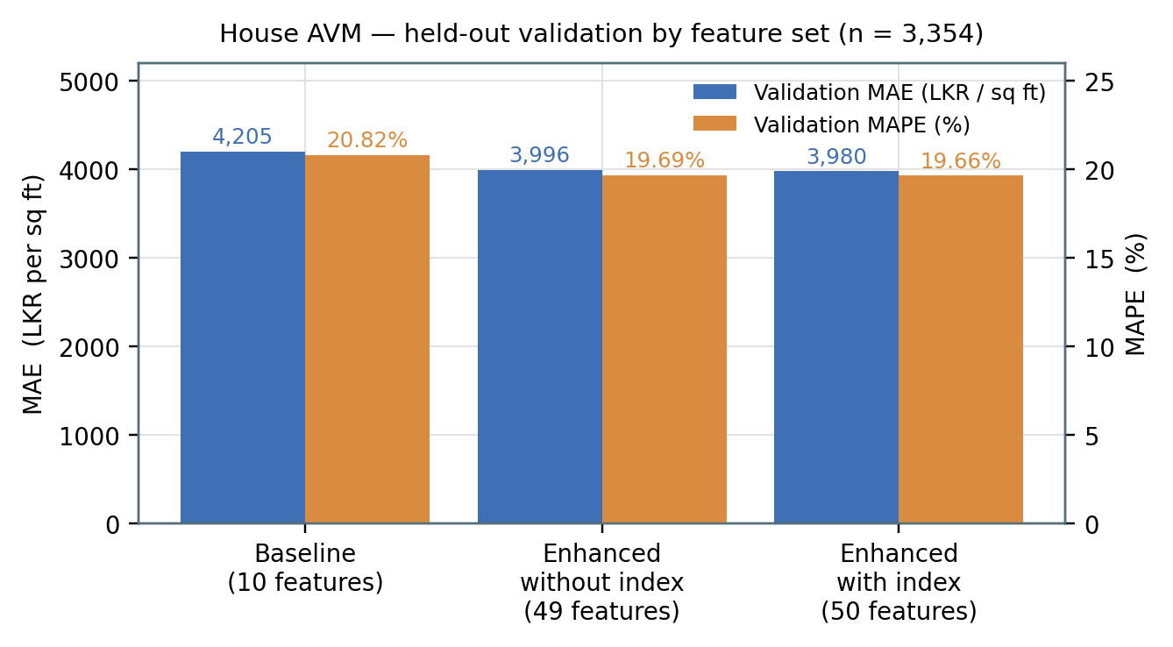
Figure 26:House valuation model — held-out validation error by feature set (n = 3,354).

7.7.2 Graph neural network experiment (negative result)
A GATv2 residual imputer was built to let a listing borrow attribute values from spatial, feature-space and location neighbours, on the hypothesis that missing bedroom counts, road widths and service distances could be recovered from comparable properties. The graph used sixteen spatial, sixteen feature and eight location neighbours per node, yielding roughly 1.73 million spatial and feature edges on the training split. Four variants were evaluated against a 2 % MAE improvement threshold.
None passed. The best variant was 3.07 % worse than the CatBoost baseline, and the standalone GNN was catastrophically worse at 20,072.80 validation MAE against 3,980.37 — its 99.99 % MAPE indicates it had collapsed to predicting a near-constant. The multi-task variants did improve numeric imputation quality (imputation MAE 0.84 against 1.04 without the auxiliary task), so the graph does carry attribute signal; it simply does not carry price signal that CatBoost had not already extracted. The component ships behind an optional import that the house service functions correctly without, and this is verified by a dedicated fallback test.
Table 16:HOUSE GNN RESIDUAL EXPERIMENT — ALL VARIANTS AGAINST THE ACCEPTED BASELINE
Variant | Val. MAE | Val. RMSE | Val. MAPE | Change vs baseline | Outcome
CatBoost baseline (accepted) | 3,980.37 | 7,098.71 | 19.66 % | — | Retained
Standalone GNN | 20,072.80 | 23,609.41 | 99.99 % | −404 % | Rejected
Residual, no imputation | 4,110.76 | 7,177.70 | 20.64 % | −3.28 % | Rejected
Residual, MTL 70/30 | 4,199.79 | 7,266.65 | 20.49 % | −5.51 % | Rejected
Residual, MTL 85/15 (best) | 4,102.72 | 7,188.11 | 20.46 % | −3.07 % | Rejected

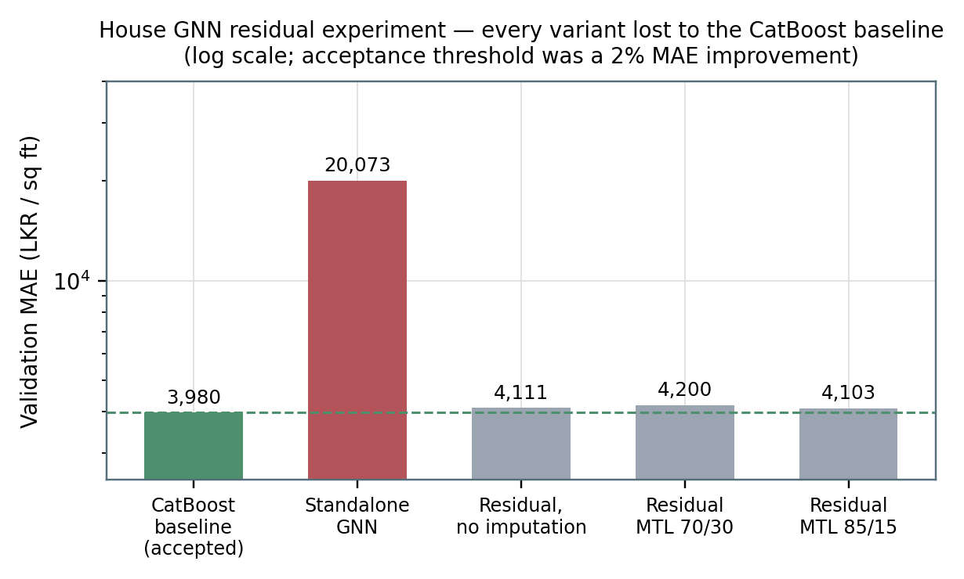
Figure 27:Every graph-neural variant lost to the tabular baseline. Logarithmic scale; the acceptance threshold was a 2 % MAE improvement.

7.7.3 Rental valuation model
The rental corpus is the hardest of the three: a single target spans a room at a few thousand rupees a month and a hotel at several hundred thousand. Four baselines were constructed of increasing sophistication, and the accepted CatBoost model improved validation MAE by 51.85 % over the strongest of them, with a train-to-validation MAE ratio of 1.224.
The temporal test is the more informative result. On 2026 postings the accepted model reaches 58.80 % MAPE with R² of 0.254 — substantially worse than its 32.05 % validation figure, and the reason the report does not claim a 32 % operating accuracy. Two observations make this interpretable. First, the LightGBM benchmark, which was marginally better than CatBoost on validation at 31.51 %, degrades to 131.04 % MAPE with negative R² on the temporal test; CatBoost was selected on temporal robustness, not on the validation figure. Second, the naive type-and-source median baseline achieves 60.89 % on the same temporal test, so the learned model retains only a modest edge once genuine forward generalisation is required. This is an honest characterisation of a thin, drifting market rather than a defect to be tuned away.
Table 17:RENTAL VALUATION MODEL — ACCEPTED MODEL AGAINST FOUR BASELINES
Model | Val. MAE (LKR) | Val. MAPE | Val. R² | Temporal MAPE | Temporal R²
Global median | 238,096 | 225.89 % | −0.059 | 60.89 % | −0.045
Property-type median | 199,126 | 91.98 % | 0.049 | 75.68 % | −0.049
Type + source median | 176,851 | 78.13 % | 0.153 | 60.89 % | −0.045
LightGBM benchmark | 85,376 | 31.51 % | 0.666 | 131.04 % | −0.066
CatBoost (accepted) | 85,149 | 32.05 % | 0.710 | 58.80 % | 0.254

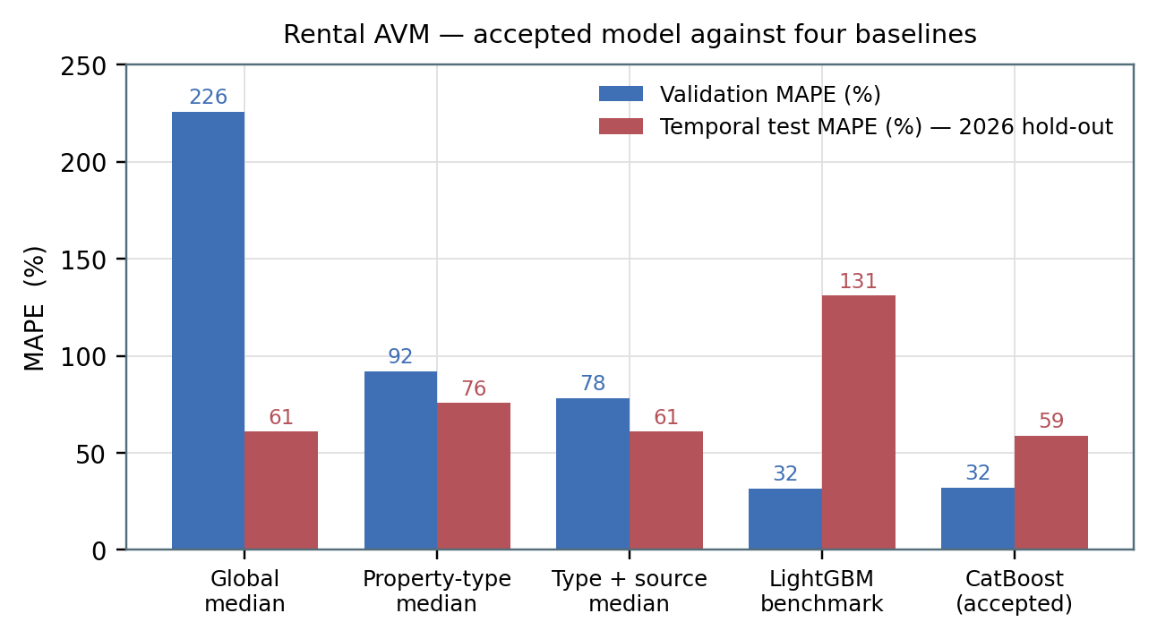
Figure 28:Rental valuation model against four baselines on the validation split and the 2026 temporal hold-out.
Segment analysis shows where the aggregate figure comes from. Residential segments with dense data are well modelled — houses at 26.64 % MAPE over 3,025 validation rows, portions at 27.64 % and apartments at 29.72 % — while thin commercial segments are not: hotels reach 73.77 % MAPE over 25 rows and other-commercial 68.83 % over 24. The pattern tracks row count almost monotonically, which supports data sparsity rather than model capacity as the binding constraint.
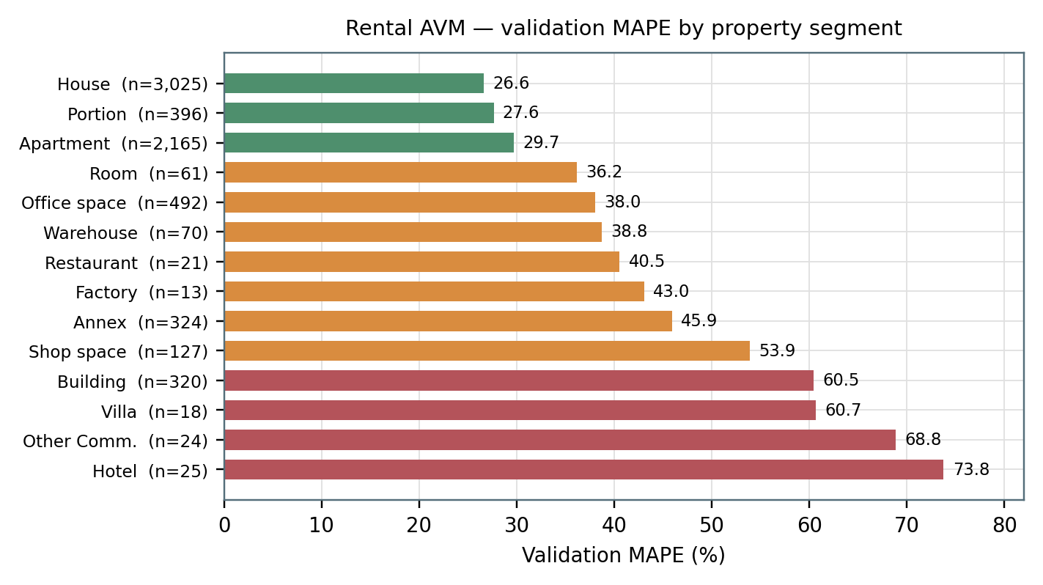
Figure 29:Rental valuation model — validation MAPE by property segment, with validation row counts. Error tracks data density.
Error calibration converts these aggregates into a statement a user can act on: half of validation predictions fall within 21.1 % of the true rent, 80 % within 43.6 %, and 90 % within 61.6 %. This distribution, not the headline MAPE, is what the confidence banding in the interface is derived from.
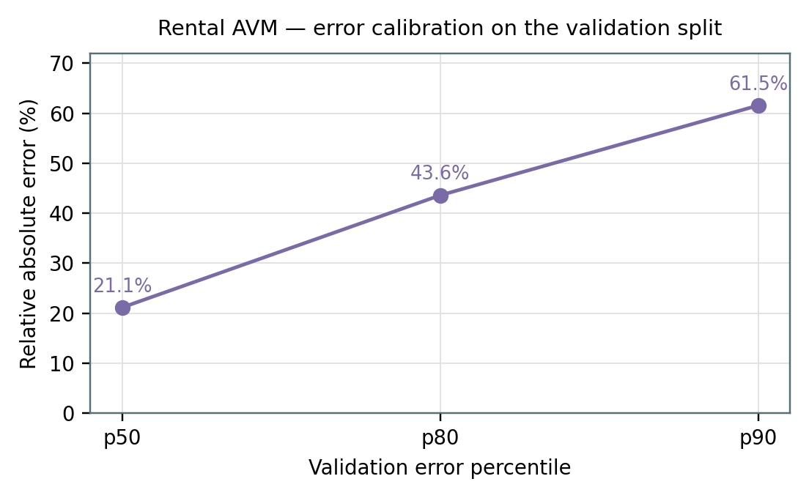
Figure 30:Rental valuation model — relative error calibration on the validation split.

7.7.4 Market-index forecasting (negative result)
Two LSTM(8)→Dense(1) models, each with 329 trainable parameters over a twelve-month window, were trained on the CBSL house and land index series and evaluated by walk-forward backtest against two non-learned benchmarks: naive, which predicts the last observed value, and drift, which extrapolates the recent linear trend.
The LSTM lost at every horizon on both series, by relative margins ranging from 27 % to 125 %. On the house index at one month it recorded 1.669 % MAPE against naive's 0.741 %; on the land index at six months, 11.259 % against 8.733 %. With 66 and 75 monthly observations against 329 parameters this is unsurprising, and the honest conclusion is that the series is too short and too smooth for a learned forecast to add value over persistence.
The consequence is architectural rather than cosmetic. The forward forecast path ships disabled by default, and disabling it flattens the forward sequence — which is exactly the naive forecast, the benchmark that won. The observed-index anchoring described in §6.4.2 is unaffected, because it uses published index values rather than predicted ones. A configuration flag allows the forecast to be re-enabled if a retrained model beats the benchmark in out-of-time testing. This is the concrete return on the evaluation discipline: a less instrumented pipeline would have shipped a forecast that is measurably worse than doing nothing.
Table 18:MARKET-INDEX LSTM AGAINST NON-LEARNED BENCHMARKS (WALK-FORWARD BACKTEST, MAPE %)
Series | Horizon | Folds | LSTM | Naive | Drift | Best
House | 1 month | 24 | 1.669 | 0.741 | 0.757 | Naive
House | 3 months | 22 | 2.323 | 1.775 | 1.790 | Naive
House | 6 months | 19 | 2.852 | 2.241 | 2.562 | Naive
Land | 1 month | 33 | 3.095 | 2.327 | 2.345 | Naive
Land | 3 months | 31 | 6.983 | 5.191 | 5.382 | Naive
Land | 6 months | 28 | 11.259 | 8.733 | 8.997 | Naive

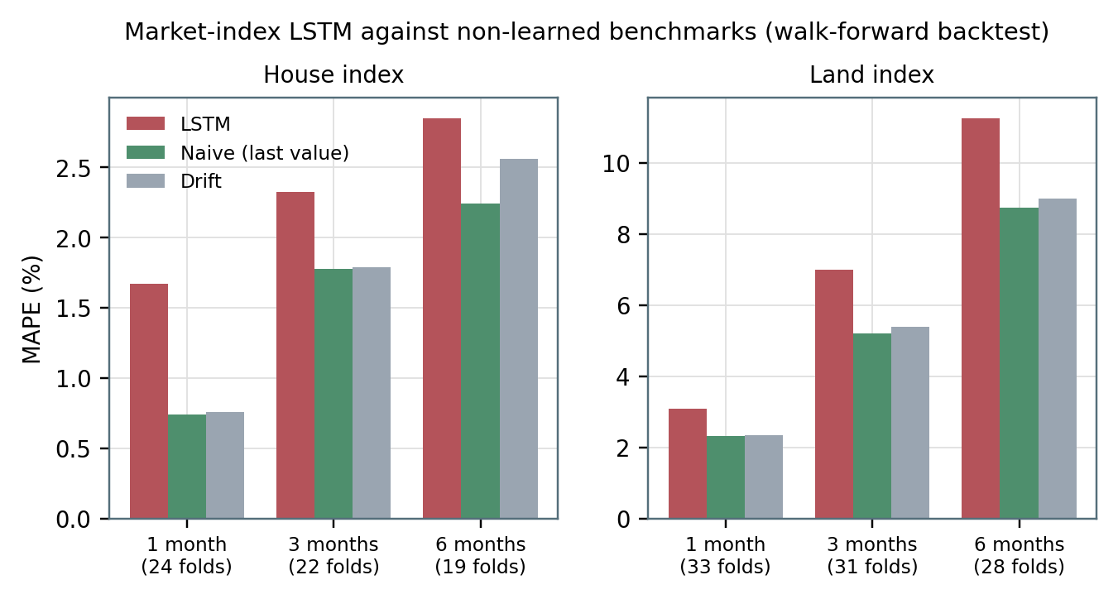
Figure 31:Market-index LSTM against naive and drift benchmarks. The learned model loses at every horizon on both series.

7.7.5 Land valuation model
The land model is reported by coverage rather than by a single error figure, because a held-out split would average across districts the model has never seen. Three tiers are returned with every estimate. High confidence applies where the district is in both the model vocabulary — Colombo, Gampaha and Kalutara — and the LVI calibration table. Medium applies where the district is in the calibration table but reaches the tree as an unseen category, so only the time calibration is district-specific. Low applies where neither holds and the table's catch-all row is used. Prior to this work an uncovered district raised an exception and failed the request; it now returns an indicative estimate that states its own limitation, which is a better outcome for a user in Jaffna than an error page, provided the limitation is visible.

7.7.6 Reinforcement-learning component
The reinforcement-learning component is not evaluated by policy performance, and this report will not claim a return figure for it. Doing so would require the reproducible training pipeline that the parallel research study establishes is not fully available in the current branch, together with walk-forward backtests and the baselines specified there.
What was evaluated is serving correctness, and it produced the single most consequential finding of the diagnostic phase. Measured against the agent's own training scaler, two of the three price features were being supplied at approximately −7.5 and −4.2 standard deviations from the training distribution, pinned to their clipping floors on every call, because they were computed as a ratio of index points to rupees. A Deep Q-Network in that regime does not degrade gracefully; it returns an arbitrary argmax. Recomputing both signals as ratios within a single index series brought them inside the trained range, and signal telemetry now reports every value before and after clipping so that a recurrence is visible immediately.
The residual exposure is portfolio size. Because the training environment rarely held more than one property of a type, the units-owned features have very tight scales: two rentals is already about +3.6 standard deviations and two houses about +2.4. The state-health module reports this per request rather than clipping it, so a user with a larger portfolio receives a recommendation explicitly marked unreliable rather than a confident one the agent is not qualified to give.

7.8 Comparison of the Solution with Existing Methods
Table 19:COMPARISON OF REVA WITH EXISTING APPROACHES
Capability | Commercial AVM platforms | Academic ML valuation studies | Reva
Price prediction | Yes, high accuracy on dense data | Yes, typically single-asset | Yes, three asset classes
Temporal drift handling | Frequent retraining on large corpora | Rarely addressed | Guarded observed-index anchoring, separately versioned
Behaviour on insufficient evidence | Imputation, not surfaced | Imputation or row exclusion | Explicit unavailable / anchor_only status with reasons
Unstructured listing text | Proprietary; not disclosed | Occasionally as embeddings | Forty engineered description features, versioned
Sentiment integration | Not exposed | Studied in isolation | Pipeline feeding the decision layer, deliberately excluded from valuation
Decision recommendation | No | Rare, usually simulated | Deployed DQN with a competence verdict per request
Portfolio tracking | Partial | No | Yes, with versioned snapshots and a transaction ledger
Negative results published | No | Rare | Yes — GNN rejected, index forecast disabled
Regional applicability | Data-rich markets | Region-specific studies | Sri Lanka, with coverage tiers stated per request

The comparison is not one of accuracy. On accuracy alone a mature commercial platform operating in a market with complete transaction records will outperform this system, and no amount of modelling closes a gap that originates in data availability. The comparison Reva can win is on disclosure: it is the only entry in Table 7.7 that reports what it does not know.

7.9 Discussion of Findings
Four findings emerge. First, feature engineering over listing text outperformed architectural sophistication. Forty features mined from prose improved the house model by 5.34 %, while a graph attention network over the same data lost to the tabular baseline in every configuration tried. Where data is scarce, encoding domain knowledge into features beat asking a larger model to discover it.
Second, validation performance and temporal performance diverge sharply, and selecting on the former would have been an error. The LightGBM rental benchmark beat CatBoost on validation and collapsed to 131 % MAPE with negative R² on the 2026 hold-out. Any protocol relying on random splits alone would have shipped the worse model with a better-looking number.
Third, learned components must earn their place against trivial baselines. The market-index LSTM is a competent implementation of a reasonable idea that loses to predicting the last observed value, at every horizon, on both series. Because the acceptance criterion was stated before the result was known, the correct action — disable it by default — was uncontroversial.
Fourth, instrumentation found defects that metrics could not. No aggregate accuracy figure would have revealed that the reinforcement-learning agent was being queried at −7.5 standard deviations, because the recommendation endpoint returned a well-formed, plausible action throughout. It took a dimensional analysis of the signal definitions to expose it. This is the strongest evidence for the hypothesis in §4.2: the instrumentation required for defensibility surfaces failures that accuracy metrics conceal.

7.10 Summary
This chapter evaluated each component against explicit baselines on held-out and temporal splits. The house model improved 5.34 % over its baseline to 19.66 % validation MAPE; the rental model improved 51.85 % over the strongest non-learned baseline, reaching 32.05 % validation and 58.80 % temporal MAPE with the only positive temporal R² among the candidates. Two components failed their acceptance criteria — the graph neural network and the index forecast — and both were reported and disabled rather than shipped. The reinforcement-learning component was evaluated for serving correctness rather than policy performance, and that evaluation found and corrected a serious distributional defect. The next chapter concludes.

CHAPTER 8

CONCLUSIONS AND FURTHER WORK

8.1 Introduction
This chapter states what the project achieved against its objectives, summarises quantitative performance, sets out the limitations honestly, and describes the work that follows.

8.2 Overall Conclusion
Reva delivers a working, deployed decision-support system for the Sri Lankan property market. It serves three supervised valuation models through a typed API, corrects each model's price level for elapsed time using a guarded observed market index, tracks user portfolios with versioned valuation snapshots and a transaction ledger, aggregates financial news into per-asset market sentiment, and issues buy / hold / sell guidance from a Deep Q-Network accompanied by a competence verdict.
The central claim of the project is not that these models are the most accurate obtainable. It is that a system built to declare the basis of every figure it produces is more useful in a thin market than a system that produces a better number it cannot account for — and that building it that way surfaces failures that would otherwise ship. The evidence for the second half of that claim is concrete: the instrumentation demanded by the provenance requirement exposed a reinforcement-learning agent operating several standard deviations outside its training distribution, and the baseline-first evaluation protocol caused two learned components to be disabled rather than deployed.
This dissertation also discharges a second responsibility. A line-by-line audit of the implementation against the interim report identified thirteen material discrepancies, including the backend framework, the claim that sentiment is a mandatory input to price prediction, the claim that user feedback updates the reinforcement-learning policy, the composition of the database schema, and the scope of administrative capability. All are corrected in the preceding chapters and catalogued in Appendix A.

8.3 Objectives-wise Achievements
Table 20:COMPARISON OF REVA WITH EXISTING APPROACHES
Objective | Achievement | Status
1 — Critical literature review | Chapter 2 reviews hedonic and machine-learned valuation, graph methods, financial sentiment analysis and offline reinforcement learning, and derives three research gaps and a problem definition | Achieved
2 — In-depth study of relevant technology | Chapter 3 justifies each adopted technology against the market's constraints; the GNN and LSTM studies in Chapter 7 go beyond survey to empirical comparison | Achieved
3 — Design and development of a solution | A deployed system: 13 FastAPI routers, 16 relational tables, three valuation models, an anchoring layer, a portfolio engine, a sentiment pipeline, a served DQN and an agentic chat layer | Achieved
4 — Evaluation of the solution | Held-out and temporal evaluation against explicit baselines, segment-level and calibration reporting, two published negative results, fourteen automated test modules | Achieved for valuation and forecasting; partial for the RL policy, which is evaluated for serving correctness rather than policy return

8.4 Summary of Quantitative Performance
Table 21:SUMMARY OF QUANTITATIVE PERFORMANCE
Component | Headline result | Comparison
House AVM | 19.66 % validation MAPE; 3,980.37 MAE (LKR/sq ft); 13.10 % median APE | 5.34 % MAE improvement over a ten-feature baseline
Rental AVM | 32.05 % validation MAPE; 58.80 % temporal-test MAPE; R² 0.710 / 0.254 | 51.85 % MAE improvement over the strongest non-learned baseline; only candidate with positive temporal R²
Rental calibration | p50 21.1 %, p80 43.6 %, p90 61.6 % relative error | Basis of the interface's confidence banding
Land AVM | Three-tier coverage verdict returned per request | Replaces a hard failure for out-of-vocabulary districts
House GNN | Best variant 3.07 % worse than baseline | Rejected against a 2 % improvement threshold
Market-index LSTM | House 1.669 / 2.323 / 2.852 % MAPE; land 3.095 / 6.983 / 11.259 % | Loses to naive at all six horizon–series combinations; forward path disabled by default
RL serving | Price-signal deviation corrected from −7.5 σ and −4.2 σ to within the trained range | Distribution-health verdict now attached to every recommendation
System integration | 14 pytest modules covering contracts, units, guards and fallbacks | Each workflow stage has a corresponding test

8.5 Challenges and Limitations
- Asking prices, not transaction prices. All three models are trained on listing asking prices, which are systematically above realised prices. Absolute levels therefore carry an upward bias that this project could not quantify without registry data.
- Geographic concentration. The land model's district vocabulary covers three districts and the CBSL index covers Colombo. Estimates elsewhere are labelled medium, low or anchor_only, which is honest but does not make them accurate.
- Temporal degradation is real and measured. The rental model moves from 32.05 % validation to 58.80 % temporal MAPE. The system does not currently retrain on a schedule, so this gap widens with time since the last training run.
- The reinforcement-learning policy is not reproducible from this branch. Training code exists as documentation (backend/rl/agent.md) rather than as an executable module, and the corresponding files under ml/rl_agent/ are empty. No policy-performance claim can therefore be made.
- The served policy is not personalised. The cash feature is a constant, and the three price signals are market-level and shared across asset blocks where training gave each block its own. Both are known train–serve mismatches that require retraining to remove.
- Sentiment has no labelled ground truth. The pipeline is evaluated for stability, not for accuracy against a human-annotated Sri Lankan property sentiment set, which does not exist.
- No human-subject evaluation. Usability and trust were assessed only through supervisor and client review sessions.
- Non-functional properties are unverified. No load, stress or security testing was performed; claims about scalability and reliability made in the interim report are withdrawn (Appendix A, item A.11).
- Administrative scope is narrow. Dataset management, retraining and export are not implemented, and administrator identity is established by an environment-configured e-mail address rather than a role column.
- LLM-generated prices in one chat path. The [PREDICTION_RESULT] route returns a figure produced by the language model rather than by a trained model; the form-triggering route is the model-backed path.

8.6 Future Work
Future work divides into four programmes, ordered by the ratio of user benefit to effort.
Programme 1 — Reproducibility and retraining. Convert backend/rl/agent.md into an executable, seeded, versioned training module with dataset manifests and logged hyperparameters. Establish scheduled retraining for the three valuation models with automatic promotion gated on temporal-test improvement, using the existing model registry as the deployment mechanism. Add drift monitoring that compares live feature distributions against training distributions, extending the state-health idea from the reinforcement-learning path to the valuation path.
Programme 2 — A research-grade reinforcement-learning agent. Follow the roadmap set out in the parallel research study. Correct the reward function, which double counts rental income by adding it both to cash before portfolio valuation and again as a separate reward term. Remove look-ahead leakage from the sentiment and forecast features. Add a target network and Double DQN updates for stability. Replace the constant cash slot with real user liquidity, debt, risk tolerance and horizon drawn from investment_preferences. Redesign the reward around risk-adjusted utility with drawdown, CVaR, liquidity, concentration and affordability penalties. Mask infeasible actions before the argmax. Then move to conservative offline learning — CQL or IQL — with walk-forward validation, stress scenarios and ablations against the baselines the study specifies.
Programme 3 — Data and coverage. Extend the land model's district vocabulary beyond three districts. Seek registry or brokerage transaction data to quantify and correct the asking-price bias. Extend index coverage beyond Colombo, or construct district-level indices from listing medians with appropriate uncertainty. Build a labelled Sri Lankan property sentiment corpus so the pipeline can be evaluated rather than only monitored. Revisit the forecast question with a longer series, retaining the requirement that any candidate must beat naive out of time before it is enabled.
Programme 4 — Product and assurance. Implement the administrative capabilities described but not built: dataset management, retraining triggers and user-data export, with a proper role column replacing the e-mail comparison. Add explanation generation to the recommendation path, so a buy or hold suggestion is accompanied by the forecast, sentiment, risk and portfolio drivers behind it. Conduct a structured usability and trust study with prospective buyers and property professionals. Perform load, stress and security testing so the non-functional claims withdrawn in this report can be restated with evidence.

8.7 Summary
This chapter concluded that Reva achieves its four objectives, delivering a deployed evidence-governed property decision-support system whose distinguishing property is that it reports the basis and the limits of every figure it produces. It summarised quantitative performance, stated ten limitations without qualification, and set out four programmes of future work. The interim report's thirteen material discrepancies are corrected in the preceding chapters and recorded in Appendix A.

REFERENCES
[1] S. Rosen, “Hedonic prices and implicit markets: Product differentiation in pure competition,” Journal of Political Economy, vol. 82, no. 1, pp. 34–55, 1974.
[2] L. Anselin, Spatial Econometrics: Methods and Models. Dordrecht, Netherlands: Kluwer Academic Publishers, 1988.
[3] T. Chen and C. Guestrin, “XGBoost: A scalable tree boosting system,” in Proc. 22nd ACM SIGKDD Int. Conf. Knowledge Discovery and Data Mining, San Francisco, CA, USA, 2016, pp. 785–794.
[4] G. Ke, Q. Meng, T. Finley, T. Wang, W. Chen, W. Ma, Q. Ye, and T.-Y. Liu, “LightGBM: A highly efficient gradient boosting decision tree,” in Advances in Neural Information Processing Systems 30, Long Beach, CA, USA, 2017, pp. 3146–3154.
[5] L. Prokhorenkova, G. Gusev, A. Vorobev, A. V. Dorogush, and A. Gulin, “CatBoost: Unbiased boosting with categorical features,” in Advances in Neural Information Processing Systems 31, Montréal, Canada, 2018, pp. 6638–6648.
[6] S. Brody, U. Alon, and E. Yahav, “How attentive are graph attention networks?,” in Proc. Int. Conf. Learning Representations (ICLR), 2022.
[7] D. Araci, “FinBERT: Financial sentiment analysis with pre-trained language models,” arXiv preprint arXiv:1908.10063, 2019.
[8] A. Kumar, A. Zhou, G. Tucker, and S. Levine, “Conservative Q-learning for offline reinforcement learning,” in Advances in Neural Information Processing Systems 33, 2020, pp. 1179–1191.
[9] I. Kostrikov, A. Nair, and S. Levine, “Offline reinforcement learning with implicit Q-learning,” in Proc. Int. Conf. Learning Representations (ICLR), 2022.
[10] V. Mnih, K. Kavukcuoglu, D. Silver, A. A. Rusu, J. Veness, M. G. Bellemare, A. Graves, M. Riedmiller, A. K. Fidjeland, G. Ostrovski, S. Petersen, C. Beattie, A. Sadik, I. Antonoglou, H. King, D. Kumaran, D. Wierstra, S. Legg, and D. Hassabis, “Human-level control through deep reinforcement learning,” Nature, vol. 518, no. 7540, pp. 529–533, 2015.
[11] H. van Hasselt, A. Guez, and D. Silver, “Deep reinforcement learning with double Q-learning,” in Proc. 30th AAAI Conf. Artificial Intelligence, Phoenix, AZ, USA, 2016, pp. 2094–2100.
[12] T. Schaul, J. Quan, I. Antonoglou, and D. Silver, “Prioritized experience replay,” in Proc. Int. Conf. Learning Representations (ICLR), 2016.
[13] M. G. Bellemare, W. Dabney, and R. Munos, “A distributional perspective on reinforcement learning,” in Proc. 34th Int. Conf. Machine Learning, Sydney, Australia, 2017, pp. 449–458.
[14] R. S. Sutton and A. G. Barto, Reinforcement Learning: An Introduction, 2nd ed. Cambridge, MA, USA: MIT Press, 2018.
[15] H. Markowitz, “Portfolio selection,” The Journal of Finance, vol. 7, no. 1, pp. 77–91, 1952.
[16] J. Devlin, M.-W. Chang, K. Lee, and K. Toutanova, “BERT: Pre-training of deep bidirectional transformers for language understanding,” in Proc. NAACL-HLT, Minneapolis, MN, USA, 2019, pp. 4171–4186.
[17] N. Reimers and I. Gurevych, “Sentence-BERT: Sentence embeddings using Siamese BERT-networks,” in Proc. EMNLP-IJCNLP, Hong Kong, 2019, pp. 3982–3992.
[18] S. Hochreiter and J. Schmidhuber, “Long short-term memory,” Neural Computation, vol. 9, no. 8, pp. 1735–1780, 1997.
[19] B. Liu, Sentiment Analysis and Opinion Mining. San Rafael, CA, USA: Morgan & Claypool Publishers, 2012.
[20] N. Kok, E.-L. Koponen, and C. A. Martínez-Barbosa, “Big data in real estate? From manual appraisal to automated valuation,” The Journal of Portfolio Management, vol. 43, no. 6, pp. 202–211, 2017.
[21] I. Sommerville, Software Engineering, 10th ed. Harlow, U.K.: Pearson Education, 2015.
[22] L. Bass, P. Clements, and R. Kazman, Software Architecture in Practice, 3rd ed. Boston, MA, USA: Addison-Wesley, 2012.
[23] A. Géron, Hands-On Machine Learning with Scikit-Learn, Keras and TensorFlow, 2nd ed. Sebastopol, CA, USA: O’Reilly Media, 2019.
[24] Object Management Group, Unified Modeling Language (UML) Specification, Version 2.5.1, 2017.
[25] Central Bank of Sri Lanka, Real Estate Market Analysis: Land Valuation Indicator and Condominium Market Indicators, Colombo, Sri Lanka: CBSL, quarterly publication, 2019–2025.

APPENDICES

Appendix A — Register of Corrections Applied to the Interim Report
Each entry states what the interim report claimed, what the implementation does, the evidence, and where this dissertation corrects it. Items A.1 to A.13 are material; A.14 to A.16 are editorial.
Table 22:REGISTER OF CORRECTIONS APPLIED TO THE INTERIM REPORT
# | Interim report claim | Implementation | Evidence | Corrected in
A.1 | Backend implemented using Flask (§3.3, §5.3.1, all sequence diagrams, appendix contributions) | Backend is FastAPI served by Uvicorn; no Flask import exists in the repository | backend/app.py instantiates FastAPI(); requirements-backend.txt pins fastapi and uvicorn; the run command is uvicorn backend.app:app | §3.1, §5.4.4
A.2 | Sentiment analysis is a mandatory step in the price prediction pipeline (FR3, §4.3.2.1, §5.2.3, Figs. 4.2, 4.10, 4.13) | The prediction service contains no reference to sentiment. Sentiment feeds the RL state vector, a standalone market endpoint and a portfolio display label | backend/dynamic/services.py contains no sentiment import or call; the only consumers are backend/rl, backend/sentiment and backend/portfolio | §4.4, Fig. 4.1
A.3 | User feedback is used as a learning signal that updates the RL policy (Abstract, §3.5, FR8, §5.2.4, class diagram, Fig. 4.15) | The RL module performs inference only. No optimiser, replay buffer, reward computation or weight write exists in the backend | backend/rl/agent_services.py loads weights and calls predict(); no fit, train_on_batch, optimiser or save_weights exists anywhere under backend/ | §5.4.3, §6.4.5
A.4 | ER diagram with Location, ListingSnapshot, Prediction, Sentiment, Model and RL entities (Fig. 4.19) | Sixteen tables; no Location, ListingSnapshot, Sentiment or RL table. Location is columns on properties; sentiment lives in MongoDB and Redis; Model is model_registry | SQLAlchemy models in backend/database/schemas.py, backend/dynamic/schemas.py and backend/admin/db_models.py | §5.4.5, Fig. 5.21
A.5 | Admin can upload and manage datasets, retrain models, deploy updated models and export user property data (FR9, §5.2.5, Figs. 4.8, 4.16–4.18) | Admin provides dashboard statistics, feature-definition CRUD, user management and a model registry. No dataset upload, retraining or export route exists; training is offline | Route list in backend/admin/routes.py; training scripts under ml/ and scripts/ | §5.4.6
A.6 | Frontend uses React with HTML, CSS and JavaScript (§3.2) | React 19 with TypeScript, built by Vite 7, routed by React Router 7, mapping by Leaflet, Google OAuth via @react-oauth/google. No JavaScript source files | frontend/package.json dependency list; every source file is .tsx or .ts | §3.3, Table 6.1
A.7 | A single relational DBMS stores predictions and user feedback (§3.4) | Four stores: PostgreSQL, Redis, MongoDB and ChromaDB, plus CSV artefacts. Predictions are persisted only for authenticated users; feedback as described is not stored | backend/database/database.py, backend/core/cache_service.py and Sentiment/Analysis/storage | §5.2, §5.4.5
A.8 | Guest users can view market sentiment, explore the map and provide feedback (§4.2.1) | The sentiment router requires authentication, as does the recommendation router. Guests may obtain predictions and post a site review with name and e-mail | Router dependencies in backend/sentiment/routes.py and backend/rl/routes.py; get_optional_current_user on the prediction and review routes | §4.6
A.9 | A single chatbot that retrieves the user's saved portfolio and calls an external LLM (Figs. 4.6, 4.14) | Two independent paths. /ask runs a Gemini chat session under a keyword protocol; /agent/ask runs a LangGraph state machine over OpenRouter. Neither retrieves a portfolio summary. Prices returned through the [PREDICTION_RESULT] keyword are LLM-generated, not model-generated | System prompt and handler in backend/app.py; backend/agent/graph.py and open_router.py | §6.4.6
A.10 | Chapters 1 and 2 describe a generic industrial price-prediction system with no mention of real estate, sentiment, reinforcement learning or Sri Lanka, contradicting the abstract and Chapter 3 of the same document | The system is a Sri Lankan property decision-support platform with three asset classes, a sentiment pipeline and an RL advisory layer | Whole-of-system audit | Chapters 1 and 2, rewritten
A.11 | Non-functional requirements assert scalability without architectural change, security and reliability (§4.2.3) | No load, stress or security testing was performed. The delivered suite covers correctness only | The tests directory contains fourteen correctness modules and no performance or security tests | §8.5, withdrawn
A.12 | Minimum 8 GB RAM; software listed generically as “a web framework”, “a server-side framework” and “relational or document-based database” (§5.3.1, §5.3.2) | TensorFlow, PyTorch, transformers, sentence-transformers, ChromaDB, CatBoost and a 39 MB LightGBM bundle require 16 GB for comfortable development; the backend lazy-loads Keras to reduce startup memory | requirements-backend.txt; the lazy-import comment in backend/rl/agent_services.py | §6.3, Table 6.1
A.13 | Omits the market-index anchoring layer, portfolio valuation v2, land LVI calibration, description feature extraction, the GNN experiment, RL state-health, caching and scheduling, the test suite and deployment | All are implemented and material to the system's behaviour | backend/predictions/market_index.py, backend/portfolio, ml/land_service/time_calibration.py, ml/house_service/description_features.py, ml/house_service/gnn, backend/rl/state_health.py, backend/core and tests | Chapters 5–7
A.14 | Chapter 5 section numbering runs 5.2.1–5.2.5, 5.3.1–5.3.2, then jumps to 5.8 Summary; Chapter 4 sub-numbering is inconsistent in the table of contents | Editorial defect | Interim report table of contents and body | Numbering follows the prescribed template throughout
A.15 | Use case diagram contains three duplicate “Incorporate Sentiment Score” ovals and a truncated actor label “Authenticate Use” | Editorial defect | Fig. 5.2 as reproduced | Noted at Fig. 5.2
A.16 | The interim report and the parallel RL research report disagree on the backend framework, Flask against FastAPI | FastAPI is correct | As A.1 | §3.1

Appendix B — REST API Endpoint Reference
Table 23:REST API ENDPOINTS EXPOSED BY THE FASTAPI SERVICE
Router | Endpoint | Method | Auth | Purpose
auth | /auth/signup, /auth/login | POST | None | Registration and token issuance
auth | /auth/google | POST | None | Google OAuth token exchange
users | /users/profile | GET, POST, PUT | Required | User profile management
users | /users/preferences | PUT | Required | Risk level, preferred type, investment horizon
properties | /properties/housing|rental|land | POST, PUT | Required | Create and update properties
properties | /properties/{id}/transactions | GET, POST | Required | Property transaction ledger
portfolio | /api/portfolio/summary | GET | Required | Portfolio value, gain, return, mix, sentiment label
portfolio | /api/portfolio/properties | GET | Required | Per-property valuation with provenance
portfolio | /api/portfolio/snapshots | GET | Required | Quarterly valuation snapshots
features | /api/features/{model_type} | GET | None | Active feature definitions for a model
predictions | /api/predictions/{model_type} | POST | Optional | Anchored price prediction
predictions | /api/predictions/history | GET | Required | Prediction records for the user
predictions | /api/predictions/recommendation/{model_type} | GET | Optional | Per-asset action label
sentiment | /api/sentiment/market | GET | Required | Per-asset horizon scores and overall verdict
recommendation | /recommendation/recommendation | GET | Required | RL action, state vector, health, reliability
recommendation | /recommendation/state_vector | GET | Required | Assembled 25-element state vector
recommendation | /recommendation/get_property_signales | GET | Required | Price signals with provenance
recommendation | /recommendation/get_sentiment_features | GET | Required | Per-asset RL sentiment features
agent | /agent/ask | POST | Required | LangGraph agentic assistant
(root) | /ask | POST | Optional | Gemini chat with keyword protocol
(root) | /chat/sessions, /chat/sessions/{id} | GET, DELETE | Required | Conversation history
(root) | /reviews | GET, POST | Optional | Site reviews
lstm | /lstm/... | GET | Required | Cached index forecasts and sequences
cache | /cache/... | GET, POST | Required | Cache inspection and refresh
admin | /api/admin/stats | GET | Admin | Dashboard statistics
admin | /api/admin/features, /features/{id} | GET, POST, PUT, DELETE | Admin | Feature definition CRUD
admin | /api/admin/users, /users/{id} | GET, DELETE | Admin | User management
admin | /api/admin/models (+ /{id}, /{id}/activate) | GET, POST, PUT, DELETE | Admin | Model registry and activation

Appendix C — Implemented Relational Schema
Sixteen tables are defined by SQLAlchemy models across three modules. The full field listing appears in Fig. 5.21; this appendix records the definition source and the cascade behaviour.
Table 24:RELATIONAL TABLES, DEFINITION SOURCE AND DELETE BEHAVIOUR
Table | Defined in | Delete behaviour
users | backend/database/schemas.py | Root of the ownership graph
user_profiles | backend/database/schemas.py | Cascade from users
investment_preferences | backend/database/schemas.py | Cascade from users
properties | backend/database/schemas.py | Cascade from users
housing_properties | backend/database/schemas.py | Cascade from properties
rental_properties | backend/database/schemas.py | Cascade from properties
land_properties | backend/database/schemas.py | Cascade from properties
rental_lease_periods | backend/database/schemas.py | Cascade from properties; unique on (property, start date, rent)
property_valuation_snapshots | backend/database/schemas.py | Cascade from properties; unique on (property, as-of date, model version, index version)
property_transactions | backend/database/schemas.py | Cascade from properties
chat_sessions | backend/database/schemas.py | Cascade from users
chat_messages | backend/database/schemas.py | Cascade from chat_sessions
reviews | backend/database/schemas.py | Independent; no foreign key
feature_definitions | backend/dynamic/schemas.py | Independent
prediction_records | backend/dynamic/schemas.py | Cascade from users
model_registry | backend/admin/db_models.py | Independent; one active row per model type

Appendix D — Reinforcement-Learning State Vector Specification
The state vector has twenty-five elements: three asset blocks of eight features, in the order land, rental, housing, followed by a single cash slot. The feature layout within each block is identical.
Table 25:STATE VECTOR LAYOUT AND PER-FEATURE NOTES
Slot | Feature | Source | Range / note
0, 8, 16 | units_owned | Property counts by type for the requesting user | Training scales are tight: land mean 1.518, sd 2.062; rental mean 0.325, sd 0.469; housing mean 0.482, sd 0.628
1, 9, 17 | sentiment_current | Mean of the most recent seven daily scores | Clipped to [−1, 1]
2, 10, 18 | sentiment_trend | Slope of a linear fit over the 30-day series | Clipped to [−0.05, 0.05]
3, 11, 19 | sentiment_volatility | Standard deviation of the 30-day series | Clipped to [0, 0.5]
4, 12, 20 | sentiment_shock | Binary: recent mean deviates from monthly mean by more than 2 sd | {0, 1}
5, 13, 21 | land_trend | Realised month-over-month change in the land index | Clipped to [−0.10, 0.15]. Market-level and identical across blocks
6, 14, 22 | rental_yield | Monthly rent over house price, both from the same scraper source | Clipped to [0.002, 0.012]. Market-level and identical across blocks
7, 15, 23 | housing_signal | Forward three-month change in the house index where the forecast passes its guards, otherwise realised three-month momentum | Clipped to [−0.15, 0.20]. Market-level and identical across blocks; source reported per request
24 | cash_normalised | Constant 1.0 | Training used cash in hand over initial investment, ranging 0 to about 3. The constant is inside that range but carries no user information

The action space is the Cartesian product {SELL, HOLD, BUY}³, giving twenty-seven joint actions indexed in the order land, rental, housing. The Q-network is a multilayer perceptron with two hidden layers of sixty-four units, each followed by batch normalisation, and a linear output layer of twenty-seven units. Distribution health is assessed per feature against the training scaler's mean and scale; any absolute z-score above three sets reliable to false and the offending features are returned in descending order of deviation.

Appendix E — Individual Contributions
Table 26:INDIVIDUAL CONTRIBUTIONS
Member | Contribution
235504U  Ahamed MFY | AI / Machine Learning — rental price model development, training and evaluation; conversational assistant design; rental feature schema and preprocessing pipeline.  Frontend — Ask Reva chat interface and interaction components; integration of chat with dashboard pages.  Backend — chat endpoint and session persistence; Gemini and OpenRouter integration; agentic LangGraph nodes.  Data Engineering — rental dataset cleaning, unit normalisation and feature derivation; rental training-pipeline tests.
235517L  Illankoon IMHL | AI / Machine Learning — house price model development, description feature extraction and tuning; GATv2 residual imputation experiment and its evaluation.  Frontend — property input forms and prediction result visualisation; dashboard prediction components.  Backend — prediction request handling and orchestration; model resolution and contract validation.  Data Engineering — house dataset collection, cleaning and feature engineering; description feature tests.
235534K  Samarasinghe SKAK | AI / Machine Learning — sentiment analysis pipeline: collection, FinBERT scoring, MiniLM embedding, semantic relevance filtering and weighted time-decayed aggregation.  Frontend — sentiment visualisation components; market insight elements on the dashboard.  Backend — sentiment routes, caching and scheduled refresh; sentiment feature aggregation for the RL state.  Data Engineering — news and web collection, text cleaning, reference vector construction and knowledge-base initialisation.
235545U  Wijerathna WDIS | AI / Machine Learning — land price model and LVI time calibration; market-index LSTM models and walk-forward backtesting; RL serving, price-signal correction and state-health module.  Frontend — UI/UX design of the Reva system; dashboard layout and navigation structure; map explorer.  Backend — portfolio valuation engine and snapshots; market-index anchoring and guards; admin functionality and model registry; database integration and API coordination.  Data Engineering — gazetteer construction and geocoding; CBSL index preparation; dataset preparation and feature selection.

