1. Add Proposal –

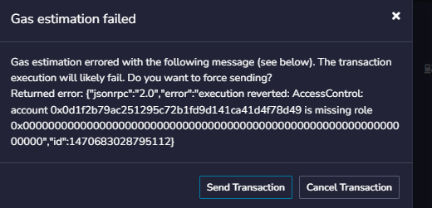

Status - Transaction failed as User does not have Admin role –

Txn hash - <https://sepolia.etherscan.io/tx/0xe61bd7f9a7cd00a7d3cd9ae4e091f7ecec684e1c05702c848aee96b4072f8368>

1. Vote for proposal

Status – Success

Txn hash- <https://sepolia.etherscan.io/tx/0x0cb297dfa98e1394e0bda32d1a1d23e92fcf5aa950e9cef069cb579ce4e7ed30>

1. Vote for Invalid Porposal

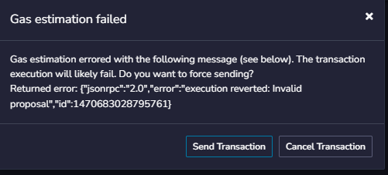

Status - Fail with error 'Invalid proposal'

<https://sepolia.etherscan.io/tx/0x87ac5421785e9d689af038e37a97933419b912a96a9716f6244150130fbb6d0b>

1. Revote to another valid proposal

Status – Success

Txn Hash - <https://sepolia.etherscan.io/tx/0x78a33665bd390d9bf2a8b4d41c7eb5ba7f37406fd9d05bd7708f328bf475f0c2>

1. Revoke Role

Status – Failed

Transaction failed as invoker does not have Admin role

Txn hash –

<https://sepolia.etherscan.io/tx/0x221748e8b726e3ba9e1370795cdf2d6f3aace1b28fe3b497e7e7c937798bff66>

1. Renounce role

Status - Success

Txn hash - <https://sepolia.etherscan.io/tx/0x069fbf4579fc7496c9521ba72df754bbbd139aa99bf223a8e84ad78abc9394bd>

1. Vote after Renouncing Role

Status - Fail with error 'AccessControl: account 0x0d1f2b79ac251295c72b1fd9d141ca41d4f78d49 is missing role

Txn Hash –

https://sepolia.etherscan.io/tx/0xe9527cd39e2417e30a5fa5bb888cabe1360340a30661a5215911ec0035b7ae68