Project Design Phase-II
Data Flow Diagram & User Stories

Date | 24 October 2026
Team ID | pappu sudarshini (individual participant)
Project Name | Medical Diagnostic Centre
Maximum Marks | 4 Marks

Data Flow Diagrams:
A Data Flow Diagram (DFD) is a traditional visual representation of the information flows within a system. A neat and clear DFD can depict the right amount of the system requirement graphically. It shows how data enters and leaves the system, what changes the information, and where data is stored.
Example: DFD Level 0 (Industry Standard)
Example: (Simplified)
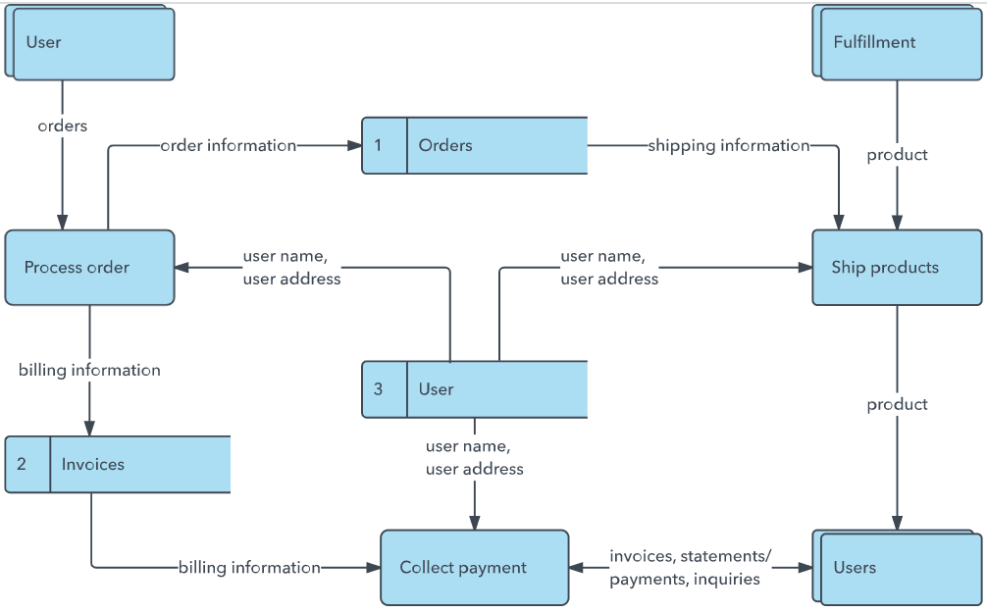

Data Flow Diagram: Medical Diagnostic Centre
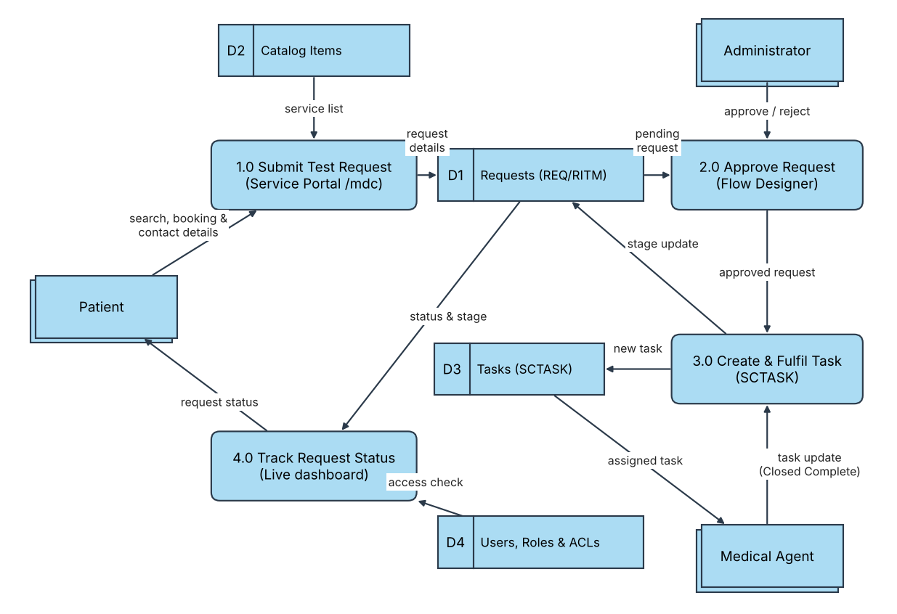
Flow
1. Patient opens the /mdc portal, searches the service catalog (D2) and submits a request with medical and contact details.
2. The request is stored as a Request / Requested Item (REQ / RITM) in D1 with the state Waiting for Approval.
3. The Administrator approves or rejects the request through the Flow Designer approval step.
4. On approval, the flow creates a catalog task (SCTASK) in D3 and assigns it to a medical agent.
5. The medical agent works the task and marks it Closed Complete (or moves its stage).
6. The stage update is written back to D1, so the patient's live dashboard moves through Assess or Scope Task, Provide Service and Closed Complete.
7. ACLs and roles (D4) are checked on every read, so patients see only their own requests.

User Stories
Use the below template to list all the user stories for the product.
User Type | Functional Requirement (Epic) | User Story Number | User Story / Task | Acceptance criteria | Priority | Release
Patient (Web user) | Access Portal | USN-1 | As a patient, I can open the Medical Diagnostic Centre portal (/mdc) and see the diagnostic services offered. | Portal home page loads with the search bar and service catalog | High | Sprint-1
 | Search & Book | USN-2 | As a patient, I can search for a diagnostic service and select a catalog item such as "Book a Blood Test". | Search returns matching catalog items; I can open an item's form | High | Sprint-1
 |  | USN-3 | As a patient, I can fill in the required medical and contact details and submit my request. | Required fields are validated; a request number (REQ) is shown after submit | High | Sprint-1
 | Track Request | USN-4 | As a patient, I can see the live status of my request on the tracking dashboard. | Stage bar shows Waiting for Approval, Assess or Scope Task, Provide Service or Closed Complete | High | Sprint-2
 | Data Privacy | USN-5 | As a patient, I can see only my own requests. | Another patient's requests are not visible to me (ACL enforced) | High | Sprint-2
Medical Agent | Fulfil Tasks | USN-6 | As a medical agent, I can view the catalog tasks (SCTASK) assigned to me. | Assigned tasks appear in my task list in ServiceNow | High | Sprint-2
 |  | USN-7 | As a medical agent, I can update a task and mark it Closed Complete. | Task state is saved and the patient's stage bar updates instantly | High | Sprint-2
Administrator | Approvals & Automation | USN-8 | As an administrator, I can approve or reject submitted requests. | Approved requests automatically generate a task for a medical agent | High | Sprint-2
 | Access & Catalog Management | USN-9 | As an administrator, I can manage catalog items, roles and ACLs. | Admin has full management access; patients remain restricted | Medium | Sprint-3
 | Deployment | USN-10 | As an administrator, I can export the application as an XML Update Set and store it on GitHub. | The Update Set imports successfully into another instance | Medium | Sprint-3

