Project Development Phase
Model Performance Test

Date | 10 February 2025
Team ID | Pappu Sudarshini (Individual Participant)
Project Name | Medical Diagnostic Centre
Maximum Marks

Model Performance Testing:
Project team shall fill the following information in model performance testing template.
S.No. | Parameter | Values | Screenshot
1. | Application Summary | Custom ServiceNow self-service app for healthcare (instance dev290217, portal /mdc). Patients search diagnostic services and submit requests; Flow Designer routes approvals and creates SCTASKs for medical agents; ACLs restrict patient data; packaged as an Update Set on GitHub. | 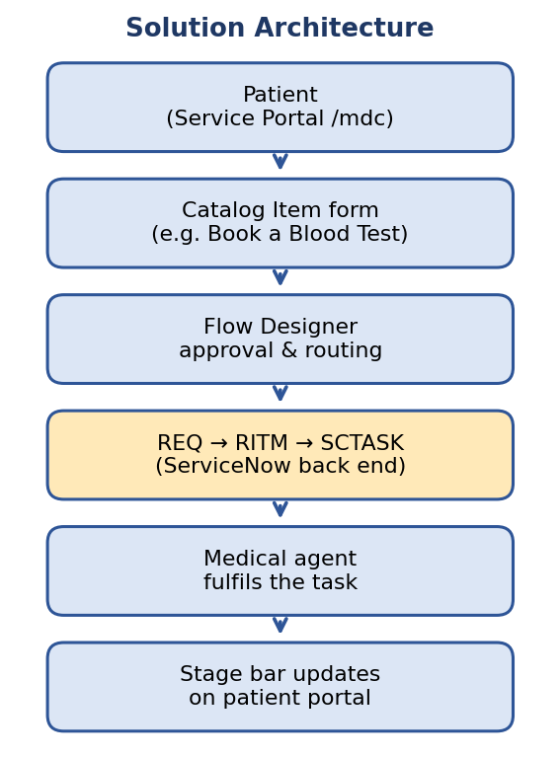
2. | Request Lifecycle Testing | Flow under test: catalog item submission → REQ → RITM → SCTASK. Stages checked: Waiting for Approval, Assess or Scope Task, Provide Service, Closed Complete. Closing the SCTASK should update the portal stage bar in real time.  Result: record Pass / Fail for each stage. | 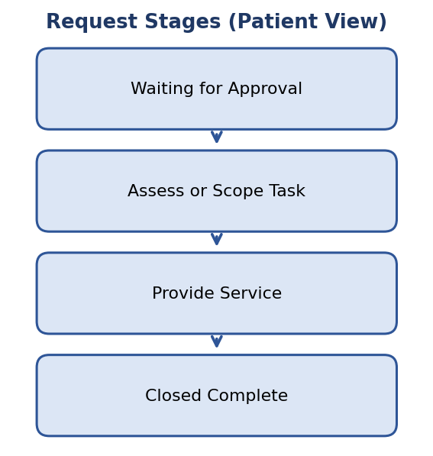
3. | Access Control (ACL) Testing | A patient user must see only their own requests; an admin must see all requests.  Result: record Pass / Fail for each role. | 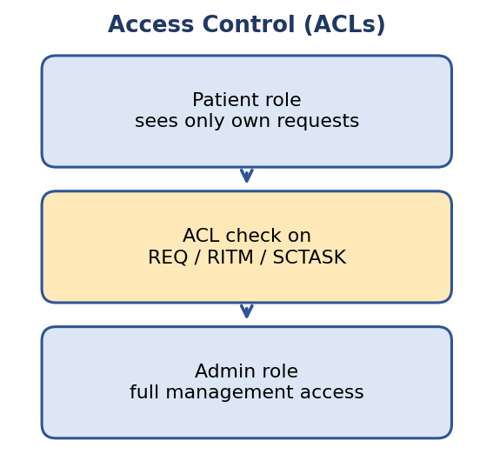
4. | Performance Tuning (if done) | Not done yet. Add before/after results here (for example portal load time) if tuning is carried out.

