Medical Diagnostic Centre
Project Documentation: ServiceNow Self-Service Healthcare Portal

1. Introduction
Project Title: Medical Diagnostic Centre
Team Members:
Name | Role
Pappu Sudarshini | Individual participant: developer, tester and documentation

2. Project Overview
Purpose: A self-service web application on the ServiceNow platform that lets patients book diagnostic tests online, while hospital or clinic staff process, fulfil and track each request through an automated workflow.
Features:
- Custom patient portal at /mdc on instance dev290217.
- Service catalog of diagnostic tests (for example "Book a Blood Test") with medical and contact variables.
- Automated approval and fulfilment: Flow Designer routes each request and creates catalog tasks (SCTASK) for medical agents.
- Live Request Tracking Dashboard showing Waiting for Approval → Assess or Scope Task → Provide Service → Closed Complete.
- Real-time stage sync between the back-end tables and the patient portal.
- Role and ACL based security: patients see only their own requests; administrators have full access.
- Packaged as an XML Update Set and stored on GitHub for version control and deployment to other instances.

3. Architecture
This project runs on ServiceNow, so the three MERN layers map to the platform as shown below.
MERN layer | This project
React frontend | ServiceNow Service Portal (portal /mdc, pages and widgets)
Node.js / Express backend | ServiceNow platform: Service Catalog, Flow Designer and server-side logic
MongoDB | ServiceNow tables (database) accessed through the platform

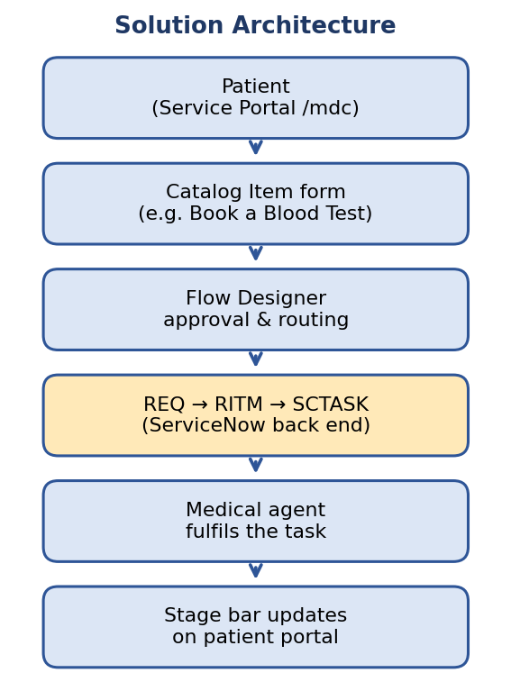
Figure 1: Solution architecture

Frontend
The patient view is a Service Portal at /mdc. Patients search diagnostic services, pick a catalog item, fill in the request form and track progress on the Live Request Tracking Dashboard, which shows the stage bar for each request.

Backend
Catalog items define the forms. Flow Designer applies the approval chain and generates SCTASKs for medical agents. Agents and administrators work in ServiceNow Classic (the standard back-end interface).

Database
Data is stored in standard ServiceNow tables, linked in the hierarchy Request (REQ) → Requested Item (RITM) → Catalog Task (SCTASK).
Table | Purpose
sc_cat_item | Catalog items: the diagnostic services offered
sc_request | Request (REQ): one per submitted order
sc_req_item | Requested Item (RITM): the booked service within a request
sc_task | Catalog Task (SCTASK): work assigned to medical agents

4. Setup Instructions

Prerequisites
- A ServiceNow instance (this project uses developer instance dev290217) and an account with admin rights.
- Access to the GitHub repository holding the exported Update Set.
- A web browser. Node.js and MongoDB are not needed for this project.

Installation
- Clone or download the repository from GitHub to get the Update Set XML file.
- Log in to the target ServiceNow instance as an administrator.
- Go to System Update Sets > Retrieved Update Sets and choose Import Update Set from XML.
- Upload the XML file, then open the loaded Update Set and click Preview Update Set.
- Resolve any preview problems, then click Commit Update Set.
- Create or assign the Patient, Agent and Admin users and roles used by the application.
- Open the portal at /mdc to confirm the catalog items appear.
There are no environment variables to configure for this application.

5. Folder Structure
ServiceNow stores application files as records instead of folders, so the structure below groups them by role.

Client (patient portal)
Service Portal /mdc
|- Theme and layout
|- Pages
| |- Home / service search
| |- Request form (catalog item)
| \- Request tracking dashboard
\- Widgets
|- Catalog search
\- Request stage tracker

Server (application and back end)
Application (Update Set / GitHub XML)
|- Catalog items and variables (sc_cat_item)
|- Flow Designer flows (approval, SCTASK creation)
|- Stage and state mapping
|- Roles and groups (Patient, Agent, Admin)
\- ACLs (own-requests rule, admin access)

6. Running the Application
There is no npm start. The application runs on the ServiceNow instance once the Update Set is committed.
- Frontend: Open the /mdc portal on the instance (for example https://dev290217.service-now.com/mdc).
- Backend: Log in to ServiceNow Classic and open Requests, Requested Items and Catalog Tasks to process work.
Note: free developer instances go to sleep after inactivity, so wake the instance from the developer site first if the page does not load.

7. API Documentation
The app uses the standard ServiceNow REST APIs rather than custom endpoints. Replace <instance> with dev290217.service-now.com. Responses are shortened examples.
Method and endpoint | Purpose | Example response (shortened)
GET /api/now/table/sc_request?sysparm_limit=10 | List requests (REQ) | {"result":[{"number":"REQ0010001","stage":"request_approved"}]}
GET /api/now/table/sc_req_item?sysparm_query=request=<sys_id> | List items (RITM) in a request | {"result":[{"number":"RITM0010001","stage":"waiting_for_approval"}]}
GET /api/now/table/sc_task?sysparm_query=active=true | List open catalog tasks (SCTASK) | {"result":[{"number":"SCTASK0010001","state":"1"}]}
POST /api/sn_sc/servicecatalog/items/<sys_id>/order_now | Order a catalog item with variables | {"result":{"number":"REQ0010002","request_id":"<sys_id>"}}
PATCH /api/now/table/sc_task/<sys_id> | Update a task (for example close it) | {"result":{"number":"SCTASK0010001","state":"3"}}

Parameters: sysparm_limit (number of records), sysparm_query (filter) and sysparm_fields (columns to return). Exact stage and state values depend on the instance configuration.

8. Authentication
- Users sign in with ServiceNow accounts; the platform manages sessions, so the app has no separate token code.
- Authorization uses roles and groups (Patient, Agent, Admin).
- ACLs enforce data access: a patient can read only their own requests, while administrative staff have full management access.
- For REST calls, use basic authentication or OAuth tokens issued by the instance.
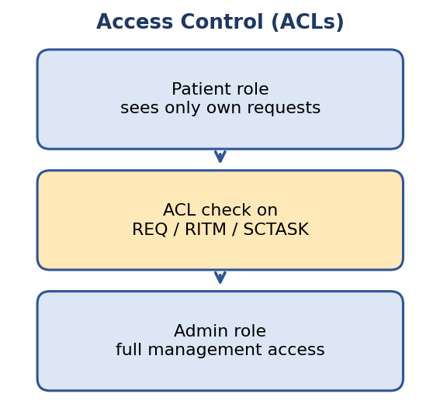
Figure 2: Role and ACL access

9. User Interface
Key interface features:
- Portal home with service search.
- Catalog item form with medical and contact fields.
- Live Request Tracking Dashboard with stage bar.
- ServiceNow Classic lists for agents and administrators.
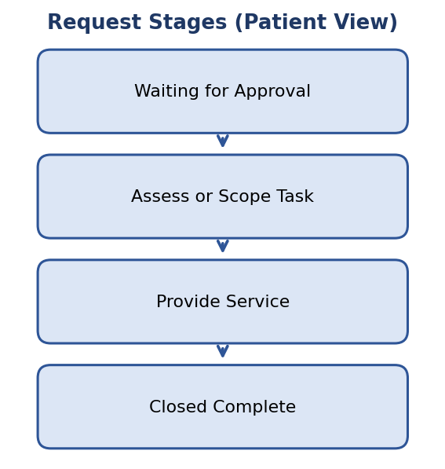
Figure 3: Stage bar shown to the patient
[Insert screenshot: /mdc portal home page]

[Insert screenshot: Book a Blood Test request form]

[Insert screenshot: Live Request Tracking Dashboard]

10. Testing
Testing combines functional checks and response time checks, documented in two separate test documents:
- Performance Test 1, Functional Testing: Request lifecycle (REQ → RITM → SCTASK, all four stages) and ACL checks for patient and admin users.
- Performance Test 2, Response Time & Load Testing: Portal load time, request submission and workflow time, stage sync latency and a multi-user load test, measured with browser developer tools, ServiceNow Transaction Logs and Flow Designer execution details.
Pass/fail results and measured values are recorded in those documents after testing.

11. Screenshots or Demo
[Insert screenshot: Back-end Request / RITM / SCTASK records]

[Insert screenshot: Flow Designer approval flow]

Demo link: [add link here]

12. Known Issues
No known issues have been recorded yet. Add any bugs found during testing here.

13. Future Enhancements
- Email or SMS notifications when a request changes stage.
- Appointment scheduling and slot booking for tests.
- Delivery of test reports to the patient inside the portal.
- Reporting dashboards for administrators (volumes, turnaround time).
- Mobile-friendly portal improvements.
These are suggestions, not committed features.

