Project Design Phase-II
Technology Stack (Architecture & Stack)

Date | 24 October 2026
Team ID | pappu sudarshini (individual participant)
Project Name | Medical Diagnostic Centre
Maximum Marks | 4 Marks

Technical Architecture:
The Deliverable shall include the architectural diagram as below and the information as per the table1 & table 2
Example: Order processing during pandemics for offline mode
Reference: https://developer.ibm.com/patterns/ai-powered-backend-system-for-order-processing-during-pandemics/
Guidelines:
Include all the processes (As an application logic / Technology Block)
Provide infrastructural demarcation (Local / Cloud)
Indicate external interfaces (third party API’s etc.)
Indicate Data Storage components / services
Indicate interface to machine learning models (if applicable)

Architecture: Medical Diagnostic Centre (ServiceNow)
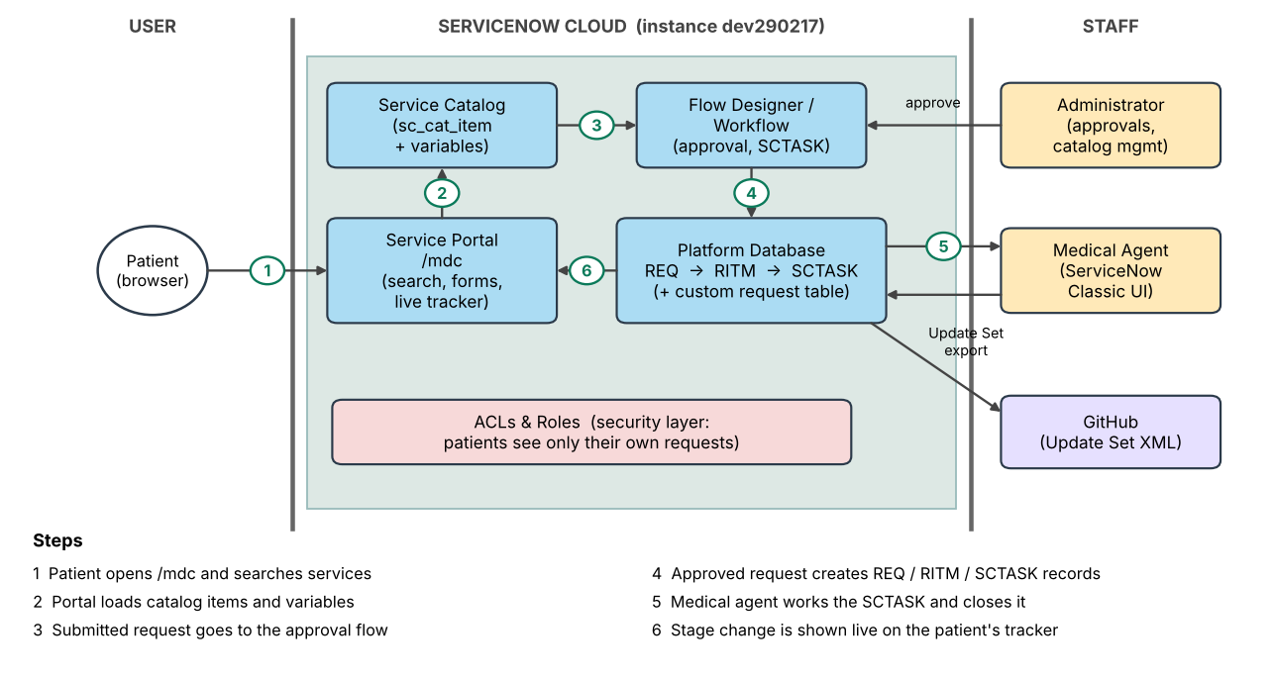

Table-1 : Components & Technologies:
S.No | Component | Description | Technology
 | User Interface | Patient-facing self-service portal at /mdc: search diagnostic services, fill in catalog item forms and track requests on a live dashboard. | ServiceNow Service Portal (HTML, CSS, JavaScript, AngularJS widgets)
 | Application Logic-1 | Service Catalog: diagnostic services such as "Book a Blood Test" defined as catalog items with medical and contact variables. | ServiceNow Service Catalog (sc_cat_item)
 | Application Logic-2 | Approval and fulfilment automation: routes each request through the approval chain and generates catalog tasks (SCTASK) for medical agents. | ServiceNow Flow Designer / Workflow
 | Application Logic-3 | Agent and admin back end: Request (REQ), Requested Item (RITM) and Catalog Task (SCTASK) are handled in ServiceNow Classic; closing a task or changing a stage updates the patient's stage bar. | ServiceNow Classic UI, server-side JavaScript
 | Database | Relational tables holding requests, items, tasks and the custom request table (u_medical_portal_request). | ServiceNow platform database
 | Cloud Database | Data is stored in the cloud-hosted ServiceNow instance (dev290217); no separate database service is used. | ServiceNow cloud instance
 | File Storage | Request attachments are kept as ServiceNow attachment records; the exported Update Set XML is stored on GitHub. | ServiceNow attachments, GitHub repository
 | External API-1 | Source control for the exported Update Set / application package, used for version control and cross-instance deployment. | GitHub
 | External API-2 | Not used. All functions run inside the ServiceNow platform. | Not applicable
 | Machine Learning Model | Not used in this project. | Not applicable
 | Infrastructure (Server / Cloud) | Application deployed on the cloud only; no local server is used.  Local Server Configuration: Not applicable  Cloud Server Configuration: ServiceNow-hosted developer instance (dev290217) | ServiceNow cloud platform; Update Set for moving between instances

Table-2: Application Characteristics:
S.No | Characteristics | Description | Technology
 | Open-Source Frameworks | The Service Portal front end uses AngularJS and Bootstrap, which come bundled with the ServiceNow Service Portal. | AngularJS, Bootstrap
 | Security Implementations | ACLs and roles restrict data so patients see only their own requests while administrative staff get full management access. The portal is served over the instance's HTTPS connection. | ServiceNow ACLs, Roles, user authentication
 | Scalable Architecture | Layered design: Service Portal (presentation), Catalog and Flow Designer (logic) and the platform database (data). New services are added as new catalog items, and the Update Set lets the application be deployed to other instances. | ServiceNow platform, Update Set
 | Availability | The application runs on the ServiceNow cloud instance, so availability depends on the platform's hosted infrastructure rather than servers managed by the project. | ServiceNow cloud hosting
 | Performance | Catalog-based forms and standard record tables keep each request light, and the tracker reads the request's current state directly from the record. | ServiceNow platform tables, Service Portal widgets

References:
https://c4model.com/
https://developer.ibm.com/patterns/online-order-processing-system-during-pandemic/
https://www.ibm.com/cloud/architecture
https://aws.amazon.com/architecture
https://medium.com/the-internal-startup/how-to-draw-useful-technical-architecture-diagrams-2d20c9fda90d

