Game Design Document

Fill up the following document

1. Write the title of your project.

The title of the game is called Pen Pals unite!

1. What is the goal of the game?

The player has to reach the end of the game and meet his pen pal

1. Write a brief story of your game.

The two friends met at a jungle convention. The parents were looking at something else but both of them were looking at the same thing. A black panther!

It is very rare to come across something like a black panther and the convention did its best to replicate the look and feel of the animal. It was actually a two-person ride! Since the parents were busy, the both of them paired up and went on the ride. It was great fun and the two of them soon became fast friends. But all good things come to an end and the two part with heavy hearts.

But then they came up with an idea! They exchanged adresses so that the both of them could become pen pals! And so, after two months, both of them became pen pals which each other. But the player became sad as he wanted to meet his friend. So he set on a journey to meet his friend

1. Which are the playing characters of this game?

* Playing characters are the ones who respond to the user based on the input from the user.
* Cars, monkeys, dinos, wizards, etc., are the playing characters in the game.

|  |  |  |
| --- | --- | --- |
| Number | Character Name | What can this character do? |
| 1 | The red box | He is the person to be controlled with the arrow keys |
| 2 | His car | His car willl allow him to go long distances but at the price of fuel |
| 3 | cycle | Same as car but not for too long distances and nee energy to use |
| 4 | Bag | This will allow the player to store a few more items so that he can use them later |
| 5 | Inventory | This will allow the player to see what is stored in the bag. |
| 6 | map | This will allow him to see where he is on a map of the area |
| 7 | pet | This will give him company and can be controlled by a menu |

1. Which are the Non-Playing Characters of this game?

* Non-Playing characters are the ones that don't have an action or behavior when the user interacts with the game.
* Hurdles, stones, bananas, coins, etc., are non-playing characters in the game.

|  |  |  |
| --- | --- | --- |
| Number | Character Name | What can this character do? |
| 1 | parents | Will give him supplies and money for the journey |
| 2 | Enemies | These try to take your supplies |
| 3 | Lava | Jump over them, will kill if touched |
| 4 | Spikes | Same as before |
| 5 | Signs | Tell you how far you are from destination |
| 6 | Pen pal | Meet and celebrate |
| 7 | water | Press up to swim in them |
| 8 | choclates | Eat to get energy |

Draw your imagination of this game. What does this game look like?

* Draw the game either on your computer or on paper.
* Add images of the game scenes to show each of the playing and non-playing

characters at least once

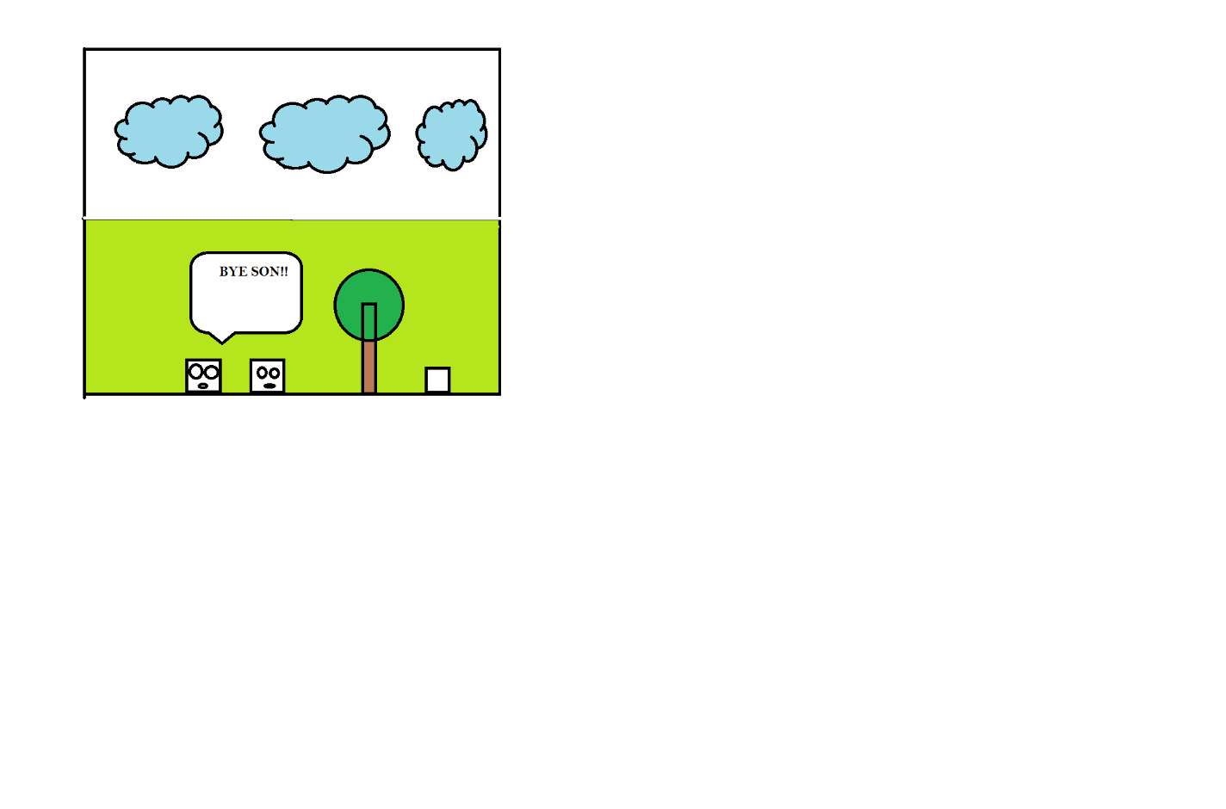

How do you plan to make your game engaging?

By letting the player enjoy the scenery and meet the different NPC’s and play to their delight