**Name:S.S.Sudeekshaa Reg.no:20BPS1157**

**MACHINE VISION DIGITAL ASSIGNMENT – 1**

# Image Enhancement Techniques: Histogram Equalization:

clc

clear all

image = imread('Parrot.png'); I= imread('Parrot.png'); subplot(2,2,1)

imshow(I) subplot(2,2,2) imhist(I)

J = histeq(image); subplot(2,2,3) imshow(J) subplot(2,2,4) imhist(J)

# Output:

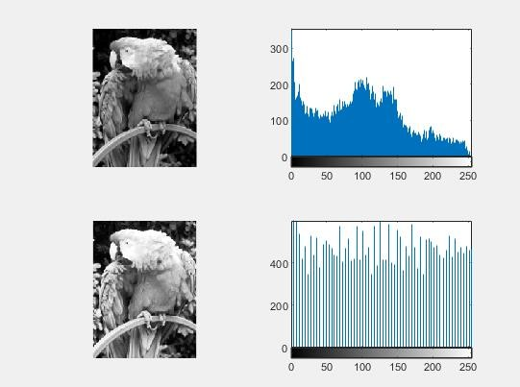

Contrast Stretching:

I = imread('Lion.png'); figure

subplot(2,2,1) imshow(I) subplot(2,2,2) imhist(I)

J = imadjust(I,stretchlim(I),[]); subplot(2,2,3)

imshow(J) subplot(2,2,4) imhist(J)

# Output:

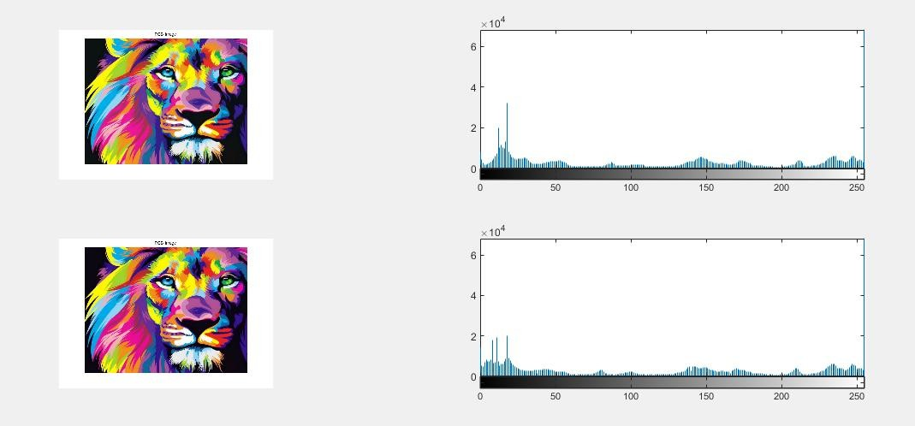

Gray Level Slicing:

clc;

clear all; i=imread('Lion.png'); j=double(i); k=double(i); [row,col]=size(j);

T1=100 %Lowest threshold value T2=200 % Highest threshold value for x=1:row

for y=1:col

if((j(x,y)>T1) && (j(x,y)<T2)) j(x,y)=i(x,y);

k(x,y)=255;

else j(x,y)=0;

k(x,y)=0; end

end end

subplot(311), imshow(i), title('Original image') subplot(312), imshow(uint8(j)), title('Graylevel slicing with background')

subplot(313), imshow(uint8(k)), title('Graylevel slicing without background')

# Output:

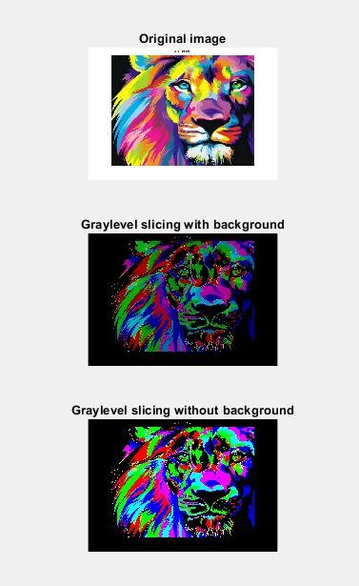

Bit Plane Slicing:

clc

clear all close all warning off;

A=imread('Parrot.png'); A=double(A);

B=bitget(A,1); subplot(2,4,1);imshow((B));title('Bit plane 1'); B=bitget(A,2); subplot(2,4,2);imshow(B);title('Bit plane 2'); B=bitget(A,3); subplot(2,4,3);imshow(B);title('Bit plane 3'); B=bitget(A,4); subplot(2,4,4);imshow(B);title('Bit plane 4'); B=bitget(A,5); subplot(2,4,5);imshow(B);title('Bit plane 5'); B=bitget(A,6); subplot(2,4,6);imshow(B);title('Bit plane 6'); B=bitget(A,7); subplot(2,4,7);imshow(B);title('Bit plane 7'); B=bitget(A,8);subplot(2,4,8);imshow(B);title('Bit plane 8');

# Output:

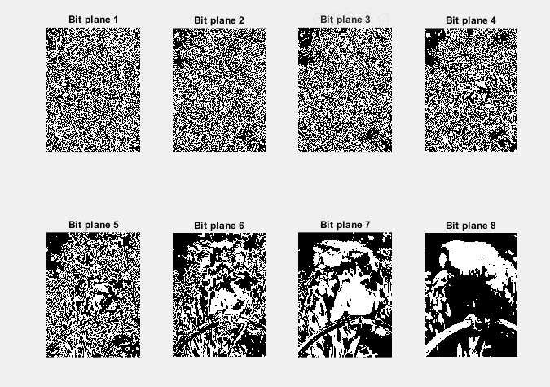

Sharpening the image:

a = imread('Lion.png'); imshow(a) title('Original Image'); b = imsharpen(a); figure, imshow(b)

title('Sharpened Image');

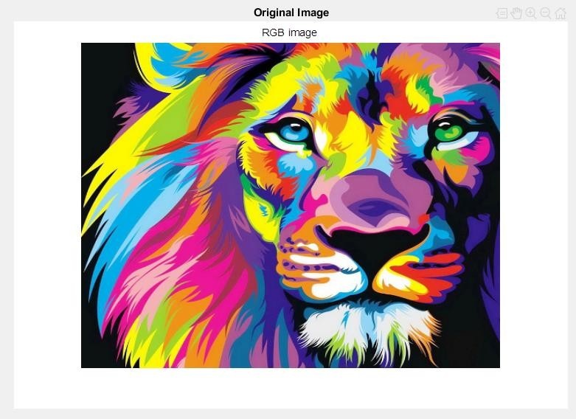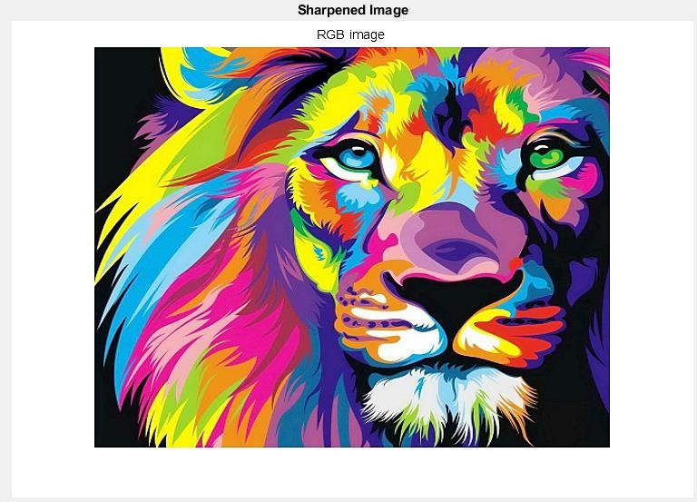

# Quality of the image:

clc

A = imread('Par.jpg');

Anoise = imnoise(A,'Gaussian',0,0.05); Ablur = imgaussfilt(A,2);

score = piqe(A); score_noise = piqe(Anoise); score_blur = piqe(Ablur); figure

montage({A,Anoise,Ablur},'Size',[1 3]) title({['Original Image: PIQE score = ',

num2str(score),' | Noisy Image: PIQE score =', num2str(score_noise),' ' '| Blurred Image: PIQE score = ', num2str(score_blur)]},'FontSize',12)

# Output:

