**Instructions to Setup, Test Code (with Assumptions)**

1. ProductApi is an ASP.Net Web API built on Visual Studio 2015.
2. Install .NET Execution Environment (DNX).

For Reference: <https://docs.asp.net/en/latest/getting-started/installing-on-windows.html>

1. Used a tool named Fiddler (By Telerik) for sending requests to and getting responses from ProductApi.

For Reference: <https://www.telerik.com/download/fiddler>

1. Uncheck **Capture Traffic**.

Refer screenshots:

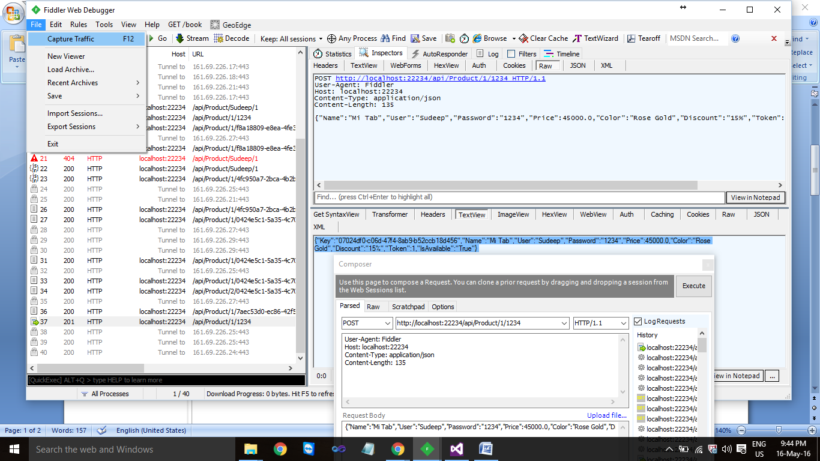

1. Use *Composer* to send requests. Dropdown will help to choose the type of request and the lower grid is for Request Body.

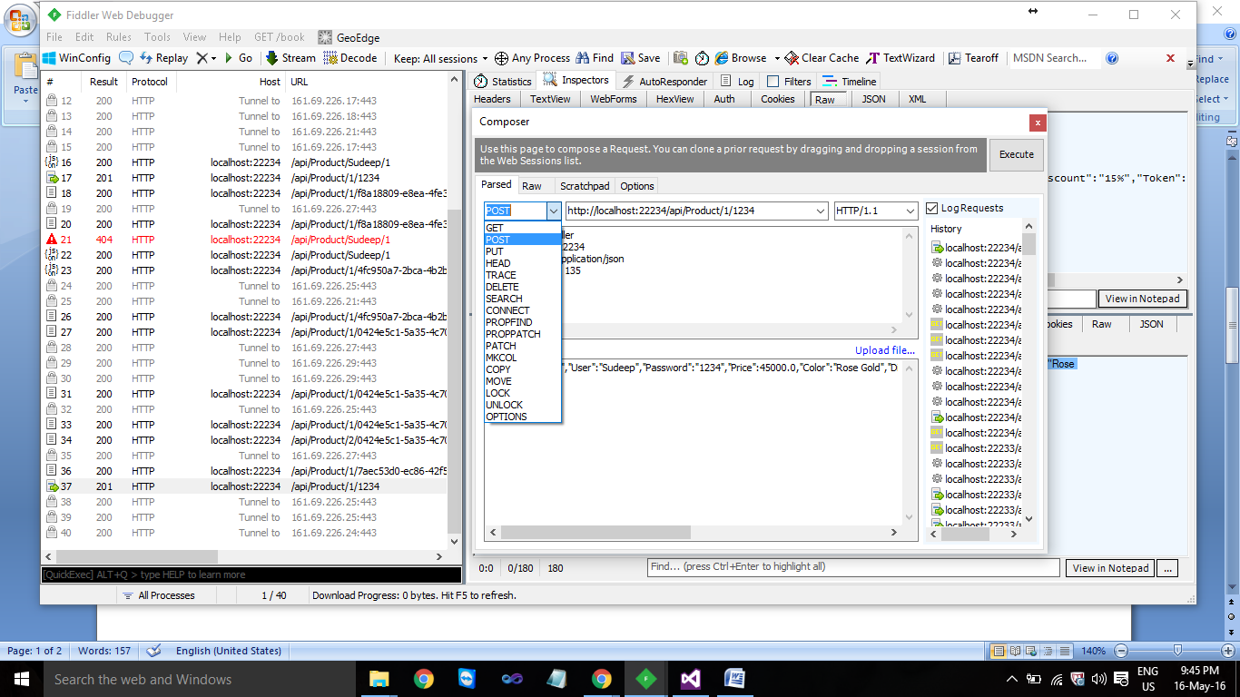

1. Example of HttpSession (Requesting products associated with User ***Sudeep***):

*Request:*

GET [http://localhost:22234/api/Product/Sudeep/1 HTTP/1.1](http://localhost:22234/api/Product/Sudeep/1)

User-Agent: Fiddler

Host: localhost:22234

Content-Type: application/json

Content-Length: 0

*Response:*

[{"Key":"7aec53d0-ec86-42f5-a730-cc3f7808805a","Name":"Iphone6S","User":"Sudeep","Password":"1234","Price":45000.0,"Color":"Silver","Discount":"15%","Token":1,"IsAvailable":"True"},{"Key":"ce6255eb-f90a-4ee3-9380-039fa650a4cf","Name":"IphoneSE","User":"Sudeep","Password":"1234","Price":25000.0,"Color":"Gold","Discount":"12%","Token":1,"IsAvailable":"True"},{"Key":"40e0c278-df08-4c6c-9398-c68f5ec85116","Name":"Iphone4S","User":"Sudeep","Password":"1234","Price":15000.0,"Color":"Silver","Discount":"12%","Token":1,"IsAvailable":"False"},{"Key":"07024df0-c06d-47f4-8ab9-b52ccb18d456","Name":"Mi Tab","User":"Sudeep","Password":"1234","Price":45000.0,"Color":"Rose Gold","Discount":"15%","Token":1,"IsAvailable":"True"}]

**Assumptions:**

1. Combination of properties like Name and Color of the product can not be same.

Example: Two Products by **Name**: IPhone6s and **Color**: Rose Gold cannot be created.

1. Products with same Names but different Colors can be added or vice versa, but products with same Name as well as Color can’t be created.
2. User name and Password at the time of creation cannot be Null.
3. Product Id (Key) can not be updated.
4. The Token property (of the user) will be unique.

Example:

If **User**: Sumit has **Token**: 1, then Sudeep can not have same Token.