1.Abstract
Travel Diaries is a social travel journaling platform that empowers users to document, share, and relive their journeys through map-based storytelling and multimedia entries. It allows travelers to pin locations, write reflections, upload photos, and curate personalized travel timelines. With features like wishlists, streaks, and community discovery, Travel Diaries transforms travel memories into interactive narratives. The platform also supports real-time engagement, enabling users to explore others’ journeys, follow travel trends, and build a connected travel community. Designed with modular architecture and user-centric design, Travel Diaries offers a scalable and immersive solution for modern explorers seeking both reflection and connection.

2.Introduction
Travel Diaries is a social travel journaling platform designed to help users capture, organize, and share their travel experiences in a visually engaging and emotionally resonant way. It enables users to pin visited locations on an interactive map, write reflections, upload photos, and curate personalized travel timelines. The platform supports both private memory keeping and public sharing, allowing users to explore others’ journeys and discover new destinations through community-driven storytelling.
With features like travel wishlists, streak tracking, and multimedia journals, Travel Diaries blends personal reflection with social engagement. Its modular design supports role-based access for users and administrators, enabling content moderation, analytics, and community curation. By combining intuitive design, real-time features, and scalable architecture, Travel Diaries offers a user-friendly and immersive solution for modern explorers seeking to preserve memories and inspire others.

3.Why the Idea for Travel Diaries?
i. Fragmented Travel Memory Keeping
- Travelers often rely on scattered tools like photo galleries, notes apps, and social media posts.
- These platforms lack structure, emotional context, and long-term discoverability.
ii. Need for Map-Based Storytelling
- Existing travel apps focus on bookings or reviews, not personal narratives.
- Users crave a way to pin locations, reflect on experiences, and visualize their journeys over time.
iii. Personalization & Emotional Connection
- Travel is deeply personal, yet most platforms offer generic content.
- Users need a system that understands their preferences, moods, and travel styles to suggest meaningful destinations and activities.
iv. Bridging the Gap Between Solo Reflection and Social Discovery
- Travelers want to document their memories privately, but also explore others’ journeys for inspiration.
- Travel Diaries offers both: a private journal and a social feed of curated travel stories.
v. Digital Companion for Lifelong Exploration
- A platform that grows with the user — from wishlist planning to post-trip reflection.
- Supports multimedia entries, streaks, and badges to gamify memory keeping and encourage consistency.
vi. Convenience and Engagement
- Easy-to-use web and mobile interfaces with map-based visualization and intuitive journaling.
- Encourages users to preserve and share travel memories without pressure or complexity.

4.Features of Travel Diaries
- Quick Location Pinning
- Users can instantly mark visited places on an interactive map.
- Each pin opens a travel entry form for journaling, photo uploads, and reflections.
- Custom Travel Entry
- Users can write detailed travel stories, upload images, and tag moods or experiences.
- Based on location and tags, the platform suggests: Destinations, Travel Tips, Local Activities, Cultural Insights, Food Spots, and Community Stories.
- Travel History & Timeline
- Displays complete history of travel entries with timestamps and locations.
- Interactive graphs show travel frequency, mood trends, and visited zones.
- Option to export travel logs as PDF for personal archiving or sharing.
- Daily Travel Journal
- Users can log daily reflections, even without a location pin.
- Journal entries are stored in a calendar view.
- Dates with saved entries appear highlighted for easy tracking.
- Wishlist & Streaks
- Users maintain a wishlist of places they want to visit.
- Streaks track consecutive days of journaling or travel logging.
- Badges awarded for milestones like “First Entry,” “Explorer,” or “Global Hopper.”
- Admin Dashboard
- Admins manage user-generated content, moderate public entries, and curate featured stories.
- View platform engagement metrics, user activity, and content trends.
- Manage flagged entries and ensure community compliance.
- Community Discovery Feed
- Users explore public travel stories from others based on location, mood, or tags.
- Follow travelers, comment on entries, and bookmark inspiring journeys.
- Discover trending destinations and hidden gems through real-time updates.

5.Implementation: How Travel Diaries Works (Technical Summary)
1. System Architecture
Travel Diaries follows a modular three-tier architecture optimized for map-based journaling and social discovery:
- Frontend (Client Layer)
  - Built using JSP, HTML5, CSS3, and JavaScript for responsive, form-driven UI.
  - Handles user interactions like location pinning, journal writing, wishlist tracking, and streak visualization.
  - Integrates Leaflet.js for map-based travel visualization and Charts.js for travel history analytics.
Backend (Application Layer)
- Developed using Spring Boot (Java) for scalable service orchestration.
- Provides REST APIs for authentication, travel entries, wishlists, streaks, recommendations, and admin moderation.
- Manages business logic for location tagging, PDF export, badge assignment, and feed curation.
Database (Data Layer)
- MySQL stores users, travel entries, journals, recommendations, wishlists, badges, and admin actions.
- Structured schema with foreign key relationships for users, locations, tags, and engagement metrics.
Key Functional Modules
- Travel Entry & Map Journaling
- Users pin locations and write travel stories with optional images and mood tags.
- Entries stored with timestamps and geo-coordinates for map visualization.
Travel History & Reports
- Historical entries visualized via interactive maps and graphs.
- PDF exports available for personal archiving or sharing.
Daily Journal & Calendar View
- Users log reflections even without location pins.
- Calendar highlights saved entries and supports streak tracking.
Wishlist & Gamification
- Users maintain a wishlist of places to visit.
- Streaks and badges awarded for consistent journaling and exploration milestones.
Community Feed & Discovery
- Public entries curated into a discovery feed based on location, tags, and popularity.
- Users can follow travelers, comment, and bookmark entries.
Admin Dashboard
- Admins manage user content, moderate public entries, and curate featured stories.
- View engagement metrics and ensure platform compliance.
Technologies Used
- Frontend: JSP, HTML5, CSS3, JavaScript, Leaflet.js,charts.js
- Backend: Spring Boot (Java), RESTful APIs
- Database: MySQL
- Authentication: JWT (JSON Web Tokens) for secure login
- File Handling: PDF generation for travel logs and reports
- Deployment: Maven for build, Tomcat server (or cloud deployment via Clever Cloud)
- Visualization: Leaflet.js for maps, Chart.js for Analytics.

6.System Architecture Diagram

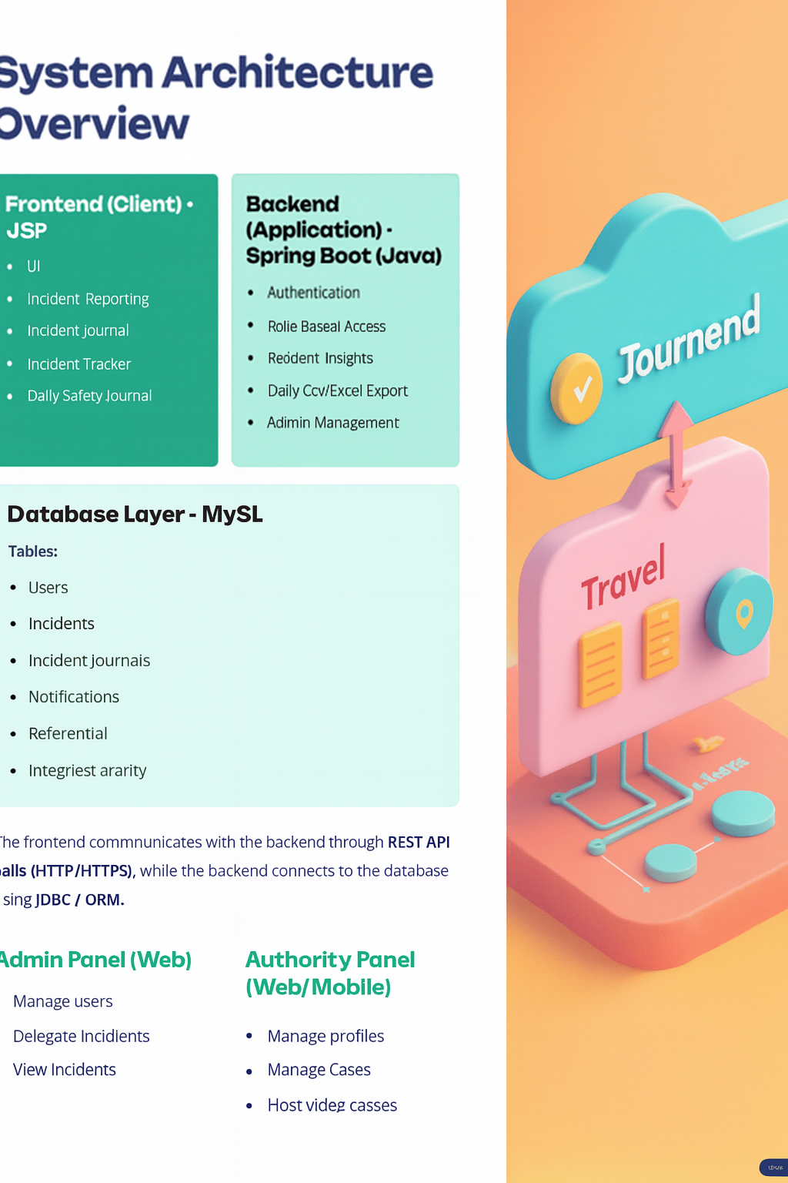
7.Database (Tables & Key Fields) – Travel Diaries
i. USERS
Column | Description
id | Unique user ID (auto-incremented primary key)
email | User email (unique)
name | Full name of the user
password | Encrypted user password
role | Role in system (user, admin)
location | User’s default location or zone
ii. TRAVEL_ENTRY
Column | Description
id | Unique travel entry ID (auto-incremented)
title | Title of the travel story
description | User’s travel notes or reflections
location | Geo-location or place name
timestamp | Date and time of entry
mood_tag | Mood or sentiment associated with the entry
image_url | Optional image link or file reference
user_id | ID of the user (foreign key)
is_public | Visibility flag (0 = private, 1 = public)
iii. JOURNAL
Column | Description
id | Unique journal entry ID
user_id | ID of the user (foreign key)
note | Daily reflection or travel thoughts
entry_date | Date of the journal entry
created_at | Timestamp when the entry was created
iv. WISHLIST
Column | Description
id | Unique wishlist entry ID
user_id | ID of the user (foreign key)
location | Desired travel destination
reason | Optional reason or note
added_on | Date the location was added
v. RECOMMENDATION
Column | Description
id | Unique recommendation ID
content | Recommendation content (place, tip, activity)
link | URL or reference to the recommendation
tag | Associated tag (e.g., adventure, food, culture)
type | Type of content (destination, tip, article, etc.)
vi. BADGES
Column | Description
id | Unique badge ID
name | Badge name (e.g., Explorer, Global Hopper)
description | Badge description
user_id | ID of the user who earned the badge
awarded_on | Date the badge was awarded
vii. COMMENTS
Column | Description
id | Unique comment ID
entry_id | Travel entry ID (foreign key)
user_id | ID of the commenting user (foreign key)
content | Comment text
timestamp | Time of comment
viii. USERS_PROFILE
Column | Description
id | Unique profile ID (auto-incremented primary key)
user_id | ID of the user (foreign key)
bio | Short bio or description
profile_pic | URL or path to profile image
interests | Travel interests or tags
joined_on | Date of profile creation
ix. FOLLOW_REQUEST
Column | Description
id | Unique follow request ID
sender_id | ID of the user sending the request (foreign key)
receiver_id | ID of the user receiving the request (foreign key)
status | Request status (Pending, Accepted, Rejected)
timestamp | Time of request creation
x. MEMORY_CAPSULE
Column | Description
id | Unique capsule ID
user_id | ID of the user who created the capsule (foreign key)
title | Capsule title or theme
description | Capsule description or story
location | Associated location or region
media_url | Optional image or video link
created_on | Date of capsule creation
is_public | Visibility flag (0 = private, 1 = public)

8.Database Relationship Diagram (ER Diagram)
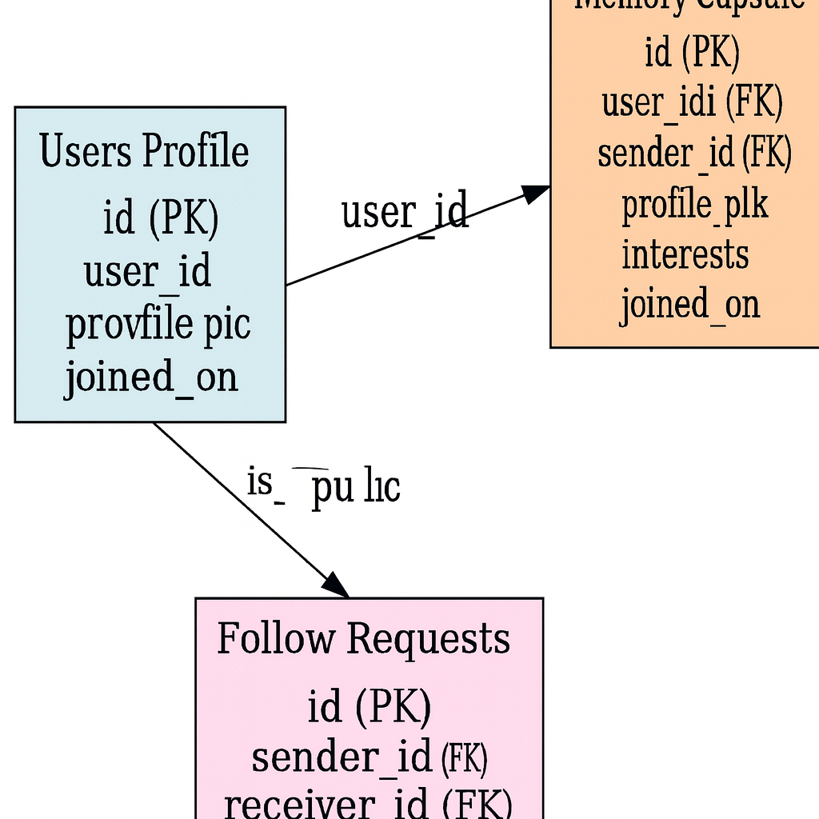

9.CRUD Workflows – Travel Diaries
1. Users
- Create: Register a new user with email, name, password, and role (user, admin).
- Read: View user profile, travel history, wishlist, and earned badges.
2. Users Profile
- Create: Add bio, profile picture, and travel interests.
- Read: View public profiles and shared travel capsules.
- Update: Edit bio, interests, or profile image.
- Delete: Remove profile data if user deletes account.
3. Travel Entry
- Create: Pin a location and write a travel story with optional media.
- Read: View personal or public travel entries on map or timeline.
- Update: Edit title, description, mood tag, or image.
- Delete: Remove travel entry from personal log or public feed.
4. Journal
- Create: Add daily reflections or travel thoughts.
- Read: View journal entries via calendar interface.
5. Wishlist
- Create: Add a new destination to wishlist.
- Read: View saved wishlist items.
- Update: Modify reason or reorder wishlist.
- Delete: Remove destination from wishlist.
6. Memory Capsule
- Create: Create a capsule with title, description, location, and media.
- Read: View capsules (private or public) with timestamp and location.
- Update: Edit capsule content or visibility.
- Delete: Remove capsule from user’s archive.
7. Follow Requests
- Create: Send a follow request to another user.
- Read: View incoming/outgoing requests and status.
- Update: Accept or reject requests.
- Delete: Cancel pending requests or unfollow users.
8. Recommendations
- Create: Admin adds travel tips, destinations, or cultural insights.
- Read: Users view recommendations based on location, mood, or tags.
- Update: Modify content, links, or tags.
- Delete: Remove outdated or irrelevant recommendations.
9. Badges
- Create: System awards badges based on milestones.
- Read: View earned badges and descriptions.
- Delete: Admin may revoke badges if needed.

10.Modules Overview – Travel Diaries
1. User Module
- Register/Login and manage profile with bio, interests, and profile picture.
- Pin locations and create travel entries with mood tags and media.
- Maintain daily travel journals and view history via calendar and graphs.
- Track streaks, earn badges, and manage wishlist destinations.
2. Social Module
- Send and receive follow requests to connect with other travelers.
- View public profiles, shared capsules, and travel feeds.
- Comment on entries, bookmark favorites, and discover trending journeys.
- Privacy controls for public/private sharing of entries and capsules.
3. Admin Module
- Manage registered users and moderate public content.
- Add, update, or remove travel recommendations and featured stories.
- View platform usage metrics and engagement trends.
- Ensure compliance and content quality across the community.
4. Recommendation Module
- Store and manage curated travel content (destinations, tips, articles, activities).
- Display personalized suggestions based on location, mood, or tags.
- Update/remove outdated recommendations and track user engagement.
5. Memory Capsule Module
- Create themed capsules with location, story, and media.
- Users can preserve travel memories privately or share publicly.
- Capsules linked to map and timeline views for immersive storytelling.
6. JWT Security Module
- Uses JSON Web Tokens (JWT) for secure authentication and authorization.
- Role-based access control for Users and Admins.
- Protects sensitive data like journals, capsules, and profile details.
- Ensures only authorized users can access specific APIs and modules.

11.Screenshots / UI Design

12.Conclusion
Travel Diaries offers a complete digital solution for travel memory preservation and social discovery by combining map-based journaling, personalized recommendations, multimedia capsules, and community engagement into one cohesive platform. With secure JWT-based authentication, intuitive interfaces, and scalable architecture, the system ensures both accessibility and data protection for users across roles.
By bridging personal reflection with social exploration, Travel Diaries empowers users to document their journeys, connect with fellow travelers, and discover new destinations through shared experiences. Its modular design supports real-time storytelling, gamified engagement, and role-based content management, making it a practical and extensible solution for modern explorers. Whether used for private memory keeping or public inspiration, Travel Diaries transforms travel into a lasting, interactive narrative.

