BloodWiser
1. Induction
BloodWiser is a health platform designed to simplify blood-related information and facilitate blood donation management. It helps you understand your blood type and its role in health, from predicting a baby's blood group to knowing who you can give and receive blood from.
The platform also makes blood donation easy with online registration and instant email certificates. You can use it to track your blood sugar with a glucometer, getting immediate feedback on your readings. For blood banks, it offers a real-time inventory that automatically updates as blood is collected and expires after 35 days, ensuring the information is always accurate.

2. Why the Idea for BloodWiser?
The idea for BloodWiser was born out of a vision to merge biology and technology into a platform that delivers both social impact and practical utility. Rather than creating just another app, the goal was to design a solution that could genuinely educate, empower, and save lives.
- Education as a Priority:
Many people lack awareness of fundamental blood-related concepts—such as blood group compatibility, safe transfusion practices, and common blood disorders. Misunderstandings in these areas can have serious consequences.
- BloodWiser aims to simplify these complex biological ideas through an interactive, user-friendly platform.
- By turning scientific knowledge into accessible content, the platform helps users better understand their own health and the science of blood.
- This focus on education encourages informed decision-making and promotes a culture of awareness in society.

- Emergency Preparedness:
Access to safe blood can mean the difference between life and death in critical situations. One major challenge is the time lost due to poor coordination and lack of available donors.
- BloodWiser addresses this by streamlining the blood donation process and connecting donors with recipients more efficiently.
- With real-time data and a potential inventory system, the platform can help hospitals, patients, and donors respond quickly during emergencies.
- This not only saves lives but also fosters a stronger sense of community responsibility.

- Bridging Science and Technology
At its core, BloodWiser reflects the belief that innovation is most meaningful when applied to real-world problems. By combining the scientific foundation of biology with modern technology, the project creates a platform that is:
- Purpose-driven: serving education and healthcare needs.
- Practical: usable in everyday situations as well as emergencies.
- Empowering: giving individuals the tools to both learn and act.

3. Features of BloodWiser
- Baby Blood Group Prediction
  - Predicts the possible blood group of a baby based on the parents’ blood groups.
- Blood Donation Compatibility
  - Provides quick guidance on which blood groups are compatible for safe transfusion.
- Emergency Search for Particular Blood
  - Helps users quickly search for specific blood types during urgent situations.

- Save Donor Information
  - Stores donor details securely for future use and easy access during emergencies.
- Generate and Send Certificates via Gmail
  - The system can create and send donor appreciation certificates through email.
- Educational Information
  - Offers knowledge about blood diseases, transfusion safety, and other blood-related topics in simple, understandable language.
- Glucometer Integration
  - Allows users to check glucose levels and monitor their health.
- Food Suggestions
  - Provides diet and food recommendations based on glucometer results for better health management.
- Blood Circle Display for Emergency Donation
  - Displays nearby donors in a real-time “blood circle” view, similar to availability charts.
  - Helps users quickly identify and connect with donors of the required blood group during emergencies.

4. Implementation: How BloodWiser Works (technical summary)
Architecture & Technologies
- Frontend: JSP pages (views) for user forms, lists, charts and uploads.
- Backend: Java Servlets (controller layer) handling requests and responses.
- Data access: DAO pattern with plain JDBC for CRUD operations.
- Database: MySQL (three main tables; detailed schema suggested below).
- Email: Gmail SMTP integration to send certificates.
- Extras: Server-side scheduling or a servlet-triggered check to mark expired blood units after 35 days; a charting library on JSP for visualizations.

Expiry & Status Handling
- On every read or via a scheduled process, the server checks collection_date + 35 days and:
  - If now > expiry_date and status != USED, set status = EXPIRED.
- When a blood unit is transfused, management updates status = USED (and optionally records recipient info / timestamp).

Database (tables & key fields)

Blood Bank Records
Database name:
Column | Description
ID | Unique identifier for each blood bank record
Name | Name of the blood bank.
Address | Full address of the blood bank.
Number | Contact phone number of the blood bank.
City | City in which the blood bank is located.
Actions | Management options to Edit or Delete the record.

Blood Donors
Database name:
Column | Description
ID | Unique donation entry identifier.
Name | Name of the donor linked to this donation.
Phone | Donor’s contact phone number
Email | Donor’s registered email
Blood Group | Blood group of the donation unit
Date of Submit | Date when the donation was submitted/recorded
Last Used | Last time the donor was contacted or the blood unit was used.
Status | Current status of the blood unit: Not Used, Used, or Expired
Actions | Management options to Edit, Delete, or Update Status

Database name:
Column | Description
ID | Unique identifier for each donor.
Name | Name of the blood donor.
Blood Group | Blood group of the donor (e.g., A+, O-).
Email | Donor’s registered email for communication
Phone | Donor’s contact phone number.
Actions | Management options to Edit or Delete the record.

CRUD Workflows
- Create: JSP forms submit to Servlets which validate input and call DAO insert() methods to save into DB.
- Read/List: Servlets fetch lists (donations, donors, banks). JSP renders tables and charts (e.g., blood-group availability pie chart).
- Update: Management pages allow updating donation status (e.g., when used), editing donor or bank details, and updating last donation date.
- Delete: Management pages allow deletion of donors and banks via DAO delete() methods.

5.Key Features Implementation Notes
- Baby Blood Group Prediction
  - Input: parents’ blood groups (form or file upload).
  - Logic: simple Mendelian compatibility rules (A/B/O/AB + Rh factor). Server-side function returns possible baby blood groups and their probabilities. JSP displays results.
- Blood Donation Compatibility
  - Given a required blood group, server returns compatible donor groups (and shows whether O- is universal donor).
- Emergency Search
  - Real-time search page: filters by blood_group, location radius, status = NOT_USED and optionally last_donation_date to ensure eligibility.
  - Results: list and ability to contact donors directly (phone/email) or via app notification.
- Save Donor Information
  - Separate donor table with contact and eligibility data. Forms validate phone/email and donor eligibility (e.g., last donation > 35 days).
- Generate & Send Certificates
  - Management triggers PDF certificate generation (iText or similar) and sends via Gmail SMTP to donor email.
- Educational Pages
  - Static/dynamic JSP pages that display articles, FAQs and simple interactive diagrams about blood diseases and transfusion safety.
- Glucometer Integration & Food Suggestions
  - Simple input form for glucose reading. Server-side logic maps reading ranges to messages (normal/high/low) and returns food suggestions (short list) and advice. Optionally store readings in user profile.
- Blood Circle Display (Emergency Donation)
  - Map or radial (circle) visualization on a JSP page:
    - Shows nearby NOT_USED donors plotted by distance and grouped by blood group.
    - Clickable nodes to call/email donor or open donor profile.
    - Smart filters: radius, blood group, urgency level.
- Alternative Blood Suggestions & Charts
  - If exact blood group not available, the system suggests compatible alternatives (e.g., for urgent needs) and displays a chart of available alternatives (counts or percentages).
  - Charts built on server-provided JSON data and rendered using a JS charting library in JSP.
6 . Search, Sorting & Management Tools
- Management console includes:
  - Advanced search (blood group, date range, location, bank).
  - Sorting (earliest expiry, nearest, most recent donation).
  - Bulk actions (mark multiple units USED or EXPIRED).
  - Audit logs for edits/deletes (recommended).

MAIN PAGE:
MANAGEMENT: 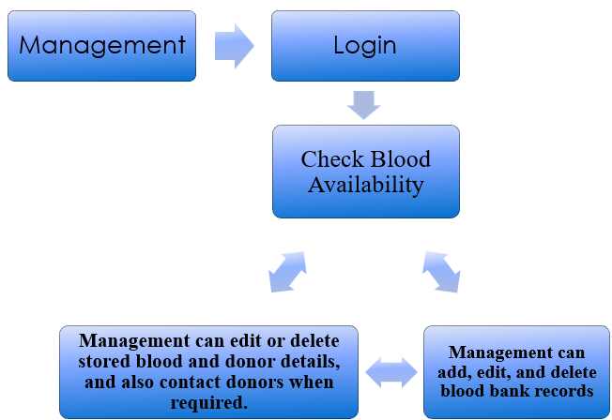

Check Glucose Level
