Xeno Implementation Internship
Assignment Submission

Submitted by
Sudeep Kumar
Registration No: RA2311026010202

Database: MySQL Community Server 8.4.9
Dataset: TAM_INTERN_TABLE.xlsx (300 customer records)

Part 1 — SQL & Data Familiarity

Q1. What steps would you take to review this data before importing it into a system?
Review for missing/null values in critical fields like customer_id and email to ensure data integrity. Check for duplicate records and verify that data types (e.g., signup_date as DATE) are consistent. Finally, validate that categorical data like city has standard spelling and formatting.
Data Insight: The dataset contains 300 customer records across 6 columns (customer_id, full_name, email, phone_number, city, signup_date). Notably, approximately 80 records (~27%) have NULL email addresses — this is a data quality issue that should be flagged to the client before any email-based campaign execution.

Q2. Display all customers from the city 'Delhi'
SQL Query:
SELECT * FROM customers WHERE city = 'Delhi';
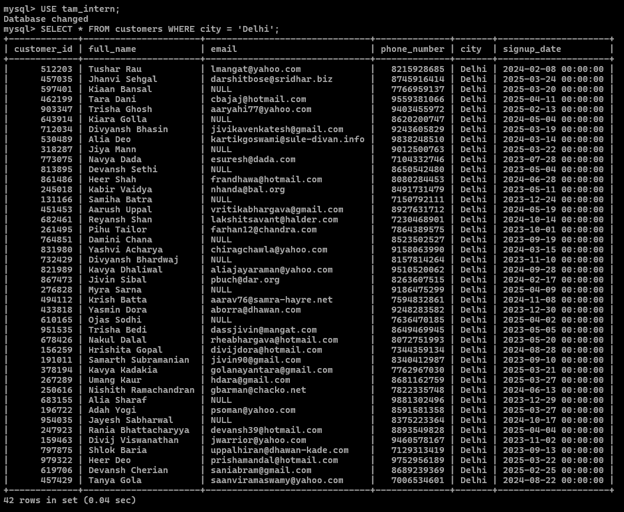
Fig 1: Customers from Delhi (42 records)

Q3. Count the number of signups in the last 30 days (reference date: April 16, 2025)
SQL Query:
SELECT COUNT(*) AS recent_signups
FROM customers
WHERE signup_date >= DATE_SUB('2025-04-16', INTERVAL 30 DAY)
AND signup_date <= '2025-04-16';
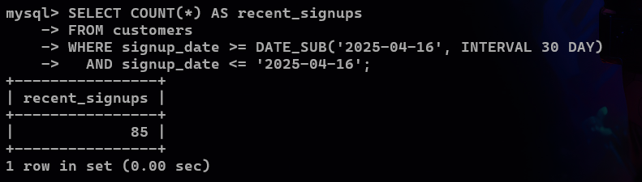
Fig 2: Count of signups in last 30 days — Result: 85

Q4. List unique cities where customers are based
SQL Query:
SELECT DISTINCT city FROM customers;
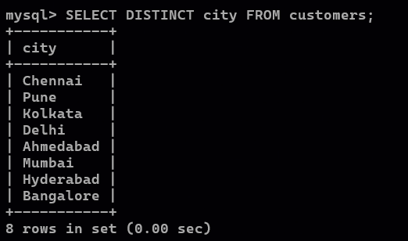
Fig 3: 8 unique cities — Chennai, Pune, Kolkata, Delhi, Ahmedabad, Mumbai, Hyderabad, Bangalore

Q5. List the top 3 cities by number of signups
SQL Query:
SELECT city, COUNT(*) AS total_signups
FROM customers
GROUP BY city
ORDER BY total_signups DESC
LIMIT 3;
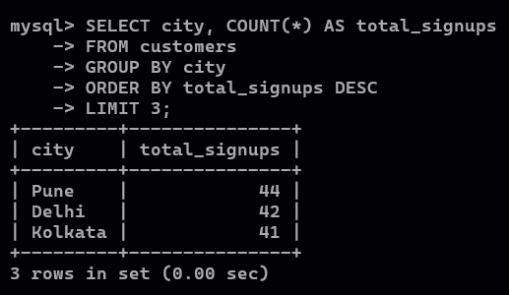
Fig 4: Top 3 cities — Pune (44), Delhi (42), Kolkata (41)

Q6. Find customers who have never placed an order
Assuming a separate orders table exists with columns (customer_id, order_id, amount). The LEFT JOIN pattern is used instead of NOT IN to safely handle potential NULL values in the orders table.
SQL Query:
SELECT c.*
FROM customers c
LEFT JOIN orders o ON c.customer_id = o.customer_id
WHERE o.customer_id IS NULL;
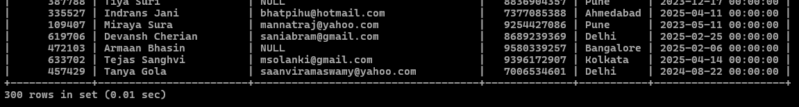
Fig 5: Customers with no matching orders (LEFT JOIN with NULL check)

Part 2 — Data Transformation & Enrichment

Task 1. Add a column to indicate if the email domain is gmail.com
Data Transformation:
ALTER TABLE customers ADD COLUMN is_gmail VARCHAR(3);
UPDATE customers SET is_gmail = IF(email LIKE '%@gmail.com', 'Yes', 'No');
Verification:
SELECT email, is_gmail FROM customers LIMIT 15;
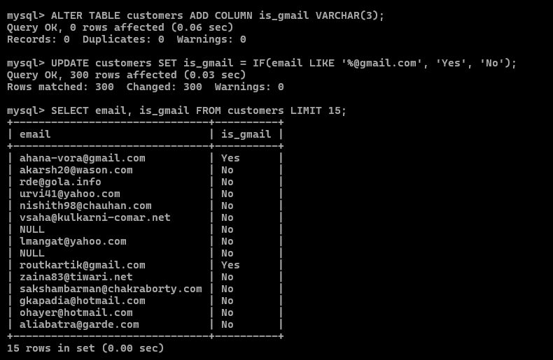
Fig 6: is_gmail column — 'Yes' for gmail.com domains, 'No' otherwise

Task 2. Extract the first name from the full name column
Data Transformation:
ALTER TABLE customers ADD COLUMN first_name VARCHAR(100);
UPDATE customers SET first_name = SUBSTRING_INDEX(full_name, ' ', 1);
Verification:
SELECT full_name, first_name FROM customers LIMIT 15;
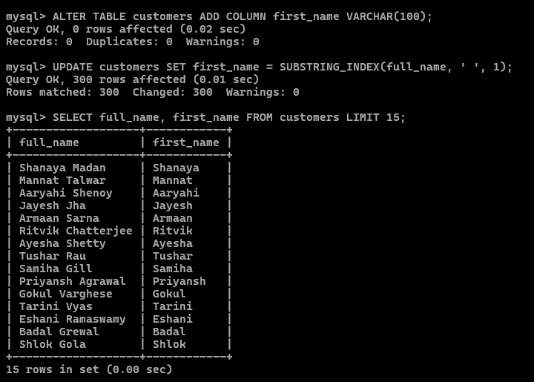
Fig 7: first_name extracted using SUBSTRING_INDEX on full_name

Task 3. Add a signup_month column with the month name
Data Transformation:
ALTER TABLE customers ADD COLUMN signup_month VARCHAR(20);
UPDATE customers SET signup_month = MONTHNAME(signup_date);
Verification:
SELECT signup_date, signup_month FROM customers LIMIT 15;
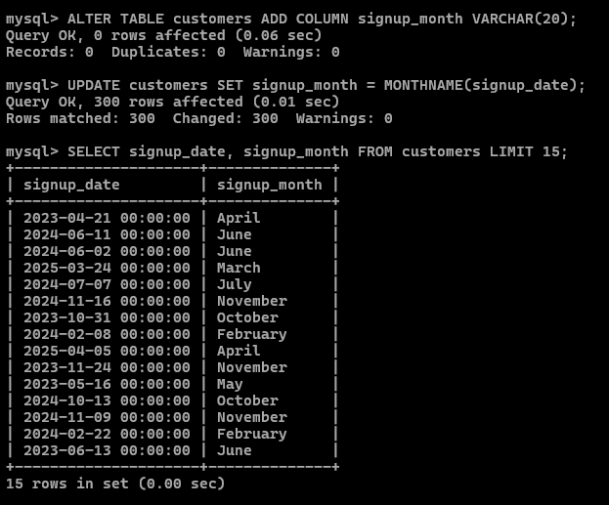
Fig 8: signup_month column populated using MONTHNAME()

Task 4. Report: Number of GMAIL customers signed up by day of the week
SQL Query:
SELECT
DAYNAME(signup_date) AS day_of_week,
COUNT(*) AS gmail_signups
FROM customers
WHERE is_gmail = 'Yes'
GROUP BY day_of_week
ORDER BY gmail_signups DESC;
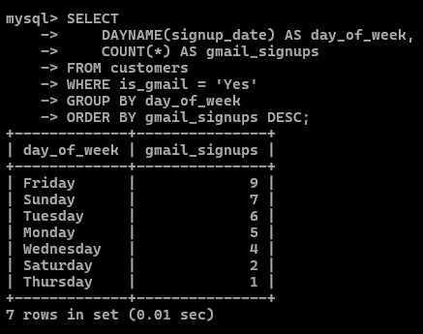
Fig 9: Gmail signups aggregated by day of the week

Task 5. Create a vip_customers table (Delhi, Mumbai, Bangalore — last 60 days)
Table Creation:
CREATE TABLE vip_customers AS
SELECT * FROM customers
WHERE city IN ('Delhi', 'Mumbai', 'Bangalore')
AND signup_date >= DATE_SUB('2025-04-16', INTERVAL 60 DAY)
AND signup_date <= '2025-04-16';
Verification:
SELECT * FROM vip_customers LIMIT 15;
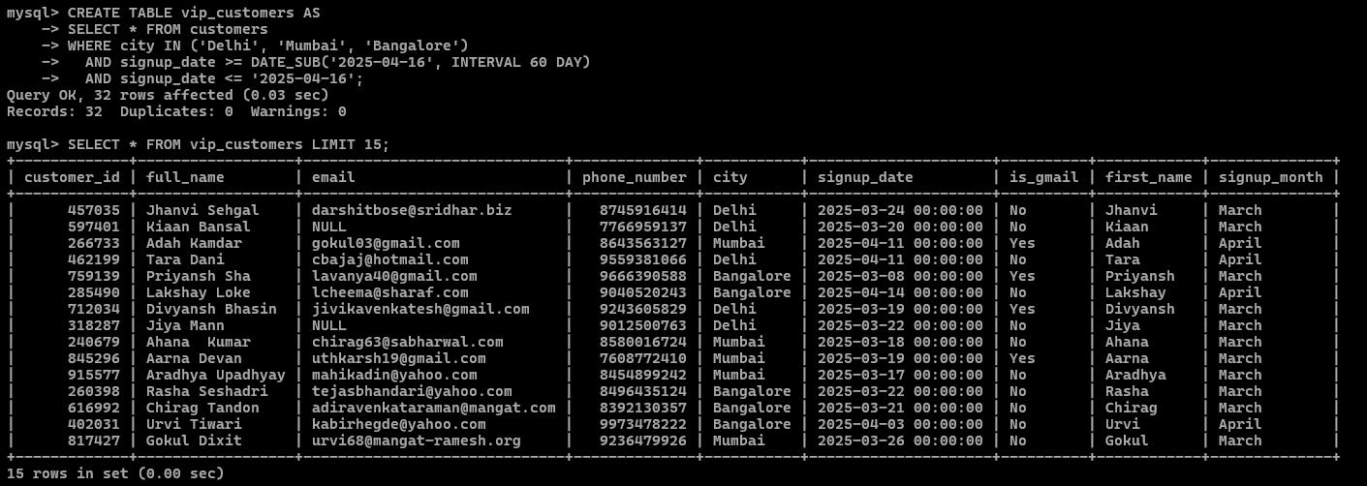
Fig 10: vip_customers table — customers from Delhi, Mumbai, Bangalore (last 60 days)

Part 3 — Analytics & Reporting

Q1. Monthly signup count for the past 6 months
SQL Query:
SELECT
DATE_FORMAT(signup_date, '%Y-%m') AS signup_month_year,
COUNT(*) AS signup_count
FROM customers
WHERE signup_date >= DATE_SUB('2025-04-16', INTERVAL 6 MONTH)
AND signup_date <= '2025-04-16'
GROUP BY signup_month_year
ORDER BY signup_month_year DESC;
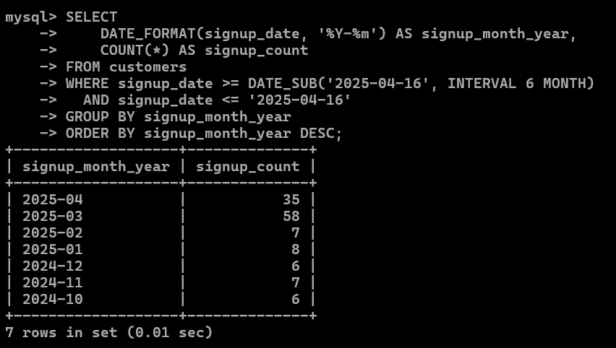
Fig 11: Monthly signup trend over the last 6 months

Q2. Cities with more than 20 customers
SQL Query:
SELECT
city,
COUNT(*) AS customer_count
FROM customers
GROUP BY city
HAVING COUNT(*) > 20
ORDER BY customer_count DESC;
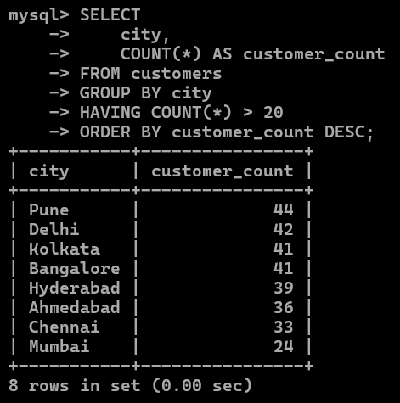
Fig 12: Cities exceeding 20 customer signups

Q3. Find the exact date with the highest number of signups
SQL Query:
SELECT
signup_date,
COUNT(*) AS total_signups
FROM customers
GROUP BY signup_date
ORDER BY total_signups DESC
LIMIT 1;
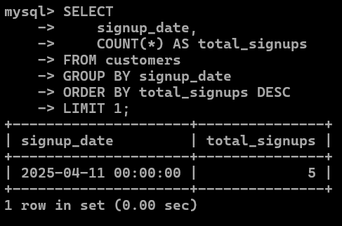
Fig 13: Date with the highest number of signups

Q4. Add a column for the day of signup, then find the day with the most signups
Data Transformation:
ALTER TABLE customers ADD COLUMN signup_day VARCHAR(15);
UPDATE customers SET signup_day = DAYNAME(signup_date);
Verification (new column):
SELECT signup_date, signup_day FROM customers LIMIT 15;
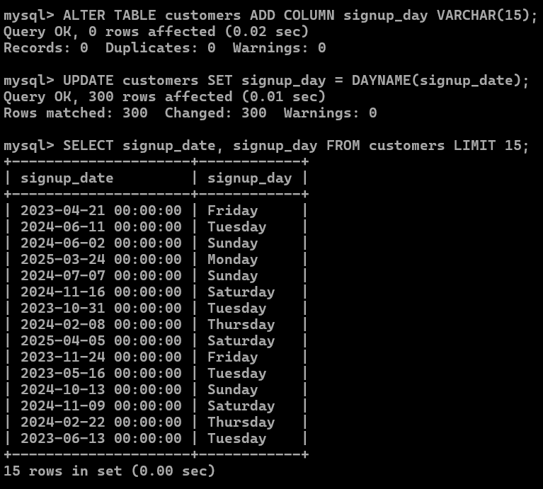
Fig 14: signup_day column populated using DAYNAME()

Q5. Finding the day with the highest number of signups:
SQL Query:
SELECT
signup_day,
COUNT(*) AS total_signups
FROM customers
GROUP BY signup_day
ORDER BY total_signups DESC
LIMIT 1;
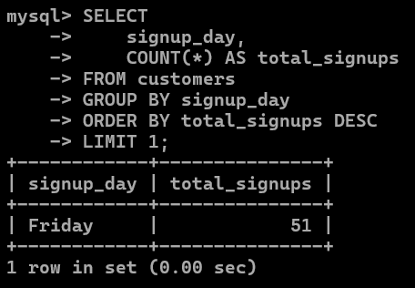
Fig 15: Day of the week with the highest signups

