**AI - Assistant Robot Using Arduino and Python**

**Introduction :**

Artificial intelligence (AI) assistant robots using Arduino are a type of robot that uses AI to perform tasks and interact with humans. They are typically made up of an Arduino microcontroller, a speech recognition module, and a natural language processing (NLP) module. The Arduino microcontroller is used to control the robot's movements, while the speech recognition module converts the user's spoken commands into text. The NLP module then analyzes the text and generates a response that is relevant to the user's needs.

**Component Used :**

1] Arduino nano -1x 2] Micro servo Sg90 – 3x

3] Ultra Sonic Sensor HCsr04 – 1x 4] Jumper wires

5] PVC Sheet 6] Bread Bord

**Software Used:**

1] Python3 2] Arduino IDE

**Circuit Diagram :**

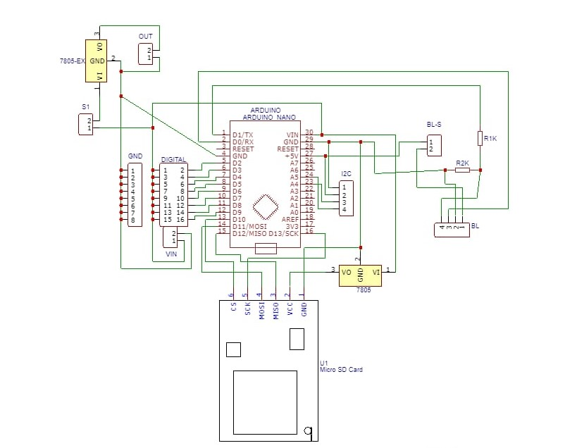

**Working Explanation :**

Firstly we need to connect the robot through USB connector and then we need to compile the Arduino code for servo motor moments and dump the code to Arduino.

Now we need to run python code

* While code is executed it will start to receive the voice command
* When we give the voice command it will take it as a input
* For example when we tell alexa please play music then it will take voice command, when it take voice command the robot will turn its neck to pc and make hand up and down for confermation and says yes boss then it will start processing and play the music on youtube.
* Like wise say anything it will work for that like open document folder , or open new tab etc….
* Actually the voice command will receive by laptop using the python code .
* Then the output will come from robot and it will say that yes boss and do what you have told.

For more information –

Visit- <https://ashrafminhajfb.blogspot.com/2020/11/make-ai-assistant-robot-with-arduino.html?m=1>