UNIX / LINUX COMMANDS

1. Basics from the below link:

<http://www.ee.surrey.ac.uk/Teaching/Unix/index.html>

This has 6 chapters and are pretty basic

1. [https://explainshell.com/explain?cmd=find+%2F+%5C%21+-name+%22*.c%22+-print](https://explainshell.com/explain?cmd=find+%2F+%5C%21+-name+%22*.c%22+-print)

**Explain shell is really good, interactive way to get little insight on what each word means in a command**

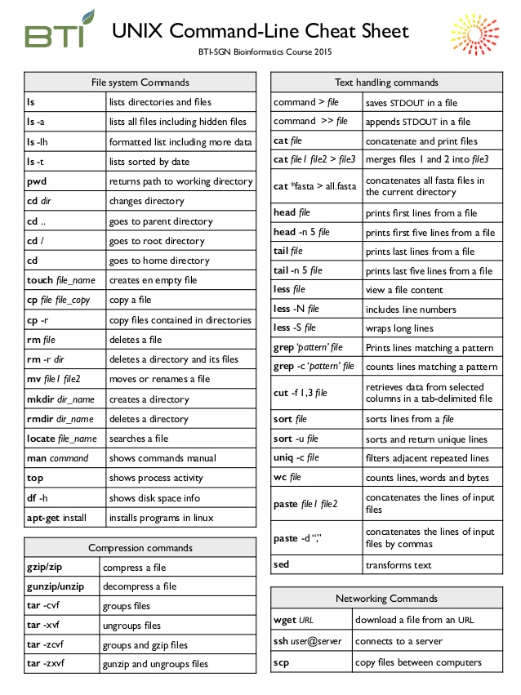

1. 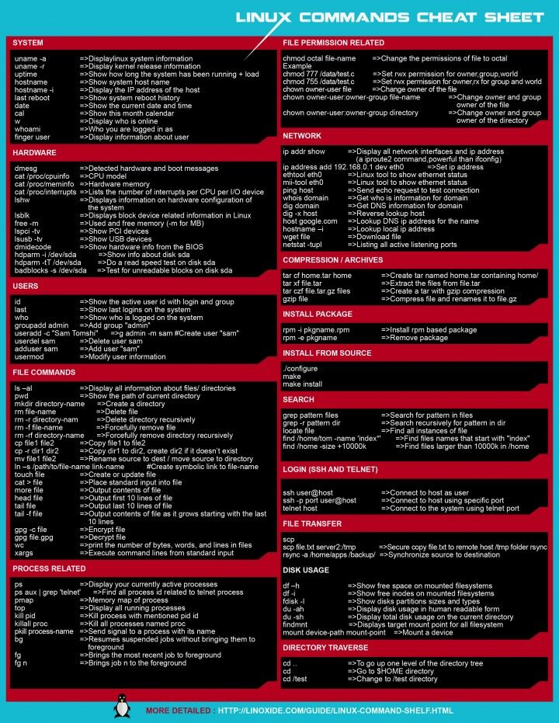
2. “ ls “ in detail

<https://www.rapidtables.com/code/linux/ls.html>

1. “ find “ command is good on terminal, type ‘man find’ and go through the default examples