THE WORLD CAME UNDER THE SWAY OF AI

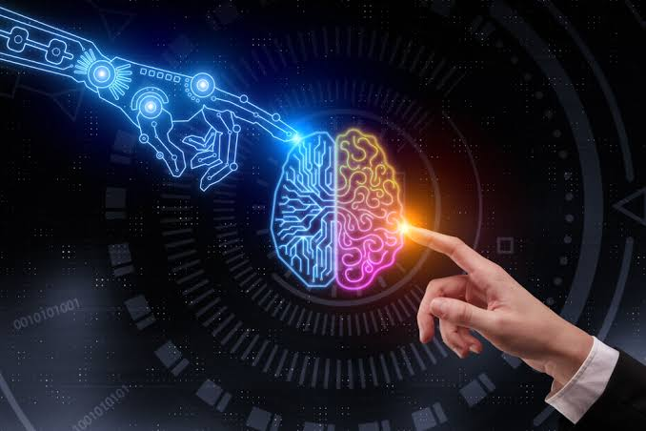

The privilege behind voice-powered personal assistants like Siri and Alexa, underlying technologies such as suggestive searches and autonomously-powered self-driving vehicles is Artificial Intelligence. Artificial Intelligence is trying to make computers think and act like humans.

The beginnings of modern AI can be traced to the classical philosopher's attempts to describe human thinking as a symbolic system. In the 1940s and 50s, a handful of scientists from a variety of fields like mathematics, psychology, engineering, economics, and political science began to discuss the possibility of creating an artificial brain. The field of artificial intelligence research was founded as an academic discipline in 1956.

Four types of AI differ in their complexity of abilities:

1. Reactive machines use previous data to conclude current decisions, such as a chess AI.
2. Limited memory uses live data to read a situation and make decisions, such as self-driving cars.
3. Theory of mind is something we haven’t reached yet, and deals with AI understanding that every entity has its own set of underlying concepts — such as motives, intentions and emotions.
4. Self-awareness is the final stage of AI, where an AI can not only understand others’ consciousness (theory of mind) but also has a concept of its existence.

Chatbots, smart cars, IoT devices, healthcare, banking, and logistics all use artificial intelligence to provide a superior experience. The finding companies like Google(Deep Mind), Amazon, Microsoft, Facebook, Apple are the top Artificial Intelligence companies. A true artificially-intelligent system is one that can learn on its own which can make connections and reach meanings without relying on pre-defined behavioral algorithms.

Why only AI?

  Artificial intelligence can help reduce human error, create more precise analytics, and turn data collecting devices into powerful diagnostic tools. The goal of keeping AI’s impact on society beneficial motivates research in many areas, from economics and law to technical topics such as verification, validity, security and control.

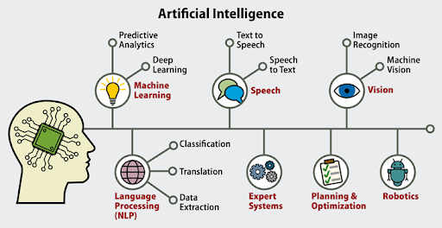

How can you get started?

  Though there are a lot of languages that you can start with, Python is what many prefer to start with because its libraries are better suited to Machine Learning. Research AI is rather academic and requires a heavy dose of math across a variety of disciplines before you even get to those parts that are specific to AI. This aspect of AI focuses on the algorithms and tools that drive the state of AI forward.

Want to program AI?

  Open application programming interfaces (APIs) are publicly available governing requirements on how an application can communicate and interact. Open APIs provide developers access to proprietary software or web services so they can integrate them into their programs.

What is the future of Artificial Intelligence?

  The field of cybernetics has already begun to meld with artificial intelligence and that trend is expected to continue. By incorporating AI technology into robotics, we’ll soon be able to enhance our bodies, giving us greater strength, longevity, and endurance. As artificial intelligence continues to evolve, these innovations will likely be overshadowed by even greater advancements.

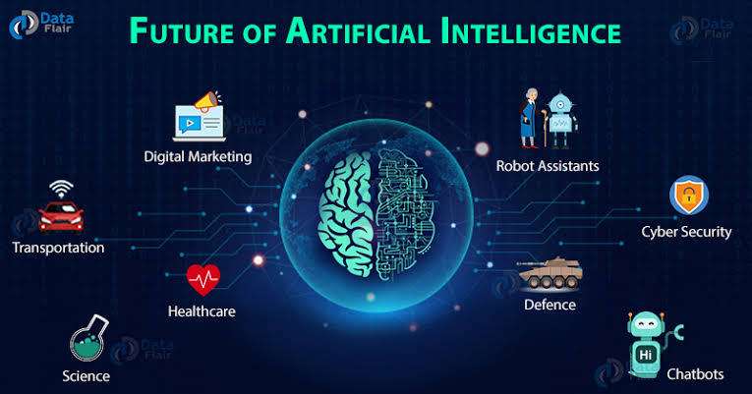

         Tech decision-makers are looking for ways to effectively implement artificial intelligence technologies into their businesses and, therefore, drive value. As we move closer toward becoming a technologically driven society, AI applications will fulfill the promise that computers would make our lives easier. AI technology will help us live happier and healthier lives, while also helping us conserve time, energy, and money.

### "Artificial Intelligence is not just software that is advancing. It is a way of life we are entering into."