Generative AI

An intermediate module in how generative AI works and how to use it in a small application. Students learn through diagrams, prepared Python notebooks and guided comparisons. The aim is to explain, adapt, test and justify a solution; research-level model training is optional.

7.1 Module overview
Field | Proposed descriptor
Module title | Generative AI
Module number | Institution to confirm. Review-pack number 01 is not an approved module code.
Stage of principal programme | 1
Semester | 2
Duration and ECTS | 12 teaching weeks; 10 ECTS retained from source.
Mandatory or elective | Mandatory, retained from source.
Weekly contact hours | 4 hours. Total learner effort is shown on the next page.
Pre-requisite and co-requisite | Basic Python functions, lists and notebooks; percentages and simple charts. Refresh arrays, probability and train/test separation through prepared examples. No prior generative AI, GPU setup or transformer implementation is required. Check readiness in week 1 and use supported practice within the planned workload. No formal co-requisite proposed.
Maximum learners | 70 per module instance; practical groups at most 25.
Capstone module | No. The module project is not a separate programme capstone.
Level of teaching | Intermediate application and analysis, using supported practice. Proposed outcome changes require academic validation.

7.1 Learning effort delivery and staffing
Learning activity | Hours
Lectures and supervised practice | 48
Reading and preparation | 60
Independent practice | 82
Assessment preparation and completion | 60
Total | 250

The source total is retained: 48 contact + 202 independent = 250 hours. Average total effort is 20.83 hours per week. Guided materials reduce complexity; they do not add hours. The source weekly-hours field means contact hours.

Teaching and learning modalities
Mode | Required effort
Full-time campus | 48 on-site contact hours plus 202 independent hours.
Part-time option in tracked source | 24 synchronous online + 24 asynchronous + 202 independent hours; total 250. Confirm the official Programme Schedule.

Staff qualifications and ratios
Role | Qualifications and preparation | Staff to learner ratio
Lecturer | Relevant master’s/PhD or institution-approved equivalent; teaching competence and recent applied AI experience. Rehearse each core lab. | 1:70 campus; 1:30 online option in S7
Tutor | Master’s in a relevant or cognate field, or approved equivalent; able to support the supplied practical work. | 1:25 proposed; source 1:70

Assessment techniques and contribution
Technique | Contribution
Project | 60%
Proctored in-person exam proposed | 40%

Section 7.7 gives dates, outcome mapping and individual marks. For Generative AI, the source exam/continuous-assessment conflict remains a decision for the programme owner; this proposal does not resolve it by assumption.

7.2 Minimum intended learning outcomes
Revised outcomes preserve the source module intent. Related programme learning outcome (MIPLO) numbers below are inherited from the source and remain provisional until checked against the approved programme outcomes.
Outcome on successful completion | Related MIPLO | Where demonstrated
LO1 Compare VAEs, GANs, diffusion models and transformer models using block diagrams, simple calculations and supplied results; explain one suitable use and one limitation of each. | 1, 4 | W1–4; project comparison; exam
LO2 Adapt a provided generative-model notebook and interpret a simple image or document example, explaining the main components and errors. | 1, 2 | W2–4 and W10; notebook; exam
LO3 Plan and interpret a small fine-tuning comparison using supplied or classroom-generated results and separate practice and final test data. | 2 | W9; adaptation study; exam
LO4 Evaluate generated outputs and retrieval using task metrics, human review, uncertainty and bias analysis. | 3, 5 | W1–12; evaluation report
LO5 Adapt a supplied Python starter into a small document-grounded application, validate its outputs and demonstrate access checks and recovery from one failure. | 1, 2 | W6–8 and W11–12; system demonstration

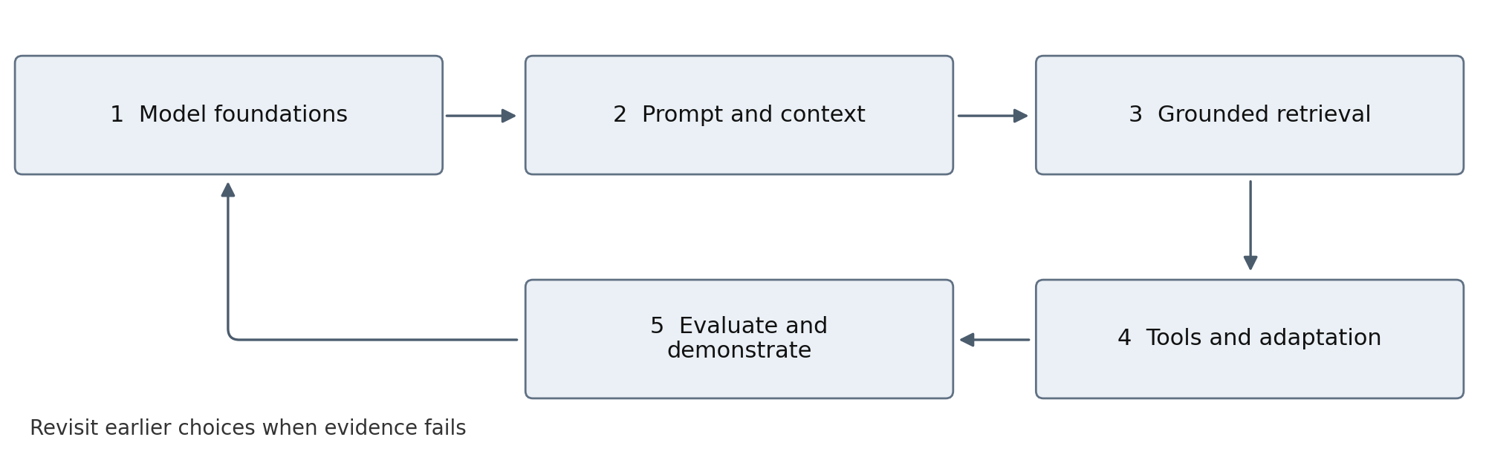
Teaching flow. Each stage produces evidence that informs the next stage; failed checks can send learners back to revise earlier choices.
Technical model and application foundations. AI for Developers extends this module into MCP, multi-agent comparisons, software engineering and operations.

7.3 Learning level and a simple system view
Target level: intermediate. Students should explain the main idea, complete a guided task, change one condition and justify the result. New technical terms are introduced with a worked example. Optional extensions add depth but are not required for the highest grade when the core outcomes are demonstrated well.
Area | Core expectation | Optional extension
Model families | Explain diagrams and compare supplied results. | Full VAE/GAN training and lengthy derivations.
Application | Modify one Python starter, one RAG flow and a calculator. | Independent framework design or public deployment.
Adaptation | Interpret supplied tuning results and recommend an approach. | Live LoRA/QLoRA training or reinforcement learning.

Useful words before the practical work
Term | Plain explanation
LLM | Large language model: a model that processes and generates language.
Prompt and context | The task instructions and information supplied for the current request.
RAG | Retrieval-augmented generation: find source material before drafting an answer.
Evaluation | Use agreed examples and checks to measure how well the system works.
Baseline | A simple starting method against which an AI approach is compared.
Fine-tuning | Further training that changes a model’s learned behaviour; it does not guarantee truth.

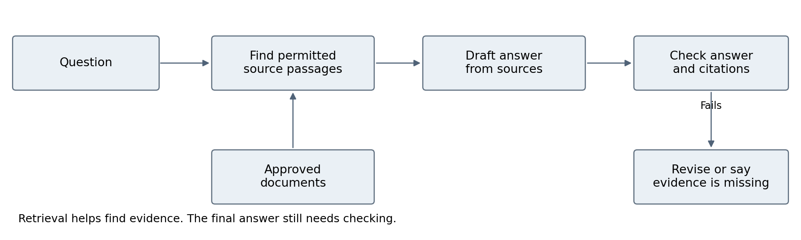
Teaching example: use five short college policies. Ask one answerable question and one question that the documents do not answer. [V6, V7]

7.3 Indicative module content organisation and structure

Weeks 1 to 4
Weekly pattern: 4 contact hours: 2 concepts and 2 guided practice. Activities use prepared materials. Evidence receives feedback unless Section 7.7 gives it a grade.
Week | Lecture topic | Lecture detail | Tutorial and evidence
1 | What generative AI does | Generation versus prediction; a model versus the surrounding application; why answers can be wrong. Introduce permissions and checking answers. [V1, V3] | Run a supplied text example. Compare ten answers with a manual answer sheet; repeat two prompts and note differences.  Evidence: Environment check and ten-case baseline; LO1 and LO4.
2 | VAE and GAN model ideas | A VAE compresses and reconstructs; a GAN learns through a generator and a discriminator. Interpret a supplied loss chart. Formal loss derivations are optional. | Label two block diagrams. Change one value in a prepared notebook and compare output images. Training both models is optional.  Evidence: Annotated diagrams, one notebook change and an error comparison; LO1 and LO2.
3 | Diffusion and generated media | Diffusion adds noise during training and learns to remove it during generation. Discuss conditioning, consent and image errors through examples. [V5] | Inspect a step-by-step denoising demonstration. Compare two prepared outputs using the same checklist.  Evidence: Image comparison, denoising explanation and source record; LO1 and LO2.
4 | Transformers without heavy mathematics | Tokens, attention and context through a small diagram. Compare encoder, decoder and encoder–decoder roles. Interpret a supplied attention grid; no derivation required. | Complete a worked attention worksheet and modify a supplied masking example. Coding attention from scratch is optional.  Evidence: Annotated attention example and explanation of a model choice; LO1 and LO2.

Before moving on, ask students to explain the main idea and show one change to the worked example. Revisit difficulties during the review session. Offer extension work when students are comfortable with the core task.

7.3 Teaching sequence continued

Weeks 5 to 8
Weekly pattern: 4 contact hours: 2 concepts and 2 guided practice. Activities use prepared materials. Evidence receives feedback unless Section 7.7 gives it a grade.
Week | Lecture topic | Lecture detail | Tutorial and evidence
5 | Clear prompts and output checks | Give the task, evidence and required format. Check required fields and missing information. A fluent explanation may still be wrong. | Improve a supplied invoice-extraction prompt and Python validation template. Try ten normal and missing-field examples.  Evidence: Before/after prompt and output-check table; LO4 and LO5.
6 | Finding useful information | Split approved documents into small passages; search for relevant passages; keep their source names and permissions. Explain embeddings as numerical representations. [V6] | Use a prepared search notebook with five short policies. Compare keyword and meaning-based search on ten questions.  Evidence: Corpus manifest and retrieval misses with evidence IDs; LO4 and LO5.
7 | Building and checking RAG | RAG means retrieving information before generating an answer. Check whether the source supports each answer and whether the system should say it lacks evidence. [V6, V7] | Extend the same starter. Compare two search settings on 20 supplied practice questions; reserve ten separate questions for final checking.  Evidence: Retrieval and answer-check table with chosen setting; LO4 and LO5.
8 | Tools and controlled actions | A tool performs a defined task. A workflow follows fixed steps; an agent can select its next step. Validate requests and obtain required approval before actions. [V8, V9] | Add one read-only calculator from a template. Walk through a teacher-supplied mock-action approval flow and one blocked request.  Evidence: Tool result, approval-flow explanation and one failure test; LO4 and LO5.

7.3 Teaching sequence continued

Weeks 9 to 12
Weekly pattern: 4 contact hours: 2 concepts and 2 guided practice. Activities use prepared materials. Evidence receives feedback unless Section 7.7 gives it a grade.
Week | Lecture topic | Lecture detail | Tutorial and evidence
9 | When fine tuning helps | Compare clearer prompts, RAG and fine-tuning. LoRA changes a small set of trainable parameters. Read supplied before/after results; live tuning and QLoRA are optional. [V12] | Use a prepared results pack to compare base, prompted and tuned outputs on separate test cases. Recommend tuning or explain why it is unnecessary.  Evidence: Comparison table and adaptation recommendation; LO3 and LO4.
10 | Working with an image or document | Multimodal AI accepts more than one type of input. Focus on one invoice or chart; distinguish reading a value from checking its correctness. | Use a prepared document-input example. Check extracted fields and calculate totals independently.  Evidence: Field-check table and source-linked output; LO2 and LO4.
11 | Testing and classroom delivery | Keep settings and tests with the application. Protect keys, remove sensitive log content and restore an earlier working version. Define a classroom release checklist. [V7, V9] | Run the starter in the managed classroom environment. Test a missing source, invalid input and one rollback; explain cost per successful answer.  Evidence: Deployment instructions, privacy-filtered trace and release decision; LO4 and LO5.
12 | Final demonstration and explanation | Bring together model understanding, the document assistant and evidence of checking. Compare with week 1 and explain remaining limitations. | Demonstrate the small application. Each learner explains a previously practised type of failure using a fresh example.  Evidence: Project submission and individual individual check; LO1–5.

7.4 Work based learning and practice placement
No placement is required. Use simulated organisational cases and approved public or synthetic data. An optional employer case must use the same outcomes, data controls and assessment criteria; access to an employer is not a condition of success.

7.5 Specific resources required
Resource | Requirement
Learning environment | Moodle or equivalent LMS, accessible readings, captioned demonstrations, downloadable worksheets and dated assessment briefs.
Learner access | Browser-capable laptop and institution-managed desktop fallback. No requirement to buy an AI subscription or own a GPU.
Primary practical environment | Python, notebooks, Git, isolated environments and tested starter repositories. Use one main deep-learning framework and one retrieval/orchestration stack; other implementations are comparative.
Data and evaluation | Small versioned corpus, synthetic records, annotation guide, development cases and separately separate final cases. Maintain data licences, source IDs and access roles.
Accounts and operations | Institution-managed credentials, per-project quotas, privacy-filtered traces, retention limits and named technical support. A replay dataset supports outages.
Specialist resources | Shared scheduled GPU only for approved small-model experiments. Provide checkpoint/log alternatives with equivalent analytical outcomes; pilot memory use before booking hardware.

7.6 Teaching learning and assessment approach
Use the teaching pattern in S2–S6: start with a familiar analogy, show the real components, demonstrate one success and one failure, let learners practise, then measure and explain. Keep the analogy separate from the technical claim. The open-book analogy introduces retrieval; the chef and kitchen analogy separates a model from the system; the connector analogy introduces MCP without implying permission or safety.
Before class, learners attempt a short question and read the assigned material. In class, the teacher models the task, learners complete a guided version and then change one condition independently. End with a brief explanation or error diagnosis. This adapts the practical orientation of OpenAI Academy and Claude Academy to the proposed adult-learning context. [V3, V4]
Supply readable tables, accessible figures and captioned media. Offer written or practical alternatives to live speaking where approved accommodations require them, while preserving individual demonstration of competence. Use a diagnostic and feedback clinic rather than assuming every learner has the same technical starting point.

7.6 Guided teaching and manageable assessment
Use one continuing case and one main platform. Give students the starter files, expected output, a worked example and a short checklist. The teaching sequence below is a suggested design for this curriculum, informed by the practical learning resources in Section 7.9; it is not a vendor-certified syllabus.
Part of a 120 minute practice block | Minutes | Teacher and learner actions
Recall and vocabulary | 10 | Use three short questions; introduce the terms needed today.
Teacher demonstration | 20 | Show one successful example and one common error.
Guided pair practice | 40 | Follow the worksheet with checkpoints and help available.
Individual change | 25 | Change one input or setting and explain the effect.
Compare and review | 15 | Use the same checklist; discuss evidence and limitations.
Exit check and feedback | 10 | Explain the idea in plain language and name the next improvement.

The 120 minutes are part of existing contact time. In the 3-hour assurance module, use a 90-minute practice block: 10 + 15 + 25 + 20 + 10 + 10 minutes in the same order. Use the remaining contact time for concepts, worked cases and supported review. Schedule breaks within the institution’s timetable.
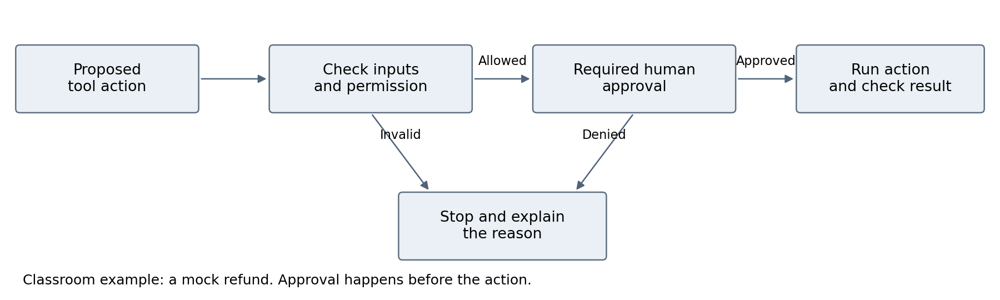
Support decision | Delivery rule
Teacher preparation | Run the supplied lab once, rehearse the failure case and retain screenshots or recorded outputs for an outage.
Student support | Use one new tool at a time. Revisit weak concepts during planned review periods before introducing an extension.
Workload | Weekly outputs build the existing portfolio or project. Avoid separate long reports for every exercise; a short table or annotated notebook is enough.
Assessment level | A fresh question uses a practised task type. Reward clear reasoning, evidence and checked results. Optional tool complexity earns no automatic extra marks.

7.7 Summative assessment strategy
All weightings below are proposed for departmental approval. They total 100%. Formative work receives feedback but no additional hidden weighting. Institutional rules determine pass thresholds, compensation, accommodations and reassessment timing.
Assessment | Weight | Due | Outcomes | Evidence and individual attribution
Group project | 60% | W12 | LO1–5 | Teams of 2–3. Shared implementation 40 percentage points; individual experiment and individual explanation 20 points.
Proctored examination | 40% | After W12 | LO1–3 | Two hours. Label diagrams, interpret supplied outputs, complete simple calculations and justify choices. No model training or unfamiliar code from scratch.

Approval issue: S7 reviewer comments identify a conflict with a Programme Schedule showing 40% continuous assessment. This proposal uses the descriptor narrative of a 40% examination. The programme owner must select and align one route before publication; the schedule is not inferred to be approved here.
AI-assisted work must include the tools used, relevant prompts or interaction summaries, checked sources, tests, corrections and the learner’s own explanation. Require short individual challenge questions and evidence of process. Do not use AI-detection scores as the sole basis for an authorship decision.

7.8 Sample assessment materials
Adapt the provided Python starter into a policy assistant for a fictional college. Use five short policies, source-linked answers and one read-only calculator. Test 20 supplied practice questions and ten separate final questions. Submit a separate small model-family comparison and fine-tuning results worksheet; neither needs a live training job. The multimodal exercise can remain a separate notebook.
Sample exam tasks: label a transformer block diagram; explain why an answer lacks evidence; read a supplied training curve; decide whether an out-of-date policy needs document updates or fine-tuning. Use the same task formats in practice. No lengthy mathematical derivations.

Assessment criteria
Criterion | Share of marking guide
Architecture and generative concepts | 20%
Working starter modifications and multimodal worksheet | 20%
Adaptation results and separate test comparison | 20%
Evaluation and failure analysis | 20%
Controls and deployment boundary | 10%
Individual explanation and attribution | 10%

Apply this marking guide to the relevant project or capstone evidence, then scale to its assessment weighting. Mark each learner’s designated individual evidence separately. Outstanding work is repeatable and critically justified; adequate work meets the brief with stated limits; weak work relies on unsupported claims or cannot be explained by its author.

7.8 Assessment evidence and reassessment
Evidence area | Review requirement
Baseline and evaluation | Keep task definition, datasets, source versions and configuration fixed for comparisons. Use a development set for improvement and a separate final test set; report denominators, failed cases and repeated-run variability.
Application evidence | Working Python repository, setup instructions, small approved dataset, schema/unit tests, evaluation runner, privacy-filtered traces and a demonstration of permission checks and recovery.
Suggested review gates | On the designated course test set: zero unauthorised successful writes or cross-user data disclosures; every consequential mock write has a logged approval; every run ends within its configured limits. Report correctness and latency against pre-agreed task thresholds.
Metric definitions | Retrieval recall@k: relevant items retrieved divided by relevant items available for each query. Citation support: checked material claims supported by cited evidence divided by checked material claims. Task success: completed tasks satisfying the marking guide divided by attempted tasks.
Cost and uncertainty | Cost per successful task = all run costs, including failures and retries, divided by successful tasks. Report no finite value if none succeeds. Record token, tool, retrieval and hosting costs plus human review where measured.
Failure challenge | Diagnose an unseen stale-source, invalid-argument, timeout or access-control case. Explain the affected layer and design a test before changing the system.

Reassessment and learner support
Proposed reassessment uses a new or substantially revised individual project and an individual defence mapped to every outcome. Supply a fresh case or changed constraints so the learner demonstrates competence. For an examination route, the assessment board must confirm whether an examination is also required by programme regulations. Feedback identifies the failed outcome and the evidence needed for a repeat attempt.
Early checkpoint at W4: problem and first evidence. Midpoint at W8: working approach and failure analysis. Final checkpoint at W12: comparison, handover and individual defence.

Appendix A Source audit and proposed upgrades
This table distinguishes material already present from the proposed changes. Source section references refer to the uploaded descriptor; weekly schedules in nested Word tables were included in the review.
Source location | Existing position or gap | Proposed change
S7 sections 7.1 and 7.6 plus reviewer comments | Exam versus continuous-assessment disagreement with the Programme Schedule is unresolved. | Keep 60/40 for review; propose the stated exam route. Programme owner must reconcile the official schedule before approval.
S7 weeks 2–6 | Separate full labs for VAE, GAN, diffusion and transformers crowd out applied systems work. | Use diagrams, simple calculations and one prepared notebook. Keep comparison outcomes; make full training and mathematical derivations optional.
S7 week 12 and LO5 | RAG and agents appear only in the last week despite the deployment outcome. | Move retrieval to W6–7 and clearly limited tools to W8; assess integration at W12.
S7 sections 7.1 and 7.5 | No prerequisite despite advanced coding; 202 hours labelled Other; the source tutor ratio is 1:70. | Add a readiness check, label independent study and propose a 1:25 practical ratio. Use templates and managed environments.
S7 tracked changes | Part-time version specifies 24 synchronous and 24 asynchronous hours; online lecturer ratio 1:30. | Retain this as a delivery option, distinct from the 48-hour campus version, subject to schedule confirmation.
S7 reading-list comment and S2–S6 | Need current primary readings, explicit evaluation and reliable control design. | Add versioned documentation, test datasets and failure evidence; avoid performance guarantees.

Decisions for the Head of Department
Confirm the revised outcomes and their MIPLO mapping; assessment routes and individual attribution; prerequisite/readiness policy; staffing; delivery mode; approved platforms and data; and the reading refresh owner. This proposal does not change an approved award, institutional policy or programme schedule by itself.
The four updated modules remain separate descriptors with their original duration and ECTS. The two new pathway plans organise teaching across a longer learning journey. Their content maps are not automatic exemptions or additional credits.

Review record and changes in this version
Check | Result or required action
Source structure | The four descriptors retain Section 7.1–7.9 headings, overview fields, learning outcomes, weekly lecture/tutorial tables, resources and assessment sections.
Learning level | Core tasks use templates, prepared examples and a single continuing case. Advanced implementations are explicitly optional.
Hours and marks | Original module ECTS and total hours retained. Assessment percentages total 100%; individual evidence and deadlines are explicit.
Outcomes and teaching | Weekly evidence is mapped to the stated outcomes. Revised outcomes and inherited MIPLO mappings require programme approval.
Teacher readiness | The teacher needs a completed core example, failure example, answer guide and access fallback. A timed pilot is required before launch.
References | Readings use official Google, NVIDIA, OpenAI, Microsoft and Anthropic resources. Each reference records its contribution.
Validation boundary | Content and layout checks are complete. Programme approval is pending. Recheck the selected platforms before teaching begins.

Local source key
S7 = Descriptor - Generative AI (new).docx. S2 = RAG notes; S3 = AI agents; S4 = MCP and vector databases; S5 = multi-agent systems; S6 = evaluation and fine-tuning. The source filenames and full eleven-file mapping appear in the pathway plans.

Changes to the teaching plan
The revised plan uses guided practice at intermediate level. Students interpret prepared model-training results; more complex implementation is optional. Weekly tables set out lecture content, practical work and assessment evidence. The diagrams introduce the teaching sequence, document retrieval and approval before an action. Preparation notes identify what the teacher needs for each class.

Decisions still requiring the department
Confirm award-level alignment, revised outcomes, assessment regulations, staff equivalence, delivery mode and approved learning platforms. The Generative AI descriptor contains a source disagreement over the 40% exam versus continuous-assessment route; the programme owner must reconcile the official schedule before publication.

7.9 References and curriculum inspiration
External references are limited to official Google, NVIDIA, OpenAI, Microsoft and Anthropic/Claude resources. These resources informed topic selection and examples. The sequence, hours, assessments and diagrams are this curriculum’s proposed design; the companies have not endorsed it.
Company | Inspiration used in this curriculum
Google | Clear model explanations and progression from introductory ideas to application practice. [V1, V2]
NVIDIA | Application building, retrieval and evaluation as practical learning topics. Select relevant excerpts; advanced infrastructure remains optional. [V5]
OpenAI | Prompting and review habits, teacher preparation and task-based evaluation. [V3, V7]
Microsoft | Grounded search, readable assurance tools and responsible adoption. [V6, V10, V11]
Anthropic Claude | Human judgement, workflow/agent distinctions and simple system design. [V4, V8]

Core learning resources
V1 Google Cloud Generative AI beginner guide. Model concepts and accessible explanations. Open official resource
V2 Google Cloud Machine learning and AI training. Progression from foundations to applied practice. Open official resource
V3 OpenAI OpenAI Academy. Prompting, review, workplace use and teacher preparation. Open official resource
V4 Anthropic Claude Claude Academy. Human judgement and effective collaboration with AI. Open official resource
V5 NVIDIA Generative AI and LLM learning paths. Selected application, retrieval and evaluation topics; advanced infrastructure is optional. Open official resource
V6 Microsoft RAG and generative AI in Azure AI Search. Document retrieval and source-grounded application design. Open official resource
V7 OpenAI Evaluation best practices. Task-based tests and checking model output quality. Open official resource
V8 Anthropic Claude Building effective agents. Simple workflows, agent choices and increasing complexity only when useful. Open official resource
V9 OpenAI Safety in building agents. Untrusted inputs, tool approvals and control checks. Open official resource
V10 Microsoft Responsible AI dashboard. Explanation, error analysis, what-if examples and their different purposes. Open official resource
V11 Microsoft Responsible AI policies and practices. Practical responsibility and governance discussion. Open official resource
V12 NVIDIA NeMo Framework overview. Teacher background on model adaptation; use supplied results for the core class. Open official resource

