WEEK 03 · TEACHING NOTES
Generative Adversarial Networks (GANs)
Learning to generate by competition: the adversarial game, its training challenges, variants and evaluation
Generative AI · MSc in Artificial Intelligence · 2-hour lecture + 2-hour lab
Descriptor Section 7.3 (revised) for this week
Lecture topic | Generative Adversarial Networks (GANs)
Detail | Motivation for adversarial learning. GAN Architecture (Generator, Discriminator). GAN Objective Function (minimax game, non-saturating loss). Training Challenges (mode collapse, instability, vanishing gradients) and stabilisation techniques (e.g. Wasserstein loss, spectral normalisation). Variants (e.g. DCGAN, cGAN, Pix2Pix / CycleGAN, StyleGAN). Evaluation of GANs (FID, Inception Score, precision and recall, human judgement). Applications of GANs, including super-resolution, image-to-image translation and adversarial distillation of fast diffusion models; misuse such as deepfakes.
Tutorials | Implementing a GAN (DCGAN) in PyTorch.  Visualizing generator outputs across epochs and diagnosing training through losses and mode collapse.  Exploring latent space interpolations.
Module learning outcomes (MIMLOs) practised this week
MIMLO 1: Critically explain the core concepts and mathematical principles underlying generative AI, and demonstrate in-depth knowledge of major generative AI model families, including VAEs, GANs, diffusion models and transformer-based LLMs.
MIMLO 3: Design, implement and fine-tune generative AI models using contemporary frameworks and parameter-efficient methods.
MIMLO 4: Critically evaluate generative AI outputs using quantitative metrics, human-centered assessments and ethical considerations, including fairness, bias and hallucination risks.
What is in this week's folder
Lecture slides | 44 slides with speaker notes, vocabulary and technical diagrams.
Teaching notes | Lecture explanations, worked examples, code maps, practice questions and readings.
Student lab | Notebook and Python file with TODOs. Embedded and separate diagrams accompany the lab.
Lab solutions | Instructor notebook and Python file with completed code and model answers.

Lecture plan at a glance
GANs are the second deep generative family. Students should leave able to write the minimax objective, derive the optimal discriminator, explain the non-saturating loss, recognise the failure modes and explain FID. All sample images in the slides come from real models trained with the lab code (curriculum/assets/make_week_03.py).
Time | Slides | Segment | What you do
0–6 min | 1–5 | Warm-up | Forger and detective; collect three answers (feedback, detective too strong, one repeated trick).
6–21 min | 6–11 | 1 · Why adversarial? | Learned loss for realism; architecture; roles; analogy and its limits.
21–51 min | 12–19 | 2 · The objective | Minimax, optimal D and JSD (derive on the board), non-saturating loss, training step code. Quiz.
51–58 min | – | Break
58–80 min | 20–26 | 3 · Challenges and fixes | Real curves; mode collapse experiment; failure table; WGAN-GP; stabilisation; quiz.
80–102 min | 27–33 | 4 · Variants | DCGAN architecture and real samples; conditional GAN; pix2pix, CycleGAN, StyleGAN, BigGAN; cycle loss; interpolation.
102–118 min | 34–40 | 5 · Evaluation, applications, risks | FID and metrics table; GANs in 2026; deepfakes; VAE vs GAN summary.
118–120 min | 41–44 | Lab preview, summary, resources

Teaching tip: The derivation of the optimal discriminator takes three lines on the board and is a very common exam question. Do it live rather than only showing the slide.

The four supporting slides fit within the existing lecture segments. Use the starting vocabulary and overall flow during the introduction, the mechanism diagram beside the first detailed explanation, and the lab flow during the lab preview. Pause for predictions before showing a worked example.

Beginner walkthrough
Read the overall flow before the detailed theory. Each numbered block performs one operation. The text below a block names the data it passes on. A feedback line means the system repeats an operation. The code names match this week's lab so you can follow the same example in the slides and notebook.

Starting vocabulary
Term | Plain meaning | Check your understanding
Neural-network weights | Learned numbers used to transform an input into a prediction. | Which operation changes weights: opt.step or plotting a sample?
Binary classification | Predicting between two labels, here real and generated. | In this lab, is label 1 used for real or generated images during the discriminator update?
Gradient | A measure of how changing a quantity would change a loss. | Why must a generator receive feedback about its output to improve?

A GAN learns from a discriminator
Two networks learn different tasks; only the generator creates new images.
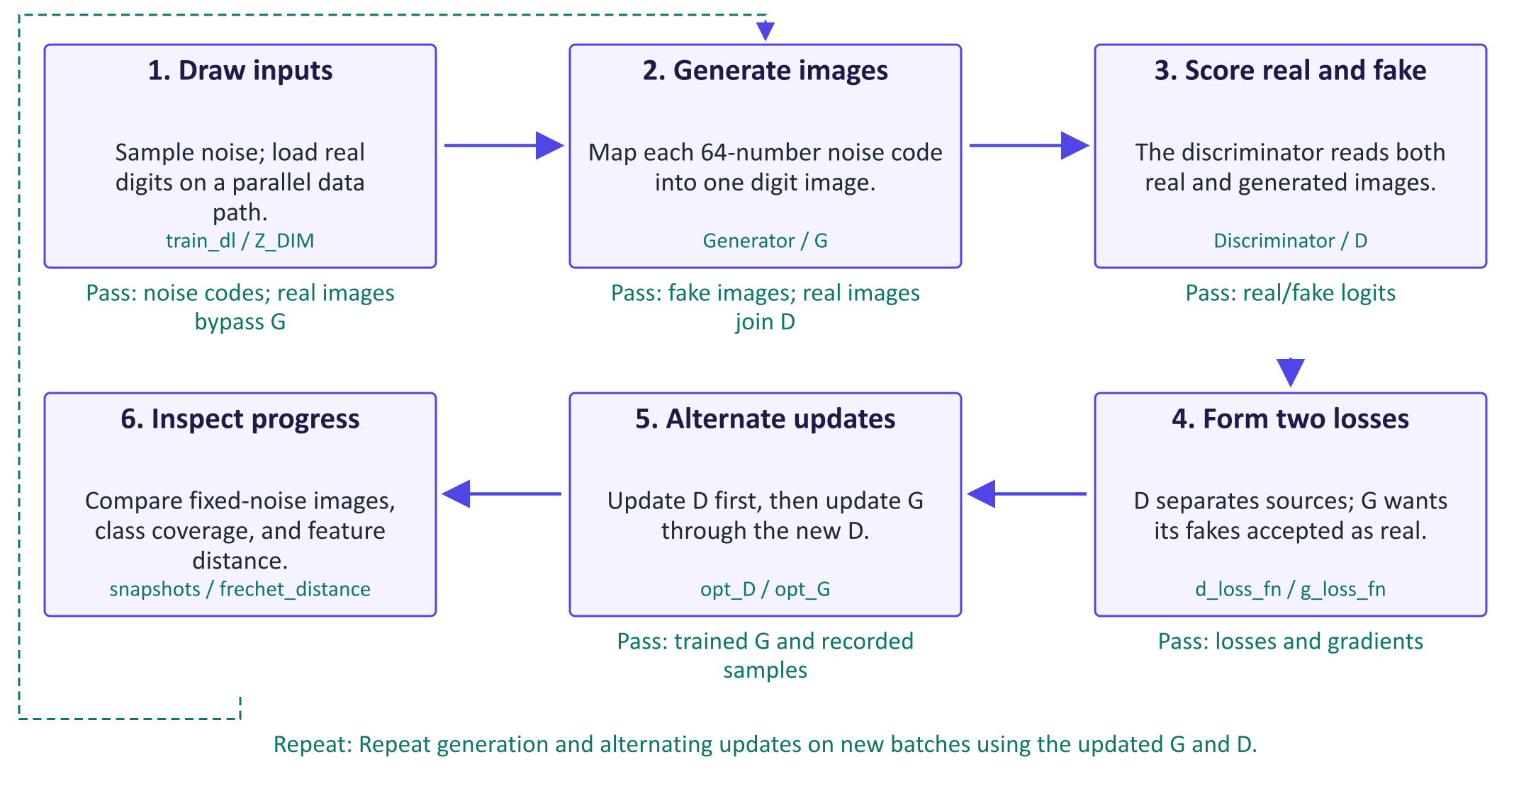
A GAN learns from a discriminator
A generative adversarial network, or GAN, contains two networks with different jobs. The generator G transforms a random latent code into an image. The discriminator D judges whether an image came from the dataset or the generator. Real images follow a separate path into D; they do not pass through G. Training alternates two updates. The discriminator learns to assign real labels to dataset images and fake labels to generated ones. The generator then learns to make its images receive the real label from the updated discriminator. Gradients from D guide G even though G never receives a matching target digit for each noise code. This creates a moving learning problem: improving either network changes the other network's task. Loss curves alone cannot show success. The lab compares fixed-code snapshots, predicted digit coverage, and a custom feature distance. Generation after training needs G and a fresh code, without D.

Worked example
- A real MNIST batch is scaled to [-1, 1]; G receives separate Gaussian codes of length 64.
- G upsamples each code through 7×7, 14×14, and 28×28 feature grids.
- D scores real images and detached fake images; opt_D updates D using source labels.
- The original connected fakes pass through updated D; opt_G improves their real-labelled score.
- After training, draw new codes and use G alone; inspect both image quality and diversity.
Check your understanding. Which networks must run to generate a new digit after training?
Instructor explanation. Only G is needed. D supplied training feedback but is not part of the generation path.

One alternating GAN update
Detach fakes for the D update; keep G connected for its own update.
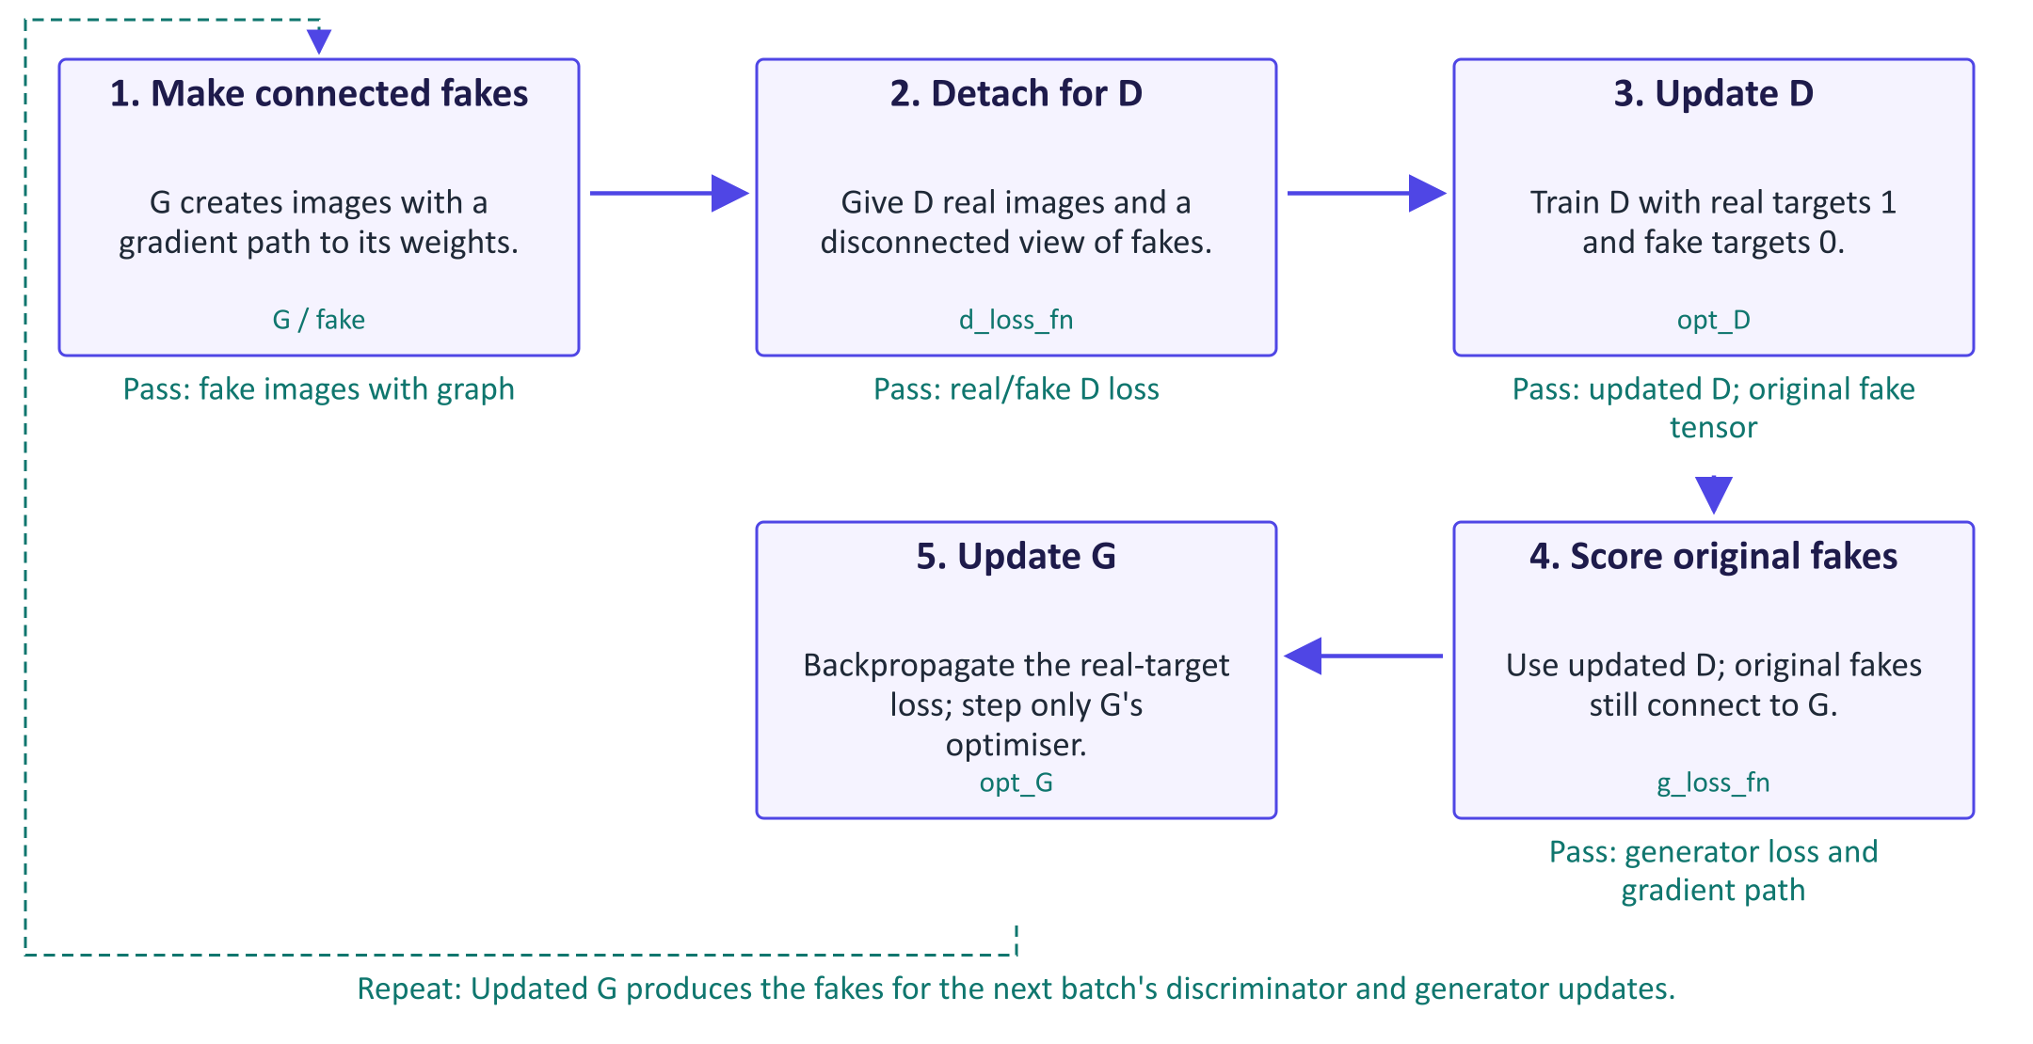
One alternating GAN update
The important distinction is between a tensor's values and its gradient connection. fake.detach supplies the same image values to D while cutting the route back to G for that operation. This lets the discriminator learn from generated images without updating the generator from the discriminator's loss. The original fake tensor remains connected to G. After opt_D changes D's weights, g_loss_fn sends that original tensor through D and asks for the real label. This non-saturating generator objective rewards fakes that D accepts. Backpropagation follows the chain from the loss through D's operations, through the fake image, and into G's weights. The optimiser step then changes only the parameters registered with opt_G. The labels therefore serve different purposes in the two updates: fake means 0 when training D, but G's desired target is 1. Repeat this sequence for each training batch.

Worked example
- Suppose D confidently rejects a generated digit; that creates a large real-target generator cost.
- During the D step, fake.detach blocks gradients from reaching G through that loss.
- During the G step, g_loss_fn uses the original fake so gradients can travel through D to G.
- opt_G steps G's parameters; the discriminator is a scoring route rather than the optimiser target.
Check your understanding. Why would detaching fake inside g_loss_fn stop the generator from learning?
Instructor explanation. It would cut the gradient path from the generator loss back to G's weights.

Train, inspect, and evaluate a GAN
Check visual quality and coverage with evidence beyond the training loss.
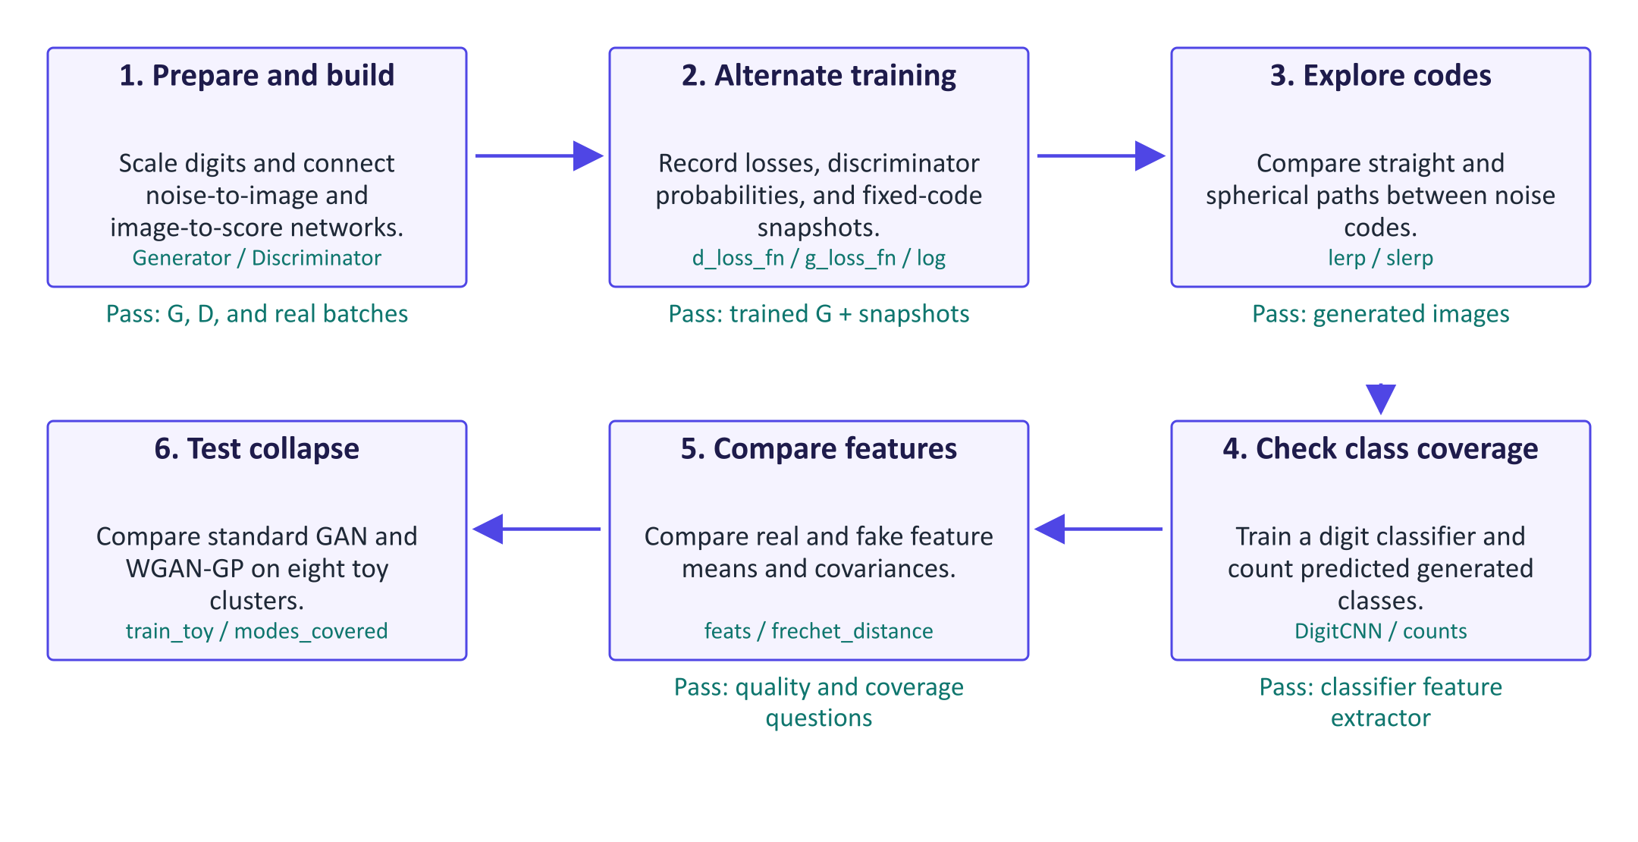
Train, inspect, and evaluate a GAN
The lab asks two separate evaluation questions: do the images resemble digits, and does the generator cover varied digits? Fixed-noise snapshots answer a visual progress question because each epoch uses the same input codes. The digit classifier estimates class coverage, but its mistakes can distort the histogram, so first check its test accuracy and inspect samples. Its hidden features also define a custom Fréchet distance. This compares two sets of feature vectors through their means and covariance matrices; it is not the standard Inception-based FID. Real-versus-real features provide a reference for finite-sample differences. Keep the feature network, preprocessing, and sample count fixed when comparing generators. The toy ring makes missing modes easy to see. WGAN-GP changes the scoring objective and adds a gradient penalty, so its training feedback differs from ordinary real/fake classification. Better toy coverage is evidence for that experiment, not a guarantee for every dataset.

Worked example
- Reuse z_fixed across epoch snapshots so image changes reflect training rather than new noise inputs.
- Compare lerp and slerp images and midpoint norms; neither path guarantees valid digits.
- Check the classifier's test accuracy before trusting its histogram of 2,000 generated digits.
- Compare real-versus-real, epoch-1, final, and uniform-noise feature distances using the same clf.
- On the eight-cluster ring, inspect both the scatter plots and modes_covered for each trained system.
Check your understanding. Can a low feature distance alone prove that every digit class is represented?
Instructor explanation. No. Inspect the coverage histogram and samples as well; the feature statistic summarises only some aspects of the distribution.

Where to look in the code
Code symbol | What it does | What to inspect
Generator.forward | Maps one latent code to one 28 by 28 image. | Follow the code reshape and three spatial sizes in the transposed convolutions.
Discriminator.forward | Maps each image to one real/fake logit. | Compare its output shape with the batch of targets.
d_loss_fn | Trains D to separate real and generated sources. | Find the detached fake path and distinguish the two target labels.
g_loss_fn | Supplies generator feedback through D. | Check that the original fake tensor remains connected to G.
frechet_distance | Compares distributions of features extracted by the same classifier. | Identify means and covariance matrices; compare the real-versus-real reference.
gradient_penalty | Regularises the toy Wasserstein critic on real/fake interpolates. | Distinguish gradients with respect to input points from gradients updating model weights.

Common points of confusion
- A discriminator output near 0.5 can reflect balance or poor learning; inspect images and coverage as well.
- A generator does not reconstruct the corresponding real training image for each random code.
- The DigitCNN feature distance has its own scale and cannot be directly compared with reported Inception FID values.

Quick glossary
Generator. A network that transforms a random code into a generated example.
Discriminator. A network trained to distinguish dataset examples from generated examples.
Logit. An unnormalised classification score; sigmoid turns a binary logit into a probability.
Detach. Keep tensor values while disconnecting their gradient path for an operation.
Non-saturating loss. The generator objective that asks D to label generated samples as real.
Mode collapse. A generator produces only a small part of the variety present in the training distribution.
Feature vector. A numerical representation extracted from an intermediate layer of a network.
Gradient penalty. A training cost encouraging the critic's input-gradient norm to stay near one on sampled interpolates.

Lecture notes

1. Why adversarial learning?
VAEs are trained with pixel-wise likelihoods. When the model is uncertain, the likelihood is maximised by predicting the average of the plausible images, which looks blurry. "Realism" is hard to write as a formula, but it can be learned: train a classifier to distinguish real images from generated ones, and use that classifier as the loss for the generator. This is the idea of a generative adversarial network (GAN) (Goodfellow et al., 2014).
- The generator G maps noise z ~ p(z) (typically N(0, I), 64–512 dimensions) to a sample G(z).
- The discriminator D maps a sample to the probability that it is real.
- G never sees real data directly; it learns only from gradients passed back through D.
GANs are implicit generative models: we can sample from them, but they give no density p(x). This rules out likelihood-based evaluation and anomaly detection, and is why GAN evaluation uses sample-based metrics such as FID.
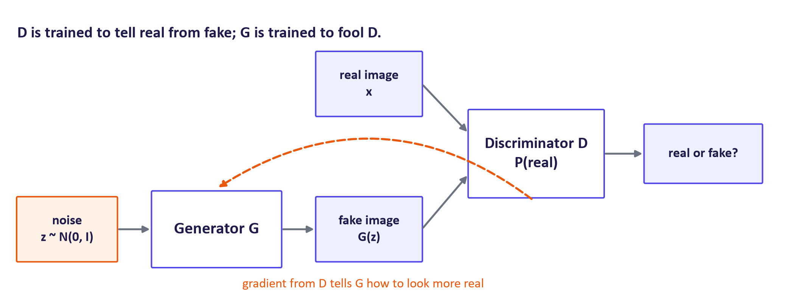
GAN architecture
Key idea: A GAN replaces a hand-written loss ("be close pixel by pixel") with a learned, adaptive loss ("be indistinguishable from real data"). The price is that training becomes a two-player game rather than the minimisation of a fixed function.

2. The GAN objective

The minimax game
For the discriminator this is (the negative of) the binary cross-entropy of a real-vs-fake classifier with labels 1 for real and 0 for fake. The generator appears only in the second term.

The optimal discriminator (derivation)
Write the expectation over fakes as an expectation over the generator's distribution pg. For a fixed G:
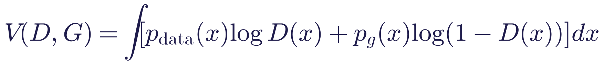
For each x, the function a log y + b log(1 - y) is maximised at y = a/(a + b). Hence
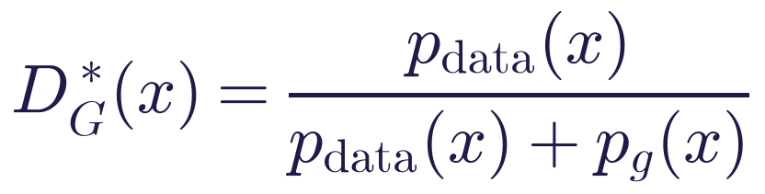
Substituting back gives
where the Jensen–Shannon divergence JSD(p‖q) = ½ D_KL(p‖m) + ½ D_KL(q‖m) with m = ½(p + q) is symmetric, non-negative and zero only when p = q. So, with an optimal discriminator and unlimited capacity, the generator minimises the JSD, and the global optimum is pg = pdata, where D^ = ½* everywhere and V = -log 4.
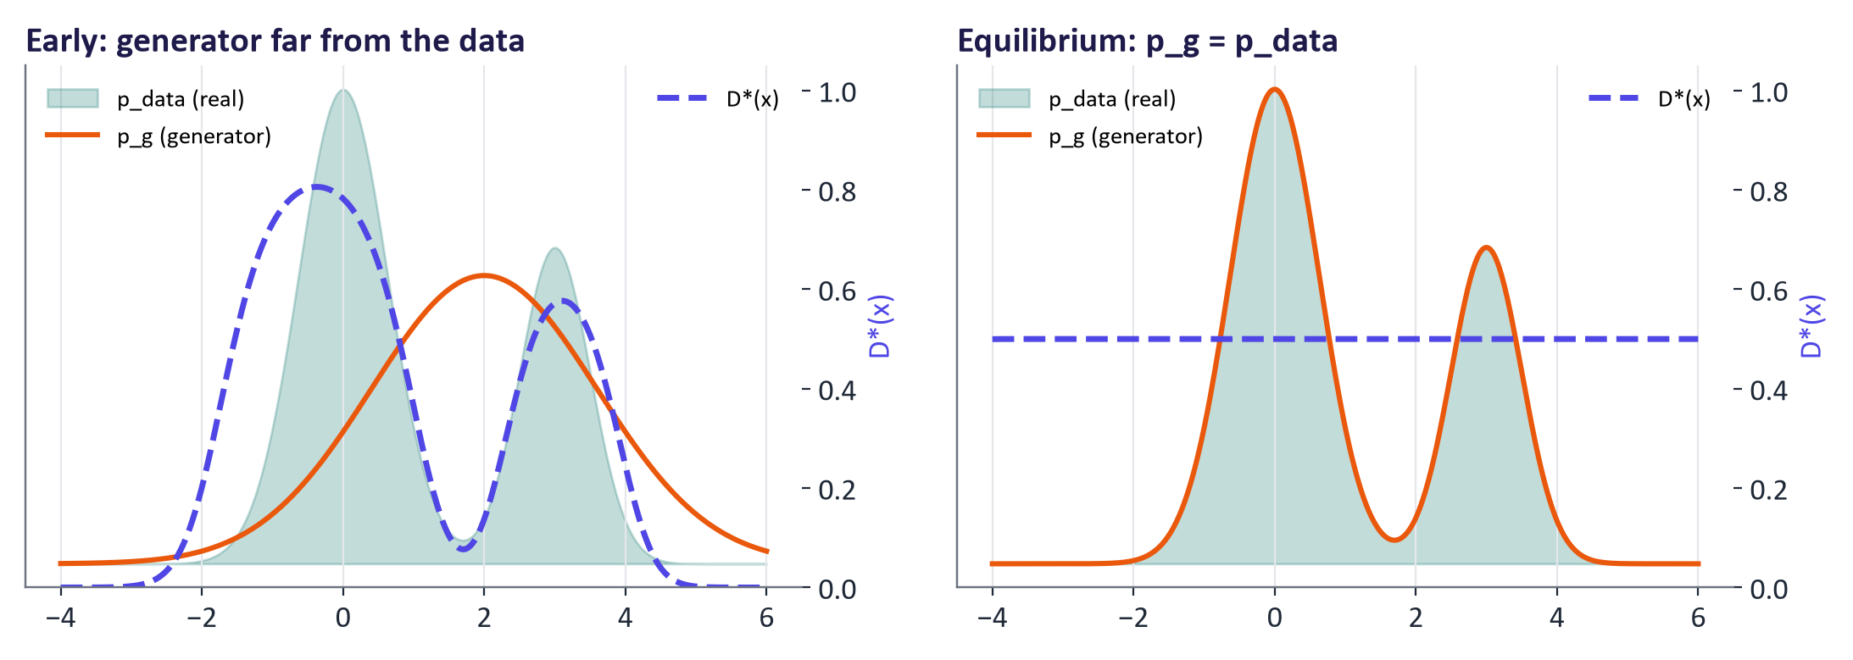
The optimal discriminator early in training and at equilibrium
In practice neither network has unlimited capacity, D is never optimal, and the game is optimised with alternating stochastic gradient steps, so this is an idealisation that explains the goal rather than a guarantee.

The non-saturating generator loss
Early in training D(G(z)) ≈ 0. The minimax generator loss log(1 - D(G(z))) is almost flat there, so its gradient is tiny exactly when the generator is worst. Goodfellow et al. therefore proposed that the generator maximise log D(G(z)), i.e. minimise -log D(G(z)), which is steep near zero. Both objectives share the same fixed point. In code, this is binary cross-entropy with the fakes labelled as real.
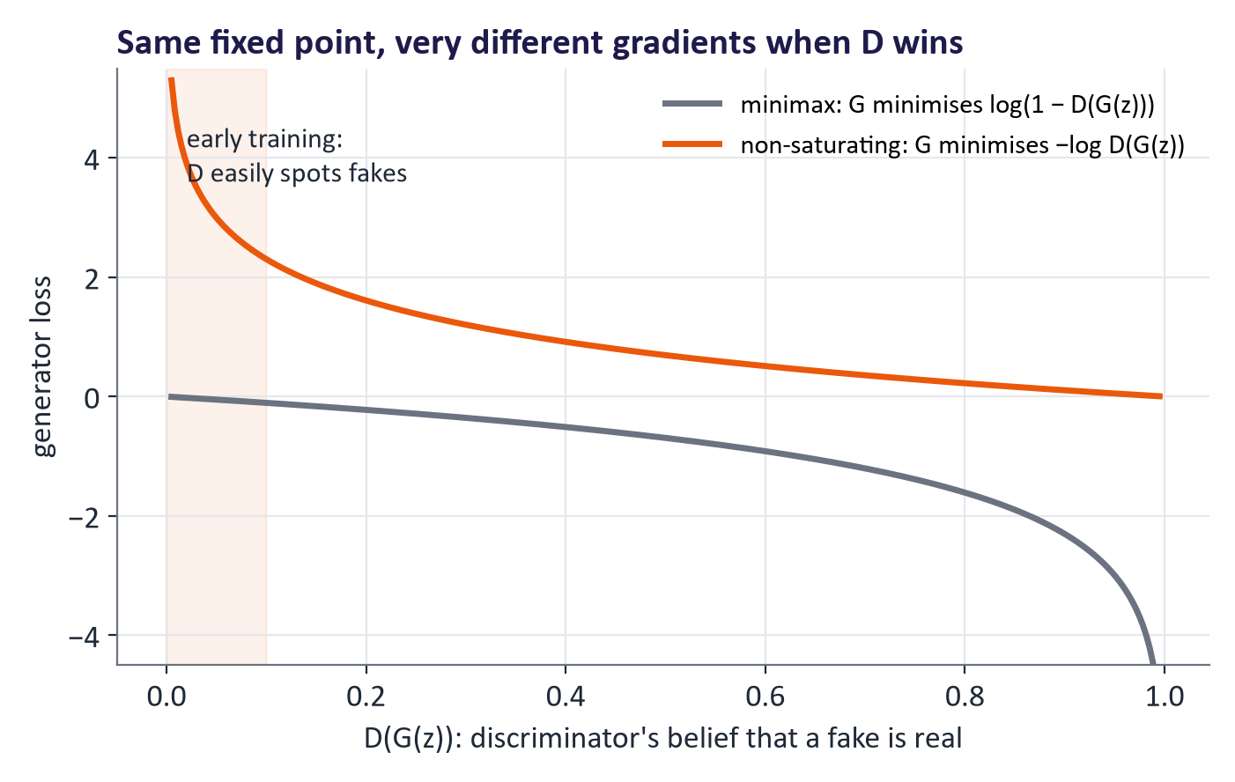
Minimax vs non-saturating generator loss

One training step
fake = G(torch.randn(b, z_dim))
loss_D = bce(D(x_real), ones) + bce(D(fake.detach()), zeros) # D step
opt_D.zero_grad(); loss_D.backward(); opt_D.step()
loss_G = bce(D(fake), ones) # G step (non-saturating)
opt_G.zero_grad(); loss_G.backward(); opt_G.step()

.detach() prevents the discriminator step from updating the generator. DCGAN defaults: Adam, learning rate 2 × 10⁻⁴, β₁ = 0.5.

3. Training challenges and fixes

Reading the diagnostics
GAN losses oscillate instead of decreasing, because each network's objective moves whenever the other improves. A healthy run keeps D(real) somewhat above D(fake) with neither pinned at 0 or 1. If D(fake) → 0 and the discriminator loss → 0, the discriminator has won and the generator's gradients are uninformative. Judge progress from fixed-noise samples and metrics, not from losses.
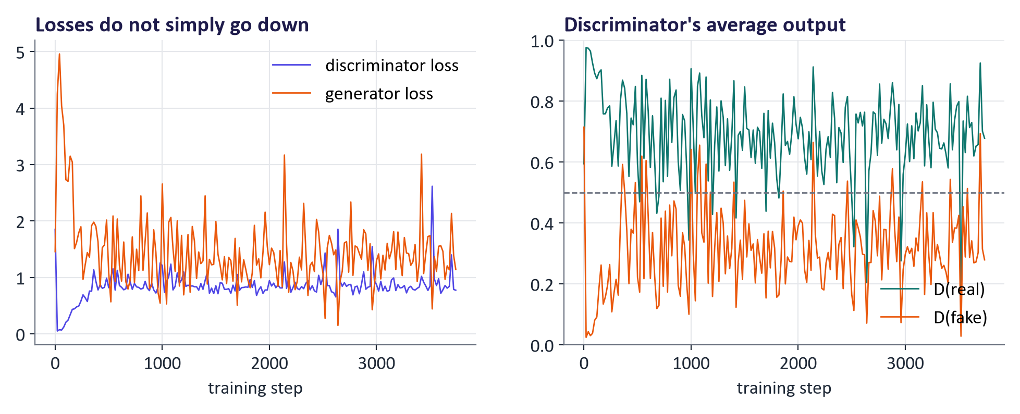
Real training curves of the lecture DCGAN

Mode collapse
The generator covers only part of the data distribution: sharp but repetitive samples (for MNIST, only a few digit classes). It arises because producing whatever currently fools D is rewarded; when D adapts, G may jump to another mode rather than spread out. On the 8-cluster ring experiment, the standard GAN covered 7 of 8 modes at the end of training while WGAN-GP covered 8 (same networks and steps).
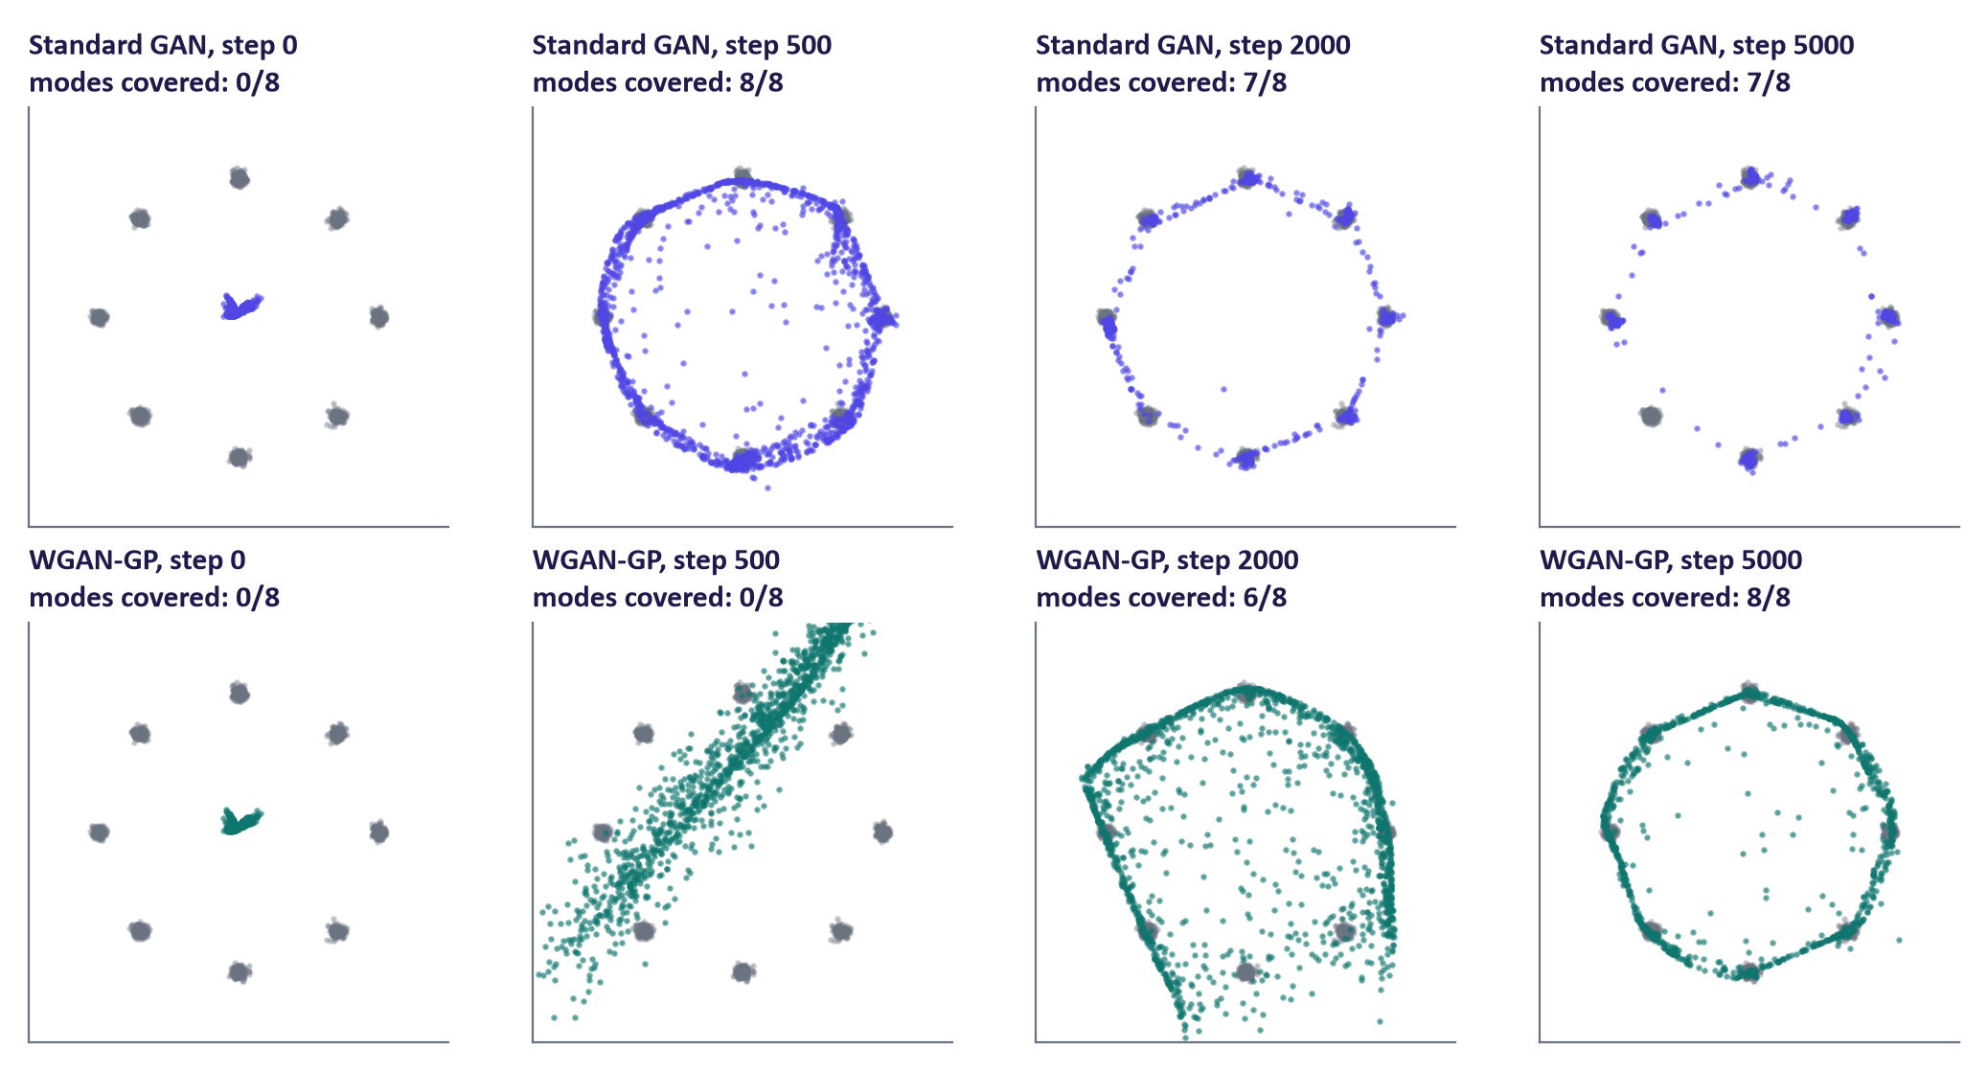
Mode collapse experiment on a ring of 8 Gaussians

Failure modes and remedies
Problem | Symptom | Remedies
Mode collapse | Samples alike; classes missing from the histogram | Wasserstein loss (+GP), minibatch statistics in D, unrolled D, more diverse data
Vanishing gradients | D(fake) ≈ 0; G stops improving | Non-saturating loss; weaker or regularised D; Wasserstein loss
Non-convergence | Samples keep changing style; wild oscillation | Lower learning rates; TTUR; spectral normalisation; EMA of G
D overfits (small data) | D(real) → 1 on training images only | Discriminator augmentation (ADA); more data
Artefacts | Checkerboards, textures stuck to screen positions | Resize-then-convolve upsampling; StyleGAN2/3 architectures

The Wasserstein GAN with gradient penalty
The Wasserstein-1 (earth-mover) distance measures the minimum "work" to move probability mass from one distribution to the other. By Kantorovich–Rubinstein duality it equals sup_‖f‖_L ≤ 1 𝔼ₚ_data[f(x)] - 𝔼ₚg[f(x)], so a critic D restricted to 1-Lipschitz functions can estimate it:
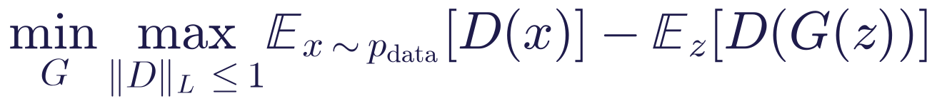
Unlike the JSD, it can vary usefully even when the two distributions do not overlap, giving the generator more informative directional feedback. WGAN-GP (Gulrajani et al., 2017) encourages the Lipschitz condition by adding to the critic's loss
with λ = 10 and typically 5 critic steps per generator step. This encourages gradient norms near 1 on sampled interpolates; it does not guarantee a globally 1-Lipschitz critic or complete mode coverage. The critic outputs an unbounded score, not a probability.

Other stabilisation techniques
- Spectral normalisation (Miyato et al., 2018): divide each discriminator layer's weight by its largest singular value, a cheap way to bound the Lipschitz constant (torch.nn.utils.spectral_norm).
- TTUR (Heusel et al., 2017): different learning rates for D and G.
- EMA of generator weights: sample from an exponential moving average of G's parameters.
- Adaptive discriminator augmentation (ADA): augment images shown to D so it cannot memorise small datasets.
- R1 regularisation: penalise D's gradient on real data (default in StyleGAN2).

4. Variants: from DCGAN to StyleGAN

DCGAN
Radford et al. (2015) made convolutional GANs train reliably: strided/transposed convolutions instead of pooling; batch normalisation in both networks (except G's output and D's input); ReLU in G with a tanh output; LeakyReLU in D; Adam with learning rate 2 × 10⁻⁴ and β₁ = 0.5. The lab model follows these rules for 28 × 28 images.
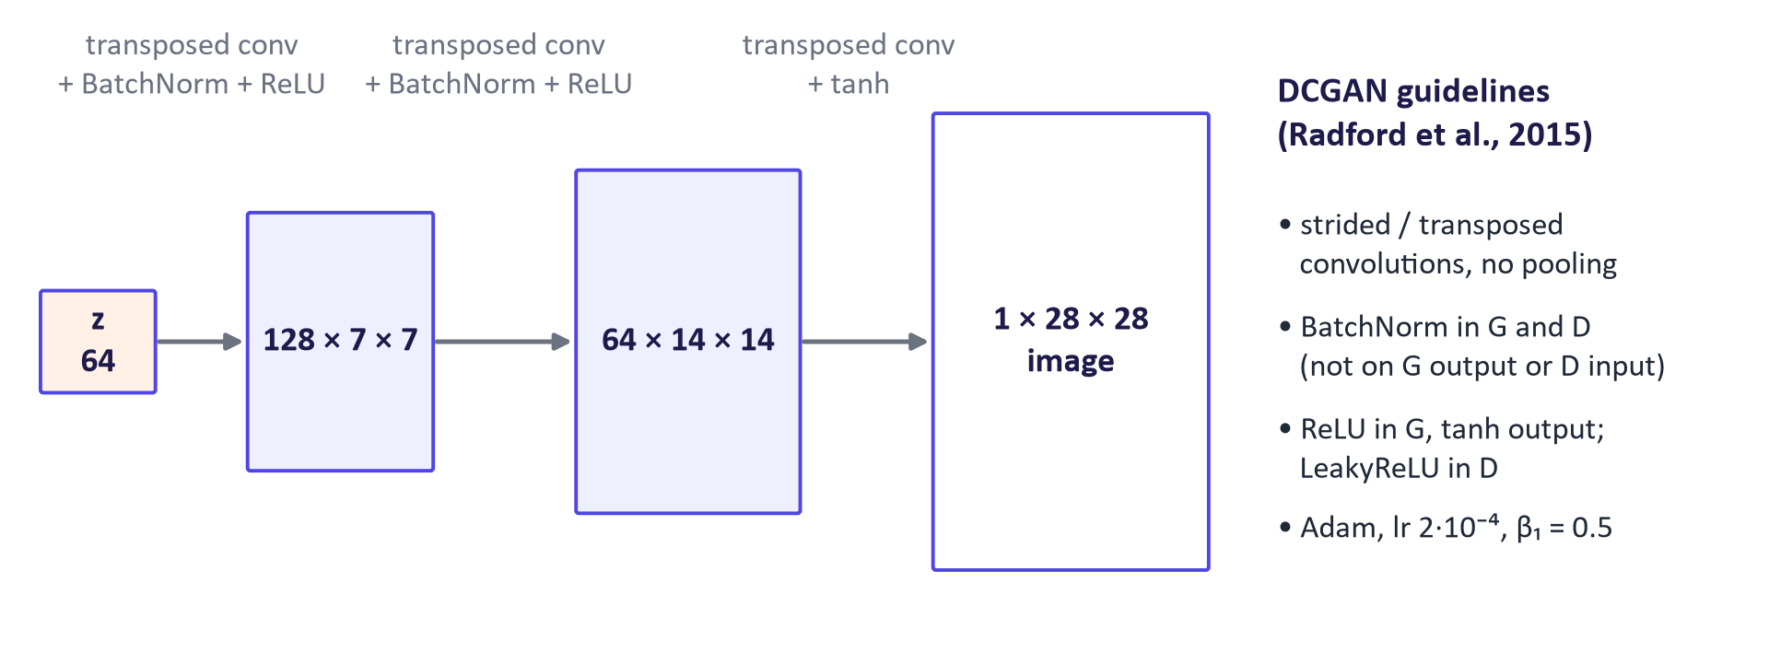
DCGAN generator and guidelines
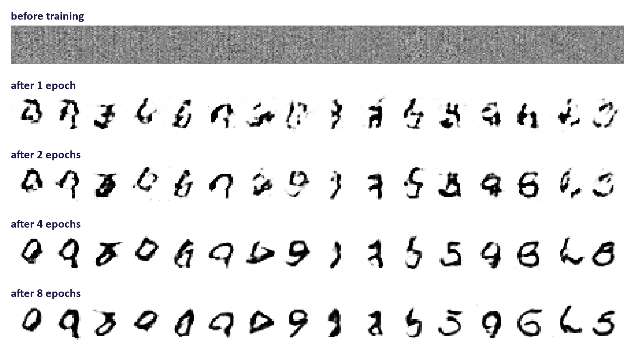
Real DCGAN samples across epochs

Conditional GANs and image-to-image translation
A conditional GAN (Mirza & Osindero, 2014) feeds a condition y to both networks: G(z, y) and D(x, y). D must check that x is real and matches y, so G learns to respect the condition.
- pix2pix (Isola et al., 2017): paired translation (sketch → photo, labels → street scene) with a conditional GAN plus an L1 reconstruction loss and a "PatchGAN" discriminator that judges local patches.
- CycleGAN (Zhu et al., 2017): unpaired translation (horse ↔ zebra) with two generators G: X → Y, F: Y → X and a cycle-consistency loss:
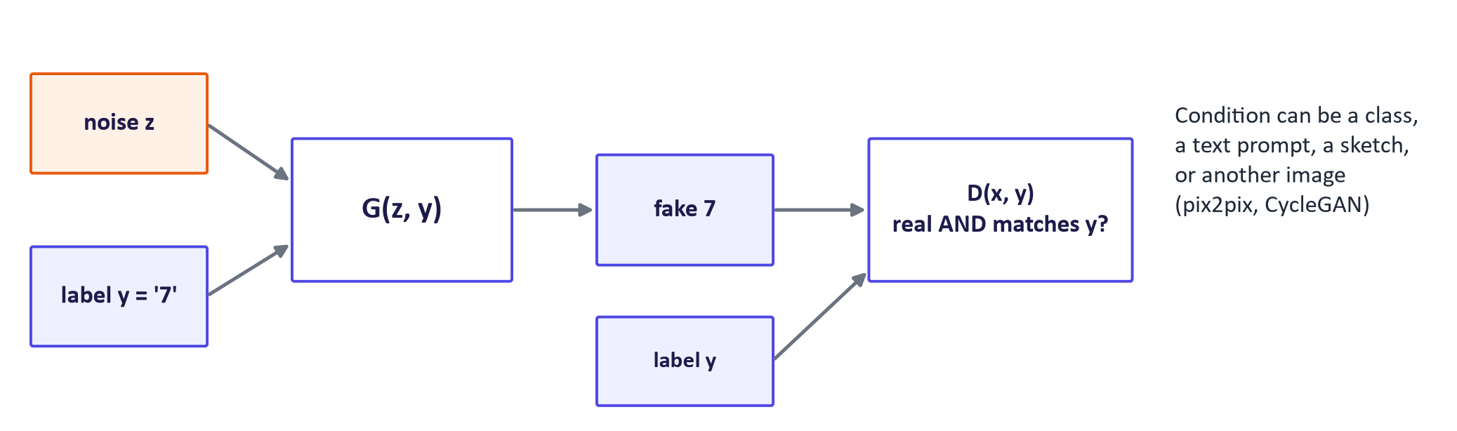
Conditional GAN

StyleGAN and BigGAN
StyleGAN (Karras et al., 2019; StyleGAN2 2020; StyleGAN3 2021) maps z through a mapping network to an intermediate style vector w that modulates every layer of the generator, giving photorealistic faces and separate control of coarse (pose, face shape) and fine (hair, skin texture) attributes. Its well-organised latent space enabled attribute editing. BigGAN (Brock et al., 2018) scaled class-conditional GANs on ImageNet and popularised the truncation trick: sampling z from a truncated normal trades diversity for quality.

Latent interpolation and GAN inversion
Interpolating between noise vectors gives smooth transitions, evidence of a continuous mapping. In high dimensions, spherical interpolation (slerp) keeps intermediate vectors at a typical norm. GANs have no encoder; editing a real photo requires GAN inversion, i.e. optimising a latent vector so that G reproduces the photo.
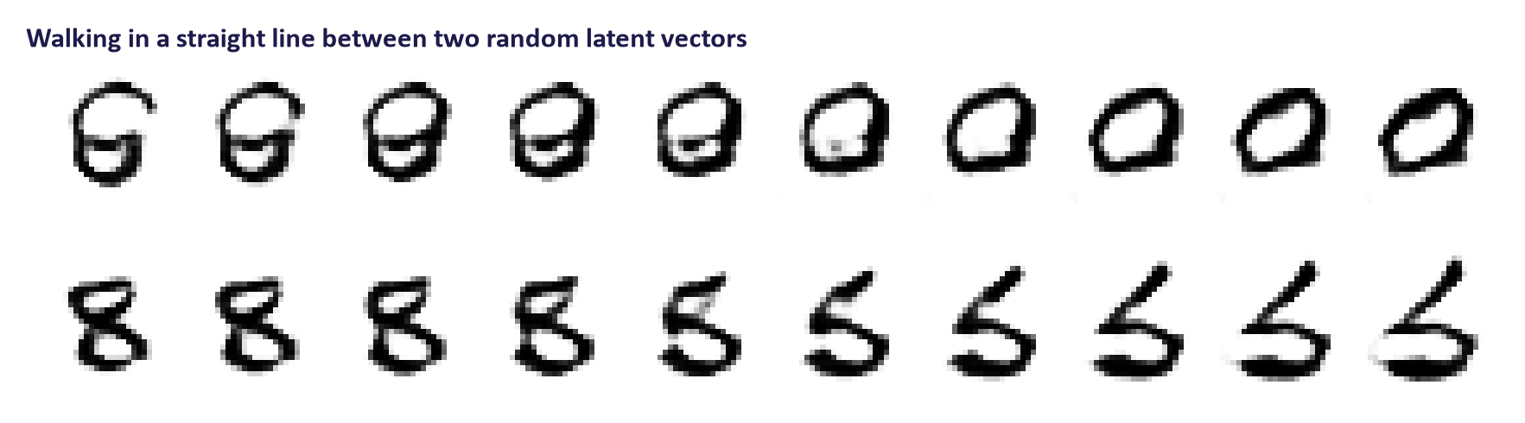
Latent interpolation in the lecture DCGAN

5. Evaluation, applications and risks

Fréchet Inception Distance (FID)
Embed real and generated images with an Inception-v3 network (2048-dimensional pool features), fit a Gaussian to each set and compute the Fréchet distance:
Lower is better. FID penalises both unrealistic samples (means differ) and low diversity (covariances differ). Limitations: assumes Gaussian features; biased for small sample sizes (use ≥ 10,000 samples or KID); ImageNet features may not suit other domains; values are only comparable with identical feature networks, preprocessing and sample sizes.
Worked example (1-D intuition). If real features have mean 0 and variance 1 and generated features have mean 0.5 and variance 0.25, then FID = 0.5² + (1 + 0.25 − 2√(1 × 0.25)) = 0.25 + (1.25 − 1) = 0.50. A collapsed generator with variance 0.01 and mean 0 gives 0 + (1 + 0.01 − 2 × 0.1) = 0.81, worse despite a perfect mean.
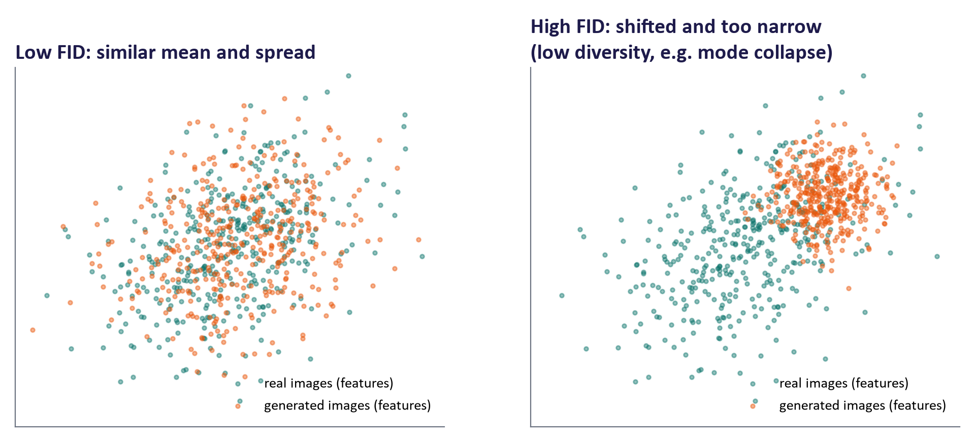
What FID measures in feature space
Lab distinction: frechet_distance uses the same distribution-comparison formula with features from the lab's DigitCNN, not Inception-v3. Call its output a custom feature Fréchet distance. Its scale differs from standard Inception FID, so do not compare it with published FID values. Check the classifier's accuracy and keep its weights, preprocessing, and sample size fixed for comparisons within the lab.

Other metrics
Metric | Captures | Limitation
Inception Score (IS, higher is better) | Confident and varied class predictions: exp(𝔼ₓ D_KL(p(y| x) ‖ p(y))) | Ignores the real data; fooled by class-diverse but unrealistic images
Precision / recall (Kynkäänniemi et al., 2019) | Fidelity and coverage separately | Sensitive to feature space and neighbourhood size
KID | Kernel version of FID; unbiased at small sample sizes | Less widely reported
Human evaluation | Realism, preference, task fit | Needs rubrics, multiple raters, agreement statistics

GANs in 2026
Diffusion models replaced GANs as the leading text-to-image generators, but GANs remain important where speed matters (one forward pass): super-resolution and restoration (e.g. Real-ESRGAN), adversarial diffusion distillation that compresses a many-step diffusion model into 1–4 steps (e.g. SDXL-Turbo), adversarial losses inside the autoencoders and tokenizers of latent diffusion models, GAN vocoders for speech synthesis (e.g. HiFi-GAN), image-to-image translation for simulation-to-real transfer and medical imaging, and synthetic tabular data.

VAE vs GAN
 | VAE | GAN
Training signal | Maximise ELBO (likelihood bound) | Two-player game with a learned discriminator
Likelihood | Lower bound available | None
Encoder | Yes | No (needs inversion)
Samples | Smooth, often blurry | Sharp
Diversity | Good coverage | Risk of mode collapse
Training | Stable | Unstable; needs tricks

Common misconceptions
Misconception | Correction
"A low generator loss means good images." | GAN losses are relative to the current discriminator; judge samples and metrics.
"The generator learns by looking at real images." | It only receives gradients through D; it never sees real data directly.
"At the end of training D should be perfect." | At the ideal equilibrium D outputs ½ everywhere; a perfect D means G has failed.
"Mode collapse means blurry images." | Mode collapse means low diversity; the images can be very sharp.
"FID is an absolute quality score." | FID values are only comparable under identical feature networks, preprocessing and sample sizes.
"GANs are obsolete." | They power super-resolution, fast distilled diffusion, sharp autoencoders and vocoders.
"WGAN's critic outputs a probability." | It outputs an unbounded score; the difference of average scores estimates the Wasserstein distance.

Responsible AI lens: deepfakes and synthetic media
- Harms: fraud (fake identities, voice cloning), harassment and non-consensual intimate imagery, political disinformation, and the liar's dividend, where genuine evidence is dismissed as fake.
- Detection is an arms race: detectors trained on one generator often fail on another, and adversarial training is literally optimised to fool a detector.
- Provenance: C2PA content credentials, invisible watermarks (e.g. SynthID) and platform labelling. Credentials can be stripped and open models may not watermark, so provenance is a layer, not a solution.
- Law: Article 50 of the EU AI Act requires deployers to disclose deepfakes (applicable since 2 August 2026) and providers to mark synthetic content in a machine-readable way.
- Data and bias: face datasets such as FFHQ raise consent questions and have demographic imbalances that generators reproduce.
Ask students to identify where their project could create synthetic media and how it would be labelled.

Lab guide and answers
Runtime: Colab T4 (about 15 s per DCGAN epoch; whole lab ≈ 15 minutes of compute) or CPU (1–3 minutes per epoch; reduce epochs to 3–4). Hand-in: samples per epoch, diagnostics, coverage histogram and Fréchet distances, ring experiment, four answers.

TODOs
- TODO 1: bce(D(x_real), ones) + bce(D(x_fake.detach()), zeros). Forgetting .detach() makes the D step also update G in the wrong direction.
- TODO 2: bce(D(x_fake), ones) (non-saturating).
- TODO 3 (slerp): Ω = arccos of the cosine between normalised vectors; weights sin((1−t)Ω)/sin Ω and sin(tΩ)/sin Ω. The printed midpoint norm shows lerp shrinks the vector (≈ 0.7 × typical norm for nearly orthogonal vectors), slerp keeps it.
- TODO 4: generate, classify with clf, argmax. A healthy DCGAN gives all 10 classes roughly 5–15% each; fewer than ~8 classes above 5% indicates partial collapse.
- TODO 5: Fréchet distance with scipy.linalg.sqrtm, keeping the real part. Expected ordering: real vs real (smallest) < GAN final < GAN after epoch 1 < uniform noise.
- TODO 6: torch.autograd.grad(D(x_hat).sum(), x_hat, create_graph=True)[0], then ((grad.norm(dim=1) - 1)**2).mean().
- Expected lecture results: DCGAN trained 8 epochs on CPU; ring experiment final coverage standard 7/8, WGAN-GP 8/8. Individual runs vary; students should report seeds.

Troubleshooting
- Samples are pure noise after an epoch: check that images are normalised to [−1, 1] and the generator ends with tanh.
- D loss → 0 immediately: the fakes are detached in the G step too, or learning rates differ by accident.
- sqrtm warnings or complex values: expected with finite samples; take the real part.

Practice questions with model answers

Multiple choice
- The optimal discriminator for a fixed generator is: (a) pg/(pdata + pg); (b) pdata/(pdata + pg); (c) ½ always; (d) pdata. Answer: (b).
- The non-saturating loss is used because: (a) it gives stronger generator gradients when D easily rejects fakes; (b) it removes the need for a discriminator; (c) it prevents overfitting; (d) it computes the likelihood. Answer: (a).
- Which symptom most directly indicates mode collapse? (a) Oscillating losses; (b) blurry samples; (c) sharp samples covering only a few classes; (d) D(real) ≈ 0.7. Answer: (c).
- FID compares: (a) pixel values of paired images; (b) means and covariances of network features for real and generated images; (c) classifier accuracy; (d) training losses. Answer: (b).

Short answer
- Derive the optimal discriminator. (4 marks) Model answer: V = ∫ pdata log D + pg log(1 - D) dx; pointwise maximise a log y + b log(1-y); derivative a/y - b/(1-y) = 0 gives y = a/(a+b); hence D^ = pdata/(pdata + pg)*.
- Explain why the Wasserstein loss helps and how WGAN-GP encourages the Lipschitz condition. (4 marks) Model answer: the Wasserstein objective can provide useful directional gradients when distributions are separated, helping training and coverage (2); the penalty (‖∇ D(x̂)‖ - 1)² encourages input-gradient norms near 1 at real/fake interpolates, without guaranteeing a global constraint or complete coverage (2).
- Compute a 1-D FID-style distance between N(0, 1) real features and N(1, 0.25) generated features. (3 marks) Model answer: (0-1)² + (1 + 0.25 - 2√(0.25)) = 1 + 0.25 = 1.25.
- Compare VAEs and GANs on three criteria. (6 marks) Model answer: likelihood (bound vs none), encoder (yes vs no), sample sharpness (blurry vs sharp), diversity (good vs collapse risk), training stability (stable vs unstable); two marks per well-explained criterion.

Exam-style question
"A start-up wants to generate realistic product photos. Explain how a GAN would be trained, what can go wrong, how you would evaluate it, and what responsible-use measures you would recommend." (20 marks)
Marking guide: architecture and objective, including the minimax and non-saturating losses (5); failure modes with diagnosis and remedies (5); evaluation with FID and at least one complementary metric or human study, including caveats (5); responsible use: provenance/labelling, data rights, misuse potential, disclosure duties (5). Strong answers suggest a conditional GAN (product category), mention diffusion models as an alternative, and justify the choice.

Glossary
Term | Meaning
Generator | Network mapping noise (and optionally a condition) to samples
Discriminator / critic | Network judging real vs fake (probability) or scoring realism (WGAN critic)
Minimax objective | The two-player value function D maximises and G minimises
Non-saturating loss | Generator minimises −log D(G(z)) instead of log(1 − D(G(z)))
Jensen–Shannon divergence | Symmetric divergence minimised by the ideal GAN
Mode collapse | Generator produces only a subset of the data's variety
Wasserstein distance | Earth-mover distance; basis of WGAN
Gradient penalty | Term encouraging input-gradient norms near 1 on sampled real/fake interpolates
Spectral normalisation | Weight normalisation bounding D's Lipschitz constant
DCGAN | Convolutional GAN architecture guidelines (2015)
Conditional GAN | GAN whose networks receive a condition y
CycleGAN | Unpaired image translation with cycle consistency
StyleGAN | Style-based generator with a mapping network
FID | Fréchet Inception Distance; lower is better
Truncation trick | Sampling z from a truncated distribution to trade diversity for quality

Readings, videos and further practice
Core reading (descriptor 7.9)
- Foster, D. (2023) Generative Deep Learning, 2nd ed.: chapter 4, "Generative Adversarial Networks", and chapter 10, "Advanced GANs" (ProGAN, StyleGAN, and others).
Papers
- Goodfellow et al. (2014) Generative Adversarial Networks
- Radford et al. (2015) DCGAN
- Arjovsky et al. (2017) Wasserstein GAN
- Karras et al. (2019) StyleGAN
- Heusel et al. (2017) TTUR and FID
Tutorials
- PyTorch DCGAN tutorial: official reference implementation on faces.
- Google for Developers: GAN course: short course covering loss functions, common problems and variants.

Link to the group project
Projects that generate images or need fast image-to-image translation can use a GAN or, more likely in 2026, a pretrained diffusion model (next week). Either way, this week's evaluation toolkit (FID with an appropriate feature network, coverage checks, human evaluation with a rubric) is required for the project's evaluation section. Projects producing realistic people or voices must include a labelling and consent plan.

