WEEK 04 · TEACHING NOTES
Diffusion Models
From noise to images: the forward and reverse processes, latent diffusion, guidance, fast samplers and flow matching
Generative AI · MSc in Artificial Intelligence · 2-hour lecture + 2-hour lab
Descriptor Section 7.3 (revised) for this week
Lecture topic | Diffusion Models
Detail | Motivation, Limitations of GANs and VAEs that diffusion models address. Theoretical Foundations (forward noising process, noise schedules, learned reverse process, noise-prediction objective, score-based view). Core Architecture (U-Net and diffusion transformers; latent diffusion with an autoencoder and a text encoder). Denoising Process and samplers (DDPM, DDIM, few-step sampling), classifier-free guidance. Variants (flow matching / rectified flow, distilled few-step models, image editing and control, video and audio diffusion). Evaluation (FID, CLIP score, human preference). Applications. Comparison with other generative models.
Tutorials | Training a simple diffusion model and visualising the forward (noising) and reverse (denoising) processes.  Generate images using a pre-trained diffusion model (e.g., Stable Diffusion via Hugging Face Diffusers).  Experiment with different noise steps, guidance scales, seeds and negative prompts.
Module learning outcomes (MIMLOs) practised this week
MIMLO 1: Critically explain the core concepts and mathematical principles underlying generative AI, and demonstrate in-depth knowledge of major generative AI model families, including VAEs, GANs, diffusion models and transformer-based LLMs.
MIMLO 2: Analyse and apply multimodal generative AI techniques, including alignment and cross-modal reasoning across text, image, audio and video modalities.
MIMLO 3: Design, implement and fine-tune generative AI models using contemporary frameworks and parameter-efficient methods.
MIMLO 4: Critically evaluate generative AI outputs using quantitative metrics, human-centered assessments and ethical considerations, including fairness, bias and hallucination risks.
What is in this week's folder
Lecture slides | 44 slides with speaker notes, vocabulary and technical diagrams.
Teaching notes | Lecture explanations, worked examples, code maps, practice questions and readings.
Student lab | Notebook and Python file with TODOs. Embedded and separate diagrams accompany the lab.
Lab solutions | Instructor notebook and Python file with completed code and model answers.

Lecture plan at a glance
Diffusion models are the backbone of today's image, video and audio generators. Students should leave able to write the forward process and its closed form, the noise-prediction loss and the DDPM update; explain latent diffusion and classifier-free guidance; and use and evaluate a pretrained pipeline. All MNIST, 2-D and Stable Diffusion images in the slides are real outputs generated for this lecture (curriculum/assets/make_week_04.py).
Time | Slides | Segment | What you do
0–5 min | 1–5 | Warm-up | Restoring a photo from static: small steps, random start, a description helps.
5–17 min | 6–10 | 1 · Why diffusion? | Limitations of VAEs and GANs; the trilemma; the core idea in one slide.
17–50 min | 11–22 | 2 · Forward and reverse | Forward process and closed form; real noising; schedules; reverse process; noise-prediction loss; code; score view; real 2-D and MNIST results. Quiz.
50–57 min | – | Break
57–74 min | 23–26 | 3 · Architecture | U-Net vs DiT; latent diffusion pipeline; role of each component.
74–97 min | 27–32 | 4 · Sampling and guidance | Samplers; steps; classifier-free guidance; guidance scale; seeds and negative prompts.
97–118 min | 33–40 | 5 · Variants, evaluation, responsibility | Flow matching; distillation; variants; evaluation; family comparison; responsible AI.
118–120 min | 41–44 | Lab preview, summary, resources

Teaching tip: Write the closed-form forward process on the board early and point out that it is the reparameterisation trick from week 2. Students who see this link find the rest of the lecture much easier.

The four supporting slides fit within the existing lecture segments. Use the starting vocabulary and overall flow during the introduction, the mechanism diagram beside the first detailed explanation, and the lab flow during the lab preview. Pause for predictions before showing a worked example.

Beginner walkthrough
Read the overall flow before the detailed theory. Each numbered block performs one operation. The text below a block names the data it passes on. A feedback line means the system repeats an operation. The code names match this week's lab so you can follow the same example in the slides and notebook.

Starting vocabulary
Term | Plain meaning | Check your understanding
Gaussian noise | Random numerical values drawn from a bell-shaped distribution. | Does standard Gaussian noise already contain a requested digit?
Regression | Learning to predict numerical values rather than selecting a class label. | Is predicting a noise value of -0.5 regression or classification?
Tensor shape | The number of entries along each dimension of an array. | Why should a pixel-noise predictor output the same shape as its noisy image input?

Train a network to predict noise
The forward process is fixed; the denoiser is the part that learns.
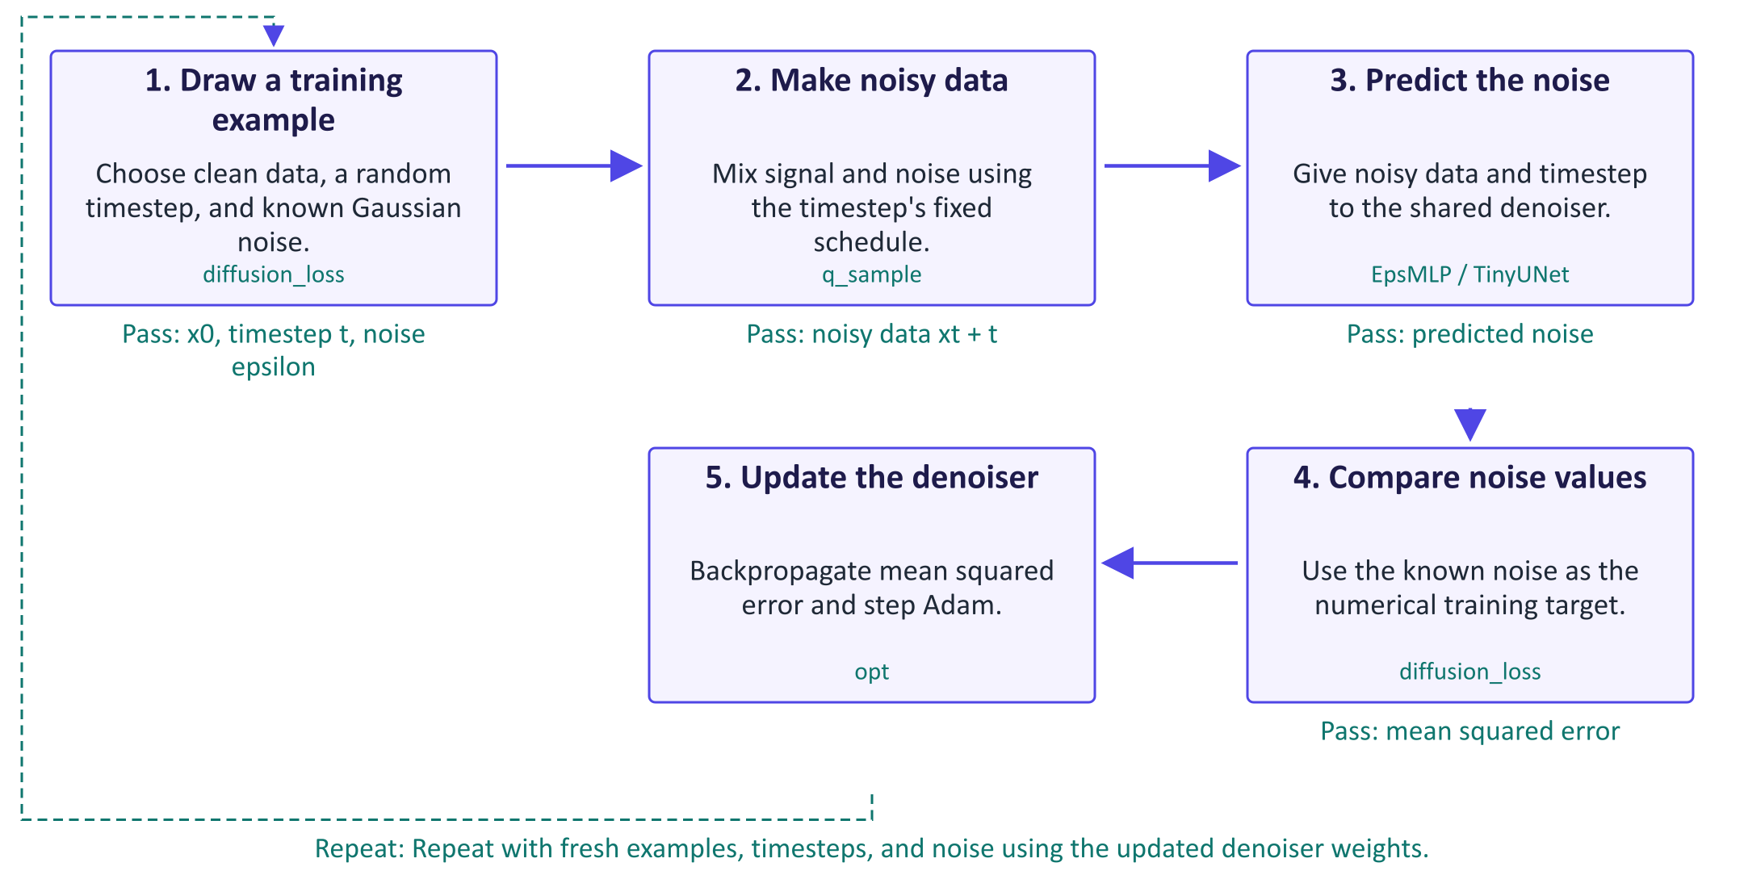
Train a network to predict noise
A diffusion model learns from examples whose corruption is known. The forward process uses a fixed noise schedule to mix clean data with Gaussian noise. q_sample can produce the noisy example for a selected timestep directly, without running every earlier noising step. The timestep tells the network how much corruption to expect. In this lab, the network predicts the noise that was added, rather than directly predicting a class or the clean image. Because the training code drew that noise, it has an exact numerical target for mean squared error. The target follows a separate path to the loss; it is not given to the denoiser. Backpropagation updates the denoiser weights, while the schedule remains fixed. Training samples many noise levels in random order. Generation is a different loop: start from new Gaussian noise and use the learned predictions to move through decreasing noise levels.

Worked example
- Take a clean pixel value x0 = 0.8 and a timestep where abar = 0.36.
- For noise epsilon = -0.5, q_sample gives 0.6 × 0.8 + 0.8 × (-0.5) = 0.08.
- The denoiser sees the noisy input and timestep; it does not receive the true epsilon as input.
- Compare its predicted noise with -0.5; the loss is aggregated across all entries.
- Generation later starts from fresh noise and repeatedly calls the trained network through reverse_step.
Check your understanding. Which quantity is the target in diffusion_loss: the clean input x0 or the sampled noise eps?
Instructor explanation. The sampled noise eps is the target. The clean input helps construct the noisy training example.

Generate by repeating reverse steps
One denoiser is reused at every timestep; the sampler decides each update.
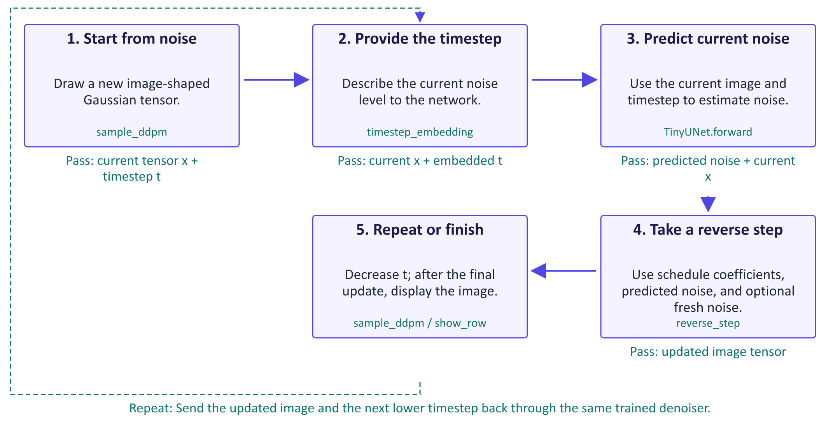
Generate by repeating reverse steps
Generation uses the trained denoiser repeatedly, but it does not train the network again. At the start, the image tensor contains random Gaussian values. A timestep embedding turns the timestep number into features the denoiser can use. TinyUNet processes the image at several resolutions and combines saved features through skip connections, returning a noise prediction with the same shape as the image. The reverse-step formula uses that prediction and the fixed schedule to compute the next state. This lab's DDPM sampler also adds fresh noise except at the final step. Each new state goes back through the same denoiser at a lower timestep until an image is produced. DDIM uses a different update to jump between selected noise levels. Reducing sample_ddpm's steps simply starts at a lower index and truncates its chain; use sample_ddim to study proper timestep skipping across the full schedule.

Worked example
- sample_ddpm starts with shape [n, 1, 28, 28] and begins at index 999 for the full schedule.
- TinyUNet predicts an equally shaped noise tensor using the current image and timestep embedding.
- reverse_step computes a lower-noise state and adds fresh noise when t is greater than 0.
- The next call uses the updated tensor and a smaller timestep, without changing model weights.
- sample_ddim instead spans the schedule with 50 selected timesteps and deterministic updates.
Check your understanding. Does taking 50 DDIM steps mean training 50 separate denoisers?
Instructor explanation. No. The same trained network is called at 50 selected timestep values; only the sampling procedure changes.

Build diffusion, then inspect a pipeline
Connect the small model's mechanics with a pretrained text-to-image system.
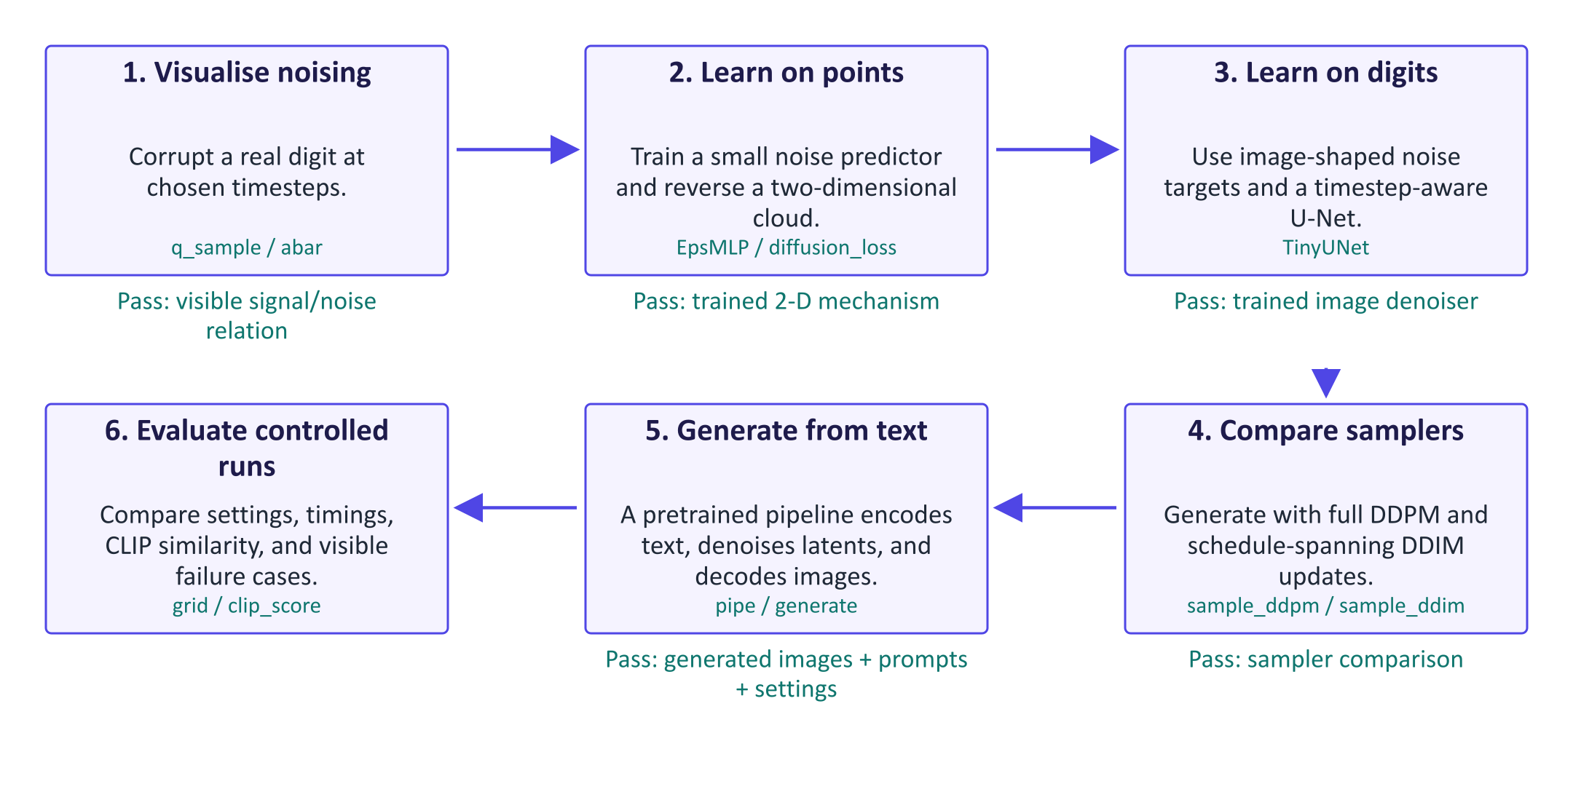
Build diffusion, then inspect a pipeline
The lab begins with a system small enough to inspect. Noising a digit exposes the meaning of the schedule. A two-dimensional point model then makes the reverse trajectory visible before you train an image network. Both networks use the same noise-prediction loss. Comparing DDPM and DDIM separates the denoiser from the sampler: fixed learned weights can support different generation procedures. The pretrained text-to-image pipeline adds components. A text encoder represents the prompt, a denoiser updates a compact image latent, a scheduler controls the updates, and a VAE decoder turns the result into pixels. The generate wrapper calls these components through pipe; it does not train them. Keep one setting change per comparison and record the active model path, because the CPU fallback uses SD-Turbo with guidance disabled. Finally, CLIP similarity measures prompt-image agreement in one embedding space; combine it with timing and careful visual inspection.

Worked example
- Inspect q_sample at t = 0 and t = 999; index 0 already adds a small amount of noise.
- On the 2-D swiss roll, compare reverse snapshots with the real point cloud.
- Train TinyUNet with diffusion_loss, then record time and visual results for DDPM and DDIM.
- generate fixes a seed while changing steps or guidance; the CPU SD-Turbo fallback forces guidance to zero.
- clip_score compares image and prompt embeddings; also inspect object counts and visible artefacts yourself.
Check your understanding. Why might changing guidance have no effect in the CPU fallback?
Instructor explanation. The generate wrapper forces guidance to 0.0 for the SD-Turbo fallback, so the requested guidance value is not used.

Where to look in the code
Code symbol | What it does | What to inspect
q_sample | Constructs noisy training inputs at a selected timestep. | Check the schedule coefficient reshape for 2-D points versus image tensors.
diffusion_loss | Draws timesteps and noise, then compares predicted and known noise. | Track which tensors enter the model and which enter the loss as targets.
TinyUNet.forward | Predicts image-shaped noise using multiscale features and timestep information. | Follow 28×28 to 14×14 to 7×7 and the two saved-feature joins.
reverse_step | Moves a generated state to a lower-noise level. | Identify the model prediction and the final-step exception for added noise.
sample_ddim | Uses selected timesteps spanning the full schedule for faster sampling. | Follow seq, t_next, and the final clean-state coefficient.
generate | Calls a pretrained text-to-image pipeline with recorded controls. | Check the active pipeline, seed, number of steps, and fallback guidance handling.

Common points of confusion
- The known noise target enters the training loss, not the denoiser's input.
- The starting seed chooses random input; it does not guarantee correctness or reproducibility across changed software and settings.
- Fewer DDPM iterations by truncating steps differ from DDIM's valid jumps across selected schedule timesteps.

Quick glossary
Forward process. A fixed procedure that progressively corrupts clean data with noise.
Noise schedule. Numbers specifying how much signal and noise appear at each timestep.
Denoiser. The learned network; here it predicts added noise from noisy data and a timestep.
Mean squared error. The average squared difference between predicted and target numbers.
Sampler. The procedure that uses model predictions to turn starting noise into an output.
U-Net. An image network with shrinking and expanding spatial stages joined by skip connections.
Latent diffusion. Generating in a compact image representation before a decoder converts it to pixels.
Guidance. Combining conditional and reference predictions to influence prompt-following during sampling.
CLIP score. A similarity between image and text representations; it is not a complete quality measure.

Lecture notes

1. Why diffusion?
 | VAE | GAN | Diffusion
Sample quality | Blurry | Sharp | Sharp, detailed
Coverage | Good | Mode collapse risk | Good
Training | Stable | Unstable game | Stable regression
Text conditioning | Weak | Hard to scale | Excellent
Sampling | 1 pass | 1 pass | 10–1000 passes (reducible)

Diffusion models combine the stable, likelihood-based training of VAEs with the sample quality of GANs, at the price of slow sampling. The generative trilemma (quality, diversity, speed) summarises the trade-off; distillation and flow matching now move diffusion towards the fast corner.
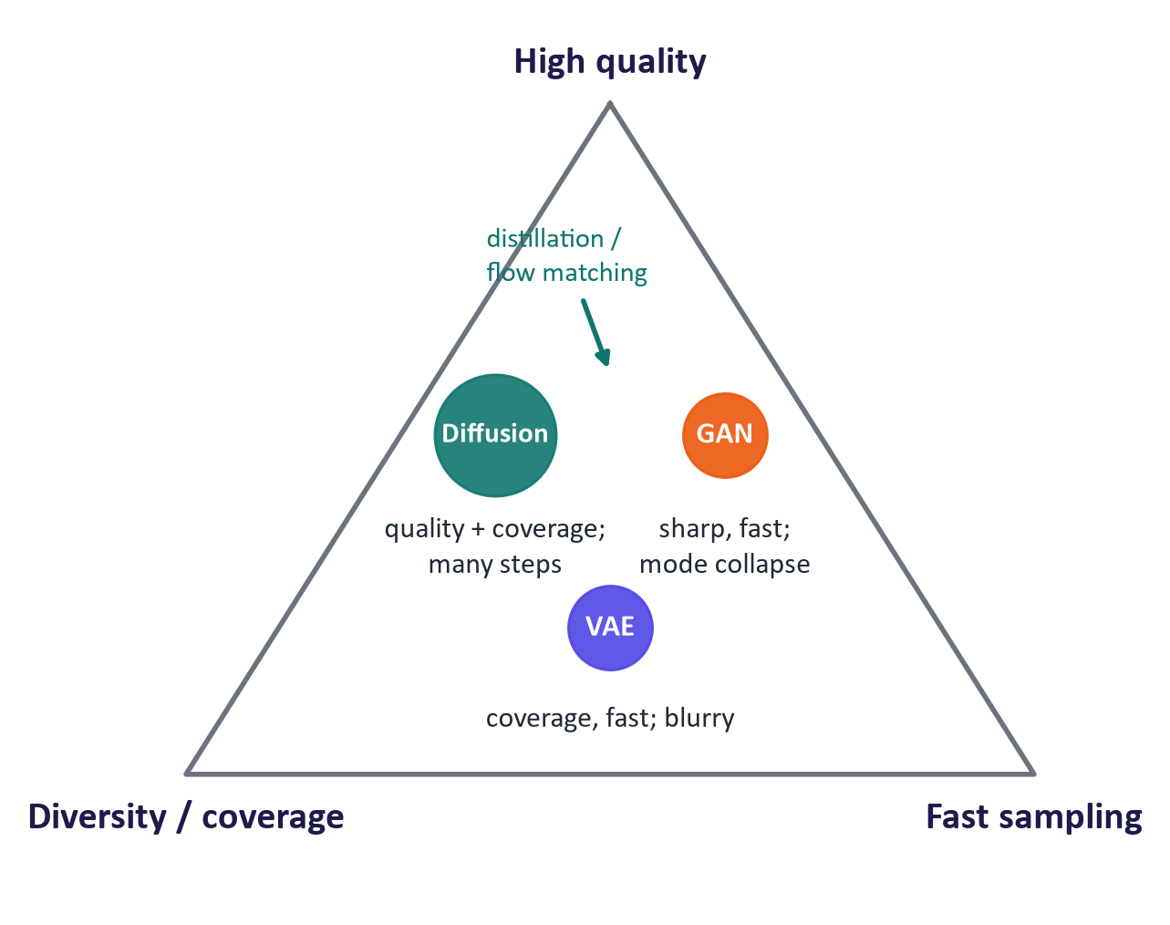
The generative trilemma
Core idea. A fixed forward process gradually adds Gaussian noise until the data become pure noise. A network learns the reverse process, removing a little noise at a time. Each reverse step is an easy denoising problem, trained as ordinary regression. Generation starts from pure noise and applies the learned reverse step repeatedly. Randomness in the starting noise gives diversity; a prompt gives control. (Sohl-Dickstein et al., 2015; Ho, Jain & Abbeel, 2020.)

2. Forward and reverse processes

The forward process
With a small noise schedule β₁, …, β_T (DDPM: linear from 10⁻⁴ to 0.02, T = 1000):
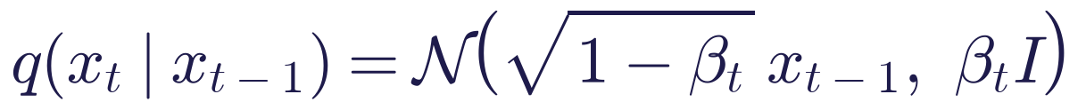
Define αₜ = 1 - βₜ and ᾱₜ = Πₛ=1^t αₛ. Because Gaussians compose, we can jump directly to any step:
This is the reparameterisation trick from week 2. The scaling by √(1-βₜ) keeps the total variance at 1 ("variance-preserving"). At t = T, ᾱ_T ≈ 4 × 10⁻⁵: essentially pure noise.
Worked example. For a pixel with clean value x₀ = 0.8, at a step where ᾱₜ = 0.36 and with sampled noise ε = -0.5: xₜ = √(0.36)(0.8) + √(0.64)(-0.5) = 0.6 × 0.8 - 0.8 × 0.5 = 0.48 - 0.40 = 0.08.
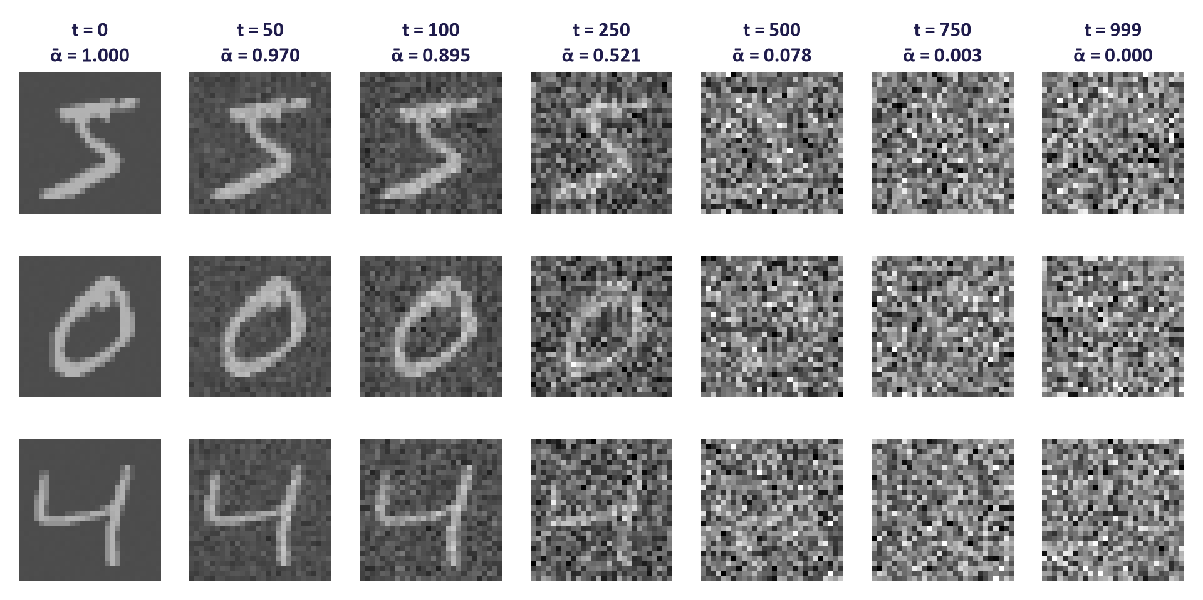
The forward process on real digits

Noise schedules
The schedule decides how quickly information is destroyed. The linear schedule leaves many late steps with almost no signal; the cosine schedule (Nichol & Dhariwal, 2021) removes signal more evenly. The signal-to-noise ratio SNR(t) = ᾱₜ / (1 - ᾱₜ) is the natural way to compare schedules (Karras et al., 2022).
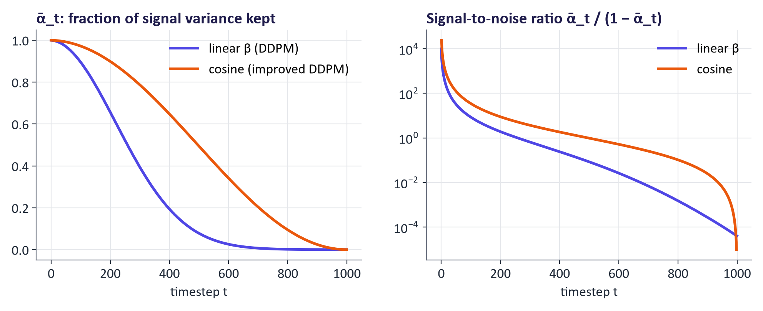
Linear vs cosine schedules

The reverse process
For small βₜ the reverse step is approximately Gaussian, so it is modelled as
with σₜ² = βₜ in the simplest DDPM. One network ε_θ, shared over all steps, receives the timestep through a sinusoidal embedding.

The training objective
- Sample a training image x₀, a timestep t ~ U1, …, T and noise ε ~ N(0, I).
- Form xₜ with the closed form.
- Predict the noise and minimise the squared error.
Ho et al. derived this from the ELBO (week 2): a diffusion model is a hierarchical latent variable model with a fixed, parameter-free "encoder" (the noising chain), and Lₛᵢₘₚₗₑ is a reweighted version of its bound. Diffusion models are therefore likelihood-based, which explains their good coverage, and trained by regression, which explains their stability.
t = torch.randint(0, T, (batch,))
eps = torch.randn_like(x0)
xt = abar[t].sqrt() * x0 + (1 - abar[t]).sqrt() * eps
loss = F.mse_loss(model(xt, t), eps)

Training costs one network evaluation per example; sampling costs one per step (1000 for ancestral DDPM).

The score-based view
The score of a distribution is ∇ₓ log p(x). Predicting the noise is equivalent to estimating the score of the noised data: ε_θ(xₜ, t) ≈ -√(1 - ᾱₜ) ∇ₓₜ log pₜ(xₜ) (denoising score matching). Song et al. (2021) showed that diffusion is a discretised stochastic differential equation with an equivalent deterministic probability-flow ODE; ODE solvers are the basis of fast samplers.

Real results
A three-layer MLP trained with Lₛᵢₘₚₗₑ on a 2-D swiss roll turns Gaussian noise into the spiral during the reverse process. A tiny U-Net (254,337 parameters) trained for 8 epochs on MNIST (an NVIDIA GTX 1650 laptop GPU, about 8 minutes) generates recognisable digits; structure appears in the middle steps and detail at the end (coarse-to-fine).
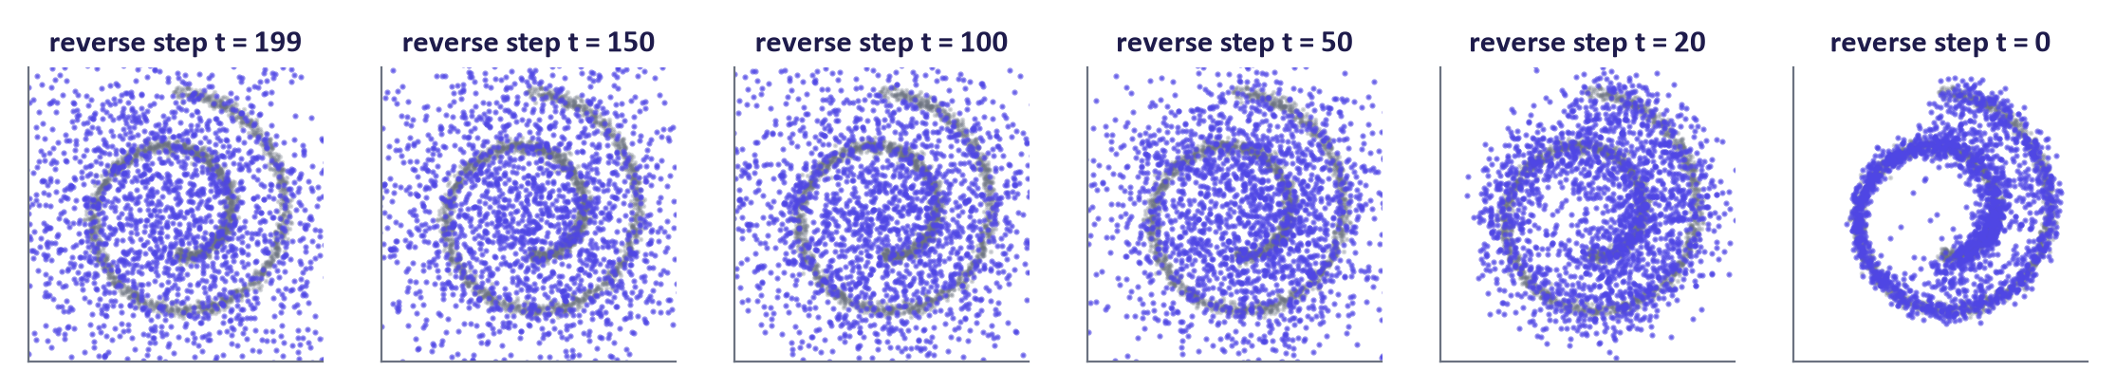
Reverse process on 2-D data
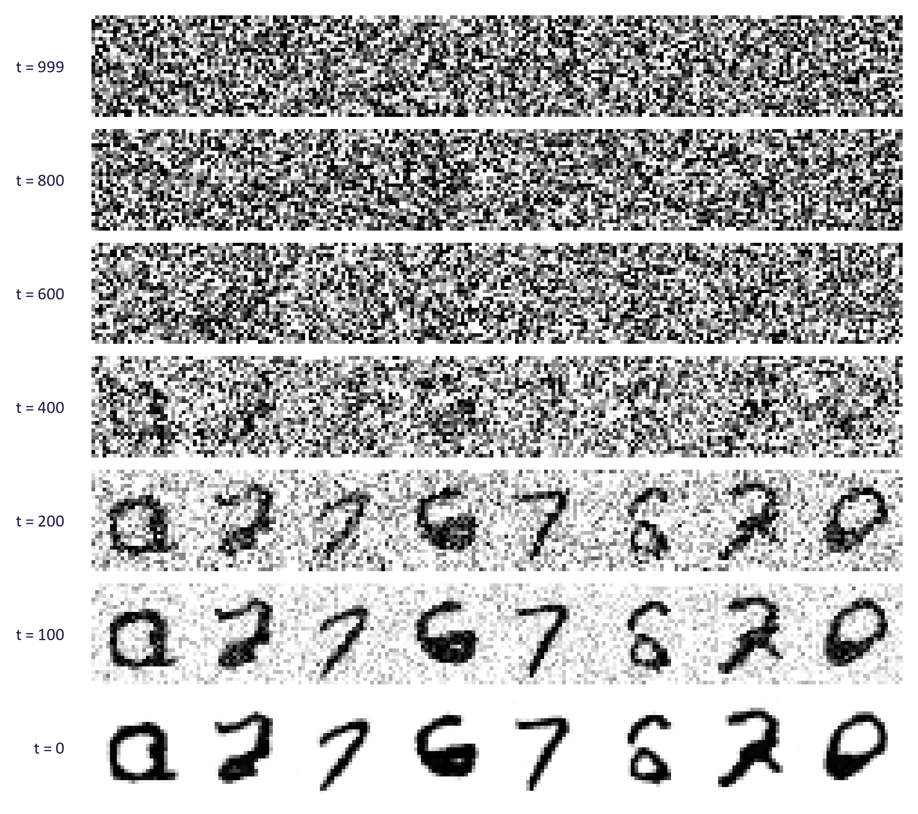
Reverse process on MNIST
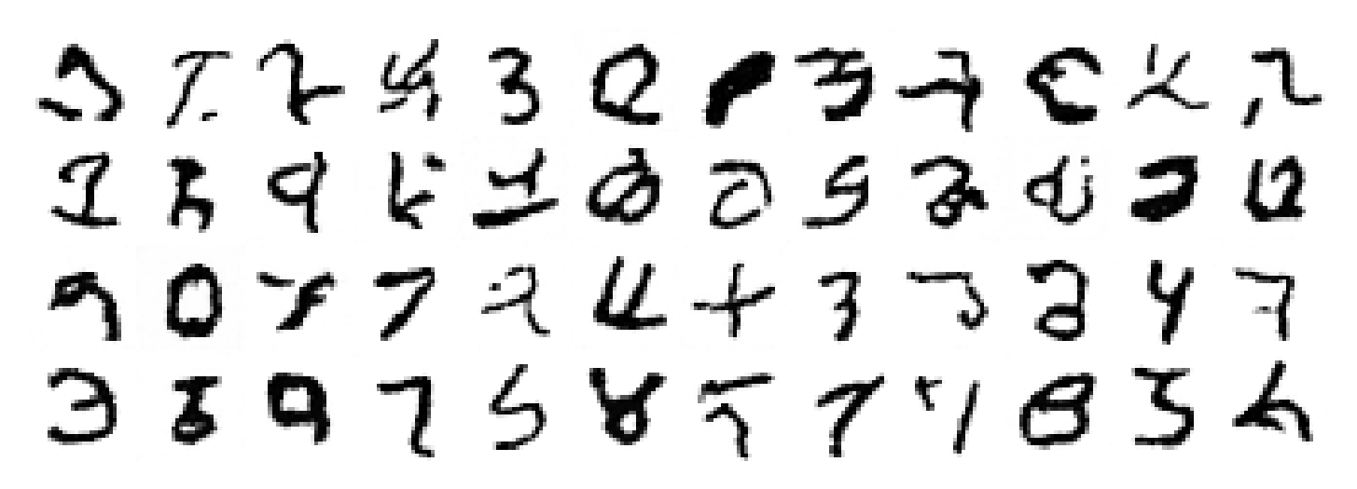
Samples from the tiny MNIST diffusion model

3. Architecture and latent diffusion

Denoiser networks
- U-Net (Ronneberger et al., 2015; used by DDPM, Stable Diffusion 1.x/2.x, SDXL): convolutional encoder–decoder with skip connections; attention layers at low resolution; output has the input's shape.
- Diffusion transformer (DiT) (Peebles & Xie, 2022): split the latent into patches (tokens) and process them with transformer blocks; conditioning through adaptive layer norm or joint attention; scales better with compute (Stable Diffusion 3, FLUX, most video models).
Both receive the timestep and the condition at every block.
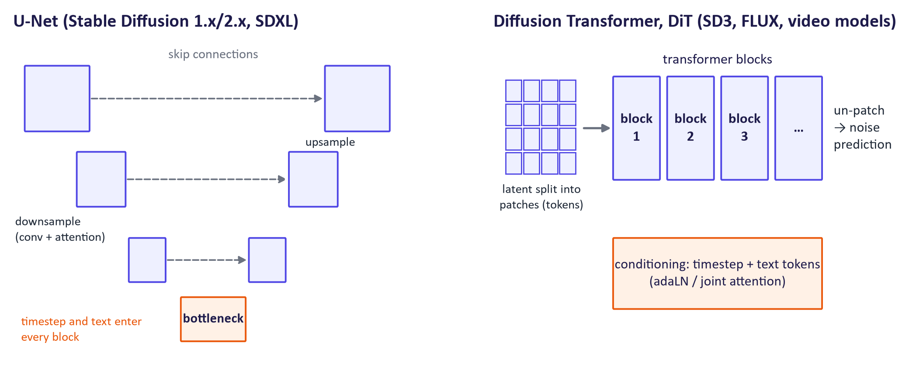
U-Net and diffusion transformer

Latent diffusion (Rombach et al., 2022)
- A VAE (week 2) compresses a 512 × 512 × 3 image to a 64 × 64 × 4 latent (48× fewer numbers).
- A text encoder (CLIP's text transformer in SD 1.5; T5 as well in later models) turns the prompt into token embeddings.
- The denoiser runs the reverse process in latent space and reads the text through cross-attention (week 5).
- The VAE decoder turns the final latent into pixels.
Measured component sizes in Stable Diffusion 1.5: U-Net ≈ 860 M parameters, CLIP text encoder ≈ 123 M, VAE ≈ 84 M. The scheduler (sampler) is not a network and can be swapped without retraining.
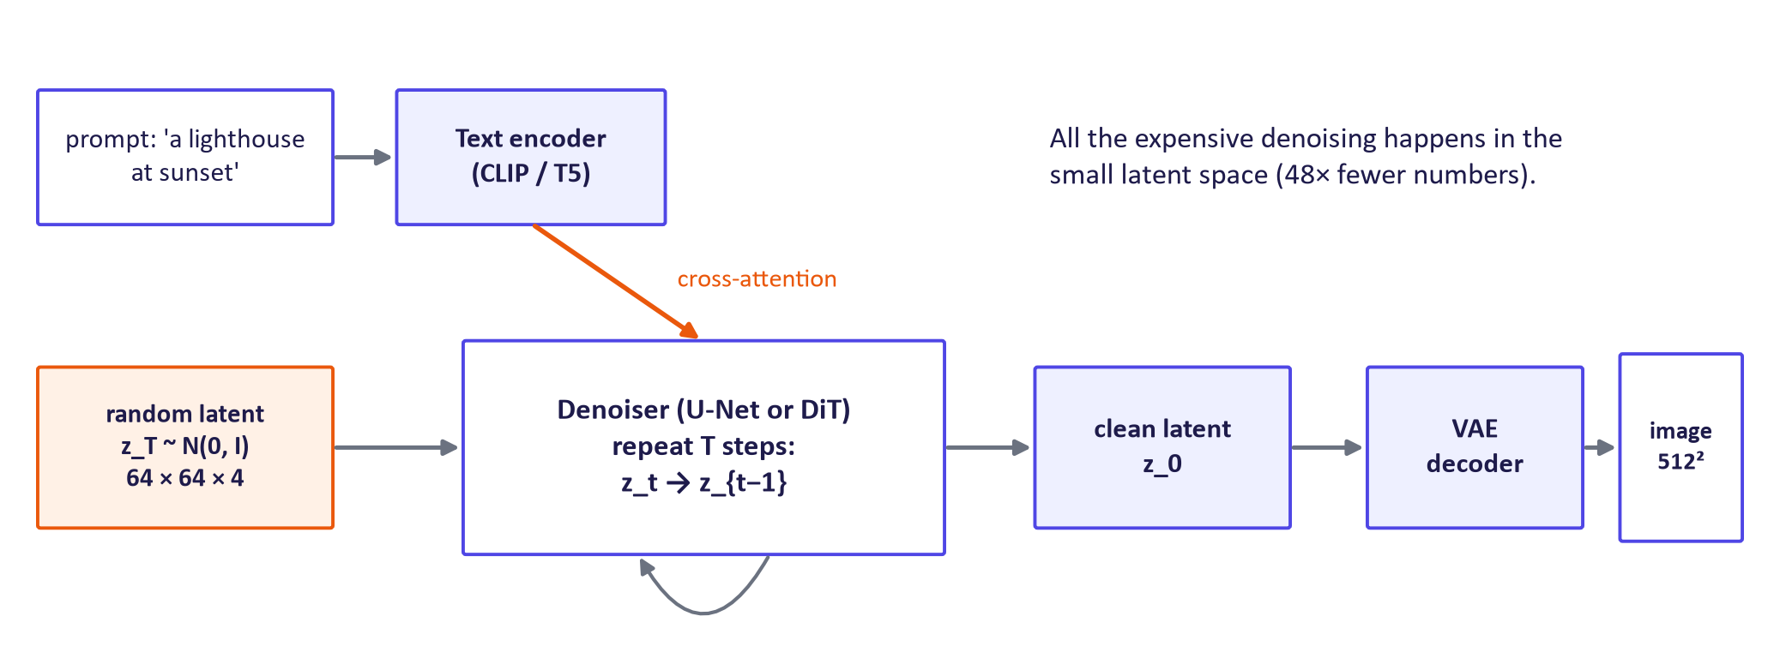
Latent diffusion pipeline

4. Sampling, guidance and prompts

Samplers
Sampler | Type | Typical steps
DDPM ancestral | Stochastic reverse chain | 250–1000
DDIM (Song, Meng & Ermon, 2020) | Deterministic update on selected timesteps (noise parameter η = 0) | 20–100
DPM-Solver++, Euler, Heun | ODE solvers; Euler is first order | 15–30
Distilled (consistency models, adversarial diffusion distillation) | Student model trained to jump far | 1–4

DDIM update. From the noise prediction ε̂ at step t, estimate the clean image and jump to an earlier step t':
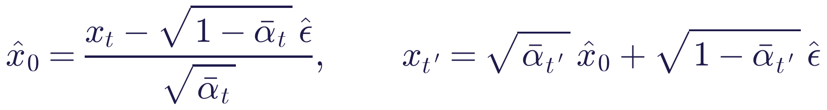
The same trained network is used; only the sampling procedure changes.
Code distinction: sample_ddim(steps=50) selects timesteps spanning index T - 1 down to 0 and uses both current and next schedule coefficients in each jump. Lowering sample_ddpm(steps) merely truncates its reverse loop and starts at a lower index with fresh Gaussian noise; it is not the same faster sampler. Use the full DDPM schedule for that baseline, and use DDIM for the skipping comparison.
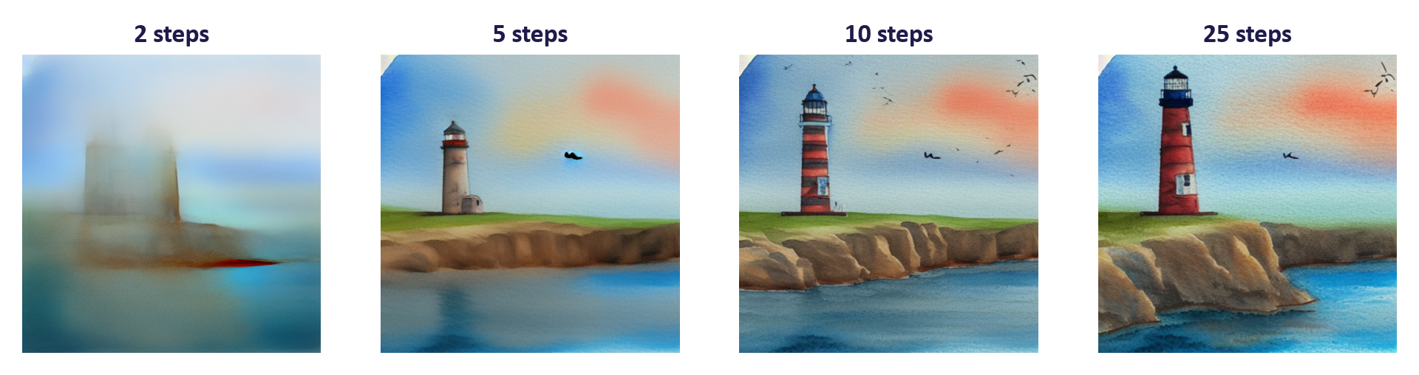
Effect of the number of steps

Classifier-free guidance (Ho & Salimans, 2022)
During training the prompt is replaced by an empty prompt about 10% of the time, so one network learns both ε_θ(xₜ, c) and ε_θ(xₜ, ∅). At sampling:
w = 1 is the plain conditional model; w ≈ 5–8 is typical; very large w over-saturates colours and reduces diversity. Each step needs two network evaluations (batched together in practice).
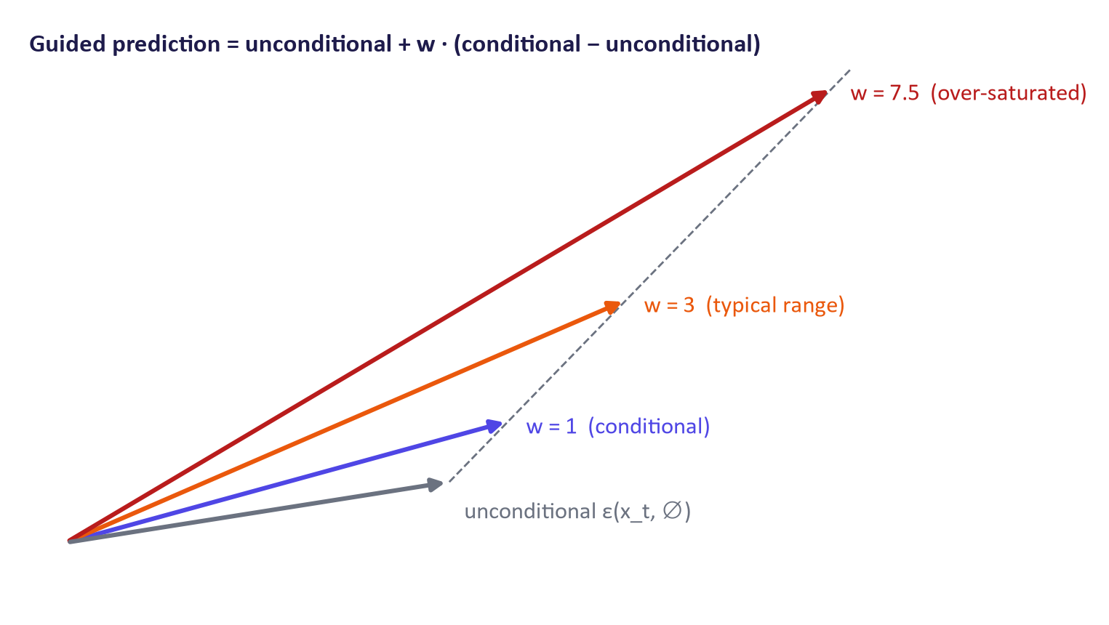
Classifier-free guidance as vector extrapolation
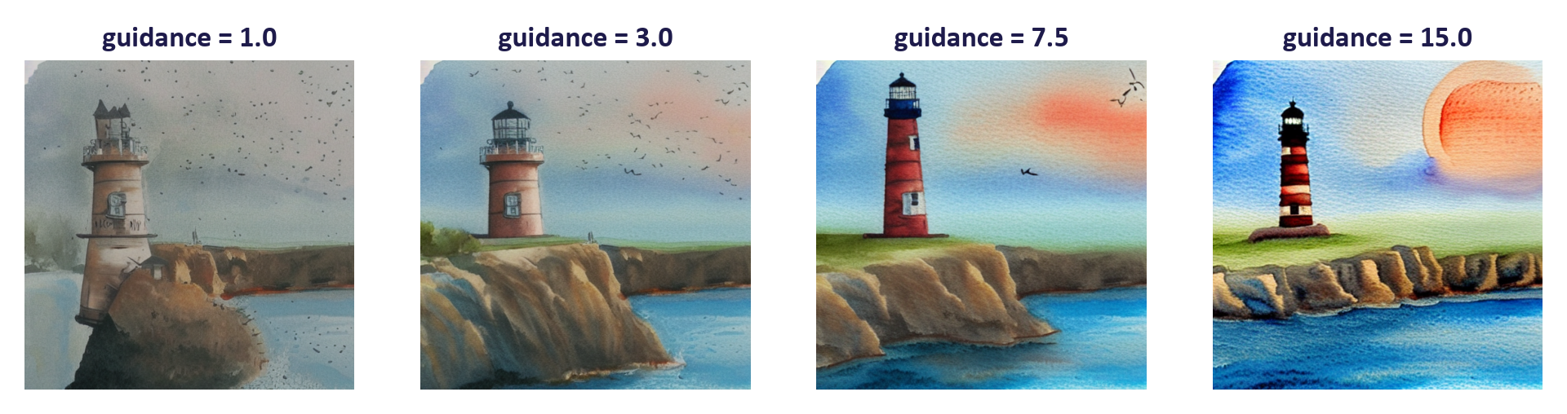
Effect of the guidance scale

Seeds and negative prompts
The seed fixes the starting noise (and any sampling noise); same seed and settings give the same image. A negative prompt replaces ∅ in the guidance formula, so sampling moves away from it. Negative prompts are useful but blunt: they cannot reliably remove small details.
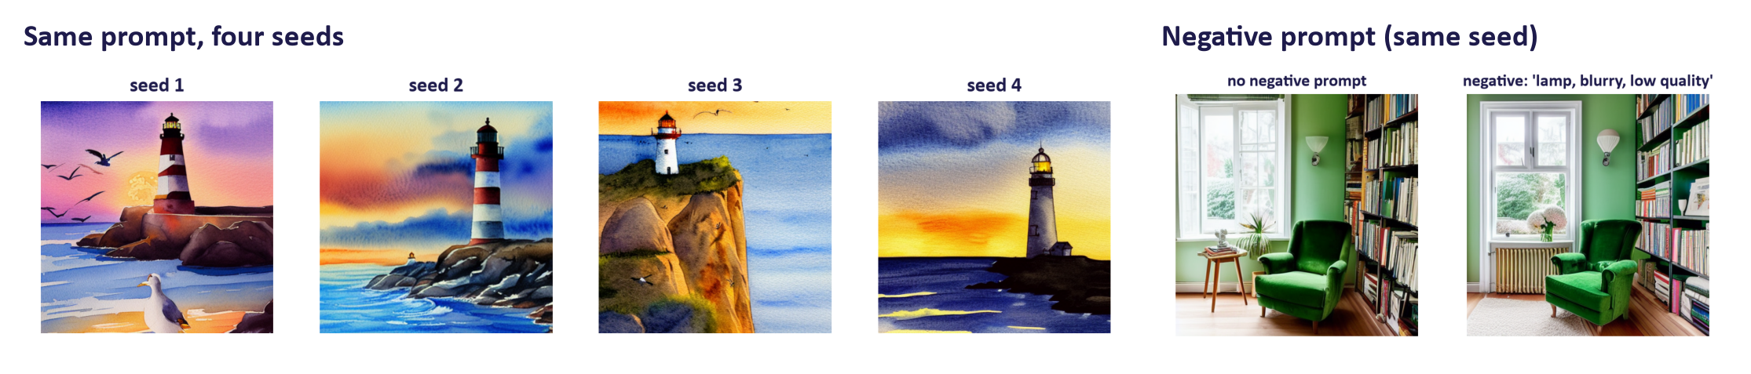
Seeds and negative prompts
Measured timings on the lecture machine (a laptop CPU, float32): SD 1.5, 2 steps: 45 s; 10 steps: 163 s; 25 steps: 419 s; SD-Turbo, 1 step: 25 s; SD-Turbo, 4 steps: 46 s per 512 × 512 image. Always report hardware with timings.

5. Variants, evaluation and responsible use

Flow matching and rectified flow
Flow matching (Lipman et al., 2022) and rectified flow (Liu et al., 2022) learn a velocity field that transports noise to data along simple, usually straight, paths:
Sampling integrates the learned ODE from noise (t = 1) to data (t = 0). Straighter paths need fewer steps; Stable Diffusion 3 and FLUX use rectified flow with transformer backbones. Conventions for the direction of time differ between papers.
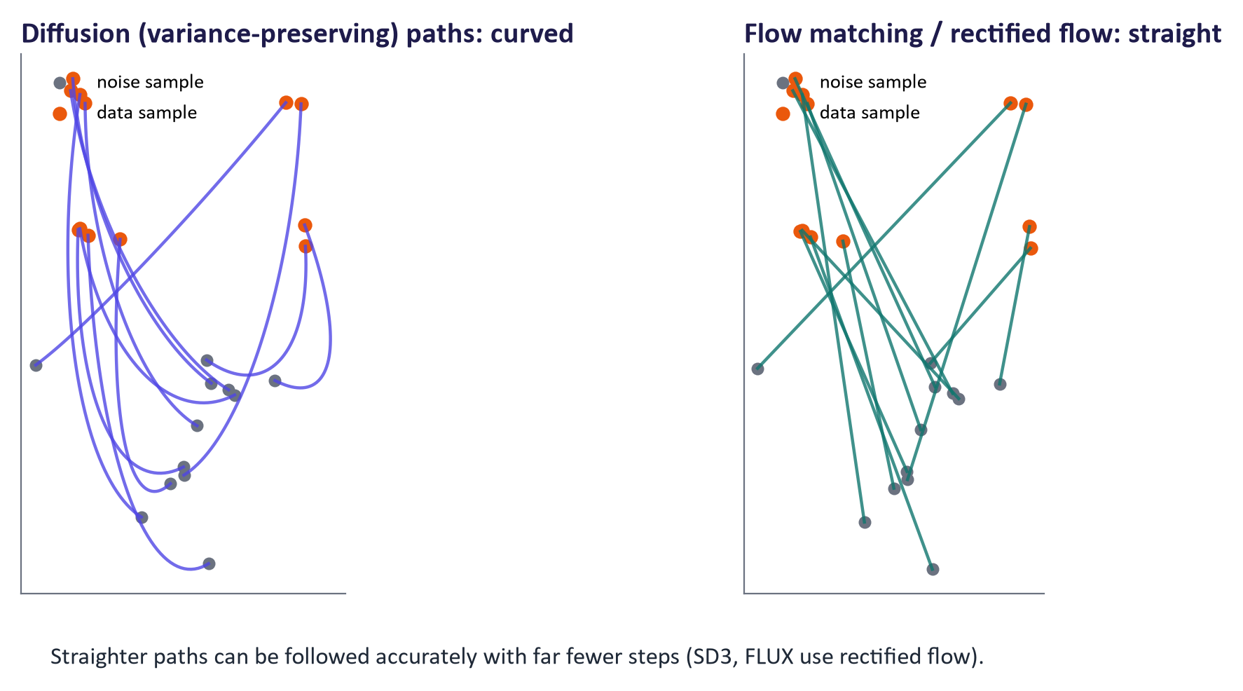
Curved diffusion paths vs straight flow-matching paths

Distillation
A student model is trained to reproduce in one or a few steps what the teacher sampler does in many. Consistency models (Song et al., 2023) and adversarial diffusion distillation (SDXL-Turbo, SD-Turbo; which adds a GAN discriminator) produce usable images in 1–4 steps, with some loss of diversity and control.
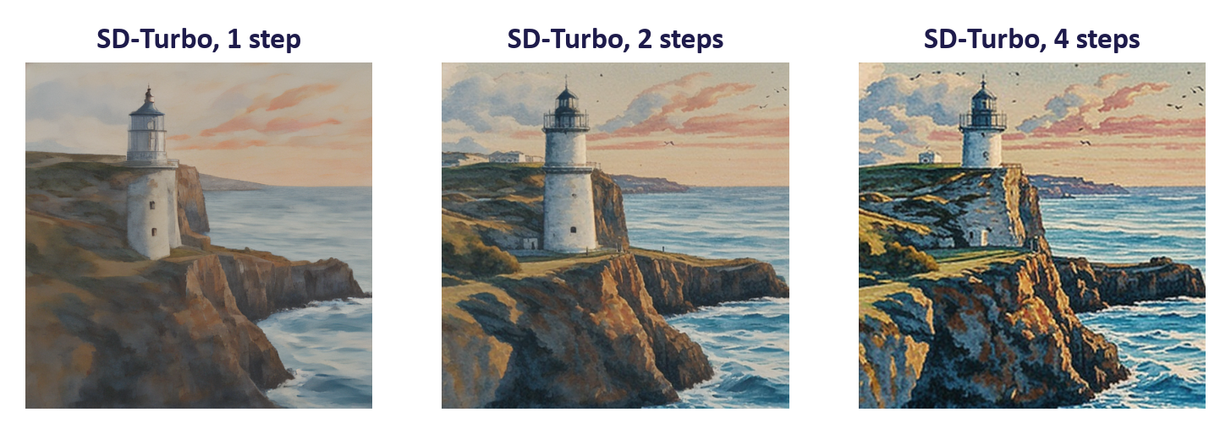
SD-Turbo with 1, 2 and 4 steps

Variants and applications
- Editing: image-to-image (SDEdit: noise part-way, then denoise with a new prompt), inpainting and outpainting.
- Control: ControlNet adds edges, depth or pose as conditions; IP-Adapter conditions on a reference image.
- Personalisation: DreamBooth and LoRA (week 8) teach new subjects or styles from a few images.
- Video: spatio-temporal diffusion transformers (e.g. the Sora and Veo families).
- Audio: latent diffusion over spectrograms or audio-codec latents.
- Science: protein and molecule design, weather forecasting, materials.

Evaluating image generators
Aspect | Metric | Notes
Realism and diversity | FID, KID | Reference set, feature network and sample size must match
Prompt alignment | CLIP score (cosine similarity ×100) | Fooled by keywords; weak on counting and relations
Compositional correctness | GenEval, T2I-CompBench | Detector-based checks of objects, counts, colours, positions
Human preference | Pairwise votes, preference models, public arenas | Most trusted; needs rubric and multiple raters
Efficiency | Steps, seconds per image, memory | Report hardware

The families compared
 | VAE | GAN | Diffusion | Flow matching
Loss | ELBO | Adversarial | Noise regression (ELBO-based) | Velocity regression
Stability | High | Low | High | High
Quality | Blurry | Sharp | Very high | Very high
Diversity | Good | Collapse risk | Good | Good
Sampling | 1 pass | 1 pass | 20–50 (1–4 distilled) | Few
2026 role | Latent compression | Super-resolution, distillation | Image, video, audio | Newest image/video models

Common misconceptions
Misconception | Correction
"The network removes all the noise in one go." | It predicts the noise at one noise level; generation applies many small steps (or a distilled few).
"Training loops over all 1000 steps for each image." | Each training example uses one random timestep; only sampling loops.
"Diffusion runs on pixels in Stable Diffusion." | It runs in the VAE's latent space; pixels appear only after decoding.
"Higher guidance is always better." | It trades diversity and naturalness for prompt adherence; very high values over-saturate.
"The seed is irrelevant." | The seed determines the starting noise; record it for reproducibility.
"Changing the sampler requires retraining." | Samplers use the same noise predictor; swap them freely (quality may change).
"Generated images are always new." | Models can memorise and reproduce duplicated training images.

Responsible AI lens: diffusion models
- Training data and copyright: large scraped image–text datasets; disputes over consent and licensing continue in several jurisdictions. Do not treat the legal position as settled.
- Memorisation: Carlini et al. (2023) extracted near-copies of training images from diffusion models, especially heavily duplicated ones: a privacy and copyright risk.
- Bias: audits have found strong occupational, gender and racial stereotypes in generated people; test prompts systematically across groups.
- Misuse: keep safety filters on; do not generate identifiable real people; provenance (C2PA, watermarks) and EU AI Act Article 50 disclosure for synthetic content.
- Licences: Stable Diffusion 1.5 uses the CreativeML OpenRAIL-M licence with use restrictions; SD-Turbo is a research release whose commercial use needs Stability AI's licence. Check before project use.
- Energy: many steps per image; distillation and smaller models reduce the footprint.

Lab guide and answers
Runtime: Colab T4 GPU. Part A (2-D and MNIST diffusion) also runs on CPU with fewer epochs. Part B needs about 4 GB of GPU memory for SD 1.5 in float16; without a GPU the notebook falls back to SD-Turbo. Hand-in: trained models, sweep grids, DDPM vs DDIM timing, CLIP-score table and three written answers.

TODOs
- TODO 1 a.sqrt() * x0 + (1 - a).sqrt() * eps; at t = 999 the signal fraction is ≈ 4 × 10⁻⁵.
- TODO 2 random t per example, eps = randn_like, xt = q_sample(...), F.mse_loss(model(xt, t), eps).
- TODO 3 DDPM step: (x - beta_t / sqrt(1 - abar_t) * eps_hat) / sqrt(alpha_t) + sqrt(beta_t) * z (no noise at t = 0).
- TODO 4 DDIM: x0_hat = (x - sqrt(1 - a_t) * eps) / sqrt(a_t); x = sqrt(a_next) * x0_hat + sqrt(1 - a_next) * eps. This uses 50 rather than 1000 network calls; measure actual runtime and quality. Unlike lowering sample_ddpm(steps), the selected timesteps span the full noise schedule.
- TODO 5 negative prompt passed as negative_prompt=....
- TODO 6 F.cosine_similarity(img_emb, txt_emb). Expect the control (unrelated prompt) to score clearly lower (≈ 15–20 vs 28–35 on the ×100 scale).

Troubleshooting
- CUDA out of memory with SD 1.5: restart the runtime; use pipe.enable_attention_slicing() or pipe.enable_model_cpu_offload().
- Black images: the safety checker replaced a flagged image, or float16 overflow on some older GPUs; change the prompt or use float32.
- Slow MNIST training on CPU: reduce to 1–2 epochs; digits will be rougher but recognisable.

Practice questions with model answers

Multiple choice
- In xₜ = √(ᾱₜ)x₀ + √(1-ᾱₜ)ε, as t → T: (a) ᾱₜ → 1; (b) xₜ approaches pure noise; (c) xₜ → x₀; (d) the variance explodes. Answer: (b).
- Classifier-free guidance requires: (a) a separate classifier; (b) training with the prompt sometimes dropped; (c) a GAN discriminator; (d) 1000 steps. Answer: (b).
- In Stable Diffusion the text influences the denoiser through: (a) the VAE; (b) cross-attention; (c) the seed; (d) the scheduler. Answer: (b).
- DDIM differs from DDPM mainly in: (a) the training loss; (b) the network architecture; (c) a deterministic sampler that skips steps; (d) the dataset. Answer: (c).

Short answer
- Compute xₜ for x₀ = 1.0, ᾱₜ = 0.64, ε = 0.5. (2 marks) Model answer: 0.8 × 1.0 + 0.6 × 0.5 = 1.1.
- Why is diffusion training stable compared with GAN training? (3 marks) Model answer: each step is a fixed regression target (the known noise) with a mean-squared-error loss; no adversary or moving objective; the loss derives from a likelihood bound, so there is no incentive to drop modes.
- Explain latent diffusion and why it matters in practice. (4 marks) Model answer: a VAE compresses images (e.g. 48×) and diffusion runs in the latent space, conditioned on text via cross-attention; the decoder maps back to pixels (2); it reduces compute and memory enough to train and run high-resolution models on modest GPUs, enabling open models such as Stable Diffusion (2).
- Describe the effect of the guidance scale using the CFG formula. (4 marks) Model answer: the guided prediction extrapolates from the unconditional towards the conditional prediction by factor w (2); larger w increases prompt adherence but reduces diversity and can over-saturate; w = 1 recovers the conditional model (2).

Exam-style question
"Explain how a text-to-image latent diffusion model is trained and how it generates an image from a prompt. Discuss two ways generation has been made faster and how you would evaluate the resulting images." (20 marks)
Marking guide: forward process and closed form (3); noise-prediction objective and its link to the ELBO (3); latent diffusion components: VAE, text encoder, denoiser with cross-attention (4); sampling with classifier-free guidance (3); two speed-ups with trade-offs, e.g. ODE samplers, distillation, flow matching (4); evaluation with FID, CLIP score and human preference including limitations (3).

Glossary
Term | Meaning
Forward process | Fixed Markov chain that gradually adds Gaussian noise
Noise schedule | Sequence β_t controlling how much noise is added per step
ᾱ_t | Product of (1 − β_s); fraction of original signal variance remaining
Reverse process | Learned chain that removes noise step by step
Noise prediction ε_θ | Network output: the noise present in x_t
Score | Gradient of the log density; equivalent (up to scale) to noise prediction
DDPM / DDIM | Original stochastic sampler / deterministic faster sampler
U-Net | Convolutional encoder–decoder with skip connections
Diffusion transformer (DiT) | Transformer over latent patches used as the denoiser
Latent diffusion | Diffusion in a VAE's latent space
Cross-attention | Mechanism letting image features attend to text tokens
Classifier-free guidance | Extrapolating conditional vs unconditional predictions by w
Negative prompt | Prompt whose direction guidance moves away from
Flow matching / rectified flow | Learning a velocity field along (straight) noise-to-data paths
Distillation | Training a few-step student to mimic a many-step sampler
CLIP score | Cosine similarity between CLIP embeddings of image and prompt

Readings, videos and further practice
Core reading (descriptor 7.9)
- Foster, D. (2023) Generative Deep Learning, 2nd ed.: chapter 8, "Diffusion Models" (builds a DDIM model in Keras).
Papers
- Ho, Jain & Abbeel (2020) Denoising Diffusion Probabilistic Models
- Rombach et al. (2022) Latent Diffusion Models
- Ho & Salimans (2022) Classifier-Free Diffusion Guidance
- Lipman et al. (2022) Flow Matching for Generative Modeling
- Peebles & Xie (2022) Scalable Diffusion Models with Transformers
Courses, explainers and videos
- Hugging Face Diffusion Models Course: notebooks with the Diffusers library.
- Hugging Face Diffusers documentation
- MIT 6.S184: Flow Matching and Diffusion Models
- 3Blue1Brown / Welch Labs: But how do AI images and videos actually work?
- Lilian Weng: What are diffusion models?
- Jay Alammar: The Illustrated Stable Diffusion

Link to the group project
Most image-generation projects in 2026 should start from a pretrained diffusion or flow model rather than training from scratch. Ask groups to (1) choose a model and check its licence, (2) define the controls they will expose (prompt templates, guidance, seeds, negative prompts), (3) plan an evaluation combining CLIP score or FID with a small human study, and (4) record all settings for reproducibility. Groups needing a specific style or subject can plan a LoRA fine-tune (week 8).

