WEEK 06 · TEACHING NOTES
Large Language Models (LLMs) and families
From n-grams to frontier models: how LLMs are built and scaled, how they decode, and how to choose among model families
Generative AI · MSc in Artificial Intelligence · 2-hour lecture + 2-hour lab
Descriptor Section 7.3 (revised) for this week
Lecture topic | Large Language Models (LLMs) and families
Detail | Evolution of NLP (n-grams, word embeddings, RNNs, Transformers, LLMs). How Transformers are used in LLMs and generative models: pre-training, scaling laws, context windows and decoding strategies (greedy, temperature, top-k, top-p). Architecture Overview. LLM families: encoder (BERT), encoder-decoder (T5) and decoder-only (e.g. GPT, LLaMA, Gemini, Claude, Mistral, Qwen, DeepSeek); proprietary vs. open-weight models, small language models, mixture-of-experts and reasoning models (test-time compute). Model cards, licences and benchmarks. Applications.
Tutorials | Use pretrained models (Hugging Face pipelines).  Comparing outputs across families (e.g., BERT vs T5 vs GPT-style decoder models).  Query a GPT or LLaMA-family model using the Hugging Face API or a local runtime; compare decoding settings and token counts.
Module learning outcomes (MIMLOs) practised this week
MIMLO 1: Critically explain the core concepts and mathematical principles underlying generative AI, and demonstrate in-depth knowledge of major generative AI model families, including VAEs, GANs, diffusion models and transformer-based LLMs.
MIMLO 3: Design, implement and fine-tune generative AI models using contemporary frameworks and parameter-efficient methods.
MIMLO 5: Deploy generative AI models in real-world scenarios, utilising contemporary frameworks and implement retrieval-augmented or agentic systems.
What is in this week's folder
Lecture slides | 44 slides with speaker notes, vocabulary and technical diagrams.
Teaching notes | Lecture explanations, worked examples, code maps, practice questions and readings.
Student lab | Notebook and Python file with TODOs. Embedded and separate diagrams accompany the lab.
Lab solutions | Instructor notebook and Python file with completed code and model answers.

Lecture plan at a glance
This week turns the transformer into the large language model and maps the model landscape. Students should leave able to explain how LLMs are pre-trained and scaled, choose decoding settings, place any model in its family, read model cards, licences and benchmarks critically, and use models through Hugging Face and an API. Tokenizer counts, next-token distributions and model outputs are real results (curriculum/assets/make_week_06.py).
Time | Slides | Segment | What you do
0–5 min | 1–5 | Warm-up | Why do two assistants answer differently? Keep the list as a comparison checklist.
5–17 min | 6–10 | 1 · Evolution of NLP | Timeline; n-grams and sparsity; each generation's limitation.
17–45 min | 11–19 | 2 · From transformer to LLM | Pipeline; compute ≈ 6ND (worked example); data scale; scaling laws; in-context learning and emergence; context windows; tokenisers.
45–52 min | – | Break
52–65 min | 20–24 | 3 · Decoding | Strategy table; real distributions; quiz.
65–90 min | 25–31 | 4 · Families | Family tree; BERT vs T5 vs GPT; proprietary and open-weight; SLM/MoE/reasoning/multimodal; reasoning models; quiz.
90–118 min | 32–40 | 5 · Choosing and using | Model cards; licences; benchmarks; API vs local; code; applications; selection process; responsible AI.
118–120 min | 41–44 | Lab preview, summary, resources

Teaching tip: Avoid turning section 4 into a list of product names. Ask students to classify each new name by family, access, size and category; the names will change before the exam, the categories will not.

The four supporting slides fit within the existing lecture segments. Use the starting vocabulary and overall flow during the introduction, the mechanism diagram beside the first detailed explanation, and the lab flow during the lab preview. Pause for predictions before showing a worked example.

Beginner walkthrough
Read the overall flow before the detailed theory. Each numbered block performs one operation. The text below a block names the data it passes on. A feedback line means the system repeats an operation. The code names match this week's lab so you can follow the same example in the slides and notebook.

Starting vocabulary
Term | Plain meaning | Check your understanding
Token ID | An integer identifying a text unit in one particular tokenizer's vocabulary. | Must two different tokenizers assign the same IDs to 'Dublin'?
Probability distribution | Nonnegative probabilities for possible outcomes, adding to one. | Do [0.6, 0.3, 0.1] form a probability distribution?
Causal language model | A model predicting the next token from the tokens already present. | What input is available before the next answer token is generated?

A decoder chat request
Trace a user's question through the local model
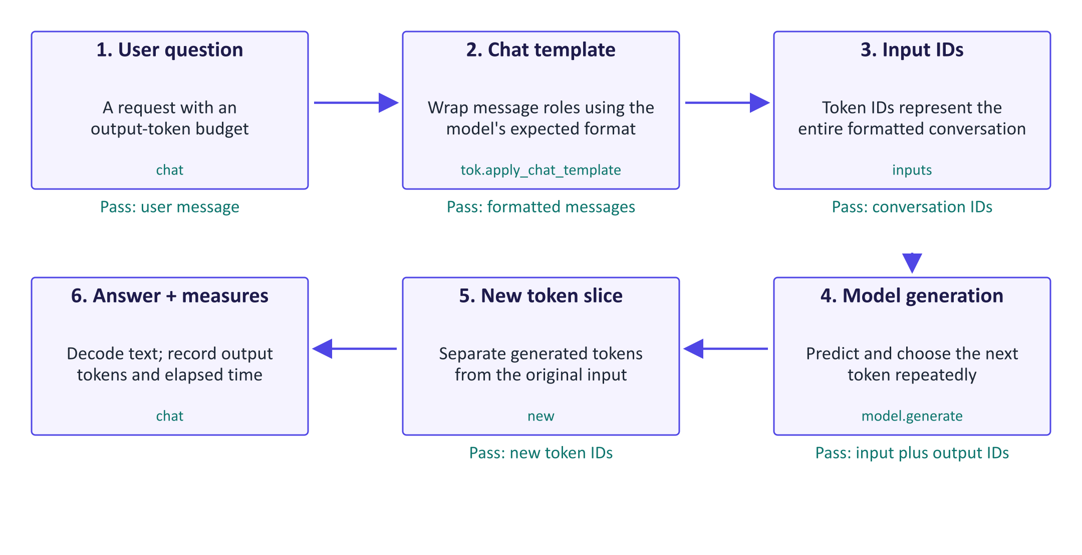
A decoder chat request
A chat interface hides several transformations. First, the user's question becomes a message with a role. A chat template adds the model-specific formatting that distinguishes user text from the assistant reply. The tokenizer converts that formatted input into IDs. The decoder then predicts successive tokens; its generation settings determine how each prediction is chosen. The returned tensor includes both the input and generated continuation, so the helper slices away the input before decoding the answer. No training happens during this call: the model's learned weights stay fixed. The lab compares this decoder workflow with BERT's masked-token prediction and Flan-T5's separate input encoder and output decoder. Those families perform different operations even when their demonstrations use similar questions. The token count and elapsed time describe this measured call, rather than guaranteeing answer quality.

Worked example
- The question 'What is the capital of Ireland?' is placed in a user message.
- The chat template adds the role and assistant-start formatting expected by Qwen.
- Generation repeatedly predicts another token until stopping or reaching its budget.
- The code slices off the input so the returned answer contains new tokens only.
- The same helper returns a token count and elapsed seconds for comparison.
Check your understanding. Why does chat slice the generated tensor at the original input length?
Instructor explanation. Because decoder generation returns input IDs followed by the continuation; the helper returns only the new answer.

Choose one next token
Separate model scores from the decoding policy
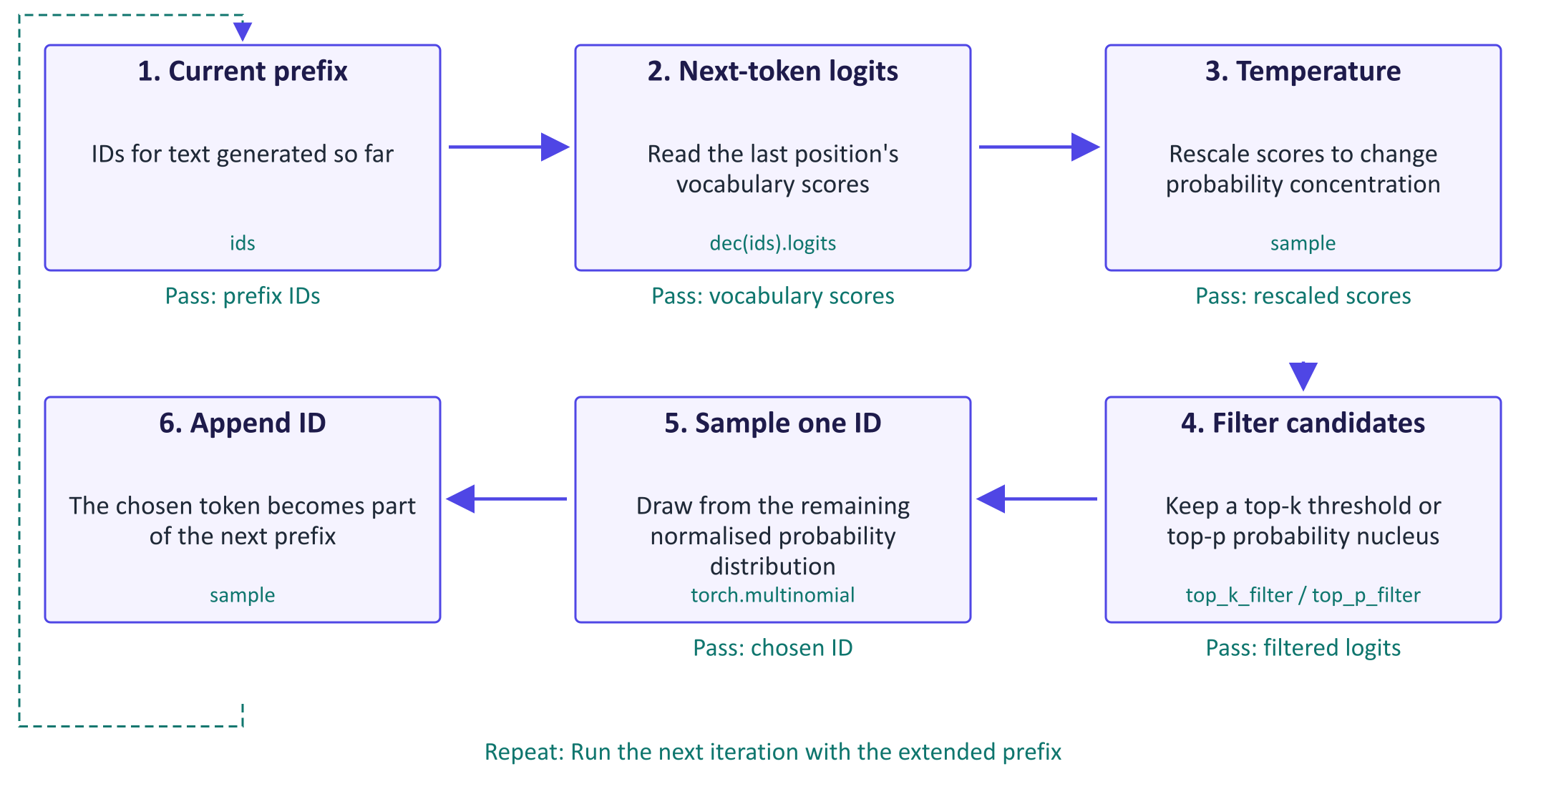
Choose one next token
The neural model provides logits, unnormalised scores for all vocabulary tokens. Decoding is the policy used to turn those scores into a continuation. Greedy decoding chooses the highest-scoring token; the sample helper instead draws a token from probabilities. Temperature rescales logits: a lower positive value concentrates probability on stronger candidates, while a higher value spreads it. Top-k filtering uses a score threshold based on the kth candidate; ties at that threshold can retain additional tokens. Top-p filtering keeps enough leading candidates to reach a chosen cumulative probability, so its retained count depends on model confidence. The chosen token changes the next prefix and therefore the next prediction. A more diverse output is not necessarily more accurate. The manual loop runs its specified number of steps; it does not contain an explicit end-of-sequence stopping test.

Worked example
- The lab's five scores [2, 1, 0.5, 0.1, -1] give probabilities about [0.56, 0.21, 0.12, 0.08, 0.03].
- Top-k with k=2 retains the two highest-scoring candidates in this example.
- Top-p with p=0.8 instead retains three: their cumulative probability first exceeds 0.8.
- Removed candidates get zero probability; retained probabilities are renormalised.
- Sampling selects one ID, which is appended before the next model call.
Check your understanding. Why can top-p retain different numbers of candidates at successive positions?
Instructor explanation. The probability distribution changes with the prefix; a confident distribution needs fewer candidates to reach p.

Compare models with evidence
Different experiments answer different comparison questions
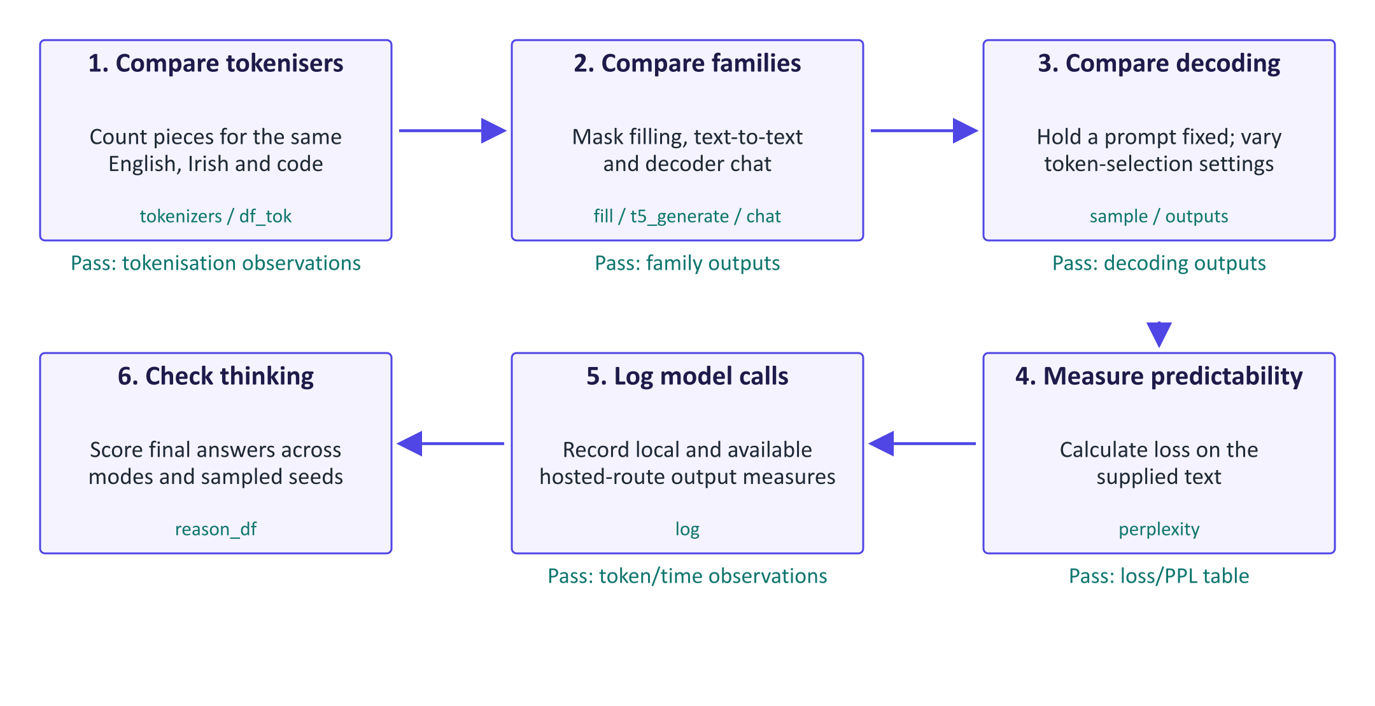
Compare models with evidence
This lab is a sequence of comparison experiments, rather than one shared model pipeline. Token counts show how the same text becomes different pieces. The family demonstrations then expose different output interfaces: BERT ranks words for a blank, Flan-T5 transforms input text into output text, and Qwen continues a formatted conversation. Decoding experiments keep a story prefix fixed while changing how tokens are selected. Perplexity measures the predictability of supplied text, but differences in token boundaries prevent a direct per-token ranking across model families. The call log measures output length and elapsed time. Finally, the thinking experiment checks final numerical answers across sampled seeds, rather than trusting persuasive intermediate text. Different mode settings also use different token budgets and sampling parameters, so the comparison reflects the complete settings used, rather than isolating the thinking switch alone.

Worked example
- Count tokens for identical source text before comparing the models' outputs.
- BERT fills [MASK]; T5 and Qwen generate text using different architectures.
- Use the same story prefix for greedy, beam and sampled continuations.
- Treat perplexity under different tokenisers as different prediction measurements.
- For the scheduling puzzle, compare final-answer correctness, tokens and time across runs.
Check your understanding. Can lower perplexity from one tokenizer prove that its model answers questions better?
Instructor explanation. No. Tokenisers define different prediction units, and text predictability is not the same measurement as question-answer correctness.

Where to look in the code
Code symbol | What it does | What to inspect
df_tok | Summarises tokens per whitespace-delimited word. | Compare columns for the same source text; inspect actual token pieces as well.
t5_generate | Runs an encoder-decoder text-to-text model. | Contrast its input/output interface with masked filling and chat.
chat | Formats a chat request and returns generated text plus measures. | Locate the boundary between input tokens and newly generated answer tokens.
sample | Shows the repeated next-token loop directly. | Track prefix length and the number of retained candidates at each step.
perplexity | Measures next-token predictability on supplied text. | Compare normal and shuffled text within each tokenizer/model pair.
reason_df | Collects thinking-mode outcomes across repeated runs. | Inspect finished, correct, tokens and seconds together; avoid judging one example.

Common points of confusion
- A fluent answer can still be wrong; output diversity is a different measure from correctness.
- Few examples inside a prompt change context, rather than updating the model's weights.
- Visible thinking text and a longer token budget do not guarantee a correct final answer.

Quick glossary
Encoder. A network producing contextual representations of an input sequence.
Decoder. A network predicting output tokens using the preceding output tokens and available input context.
Chat template. Model-specific formatting used to represent roles and messages as a token sequence.
Temperature. A positive divisor on logits that changes the concentration of sampling probabilities.
Nucleus. The leading token candidates retained by a top-p cumulative-probability threshold.
Latency. The elapsed time taken to produce a response.

Lecture notes

1. The evolution of NLP
Approach | Representation | Context | Main limitation
Rules, statistics, n-gram LMs (1990s–2000s) | Words as symbols | n − 1 words | Sparsity; no similarity between words
Word embeddings (word2vec 2013, GloVe) | One dense vector per word | None at use time | One vector for all senses ("bank")
RNN/LSTM seq2seq (2014), + attention (2015) | Contextual hidden states | Whole sequence in theory | Sequential; long-range information fades
Transformer (2017) → BERT/GPT (2018) → GPT-3 (2020) → ChatGPT (2022) | Contextual vectors via attention | Thousands to millions of tokens | Cost with context; hallucination; data hunger

An n-gram model estimates p(wₜ | wₜ₋ₙ₊₁, …, wₜ₋₁) by counting, which is maximum likelihood (the week 1 lab). It fails because most long sequences never occur (sparsity) and because knowledge about cat does not transfer to dog. Neural language models (Bengio et al., 2003) introduced learned word vectors; pre-training on unlabelled text and fine-tuning (BERT, GPT, 2018) replaced task-specific models; scale enabled few-shot prompting (GPT-3); instruction and preference tuning produced assistants (ChatGPT, 2022).
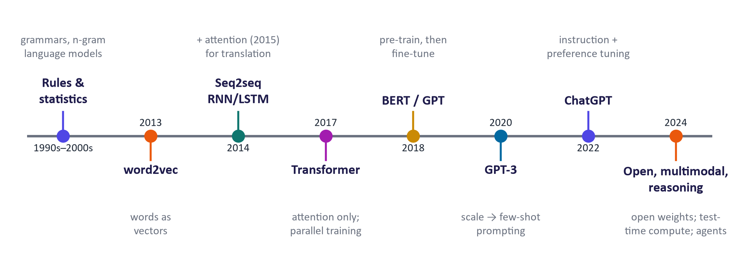
NLP timeline

2. From transformer to LLM: data, scale and context

The pipeline
- Collect web crawls (e.g. Common Crawl), books, code, maths, papers and multilingual text.
- Clean and filter: de-duplicate (duplicates are memorised), remove low-quality and unsafe text (often with classifiers), remove benchmark test sets (decontamination), balance the mix. Synthetic data generated by other models is increasingly used.
- Tokenise with a trained BPE-style tokenizer.
- Pre-train with next-token prediction on thousands of GPUs for weeks.
- Post-train into an assistant (week 8).
The architecture is last week's decoder transformer, scaled up.

Compute

Training FLOPs ≈ 6 × parameters × tokens (≈ 2 per parameter per token forward, ≈ 4 backward). Worked example: N = 7×10⁹, D = 2×10¹²: C ≈ 8.4 × 10²² FLOPs. At an effective 4×10¹⁴ FLOP/s per GPU this is 2.1×10⁸ GPU-seconds ≈ 58,000 GPU-hours (≈ 1,000 GPUs for 2.5 days). Frontier models use orders of magnitude more, so most organisations adapt existing models rather than pre-train.

Data scale
GPT-3 was trained on ≈ 300 B tokens (2020), Chinchilla on 1.4 T (2022), Llama 3 on more than 15 T (2024); Hugging Face's open FineWeb dataset contains ≈ 15 T filtered web tokens. One trillion tokens ≈ 750 billion English words.

Scaling laws
Kaplan et al. (2020) and Hoffmann et al. (2022) found that pre-training loss follows smooth power laws in parameters and data. The Chinchilla fit is
For a fixed compute budget the loss is minimised with roughly 20 training tokens per parameter. GPT-3 (≈ 1.7 tokens/parameter) was under-trained by this criterion. Recent small models are deliberately trained far beyond it (Llama 3 8B: ≈ 1,900 tokens/parameter) because a smaller model is cheaper to serve to millions of users; inference cost, not only training cost, drives design.
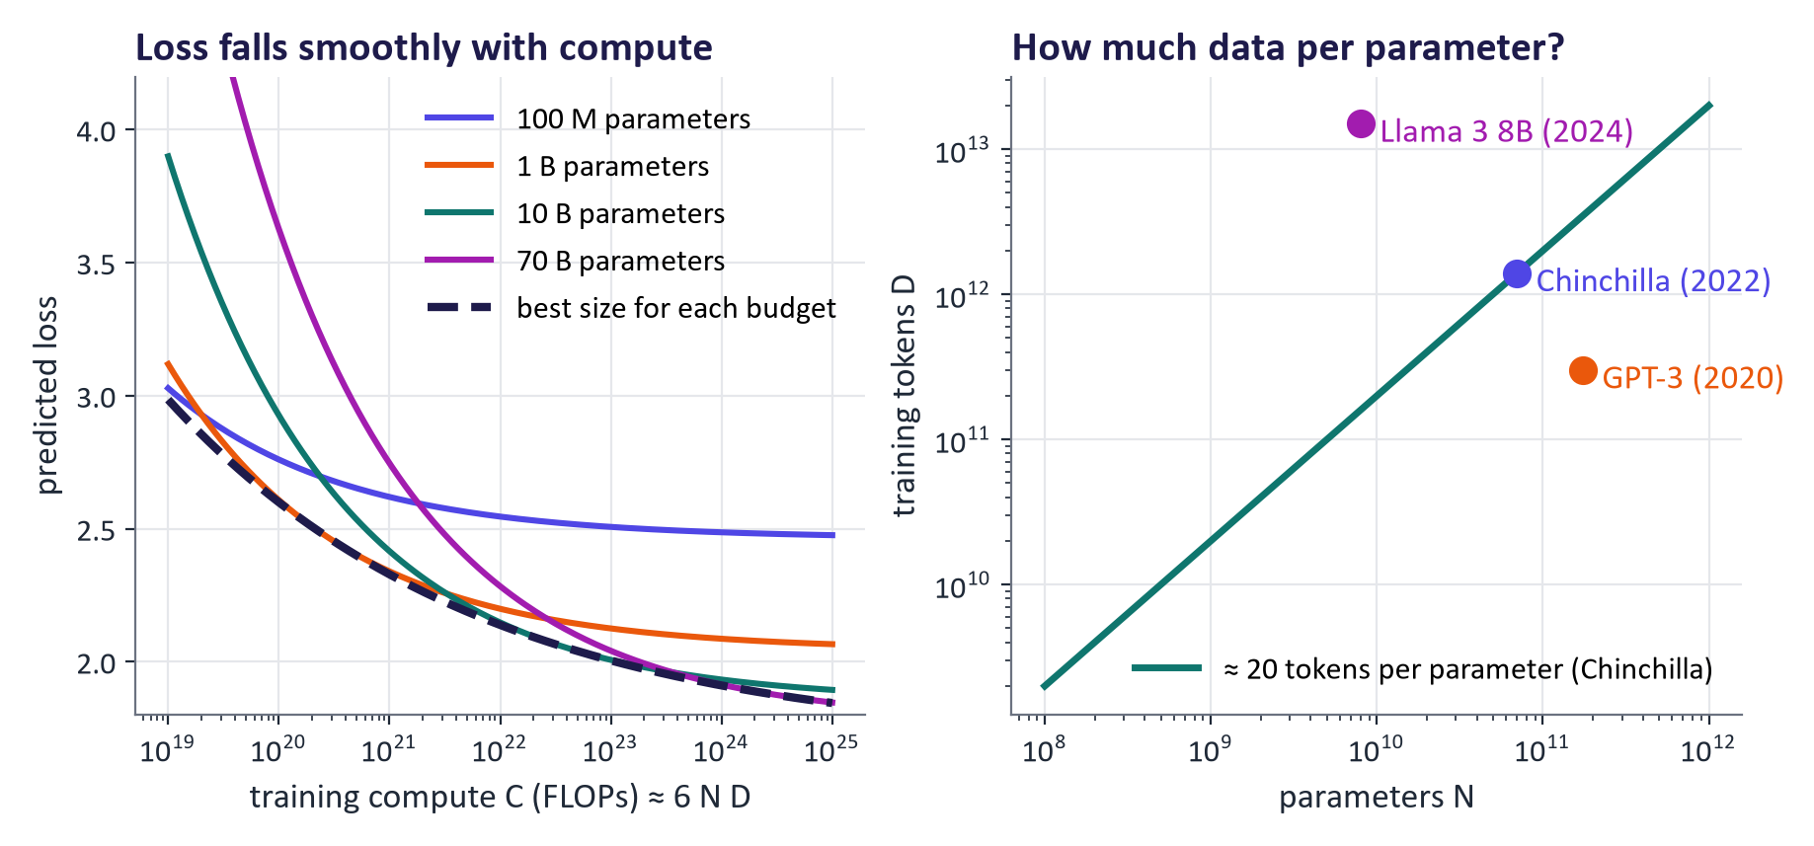
Scaling laws

In-context learning and emergence
Large models can perform a task from a few examples in the prompt without updating weights (in-context learning, GPT-3). Some abilities appeared to "emerge" abruptly with scale; Schaeffer et al. (2023) showed that many such jumps reflect discontinuous metrics (exact match), and with continuous metrics improvement is often smooth. Practical rule: test the capability you need at the size you can afford.

Context windows
The context window (≈ 2 K tokens in 2020; 128 K–2 M in current models) holds the system prompt, conversation, retrieved documents, tool outputs and the answer. Cost and latency grow with context. Models use long contexts unevenly: information in the middle of long inputs is used less reliably ("lost in the middle", Liu et al., 2023). Long context does not remove the need to select relevant information (retrieval, week 12).

Tokenisers differ between families
Tokenizer | Vocabulary | English | Irish | Python code
GPT-2 | 50,257 | 15 | 38 | 33
BERT | 30,522 | 16 | 33 | 30
Flan-T5 | 32,100 | 17 | 55 | 37
Qwen2.5 | 151,665 | 15 | 35 | 21
SmolLM2 | 49,152 | 15 | 39 | 27

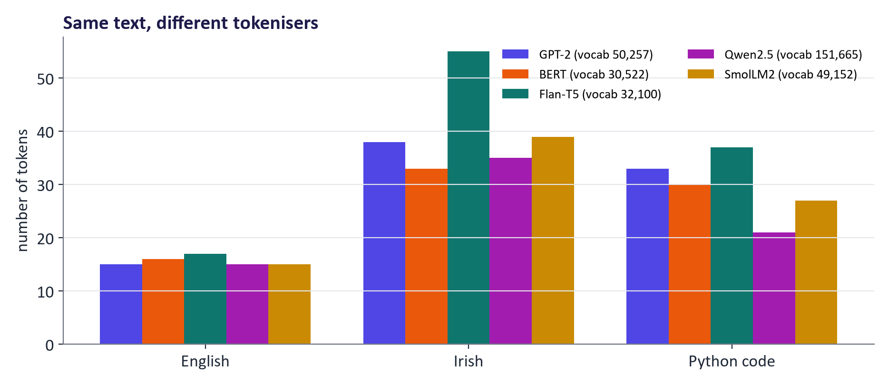
Token counts for the same texts across tokenisers

3. Decoding strategies
Strategy | Mechanism | Use for | Risk
Greedy | Most likely token each step | Short factual answers, extraction | Loops, bland text
Beam search | Keep k best partial sequences | Translation, summarisation with encoder–decoders | Generic output in open chat
Temperature | Divide logits by T before softmax | Controlling creativity | High T: errors
Top-k | Sample among k most likely tokens | Removing the unlikely tail | Ignores model confidence
Top-p (nucleus) | Sample among the smallest set with cumulative probability ≥ p | General chat/writing | Interacts with temperature
Repetition penalty | Down-weight used tokens | Long generation | Can corrupt names, numbers, code

Worked example (top-p). Logits [2, 1, 0.5, 0.1, −1] give probabilities [0.56, 0.21, 0.12, 0.08, 0.03]. With p = 0.8 the cumulative sums are 0.56, 0.76, 0.89: the nucleus is the first three tokens; the rest are removed and the three kept probabilities are renormalised.
Real distributions from the base (pre-trained, not instruction-tuned) Qwen2.5-0.5B model: after “The capital of Ireland is” the top tokens are ' ______' (0.19), ' located' (0.09), ' the' (0.06), ' Dublin' (0.05); after “My favourite food is” the top tokens are ' ______' (0.07), ' ' (0.05), ' pizza' (0.04), ' ' (0.04). Base models are pure next-token predictors: they continue text the way their training data does, so even a factual prefix has many plausible continuations (“located”, “the”, “Dublin”), and the top token “” reflects the fill-in-the-blank worksheets found on the web. Post-training (week 8) turns this continuation engine into an assistant that answers the question.
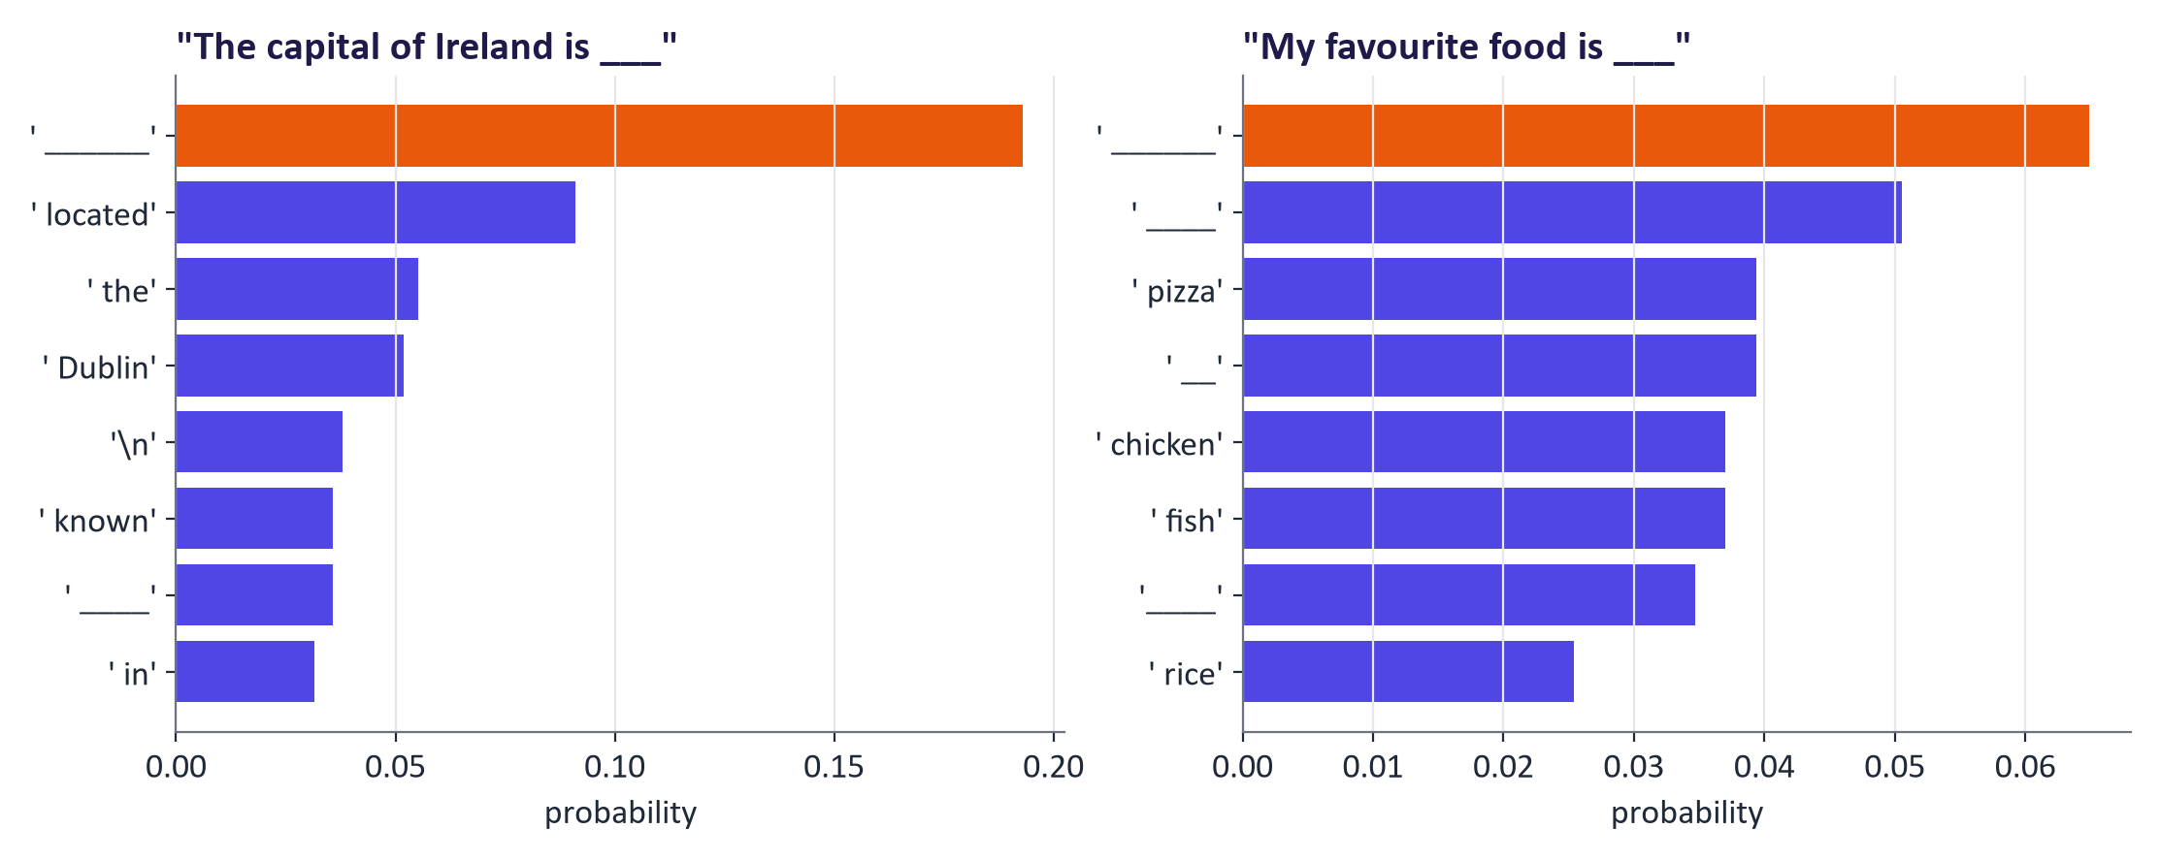
Real next-token distributions

4. LLM families

By architecture
- Encoder-only: BERT (2018), RoBERTa, DeBERTa, ModernBERT (2024), most embedding models. Masked-language-model pre-training; bidirectional. Use: classification, tagging, embeddings for search. Not a free-text generator.
- Encoder–decoder: T5 (2019; Flan-T5 is instruction-tuned), BART, mT5, Whisper (speech). Every task as text-to-text.
- Decoder-only: GPT family (OpenAI), Claude (Anthropic), Gemini (Google), Llama (Meta), Gemma (Google, open-weight), Qwen (Alibaba), DeepSeek, Mistral, Phi (Microsoft), OLMo (AI2, fully open with data and code), gpt-oss (OpenAI open-weight, 2025).
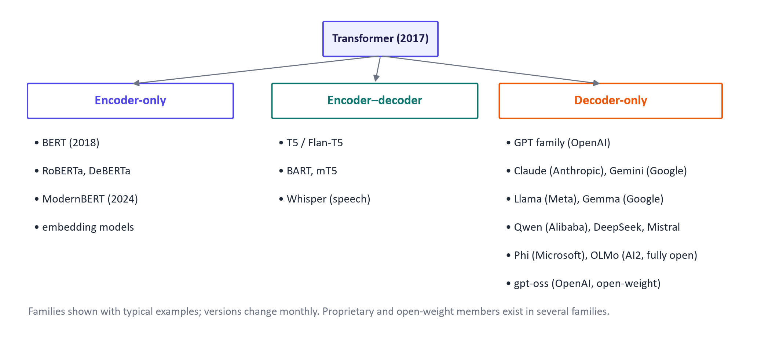
Family tree

Same input, different families (real outputs from the lecture preparation)
BERT (encoder, fill-mask) on “The capital of Ireland is [MASK].”: “dublin” (0.73), “galway” (0.09), “belfast” (0.05). BERT fills gaps; it does not write answers.
Prompt | Flan-T5-base (encoder–decoder) | Qwen2.5-0.5B-Instruct (decoder)
What is the capital of Ireland? | dublin | The capital of Ireland is Dublin.
Translate English to German: How old are you? | Wie old sind Sie? | Wie alt bist du?
Summarize in one sentence: Generative models learn a… | Understand how to use generative models. | Generative models generate new samples from their learned…

By access
Family | Developer | Access
GPT | OpenAI | Proprietary API/app; open-weight gpt-oss (Apache 2.0)
Claude | Anthropic | Proprietary API/app
Gemini / Gemma | Google | Proprietary / open-weight (Gemma terms)
Llama | Meta | Open-weight, community licence, gated download
Qwen | Alibaba | Open-weight, mostly Apache 2.0
DeepSeek | DeepSeek | Open-weight (MIT for R1); mixture-of-experts
Mistral | Mistral AI | Open-weight and proprietary
Phi / OLMo | Microsoft / AI2 | Open-weight (MIT / Apache 2.0)

Newer categories
- Small language models (≈ 0.1–8 B parameters): run locally or on devices; with good data and distillation they match much larger older models on many tasks.
- Mixture-of-experts: many parameters, few active per token (week 5); need memory for all experts.
- Reasoning models: trained (usually with reinforcement learning on checkable problems) to produce a long chain of reasoning before answering; spend test-time compute. Examples: OpenAI's o-series (2024), DeepSeek-R1 (2025, open), thinking modes in Claude, Gemini and Qwen3. Visible reasoning text is not guaranteed to reflect the internal computation.
- Multimodal LLMs: weeks 9–10.
Real test (thinking off vs on). An easy word problem and a scheduling puzzle with a hidden constraint (only one 2-GPU run fits on 3 GPUs at a time, so 5 runs take 5 × 4 = 20 hours). Qwen3-0.6B on an NVIDIA GTX 1650 laptop GPU, three sampled runs per mode (the model card's settings; greedy decoding makes thinking mode loop). word problem (answer 21): without thinking 3/3 correct, ≈154 tokens, ≈15 s each; with thinking 3/3 correct, ≈783 tokens, ≈73 s each; scheduling puzzle (answer 20): without thinking 1/3 correct, ≈117 tokens, ≈11 s each; with thinking 0/3 correct, ≈2,048 tokens, 3 ran out of the 2,048-token budget, ≈201 s each.
Problem | Thinking | Correct | Mean tokens | Mean seconds | Out of budget
word problem | off | 3/3 | 154 | 15 | 0
word problem | on | 3/3 | 783 | 73 | 0
scheduling puzzle | off | 1/3 | 117 | 11 | 0
scheduling puzzle | on | 0/3 | 2,048 | 201 | 3

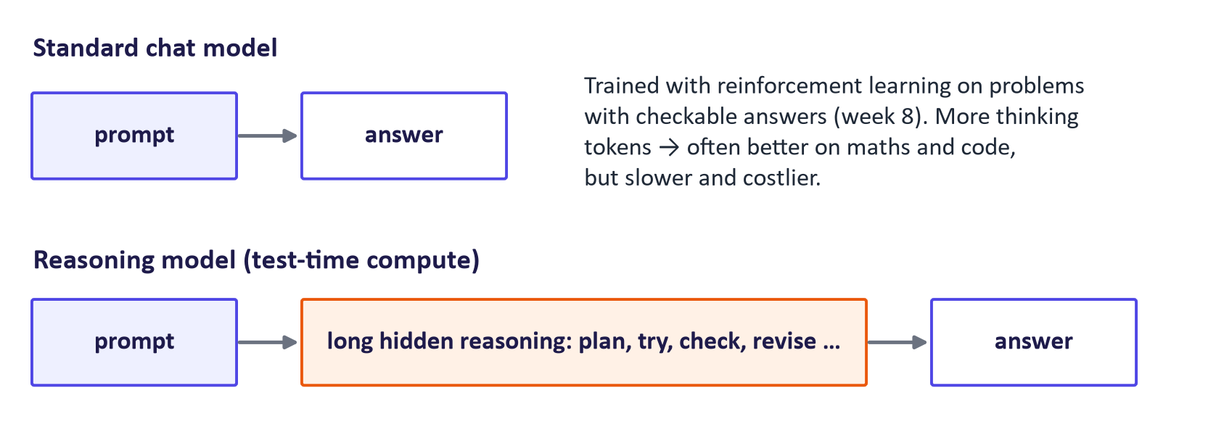
Reasoning models spend extra tokens before answering

5. Choosing and using models

Model cards
Check: intended use and out-of-scope uses; training data (sources, languages, dates, personal/copyrighted data); evaluations and settings; limitations and biases; licence and access; technical details (size, context length, tokenizer, chat template, hardware). Missing information is itself relevant for risk assessment (Mitchell et al., 2019).

Licences
Type | Examples | Usually means
Permissive (Apache 2.0, MIT) | Qwen (most), OLMo, Phi, DeepSeek-R1, gpt-oss | Use, modify and commercialise with notices
Community/custom | Llama, Gemma | Free use with acceptable-use policies and conditions (Llama: separate licence above 700 M monthly users)
OpenRAIL | Stable Diffusion 1.5, BLOOM | Open use with listed prohibited uses
Non-commercial research | e.g. SD-Turbo | No commercial use
Proprietary API terms | GPT, Claude, Gemini | Pay per use; provider sets data and output terms

Benchmarks
Benchmark | Measures | Caveat
MMLU / MMLU-Pro | Multiple-choice knowledge | Saturation, contamination
GSM8K, MATH | Maths problems | Format sensitivity, memorisation
HumanEval, SWE-bench | Code generation; real repository fixes | Narrow languages and tasks
GPQA | Hard graduate-level science | Small
Human preference arenas | Pairwise votes (Elo) | Style and length bias

Build a small test set from your own task (week 7) and evaluate shortlisted models with fixed prompts and settings.

API vs local
Hosted APIs give the strongest models without hardware but send data to a provider, cost per token and may change or retire models. Local/self-hosted open models (Transformers, Ollama, vLLM) give privacy, control and fixed versions and allow fine-tuning, but need hardware and operations. Most providers and local servers accept the same OpenAI-compatible chat format (messages in, message out).
from transformers import pipeline
chat = pipeline("text-generation", model="Qwen/Qwen2.5-0.5B-Instruct")
out = chat([{"role": "user", "content": "Explain tokens in one sentence."}],
max_new_tokens=60, do_sample=False)
print(out[0]["generated_text"][-1]["content"])

from huggingface_hub import InferenceClient
client = InferenceClient(api_key=os.environ["HF_TOKEN"])
resp = client.chat.completions.create(model="Qwen/Qwen2.5-7B-Instruct",
messages=[{"role": "user", "content": "Name three LLM families."}],
max_tokens=100, temperature=0.2)

A selection process
Define the task → list constraints (privacy, budget, latency, hardware, licence, languages) → shortlist 2–4 candidates → evaluate on your own test set (quality, cost, latency) → decide, document and re-test when models change. The best model is the smallest, cheapest one that meets the quality bar within the constraints.

Common misconceptions
Misconception | Correction
"BERT, T5 and GPT are interchangeable chatbots." | Encoder, encoder–decoder and decoder models do different jobs.
"Bigger is always better." | Task fit, data, post-training, cost and latency matter; small models often suffice.
"Open-weight means open-source and free to use for anything." | Weights ≠ data/code; licences impose conditions.
"A top leaderboard score means the model is best for my task." | Benchmarks can be contaminated or saturated; test on your own data.
"A million-token context means retrieval is unnecessary." | Cost, latency and lost-in-the-middle effects remain.
"Reasoning models show their true reasoning." | Visible reasoning may not be faithful; check answers.
"Temperature 0 makes an API perfectly reproducible." | Server-side changes and non-determinism can still alter outputs.

Responsible AI lens: large language models
- Data provenance and copyright: limited disclosure of training data; ongoing litigation.
- Bias: stereotyped outputs (e.g. BERT's gendered predictions in the lab) and unequal quality across languages and dialects.
- Hallucination and overconfidence: fluent answers without guarantees.
- Privacy: memorisation of training data; data sent to APIs.
- Openness: open weights support scrutiny and local control but also misuse; the EU AI Act adds obligations for general-purpose AI model providers.

Lab guide and answers
Runtime: Colab (T4 recommended; CPU works). Downloads ≈ 3 GB (BERT, Flan-T5, Qwen2.5-0.5B, GPT-2, Qwen3-0.6B). Optional keys: HF_TOKEN, GEMINI_API_KEY. Hand-in: tables, decoding implementation, perplexity results, API log, four answers, model-card worksheet.

TODOs
- TODO 1 len(tok(text, add_special_tokens=False)["input_ids"]) and divide by word count. English ≈ 1.2–1.5 tokens/word; Irish much higher, especially for Flan-T5 and GPT-2 (≈ 3–4); code varies (Qwen's tokenizer is the most efficient).
- Part 2: BERT ranks "dublin" first for the capital; Flan-T5 answers short tasks concisely; Qwen answers fluently but may be verbose. BERT's "The doctor said [MASK]…" often predicts "he": a bias example.
- TODO 2 kth = topk(logits, k).values[..., -1]; masked_fill(logits < kth, -inf).
- TODO 3 sort, cumulative softmax, remove tokens whose preceding cumulative mass is already ≥ p, scatter back. Test: 3 tokens kept for p = 0.8.
- TODO 4 math.exp(loss). Expected pattern: code < normal < Irish < shuffled for both models; code is extremely low for Qwen, and Irish much higher for GPT-2 than for Qwen.
- Part 5: without keys only the local row appears; with keys, compare latency and token usage.
- Part 6: both modes solve the word problem, thinking with about five times as many tokens. On the scheduling puzzle the 0.6 B model rarely reaches 20 h in either mode; in thinking mode it tends to run out of budget (instructor run: 1/3 correct without thinking, 0/3 with thinking, all three out of budget). Use this to discuss when test-time compute pays off.

Practice questions with model answers

Multiple choice
- Chinchilla's scaling result suggests, for a fixed compute budget: (a) as many parameters as possible; (b) about 20 tokens per parameter; (c) 1 token per parameter; (d) no dependence on data. Answer: (b).
- Training compute is approximately: (a) N + D; (b) 6ND; (c) N²D; (d) 2N/D. Answer: (b).
- Which model family generates free text left to right? (a) BERT; (b) RoBERTa; (c) decoder-only models such as Llama; (d) embedding models. Answer: (c).
- Top-p sampling with p = 0.9: (a) keeps 90% of tokens; (b) keeps the smallest set of tokens with cumulative probability ≥ 0.9; (c) sets temperature to 0.9; (d) keeps the 9 most likely tokens. Answer: (b).

Short answer
- Estimate the training compute for a 1 B-parameter model trained on 100 B tokens. (2 marks) Model answer: 6 × 10⁹ × 10¹¹ = 6 × 10²⁰ FLOPs.
- Explain why modern small models are trained on far more than 20 tokens per parameter. (3 marks) Model answer: Chinchilla optimises training compute only; deployed models serve many requests, so a smaller model trained longer reaches the required quality with lower inference cost and latency.
- Compare BERT, T5 and GPT on architecture, pre-training objective and typical use. (6 marks) Model answer: encoder / masked LM / classification and embeddings; encoder–decoder / span corruption text-to-text / translation and summarisation; decoder / next-token / generation and chat (2 each).
- Give two reasons to be cautious about leaderboard scores. (2 marks) Model answer: contamination, saturation, prompt/format sensitivity, mismatch with your task, style bias in human votes.

Exam-style question
"A hospital wants an assistant that summarises patient discharge letters. Discuss how you would choose an LLM, covering model families, open vs proprietary access, size, decoding settings, evaluation and responsible-AI considerations." (20 marks)
Marking guide: task definition and constraints including privacy/GDPR (4); family and size justification, e.g. a decoder LLM or encoder–decoder summariser, preferring locally hosted open weights (4); decoding choice for faithful summaries (low temperature/greedy or beam) (3); evaluation plan on a de-identified test set with factual-consistency checks and clinician review (5); responsible AI: hallucination risk, bias, licence, audit trail, human oversight (4).

Glossary
Term | Meaning
n-gram model | Predicts the next word from the previous n − 1 words by counting
Word embedding | Dense learned vector per word
Pre-training | Self-supervised training on large unlabelled text
Scaling law | Empirical power law relating loss to parameters, data and compute
Chinchilla optimum | ≈ 20 training tokens per parameter for fixed compute
In-context learning | Performing a task from examples in the prompt without weight updates
Context window | Maximum tokens the model can attend to in one call
Beam search | Decoding that keeps the k most probable partial sequences
Top-p (nucleus) | Sampling from the smallest set of tokens with cumulative probability ≥ p
Open-weight model | Model whose weights are downloadable under a licence
Small language model | Model of roughly ≤ 8 B parameters for local or device use
Reasoning model | Model trained to generate extended reasoning before answering
Test-time compute | Extra inference computation (e.g. thinking tokens) to improve answers
Model card | Documentation of a model's intended use, data, evaluation, limits and licence
Contamination | Benchmark test data appearing in training data

Readings, videos and further practice
Core reading (descriptor 7.9)
- Tunstall, von Werra & Wolf (2022) Natural Language Processing with Transformers: chapter 1 ("Hello Transformers") and chapter 5 ("Text Generation", decoding strategies).
- Ozdemir, S. (2023) Quick Start Guide to Large Language Models: part I.
- Rothman, D. (2022) Transformers for Natural Language Processing: chapters on BERT and GPT (supplementary).
Videos
- Andrej Karpathy: Intro to Large Language Models
- Andrej Karpathy: Deep Dive into LLMs like ChatGPT
- Google Cloud Tech: Introduction to large language models
- 3Blue1Brown: Large Language Models explained briefly
Courses and documentation
- Hugging Face LLM Course, chapters 1–2
- Google ML Crash Course: Introduction to LLMs
- Hugging Face Transformers pipelines and chat templates
- Hugging Face Inference Providers
Papers
- Devlin et al. (2018) BERT; Raffel et al. (2019) T5; Brown et al. (2020) GPT-3; Touvron et al. (2023) LLaMA
- Hoffmann et al. (2022) Chinchilla; DeepSeek-AI (2025) DeepSeek-R1

Link to the group project
Each group writes a one-page model selection memo: task definition, constraints, 2–4 shortlisted models (family, size, access, licence), the evaluation they will run in week 7, and a provisional choice. This memo becomes part of the project report's design section.

