WEEK 08 · TEACHING NOTES
Fine-Tuning and Domain Adaptation
Adapting pretrained models to your task: supervised and instruction tuning, preference alignment, and parameter-efficient methods such as LoRA
Generative AI · MSc in Artificial Intelligence · 2-hour lecture + 2-hour lab
Descriptor Section 7.3 (revised) for this week
Lecture topic | Fine-Tuning and Domain Adaptation
Detail | Choosing between prompting, retrieval and fine-tuning. Fine-tuning approaches: full fine-tuning, supervised fine-tuning (SFT) and Instruction Tuning. Preference alignment: reinforcement learning with human feedback (RLHF), direct preference optimisation (DPO) and reinforcement learning with verifiable rewards for reasoning models. Parameter-efficient tuning: LoRA, QLoRA, adapters, prompt tuning. Knowledge distillation. Domain-Specific Fine-Tuning (data preparation, chat templates, overfitting, catastrophic forgetting). Evaluation & Benchmarks.
Tutorials | Fine-tune a small pre-trained LLM for a domain-specific task.  Apply parameter-efficient fine-tuning (LoRA / QLoRA) with Hugging Face PEFT and TRL.  Compare base vs fine-tuned model performance on a held-out test set.
Module learning outcomes (MIMLOs) practised this week
MIMLO 1: Critically explain the core concepts and mathematical principles underlying generative AI, and demonstrate in-depth knowledge of major generative AI model families, including VAEs, GANs, diffusion models and transformer-based LLMs.
MIMLO 3: Design, implement and fine-tune generative AI models using contemporary frameworks and parameter-efficient methods.
MIMLO 4: Critically evaluate generative AI outputs using quantitative metrics, human-centered assessments and ethical considerations, including fairness, bias and hallucination risks.
What is in this week's folder
Lecture slides | 44 slides with speaker notes, vocabulary and technical diagrams.
Teaching notes | Lecture explanations, worked examples, code maps, practice questions and readings.
Student lab | Notebook and Python file with TODOs. Embedded and separate diagrams accompany the lab.
Lab solutions | Instructor notebook and Python file with completed code and model answers.

Lecture plan at a glance
This week is the core of MIMLO 3: adapting pretrained models by changing their weights. Students should leave able to decide when fine-tuning is appropriate, explain SFT, instruction tuning, RLHF, DPO and RL with verifiable rewards, compute LoRA parameter counts, fine-tune with PEFT/TRL, and evaluate base vs fine-tuned models honestly. The results in section 5 are real, from running this week's lab notebook in advance (saved to curriculum/assets/week_08/results.json).
Time | Slides | Segment | What you do
0–5 min | 1–5 | Warm-up | Brand voice / weekly rates / 50,000 messages: prompt, retrieve or fine-tune?
5–18 min | 6–10 | 1 · When to fine-tune | Comparison table; decision process; good and bad reasons.
18–38 min | 11–16 | 2 · SFT and instruction tuning | Full vs SFT; loss with masking; instruction tuning; chat template; data preparation.
38–63 min | 17–23 | 3 · Preference alignment | RLHF pipeline; reward model and KL objective; DPO; three approaches; AI feedback and failure modes; quiz.
63–70 min | – | Break
70–95 min | 24–32 | 4 · PEFT | LoRA diagram and equations (worked count); lab model counts; QLoRA; method comparison; memory table; distillation.
95–118 min | 33–40 | 5 · Domain adaptation | Workflow; pitfalls; real results and loss curve; evaluation; domain models; responsible AI.
118–120 min | 41–44 | Lab preview, summary, resources

Teaching tip: Do the LoRA parameter count (16 × (4096 + 4096) = 131,072 vs 16,777,216) on the board; it is a common exam calculation.

The four supporting slides fit within the existing lecture segments. Use the starting vocabulary and overall flow during the introduction, the mechanism diagram beside the first detailed explanation, and the lab flow during the lab preview. Pause for predictions before showing a worked example.

Beginner walkthrough
Read the overall flow before the detailed theory. Each numbered block performs one operation. The text below a block names the data it passes on. A feedback line means the system repeats an operation. The code names match this week's lab so you can follow the same example in the slides and notebook.

Starting vocabulary
Term | Plain meaning | Check your understanding
Model weight | A learned number used by a neural network to transform its input. | Do ordinary prompt-only calls update stored model weights?
Train / validation / test | Separate examples for learning, choosing settings and final measurement. | Which split must not be used to train the adapter?
Matrix projection | Multiplying a vector by learned weights to produce another vector. | If a projection maps 8 numbers to 4 numbers, what is its output length?

Adapt a banking classifier
Measure whether training improves on a strong prompting baseline
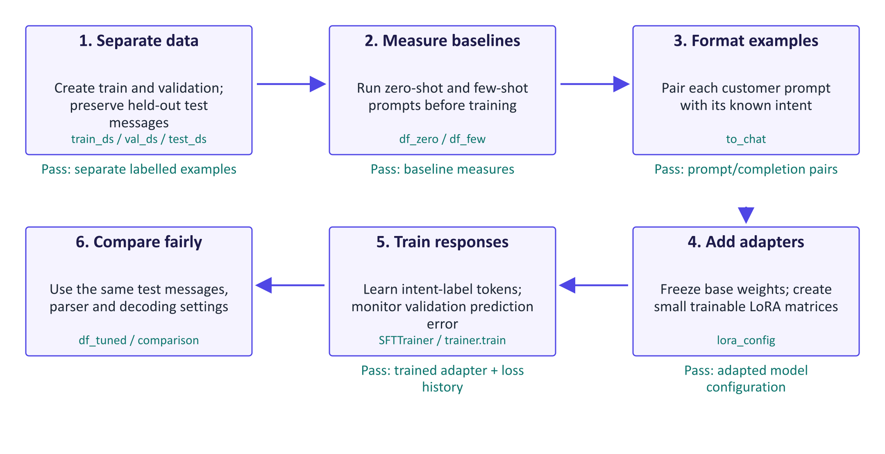
Adapt a banking classifier
Fine-tuning changes learned parameters, whereas prompting changes the current input. This lab adapts a pretrained language model to emit banking intent labels. The training examples teach the task; validation examples help monitor learning; test examples provide the final comparison. The lab also measures a few-shot baseline so that training must improve on a useful prompting approach. Supervised fine-tuning means learning from known prompt/response pairs. LoRA describes which parameters change: small adapter matrices learn while the base weights remain frozen. These are different choices and can be combined. The trainer measures loss on completion tokens, rather than asking the model to reproduce the prompt. After training, the same parser and test messages are used for comparison. Reduced training loss alone cannot establish better routing accuracy, and the original customer labels can contain ambiguity.

Worked example
- A message about a missing card has a reference banking-intent label.
- The unmodified model is evaluated with no examples and with one example per intent.
- Training pairs put the customer message in the prompt and the intent in the completion.
- Only the LoRA adapter parameters learn from the training examples.
- The tuned model uses the original zero-shot format on the same held-out test messages.
Check your understanding. Why compare the tuned model with the few-shot baseline as well as the zero-shot baseline?
Instructor explanation. Few-shot prompting is a stronger alternative that needs no training; the adapter's improvement should justify its extra work.

A LoRA training update
Trace information forward and learning backward while the base stays frozen
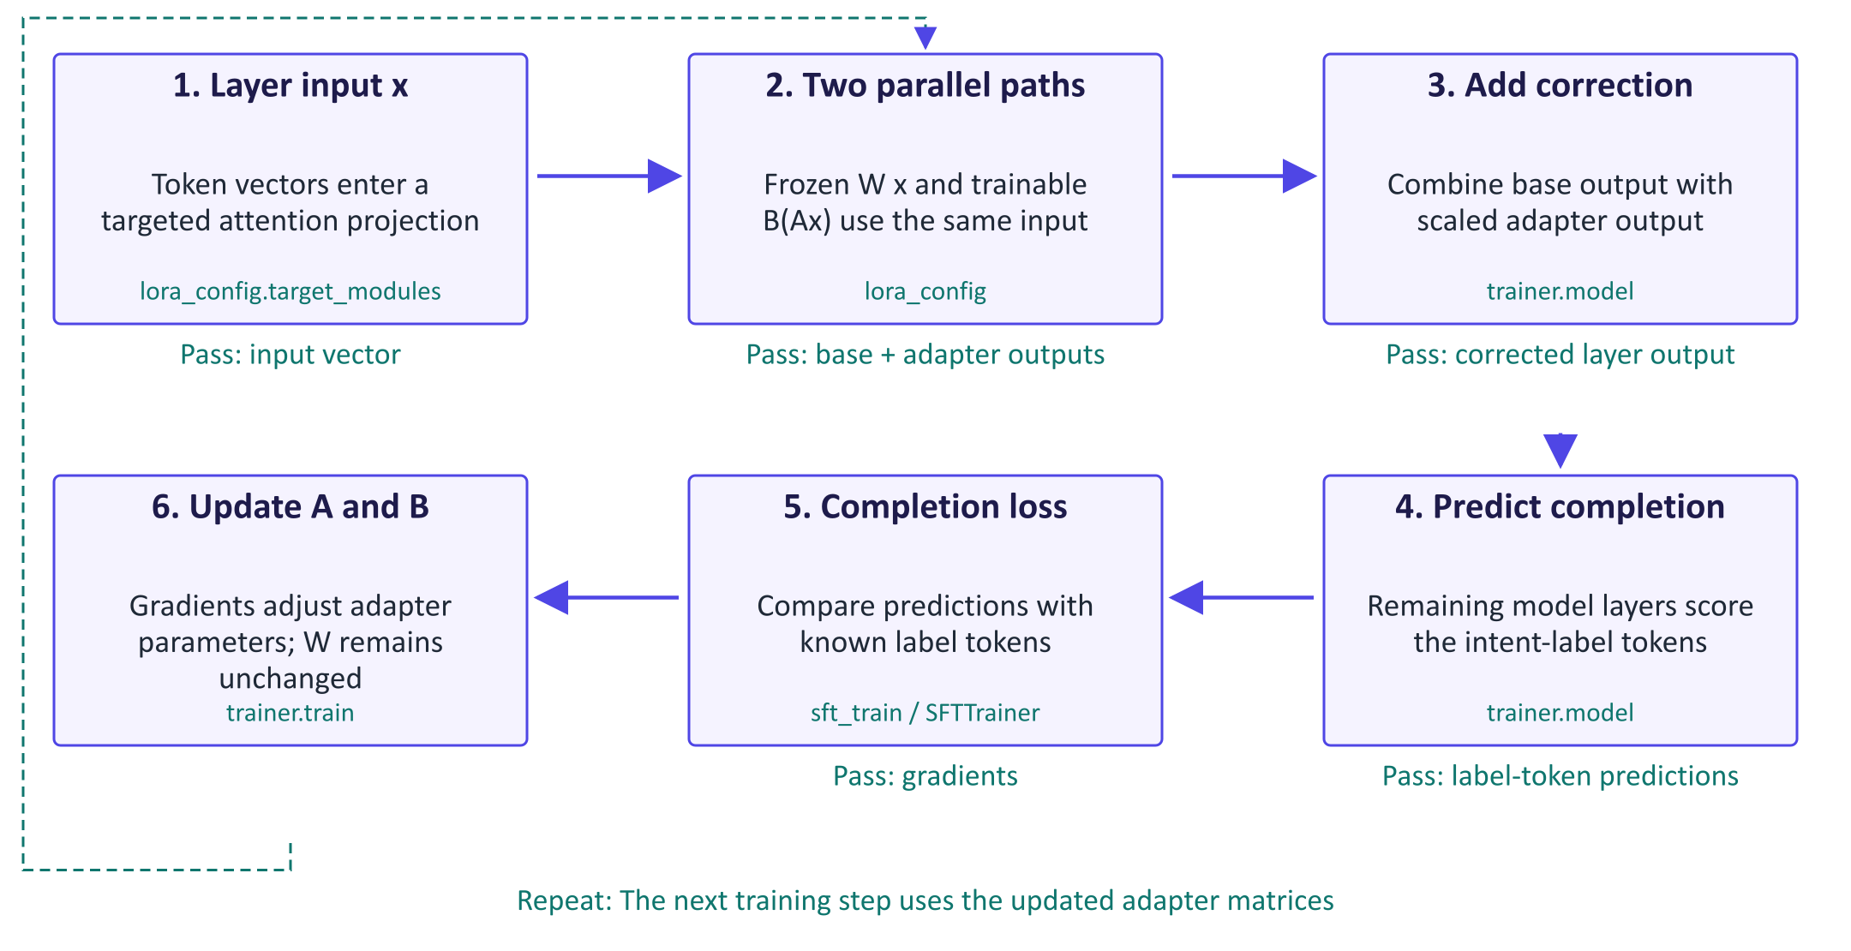
A LoRA training update
LoRA adds a learned correction to selected weight matrices. If a base projection maps k input features to d output features, its matrix W contains d times k weights. The adapter first projects the same input through A into r features, then through B back into d features. The small number r is the rank and controls the size of the correction. The forward result is the original W x plus the scaled B(Ax) contribution; these are parallel paths. The trainable count is r times the sum of d and k, rather than d times k. Backpropagation uses the completion loss to adjust A and B while W is frozen. Freezing W preserves the original base parameters, but the active adapter can still change general-answer behaviour. Disabling the adapter restores the base path.

Worked example
- For an illustrative 8-input, 8-output projection, the frozen W has 64 entries.
- Rank r=2 uses A with shape [2, 8] and B with shape [8, 2]: 32 trainable entries total.
- W x and B(Ax) are parallel contributions; the adapter is not a layer after W.
- Their summed output feeds the remaining network and its completion-token loss.
- The optimizer updates A and B, while W keeps its pretrained values.
Check your understanding. Does the adapter take W x as its input, or does it use the same x as the base projection?
Instructor explanation. It uses the same x. The base and adapter paths run in parallel and their outputs are added.

From labels to a saved adapter
Read the learning curve and the held-out decisions together
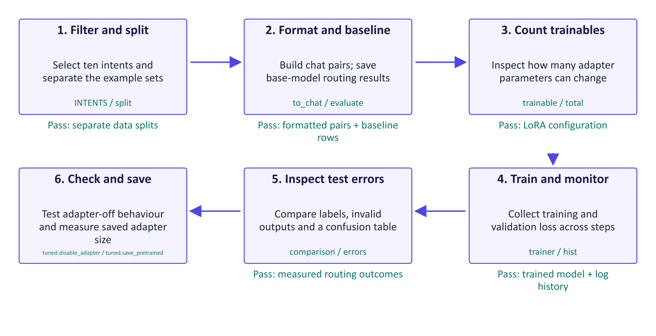
From labels to a saved adapter
The code connects data preparation, training and evaluation. INTENTS filters the source dataset to ten routing categories. to_chat creates conversational prompt/completion pairs, while evaluate records raw outputs, parsed labels and correctness. normalise is deliberately lenient: a label wrapped in explanatory text can still count as recognised, so the invalid rate is defined by this parser rather than by strict label-only output. The trainer records loss history for learning-curve inspection. After training, comparison uses the same test examples for both baselines and the tuned model, and the error table reveals which categories were confused. The adapter-off question is one illustrative check of specialisation, rather than a broad general-capability benchmark. Finally, the saved adapter's disk size is compared with the base parameters' in-memory byte count, so the size figures have slightly different definitions.

Worked example
- Check that the train and validation data come from the training split, while test messages remain separate.
- Inspect one to_chat pair before running the trainer.
- Watch validation loss alongside training loss rather than choosing by training loss alone.
- A recognised wrong intent is a decision error; no recognised intent is a parser/format failure.
- Ask a general question with the adapter on and off, then save the small adapter artifact.
Check your understanding. What two different failures should you distinguish in the test output table?
Instructor explanation. A recognised but incorrect intent is a decision error; an output with no recognised intent is an invalid/parser-format outcome.

Where to look in the code
Code symbol | What it does | What to inspect
to_chat | Converts a labelled message into a prompt/completion training example. | Identify which tokens belong to the input and which represent the supervised response.
normalise | Finds a recognised intent label inside generated text. | Check how wrapped labels and multiple label mentions are interpreted.
evaluate | Collects routing predictions and correctness for the same test examples. | Read raw, pred and gold together; distinguish parser failure from wrong classification.
lora_config | Selects adapter rank and the attention projections receiving adapters. | Compare trainable with total and relate the count to rank.
hist | Holds trainer log history for the learning curve. | Follow validation loss as well as training loss; smoke mode omits validation evaluation.
tuned.disable_adapter | Temporarily uses the unchanged base projection paths. | Compare the same general question with the adapter active and disabled.

Common points of confusion
- SFT describes the training examples and objective; LoRA describes the trainable parameters. They can be used together.
- Frozen base weights do not guarantee unchanged behaviour while the adapter is active.
- A lower training loss or one successful sample is insufficient evidence of better held-out routing.

Quick glossary
Intent. A category describing what a customer's message is asking about.
Supervised fine-tuning. Learning from supplied input prompts and known desired responses.
Frozen parameter. A model weight held unchanged by the optimizer during training.
LoRA adapter. Small trainable matrices adding a low-rank correction to selected base-model projections.
Rank. The adapter's intermediate feature dimension, controlling its correction capacity and parameter count.
Overfitting. Learning training examples in a way that fails to improve predictions on separate examples.

Lecture notes

1. When to fine-tune
 | Prompting | Retrieval (RAG) | Fine-tuning
Changes | Input | Input (adds documents) | Weights
Solves | Task description, format | Missing/changing knowledge | Behaviour, style, format, specialised skills
Data | A few examples | Document collection | Hundreds–thousands of labelled examples
Update | Edit text | Re-index | Re-train and re-evaluate
Traceability | High | High (citations) | Low

Decision process. Start with a prompt and an evaluation set. If quality is insufficient, diagnose: missing or outdated knowledge → retrieval; behaviour, format, style or a specialised skill that examples cannot teach, or a need for a smaller cheaper model → fine-tuning. Combine approaches as needed.
Good reasons: consistent format/style; specialised classification or extraction; domain language; replacing a large prompted model with a small tuned one (cost, latency, privacy); reliable tool calling; new languages. Bad reasons: adding frequently changing facts; "fixing hallucination" in general (fine-tuning on new facts can increase it); tiny datasets without an evaluation set; licence restrictions.
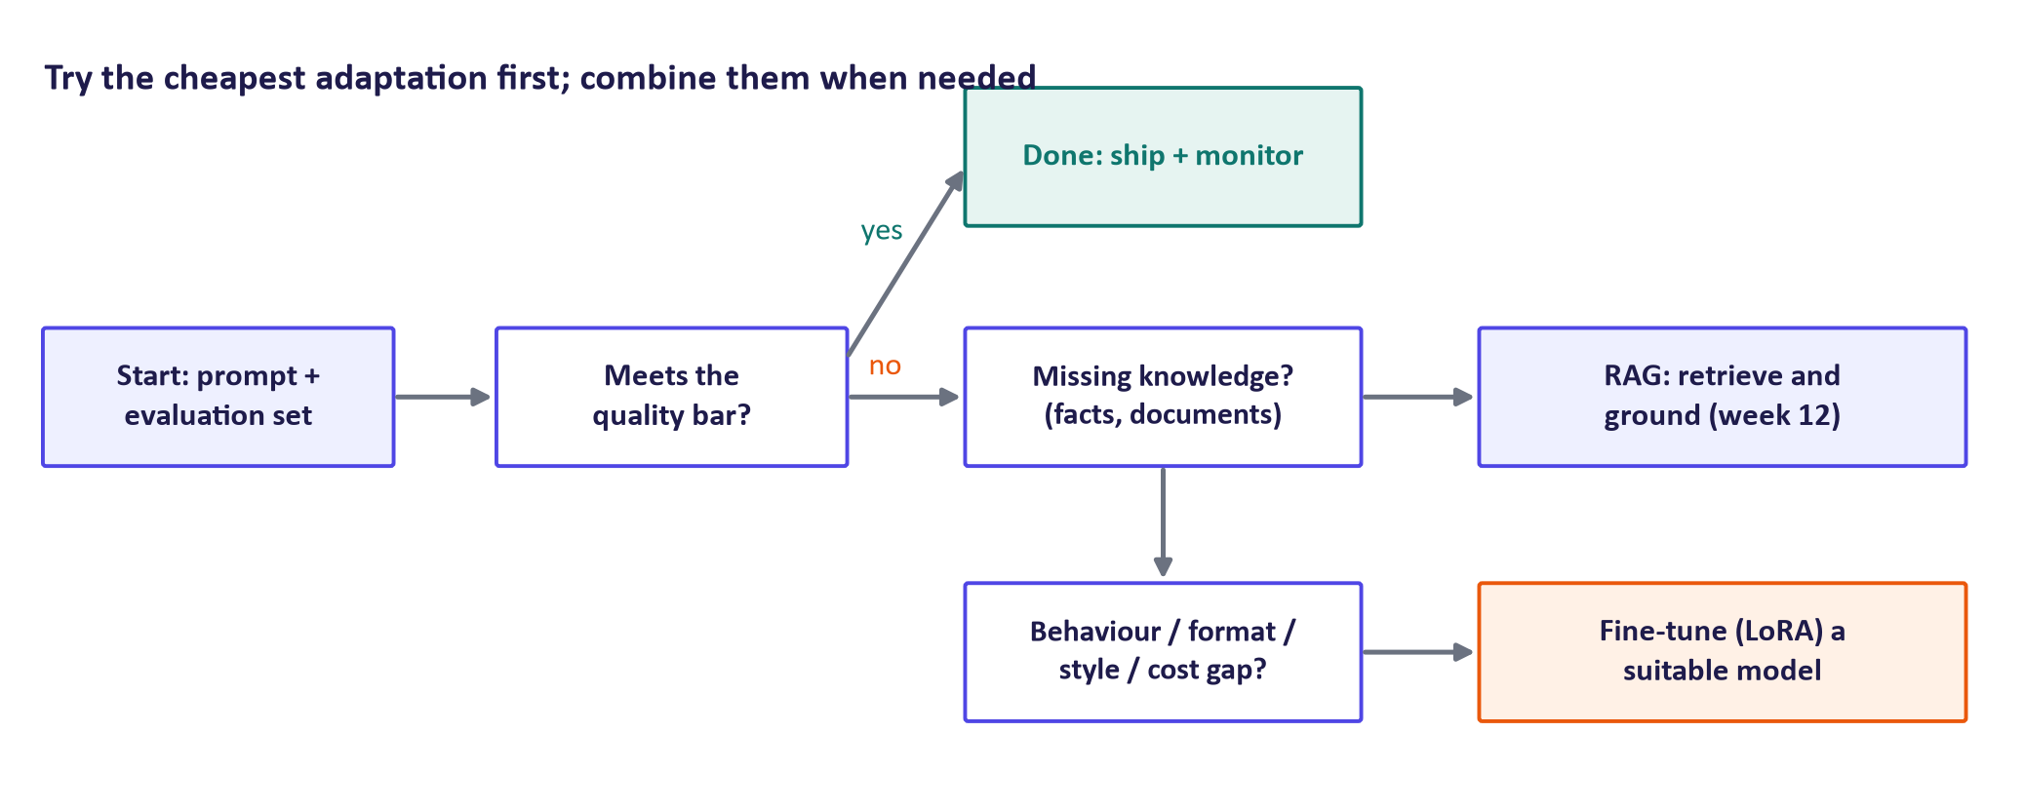
Decision process

2. Supervised and instruction fine-tuning
Full fine-tuning updates all weights; supervised fine-tuning (SFT) describes training on (prompt, response) pairs and can be done with full fine-tuning or with adapters.
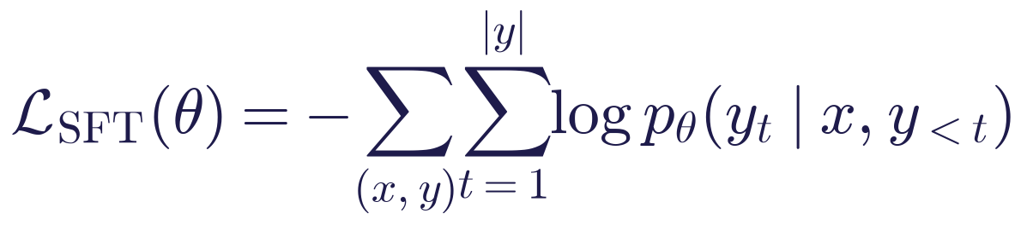
Prompt tokens are masked out of the loss (labels set to be ignored), so the model learns to produce responses, not to reproduce prompts. TRL does this automatically when data are provided as prompt/completion pairs.
Instruction tuning fine-tunes on many tasks expressed as instructions (FLAN, 2021; the SFT stage of InstructGPT, 2022), giving general instruction following, including for unseen tasks. Chat templates wrap messages in model-specific special tokens; training and inference must use the same template (tokenizer.apply_chat_template). LIMA (Zhou et al., 2023) showed that 1,000 carefully curated examples can yield strong assistant behaviour: quality beats quantity.
Data preparation checklist: correct, consistent labels; coverage of real input variety and edge cases; clean train/validation/test splits without near-duplicates (leakage); personal data removed and rights to use data confirmed; class balance considered; a datasheet documenting source, size, labelling and gaps.

3. Preference alignment

RLHF
- SFT on demonstrations.
- Humans compare model answers to the same prompt.
- Train a reward model r_φ on the comparisons (Bradley–Terry):
Step 4. Optimise the policy with RL (PPO), maximising reward while staying close to the reference model:
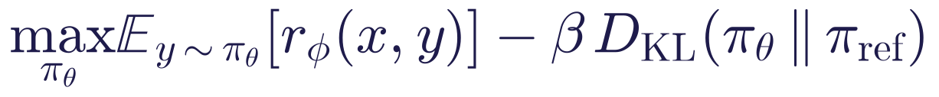
The KL penalty prevents reward hacking (exploiting reward-model flaws). In InstructGPT (Ouyang et al., 2022), people preferred a 1.3 B-parameter InstructGPT over the 175 B GPT-3.
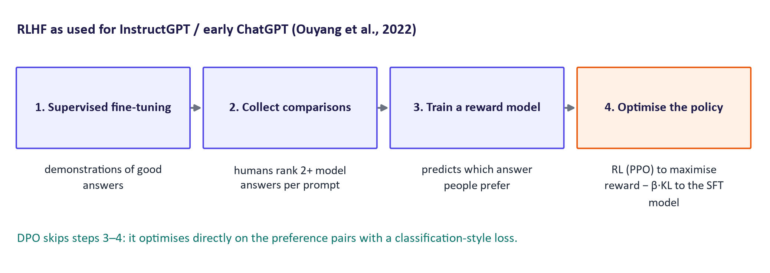
RLHF pipeline

Direct Preference Optimisation (DPO)
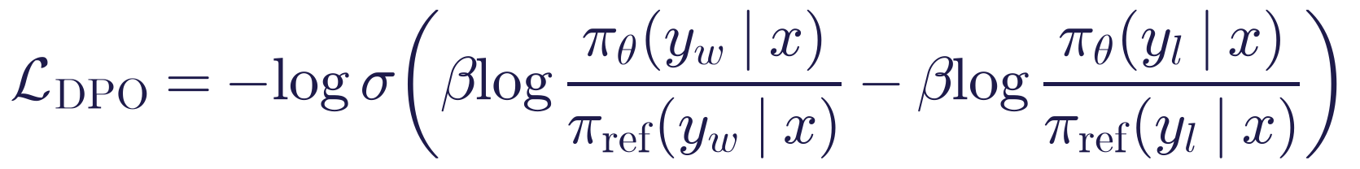
DPO (Rafailov et al., 2023) optimises the same objective as RLHF under its assumptions without a separate reward model or RL loop: simpler and more stable. Variants include IPO, KTO, ORPO and SimPO.

RL with verifiable rewards
When correctness can be checked automatically (maths answers, unit tests), the reward needs no human labels. GRPO (group relative policy optimisation, DeepSeek) samples several answers per problem and rewards those better than the group average. DeepSeek-R1 (2025) showed that extended step-by-step reasoning emerges from such training: this is how reasoning models are made.

AI feedback and failure modes
RLAIF / Constitutional AI (Bai et al., 2022): a model critiques and ranks outputs against written principles, reducing the need for human labels. Failure modes: reward hacking (e.g. verbosity), sycophancy, and the question of whose preferences are encoded.

4. Parameter-efficient fine-tuning

LoRA
Only A and B are trained; W is frozen; B is initialised to zero so training starts from the base model. Trainable parameters per matrix: r(d + k) instead of dk.
Worked example: d = k = 4096, r = 16: 16 × 8192 = 131,072 trainable vs 16,777,216 frozen (0.78%).
After training, merge BA into W (no inference overhead) or keep adapters separate and swap them per task. Typical hyper-parameters: r = 4–64, α ≈ 2r, dropout 0.05, learning rate 10⁻⁴–3×10⁻⁴, targets = attention projections (and sometimes MLP layers). The LoRA paper reported 10,000× fewer trainable parameters and 3× less GPU memory than full fine-tuning of GPT-3 with comparable quality.
The lab model: LoRA (r = 16, attention projections) trains 2,162,688 of 496,195,456 parameters (0.44%).
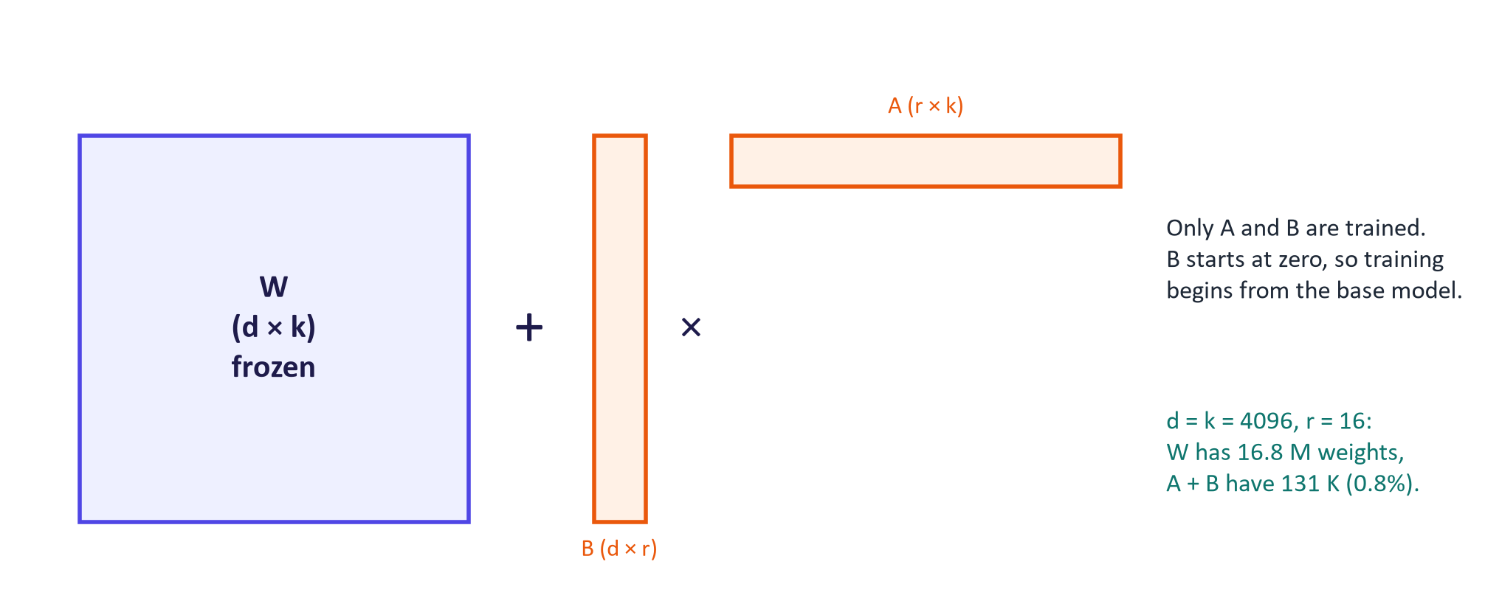
LoRA
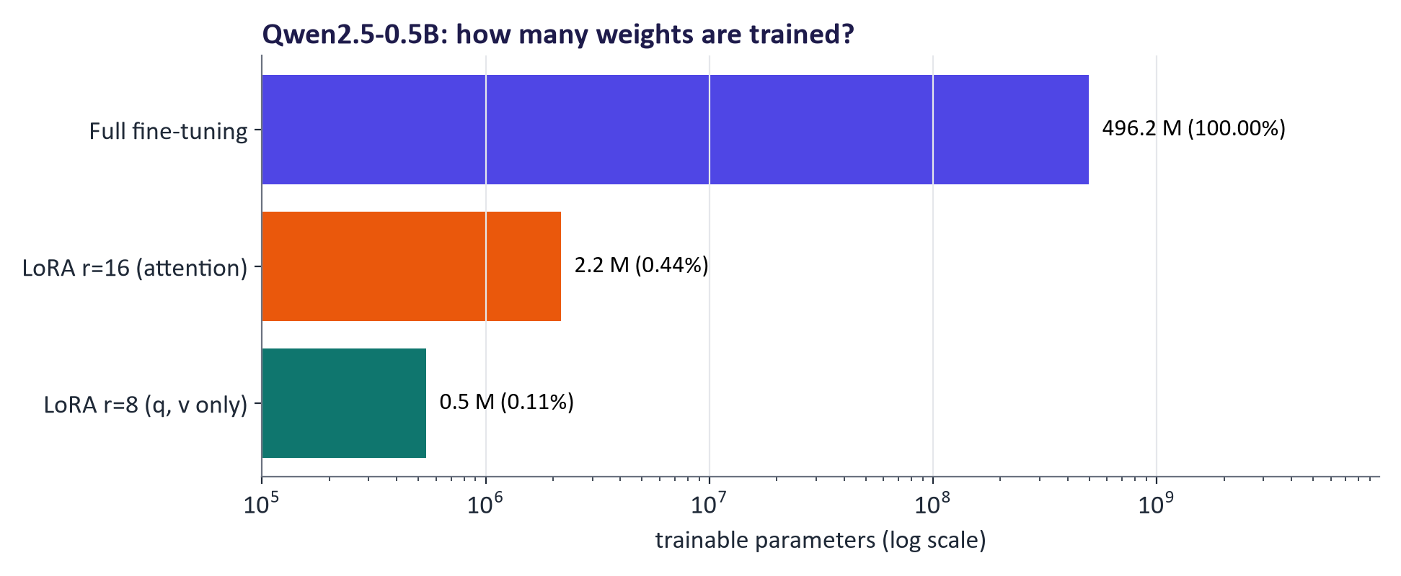
Trainable parameters for the lab model

QLoRA
Store the frozen base in 4-bit NormalFloat (NF4) and train LoRA adapters in 16-bit; double quantisation and paged optimizers reduce memory further (Dettmers et al., 2023). QLoRA fine-tuned a 65 B model on a single 48 GB GPU; 7–8 B models fit on a free Colab T4.

Other methods
Method | Trained | Pros | Cons
LoRA | Low-rank updates | Strong, mergeable, swappable | Rank/target choices
QLoRA | LoRA on a 4-bit base | Large models on small GPUs | Slower; small quality cost
Adapters (Houlsby et al., 2019) | Bottleneck layers in each block | Modular | Extra latency
Prompt/prefix tuning | Soft prompt vectors | Tiny | Weaker on small models
Full fine-tuning | All weights | Maximum flexibility | Memory, cost

Memory rules of thumb (7–8 B model)
Full fine-tuning with Adam in mixed precision needs roughly 16 bytes per parameter (≈ 100+ GB); LoRA with a 16-bit base ≈ 18–24 GB; QLoRA ≈ 7–12 GB. Activations depend on sequence length and batch size.

Knowledge distillation
A small student imitates a large teacher by matching its output distributions (soft labels; Hinton et al., 2015) or by fine-tuning on teacher-generated answers. DeepSeek-R1 was distilled into small Qwen and Llama models. Students inherit teachers' errors and biases; some API terms forbid training competing models on outputs.

5. Domain adaptation in practice
Workflow: define task and metric (held-out test set first) → prepare data → prompting baseline → LoRA SFT with validation monitoring → evaluate task metric, general abilities, safety and cost → iterate or deploy.
Pitfalls: overfitting (validation loss rises); catastrophic forgetting (loss of general ability); data leakage; chat-template mismatch; learning rate too high; weak evaluation.

Real results from the lab (instructor run)
Model | Accuracy | Invalid answers
base, zero-shot | 52% | 6.5% (13 of 200)
base, few-shot | 85% | 1.0% (2 of 200)
LoRA fine-tuned | 97% | 0.5% (1 of 200)

Test set: 200 held-out Banking77 messages (10 intents). Training: 1216 training examples, 1 epoch, 76 min on a laptop CPU. Adapter: 8.7 MB.
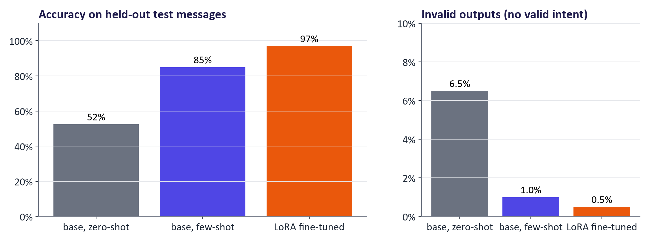
Prompting vs LoRA fine-tuning
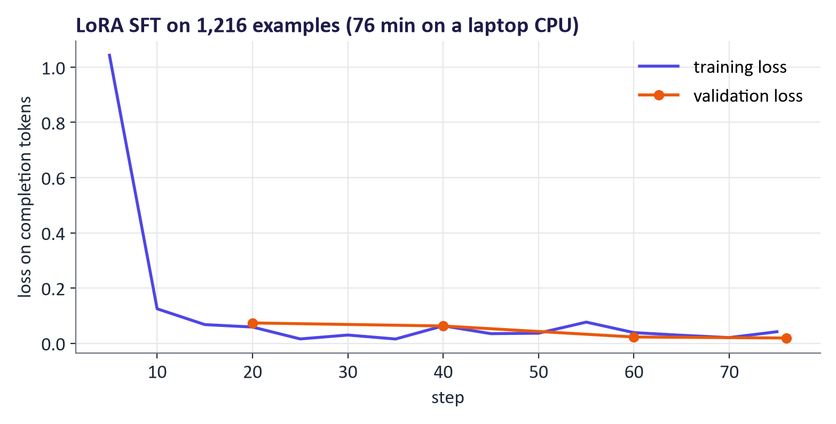
Training and validation loss

Evaluation after fine-tuning
Task metric on held-out data vs the prompting baseline (with margins of error); a general-capability regression suite; safety tests before and after; robustness (paraphrases, typos, new periods); cost and latency; expert review with a rubric.

Domain models
BloombergGPT (2023; 50 B parameters, mixed financial and general data) is an example of heavy domain training. Today, strong general models plus retrieval often match or beat older domain models; fine-tuning is used mainly for format, cost and specialised skills. Domain data is usually sensitive: governance comes first.

Common misconceptions
Misconception | Correction
"Fine-tuning is how you add new facts." | Retrieval handles changing facts better; fine-tuning on new facts can increase hallucination.
"More epochs are better." | Overfitting and forgetting grow; monitor validation loss.
"LoRA is a different model architecture." | It adds a low-rank update to existing weights; it can be merged back.
"RLHF teaches the model facts." | It shapes preferences and behaviour; knowledge comes mainly from pre-training.
"DPO needs no data." | It needs preference pairs, but no reward model or RL loop.
"A fine-tuned model is as safe as its base." | Fine-tuning can erode safety; re-test.
"Good training loss means a good model." | Only held-out evaluation tells you.

Responsible AI lens: fine-tuning
- Safety erosion: fine-tuning aligned models, even on benign data, can weaken refusal behaviour (Qi et al., 2023). Re-run safety tests.
- Memorisation and privacy: remove personal data; test for regurgitation.
- Bias amplification: audit performance by group; examine label sources.
- Licences and terms: check base-model licences and API terms for fine-tuning and output use.
- Documentation: publish a model card for the adapter (data, evaluation, limitations, intended use).

Lab guide and answers
Runtime: Colab T4 (training ≈ 5–8 min, evaluation ≈ 2–4 min per condition). CPU only for the smoke test (10 steps). Dataset: mteb/banking77 (CC-BY-4.0 source data), 10 intents. Hand-in: comparison table, loss curve, confusion table, three answers.

TODOs
- TODO 1 {"prompt": [{"role": "user", "content": f"{INSTRUCTION}\nMessage: {text}\nIntent:"}], "completion": [{"role": "assistant", "content": label}]}.
- TODO 2 LoraConfig(r=16, lora_alpha=32, lora_dropout=0.05, target_modules=["q_proj","k_proj","v_proj","o_proj"], bias="none", task_type="CAUSAL_LM"). Expect ≈ 0.4–0.5% trainable.
- TODO 3 evaluate the tuned model with the zero-shot prompt and build the table.
- TODO 4 sum file sizes in the adapter folder; model size = parameters × bytes per element.

Expected results
See the real results above. Students should find zero-shot prompting around half correct with some invalid labels, few-shot prompting much better (the examples fix the format and show the boundaries), LoRA best with near-zero invalid outputs, remaining confusions between similar intents, and over-specialisation on general questions with the adapter on (fixed by switching it off).

Troubleshooting
- SFTConfig argument errors: library versions change; this notebook uses warmup_steps (not warmup_ratio) and max_length.
- Out of memory: lower per_device_train_batch_size to 8 and add gradient_accumulation_steps=2.
- Accuracy does not improve: check that completion holds only the label and that the evaluation prompt matches the training prompt.

Practice questions with model answers

Multiple choice
- LoRA trains: (a) all weights; (b) low-rank matrices added to frozen weights; (c) only the embedding layer; (d) a reward model. Answer: (b).
- The KL term in RLHF: (a) speeds up training; (b) keeps the policy close to the reference model to limit reward hacking; (c) measures accuracy; (d) is used only in DPO. Answer: (b).
- Which is the best use of fine-tuning? (a) Keeping up with daily news; (b) enforcing a consistent classification format for 50 subtle categories; (c) answering questions about this week's prices; (d) avoiding an evaluation set. Answer: (b).
- QLoRA reduces memory mainly by: (a) removing layers; (b) storing the frozen base in 4-bit; (c) shorter prompts; (d) smaller vocabulary. Answer: (b).

Short answer
- Compute the LoRA trainable parameters for a 2048 × 2048 matrix with rank 8, and the percentage. (3 marks) Model answer: 8 × (2048 + 2048) = 32,768; 2048² = 4,194,304; 0.78%.
- Explain the difference between RLHF with PPO and DPO. (4 marks) Model answer: RLHF trains a reward model on preferences and optimises the policy with RL under a KL penalty; DPO optimises the same objective directly with a loss on preference pairs, needing no reward model or RL loop; DPO is simpler and more stable.
- Describe two signs of overfitting in fine-tuning and two remedies. (4 marks) Model answer: validation loss rises while training loss falls; held-out accuracy drops or general abilities degrade; remedies: fewer epochs/early stopping, lower learning rate or rank, more/diverse data, mixing general data.
- Why is retrieval preferred over fine-tuning for frequently changing facts? (3 marks) Model answer: updates require only re-indexing; answers can cite sources; fine-tuning is slow to update, opaque and can increase hallucination on new facts.

Exam-style question
"A telecom company wants a model that classifies support tickets into 60 categories and drafts replies in its style. Propose and justify an adaptation strategy, including data, method, evaluation and risks." (20 marks)
Marking guide: diagnosis of task needs and decision between prompting/RAG/fine-tuning (4); data preparation incl. splits, leakage, privacy (4); method: LoRA/QLoRA SFT for classification and style, optional DPO for reply preferences, retrieval for policies (4); evaluation: held-out metrics vs baseline, general/safety regression, human review, cost (5); risks: forgetting, safety erosion, bias, licences, documentation (3).

Glossary
Term | Meaning
Full fine-tuning | Updating all model weights
SFT | Supervised fine-tuning on prompt–response pairs
Instruction tuning | SFT on many instruction-formatted tasks
Chat template | Model-specific special-token format for messages
RLHF | Reinforcement learning from human feedback (reward model + PPO)
Reward model | Model predicting which response humans prefer
PPO | Proximal Policy Optimisation, the RL algorithm used in RLHF
DPO | Direct Preference Optimisation: preference loss without RL
GRPO / RLVR | Group relative policy optimisation / RL with verifiable rewards
Reward hacking | Exploiting flaws in a reward signal
LoRA | Low-rank adaptation: trainable low-rank update to frozen weights
QLoRA | LoRA on a 4-bit quantised base model
Adapter | Small trainable module inserted into a frozen network
Prompt tuning | Learning soft prompt vectors
Distillation | Training a student model to imitate a teacher
Catastrophic forgetting | Loss of prior abilities after fine-tuning

Readings, videos and further practice
Core reading (descriptor 7.9)
- Tunstall, von Werra & Wolf (2022) NLP with Transformers: chapters on fine-tuning (e.g. text classification, chapter 2; few-to-no labels, chapter 9).
- Ozdemir, S. (2023) Quick Start Guide to LLMs: chapters on fine-tuning and RLHF.
Courses and documentation
- Hugging Face LLM Course: Supervised fine-tuning
- Hugging Face PEFT and TRL
- Hugging Face blog: Illustrating RLHF
- Google ML Crash Course: LLMs (fine-tuning, distillation)
Videos
- Andrej Karpathy: Deep Dive into LLMs like ChatGPT (post-training, RLHF, reasoning)
Papers
- Ouyang et al. (2022) InstructGPT; Rafailov et al. (2023) DPO; Hu et al. (2021) LoRA; Dettmers et al. (2023) QLoRA; DeepSeek-AI (2025) DeepSeek-R1

Link to the group project
Groups whose evaluation (week 7) shows a behaviour or format gap may fine-tune a small open model with LoRA. The report must include the prompting baseline on the same held-out test set, the fine-tuning configuration, training/validation curves, general and safety regression checks, and a model card for the adapter. Groups that do not fine-tune must justify why prompting and/or retrieval suffice.

