WEEK 02 · TEACHING NOTES

Variational Autoencoders (VAEs)
How a VAE learns short hidden codes, rebuilds images and generates new digits
Generative AI · MSc in Artificial Intelligence · 2-hour lecture + 2-hour lab
Descriptor Section 7.3 (revised) for this week
Lecture topic | Variational Autoencoders (VAEs)
Detail | Motivation: from autoencoders to probabilistic generative models. Concept of Latent space and Exploration. Encoder-decoder architecture, probabilistic encoder and the reparameterisation trick. Reconstruction and Regularization (KL divergence) Loss and the evidence lower bound (ELBO). Training. Variants (e.g. Conditional VAE, β-VAE, VQ-VAE). Evaluation of VAEs (reconstruction error, sample quality, latent traversals). Applications of VAEs, including anomaly detection and the image autoencoder inside latent diffusion models.
Tutorials | Implementing a VAE in PyTorch (e.g. MNIST or Fashion-MNIST).  Visualize the latent space and latent space interpolation.  Generate new images from the learned latent distribution and compare the effect of the KL weight (β).
Module learning outcomes (MIMLOs) practised this week
MIMLO 1: Critically explain the core concepts and mathematical principles underlying generative AI, and demonstrate in-depth knowledge of major generative AI model families, including VAEs, GANs, diffusion models and transformer-based LLMs.
MIMLO 3: Design, implement and fine-tune generative AI models using contemporary frameworks and parameter-efficient methods.
MIMLO 4: Critically evaluate generative AI outputs using quantitative metrics, human-centered assessments and ethical considerations, including fairness, bias and hallucination risks.
What is in this week's folder
Lecture slides | 46 slides with speaker notes, vocabulary and technical diagrams.
Teaching notes | Lecture explanations, worked examples, code maps, practice questions and readings.
Student lab | Notebook and Python file with TODOs. Embedded and separate diagrams accompany the lab.
Lab solutions | Instructor notebook and Python file with completed code and model answers.

Lecture plan at a glance
This week introduces the first deep generative model family of the module. Students should leave able to write the ELBO, explain each term, compute a Gaussian KL divergence, and implement a VAE. All result images in the slides come from real models trained with the lab code (see curriculum/assets/make_week_02.py), so students can connect the lab steps to the lecture. Their outputs can differ with the seed and training settings.
Time | Slides | Segment | What you do
0–7 min | 1–5 | Warm-up | "Describe a face with 32 numbers": motivates codes, generation and gaps.
7–27 min | 6–12 | 1 · From autoencoders to VAEs | Autoencoder recap; real latent plots; random codes decode to nonsense; AE vs. VAE. Quiz.
27–60 min | 13–23 | 2 · Model and ELBO | Probabilistic model; architecture; a likelihood that is difficult to calculate exactly; ELBO; KL closed form with worked numbers; reconstruction term. Quiz.
60–67 min | – | Break
67–84 min | 24–29 | 3 · Reparameterisation | The trick, why it matters, the PyTorch model, training curves and posterior collapse.
84–104 min | 30–36 | 4 · Exploring and evaluating | Reconstructions, latent grid, interpolation, β trade-off, evaluation table.
104–118 min | 37–42 | 5 · Variants and applications | CVAE, β-VAE, VQ-VAE, hierarchical; VAE inside latent diffusion; applications; anomaly demo; responsible AI.
118–120 min | 43–46 | Lab preview, summary, resources

Teaching tip: Derive the ELBO on the board (see the derivation below) rather than only showing the slide. Students who see the two-line Jensen derivation remember that the gap is a KL divergence, which is a common exam question.

The 6 supporting slides fit within the existing lecture segments. Use the starting vocabulary and overall flow during the introduction, the mechanism diagram beside the detailed explanation, the build and use diagrams beside their topics, and the lab flow during the lab preview. Pause for predictions before showing a worked example.

Beginner walkthrough

Where we are in the course
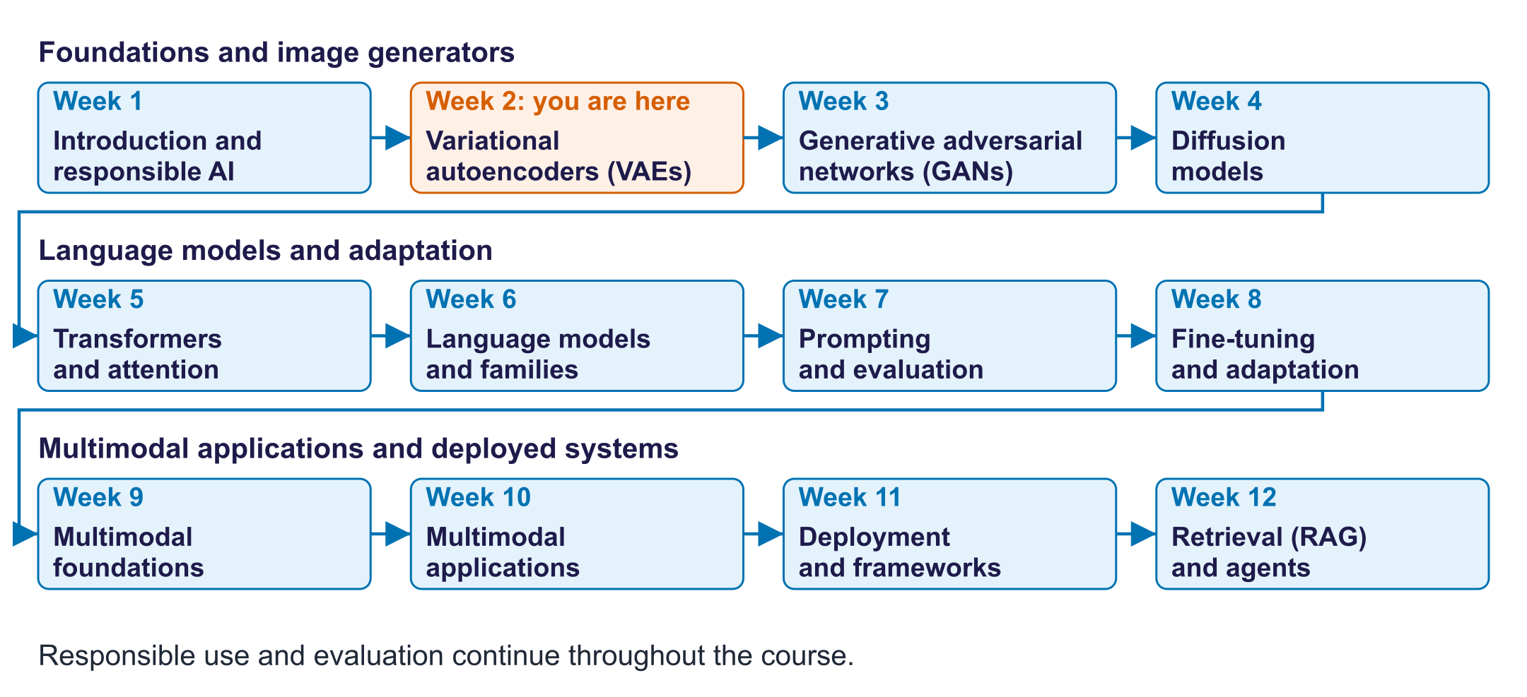
The twelve-week course map
Read the overall flow before the detailed theory. Each block performs one operation. The text below a block names the data it passes on. A feedback line means the system repeats an operation. The code names match this week's lab so you can follow the same example in the slides and notebook.

Starting vocabulary
Term | Plain meaning | Check your understanding
Image tensor | A numerical array holding a batch of images, their channels, rows, and columns. | How many pixels are in one 28 by 28 grayscale digit?
Mean and standard deviation | The centre of a distribution and a measure of its spread. | Does a larger standard deviation make samples more concentrated or more spread out?
Training loss | A number used to measure mistakes and guide weight updates. | Which changes model weights: an optimiser step or displaying an image?

Answers to the checks.
- Image tensor: 784, because 28 × 28 = 784.
- Mean and standard deviation: More spread out. A larger standard deviation means a wider spread.
- Training loss: The optimiser step. Displaying an image changes nothing.

Train a VAE to rebuild digits
Learn a distribution of short codes and a decoder that turns codes into pixels.
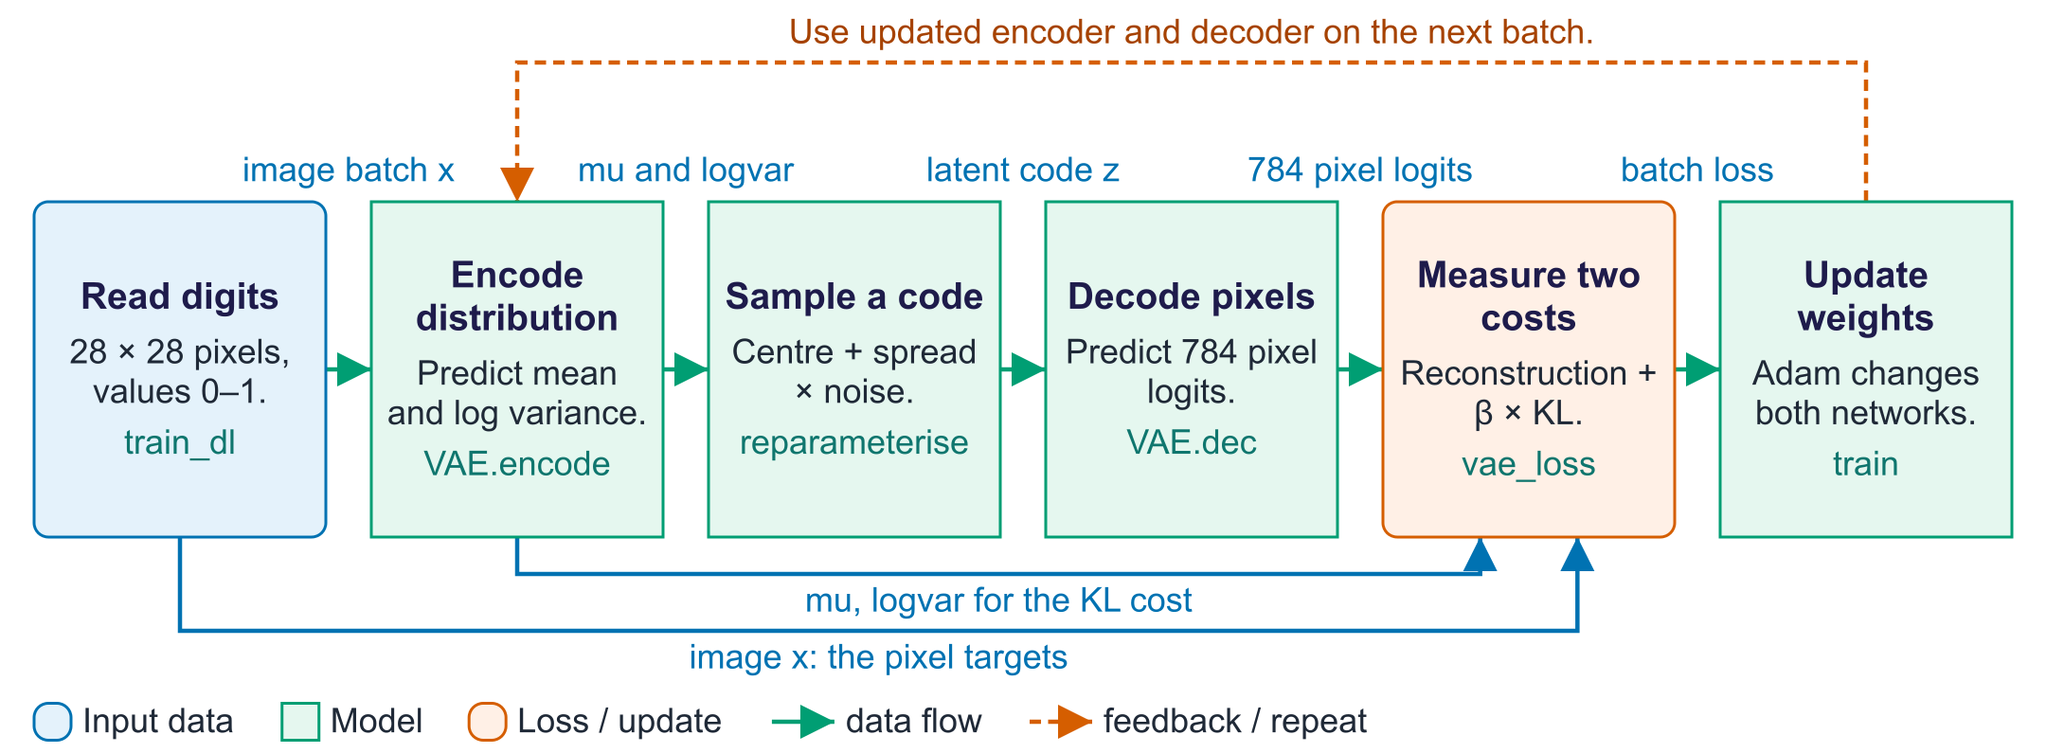
Train a VAE to rebuild digits
A variational autoencoder, or VAE, learns an encoder and a decoder. The encoder compresses an image into parameters of a distribution over a shorter hidden representation called a latent code. It produces two branches, mu and logvar, which describe the centre and spread; both branches meet at the sampling step. The decoder receives a sampled code and predicts pixel logits. Training compares those predictions with the original pixels using a reconstruction cost. A second cost, KL divergence, encourages each encoder distribution to stay close to the chosen prior, here a standard Gaussian. The β setting controls that pressure. Backpropagation computes how both costs depend on the weights, and Adam updates the encoder and decoder. To generate a new digit after training, bypass the encoder: draw a code from the prior and decode it. The lab displays sigmoid pixel probabilities rather than sampling individual binary pixels.

Worked example
- A batch of 128 digits has shape [128, 1, 28, 28]; flattening gives 784 values per image.
- With zdim = 2, the encoder produces two means and two log-variances for each image.
- A sampled two-number code becomes 784 decoder logits; the original image also enters the loss.
- vae_loss adds reconstruction cost and a KL cost that compares the encoder distribution with N(0, I).
- After training, torch.randn draws codes from the prior and VAE.decode displays new pixel probabilities.
Check your understanding. Does generating from a fresh prior code require an input digit?
Instructor explanation. No. The decoder can receive a code sampled from N(0, I) directly; reconstruction uses an input image and the encoder.

Sample a latent code while training
Random noise enters from outside; the encoder learns only the centre and spread.
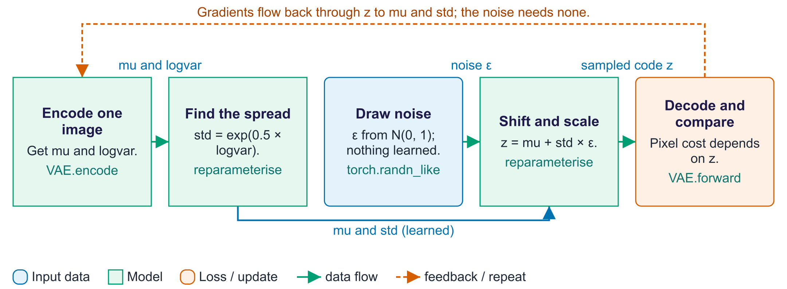
Sample a latent code while training
The encoder predicts a distribution, so repeated passes can produce different latent codes for the same image. Reparameterisation expresses this sampling as three understandable parts: learn a centre, learn a spread, and draw independent noise. In this lab, logvar means the logarithm of the variance, not the variance itself. Converting it to a standard deviation uses exp(0.5 × logvar), which is always positive. Standard-normal noise has centre zero and standard deviation one. Scaling that noise by the predicted standard deviation and adding mu gives a sample from the encoder's Gaussian. The random draw does not depend on learned weights, while the shift and scale do. This allows the reconstruction cost to supply gradients to both encoder branches through the sampled code. The KL cost takes a separate path directly from mu and logvar. Neither path requires the latent dimensions to have predefined digit labels.

Worked example
- For one latent coordinate, suppose mu = 1 and logvar = 0, so standard deviation = 1.
- With a drawn noise value ε = −0.5, the sampled code coordinate is 0.5.
- With the same encoder output and ε = 0.5, that coordinate would instead be 1.5.
- The decoder uses the sampled code; the KL term uses mu and logvar directly.
Check your understanding. If logvar is zero, is the standard deviation zero or one?
Instructor explanation. One: exp(0.5 × 0) = 1. A zero log-variance still describes a distribution with spread.

Build, train, then explore the VAE
Use reconstruction, generation, and anomaly tests for different questions.
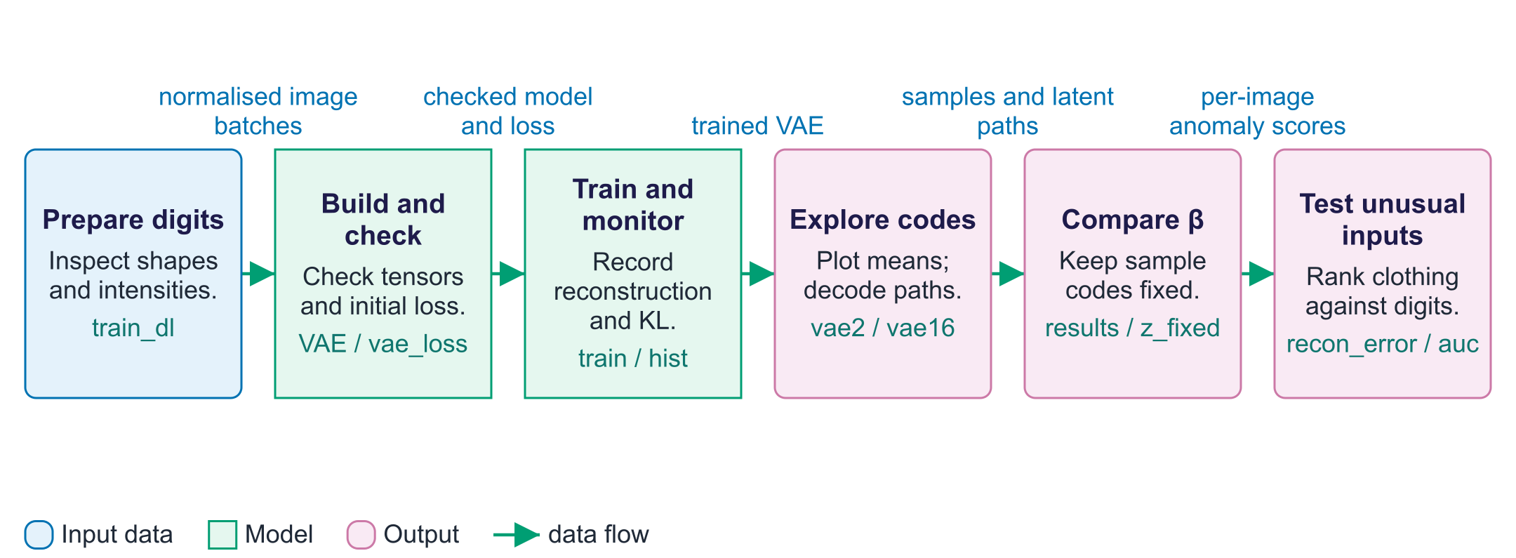
Build, train, then explore the VAE
The lab separates several uses of the same model. First, a quick forward pass checks that the model produces the expected tensor shapes and sensible initial losses. Training then changes weights while recording reconstruction and KL costs separately. The two-dimensional VAE makes a map possible: each plotted point is an encoder mean for one test image. Labels only colour this map; the ordinary VAE learns without them. A sixteen-dimensional model supports interpolation and new generation. Interpolation joins two encoded means, while prior sampling chooses new codes without an input image. The β experiment trains separate models and decodes the same fixed codes, allowing a more useful visual comparison. Finally, reconstruction error becomes an anomaly score: clothing may be harder to rebuild than digits. A high score suggests an unusual input relative to this training set; it is not a guarantee of a real-world defect.

Worked example
- Start with the eight-image check: logits has shape [8, 784] and both costs are finite.
- Train vae2 to plot latent means; digit labels colour the plot without entering VAE training.
- Train vae16, interpolate between encoded means of a 1 and a 7, and compare with pixel blending.
- Decode z_fixed for each β run to reduce randomness in the sample comparison.
- Use per-image reconstruction costs for digits and clothing; judge separation without assuming a perfect detector.
Check your understanding. Why does the β experiment reuse z_fixed instead of drawing new codes for each row?
Instructor explanation. Keeping the input codes fixed helps distinguish changes in the trained decoder from changes caused by random input codes.

How the two VAE costs train the model
One image supplies both a reconstruction target and a code-distribution penalty.
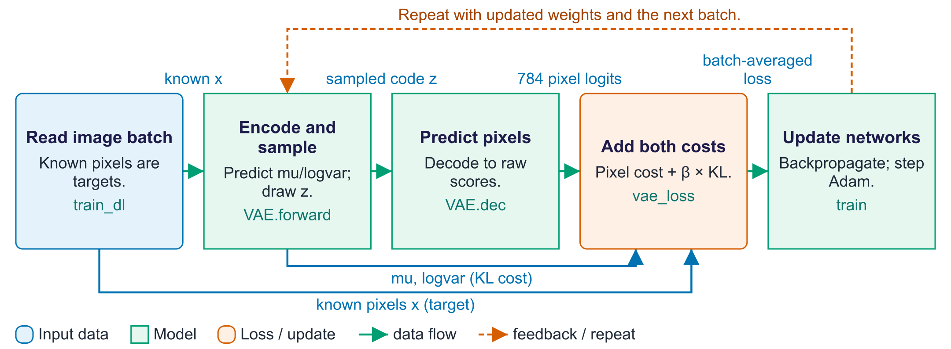
How the two VAE costs train the model
The original image is the reconstruction target. The decoder produces raw pixel scores, called logits. Binary cross-entropy compares them with the known pixels. The other cost, KL, compares the encoder's code distribution with the chosen prior N(0, I). The vae_loss function adds reconstruction cost and β times KL, then averages over the batch. Backpropagation calculates how each learned number affected the loss. The optimiser changes both encoder and decoder weights. The code is sampled with the reparameterisation trick so reconstruction feedback can reach the encoder.

Worked example
- Suppose one image has reconstruction cost 120 and KL cost 3.
- At β = 1, its combined cost is 123. At β = 4, it is 132.
- For a batch, sum image costs and divide by the number of images.
- The larger β increases pressure to match the prior, rather than changing the pixel target.
Check your understanding. Does a low total loss by itself show why the model improved?
Instructor explanation. No. Track reconstruction and KL separately to see which cost changed.

Generate a digit without an input image
Random codes come from the prior. Only the trained decoder is needed.
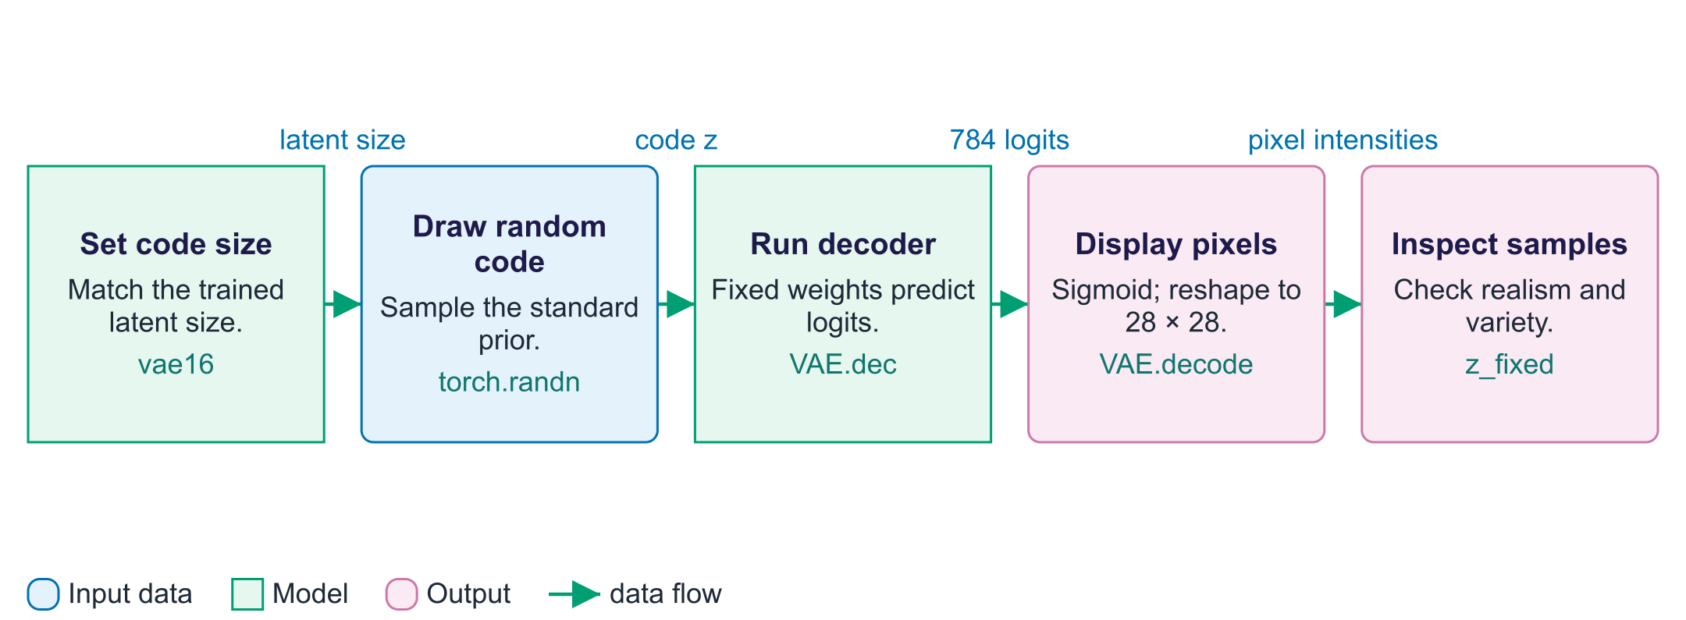
Generate a digit without an input image
Generation differs from reconstruction. A reconstruction begins with an image and uses the encoder. A new sample starts with a code drawn from the prior, so no image or encoder is needed. The trained decoder turns that code into 784 pixel logits. VAE.decode applies sigmoid to put display intensities between zero and one, then reshapes them into a 28 by 28 image. In this lab we display the predicted pixel probabilities. We do not separately draw every pixel from a Bernoulli distribution. Keep fixed codes when comparing trained models.

Worked example
- For the two-dimensional model, a code might be [0.2, −0.7].
- The decoder maps those two numbers to 784 raw pixel scores.
- Sigmoid maps a score of 0 to intensity 0.5. The grid then displays the digit.
- A different random code can give a different digit. Poor codes may still give poor samples.
Check your understanding. Must the encoder run to generate a fresh prior sample?
Instructor explanation. No. Use a prior code and the trained decoder. The encoder is needed when mapping an existing image to a code.

Where to look in the code
Code symbol | What it does | What to inspect
VAE.encode | Produces the mean and log-variance branches. | Compare mu and logvar shapes for zdim = 2 and zdim = 16.
VAE.reparameterise | Draws a code from the encoder distribution. | Follow where independent noise enters and why repeated codes can differ.
VAE.forward | Connects encoding, sampling, and pixel-logit decoding during training. | Track the three returned tensors and their uses in vae_loss.
vae_loss | Combines reconstruction cost and β-weighted KL. | Distinguish summing over pixels from dividing by the batch size.
VAE.decode | Turns supplied codes into displayable pixel probabilities. | Observe sigmoid and the reshape to 28 by 28; no encoder is called.
recon_error | Returns one reconstruction score for each image. | Compare its per-image output with the batch-averaged training loss.

Common points of confusion
- mu is the centre of an encoder distribution; it is not the random code used in every forward pass.
- Generating from the prior and reconstructing a supplied image follow different input paths.
- Changing β changes the training objective; it does not guarantee interpretable coordinates or a perfect anomaly detector.

Quick glossary
Encoder. A network that converts input data into numerical representations or distribution parameters.
Decoder. A network that turns a representation or previous outputs into predictions for the output.
Latent code. A shorter hidden numerical representation used by the model.
Prior. The chosen code distribution used for generating new examples, here N(0, I).
Reparameterisation. Writing a random code as learned shift and scale applied to independent noise.
KL divergence. A non-negative measure of how one probability distribution differs from another.
ELBO. A lower bound on data log-likelihood; its negative balances reconstruction and KL at beta = 1.
Epoch. One pass through the training data.

Lecture notes

Begin with two different routes
Show one digit. The reconstruction route is image → encoder mean/spread → sampled code → decoder. Then hide the digit: generation is prior code → decoder. Ask students to draw both routes before introducing q, p, θ or φ.
One-number check. With μ = 1, σ = 0.5 and ε = −2, z = 0. Repeating the same image can give another z because ε changes. logvar = 0 gives σ = 1, not zero.
Learning loop. Predict a shape, run a forward pass, compare the result, explain an error, then repeat on a second batch. Track the two losses separately. Before comparing β values, predict their effect on the cost formula; use measured samples to test the prediction rather than promising sharper or perfectly complete outputs.

1. From autoencoders to VAEs

Autoencoders
An autoencoder learns to rebuild its input using two networks. The encoder compresses image x into a short numerical code z. The decoder rebuilds an image x̂ from that code. MNIST digits have 28 × 28 = 784 pixel values. A code might contain 2 or 32 numbers.
Training reduces reconstruction error, using mean squared error or binary cross-entropy. The short code must retain useful image information. A narrow code alone does not guarantee meaningful or separate features.
Autoencoders are useful for compression, denoising (train to reconstruct clean images from corrupted ones), representation learning (use z as features for another model) and anomaly detection (unusual inputs reconstruct badly).
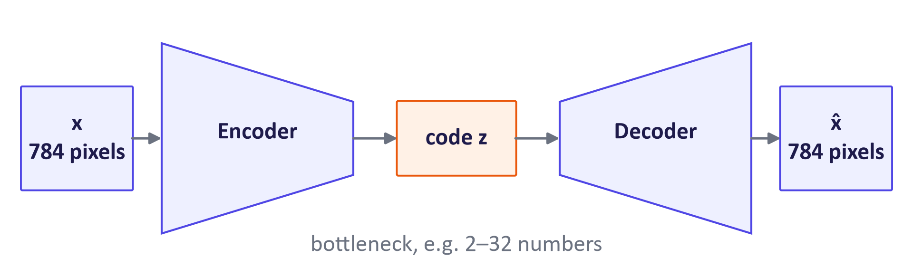
An autoencoder compresses to a code and rebuilds the input

Why an autoencoder is a poor generator
The decoder learns from codes supplied by the encoder. Ordinary reconstruction training does not specify where those codes should lie or what scale they should use. A random code drawn from a standard Gaussian may land in a region the decoder has rarely seen. It can then produce a poor image. The VAE adds a known sampling distribution and a penalty that encourages encoder codes to match it.
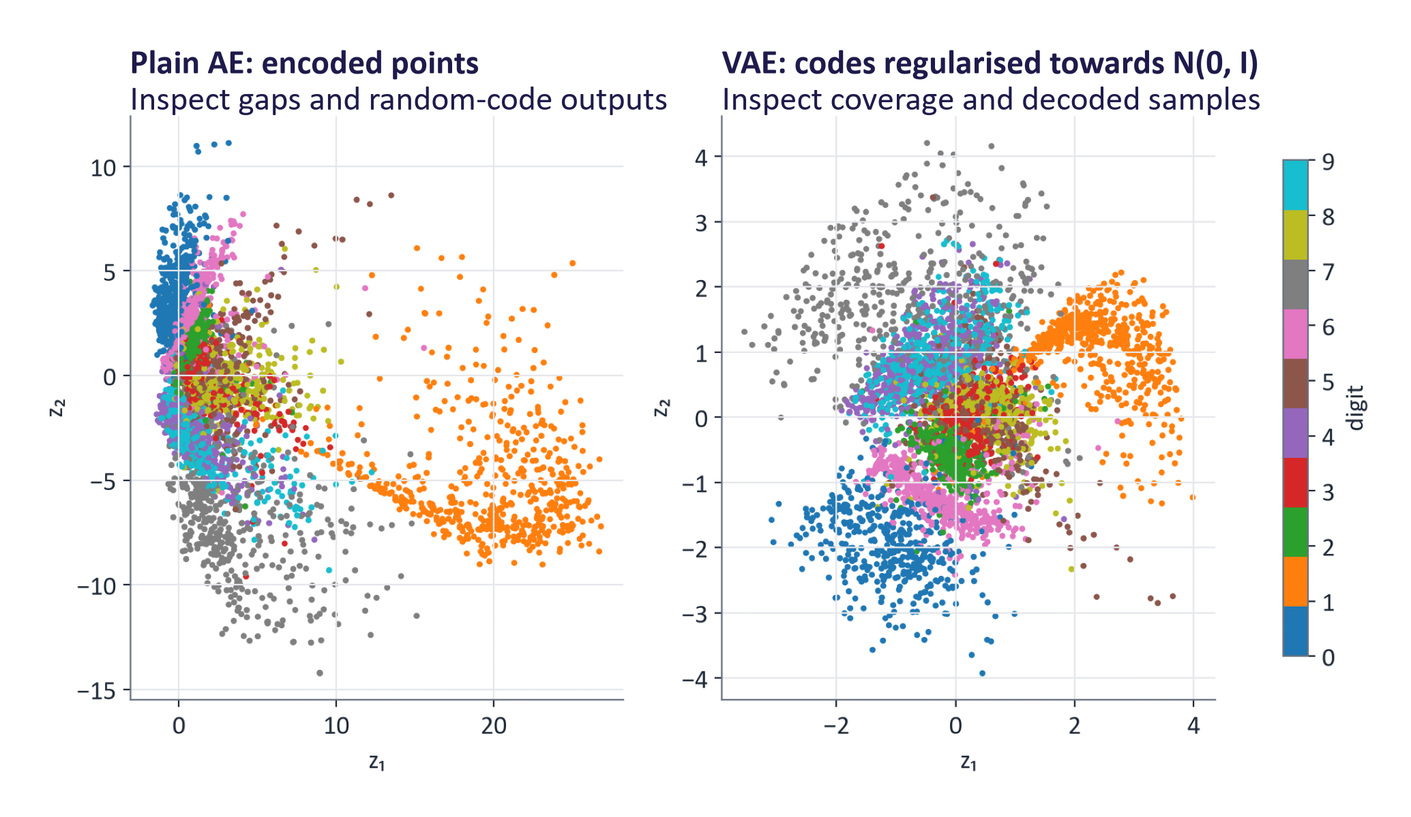
Real latent spaces of an autoencoder and a VAE with 2-D codes
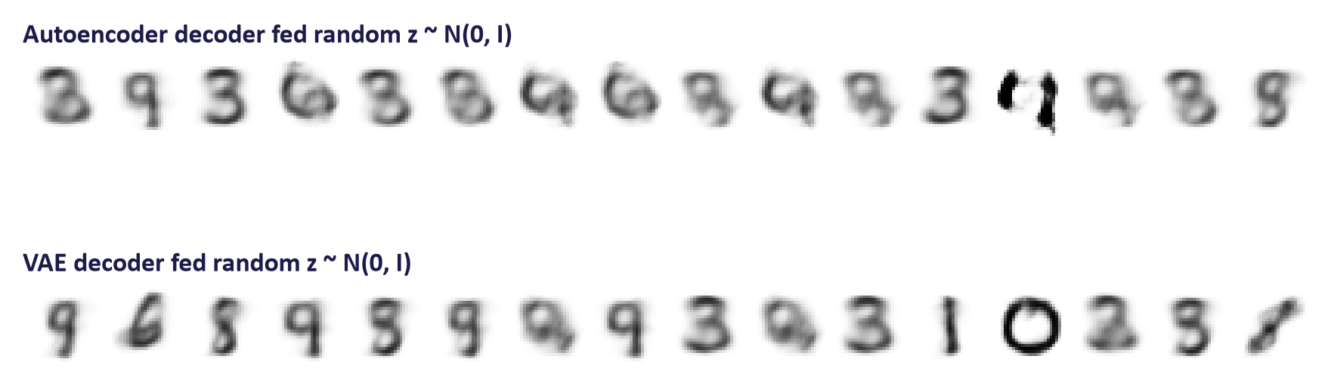
The same random codes decoded by each model
For generation we need a latent space that is:
- continuous: nearby codes decode to similar outputs; and
- useful for prior sampling: many likely prior codes should produce plausible outputs; verify this empirically.
A variational autoencoder (VAE) encourages a more useful sampling space with two changes: the encoder outputs a probability distribution q(z | x) rather than a point, and the loss adds a KL divergence that pulls every such distribution towards a fixed prior p(z) = N(0, I).
Key idea: A VAE is an autoencoder whose code is a probability distribution, regularised to look like a simple prior, so that sampling from the prior and decoding generates new data.

2. The VAE model and the ELBO
A Gaussian is a bell-shaped distribution. Its mean is the centre, its standard deviation is the spread, and its variance is spread squared. N(0, I) means zero-centred, unit-variance independent code dimensions. In formulas, θ and φ name learned weights; E means average, and the vertical bar means “given”.

The probabilistic model
A VAE is a latent variable model:
- Prior: z ∼ p(z) = N(0, I).
- Decoder (likelihood): x ∼ p_{θ}(x | z), where a neural network with parameters θ outputs the parameters of the distribution over x (for MNIST, one Bernoulli probability per pixel).
- Encoder (approximate posterior): q_{φ}(z | x) = N(μ_{φ}(x), diag(σ²_{φ}(x))), a neural network with parameters φ that guesses which codes could have produced x.
A prior is the code distribution we choose before seeing an image. A posterior describes possible codes after seeing that image. The encoder estimates the posterior. Generation needs a prior code and the decoder. Training also uses the encoder to propose codes for each known input.
Variational inference means replacing a difficult distribution with an easier approximation. The VAE uses Gaussian approximations described by encoder-predicted means and variances.
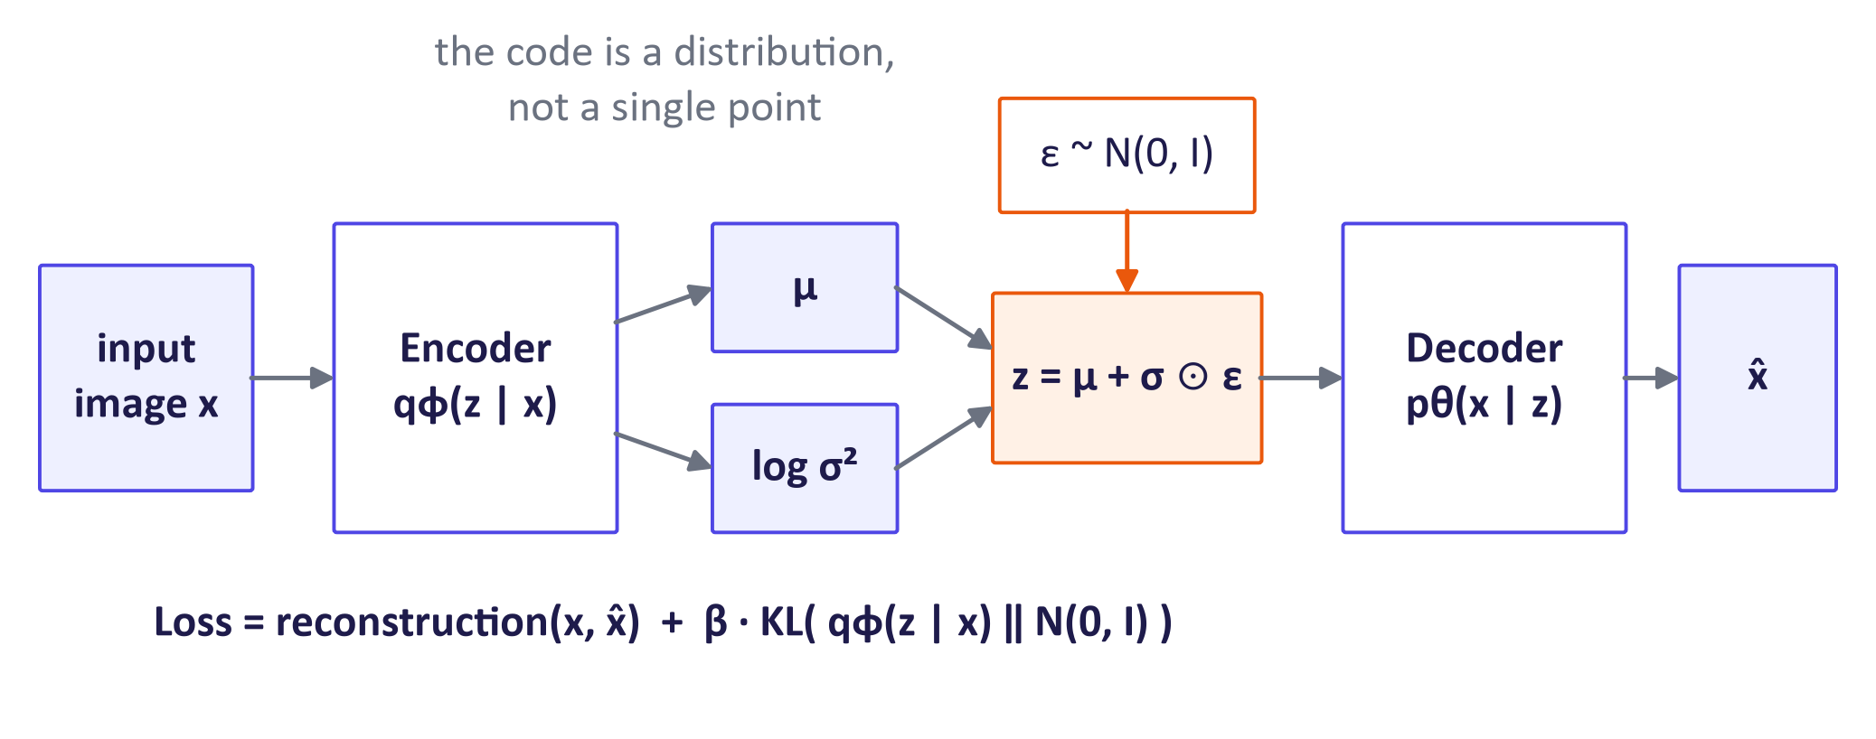
VAE architecture

Why the likelihood is too difficult to calculate exactly
The likelihood of an image is an average of the decoder over all codes:
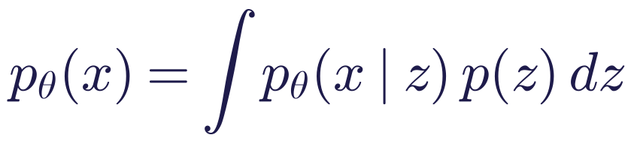
Read the integral. Imagine only two possible codes, each with prior probability 0.5. If their likelihoods for x are 0.2 and 0.6, their weighted sum is 0.4. The continuous model uses an integral instead of this sum.
For a neural decoder, the integral has no convenient exact formula. Sampling codes from the prior is inefficient for explaining one specific image: most samples give it little probability. The exact posterior uses the same difficult denominator p_{θ}(x). The encoder instead learns a useful approximation, and we train with a computable lower bound.

Deriving the evidence lower bound (ELBO)
Multiply and divide by the encoder distribution inside the integral, then apply Jensen's inequality (log 𝔼[Y] ≥ 𝔼[log Y] because log is concave):
Read the inequality. The expectation means an average under the encoder distribution. Jensen’s inequality moves log inside that average and gives a lower value. This is the mathematical step that makes a usable training bound.
Splitting the logarithm gives the familiar form:
Worked example. If expected reconstruction log-probability is −120 and KL is 3, ELBO is −123. The loss we minimise is 123. These are illustrative values, not a measured run.
An exact identity shows what the bound loses:
Worked example. If ELBO = −123 and the posterior KL gap is 2, then log p(x) = −121. Adding a nonnegative gap explains the lower-bound direction.
KL divergence measures a difference between distributions. It cannot be negative, although it is not a symmetric distance. The equation shows that log likelihood equals ELBO plus KL to the true posterior. Therefore ELBO cannot exceed log likelihood.
In code, minimise negative ELBO, averaged over the image batch. This jointly trains the encoder and decoder. Improving a lower bound is useful, but does not guarantee every optimisation step raises the exact likelihood.

Reading the ELBO: two forces
- Reconstruction term 𝔼_{q}[log p_{θ}(x | z)]: codes drawn from the encoder must let the decoder rebuild x. Without KL pressure, the model has no reason to match the chosen prior; learned variances may shrink.
- KL term D_{KL}(q_{φ}(z | x) ‖ p(z)): every image's code distribution should resemble the prior. Alone, it makes the code distribution ignore the input.
Training seeks a compromise between preserving input information and matching the prior. It does not guarantee that every prior code decodes well. Basic pixel losses can favour average intensities where the code leaves image details uncertain, contributing to blur.

The KL divergence between Gaussians
For a one-dimensional Gaussian encoder and a standard normal prior:
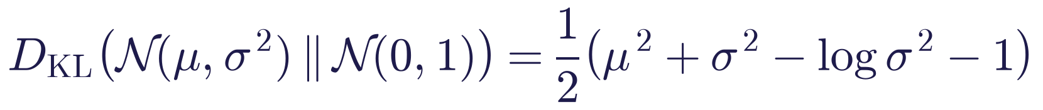
Start with a zero-cost case. Mean 0 and standard deviation 1 give 0.5 × (0 + 1 − log 1 − 1) = 0. Work the shifted and narrowed cases below next.
For a d-dimensional diagonal Gaussian, sum over dimensions. In PyTorch, with the network outputting logvar = log σ²:
kl = -0.5 * torch.sum(1 + logvar - mu**2 - logvar.exp())

Worked examples (natural logs; ln 0.25 = −1.386, ln 4 = 1.386):
Encoder q | Calculation | KL (nats)
μ = 0, σ = 1 | ½(0 + 1 − 0 − 1) | 0.00
μ = 1, σ = 1 | ½(1 + 1 − 0 − 1) | 0.50
μ = 0, σ = 0.5 | ½(0 + 0.25 + 1.386 − 1) | 0.32
μ = 2, σ = 0.5 | ½(4 + 0.25 + 1.386 − 1) | 2.32
μ = 1, σ = 2 | ½(1 + 4 − 1.386 − 1) | 1.31

Moving the mean away from zero and making the distribution either too narrow or too wide both cost nats. KL is not symmetric: D_{KL}(q‖ p) ≠ D_{KL}(p‖ q) in general.
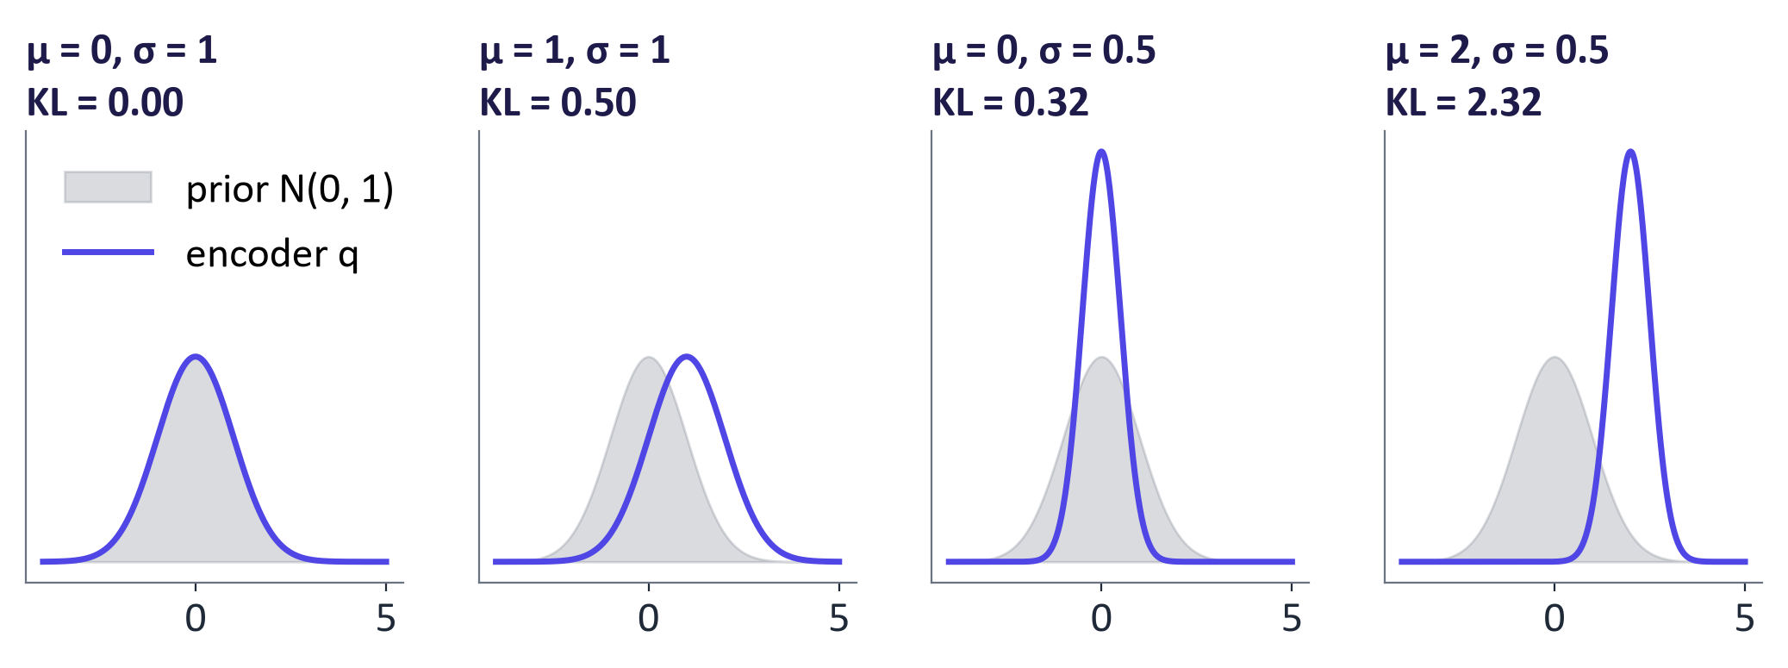
KL divergence for the worked examples

The reconstruction term
The reconstruction term becomes a standard loss once we choose the decoder distribution:
- Bernoulli decoder (binary pixels): negative log-likelihood is binary cross-entropy summed over pixels. Our lab keeps greyscale MNIST intensities and uses the same formula as a conventional soft-target reconstruction surrogate; the literal Bernoulli ELBO interpretation requires binary observations:
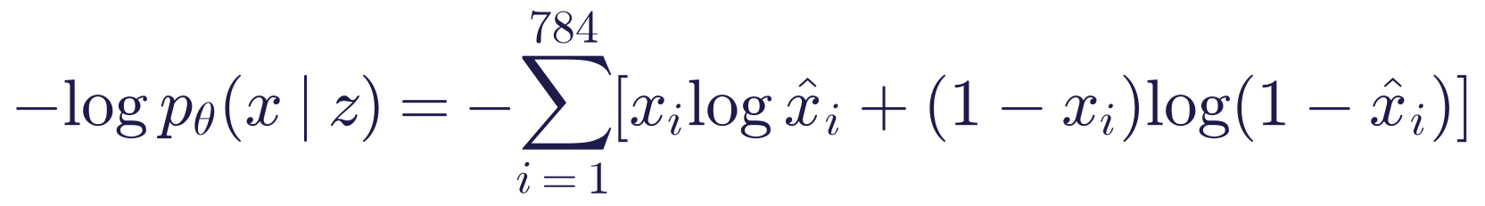
One-pixel example. A target pixel of 1 predicted as 0.8 costs −ln(0.8), about 0.223. Predicting 0.2 costs about 1.609. Add the costs over all pixels.
- Gaussian decoder with fixed variance σ²ₓ (real-valued data): negative log-likelihood = ‖ x − x̂‖² / (2 σ²ₓ) + constant, i.e. squared error. The choice of σ²ₓ implicitly sets the balance with the KL term.
The expectation over q is estimated with one sampled code per image per step (a Monte Carlo estimate); across many steps the noise averages out.
Common mistake: averaging the BCE over pixels (PyTorch's default reduction="mean") while summing the KL over dimensions. The KL term then dominates by a factor of 784 and every sample looks like an average blurry digit. Sum over pixels, then divide the total by the batch size.

3. Training: the reparameterisation trick
We need gradients of 𝔼_{qφ(z | x)}[log p_{θ}(x | z)] with respect to the encoder parameters φ. A direct PyTorch sample() call disconnects the pathwise autograd route through its draw. Other gradient estimators exist, but the Gaussian reparameterisation trick provides a differentiable calculation for fixed noise:
One-number example. Let μ = 1, σ = 0.5 and ε = −2. Then z = 1 + 0.5 × (−2) = 0. A fresh ε changes z while still allowing gradients through μ and σ.
The trick samples ε from a fixed standard Gaussian, then shifts and scales it using the encoder outputs. This gives the same distribution for z as direct Gaussian sampling. The noise is now an input to a differentiable calculation. Reconstruction gradients can flow through z to μ and σ.
A score-function estimator such as REINFORCE is another option, but typically has higher variance here. Diffusion also uses "clean signal plus scaled noise" in week 4.
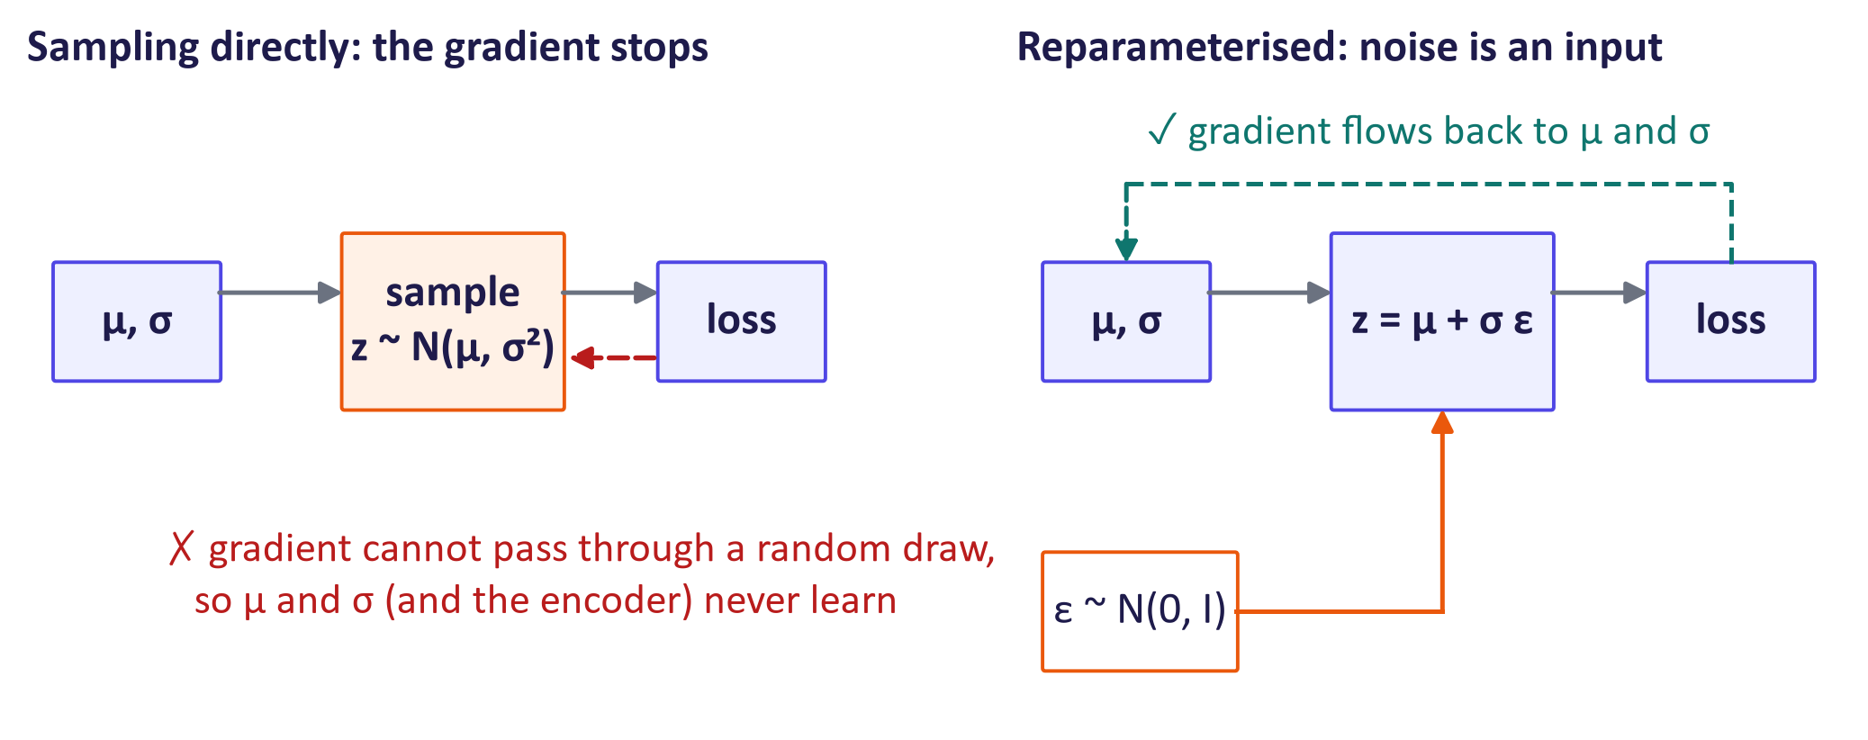
Without and with the reparameterisation trick

A complete PyTorch model
This is the lab's completed model and loss (the lab leaves TODOs in encode, reparameterise and vae_loss).
class VAE(nn.Module):
def __init__(self, zdim=2, hidden=400):
super().__init__()
self.zdim = zdim
self.enc = nn.Sequential(nn.Flatten(), nn.Linear(784, hidden), nn.ReLU())
self.mu_head = nn.Linear(hidden, zdim)
self.logvar_head = nn.Linear(hidden, zdim)
self.dec = nn.Sequential(nn.Linear(zdim, hidden), nn.ReLU(),
nn.Linear(hidden, 784))

def encode(self, x):
h = self.enc(x)
return self.mu_head(h), self.logvar_head(h)

def reparameterise(self, mu, logvar):
std = torch.exp(0.5 * logvar)
eps = torch.randn_like(std)
return mu + std * eps

def forward(self, x):
mu, logvar = self.encode(x)
z = self.reparameterise(mu, logvar)
return self.dec(z), mu, logvar

@torch.no_grad()
def decode(self, z):
# Display pixel probabilities; this path needs a code, not an input image.
return torch.sigmoid(self.dec(z)).view(-1, 28, 28)

def vae_loss(logits, x, mu, logvar, beta=1.0):
rec = F.binary_cross_entropy_with_logits(logits, x.view(-1, 784), reduction="sum")
kl = -0.5 * torch.sum(1 + logvar - mu.pow(2) - logvar.exp())
n = x.size(0)
return (rec + beta * kl) / n, rec / n, kl / n

Variance must be positive. The network predicts log-variance, which can be any real number, then exponentiates it. For logvar = 0, variance = exp(0) = 1 and standard deviation = 1.
VAE.encode predicts mean and log-variance. VAE.decode applies sigmoid to decoder logits and returns displayable pixels. These are predicted pixel probabilities. The lab displays them directly rather than drawing each Bernoulli pixel separately.

Training practice
- Adam with learning rate 10⁻³, batch size 128 and 10 epochs. The model is small enough for a laptop CPU; a GPU is faster. Time one epoch before planning longer runs.
- Always log reconstruction and KL separately. Initial KL depends on the network initialisation. It can rise as codes carry more image information; a rising KL alone does not mean training has failed.
- Posterior collapse: the KL falls to (almost) zero and the decoder ignores z. It is common when the decoder is powerful (e.g. autoregressive). Remedies: KL warm-up (increase β from 0 to 1 over the first epochs), free bits (no penalty below a minimum KL per dimension), or a less powerful decoder.
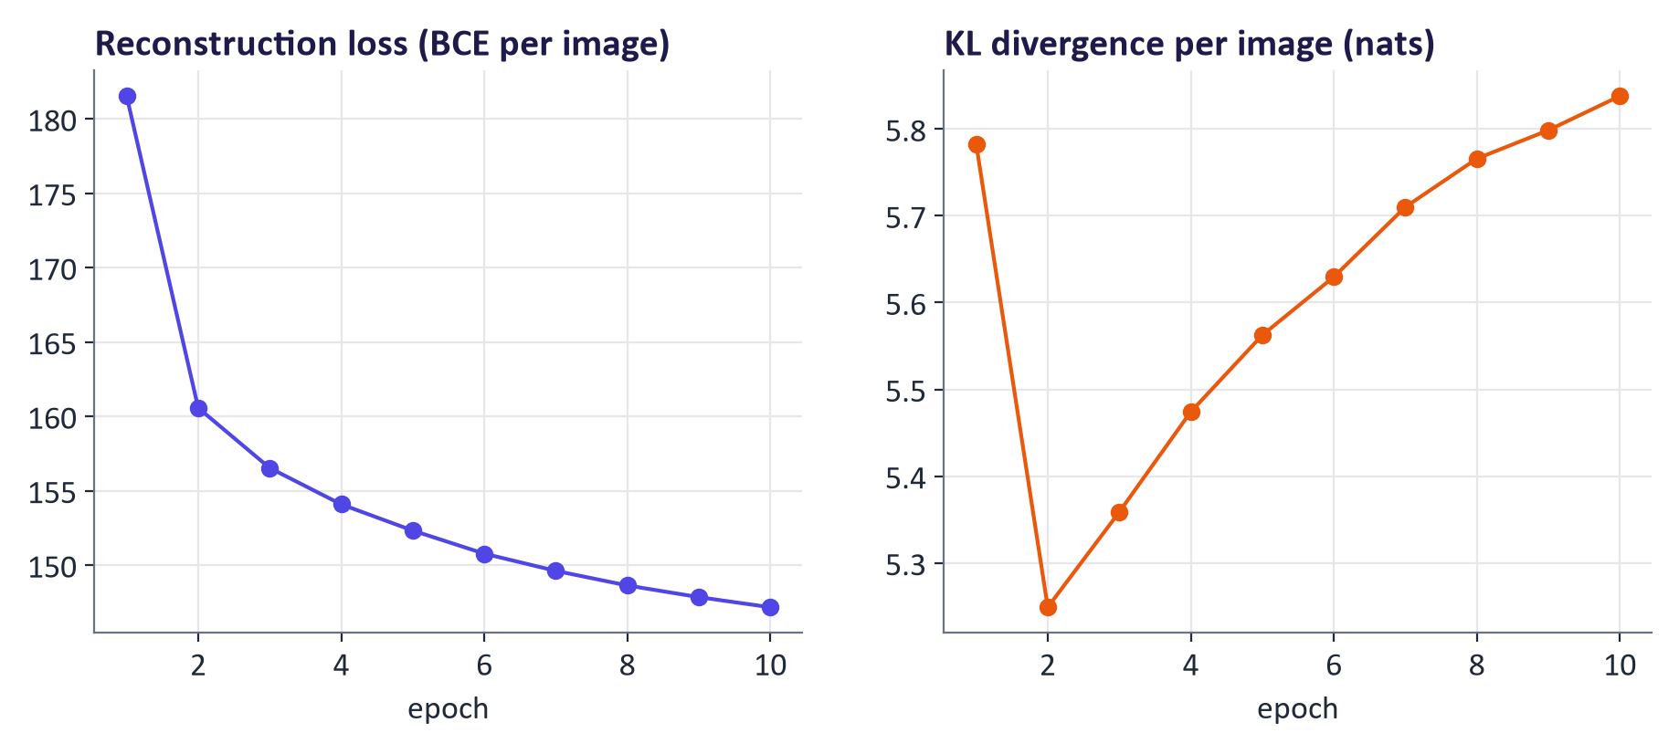
Real training curves for the 2-D VAE

4. Exploring and evaluating the latent space

Reconstructions and blur
The held-out digit reconstructions are recognisable but often softer than the originals. Pixel losses can reward average intensities when details are uncertain. Basic VAE codes also balance image information against the prior. These effects can blur edges. GANs introduce a learned realism checker in week 3. Latent diffusion uses an autoencoder trained with extra visual and adversarial losses in week 4.
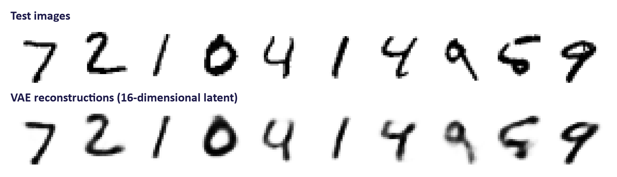
Test images and their reconstructions

Latent grid and interpolation
A two-dimensional code can be plotted as a map. Decode a grid of code points and compare neighbouring cells. Smooth changes and many recognisable digits are evidence about this trained model, rather than a guarantee that every possible code works.
Interpolation chooses points between codes z₁ and z₂: zₜ = (1−t)z₁ + tz₂. At t = 0.5, use their midpoint. Decode each point and inspect the path. In high dimensions, spherical interpolation follows a curved path closer to the typical radius of random Gaussian codes.
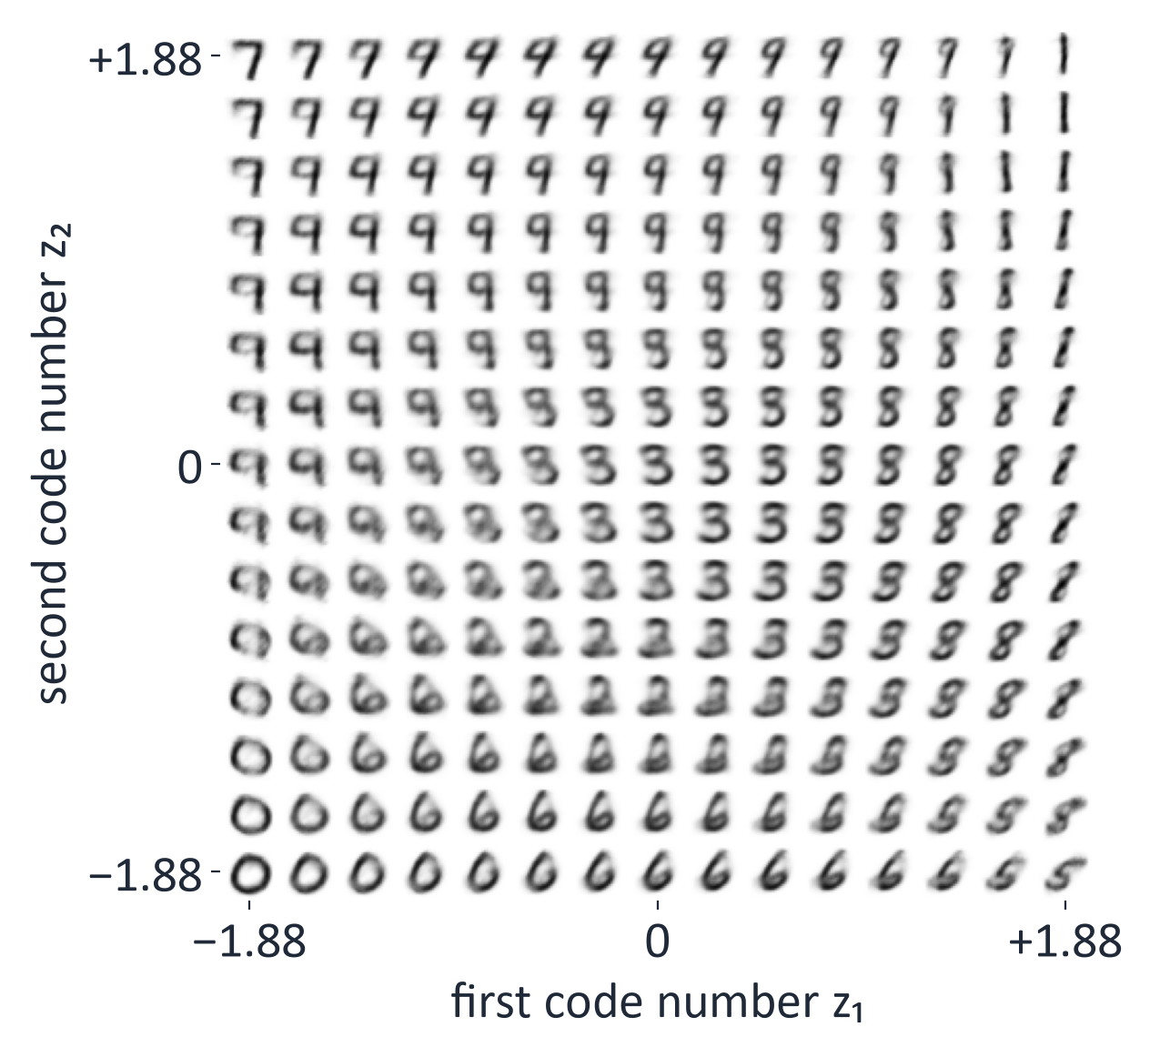
Decoded grid of the 2-D latent space
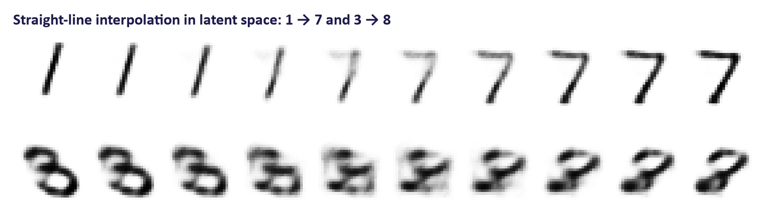
Latent interpolation between digits

The β trade-off
Weighting KL by β gives the β-VAE objective. With β = 1 and a correctly specified decoder likelihood, the two terms form the ELBO. Our greyscale soft-target BCE experiment uses the conventional reconstruction surrogate. Measured on the archived 16-D models after 5 epochs:
β | Reconstruction (BCE per image) | KL (nats per image) | Samples from the prior
0.1 | 77.6 | 49.7 | sharp details but many malformed digits
1.0 | 87.9 | 22.8 | useful balance in this archived run
4.0 | 119.3 | 8.6 | well-formed but blurry, generic

β multiplies the KL cost. Increasing it puts more pressure on code distributions to match the prior, often reducing code information and increasing reconstruction error. Lower β can improve reconstruction while weakening random prior samples. Actual effects depend on training.
The rate–distortion view names KL the information rate and reconstruction error the distortion. A disentangled code aims to separate factors such as stroke width and slant. β above one can encourage this but cannot guarantee it.
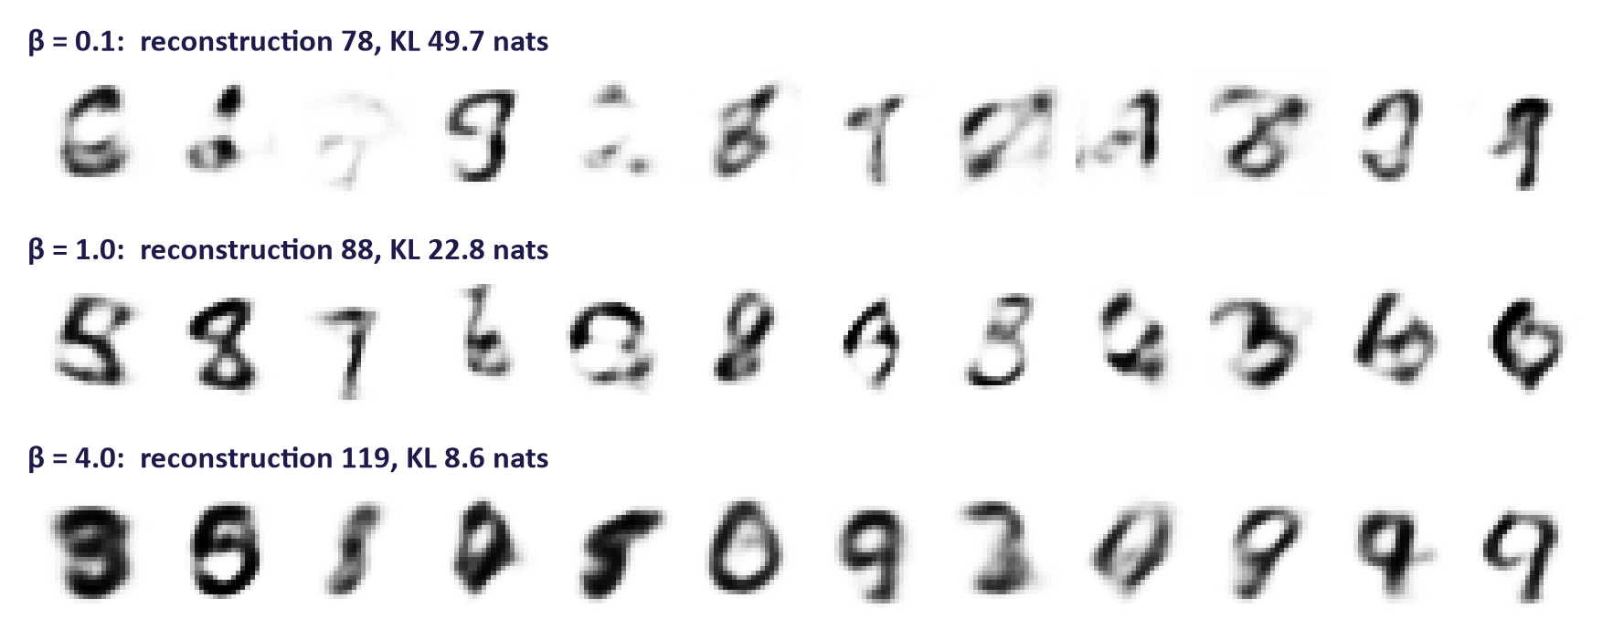
Samples for three values of β
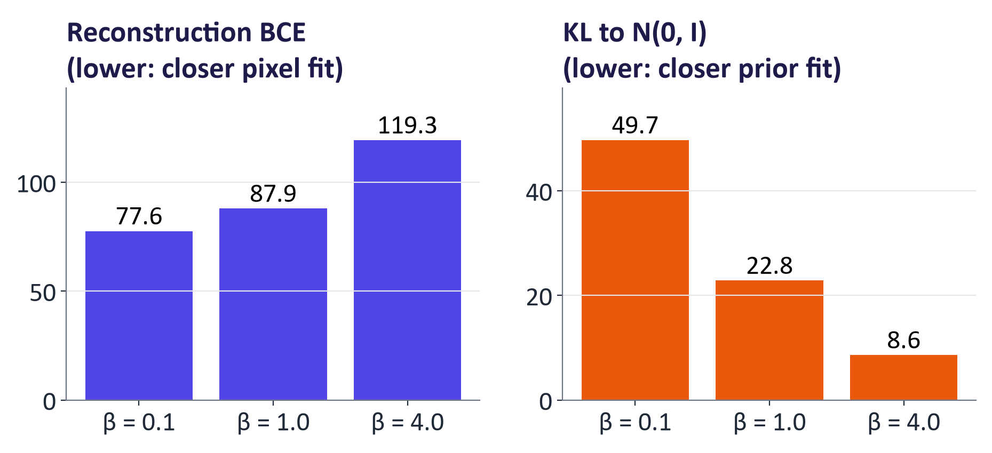
Reconstruction and KL for each β

How to evaluate a VAE
Aspect | Metric | Caveat
Fit to data | Held-out negative ELBO (nats per image, or bits per dimension) | A bound; only compare models with the same decoder likelihood
Reconstruction | BCE or MSE on held-out data; side-by-side pictures | Good reconstructions do not guarantee good samples
Sample quality | Fréchet Inception Distance (FID, week 3); human rating with a rubric | FID needs thousands of samples and a relevant feature network
Latent space | Interpolations, traversals, disentanglement metrics | Visual inspection is subjective; report seeds and failures
Usefulness | Task metric, e.g. anomaly-detection ROC AUC | Needs realistic held-out test cases

5. Variants and applications
- Conditional VAE (CVAE): condition both networks on a label or other information y to model p(x | z, y); sampling with a chosen y generates that class (lab extension).
- β-VAE: β > 1 increases prior pressure and can encourage separated factors; test interpretability rather than assuming it.
- VQ-VAE: replaces the Gaussian code with the nearest vector in a learned codebook, so images (or audio) become grids of discrete tokens. This is the basis of many image and audio tokenizers used by autoregressive and multimodal transformers.
- Hierarchical VAEs (e.g. NVAE): several layers of latents; can model detail at different scales.

VAEs inside latent diffusion
Latent diffusion first learns a smaller image representation. In the Stable Diffusion example, 512 × 512 × 3 = 786,432 pixels become 64 × 64 × 4 = 16,384 hidden values: 48 times fewer numbers. Text-to-image generation starts from random noise in that smaller space; the diffusion model removes the noise step by step while following the prompt, and the VAE decoder turns the final latent into pixels. The encoder is not needed for that path. It turns training photos into latents, and it encodes an existing picture when you edit it (image-to-image).
The autoencoder uses a small KL weight plus visual and adversarial losses to preserve detail. It is more specialised than our basic MNIST VAE. This explains why VAE-style components remain useful even when the main image generator is diffusion.

Applications
- Anomaly detection: reconstruction scores can flag inputs unlike the training data; validate realistic failures because some unusual inputs reconstruct well.
- Synthetic data: sample new records or images to augment small datasets (with privacy caveats).
- Molecule and design search: improve in a smooth latent space, then decode candidates.
- Compression and tokens: learned codecs; latent spaces for diffusion and multimodal models.
In our demonstration, a VAE trained only on digits separated unseen digits from Fashion-MNIST clothing images using reconstruction error with ROC AUC = 0.9995: a randomly chosen clothing image had a higher error than a randomly chosen digit 99.95% of the time. An AUC of 1 would mean every clothing image scored higher than every digit; 0.9995 is close but not perfect. Real anomalies are much subtler; always evaluate on realistic, held-out cases.
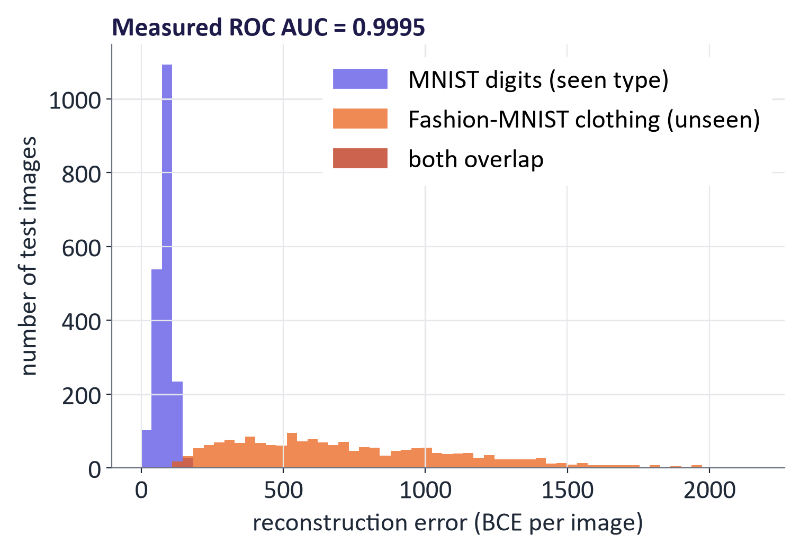
Reconstruction error for digits and clothing

Common misconceptions
Misconception | Correction
"A VAE is just an autoencoder with noise added." | The noise comes from a learned distribution, and the KL term to a prior is what makes the latent space usable for generation.
"The ELBO is the log-likelihood." | It is a lower bound; the gap equals the KL between the encoder and the true posterior.
"Lower KL is always better." | KL = 0 means the code carries no information about the input; the balance with reconstruction matters.
"Blurry samples mean a bug." | Some blur is expected (overlapping codes, pixel-wise likelihood). Severe blur often means the loss terms are mis-scaled (mean vs. sum).
"The encoder is needed to generate." | Generation uses only the prior and the decoder; the encoder is used in training and for encoding real images.
"Interpolation that looks good proves the model is good." | carefully selected best pairs can mislead; evaluate quantitatively and show failures.
"VAEs are obsolete." | Their autoencoders power latent diffusion; VQ-VAE ideas power image and audio tokenizers.

Responsible AI lens: VAEs and synthetic data
- Privacy: synthetic data is not automatically anonymous. Generative models can memorise rare records. Check for near-duplicates of training data and consider differential privacy for sensitive data.
- Bias in anomaly detection: the detector flags whatever differs from its training data. If a group is under-represented, its normal cases look anomalous (for example in fraud or clinical screening). Ask "normal for whom?" and measure error rates across groups.
- Consent and licences: MNIST is public; faces, medical images and voices require consent, a lawful basis (GDPR) and appropriate licences.
- Honest reporting: report typical samples, failure cases, seeds and metrics, not only the best interpolation.

Lab guide and answers
Runtime: Colab or a laptop CPU. The complete solution notebook ran in about 9 minutes on the laptop CPU used to check this pack (9 October 2026); a GPU is faster. Ask students to record their own timings. MNIST and Fashion-MNIST download through torchvision. Hand-in: completed TODOs, figures, the β table and four written answers.

TODOs and expected results
- TODO 1 in VAE.encode: mu, logvar = self.mu_head(h), self.logvar_head(h).
- TODO 2 std = torch.exp(0.5 * logvar); return mu + std * torch.randn_like(std).
- TODO 3 BCE with logits summed over pixels; KL -0.5 * sum(1 + logvar - mu**2 - exp(logvar)); divide by batch size.
- Question 1: if initial pixel predictions are near 0.5, reconstruction cost is approximately 784 × ln 2 ≈ 543. If μ ≈ 0 and σ ≈ 1, KL is near zero. Check actual initial predictions; these conditions depend on initialisation.
- Training (2-D model, 10 epochs): reconstruction falls to about 147 nats per image; the KL dips after the first epoch, then rises slowly to 5.8 nats at epoch 10 (measured with the lecture model). Your values will differ a little.
- Part 3: the scatter shows class clusters packed around the origin; the grid decodes to a smooth map of digits. TODO 4 (1 - ts) * z1 + ts * z2. Latent interpolation may change strokes more coherently; inspect the actual intermediate digits and compare with pixel blending.
- Part 4 (β): expect the pattern in the table above; exact values vary with seeds and epochs.
- TODO 5 per-image BCE: F.binary_cross_entropy_with_logits(logits, x.view(-1, 784), reduction="none").sum(dim=1). The saved digit-versus-clothing experiment had ROC AUC 0.9995 (the lab prints four decimals so it is not shown as 1.000); record your measured result and do not generalise it to realistic defects.
- Extension (CVAE): each row should show the requested digit in varied styles.

Troubleshooting
- Samples all look like the same blurry blob: the BCE was averaged instead of summed, so the KL dominates.
- NaN loss: usually logvar exploding; lower the learning rate or clamp logvar to [−10, 10].
- Very slow on CPU: reduce epochs to 3 for the β study; inspect whether the observed pattern changes with shorter training.

Practice questions with model answers

Multiple choice
- The KL term in the VAE loss: (a) keeps each encoder distribution close to the prior; (b) measures how well the decoder reconstructs each input; (c) is the log-likelihood of the data under the decoder; (d) is only used at generation time, to sample new codes. Answer: (a).
- The reparameterisation trick is needed because: (a) the decoder is non-linear, so its loss cannot be differentiated; (b) MNIST images are binary, which breaks ordinary backpropagation; (c) the prior is not Gaussian, so the KL term has no closed form; (d) an ordinary sample() call passes no pathwise gradient to μ and σ. Answer: (d).
- Increasing β from 1 to 4 usually: (a) sharpens reconstructions, because the KL weight is larger; (b) increases the KL, since codes spread further from the prior; (c) lowers the KL and increases reconstruction error; (d) has no effect, because β only scales the reported loss. Answer: (c).
- In latent diffusion models the VAE is used to: (a) classify images so the denoiser knows what to draw; (b) compress images into a smaller latent space where diffusion runs; (c) encode the text prompt into vectors for cross-attention; (d) compute FID between generated and real image batches. Answer: (b).

Short answer
- Compute the KL divergence to N(0, 1) for q = N(1.5, 0.5²). (3 marks) Model answer: ½(μ² + σ² − ln σ² − 1) = ½(2.25 + 0.25 − (−1.386) − 1) = ½(2.886) = 1.44 nats.
- Explain why the ELBO is a lower bound on log p(x) and what the gap represents. (4 marks) Model answer: log p(x) = ELBO + KL(q(z|x) ‖ p(z|x)); KL ≥ 0 so ELBO ≤ log p(x) (2). The gap is the KL between the encoder's approximate posterior and the true posterior; for a fixed decoder, a closer encoder approximation makes it smaller (2).
- Why are VAE samples often blurry, and name two ways to reduce this. (4 marks) Model answer: overlapping latent codes make the decoder average several compatible images; pixel-wise likelihoods (BCE/MSE) reward the mean prediction under uncertainty (2). Remedies: hierarchical latents or more expressive decoders; perceptual or adversarial losses (as in latent-diffusion autoencoders); lower β; convolutional architectures (2 for any two, justified).
- Describe how you would use a VAE for anomaly detection and one limitation. (4 marks) Model answer: train on normal data only; score new inputs by reconstruction error (or negative ELBO); choose a threshold on a validation set; flag inputs above it (3). Limitation: subtle anomalies can reconstruct well, or under-represented normal cases get flagged; needs realistic evaluation (1).

Exam-style question
"Derive the evidence lower bound for a variational autoencoder, explain the role of each term, and discuss how the reparameterisation trick enables training. Illustrate with the effect of the β parameter." (20 marks)
Marking guide: latent variable model and a likelihood that is difficult to calculate exactly (3); derivation via Jensen's inequality or the KL identity (5); interpretation of reconstruction and KL terms including their tension (4); reparameterisation trick with equation and gradient argument (4); β trade-off with a concrete consequence for samples or reconstructions (4). Excellent answers mention the gap as a KL to the true posterior, the closed-form Gaussian KL, and posterior collapse.

Glossary
Term | Meaning
Autoencoder | Encoder–decoder network trained to reconstruct its input through a bottleneck
Latent space | The space of codes z; in a VAE, shaped to match the prior
Prior p(z) | Fixed distribution over codes, usually N(0, I)
Encoder q_{φ}(z | x) | Network outputting a Gaussian over codes for an input; approximates the posterior
Decoder p_{θ}(x | z) | Network mapping a code to a distribution over data
ELBO | Evidence lower bound: reconstruction term minus KL; maximised in training
KL divergence | Non-negative, asymmetric measure of difference between distributions
Reparameterisation trick | Writing z = μ + σ ⊙ ε so sampling becomes differentiable
Posterior collapse | Failure where KL → 0 and the decoder ignores the code
β-VAE | VAE with the KL weighted by β, trading reconstruction for structure
VQ-VAE | VAE with a discrete codebook of latent vectors (image/audio tokens)
Latent interpolation | Decoding points on a path between two codes
Latent diffusion | Diffusion model operating in a VAE's latent space

Readings, videos and further practice

Core reading (descriptor 7.9)
- Foster, D. (2023) Generative Deep Learning, 2nd ed.: chapter 3, "Variational Autoencoders" (autoencoders, VAEs, latent space exploration; Keras code).
Papers
- Kingma & Welling (2013) Auto-Encoding Variational Bayes: the original VAE and the reparameterisation trick.
- Higgins et al. (2017) β-VAE: disentanglement with β > 1.
- van den Oord et al. (2017) Neural Discrete Representation Learning (VQ-VAE).
- Rombach et al. (2022) Latent Diffusion Models: preview of week 4.
Tutorials and explainers
- Lilian Weng: From Autoencoder to Beta-VAE: derivations and variants.
- TensorFlow tutorial: Convolutional VAE: the same model in TensorFlow (the descriptor allows either framework).

Link to the group project
Groups that generate images, detect anomalies or need synthetic data can reuse this week's model directly. Ask students to note (1) whether their project needs a latent space (for search, interpolation or compression), (2) which evaluation from the table above suits their use case, and (3) any privacy risk if they plan to generate synthetic records.

Detailed explanations behind the short slides
The lecture shows the essential idea first. These fuller explanations retain the supporting comparisons, examples and checks for revision.

Slide 8: An autoencoder: squeeze, then rebuild
- Encoder: turn image pixels x into a shorter code z.
- Decoder: turn z back into a reconstructed image x-hat.
- Training reduces the difference between original and reconstructed pixels.
- Uses include compression, removing noise and learning useful features.

Slide 10: Consequence: random codes decode to nonsense in an autoencoder
The same 16 random points z ~ N(0, I) decoded by each model.
A good generator needs its chosen random codes to reach regions the decoder has learned to use.

Slide 11: Autoencoder vs. variational autoencoder
A prior is a chosen distribution for codes. The VAE learns to reconstruct while keeping codes near it.
Autoencoder.
- Encode each input as one point z
- Train using reconstruction error
- The code locations can have gaps or an arbitrary scale
- Useful for compression and features
- Random codes may decode poorly
Variational autoencoder.
- Encode each input as a Gaussian distribution: a centre μ and spread σ
- Train using reconstruction error plus a KL penalty
- Encourage codes to match a known prior, N(0, I)
- Draw a code from the prior and decode a new image
- Sample quality still depends on data, model and training

Slide 14: The VAE as a probabilistic model
- To generate, sample from the prior and use the decoder. No input image is needed.
- To train, the encoder proposes useful codes for each known image.
- θ names the decoder weights and φ the encoder weights. Both learn together.
Prior. Draw code z from N(0, I), a Gaussian centred at zero
Decoder. Predict pixel probabilities from the code z
Data. Observe image x, such as a handwritten digit
Encoder. Estimate which codes could explain image x

Slide 16: Why we cannot maximise the likelihood directly
- To calculate p(x), we would need to combine the decoder's predictions over every possible code z.
- For a neural decoder, this integral and the exact posterior p(z | x) are too difficult to calculate exactly.
- The encoder q(z | x) estimates the posterior. We maximise a quantity below log p(x): a lower bound.

Slide 18: The evidence lower bound (ELBO)
- Reconstruction reward: sampled codes should help the decoder rebuild the input.
- KL penalty: keep encoder distributions near the prior N(0, I). KL measures a difference between distributions.
- The gap is a nonnegative KL, so ELBO cannot exceed log p(x). Minimise negative ELBO to train.

Slide 19: Reading the ELBO: two forces in tension
The loss balances image detail with useful random codes. β sets the KL weight.
Reconstruction term.
- Keep enough image information in the code
- Reward accurate reconstructions
- Use pixel cross-entropy or squared error
KL term.
- Keep each code distribution close to N(0, I)
- Encourage overlap between code distributions
- Too much pressure can make the decoder ignore the input

Slide 20: KL divergence between two Gaussians has a closed form
- Calculate this cost for each code dimension, then add the costs.
- For μ = 0 and σ = 1, the encoder matches the prior and KL = 0.
- Lab code: kl = -0.5 * sum(1 + logvar - mu**2 - logvar.exp()). Here logvar means log variance.

Slide 21: Worked examples: how far is the encoder from the prior?
- Shift the centre: μ = 1, σ = 1 gives KL = 0.5 × (1 + 1 − 0 − 1) = 0.50.
- Shrink the spread: μ = 0, σ = 0.5 gives KL about 0.32.
- Do both: μ = 2, σ = 0.5 gives KL about 2.32. Add the penalties across dimensions.

Slide 22: The reconstruction term in practice
- For MNIST intensities in [0, 1], we use binary cross-entropy summed over the 784 pixels.
- Binary observations give a Bernoulli likelihood; greyscale intensities use a soft-target surrogate. A fixed-variance Gaussian likelihood instead gives squared error, up to constants and scale.
- Use one sampled code per image in each step to estimate the reconstruction expectation.

Slide 26: The reparameterisation trick
- Draw fresh standard-normal noise ε, then set z = μ + σ × ε.
- For each draw, noise is an input. The calculation remains differentiable with respect to μ and σ.
- Reconstruction gradients can train both encoder branches. Draw fresh noise for later examples.

Slide 28: A complete VAE in PyTorch
- The encoder predicts mu and logvar, meaning mean and log variance.
- randn_like draws noise. Shift and scale it to make code z.
- Loss: summed pixel cross-entropy + β × KL, then average over the batch.
- To generate, decode a fresh random-normal code and apply sigmoid.

Slide 29: Training in practice: watch both terms
- This run uses Adam, learning rate 0.001, batch 128 and 10 epochs. Runtime depends on hardware.
- Track reconstruction and KL separately. The curves show what changed in this run.
- Posterior collapse means the decoder largely ignores z, often with KL near zero.
- Possible remedies: increase KL weight gradually, allow a small free KL amount or reduce decoder capacity.

Slide 33: Decoding a grid of latent points: a map of the learned space
- Each cell is one decoded point from a 15 × 15 grid of 2-D codes.
- Nearby points often make similar digits: the output changes smoothly.
- Many grid points make digit-like images in this run. This does not guarantee every code is realistic.
- Look for changes in shared strokes: along the bottom row a 0 becomes a 6, then a 5.

Slide 34: Interpolation: walk in a straight line through latent space
- Encode two images as z₁ and z₂. Decode (1 − t) z₁ + t z₂ as t moves from 0 to 1.
- At t = 0.5, the code is halfway between them. Inspect the resulting image.
- Spherical interpolation (slerp) follows a curved path and can help for high-dimensional random codes.

Slide 35: β changes the balance between sharpness and structure
- β multiplies the KL penalty. The images compare three β values.
- Low β puts more weight on reconstruction. Prior samples may then be less reliable.
- High β pulls codes closer to the prior. Reconstructions may lose detail.
- With β = 1 and a decoder likelihood, this is the ELBO objective; our greyscale BCE uses a surrogate. Compare costs and samples.

Slide 36: How to evaluate a VAE
What | Metric | Watch out for
Fit to data | Negative ELBO on held-out data (nats, or bits per dimension) | Only a bound; compare models with the same likelihood setup
Reconstruction | BCE or MSE on held-out images; side-by-side pictures | Low error can coexist with poor samples
Sample quality | FID against real images (week 3); human rating | FID needs thousands of samples; humans need a rubric
Latent space | Interpolations, traversals, disentanglement scores | Visual inspection is subjective; report seeds
Usefulness | Downstream task, e.g. anomaly-detection ROC AUC | Test on realistic, held-out anomalies

Slide 38: Important VAE variants
Conditional VAE. Give the encoder and decoder a class label y, so the model can generate a selected class.
β-VAE. Increase β above 1 to encourage separate factors in the codes. This can cost image detail.
VQ-VAE. Choose codes from a learned table, called a codebook. Images become grids of discrete tokens.
Hierarchical VAEs. Use several layers of hidden codes to describe data at different scales.

Slide 39: Where you meet VAEs every day: inside latent diffusion
- The slide shows text-to-image generation in this Stable Diffusion design. The latent holds 48 times fewer numbers than the image.
- The VAE encoder does not appear in that path. It turns training photos into latents and encodes an existing picture for editing.
- Its autoencoder also uses visual and adversarial losses to help preserve detail. It differs from our simple digit VAE.
Random latent. Start from 64 × 64 × 4 random noise values
Diffusion model. Remove the noise step by step, guided by the text prompt (week 4)
VAE decoder. Turn the final latent into image pixels
Image. 512 × 512 × 3 pixel values

Slide 40: Applications of VAEs
Anomaly detection. Use high reconstruction error as a possible warning for unusual inputs. Test real anomalies.
Synthetic data. Generate extra tabular, image or sensor examples. Check for copies and unfair patterns.
Molecule and design search. Search through hidden codes, then decode candidate molecules or shapes.
Compression & tokens. Compress images, audio or video into smaller numerical representations.

Slide 42: Responsible AI lens: VAEs and synthetic data
- Privacy: synthetic data can memorise and leak training records; test for near-copies and consider differential privacy.
- Bias: an anomaly detector flags whatever differs from its training data, which can mean under-represented groups. Ask: normal for whom?
- Consent & licences: MNIST is public; faces, medical scans and voices need consent and a lawful basis.
- Honest reporting: show failure cases and blurry samples, not only the best interpolations.

Slide 44: Lab 2: implement and explore a VAE in PyTorch
Google Colab or a local CPU; timings vary with hardware
Notebook with completed TODOs, figures, the β comparison table and four written answers
- Load MNIST digit images. Implement the encoder, code sampling and decoder.
- Implement reconstruction cost plus β times KL, the usual VAE objective; a literal ELBO requires an appropriate decoder likelihood.
- Train for 10 epochs and plot reconstruction and KL costs separately.
- Plot 2-D codes. Decode a grid and points between two digit codes.
- Train with β = 0.1, 1 and 4. Compare fixed-code samples and measured losses.
- Compare digit and clothing reconstruction errors. Compute ROC AUC. Optional: add a class condition.

Slide 46: Summary
- An autoencoder compresses and rebuilds. Random codes may fall in poorly learned regions.
- A VAE encoder predicts a distribution of codes for each input.
- Loss = reconstruction cost + β × KL. At β = 1 this is the standard VAE objective; binary targets give the literal negative ELBO.
- Gaussian KL: 0.5 × (μ² + σ² − log σ² − 1) per dimension.
- Sample with z = μ + σ × ε, using fresh random-normal noise.
- Inspect reconstructions, random samples and paths. Evaluate on held-out data.
- β changes the balance between reconstruction and the prior.
- Conditional VAEs, β-VAEs, VQ-VAEs and hierarchical VAEs extend the basic idea.

Full implementation from the lecture
The projected slide shows the encode, reparameterise and forward methods. The complete class, including the layers, decode and vae_loss, is listed in section 3 under "A complete PyTorch model" and matches the lab solution.

Class recap
- Encoder predicts a code distribution.
- Decoder maps codes to pixels.
- Loss balances reconstruction and KL.
- Reparameterisation carries encoder gradients.
- Generate using prior + decoder.
- Evaluate quality, variety and task performance.
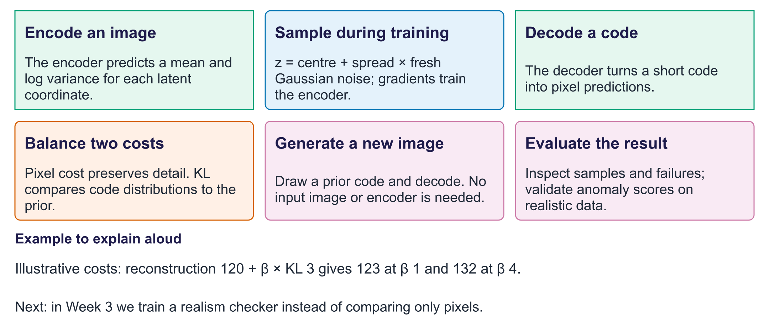
Week 2: what we learned
Exit question. If logvar = 0, is the standard deviation 0 or 1?
Answer. It is 1: exp(0.5 × 0) = 1. Zero log variance still has spread.

