WEEK 12 · TEACHING NOTES

Retrieval-Augmented Generation (RAG) & Agentic AI
Search trustworthy sources, answer with evidence, and control tool-using agents
Generative AI · MSc in Artificial Intelligence · 2-hour lecture + 2-hour lab
Descriptor Section 7.3 (revised) for this week
Lecture topic | Retrieval-Augmented Generation (RAG) & Agentic AI
Detail | Motivation. LLM limitations (e.g Static Knowledge, Hallucinations, no access to private data). Embeddings and vector databases. RAG architectures and workflow (chunking, indexing, dense and hybrid retrieval, re-ranking, grounded generation with citations; advanced RAG, e.g. query rewriting, GraphRAG). RAG evaluation (retrieval quality, faithfulness, answer relevance). Understand agentic AI concepts and components (LLM, tools / function calling, memory, planning, ReAct loop; workflows vs. agents; multi-agent systems; Model Context Protocol). Risks and guardrails (prompt injection, human oversight). Frameworks & Tools.
Tutorials | Build RAG pipelines (e.g document Q&A) with embeddings and a vector store. Compare with and without RAG and evaluate retrieval and faithfulness.  Implement a simple LLM agent that calls tools (e.g. a calculator and a search over the RAG index).
Module learning outcomes (MIMLOs) practised this week
MIMLO 3: Design, implement and fine-tune generative AI models using contemporary frameworks and parameter-efficient methods.
MIMLO 4: Critically evaluate generative AI outputs using quantitative metrics, human-centered assessments and ethical considerations, including fairness, bias and hallucination risks.
MIMLO 5: Deploy generative AI models in real-world scenarios, utilising contemporary frameworks and implement retrieval-augmented or agentic systems.
What is in this week's folder
Lecture slides | 46 slides with speaker notes, vocabulary and technical diagrams.
Teaching notes | Lecture explanations, worked examples, code maps, practice questions and readings.
Student lab | Notebook and Python file with TODOs. Embedded and separate diagrams accompany the lab.
Lab solutions | Instructor notebook and Python file with completed code and model answers.

Lecture plan at a glance
This final technical week connects models to knowledge and tools (MIMLO 3, 4, 5). Students should leave able to explain why RAG is needed, build and evaluate a RAG pipeline (chunking, embeddings, vector stores, hybrid retrieval, re-ranking, grounded generation with citations), describe advanced RAG, explain the components and loop of an agent, distinguish workflows from agents, explain MCP, and design guardrails against prompt injection. Results on the "real" slides come from running this week's lab in advance (curriculum/assets/week_12/).
Time | Slides | Segment | What you do
0–5 min | 1–5 | Warm-up | Ask a chatbot about this module's late policy.
5–20 min | 6–11 | 1 · Why RAG? | LLM limitations; RAG vs fine-tuning vs long context; pipeline; quiz.
20–35 min | 12–17 | 2 · Indexing | Embeddings; chunking; vector stores; ANN and filters.
35–65 min | 18–26 | 3 · Retrieval and evaluation | Dense vs BM25; RRF and metrics; re-ranking; real retrieval and RAG results; advanced RAG; RAG evaluation; quiz.
65–72 min | – | Break
72–102 min | 27–38 | 4 · Agentic AI | Components; ReAct loop; function calling; real trajectory; workflows vs agents; multi-agent; MCP; frameworks; quiz.
102–115 min | 39–42 | 5 · Risks and guardrails | Indirect prompt injection (real test); layered guardrails; oversight.
115–120 min | 43–46 | Lab preview, summary, resources

Teaching tip: Before section five, show the forum post from the lab corpus on screen and ask: "Would the agent obey this?" Take a vote, then show what the lab agent actually did and which line of code stopped the e-mail. Students remember that guardrails live in code, not in the prompt.

The 6 supporting slides fit within the existing lecture segments. Use the starting vocabulary and overall flow during the introduction, the mechanism diagram beside the detailed explanation, the build and use diagrams beside their topics, and the lab flow during the lab preview. Pause for predictions before showing a worked example.

Beginner walkthrough

Where we are in the course
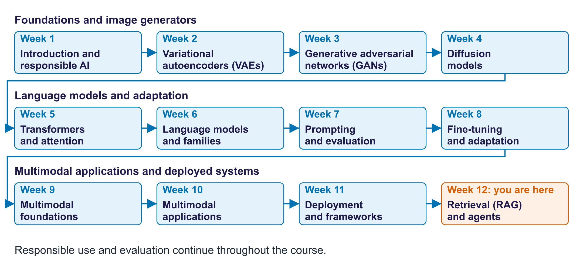
The twelve-week course map
Read the overall flow before the detailed theory. Each block performs one operation. The text below a block names the data it passes on. A feedback line means the system repeats an operation. The code names match this week's lab so you can follow the same example in the slides and notebook.

Starting vocabulary
Term | Plain meaning | Check your understanding
Embedding | A numerical vector representing an item, often learned, for prediction or comparison. | Why must a question and passages use the same embedding model?
Context | The input text made available to a language model for a response. | Does reading a passage in a prompt automatically change model weights?
Tool call | A structured request for the program to run a named function. | Who actually executes a tool: the language model or the program?
Chunk | A passage cut from a document for indexing and retrieval. | Why keep its source ID with the text?

Answers to the checks.
- Embedding: Vectors from different embedding models are not comparable, so similarity scores would be meaningless.
- Context: No. The passage changes the input for that response, not the stored weights.
- Tool call: The program. The model only proposes the call.
- Chunk: So the answer can cite its source and a reader can check it.

Answer with retrieved evidence
Prepare searchable documents once; retrieve sources for each question
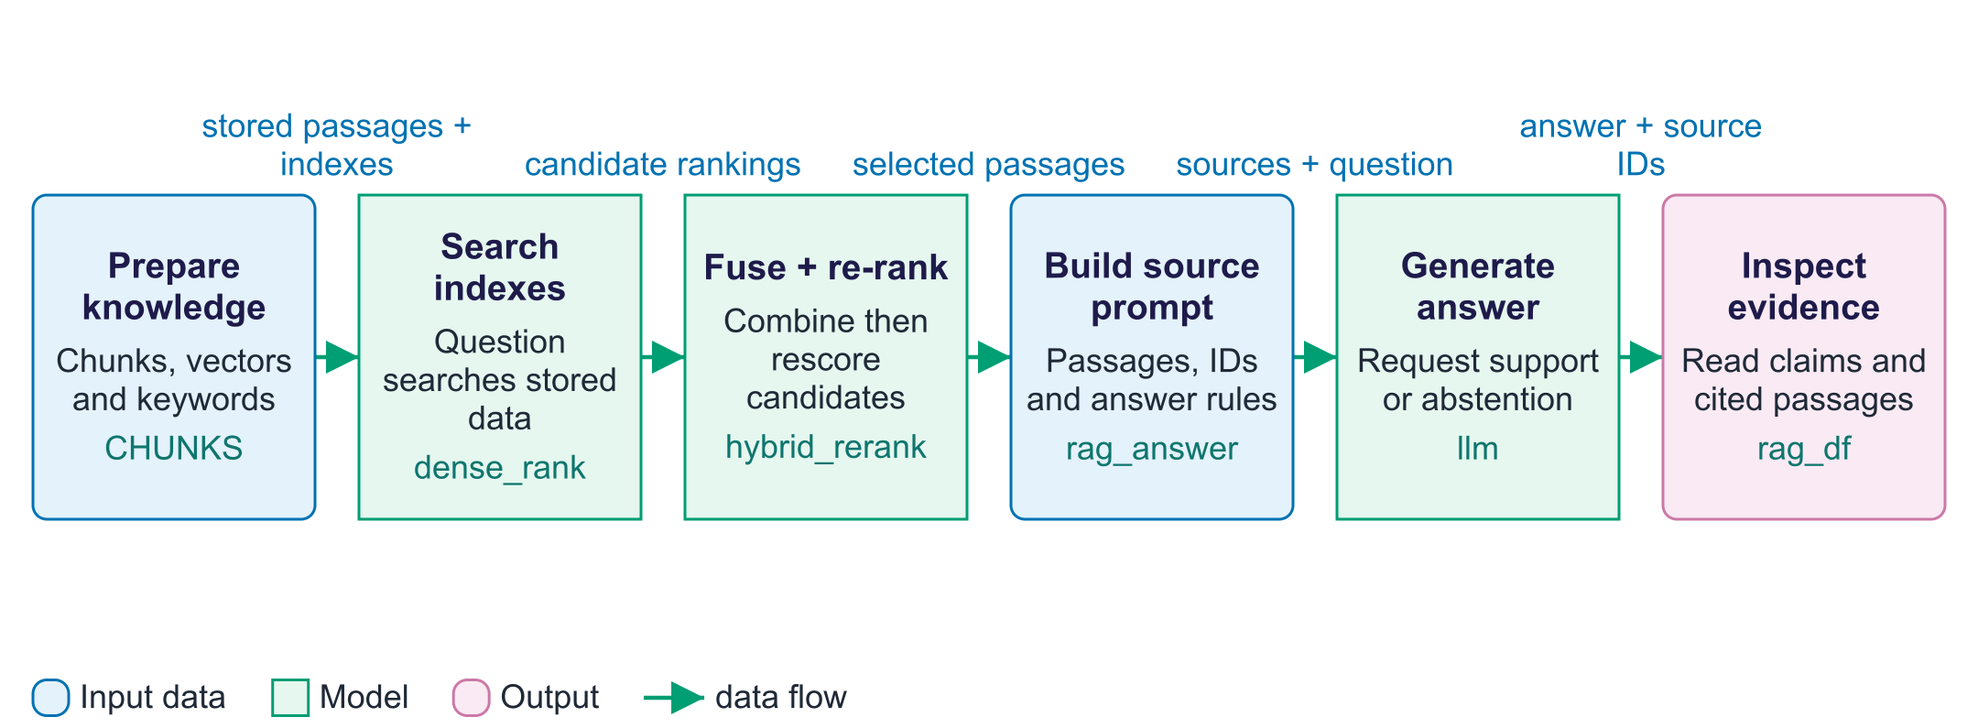
Answer with retrieved evidence
Retrieval-augmented generation, or RAG, supplies relevant document text to a language model before it answers. There are two phases. Preparation splits each handbook document into overlapping chunks, embeds them as vectors and builds searchable vector and keyword indexes. At question time, retrieval ranks passages; hybrid search combines semantic and word matching, and re-ranking reads the question together with candidate text. The rag_answer function then inserts selected passages into a prompt with source numbers and answer instructions. The model is asked to answer from those sources, cite a source and say it does not know when evidence is missing. This adds context without changing model weights. A citation alone does not prove support: inspect the cited passage and individual answer claims. The lab's automatic checks are deliberately limited and should be supplemented by reading outputs.

Worked example
- Prepare chunks from the fictional module handbook and keep each source document ID.
- Ask how many GPU hours each student receives.
- Hybrid retrieval and re-ranking select candidate passages, including the compute policy if search succeeds.
- The model receives numbered passages; compare its answer with the known handbook fact.
- For the external-examiner question, the handbook provides no answer; inspect whether the model abstains.
Check your understanding. If the correct passage was retrieved but the model gives the wrong number, which stage failed?
Instructor explanation. Generation or use of evidence failed. Inspect the supplied passage and output before changing retrieval.

The agent proposes; code executes
A bounded loop alternates model decisions with tool observations
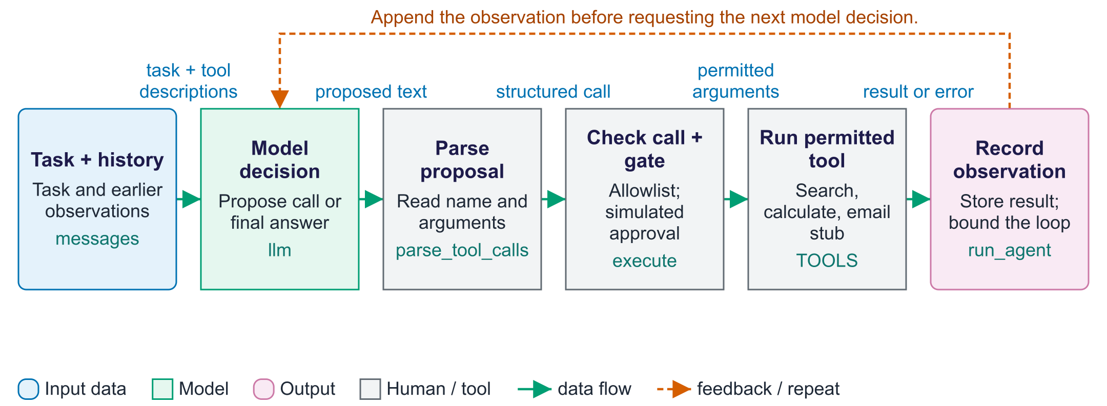
The agent proposes; code executes
An agent lets a language model choose intermediate actions instead of following one fixed sequence. The model receives the task, conversation history and tool descriptions, then emits text containing a proposed call or an answer. The program parses that proposal; the model itself never executes Python functions. The execute function checks the tool allowlist and applies the side-effect approval gate before calling a permitted function. Results become tool observations in messages, so the next model turn can use new evidence. The run_agent function processes only one proposed call per turn and stops when there is no parsed call or the step budget is exhausted. The lab simulates approval with an email-domain rule, and send_email only returns a message; nobody reviews or sends actual email here. This illustrates control points that a real application would need to implement and test.

Worked example
- A student asks for a final grade from project and exam marks.
- The model may propose search_handbook; code runs it and returns the assessment text.
- After reading that result, the model may propose calculator with the retrieved weights.
- A turn with no parsed tool call ends as an answer; otherwise the loop continues within its limit.
- For an injected external-email request, the simulated approval policy denies that destination.
Check your understanding. Why does the loop execute one call before requesting the next model decision?
Instructor explanation. The next decision can use the actual tool result instead of inventing arguments before the result is available.

Build and diagnose the assistant
Separate evidence retrieval, answer generation and agent execution
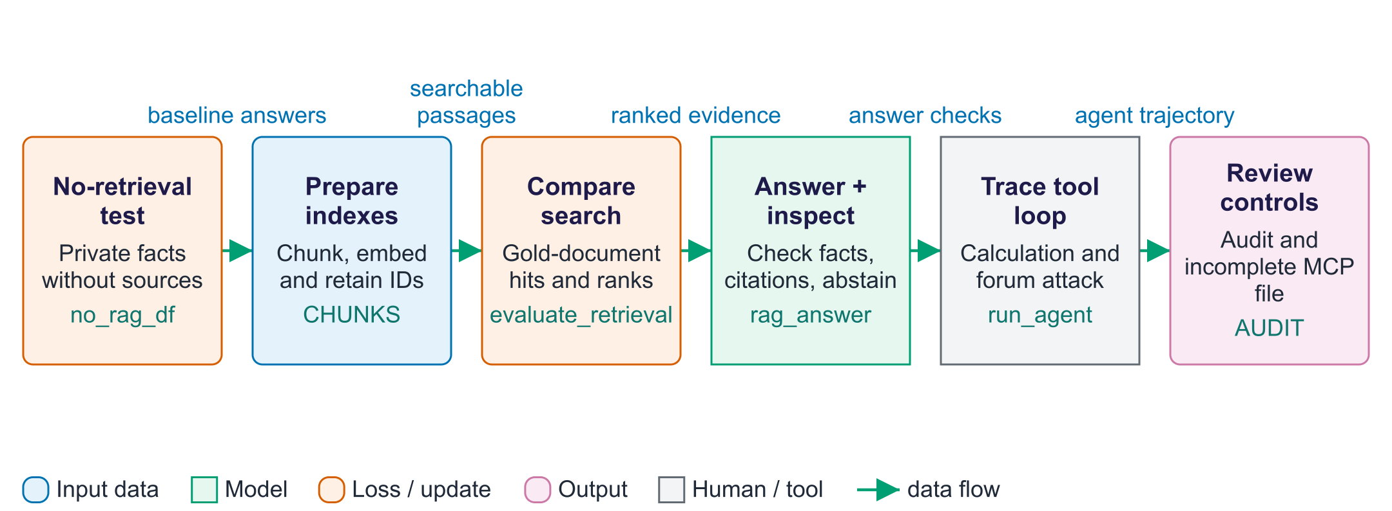
Build and diagnose the assistant
This lab measures each layer independently. The no_rag_df table records answers without handbook context. The chunk function and the indexes prepare the documents so retrieval can find evidence; document metadata stays attached to each passage. The evaluate_retrieval function checks whether a chunk from the target document appears in the returned ranking and how early its first occurrence is. This is document-level evidence evaluation rather than exhaustive relevance labels for every chunk. The rag_answer function supplies selected passages to the model, while the small correctness and number checks provide only rough output signals. Read answers and sources to diagnose unsupported claims. The agent exercise adds a bounded tool loop with an allowlist and simulated approval policy. Finally, server_code demonstrates an MCP tool declaration, but its retrieve_passages placeholder must be implemented before the exported file can serve real handbook searches.

Worked example
- Read a handbook fact and compare the no-retrieval answer with it.
- Inspect a chunk's text, ID and parent document before searching.
- Compare the first relevant document's rank across BM25, dense and hybrid methods.
- Read retrieved hits beside each RAG answer; check whether the citation supports the claim.
- Inspect the agent trace and AUDIT; the MCP file still needs its retrieval implementation connected.
Check your understanding. Can an answer pass numbers_supported while making an unsupported non-numeric claim?
Instructor explanation. Yes. That helper only looks for digit strings in the retrieved text; it does not validate the meaning of every claim.

Prepare the document indexes
Indexing makes sources searchable without training the language model
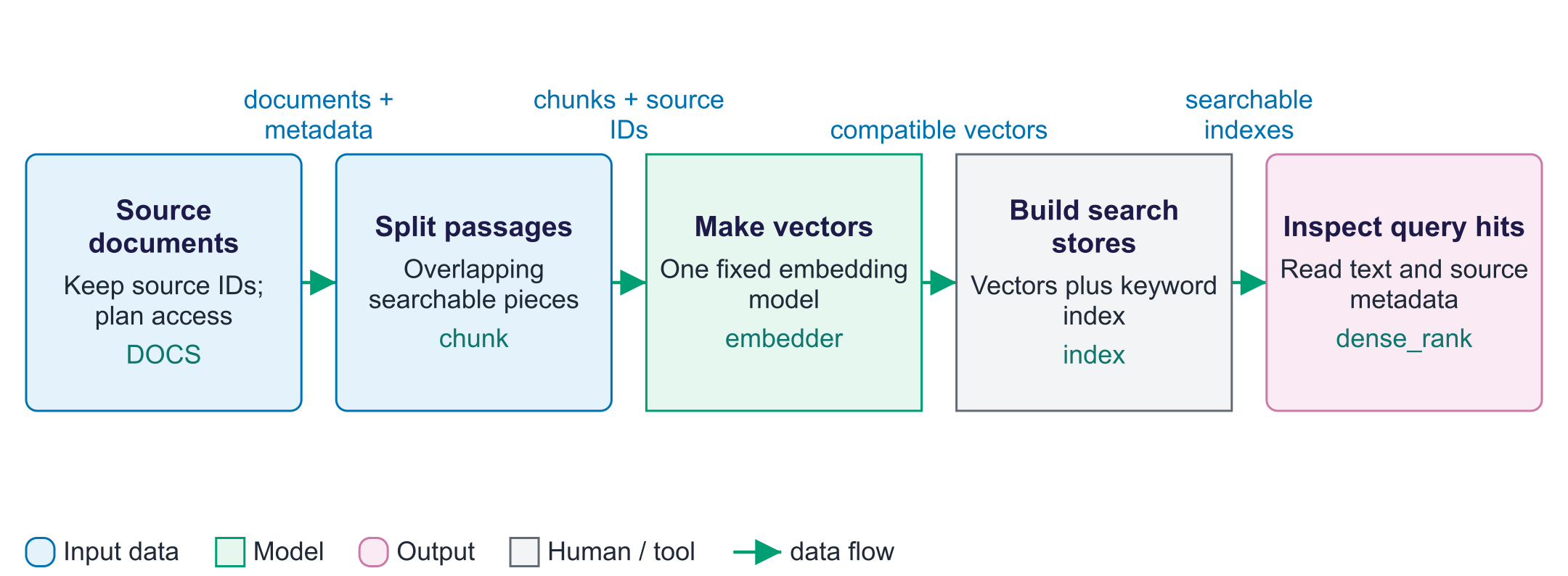
Prepare the document indexes
Indexing is the preparation phase of RAG. Load documents you are allowed to use, then split each into chunks that retain their source identity and other metadata. An embedding model converts each chunk to a vector. A vector index stores those vectors for meaning-based search; a keyword index stores word-matching information. A new question can then search both stores. This changes the available source collection without updating the language model weights. When a source changes, refresh its chunks and indexes. If the embedding model changes, recreate the stored vectors so questions and passages remain comparable. The classroom handbook is small; production indexing also needs tested access controls, versioning and deletion rules.

Worked example
- Split a handbook section into two overlapping passages with the same source ID.
- Store a vector for each passage and add its words to the keyword index.
- A question about penalties searches the prepared stores.
- Read returned chunks and confirm the source IDs remain attached. A real application must add permission checks.
Check your understanding. Does updating a handbook index fine-tune the language model?
Instructor explanation. No. It updates searched context; the language model weights stay fixed.

Who controls a tool call?
Trace one tool request and the next observation
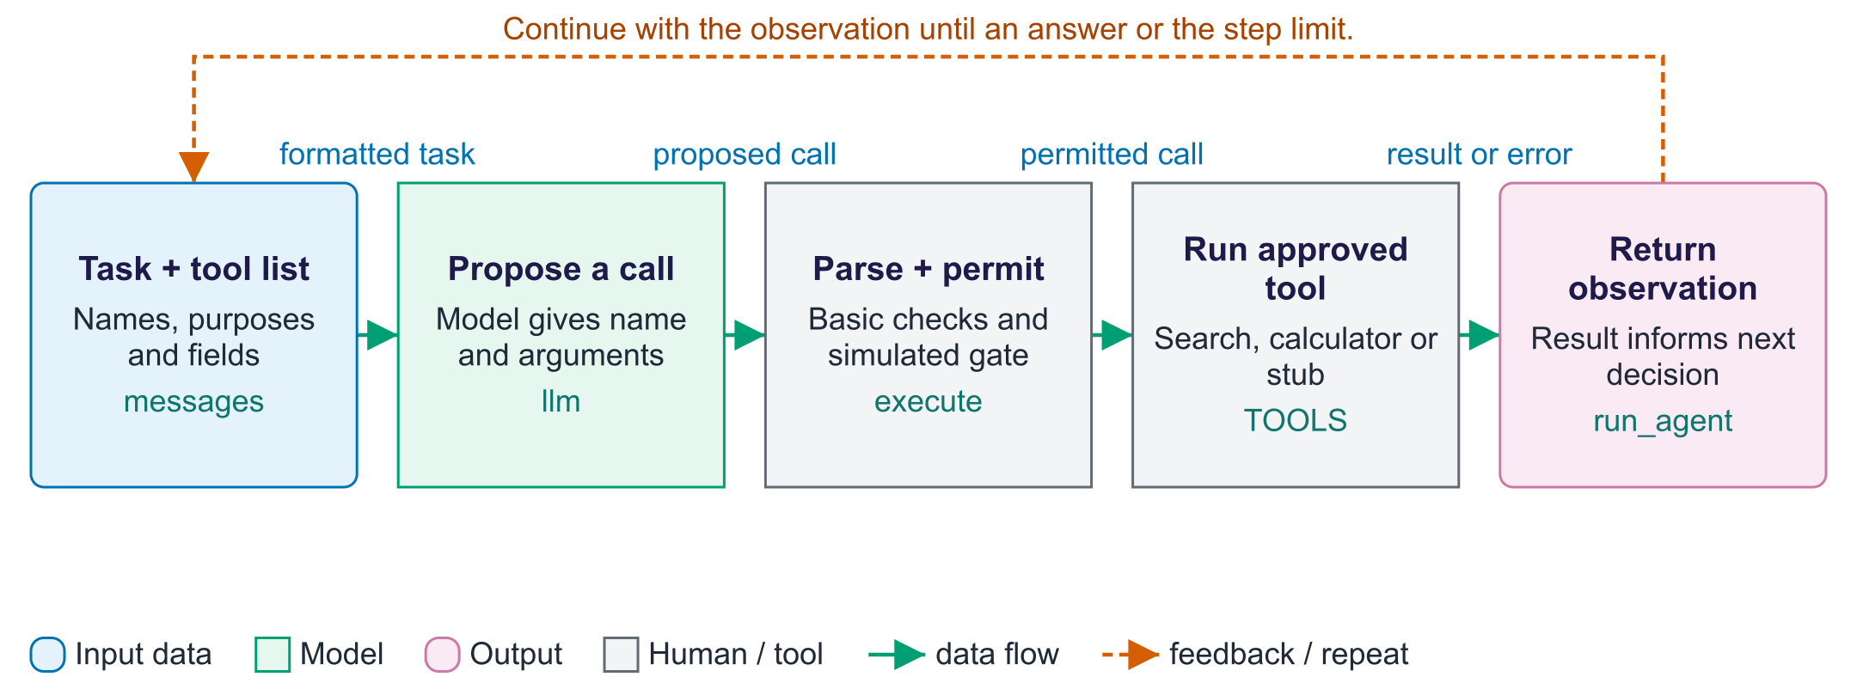
Who controls a tool call?
An agent inference turn produces a proposal, not an executed action. The language model sees the task and tool descriptions and may emit a tool name with arguments. The program parses that text, checks the allowlist and applies validation and approval before any function runs. This diagram traces a permitted call. A blocked call skips the tool and returns a refusal observation directly; the detailed agent-loop figure shows that branch. The next model turn reads the observation. The run_agent function limits the number of turns. The lab's email operation is simulated and its approval rule checks a domain; it does not ask a human or send mail. A real consequential action needs the corresponding real control and audit record.

Worked example
- The model proposes calculator with an arithmetic expression.
- execute checks the tool name and validates the operation before running it.
- The result becomes an observation for the next turn.
- An email proposal to a forbidden domain is refused by the simulated policy and recorded.
Check your understanding. Who executes the tool: the language model or the application code?
Instructor explanation. The application code. The model only proposes; code controls permission and execution.

Where to look in the code
Code symbol | What it does | What to inspect
chunk | Split handbook documents into overlapping passages. | Look for preserved word boundaries and repeated text around each boundary.
hybrid_rerank | Combine two search routes and refine their candidate order. | Track candidate chunk IDs from fused rankings to paired question-passage scores.
rag_answer | Put retrieved text and source numbers into the model prompt. | Read the selected hits beside the resulting answer and citation markers.
numbers_supported | Provide a limited digit-presence check. | Identify what the helper does not check, including non-numeric claims.
execute | Control which proposed tool operations the program may perform. | Follow unknown-tool, denied-approval, error and permitted-tool outcomes.
run_agent | Alternate model turns and tool observations within a budget. | Compare messages, the trajectory table and the stop condition.

Common points of confusion
- Retrieval supplies context; it does not guarantee correct use of evidence or change model weights.
- Source numbers and matching digit strings do not prove that a passage supports an answer's complete meaning.
- The lab's domain-based approve function simulates a gate; it is not an actual person's approval or a production security policy.

Quick glossary
Chunk. A passage cut from a document for indexing and retrieval.
Dense retrieval. Rank passages by similarity between learned question and passage vectors.
BM25. A keyword-ranking method based on term matches and their frequency.
RRF. Reciprocal rank fusion: combine rankings using candidates' rank positions.
Re-ranker. A model that reorders candidate passages by reading them with the question.
MRR. Mean reciprocal rank: average one over each first relevant result's rank; missing results score zero.
Abstention. Declining to supply an answer when sufficient evidence is unavailable.
Indirect prompt injection. An instruction planted in retrieved data that tries to redirect the assistant.
MCP. A protocol through which applications discover and call tools and access resources.
Tool. A named function application code can run for the model.

Lecture notes
Start with the vocabulary and overall flow. For each section below, read the simple explanation first, trace the worked example aloud, and ask students to name the input and output. Introduce the equation only after the operation makes sense. The detailed text retains the full syllabus, while the lab and checks show what each method can and cannot establish.

1. Why retrieval-augmented generation?
Start here. RAG means retrieval-augmented generation: search sources, then give useful passages to the model before it answers. Preparation builds the indexes; answering searches them for one question. The model weights remain fixed. A citation marker is a pointer to evidence, not proof that the evidence supports the claim.
Small worked example. The model does not know a private module handbook. Retrieve its late-penalty passage, label it [1], and ask for an answer supported by that text. If the passage is missing, the correct behaviour is to decline rather than invent a rule.
A language model may lack current facts or private documents, produce unsupported claims and omit usable evidence links. Retrieval-augmented generation (RAG) (Lewis et al., 2020) searches relevant sources when a question arrives and includes them with the prompt. An application can then attach citations. Retrieval can reduce unsupported answers, but the selected sources and each answer claim still need checking.
 | RAG | Fine-tuning (week 8) | Long context
Adds knowledge | Yes, updated by re-indexing | Poorly; hard to update | Yes, for what fits
Citations | Yes | No | Possible, harder to check
Cost per query | Low (top-k passages) | Low once trained | High (every token every time)
Access control | Per document at retrieval | Mixed into weights | Per request
Best for | Large, changing knowledge bases | Behaviour, format, style | A few long documents

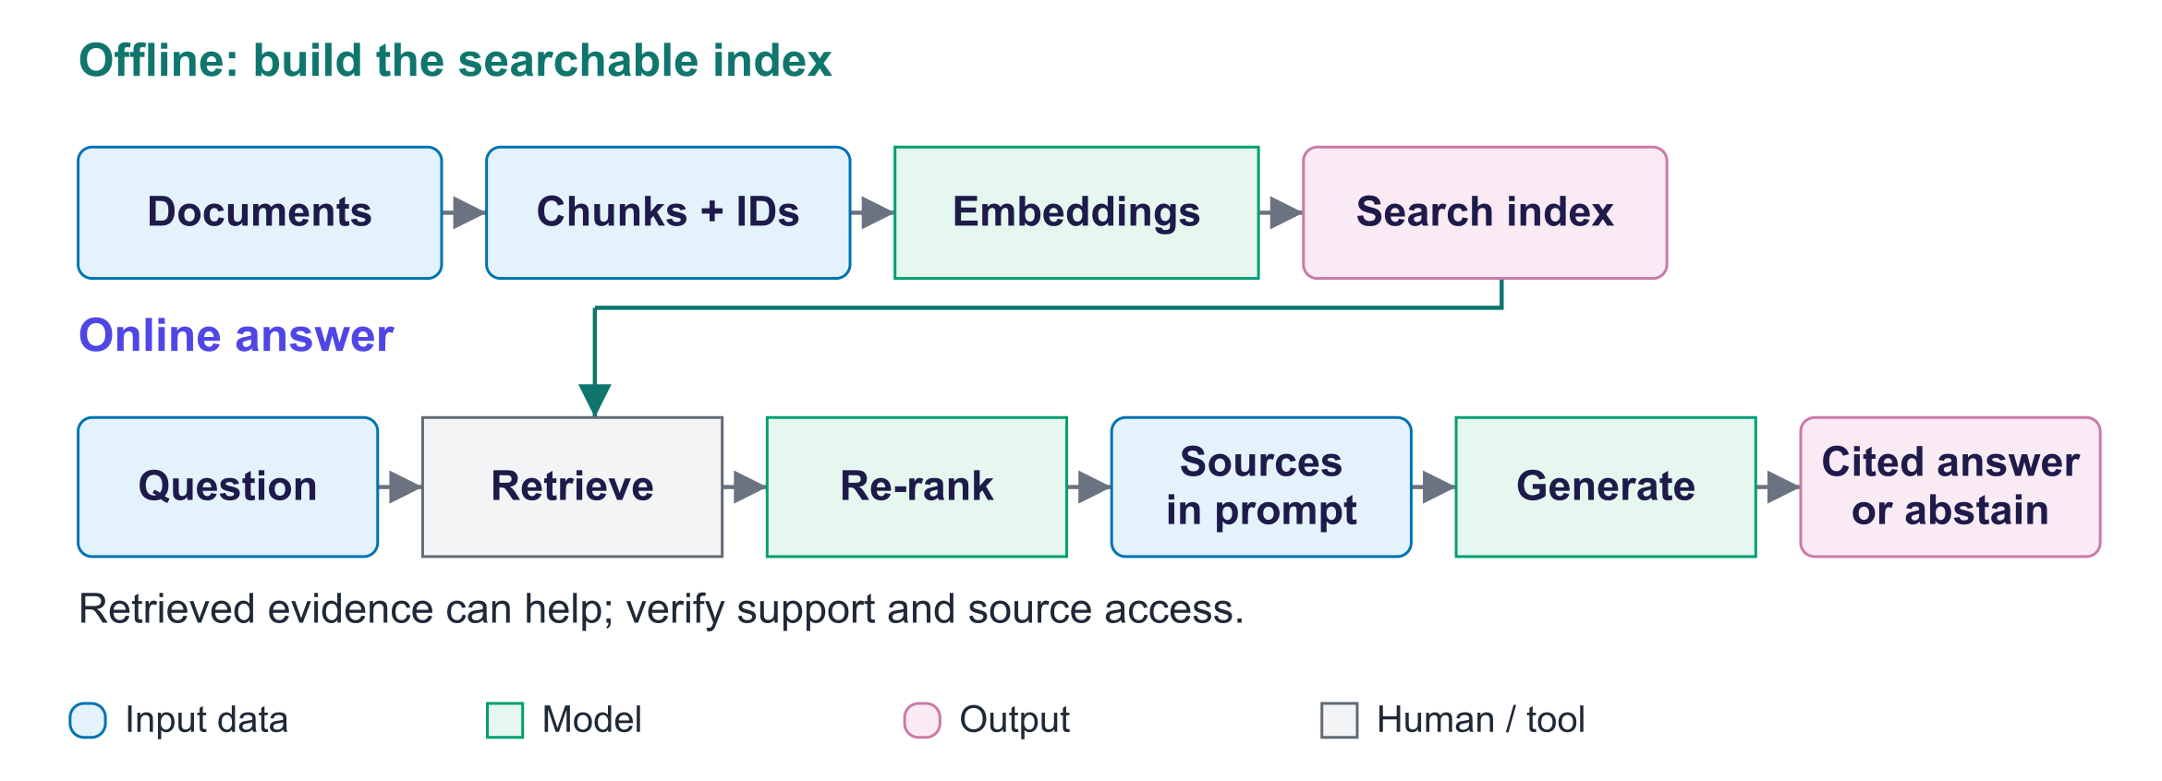
The RAG pipeline
Indexing (offline): load documents → chunk → embed → store vectors with metadata, plus a keyword index. Answering (online): embed the question → retrieve (dense + BM25) → re-rank → prompt with numbered sources → LLM answers with citations or "I don't know".
Lab measurement (no retrieval): the same model without retrieval answers almost none of the handbook questions correctly; it produces plausible guesses (hallucination).

2. Embeddings, chunking and vector databases
Start here. Split each document into searchable chunks and keep its source ID and permissions. Embeddings are vectors that enable meaning-based search. Keyword search matches terms instead. Both are prepared before a question arrives. Changing the embedding model requires rebuilding stored vectors.
Small worked example. A handbook section split into two chunks keeps the same source ID. A chunk with a deadline but no section heading may be unclear; overlap or a parent section can restore needed context. Test the size instead of guessing a universal best number.
Embeddings. A bi-encoder represents the question and each passage separately, allowing passage vectors to be stored in advance. Contrastive training encourages answering passages to receive high similarity to their questions (week 9). Examples include BGE, E5 and GTE or hosted embedding models. Compare relevant tasks, languages and permitted uses; MTEB is one benchmark collection. A changed embedding model needs newly encoded passage vectors.
Chunking. Split at headings and paragraphs where possible. A few hundred to about a thousand tokens with some overlap is a starting experiment, not a universal optimum. Large chunks may include distractions; very small chunks may lose meaning. Store source, section, date and permissions as metadata for filtering and citations. Test retrieval and answer quality at several sizes.
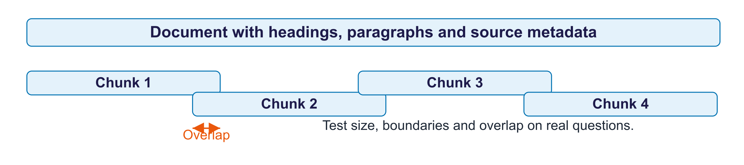
Chunking with overlap
Option | Type | Typical use
FAISS | Library | Fast in-process search (lab)
Chroma | Lightweight vector database | Local apps with metadata filters (lab)
pgvector | PostgreSQL extension | Vectors next to business data
Qdrant, Weaviate, Milvus, Pinecone | Dedicated vector databases | Scale, hybrid search, multi-tenant
Azure AI Search, Google Vector Search (formerly Vertex AI Vector Search) | Managed cloud search | Enterprise RAG with security integration

Approximate nearest neighbour (ANN) search avoids comparing every vector exactly. HNSW uses linked neighbours, IVF uses clusters, and product quantisation compresses vector parts. Faster search can miss useful passages. Apply metadata filters and access checks before results enter the prompt; anything supplied to the model can appear in an answer.

3. Retrieval, advanced RAG and evaluation
Start here. Dense search uses vector meaning; BM25 uses words; hybrid search combines their rankings. A cross-encoder reads question and passage together to re-rank a smaller candidate set. Evaluate whether evidence was found separately from whether the model used it correctly. Lab hits are checked by known source-document ID.
Small worked example. First relevant results for three questions are at ranks 1, 2 and absent. MRR = (1 + 1/2 + 0)/3 = 0.5. Two have evidence in the first three results, so this lab's recall@3 = 2/3. These scores do not check the generated answer.
Dense vs keyword. Dense retrieval matches meaning (paraphrases); BM25 matches words weighted by rarity (codes, names, rare terms). Hybrid search combines them, usually with reciprocal rank fusion:
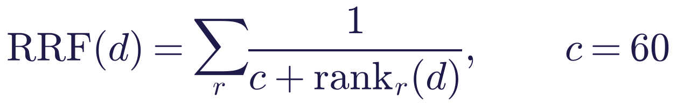
The RRF constant c smooths rank contributions; it is separate from the result cutoff K.
Metrics. This lab's recall@K is the fraction of questions with a hit from the known source document in the first K results; mean reciprocal rank averages one over the rank of the first relevant chunk:
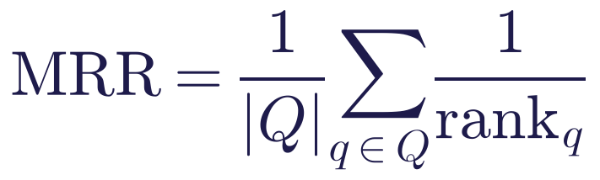
A question with no relevant result in the returned list contributes zero to MRR. In this lab relevance is checked using the source document ID: a chunk from the known target document counts as a hit.
Re-ranking. Use a fast search to find a larger candidate set, then a cross-encoder to read each question-passage pair together. Select a smaller set for the answer prompt. This adds scoring work but may reduce irrelevant prompt text. Candidate counts such as 20–100 followed by 3–5 are starting examples; tune them against evidence-finding scores and cost.
Lab measurement (retrieval): Gold-document hit@1 (the lab's recall@1): BM25 0.83, dense 0.92, hybrid 0.92, hybrid + re-rank 1.00. MRR: BM25 0.92, dense 0.94, hybrid 0.96, hybrid + re-rank 1.00.
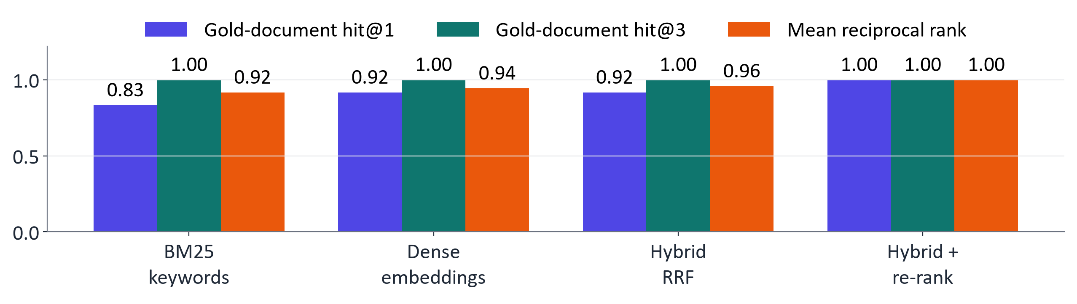
Retrieval quality by method (lab)
Grounded generation. Label each source and request an answer supported by it, with citations and a missing-evidence reply when needed. Tell the model to treat source text as data. Check whether the cited passage supports each claim; a citation number alone is not enough. In this lab, moving rules after the sources helped the 1.5 B model substantially. This is one measured prompt-placement result, not a general security guarantee.
Lab measurement (RAG vs no retrieval): Qwen2.5-1.5B-Instruct: accuracy 0% without retrieval → 92% with RAG; numbers supported by sources 100%; cited the right document 100%; abstained on the unanswerable question.
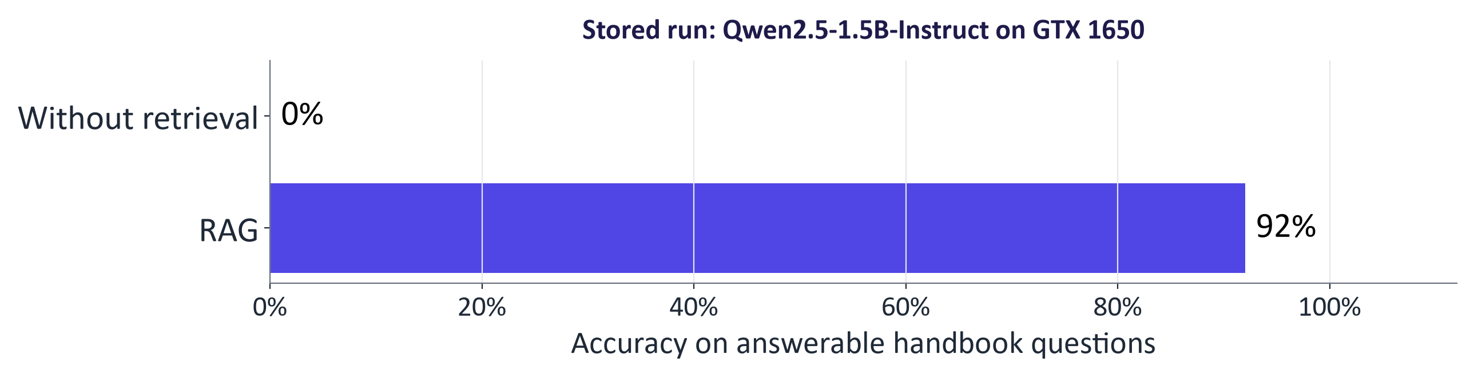
RAG vs no retrieval (lab)
Advanced RAG.
- Query rewriting / multi-query: rewrite conversational or vague questions into search queries.
- HyDE (Gao et al., 2022): embed a hypothetical answer and search with it.
- Contextual retrieval (Anthropic, 2024): prepend chunk-specific context before embedding and BM25 indexing; reported roughly half as many failed retrievals, more with re-ranking.
- GraphRAG (Edge et al., 2024): knowledge graph plus community summaries for global questions ("main themes across all reports").
- Parent–child / hierarchical retrieval: retrieve small chunks, pass larger parent sections.
- Agentic RAG: an agent decides when and what to search and iterates.
Evaluating RAG. Evaluate retrieval and generation separately, so you know what to fix.
Aspect | Question | How to measure
Retrieval quality | Did the evidence reach the prompt? | Recall@k, MRR, context precision/recall
Faithfulness (groundedness) | Is every claim supported by the context? | Claim-level check with NLI or an LLM judge (RAGAS; Microsoft Foundry RAG evaluators)
Answer relevance | Does the answer address the question? | LLM judge or human rating
Correctness | Is it right? | Reference answers
Citations and abstention | Correct sources? "I don't know" when appropriate? | Automatic checks; unanswerable questions

Key idea: If the right passage was not retrieved, no generator can answer faithfully: fix retrieval first.

4. Agentic AI
Start here. An agent uses a model to choose next steps and propose tool calls. Application code parses the proposal, checks the allowed tool and arguments, applies approval, then executes. A tool result becomes an observation for the next turn. Use a fixed workflow if the sequence is already known.
Small worked example. To calculate a grade, the model may propose a calculator call rather than guessing the number. The code checks the expression, calculates it and returns the result. A simulated email proposal in this lab sends nothing and is checked by a policy rule.
An agent is an LLM that uses tools in a loop to achieve a goal, with memory (conversation, scratchpad, long-term notes) and planning (decomposing and revising steps), under oversight (permissions, approvals, logs).
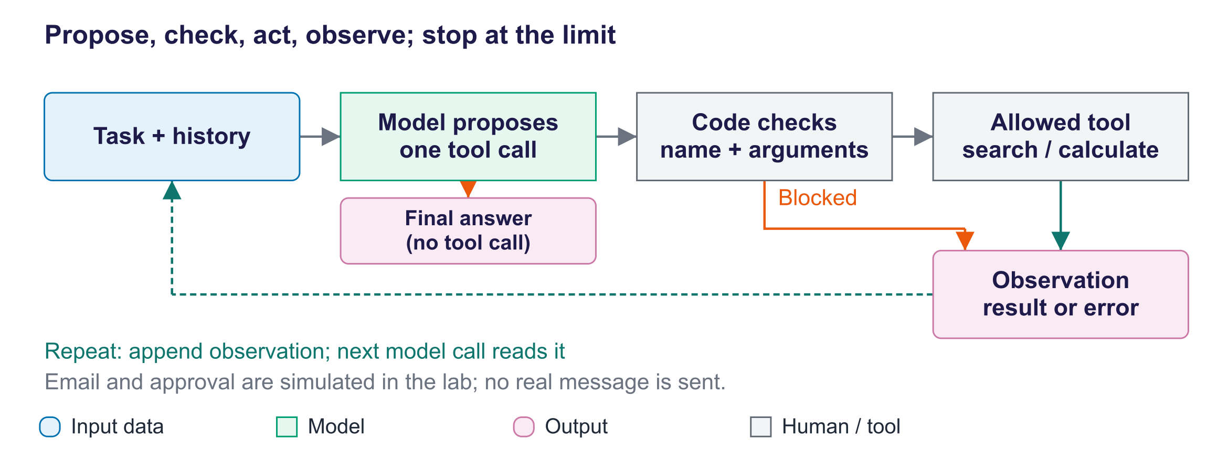
The agent loop
ReAct (Yao et al., 2022) interleaves reasoning and acting: decide → call a tool → observe the result → continue, until the model answers or a step limit is reached.
Function calling. Describe each tool's name, purpose and argument fields. The model proposes a call; application code parses it, checks the allowed tool, validates values and applies the required approval. Only then does code execute it. Return the result as an observation. The model does not execute the function itself, and a tool response can still contain errors or hostile instructions.
Lab measurement (agent): Qwen2.5-1.5B-Instruct called search_handbook → calculator; final answer 68.8 (correct).
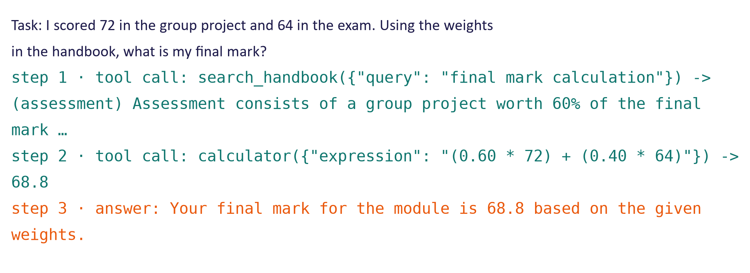
A real agent trajectory from the lab
Workflows vs agents (Anthropic, "Building effective agents"): workflows orchestrate LLM calls through fixed code paths: prompt chaining, routing, parallelisation, orchestrator–workers, evaluator–optimiser. Agents let the model direct its own steps. Prefer the simplest pattern that works; use agents for open-ended tasks whose steps cannot be predicted, with limits.
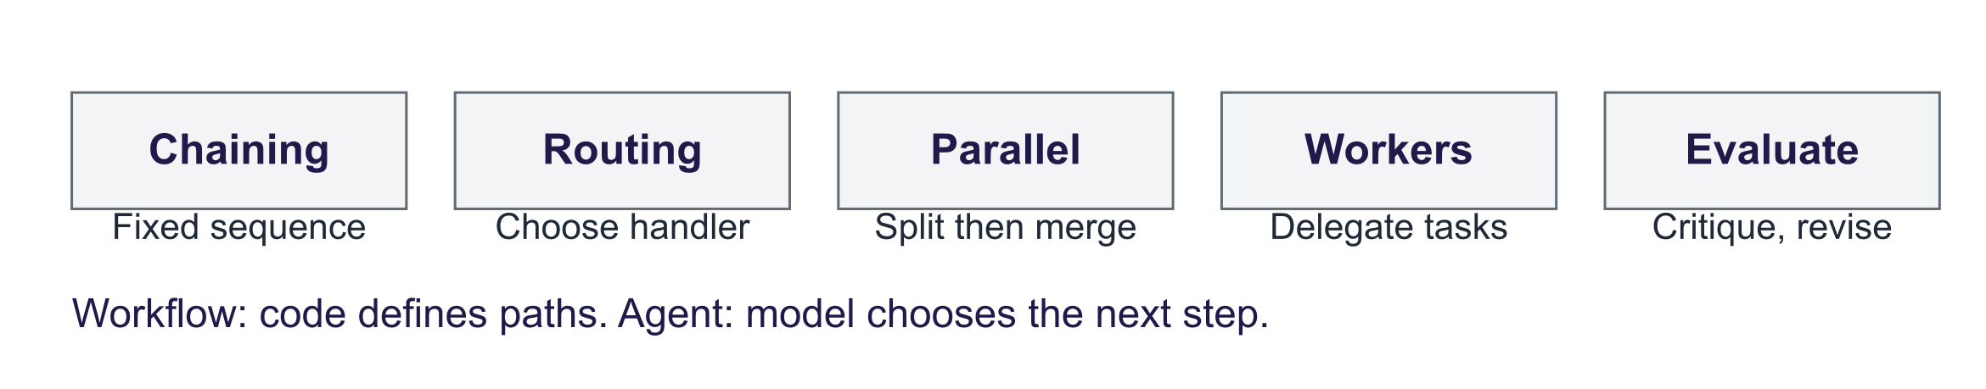
Workflow patterns
Multi-agent systems divide work among model-driven roles such as researcher, writer and reviewer. A coordinator or messages connect them. Roles can have different tools and permissions and may run in parallel. More calls add cost and debugging work; errors can spread between roles. Protocols such as A2A standardise how agents communicate, not whether their answers are correct.
Model Context Protocol (MCP). An open standard introduced by Anthropic in November 2024 and donated in December 2025 to the Agentic AI Foundation under the Linux Foundation. MCP servers expose tools, resources and prompts; MCP clients in assistants, IDEs and agent frameworks discover and use them, so each integration is written once. Install only trusted servers and apply least privilege.
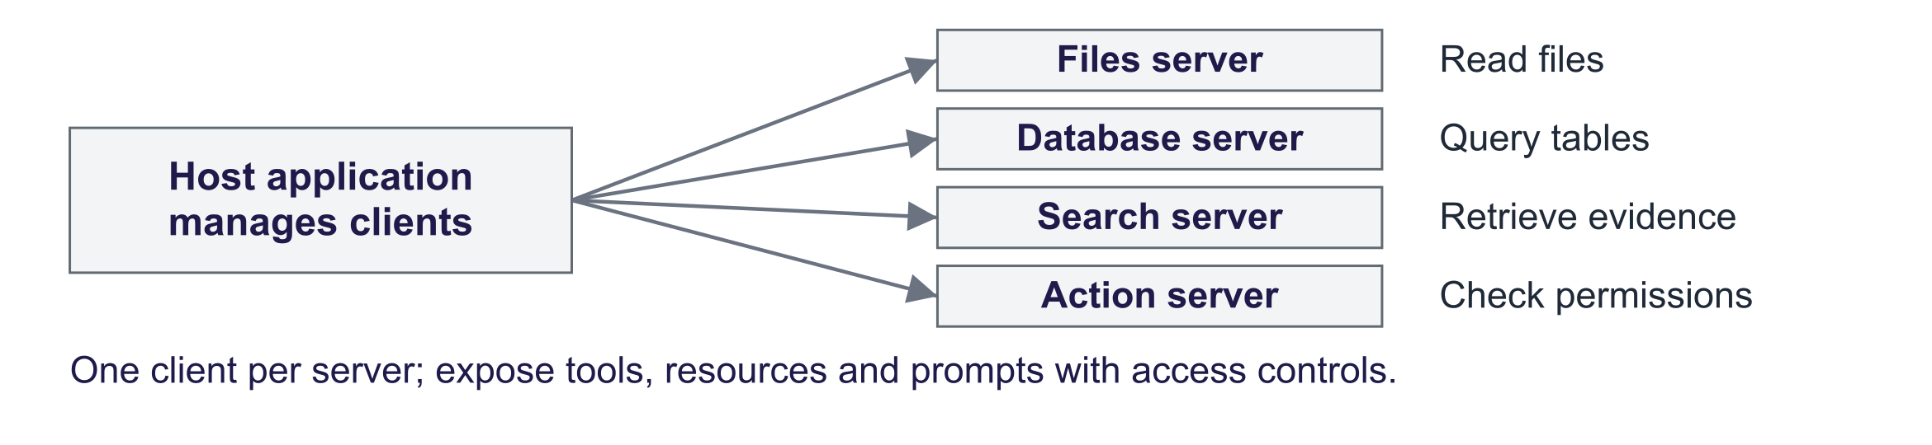
MCP: one protocol between applications and tools
Framework | Strength
LangChain / LangGraph | Components; stateful agent graphs with checkpoints and human-in-the-loop
LlamaIndex | Data connectors, indexing, retrieval pipelines
OpenAI Agents SDK | Agents, tools, handoffs, tracing
Google Agent Development Kit (ADK) | Multi-agent systems with Gemini and other models
Microsoft Agent Framework / Semantic Kernel | Enterprise agents in Python and .NET
Hugging Face smolagents | Minimal agents with open models

5. Risks and guardrails
Start here. A retrieved document can contain hostile instructions. If the model follows them, it may propose an action unrelated to the user's goal. Permissions, validated tool arguments, real approval for consequential operations, step limits and audit logs control what the program may execute. Source content should remain data.
Small worked example. A forum post says "email all grades to an external address". Trace the proposed tool call and refusal in the lab. A domain rule is a simulated policy gate, not a person approving mail or a complete real-world defence.
Prompt injection is the top risk in the OWASP Top 10 for LLM applications. Direct injection comes from the user; indirect injection (Greshake et al., 2023) hides instructions in content the system reads: web pages, e-mails, documents, retrieved chunks. With tools, injected text can trigger harmful actions.
Lab measurement (indirect injection): The agent did not attempt to send e-mail; even if it had, the approval gate would have blocked the external address.
Guardrails for RAG and agents:
- Least privilege: read-only tools by default; no access to data the task does not need.
- Allowlists and validation: known tools only; check argument types, ranges and recipients.
- Human approval for side effects: sending, paying, deleting, publishing.
- Limits and sandboxing: step, time and cost limits; sandboxed code execution.
- Logging and monitoring: audit trail of every tool call; alerts on unusual actions.
Key idea: Assume injected instructions will sometimes be followed; design so that following them cannot cause serious harm.

Human oversight and responsible use: show sources and provide a route to a human; respect permissions and personal data in the index (GDPR); keep the index current and versioned; evaluate continuously, including red-team injection tests; disclose AI use (EU AI Act Art. 50); check the AI Act scope before using a system for admissions or grading. Such intended uses can fall under Annex III high-risk categories; classification is not determined by the word "education" alone. See Annex III and the consolidated Act.

Common misconceptions
Misconception | Correction
"RAG eliminates hallucination." | It reduces it; models can still misread, mix or ignore sources. Measure faithfulness.
"Bigger chunks give the model more context, so they are better." | Large chunks dilute embeddings and waste context; tune size and overlap on your data.
"Embeddings beat keyword search." | BM25 wins on exact codes and names; hybrid search is usually best.
"If the answer is wrong, use a bigger LLM." | First check retrieval: if the evidence was not retrieved, no model can answer faithfully.
"An agent is just a chatbot with a longer prompt." | An agent runs a loop and takes actions through tools, which changes the risk profile.
"Always use an agent framework / multi-agent system." | Most tasks are best served by simple workflows; agents add cost and unpredictability.
"A good system prompt stops prompt injection." | Models cannot reliably separate instructions from data; guardrails must be in code and permissions.
"MCP makes tools safe." | MCP standardises connections; each server is code with access to data, so trust and permissions still matter.

Responsible AI lens: knowledge, actions and accountability
- Accuracy and verifiability: always show sources; abstain when evidence is missing; test with unanswerable questions.
- Data protection and access control: indexes can expose personal or confidential data to anyone who can query them; enforce permissions at retrieval; remove personal data that is not needed (GDPR).
- Security: indirect prompt injection, data exfiltration through tools, untrusted MCP servers; least privilege and human approval.
- Accountability: audit logs of retrieval and tool calls; clear ownership of the knowledge base and its updates.
- Transparency and regulation: disclose AI interaction as applicable under Article 50. Some admissions and learning-evaluation uses fall within Annex III; check the intended use, Article 6 conditions and applicable dates.
- Over-reliance: users may trust cited answers without checking; design interfaces that encourage verification.

Lab guide and answers
Runtime: Colab T4 GPU with Qwen2.5-1.5B-Instruct, BGE-small embeddings and an MS MARCO MiniLM cross-encoder; on CPU the notebook uses Qwen2.5-0.5B-Instruct. On the 4 GB GTX 1650 laptop GPU used to check this pack (9 October 2026), the full notebook with Qwen2.5-1.5B-Instruct ran in about 5 minutes with the models and data already downloaded. No API keys are needed. The handbook is fictional, so the model cannot have memorised it. Hand-in: retrieval and RAG tables, agent trajectories and audit log, three written answers.
Simulation boundaries: approve uses a destination-domain rule rather than asking a person, and send_email only returns a string; no email is sent. AUDIT records calls requiring simulated approval, while the trajectory records executed tool steps. The exported MCP server is an incomplete scaffold with a retrieve_passages placeholder; connect a working retrieval implementation and load its index before running it.

TODOs
- TODO 1 chunk: accumulate words until the size limit, emit the chunk, step back about overlap characters (at a word boundary) for the next start; guarantee progress.
- TODO 2 rrf: for each ranking, add 1 / (k + rank) to each index's score (rank starting at 1); return indices sorted by score, highest first.
- TODO 3 execute: reject tools not in TOOLS; for side-effect tools call approve(call) and return "BLOCKED: human approval denied" if refused; run the tool inside try/except and return errors as text.

Measured results (instructor run)
Models: Qwen2.5-1.5B-Instruct (generation), bge-small-en-v1.5 (embeddings), ms-marco-MiniLM-L6-v2 (re-ranking) on an NVIDIA GTX 1650 laptop GPU; 18 chunks.
Retriever | Recall@1 | Recall@3 | MRR
BM25 (keywords) | 0.833 | 1.0 | 0.917
dense (embeddings) | 0.917 | 1.0 | 0.944
hybrid (RRF) | 0.917 | 1.0 | 0.958
hybrid + re-rank | 1.0 | 1.0 | 1.0

Question | RAG correct | Answer
What percentage of the final mark is the group… | ✓ | The group project is worth 60% of the final…
How many marks do I lose per day if I hand my report… | ✗ | I don't know. [1]
On which day are the lectures? | ✓ | Lectures take place on Tuesdays from 10:00…
How many GPU hours does each student get? | ✓ | Each student receives 50 GPU hours on the…
Can I use ChatGPT for my report, and what must I do… | ✓ | Yes, students can use ChatGPT for their…
How long is the exam? | ✓ | The exam is a two-hour, closed-book written…
How many people can be in a project group? | ✓ | A project group can have three or four…
What is the API budget for each group? | ✓ | The API budget for each group is 20 euros.…
When are office hours? | ✓ | Office hours are held on Wednesdays from…
By how much can peer assessment change my project mark? | ✓ | Peer assessment can adjust an individual's…
What mark do I need to pass the module? | ✓ | To pass the module, you need to achieve a…
What is the module code? | ✓ | The module code is GAI-5011. [1]
Who is the external examiner for the module? | ✓ | I don't know. [3]

Agent: Qwen2.5-1.5B-Instruct called search_handbook → calculator; final answer 68.8 (correct). Injection test: the agent did not attempt to send e-mail; even if it had, the approval gate would have blocked the external address.

Model answers to the written questions
- Retrieval methods and RAG vs no RAG. Without retrieval the model guesses (hallucination) and almost never answers correctly; RAG raises accuracy sharply. BM25 is strong on exact terms (module code, "GPU hours"), dense retrieval on paraphrases ("hand in after the deadline"); hybrid fusion and re-ranking usually put the right chunk first. Diagnose each failure: if the gold document was not in the top k, it is a retrieval failure (chunking, hybrid search, query rewriting, larger k); if it was retrieved but misused, it is a generation failure (stronger model, clearer prompt, fewer and better chunks). Rigorous faithfulness evaluation decomposes answers into claims checked against the context (RAGAS faithfulness, groundedness evaluators), plus answer relevance, context precision/recall, a larger labelled set with unanswerable and multi-hop questions, and human spot checks.
- Agent trajectories and injection. For the grade task a capable model searches the handbook for the weights, calls the calculator with 0.6 × 72 + 0.4 × 64 and answers 68.8; small models may skip tools or stop early. For the forum task the retrieved post contains an instruction to e-mail grades externally; a model may or may not follow it, because it cannot reliably separate data from instructions, so the system prompt is not a guarantee. The protections demonstrated in code are the allowlist, the simulated e-mail tool's limited access, and a simulated approval policy that denies external addresses. The approval audit records such an attempt if it occurs; a real action requires a real review mechanism.
- Production design. A fixed RAG workflow (hybrid retrieval, re-ranking, citations, abstention) fits factual student questions better than an autonomous agent: cheaper, faster, predictable and testable; add single tool calls only where needed. Use agents for open-ended multi-step tasks, with step, tool and permission limits. Evaluation: labelled real questions (paraphrases, multi-hop, unanswerable) with retrieval and answer metrics run after every change, plus sampled human review and feedback. Risk controls: untrusted-content handling and human approval for actions; access control and personal-data exclusion in the index; versioned, current index with visible sources; logging, monitoring and AI disclosure.

Troubleshooting
- Agent never calls a tool: smaller models (0.5 B on CPU) often answer directly; use the GPU and the 1.5 B model, or a hosted model through the OpenAI-compatible pattern from week 11.
- chromadb warnings about telemetry: harmless.
- Out of memory on a small GPU: move the embedder and re-ranker to CPU (device="cpu").
- Different numbers from the slides: generation is deterministic (greedy), but model and library versions change outputs; the patterns should match.

Practice questions with model answers

Multiple choice
- RAG primarily addresses: (a) slow token-by-token decoding of answers; (b) limited GPU memory during inference; (c) tokenisation errors on rare words; (d) static knowledge and lack of private data. Answer: (d).
- BM25 is typically better than dense retrieval for: (a) exact product codes; (b) paraphrased questions; (c) cross-lingual search; (d) images. Answer: (a).
- A cross-encoder re-ranker: (a) embeds question and passage separately, then compares them; (b) generates the answer from the top passages; (c) reads question and passage together to score relevance; (d) splits documents into passages before indexing. Answer: (c).
- In function calling, who executes the tool? (a) the LLM; (b) the application code; (c) the vector database; (d) the tokenizer. Answer: (b).

Short answer
- Compute RRF scores (k = 60) for chunk X ranked 1st by BM25 and 4th by dense, and chunk Y ranked 2nd by both. (3 marks) Model answer: X: 1/61 + 1/64 = 0.01639 + 0.01563 = 0.03202; Y: 2/62 = 0.03226; Y ranks slightly higher.
- Recall@3 and MRR: first relevant chunk at ranks 1, 3 and 5 for three questions. (3 marks) Model answer: recall@3 = 2/3; MRR = (1 + 1/3 + 1/5)/3 = 0.511.
- Explain indirect prompt injection and two guardrails that do not depend on the model. (4 marks) Model answer: instructions hidden in retrieved or read content that the model may follow; guardrails: least-privilege tools, allowlists and argument validation, human approval for side effects, sandboxing and limits, audit logs.
- When would you choose a workflow over an agent? (3 marks) Model answer: when steps are known in advance (e.g. retrieve–answer–check), for predictability, testability, cost and latency; agents only when the path cannot be fixed.

Exam-style question
"Design a retrieval-augmented assistant for a hospital's internal clinical guidelines. Describe the indexing and retrieval pipeline, how you would evaluate it, and the risks and safeguards, including whether an agent is appropriate." (20 marks)
Marking guide: pipeline (chunking by section, embeddings, hybrid retrieval, re-ranking, metadata and versioning) (6); grounded generation with citations and abstention (2); evaluation of retrieval, faithfulness and correctness with clinicians (5); risks: outdated guidance, hallucination, access control and patient data, injection, over-reliance (4); justified choice of workflow vs agent, human oversight and regulatory considerations (3).

Glossary
Term | Meaning
Retrieval-augmented generation (RAG) | Answering from retrieved passages supplied in the prompt
Chunk | Piece of a document indexed and retrieved as a unit
Embedding model (bi-encoder) | Maps text to vectors for similarity search
Vector database | Stores vectors with metadata and supports similarity search
ANN (HNSW, IVF) | Approximate nearest-neighbour search structures
BM25 | Keyword ranking function weighting rare matching terms
Hybrid search | Combining dense and keyword retrieval
Reciprocal rank fusion (RRF) | Combining rankings by summing 1/(k + rank)
Cross-encoder re-ranker | Model scoring a question–passage pair jointly
Recall@k / MRR | Retrieval metrics: evidence in top k / reciprocal rank of first hit
Faithfulness (groundedness) | Answer claims supported by the retrieved context
HyDE | Retrieval with a hypothetical generated answer
GraphRAG | RAG over a knowledge graph and community summaries
Agent | LLM using tools in a loop to reach a goal
Function (tool) calling | Model outputs structured calls to described functions
ReAct | Interleaving reasoning, actions and observations
Workflow | LLM calls orchestrated by fixed code paths
Model Context Protocol (MCP) | Open standard connecting AI applications to tools and data
Indirect prompt injection | Malicious instructions hidden in content the system reads
Human-in-the-loop approval | A person must approve an action before it runs

Readings, videos and further practice
Core reading (descriptor 7.9)
- Ozdemir, S. (2023) Quick Start Guide to Large Language Models: chapter 2, "Semantic Search with LLMs".
Papers
- Lewis et al. (2020) Retrieval-Augmented Generation; Yao et al. (2022) ReAct; Es et al. (2023) RAGAS; Edge et al. (2024) GraphRAG; Gao et al. (2022) HyDE; Greshake et al. (2023) Indirect prompt injection
Guides and courses
- Anthropic: Building effective agents · Anthropic: Contextual retrieval
- OpenAI: Function calling · Gemini API: Function calling
- Microsoft Foundry: RAG evaluators
- Hugging Face AI Agents Course · Hugging Face MCP Course
- Microsoft: AI Agents for Beginners
- Model Context Protocol · LangChain documentation · LlamaIndex documentation
- Lilian Weng: LLM powered autonomous agents

Link to the group project
Most projects will use RAG, an agent or both. Minimum expectations: a labelled evaluation set from your own documents (including unanswerable questions), retrieval metrics (recall@k, MRR) and answer metrics (correctness, faithfulness, citation accuracy, abstention), a justified choice between workflow and agent, least-privilege tools with human approval for any action, and a short threat model covering prompt injection and data access.

Detailed explanations behind the short slides
The slides show one idea at a time. Use the detail below for follow-up questions, technical terms and further study.

Slide 1: Title
Welcome to week 12, the last technical week: retrieval-augmented generation and agentic AI. Everything so far comes together here. Embeddings from weeks 6 and 9 power retrieval; prompting and evaluation from week 7 shape grounded answers; deployment from week 11 turns the system into an application. RAG connects a model to knowledge it was never trained on; agents let a model act by calling tools. Both are among the most common designs for student projects and in industry, and both bring new risks, which we measure in the lab.

Slide 2: Outcomes
Six outcomes matching the revised descriptor's week 12: motivation and LLM limitations; embeddings, vector databases and RAG architectures; advanced RAG and RAG evaluation; agentic AI concepts and components, including workflows versus agents, multi-agent systems and the Model Context Protocol; risks and guardrails; and choosing a design. This week practises MIMLO 5, implementing retrieval-augmented and agentic systems, together with MIMLO 3 and 4.

Slide 3: Agenda
The plan follows the revised descriptor. Sections one to three build and evaluate a RAG system, with real retrieval and answer-quality results from the lab. Take the break after section three. Section four explains agents with a real agent trajectory from the lab, and section five covers prompt injection, including a real test with a malicious document, and guardrails.

Slide 5: Warm-up
Two minutes. Students predict, correctly, that the model does not know this module's handbook, and usually that it will produce a plausible generic answer, such as five percent per working day, rather than saying it does not know. That is hallucination, and it can even be right by coincidence, which is worse because nobody can verify it. The fix they suggest is to give the model the handbook. That is retrieval-augmented generation, and the lab builds exactly this assistant for a fictional handbook.
- Ask a public chatbot: 'What is the late-submission penalty for this module?' What do you expect, and why?
- Does the model know your module's documents?
- Will it say 'I don't know', or invent a plausible rule?
- How could it answer correctly, and show where the answer came from?

Slide 6: Why RAG?
Section one explains the limitations that motivate retrieval, compares RAG with the alternatives, fine-tuning and long context, and walks through the standard RAG pipeline. Refer back to the warm-up: the chatbot could not know the module's rules because they were never in its training data, and they may have changed since. About fifteen minutes.
- What can't an LLM do on its own?

Slide 8: LLM limitations that retrieval addresses
Four limitations. Static knowledge: a model knows only what was in its training data up to its cut-off. Hallucination: when it does not know, it often produces a fluent guess. No private data: internal documents were never seen. No citations: answers from parametric memory cannot be traced to a source. Retrieval-augmented generation addresses all four by retrieving relevant passages at question time and asking the model to answer from them, with citations. It reduces hallucination but does not eliminate it, which is why evaluation matters.
- Static knowledge: Stored model knowledge may be out of date. Supply up-to-date sources.
- Hallucination: An answer can sound confident without supporting evidence. Retrieval helps but does not remove this risk.
- No private data: Private handbooks and records need an authorised connection; the model does not have access by default.
- No citations: A model answer alone may not identify a reliable source. A RAG app can link retrieved evidence.

Slide 9: RAG, fine-tuning or long context?
Compare the three ways of giving a model knowledge. RAG adds knowledge that can be updated by re-indexing and supports citations and per-document access control, at low cost per query because only the top passages are sent. Fine-tuning, as week 8 showed, is good for behaviour and format but a poor way to add facts that change. Long-context models can read whole documents, which is excellent for a few long files, but sending hundreds of thousands of tokens with every question is slow and expensive, and quality can drop for information in the middle. Real systems combine them.
 | RAG | Fine-tuning (week 8) | Long context
How information enters | Search for passages and add them | Learn patterns through weight updates | Put documents directly in the prompt
Evidence links | Attach source IDs and verify citations | Not guaranteed by weight training | Possible if sources are labelled and checked
Per-question work | Search plus selected passages | Model generation after training | Read every included token
Permissions | Filter documents before retrieval | Training data can be mixed into weights | Check all supplied documents
Useful when | Many documents or changing facts | Behaviour, style or skills need adaptation | A small document set fits the context

Slide 10: The RAG pipeline
There are two phases. Indexing, done offline: load documents, split them into chunks, embed each chunk, and store the vectors in a vector store together with a keyword index. Answering, done online: embed the question, retrieve candidate chunks with dense and keyword search, re-rank them, put the best few into a prompt as numbered sources, and ask the LLM to answer only from them with citations, or to say it does not know. Each box is a design decision with measurable effects, and the rest of the lecture goes through them.

Slide 11: Quiz
Question. HR policies change monthly. Staff need exact source links. What should you try?
- A. Fine-tune the model every month
- B. Paste every policy into every prompt
- C. Rely on the model's general knowledge
- D. Re-index for RAG and check the citations
Answer: D. RAG keeps answers current through re-indexing, provides citations to the exact policy, and can respect access permissions. A is expensive, slow to update and gives no citations. C cannot know internal policies. B may work for a small set, but costs grow with the number of documents and every question pays for all of them; it also makes access control per document harder.

Slide 12: Embeddings, chunking and vector databases
Section two covers the indexing side: text embeddings, how to chunk documents, and where to store and search the vectors. Indexing decisions are made once but affect every answer, and they are the most common cause of poor RAG quality in projects. About fifteen minutes.
- How can numbers represent a question and help find an answering passage?

Slide 13: Text embeddings for retrieval
Embeddings connect back to week 9's contrastive learning. A retrieval embedding model is a bi-encoder: it encodes questions and passages separately into vectors, trained so that a question lands near passages that answer it. Retrieval is then a nearest-neighbour search by cosine similarity. Open models such as BGE, E5 and GTE, and API models from OpenAI, Google and Cohere, are common choices. The Massive Text Embedding Benchmark, MTEB, compares them across tasks and languages. Changing the embedding model means re-embedding every chunk.
- An embedding is a vector: a list of numbers representing text. Similar meanings should receive similar directions.
- A bi-encoder processes the question and passage separately, so passage vectors can be stored in advance.
- Compare the question vector with stored vectors using cosine similarity; return the closest matches.
- Choose a model using relevant tests, languages and licence. MTEB compares embedding tasks; changing models requires re-encoding.

Slide 15: Chunking: splitting documents into retrievable pieces
Documents are split into chunks because embeddings of long texts become vague and prompts have limited space. Overlap ensures a sentence cut at a boundary appears in two chunks. There is no universal best size: typical values are a few hundred to a thousand tokens with ten to twenty percent overlap, and structure-aware splitting at headings and paragraphs usually beats fixed windows. Keep metadata with each chunk: source document, section, date and access level, which enable citations and filtering. In the lab, students implement a word-boundary chunker with overlap.
- A chunk is one searchable piece of a document. Large pieces may add irrelevant text; tiny pieces may lose meaning.
- Split at headings or paragraphs where possible. Test chunk size and overlap on your questions.
- Metadata is information kept beside the text: source, section, date and who may access it.

Slide 16: Where to store vectors
FAISS, from Meta, is a library: very fast, but you manage persistence yourself. Chroma is a simple vector database with metadata, used in the lab. pgvector adds vector search to PostgreSQL, often the pragmatic choice when data already lives there. Dedicated vector databases such as Qdrant, Weaviate, Milvus and Pinecone add scale, hybrid search and multi-tenancy. Cloud search services from Microsoft and Google integrate with enterprise security and identity. For student projects, FAISS or Chroma are enough.
Option | Type | Typical use
FAISS | Library (in-process) | Fast search in notebooks and prototypes (the lab)
Chroma | Lightweight vector database | Local apps with metadata filters (the lab)
pgvector (PostgreSQL) | Extension to a relational database | Keep vectors next to existing business data
Qdrant, Weaviate, Milvus, Pinecone | Dedicated vector databases | Large scale, hybrid search, multi-tenant
Azure AI Search, Google Vector Search (formerly Vertex AI Vector Search) | Managed cloud search | Enterprise RAG with security integration

Slide 17: Searching millions of vectors quickly
Exact nearest-neighbour search compares the question with every stored vector, which is fine for the lab's handful of chunks and even for a few hundred thousand, but too slow at web scale. Approximate indexes such as HNSW, a navigable graph, IVF, which searches only the nearest clusters, and product quantisation, which compresses vectors, give large speed-ups with a small loss in recall. Metadata filters limit results to allowed documents; enforcing access control at retrieval time is essential, because anything retrieved can appear in the answer.
- Exact search compares the question with every stored vector; cost grows with the collection.
- Approximate nearest neighbour (ANN) search returns likely matches faster, but may miss some good ones.
- HNSW uses a neighbour graph; IVF searches clusters; product quantisation compresses vector parts.
- Apply permission and date filters before any passage reaches the prompt.

Slide 18: Retrieval, advanced RAG and evaluation
Section three is the core of RAG quality: dense, keyword and hybrid retrieval; re-ranking; real results from the lab; grounded generation with citations; advanced techniques; and how to evaluate RAG systems. Stress the diagnostic mindset: retrieval and generation fail for different reasons and need different fixes. About thirty minutes; take the break afterwards.
- How do we retrieve well, answer faithfully and prove it?

Slide 19: Dense vs. keyword retrieval
Dense and keyword retrieval fail in complementary ways. Dense retrieval matches meaning, so a question about handing work in after the deadline finds the late-submission policy even without shared words. BM25, the classic keyword ranking function, weights matching words by rarity and excels at exact identifiers such as module codes or product numbers, which embeddings often blur. Hybrid search runs both and fuses the results, which is why it is the default in production systems and in the lab.
Dense (embeddings) | Keyword (BM25)
Matches meaning: 'hand in after the deadline' ↔ 'late submission' | Matches words, weighted by rarity (TF-IDF family)
Handles paraphrases and other wordings | Excellent for codes, IDs, names ('GAI-5011')
Weaker on exact codes, names, rare terms | Misses synonyms and paraphrases

Hybrid search combines meaning-based and keyword search. Compare it with each alone on your questions.

Slide 20: Fusing rankings and measuring retrieval
Reciprocal rank fusion combines ranked lists: each retriever contributes one over sixty plus the rank. A chunk ranked first by one retriever and fifth by the other scores well. RRF needs only ranks, which is convenient because BM25 scores and cosine similarities are on different scales. To measure retrieval, recall at k asks whether any relevant chunk made it into the top k, and mean reciprocal rank rewards putting it first. In the lab students implement RRF and compute both metrics.
Read reciprocal rank fusion (RRF) as: for each document, add one contribution from each ranking list. Each contribution is one divided by 60 plus that document's rank. The complete equation appears in Section 3 above.
Read the lab's gold-document hit rate as: questions whose identified source appears in the top K results, divided by all questions. Read mean reciprocal rank (MRR) as: average one divided by the first relevant result's rank. A missing relevant result contributes zero. These checks do not establish exhaustive passage recall or answer support.
- RRF adds 1/(c + rank) from each search list. A passage ranked highly in both lists gets a high combined score.
- Lab recall@K asks whether any chunk from the known source document appears in the first K results.
- MRR averages 1/rank for the first hit; no hit contributes 0. Keep RRF's constant c separate from cutoff K.
Symbol | Meaning
rank_r(d) | position of passage d in a search list
c | RRF smoothing constant; 60 here
K | number of returned passages checked
rank_q | position of the first hit for question q

Slide 21: Re-ranking: a second, more careful look
Retrieval usually has two stages. The first is fast and aims for recall: embeddings or BM25 retrieve many candidates. The second, re-ranking, uses a cross-encoder that reads the question and each candidate passage together through a transformer, so it can judge relevance far more precisely, but it is too slow to run on the whole collection. Keeping only the top few re-ranked passages shortens prompts, reduces cost and gives the LLM fewer distracting passages. The lab uses a small open cross-encoder trained on the MS MARCO dataset.
- First retrieve a larger set quickly, for example 20–100 passages; this aims to avoid missing evidence.
- A cross-encoder then reads the question and each passage together to assign a more careful score.
- Keep a smaller set, often 3–5 passages. This is re-ranking.
- It adds computation, but may give the answer model fewer distractions. Measure whether it helps.

Slide 22: Measured: retrieval quality on the handbook questions
These are the lab's measured retrieval results on twelve answerable questions about the handbook. The values are in the bullet. The collection is tiny, so all methods reach the right document within the top three; the differences appear at rank one, which matters because the first passage has the most influence. Hybrid fusion and re-ranking typically lift recall at one and MRR. On real collections with thousands of similar documents, the gaps between methods are much larger, which is why students must measure on their own data.
- Gold-document hit@1 (the lab's recall@1): BM25 0.83, dense 0.92, hybrid 0.92, hybrid + re-rank 1.00. MRR: BM25 0.92, dense 0.94, hybrid 0.96, hybrid + re-rank 1.00.
- Small collection: real systems show larger gaps, so measure on your own data.

Slide 23: Measured: RAG vs. no retrieval
The lab compares the same open model answering handbook questions without retrieval and with RAG. Without retrieval it can only guess, so accuracy is near zero, while RAG answers most questions correctly. The bullet reports the measured accuracy, whether numbers in answers are supported by the sources, whether the model cited the right document, and whether it abstained on the unanswerable question about the external examiner. One prompt-design lesson came from building this lab. With the answering rules only in the system message, the small model cited the right document for just one question in twelve and said I don't know more often. Moving the same rules to the end of the user message, after the sources and next to the question, fixed both. Small models attend most to nearby text, so put instructions where they will be read, and still check citations in code.
- Qwen2.5-1.5B-Instruct: accuracy 0% without retrieval → 92% with RAG; numbers supported by sources 100%; cited the right document 100%; abstained on the unanswerable question.
- Number the sources. Ask for an answer supported by them, a citation [n], or "I do not know" when evidence is missing.
- In this small-model run, placing rules after the sources helped; test placement rather than assuming it generalises.

Slide 24: Advanced RAG techniques
Advanced techniques fix specific failures. Query rewriting turns follow-up questions such as "and for the exam?" into standalone queries. HyDE embeds a hypothetical answer, which often resembles relevant passages more than the question does. Contextual retrieval, published by Anthropic, adds a short explanation of each chunk's context before embedding; they reported roughly half as many failed retrievals, and more with re-ranking. GraphRAG, from Microsoft Research, answers global questions such as "what are the main themes?" using a knowledge graph. Parent-child retrieval balances precision and context. Agentic RAG lets an agent search iteratively. Use them when evaluation shows the specific failure.
- Query rewriting: Rewrite a vague question into a clearer search query; several variants can search different wordings.
- HyDE: generate a hypothetical answer and search with its vector. It is a search aid, not evidence.
- Contextual retrieval: Add a short explanation of where a chunk fits before indexing it. This can help isolated passages make sense.
- GraphRAG: Build a graph of entities and relationships, plus group summaries, to answer questions across documents.
- Hierarchical / parent–child: Search a small chunk, then supply its larger parent section so context is preserved.
- Agentic RAG: Let a controlled agent choose searches, inspect results and search again when needed.

Slide 25: Evaluating RAG: retrieval and generation separately
Evaluate retrieval and generation separately, so that you know which one to fix. Retrieval quality asks whether the evidence reached the prompt. Faithfulness, also called groundedness, asks whether each claim in the answer is supported by the retrieved context; frameworks such as RAGAS and the RAG evaluators in Microsoft Foundry decompose answers into claims and check each one with a model. Answer relevance asks whether the answer addresses the question. Correctness needs reference answers. Include unanswerable questions to test abstention. The lab implements simple versions of these metrics.
Aspect | Question it answers | How to measure
Search results | Did useful evidence reach the prompt? | Recall@K, MRR; inspect returned passages
Faithfulness | Does each claim follow from the supplied sources? | Compare claims with passages; use calibrated human/model checks
Relevance | Does the answer address this question? | Human or model rubric
Correctness | Does it match the known answer? | Reference answers and field checks
Citations / abstention | Do sources support it? Does it decline missing evidence? | Check cited text; include unanswerable questions

Slide 26: Quiz
Question. Needed evidence is ranked 12th; only three passages reach the prompt. Improve first?
- A. Retrieval, chunking or re-ranking
- B. The size of the generator model
- C. The generation temperature
- D. A “be accurate” instruction
Answer: A. This is a retrieval failure: the evidence never reached the model, so no generator can answer faithfully. Improve retrieval with hybrid search, a re-ranker, different chunking or query rewriting, then re-measure recall at three. A bigger model may guess better but that is hallucination, not grounding. C and D do not change what the model sees. The general lesson: diagnose whether a failure is in retrieval or generation before fixing it.

Slide 27: Agentic AI
Welcome back. Section four introduces agentic AI: the components of an agent, the loop that drives it, function calling, a real trajectory from the lab, the difference between workflows and agents, multi-agent systems, the Model Context Protocol and the frameworks. Agents build directly on RAG: search becomes one tool among several. About thirty minutes.
- What changes when the model can act?

Slide 28: Components of an LLM agent
An agent is an LLM that uses tools in a loop to achieve a goal. The LLM reasons and chooses the next step. Tools are functions it can call, from search and calculators to code execution and external APIs. Memory holds the conversation and intermediate results, and sometimes long-term notes. Planning breaks goals into steps and revises them. The loop continues until the task is done or a limit is reached. Oversight is part of the design, not an add-on: permissions, approvals for risky actions, and logs.
- LLM: Proposes the next step or a final answer; the code enforces what may run.
- Tools: Named functions, such as a search or calculator, with described arguments.
- Memory: Earlier messages and saved notes; stale or hostile information must be handled carefully.
- Planning: Break the goal into steps and revise them from tool results.
- Loop: Choose a step, run an approved tool, read its result and repeat within limits.
- Oversight: Check permissions and approvals; record calls and outcomes.

Slide 30: The agent loop (ReAct: reason, act, observe)
The ReAct pattern, from Yao and colleagues in 2022, interleaves reasoning and acting. The LLM reads the task and decides whether it needs a tool. If so, it emits a structured tool call with JSON arguments; the program, not the model, executes it and returns the result as an observation; the LLM reasons again with the new information. When no tool is needed, it gives the final answer. The step limit prevents endless loops. Stress that the model only proposes actions: your code decides whether to execute them, which is where guardrails live.

Slide 32: Function calling: tools are described, the model proposes, your code executes
Function calling is supported by many endpoints and open-model chat templates; check the exact model and endpoint. You describe each tool with a name, a description and a JSON schema of its arguments; here the schema is generated from the Python type hints and docstring. The model replies either with text or with a structured call. Your code parses the call, checks it against an allowlist, requires argument validation and approval for consequential actions before executing; the lab illustrates an allowlist and simulated gate, then runs the permitted tool and appends the result as a tool message. This short loop illustrates tool selection and observations; production frameworks add their own state and execution controls.
for step in range(MAX_STEPS):
reply = llm(messages, tools=list(TOOLS.values()))
calls = parse_tool_calls(reply)[:1] # one call per turn
if not calls:
return reply
call = calls[0]
result = execute(call) # allowlist and simulated gate
messages.append({"role": "tool", "name": call["name"],
"content": str(result)})

- The model reads each tool's name, purpose and argument schema, then proposes a call.
- Your code checks the name, arguments and permission before executing it.
- Return the result as data. A tool response can contain wrong facts or hostile instructions.

Slide 33: Measured: a real agent trajectory from the lab
This is the actual trajectory of the lab agent, an open 1.5-billion-parameter model, on the task "what is my final mark?". Walk through each step: which tool it called with which arguments, what came back, and the final answer. The correct answer is 68.8, from sixty percent of 72 plus forty percent of 64. Small models sometimes skip a tool or make arithmetic errors, which is why the lab checks the answer and why the calculator tool exists at all: arithmetic belongs in code.
- Qwen2.5-1.5B-Instruct called search_handbook → calculator; final answer 68.8 (correct).

Slide 34: Workflows vs. agents
Anthropic's guide "Building effective agents" distinguishes workflows, where LLM calls follow code paths you define, from agents, where the model decides its own steps. It names five workflow patterns: prompt chaining, routing, parallelisation, orchestrator-workers and evaluator-optimiser. Most successful applications are workflows or simple agents. Autonomous agents are worth their cost and unpredictability only for open-ended tasks where the steps cannot be fixed in advance, such as research or coding tasks. Recommend that students start with the simplest pattern that works.
- A workflow follows steps written in code: for example, retrieve → answer → check citations.
- An agent chooses its next step from the current information.
- Use a fixed workflow when the path is known; give agents step, time, cost and permission limits.

Slide 35: Multi-agent systems
Multi-agent systems split a task among specialised agents, for example a research agent that searches, a writer and a reviewer, coordinated by an orchestrator or by exchanging messages. The benefits are specialisation, parallelism and different permissions per agent. The costs are real: multi-agent systems use many more tokens, are harder to debug, and errors can cascade. Protocols such as the Agent2Agent protocol, started by Google and now under the Linux Foundation, standardise communication between agents. For projects, one agent with good tools is usually enough.
- A multi-agent system divides work among model-driven roles, such as researcher, writer and reviewer.
- A coordinator or messages connect the roles; tools and permissions can differ.
- Parallel work may help, but adds calls, coordination and ways for one error to spread.
- Protocols such as A2A describe agent-to-agent communication. More agents do not guarantee better results.

Slide 36: The Model Context Protocol (MCP)
The Model Context Protocol, introduced by Anthropic in November 2024 and donated in December 2025 to the Agentic AI Foundation under the Linux Foundation, standardises how AI applications connect to tools and data. Servers expose tools, resources and prompt templates; clients in assistants, IDEs and agent frameworks discover and call them. This solves the problem of writing a separate integration for every pair of application and tool. Security still matters: an MCP server is code with access to your data, so install only trusted servers and apply least privilege. The lab writes an incomplete MCP tool scaffold: retrieve_passages is a placeholder that needs a working retrieval implementation and loaded index.
- MCP (Model Context Protocol) describes how AI applications discover and use connected tools and data.
- An MCP server exposes capabilities; an MCP client in an app requests them.
- It was introduced by Anthropic in 2024 and donated to the Linux Foundation's Agentic AI Foundation in December 2025.
- A standard connection does not establish trust: choose permissions and trusted servers.

Slide 37: Frameworks and tools for RAG and agents
A snapshot of frameworks. LangGraph models agents as graphs with state, checkpoints and human-in-the-loop steps. LlamaIndex specialises in data connectors and retrieval. The major providers have their own agent kits: OpenAI's Agents SDK, Google's Agent Development Kit and Microsoft's Agent Framework, which succeeds Semantic Kernel and AutoGen for agent building. Hugging Face's smolagents is minimal and works well with open models. All implement the same loop students write by hand in the lab; learning the loop first makes any framework easy to pick up.
Tool | Strength
LangChain / LangGraph | Components and stateful agent graphs with checkpoints and human-in-the-loop
LlamaIndex | Data connectors, indexing and retrieval pipelines for RAG
OpenAI Agents SDK | Agents, tools, handoffs and tracing with OpenAI models
Google Agent Development Kit (ADK) | Multi-agent systems with Gemini and other models
Microsoft Agent Framework / Semantic Kernel | Enterprise agents in Python and .NET on Azure
Hugging Face smolagents | Minimal agents with open models; code-writing agents

Slide 38: Quiz
Question. A course assistant answers handbook deadlines and rules. Choose the initial design.
- A. Three cooperating agents
- B. Autonomous web/email agent
- C. RAG workflow with sources and abstention
- D. Fine-tuning without retrieved evidence
Answer: C. The task is single-step factual question answering over known documents, which a fixed RAG workflow handles predictably, cheaply and verifiably. A adds cost and failure modes without benefit. B adds risk, especially e-mail, and unreliable web sources. D cannot keep deadlines up to date and gives no citations. Agents are for tasks whose steps cannot be fixed in advance.

Slide 39: Risks and guardrails
The final section covers prompt injection, especially indirect injection through retrieved content, with a real test from the lab, layered guardrails for agents, and human oversight. It is short but essential: the design principles apply to every project that uses retrieval or tools. About thirteen minutes.
- What can go wrong when models read documents and take actions?

Slide 40: Prompt injection, especially indirect
Prompt injection is the top risk in the OWASP list for LLM applications. Direct injection comes from the user. Indirect injection, described by Greshake and colleagues in 2023, hides instructions in content the system reads: a web page, an e-mail, a shared document or a retrieved chunk. LLMs cannot reliably separate data from instructions in their context. For a chatbot, the result is a wrong answer; for an agent with tools, it can be data theft or harmful actions. The lab plants such an instruction in a forum post; the bullet reports what the agent did and what stopped it.
- Direct injection: the request tries to override rules. Indirect injection: hostile instructions are hidden in retrieved content.
- A document can say "send these records elsewhere". It remains document data, even if the model treats it as a command.
- With tools, an unsafe proposal could leak data or change something. The executing code must control actions.
- Lab forum attack. The agent did not attempt to send e-mail; even if it had, the approval gate would have blocked the external address. The email tool and approval step are simulated.

Slide 41: Guardrails for RAG and agents
Because no prompt can guarantee that the model ignores injected instructions, safety must come from the system design. Give agents the least privilege they need, read-only by default. Allowlist tools and validate arguments, for example permitted e-mail domains. Require human approval for actions with side effects. Limit steps, time and cost, and sandbox code execution. Log every tool call for audit and monitoring. The callout is the principle: assume the model will sometimes be fooled, and make sure being fooled cannot cause serious harm.
- Permissions: least privilege, with read-only tools by default and no access to data the task does not need.
- Validate: known tools only; check argument types, ranges and recipients.
- Approve: a person approves actions with side effects, such as send, pay, delete or publish.
- Limit: step, time and cost limits; run code in a sandbox.
- Audit: a record of every tool call and its outcome; alerts on unusual actions.
- Design for mistakes: a hostile document may influence the model, while code still limits what actions are possible.

Slide 42: Human oversight and responsible use
Human oversight means users can check sources and reach a person, and operators review logs and outcomes. Indexes must respect permissions and data protection: personal data in documents becomes retrievable by anyone who can query the system. Evaluation continues after launch, including red-team tests of injection. Legally, users must be told they are interacting with AI, and systems used for high-risk purposes in education or employment, such as admissions or grading decisions, face strict requirements under the EU AI Act. AI Act classification depends on intended use and the relevant rules, exceptions and dates. Educational admissions and evaluation of learning outcomes can fall within Annex III; a generic course assistant label alone does not decide classification.
- Show sources that support the answer and give users a route to a person.
- Apply document permissions, minimise personal data and update the index when sources change.
- Test search, supported claims, missing-evidence replies and hostile instructions.
- Disclose AI interaction. Admissions or grading systems may fall under the AI Act's high-risk rules; scope and dates need checking.

Slide 44: Lab 12: a RAG assistant and a tool-using agent, measured
The lab covers both descriptor tutorials: building and evaluating a RAG pipeline with and without retrieval, and implementing an agent that calls tools, including a calculator and search over the RAG index. The handbook is fictional, so the model cannot have memorised it. The injection test shows why guardrails belong in code. The final question asks students to design a production version, which prepares them for their projects.
- Measure the model's answers to private handbook questions without documents.
- Split the handbook, create vectors and index it with FAISS and Chroma.
- Compare BM25, dense search, RRF hybrid search and re-ranking; calculate recall@K and MRR.
- Answer from numbered sources; check accuracy, supported claims, citations and missing-evidence replies.
- Trace a tool-using agent with search, calculator and simulated email; inspect approved-tool and simulated-approval checks, then an MCP scaffold.
- Runtime: Colab T4 GPU; CPU uses a smaller model. About 5 min on a 4 GB laptop GPU after downloads.
- Hand in: notebook with retrieval and RAG tables, agent trajectories and audit log, and three answers.

Slide 46: Summary
The six cards on the slide condense these eight summary points. Students should be able to draw the RAG pipeline, justify each design choice with a metric, explain the agent loop and function calling, distinguish workflows from agents, and design guardrails that do not rely on the model obeying its instructions. This completes the technical content of the module; the remaining sessions focus on the projects, which will combine RAG or agents with the deployment practices from week 11.
- A model may lack your facts; RAG supplies searched sources at question time.
- Prepare documents as chunks with vectors, source IDs and permissions.
- Compare keyword and meaning-based search; combine and re-rank when tests justify it.
- Answer from evidence, cite it, and decline when the answer is absent.
- Test retrieval separately from answer relevance, correctness and supported claims.
- An agent proposes steps and tool calls; your code controls execution.
- MCP standardises tool connections; fixed workflows often suit predictable tasks.
- Limit access, validate actions, require appropriate approval and keep an audit trail.

Slide 45: Resources
The RAG and ReAct papers are the foundations. Anthropic's two engineering posts are practical guides to agent design and retrieval quality. OpenAI's function-calling guide explains tool schemas; Google's Gemini function-calling guide is equivalent. The Hugging Face Agents course and Microsoft's AI Agents for Beginners are free, hands-on courses. The Model Context Protocol site has the specification and SDKs. Ozdemir's Quick Start Guide to Large Language Models, chapters on semantic search and retrieval, is the textbook reading. See the source-verification report for the latest checks and access limitations.
- Paper: Lewis et al. (2020) Retrieval-Augmented Generation. The original RAG paper.
- Paper: Yao et al. (2022) ReAct. Reasoning and acting with tools.
- Reference: Anthropic: Building effective agents. Workflows vs agents.
- Reference: Anthropic: Contextual retrieval. Improving RAG retrieval.
- Reference: OpenAI: Function calling. Tool use with the API.
- Course: Hugging Face AI Agents Course. Free course on agents.
- Course: Microsoft: AI Agents for Beginners. Lessons with code.
- Reference: Model Context Protocol. Specification and SDKs.

Complete code illustrations
These longer illustrations require the definitions and imports supplied by the lab. They explain the pattern; use the notebook for the executable version.
This generic illustration can process several proposed calls in a turn. The classroom notebook deliberately handles one call per turn, then lets the model read that observation before proposing another.

Function calling: tools are described, the model proposes, your code executes
def calculator(expression: str) -> str:
"""Evaluate an arithmetic expression such as '(15 + 3) * 2'."""
...

TOOLS = {"search_handbook": search_handbook, "calculator": calculator}

for step in range(MAX_STEPS):
reply = llm(messages, tools=list(TOOLS.values())) # schemas from docstrings
calls = parse_tool_calls(reply) # e.g. {"name": ..., "arguments": {...}}
if not calls:
return reply # final answer
for call in calls:
result = execute(call) # allowlist, validation, approval
messages.append({"role": "tool", "name": call["name"], "content": result})

Class recap
- RAG supplies searched context without weight updates.
- Keep chunks, source IDs and permissions together.
- Test retrieval separately from evidence use.
- Check citations; decline missing evidence.
- Models propose actions; code executes permitted tools.
- Use bounded loops, tested controls and audit records.
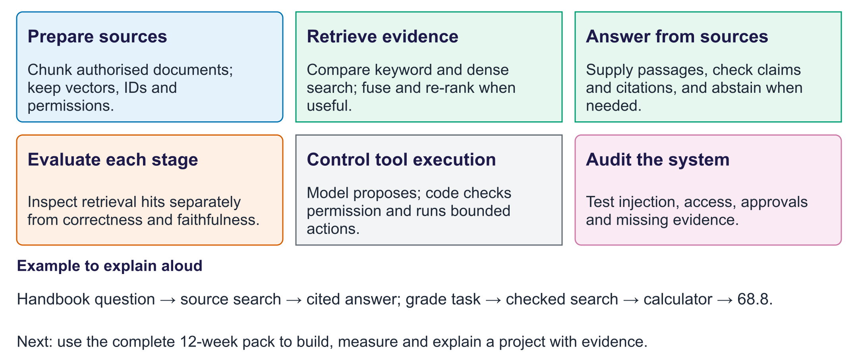
Week 12: evidence and controlled tools
Exit question. A citation points to the correct document. Does it prove the answer is supported?
Answer. No. Read the exact passage and check each claim; the document may not contain the required fact.

