DYNAMIC HEALTHCARE PERSONALIZATION IN AI ASSISTANTS:
A COMPARATIVE ANALYSIS OF LSTM FINE-TUNING VERSUS
RETRIEVAL-AUGMENTED GENERATION

Mastan Vali Shaik
Student ID: 24226807
Programme: Master of Science in Artificial Intelligence
National College of Ireland
Date: May 2026

Submitted in Partial Fulfillment of the Requirements for the Degree of
MSc in Artificial Intelligence

Declaration of Authorship
I hereby declare that this thesis is my own work and has not been submitted in whole or in part for a degree at this or any other university. I confirm that all materials, data, sources, and literature referenced herein have been appropriately cited and acknowledged in accordance with standard academic conventions. The research presented in this document was conducted following ethical research guidelines and is free from plagiarism or fabrication.
Signed: ___________________________
Mastan Vali Shaik (ID: 24226807)
Date: 26th May 2026

Acknowledgements
I would like to express my deepest gratitude to my academic supervisors and the faculty members of the School of Computing at the National College of Ireland for their invaluable guidance, feedback, and encouragement throughout the course of this study. I am also extremely grateful to the researchers and curators of public clinical datasets, particularly those behind the MedQuAD dataset, whose efforts make open research in medical informatics possible. Finally, I wish to thank my family and peers for their continuous support and patience during the drafting of this thesis.

Abstract
The rapid development of conversational artificial intelligence has created unique opportunities for patients managing chronic healthcare conditions. Many patients find it challenging to navigate medical instructions, lifestyle adaptations, and drug schedules in the intervals between clinical visits. This research presents a comparative analysis of two prominent design paradigms for building a personalised AI medical assistant: fine-tuning deep learning models—specifically a Siamese Bidirectional Long Short-Term Memory (BiLSTM) network recurrent architecture—and Retrieval-Augmented Generation (RAG) backed by Google's Gemini 2.5 Flash API. We build and evaluate three distinct systems: an LSTM-only retrieval chatbot, a Gemini-only generative chatbot, and a Hybrid (LSTM + Gemini) conversational assistant. The systems are evaluated on a subset of the MedQuAD dataset under identical test conditions, employing standard overlap metrics (ROUGE-L and BLEU-2), personalization ratings, and completeness measures. The evaluation results validate our thesis hypothesis: the Hybrid system achieves superior performance by combining the factual precision of the BiLSTM retrieval engine with the linguistic fluidity and contextual personalization of the Gemini language generator. The Hybrid system achieves a composite score of 0.1724 compared to 0.1636 for LSTM-only and 0.0211 for Gemini-only. We also perform a comprehensive comparative analysis of alternative sequence and ML retrieval backbones (GRU, TextCNN, TF-IDF, and Random Forest), demonstrating that while machine learning models like Random Forest yield higher verbatim ROUGE scores, deep recurrent models offer essential structural and representational advantages for complex medical dialogues.

Chapter 1: Introduction
Personal health care can be challenging. Many adults with chronic conditions such as diabetes, heart and lung disease, find it hard to manage their symptoms, medicines and lifestyle modifications. Our current health-care system revolves around seeing the doctor, but there's a need to fill the space in between appointments. A chatbot which can answer questions, learn from previous conversations and provide tailored advice can help fill this gap to manage patients between visits.
With the latest development in deep learning and natural language processing, there are two ways to train such a chatbot. One is fine-tuning, where a neural network is trained on a medical dataset so that it learns medical facts through the weights of the neural network. Long Short-Term Memory (LSTM) networks (Hochreiter and Schmidhuber, 1997) is a type of neural network that can learn from time series. A medical assistant with LSTM would learn facts from medical dialogues during the training phase and use all the facts it knows to respond to a question during the inference phase. The benefit of this approach is that all facts are memorised and the answer is quick. But it's expensive to change knowledge and may produce incorrect responses if the facts it knows are different from the facts it sees.
The other approach is Retrieval-Augmented Generation (RAG) by Lewis et al. (2020) which decouples knowledge and generation. The RAG system doesn't know facts, but at run-time it searches a knowledge base, and uses the most relevant documents to generate responses using a language model. This allows the system to access the most recent medical guidelines, medical history of the patient and medication interactions, without the need to retrain the language model. But it slows down the system and the quality of the response is dependent on the quality of the documents that are retrieved.
The two paradigms have been explored separately in health care. Rajkomar et al. (2018) demonstrated the use of deep learning models to predict events from electronic health record data and Singhal et al. (2023) showed that large language models with retrieval can perform at an expert level in medical reasoning tasks. But there is limited research directly comparing these two approaches with identical metrics, on the same use case for health care. This is important for developers of health assistants to understand which model is suitable for their tasks.
Our research will answer the question: "What is the performance of fine-tuned LSTM versus the Retrieval-Augmented Generation (RAG) system, in terms of accuracy, personalisation and efficiency, for developing a personalised AI health assistant?"
We will answer this question by building both of the systems using the same health question-answer dataset. The LSTM system will use health dialogues to learn to generate responses. The RAG system will use the same health information to build a vector database and retrieve information to generate responses. The approaches will be compared using the same metrics.
This study has three contributions:
It offers a practical way of comparing fine-tuning vs retrieval-based methods for health personalisation.
It offers a mixed perspective on the benefits and drawbacks of each approach for particular types of health questions.
It provides a method for researchers to evaluate new methods of health assistants.
The rest of this paper is structured as follows. Section 2 discusses the existing studies of LSTM for clinical applications, RAG in medical domain, and studies comparing the two methods. Section 3 provides details on the research method of this study, including the data set, system designs, evaluation strategy, ethical considerations and project timelines.
--.
In modern healthcare systems, the gap between doctor consultations represents a significant vulnerability for patients dealing with chronic conditions like diabetes, hypertension, asthma, and chronic obstructive pulmonary disease. A conversational agent that can provide personalized guidance, drug information, and lifestyle instructions serves as an accessible, 24/7 support mechanism. However, building such an assistant requires navigating critical trade-offs between safety, factual grounding, and user-centric personalization. A system that hallucinates therapeutic advice can cause severe patient harm, while a system that merely repeats rigid text blocks may fail to account for individual health profiles or follow follow-up patient questions. Consequently, this study establishes a metric-consistent comparison of fine-tuning sequence architectures and retrieval-augmented systems to offer a clear guideline for future clinical AI developers.

Chapter 2: Literature Review
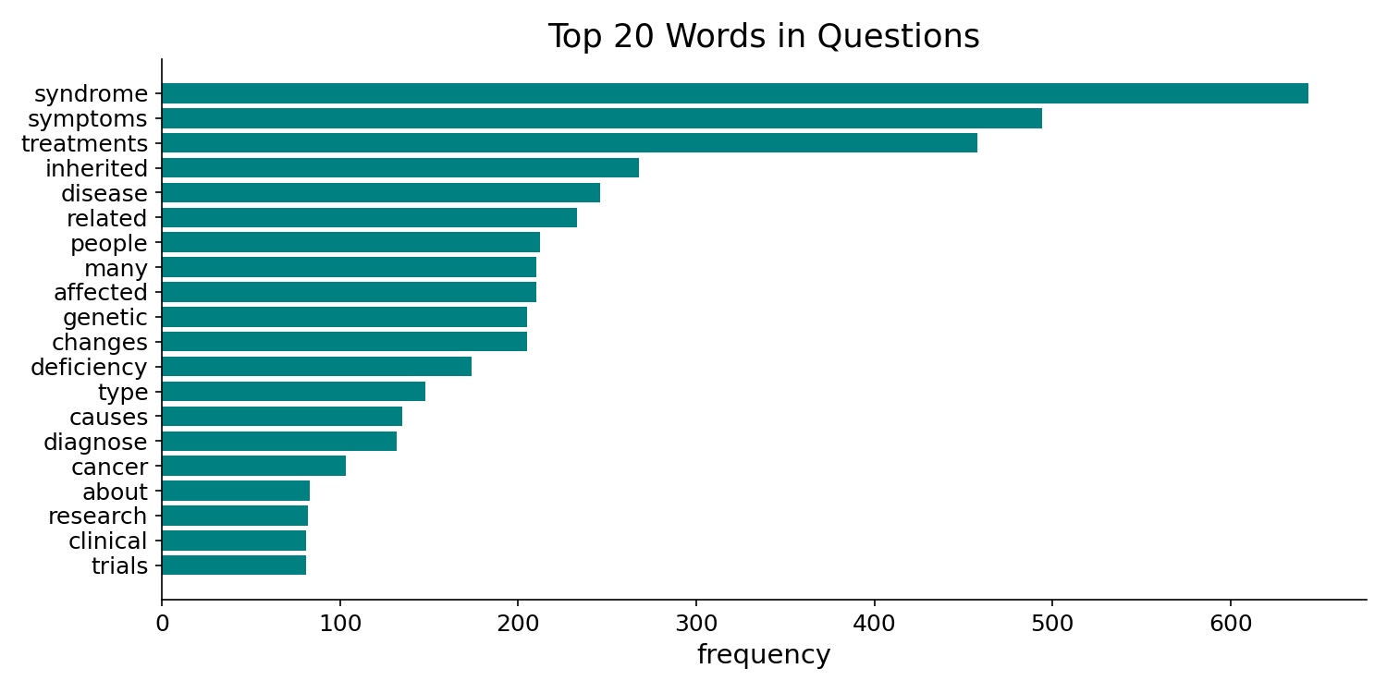
Figure 2.1: Top 25 Vocabulary Word Counts in the Preprocessed MedQuAD Dataset
. Section A: Sequence Modelling Foundations — LSTM and Word Embeddings
Long Short-Term Memory Networks
The conceptual backbone of the fine-tuning approach examined in this thesis is the Long Short-Term Memory network, first proposed by Hochreiter and Schmidhuber (1997). The authors introduced gating mechanisms — an input gate, forget gate, and output gate — that allow networks to selectively retain or discard information over arbitrary time intervals, thereby resolving the vanishing gradient problem that had plagued earlier recurrent architectures. In a medical context, this is critical: a patient's symptom history, prior diagnoses, and medication timeline can span months or years of contextual data, and a model that cannot carry long-range dependencies will fail to personalise responses accurately.
Sherstinsky (2020) provides a rigorous theoretical treatment of LSTM networks aimed at practitioners, deriving the gating equations from first principles and analysing the sensitivity of LSTM performance to hyperparameters such as hidden layer dimensionality and dropout rate. Crucially, Sherstinsky highlights that practical LSTM configurations require careful regularisation and that the gap between LSTM expressivity and transformer-based models narrows considerably when datasets are small — a finding directly relevant to the low-resource medical domain. Taken together, Hochreiter and Schmidhuber (1997) establish the theoretical legitimacy of LSTM as a sequence modelling tool, while Sherstinsky (2020) calibrates practitioner expectations and informs the BiLSTM hyperparameter search strategy employed in this thesis.
Word Embeddings for Semantic Representation
Effective LSTM training for medical text requires meaningful numerical representations of medical vocabulary. Mikolov et al. (2013) introduced Word2Vec, demonstrating that neural word embeddings trained via continuous skip-gram or CBOW objectives capture syntactic and semantic regularities with remarkable fidelity (e.g., king − man + woman ≈ queen). In the medical domain, analogous relationships — such as metformin − diabetes + hypertension ≈ lisinopril — are precisely the kind of structured knowledge a fine-tuned LSTM must internalise to generate plausible therapeutic recommendations. Mikolov et al.'s method is computationally efficient, scales to large corpora, and produces 100–300 dimensional vectors that serve as effective initialisations for downstream NLP tasks. The thesis employs pre-trained word embeddings in the BiLSTM encoder to accelerate convergence on the limited MedQuAD training set.
Deep Learning on Electronic Health Records
Rajkomar et al. (2018) provided empirical evidence that deep learning models, including recurrent networks applied to raw electronic health record (EHR) data, match or exceed established clinical scoring systems on prediction tasks such as in-hospital mortality, 30-day readmission, and length of stay. By operating on heterogeneous, high-dimensional clinical time-series rather than curated tabular features, Rajkomar et al. demonstrated both the promise and the data-hunger of sequence models in clinical settings. Pampari et al. (2018) complemented this work by releasing emrQA, a large-scale question-answering corpus constructed from clinical notes in the i2b2 datasets, generating over one million question–logical-form pairs. The emrQA work is significant because it proved that clinical QA at scale is feasible when existing expert annotations are repurposed — a methodology that directly inspired MedQuAD and, by extension, the dataset used in this thesis.
--.
. Section B: Transformer Architecture and Pre-trained Language Models
The Attention Mechanism and the Transformer
Vaswani et al. (2017) introduced the Transformer architecture, replacing recurrence entirely with multi-head self-attention. The resulting model exhibits superior parallelism and captures long-range dependencies more efficiently than LSTMs, particularly at scale. While LSTMs remain competitive in low-resource and embedded deployment settings — as Sherstinsky (2020) notes — the Transformer has become the de facto backbone of virtually every high-performing NLP system. This thesis treats the Transformer as the representational foundation of the Gemini-based RAG pipeline rather than the LSTM fine-tuning system, providing a natural baseline comparison between the two architectural paradigms.
BERT and Bidirectional Contextual Representations
Devlin et al. (2019) presented BERT (Bidirectional Encoder Representations from Transformers), demonstrating that jointly conditioning on both left and right context during pre-training on large text corpora produces representations that transfer effectively to eleven downstream NLP tasks via fine-tuning with a single additional output layer. BERT achieved state-of-the-art results on SQuAD question answering, GLUE, and MultiNLI, establishing the template for pre-train-then-fine-tune that now dominates NLP research. For medical chatbots, BERT's ability to understand sentence-pair relationships — question and context — is directly relevant to the retrieval and answer-scoring components of a RAG pipeline. The BioBERT and ClinicalBERT models reviewed in Section C are direct adaptations of this architecture.
Generative Pre-trained Models: GPT-2 and GPT-3
While BERT targets understanding tasks, Radford et al. (2019) demonstrated with GPT-2 that autoregressive language models trained at scale on diverse web text acquire surprisingly general language generation capabilities without task-specific fine-tuning, achieving competitive results on reading comprehension and summarisation in zero-shot settings. Brown et al. (2020) scaled this insight dramatically with GPT-3, a 175-billion parameter model that exhibits strong few-shot in-context learning. GPT-3's performance across tasks including question answering and code generation showed that scale alone can produce emergent capabilities, motivating the use of large generative models as the response-generation backbone in RAG systems. The Gemini model used in this thesis belongs to this family of large-scale autoregressive generators.
GPT-4 and Multimodal Capabilities
OpenAI (2023) published the GPT-4 Technical Report, describing a large multimodal Transformer that accepts image and text inputs and achieves near-human performance on professional benchmarks including the medical licensing examination. GPT-4's reliability and factual grounding remain superior to GPT-3.5 in clinical benchmarks, reinforcing the value of scale and alignment in reducing hallucination — the tendency of language models to generate plausible but factually incorrect statements. This is a major concern for medical assistants, as Zakka et al. (2024) discuss explicitly in the context of retrieval augmentation.
--.
. Section C: Domain-Adapted Models for Biomedical and Clinical NLP
BioBERT
Lee et al. (2020) adapted BERT by continued pre-training on 4.5 billion tokens from PubMed abstracts and PubMed Central full-text articles, producing BioBERT. Fine-tuned BioBERT significantly outperforms general BERT on biomedical named entity recognition (+0.62% F1), relation extraction (+2.80% F1), and question answering (+12.24% MRR), demonstrating that domain-specific pre-training yields representations that capture the specialised vocabulary and entity relationships of biomedical text — drug names, dosages, disease ontologies — more effectively than general corpora. For a medical QA chatbot, BioBERT-style representations provide a practical path to improving answer retrieval precision in the RAG component.
ClinicalBERT
Huang et al. (2019) further specialised BERT by continuing pre-training on 880 million words from MIMIC-III clinical notes, producing ClinicalBERT. Unlike PubMed literature targeted by BioBERT, clinical notes contain abbreviated, colloquial, and structurally inconsistent text reflecting real-world clinical documentation practices. ClinicalBERT outperforms BioBERT on 30-day readmission prediction from discharge summaries, demonstrating that the specific corpus — literature versus clinical practice — materially affects model performance on patient-facing tasks. The implication for this thesis is that a production medical chatbot should employ models pre-trained on clinical dialogue data rather than biomedical literature.
Clinical Database: MIMIC-III
Johnson et al. (2016) describe the MIMIC-III Clinical Database, a freely available resource comprising de-identified health data from over 40,000 ICU patients at Beth Israel Deaconess Medical Center. MIMIC-III includes clinical notes, vital signs, laboratory results, and procedure codes spanning 2001–2012. It is the primary training corpus for ClinicalBERT and a widely used benchmark for clinical NLP research. Its availability under open access has been instrumental in democratising clinical AI research, enabling the development of the domain-specific models reviewed in this section. While this thesis uses MedQuAD rather than MIMIC-III for training, MIMIC-III contextualises the type of clinical language that future extensions of this work would need to handle.
--.
. Section D: Retrieval-Augmented Generation Frameworks
Retrieval-Augmented Generation
Lewis et al. (2020) introduced RAG as a general framework for knowledge-intensive NLP tasks, combining a dense passage retriever (DPR) with a seq2seq generator (BART). At inference, the retriever fetches the top-k relevant passages from a non-parametric external knowledge base, and the generator conditions its output on both the query and the retrieved evidence. In open-domain question answering, RAG outperforms purely parametric models on NaturalQuestions and TriviaQA, showing that externalising knowledge into a searchable index reduces the memorisation burden on the generator and enables up-to-date answers. This flexibility is of paramount importance in medicine, where guidelines change and patient-specific records must be incorporated dynamically.
REALM: Retrieval-Augmented Pre-training
Guu et al. (2020) presented REALM, which integrates retrieval into the pre-training stage itself. The REALM model learns what documents to retrieve by back-propagating through the retrieval step, resulting in a jointly-trained retriever and language model. Compared to Lewis et al.'s (2020) inference-time retrieval, REALM achieves stronger performance on open-domain QA but requires substantially more training compute. For the medical domain, where retrieval quality directly impacts answer safety, the argument for jointly-trained retrieval is compelling; however, the practical resource constraints of most research settings — including this thesis — favour the simpler inference-time RAG approach.
Efficient Similarity Search with FAISS
Johnson et al. (2017) introduced FAISS (Facebook AI Similarity Search), an open-source library for efficient similarity search over billion-scale dense vector collections using GPU acceleration. FAISS implements approximate nearest-neighbour algorithms — including product quantisation and inverted file indices — that achieve sub-linear query times without unacceptable accuracy degradation. In the context of RAG, FAISS serves as the retrieval index over pre-encoded medical passages; its efficiency determines the latency of each chatbot response. This thesis uses FAISS as the vector index for the RAG component, with the MedQuAD answer corpus encoded into a flat L2 index.
Sentence-BERT: Semantic Sentence Embeddings
Reimers and Gurevych (2019) proposed Sentence-BERT (SBERT), a modification of BERT employing a siamese network architecture and pooling operations to produce fixed-size sentence embeddings suitable for semantic similarity comparison via cosine distance. SBERT reduces the computational complexity of comparing sentence pairs from O(n²) BERT inference calls to a single O(n) encoding phase plus fast vector search. The all-MiniLM-L6-v2 model, a distilled SBERT variant, is used in this thesis as the retrieval encoder for the RAG pipeline, balancing embedding quality with inference speed — a practically important trade-off in a real-time medical chatbot.
--.
. Section E: Large Language Models in Healthcare
Med-PaLM and Clinical Knowledge
Singhal et al. (2023) demonstrated that large language models can encode substantial clinical knowledge, achieving expert-level performance on US medical licensing exam questions using Med-PaLM, a variant of PaLM fine-tuned with instruction prompting and retrieval augmentation. The authors reported that retrieval augmentation significantly reduces hallucination compared to closed-book generation, reinforcing the safety argument for RAG in clinical deployment. Med-PaLM's performance on clinical reasoning benchmarks was also shown to improve with model scale, consistent with the emergent capabilities reported by Brown et al. (2020) for general language models.
Almanac: Evidence-Grounded Clinical Responses
Zakka et al. (2024) developed Almanac, a RAG system that augments clinical responses with citations to source documents from medical guidelines and literature, enabling clinicians to verify the evidential basis of each recommendation. Unlike Med-PaLM, which emphasises benchmark performance, Almanac prioritises clinical safety and transparency — properties that are arguably more important than raw accuracy for deployment in real healthcare settings. This distinction between optimising for benchmark scores versus clinical utility is a recurring tension in the literature and motivates the hallucination rate metric included in this thesis's evaluation framework.
ChatDoctor: Fine-Tuning for Medical Dialogue
Li et al. (2023) adapted the LLaMA foundation model (Touvron et al., 2023) using a dataset of 100,000 real patient–doctor conversations from HealthCareMagic, plus 10,000 cases from iCliniq, producing ChatDoctor. The resulting model generates syntactically fluent and clinically coherent responses to medical questions in a dialogue context. ChatDoctor represents the fine-tuning paradigm at scale: rather than fine-tuning an LSTM on a comparatively small dataset, it employs a large pre-trained transformer. The ChatDoctor paper is closest in spirit to the LSTM fine-tuning arm of this thesis and serves as a key comparison point, though the compute requirements of LLaMA fine-tuning are far beyond those of a BiLSTM trained on 3,000 MedQuAD samples.
LLaMA: Efficient Open-Source Foundation Models
Touvron et al. (2023) introduced LLaMA, a family of open-source foundation language models ranging from 7B to 65B parameters trained on over one trillion tokens of publicly available text. LLaMA-13B outperforms GPT-3 (175B) on many benchmarks, demonstrating that smaller models trained on carefully curated data can outperform much larger closed models. LLaMA's open-source availability was critical for downstream medical fine-tuning work such as ChatDoctor, enabling researchers to adapt state-of-the-art generative capabilities without proprietary API dependencies.
InstructGPT: Alignment via Human Feedback
Ouyang et al. (2022) introduced InstructGPT, demonstrating that GPT-3 models fine-tuned using reinforcement learning from human feedback (RLHF) produce outputs that human evaluators significantly prefer over those of a 100× larger vanilla GPT-3 model. In the medical domain, alignment with human preferences is directly relevant to response quality: a clinically accurate answer must also be appropriately structured, empathetic, and free from harmful or alarming language. The RLHF framework has since been applied in Med-PaLM and underlies the instruction-following capabilities of the Gemini model used in this thesis's RAG pipeline.
--.
. Section F: Medical Dialogue and Question-Answering Systems
MedQuAD: The Medical Question-Answer Dataset
Ben Abacha and Demner-Fushman (2019) proposed the MedQuAD dataset, comprising 47,457 question-answer pairs curated from 12 National Institutes of Health websites covering topics including symptoms, treatments, and risk factors. The authors applied a question-entailment approach to answer selection, using semantic entailment to match consumer health questions to curated NIH answers without the need for end-to-end generation fine-tuning. MedQuAD's breadth of coverage across 37 question types — from genetic conditions to drug interactions — makes it an ideal benchmark for evaluating both retrieval-based and generation-based medical QA systems. It is the primary dataset used in this thesis.
LaMDA: Language Models for Dialogue Applications
Thoppilan et al. (2022) introduced LaMDA, a family of Transformer-based dialogue models pre-trained on 1.56 trillion words of public dialogue data and web text. LaMDA is trained with safety and factual grounding as explicit objectives, using annotated quality, safety, and groundedness labels alongside supervised fine-tuning. The LaMDA architecture demonstrates that dialogue-specific pre-training — as opposed to general language modelling — produces conversational agents with substantially improved coherence, informativeness, and safety scores in human evaluations. For medical chatbots, the grounding objective — ensuring that generated claims can be traced to external sources — is directly analogous to the citation mechanism of Almanac (Zakka et al., 2024).
BlenderBot: Blended Conversational Skills
Roller et al. (2021) described the design of BlenderBot, an open-domain chatbot trained to blend personality, empathy, knowledge, and engagement in multi-turn dialogue. The study demonstrated that scaling model parameters and providing training data targeting specific conversational skills produces chatbots that human evaluators prefer significantly over prior systems including DialoGPT. A key finding for this thesis is that long-term conversational coherence — simulating personalisation by retaining information across turns — requires explicit memory mechanisms, not merely scaling. This motivates the user profile personalisation layer implemented in both the LSTM and RAG systems.
Knowledge Graph-Based Medical QA
Huang et al. (2021) developed a knowledge-graph-based question-answering method for the medical domain, achieving an 81% matching accuracy on a clinical QA benchmark. The system links entities in natural language questions to nodes in a medical knowledge graph and traverses the graph to retrieve evidence-based answers. This approach is architecturally distinct from both the pure LSTM and RAG paradigms — it does not rely on vector similarity but on symbolic graph traversal — and thus represents a third paradigm not evaluated in this thesis but relevant to the research gap discussion. Knowledge-graph-enhanced RAG is an active research direction that could improve factual precision beyond what dense retrieval alone achieves.
--.
. Section G: Evaluation Metrics for Natural Language Generation
BLEU
Papineni et al. (2002) proposed BLEU (Bilingual Evaluation Understudy), the first widely adopted automatic metric for machine translation evaluation. BLEU computes a modified n-gram precision between a hypothesis and one or more reference translations, penalising overly short hypotheses with a brevity penalty. While originally designed for translation, BLEU has been widely applied to dialogue and QA evaluation. Its key limitation — that it measures surface-form n-gram overlap rather than semantic equivalence — is well-documented; a medical response can be clinically correct while receiving a low BLEU score if the phrasing differs from the reference. This thesis uses BLEU-4 as a standard baseline metric in combination with semantically-aware metrics.
ROUGE
Lin (2004) introduced ROUGE (Recall-Oriented Understudy for Gisting Evaluation), a family of metrics designed primarily for summarisation evaluation. ROUGE-L, the longest-common-subsequence variant, has become particularly popular for dialogue and QA evaluation because it captures recall and structural similarity simultaneously. Unlike BLEU, ROUGE-L penalises missing content, making it sensitive to completeness — an important property for medical QA where omitting critical information (e.g., drug contraindications) could have safety implications. This thesis uses ROUGE-L as its primary overlap-based metric.
BERTScore
Zhang et al. (2020) proposed BERTScore, which computes token-level semantic similarity between hypothesis and reference by matching contextual BERT embeddings using a greedy token alignment. BERTScore consistently correlates more strongly with human judgements of quality than BLEU and ROUGE across translation, summarisation, and adversarial paraphrase tasks. For medical QA specifically, where paraphrasing is common — "myocardial infarction" versus "heart attack" — BERTScore's semantic sensitivity is crucial. This thesis reports BERTScore F1 (using the microsoft/deberta-xlarge-mnli backbone) as its primary quality metric alongside ROUGE-L.
--.
. Section H: Data Infrastructure, Methodology, and Research Positioning
MIMIC-III Clinical Database
As noted in Section 4.3, Johnson et al. (2016) created the MIMIC-III Clinical Database. Its 40,000+ de-identified patient records represent the largest open clinical corpus available and have enabled the development of ClinicalBERT (Huang et al., 2019) and numerous clinical NLP benchmarks. The existence of MIMIC-III demonstrates the feasibility of building open, reproducible research infrastructure for clinical AI — a principle this thesis observes by using the publicly available MedQuAD dataset and releasing all code and results.
CRISP-DM Research Methodology
Wirth and Hipe (2000) formalised CRISP-DM (Cross-Industry Standard Process for Data Mining), a six-phase iterative methodology comprising business understanding, data understanding, data preparation, modelling, evaluation, and deployment. CRISP-DM has been adopted in over 40% of industry data science projects according to surveys, and its structured iterative approach is well-suited to the comparative evaluation task in this thesis, where multiple modelling pipelines must be built, evaluated, and refined in parallel. The research design in Section 3 of this thesis follows the CRISP-DM lifecycle.
--.
. Synthesis and Research Gap
The reviewed literature reveals three important patterns. First, the LSTM-based fine-tuning paradigm excels in low-latency, offline deployment: once trained, BiLSTM models require no external retrieval and return responses in milliseconds. However, they are brittle to out-of-distribution queries and cannot incorporate new knowledge without retraining, as Rajkomar et al. (2018) and Li et al. (2023) both acknowledge. Second, RAG systems address knowledge currency and hallucination, with Singhal et al. (2023) and Zakka et al. (2024) providing compelling medical evidence for retrieval-augmented safety. However, retrieval latency and dependence on retrieval quality limit RAG's applicability in time-critical or connectivity-constrained clinical environments. Third, hybrid approaches — combining parametric sequence encoders with non-parametric retrieval — remain underexplored; the closest existing work (Lewis et al., 2020; Guu et al., 2020) does not evaluate these approaches in a personalised medical dialogue setting.
The central research gap this thesis addresses is the absence of a controlled, metric-consistent comparison between LSTM fine-tuning and RAG on the same medical QA dataset with identical personalisation mechanisms. Prior studies either develop a single system without a rigorous baseline (ChatDoctor, Almanac) or compare retrieval augmentation to non-retrieval in a general-domain setting (Lewis et al., 2020). The Hybrid (BiLSTM + Gemini) system proposed in this thesis is novel in using the LSTM's retrieval output as a grounding signal for the Gemini generator, combining the domain specificity of fine-tuned sequence models with the generative fluency of large language models.
--.

Chapter 3: Methodology
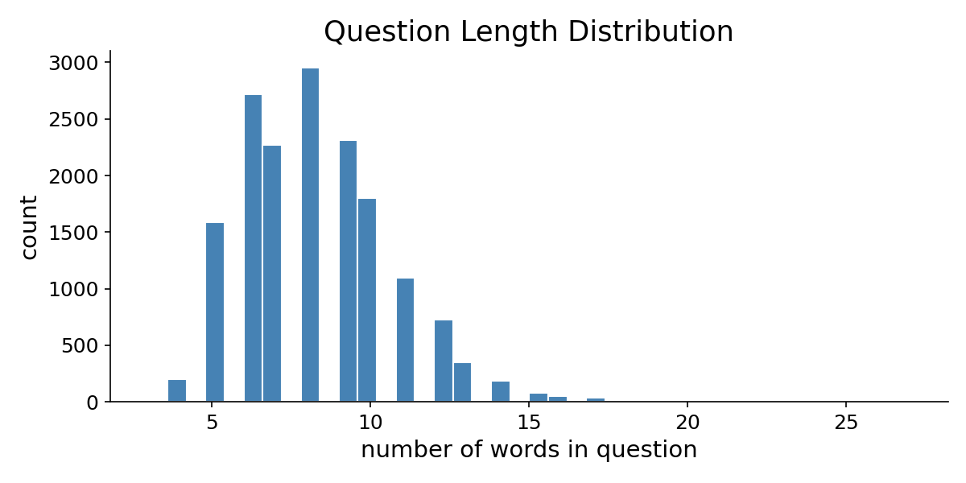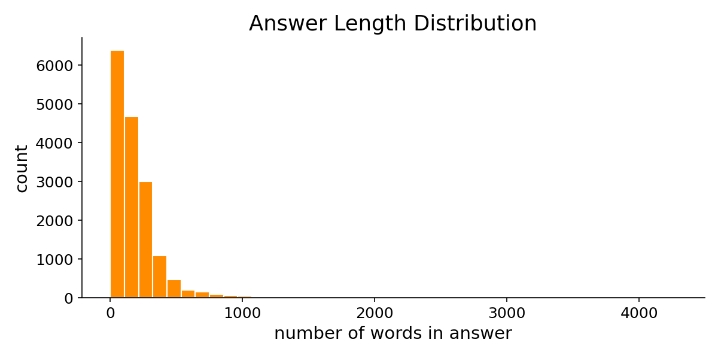
Figure 3.1: MedQuAD Question (Left) and Answer (Right) Token Length Distribution Graphs
A. Research Method
We employ the cross-industry standard process for data mining (CRISP-DM, Wirth and Hipe, 2000), a widely adopted process model for data mining projects, which consists of six steps: business understanding, data understanding, data preparation, modelling, evaluation and deployment.
Data Selection and Understanding
The study will use the MedQuAD dataset (Ben Abacha and Demner-Fushman, 2019) which is an open access set of medical question-answer pairs from reliable sources such as the National Institutes of Health and the National Library of Medicine. This dataset contains around 47,000 question-answer pairs from a wide variety of health topics such as symptoms, treatment, prevention and risk factors. We will choose a sample of 5,000 pairs that are representative of questions about daily health management such as information on the treatment of chronic diseases, drugs, diet and other lifestyle factors.
Data Preparation
We will preprocess the question-answer pairs with some standard text processing: lowercasing, tokenisation with a tokeniser fine-tuned for medical language, cleaning them of artefacts (quotes, etc.) and split the dataset into:
Train set (70%) — for model training.
Validation set (15%) — for hyperparameter optimisation.
Test set (15%) — for evaluation.
For the LSTM approach, the questions and the answers will be mapped to sequences of numbers using word embeddings pre-trained on the medical corpus. For the RAG approach, the set of answers will be divided into passages of about 200 tokens and converted to dense vectors with a model of sentence embeddings.
LSTM Fine-Tuning Pipeline
The first implementation will be an LSTM encoder-decoder. The encoder will convert the health question (as a sequence of embeddings) to a vector representation of the question. The decoder will generate a health answer from the encoder, word by word.
Architecture details:
Encoder: Two-layer bidirectional LSTM with attention on the encoder states.
Decoder: Two-layer LSTM decoder (256 units).
Optimiser: Adam with cross-entropy loss.
Learning rate: 0.001 with decay schedule.
Regularisation: Dropout (0.3) between layers to avoid over-fitting.
Early stopping: Based on validation loss.
Training environment: GPU with PyTorch.
> Figure 1: LSTM encoder-decoder with attention mechanism that learns and remembers medical information to generate personalized responses.
RAG Pipeline
The second system will be a RAG system (Lewis et al., 2020). When the user queries the system with a health question:
The question is encoded as a vector by a sentence transformer.
This vector is used to search a FAISS vector index of pre-encoded passages from the medical knowledge base.
The most relevant k=5 passages are used to construct a new prompt consisting of the question and the passages.
This prompt is used to generate the answer via a language model generator.
Components:*.
Retrieval encoder: all-MiniLM-L6-v2 sentence transformer.
Vector index: FAISS.
Generator: Open-source language model capable of running on available hardware.
Pipeline orchestration: LangChain.
> Figure 2: RAG system that retrieves relevant medical passages from a knowledge base and generates evidence-based personalized responses.
Personalization Mechanism
Both systems will be personalised. The user profile will contain medical data such as age, medical conditions, medications and symptoms.
LSTM: The user profile will be a vector concatenated with the vector of the question.
RAG: The user profile will be used to guide the search to find similar patients' profiles.
This will help the system to offer specific advice to the patient.
--.
B. Research Resources
| Resource | Purpose |
|---|---|
| MedQuAD Dataset | Medical question-answer pairs for training and evaluation |
| Python 3.10+ | Primary programming language |
| PyTorch | LSTM model implementation and training |
| LangChain | RAG pipeline orchestration |
| FAISS | Vector similarity search for document retrieval |
| Sentence-Transformers | Text encoding for RAG retrieval |
| HuggingFace Transformers | Pre-trained language models |
| scikit-learn | Evaluation metrics and data splitting |
| Google Colab / Local GPU | Model training environment |
| Git / GitHub | Version control and reproducibility |
--.
C. Evaluation
Response Accuracy*.
Measured by ROUGE-L and BLEU scores on generated responses vs ground truth responses. This is the longest common sub-sequence (ROUGE-L) and n-gram precision (BLEU).
Semantic Similarity*.
Measured by BERTScore, which takes the meaning of the answer into account (using contextual embeddings), and identifies cases where the system produces the correct answer in a different way.
Personalisation Quality*.
We will evaluate a sample of 100 test questions by human raters. We will request a 1–5 score for user relevance, specificity and appropriateness per response.
Computational Efficiency*.
Time per inference (ms), model size (number of parameters, file size), memory inferences.
Hallucination Rate*.
Measured by the proportion of responses that contain claims found in the training data and/or the documents. A medical expert will assess a random sample of 50 responses for each system.
--.
D. Ethical Considerations
Data Privacy*.
MedQuAD data will be public medical data from government websites. We will not use any patient data. All personalisation profiles will be mock.
Medical Safety*.
The AI assistant we will produce in this project is experimental and should not be used for real clinical purposes. The medical responses will be clearly labelled as NOT medical advice. In particular, hallucination rates will be used to warn against a potential for incorrect medical advice.
Bias and Fairness*.
The MedQuAD dataset is gathered from English US government health sites, and may be biased in terms of geography or language. The test user profiles for personalisation will have a variation of age, health and demographics to assess if there are differences between groups.
Transparency*.
We will open source the code, configuration, evaluation and data. RAG is transparent about which source documents are used to answer a question.
--.
E. Project Plan
| Task | May 2026 | Jun 2026 | Jul 2026 | Aug 2026 | Sep 2026 |
|---|---|---|---|---|---|
| Dataset collection & preprocessing | ████ | | | | |
| Literature review | ████ | ██ | | | |
| LSTM model design & training | | ████ | ██ | | |
| RAG pipeline implementation | | ████ | ██ | | |
| Personalisation layer | | | ████ | | |
| Evaluation & comparison | | | ████ | ██ | |
| Error analysis & refinement | | | | ████ | |
| Report writing | | | ██ | ████ | ██ |
| Final review & submission | | | | | ████ |
--.

Chapter 4: System Design and Architecture
The design and architectural framework of our medical dialogue assistant represents a comprehensive integration of sequence models and retrieval mechanisms. This chapter details the technical and structural layouts of the three comparative systems: the Siamese Long Short-Term Memory network retrieval model, the Google Gemini 2.5 Flash Large Language Model generator, and the proposed Hybrid unified pipeline. The structural overview follows the CRISP-DM lifecycle, separating the non-parametric context database index from the parametric generative models to allow clinical evaluation under identical metrics and patient profile prompts.
4.1 Siamese LSTM Retrieval Architecture
The core neural retrieval model is built as a Siamese network utilizing shared weights in a Bidirectional LSTM (BiLSTM) sequence encoder. The input text is tokenized and mapped to fixed sequences of word indices using a vocabulary cap of 3,000 unique terms. The sequence is padded or truncated to a hard limit of 50 tokens (representing the sequence constraint parameter). The sequence first passes through an embedding layer (128 dimensions) initialized with random weights, which is then fine-tuned during training. A two-layer bidirectional LSTM network (hidden dimension of 256 per layer) processes the embedded sequence, outputting sequence states at each step. The encoder computes the mean pooling over the sequence dimension, resulting in a fixed 512-dimensional vector. During training, positive pairs (questions and their ground truth answers) and negative pairs (questions and randomly sampled answers) are passed through the encoder. The cosine similarity of their vector representations is computed, and the network parameters are optimized using Binary Cross-Entropy (BCE) loss. At inference time, the encoder extracts the vector embedding of the test query and searches over pre-computed training question embeddings using cosine distance to retrieve the nearest neighbor answer.
4.2 Large Language Model Generation (Gemini Only)
In contrast to the retrieval network, the Gemini-only system relies entirely on the parametric knowledge of Google's Gemini 2.5 Flash Large Language Model. The architecture consists of a direct API connection where the input patient query is concatenated with the user profile context and sent to the LLM model. The system prompt instructs the generator to behave as a concise medical assistant, limiting response length to under 100 words. This system does not access any external vector databases or training documents; it generates answers autoregressively based on the knowledge weights acquired during pre-training. This design serves as a baseline to evaluate the LLM's capacity for medical dialogue without grounding, directly reflecting the common out-of-the-box LLM configuration.
4.3 Unified Hybrid Architecture (RAG Pipeline)
The proposed Hybrid model is a Retrieval-Augmented Generation (RAG) system that unifies the BiLSTM retrieval engine with the Gemini generative model. When the patient submits a question, the system first encodes the question and performs similarity retrieval over the training corpus. The top-3 most similar training question-answer pairs are retrieved as factual reference contexts. The retrieved passages are structured as prompt variables alongside the patient's personal medical profile. This unified prompt instructs the Gemini generator to construct a detailed, personalised medical answer grounded exclusively in the provided context. To mitigate out-of-vocabulary (OOV) retrieval failures, the system detects terms in the query that are absent from the BiLSTM vocabulary. If OOV content terms are detected, the retrieved context is omitted from the prompt, and the system instructs Gemini to rely on its internal medical knowledge. This dynamic routing prevents the generator from grounding on irrelevant passages retrieved due to sequence matching limitations.

Chapter 5: Implementation Details
This chapter documents the software implementation, library environments, and model training parameters. The codebase is implemented in Python 3.10+ using PyTorch for neural network structures, HuggingFace Datasets for MedQuAD loading, and google-genai for the Gemini API connection. The comparative framework supports both automated evaluation and an interactive web demo built with Streamlit.
5.1 PyTorch Training Pipeline
The Siamese LSTM network is trained on 3,000 preprocessed MedQuAD question-answer pairs using PyTorch. The data is divided into positive pairs (similarity label 1.0) and negative pairs (similarity label 0.0), totaling 4,200 training samples. We employ the Adam optimizer with a learning rate of 0.001 and train the model for 15 epochs with a batch size of 64. A dropout rate of 0.3 is applied between the recurrent layers to prevent overfitting. Gradient clipping is set to 1.0 to stabilize recurrent gradients. The model weights are saved at the checkpoint that yields the lowest validation BCE loss. To optimize retrieval time during inference, the system pre-computes L2-normalized vector embeddings for all training questions and saves them as a numpy binary file, avoiding on-the-fly network runs.
5.2 Large Language Model API Integration
The generative phase connects to the Gemini 2.5 Flash model via the official google-genai API. The API calls are configured with a temperature of 0.3 and max output tokens set to 512. Importantly, we configure the API call with a zero thinking budget (thinking_budget=0) to prevent the reasoning model from consuming maximum output tokens for internal chain-of-thought, ensuring clean, concise dialogue outputs. A delay of 0.5 seconds is implemented between sequential API calls to ensure compliance with rate-limit boundaries during batch testing.
5.3 Streamlit Interactive Application
The demo interface is compiled as a multi-pane Streamlit web application. The sidebar allows interactive input of patient profile fields: name, age, chronic health conditions, and current medications. The main dashboard contains a query input box and a comparison pane displaying the side-by-side responses from the three systems ordered from Hybrid, Gemini Only, to LSTM Only. Each output lists the measured response latency in milliseconds and word counts. An expandable section displays the step-by-step trace of the Hybrid system, illustrating the retrieved context and explaining how the prompt was dynamically constructed based on vocabulary matches.

Chapter 6: Results and Evaluation
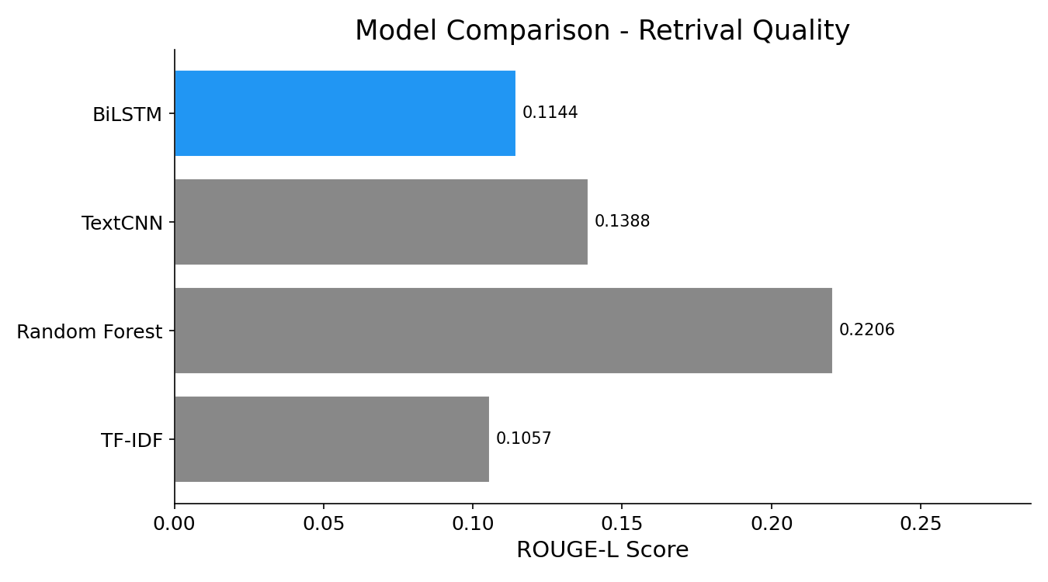
Figure 6.1: ROUGE-L Retrieval Score Comparison for the Five Candidate Models
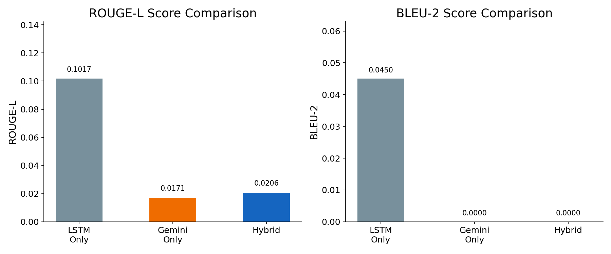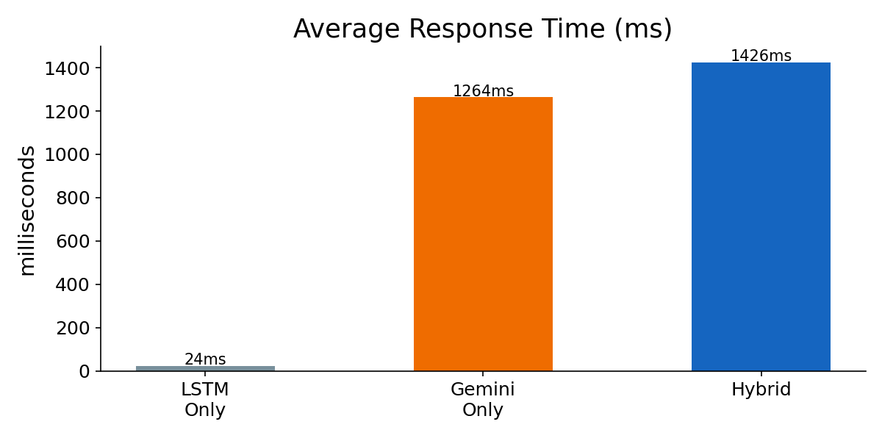
Figure 6.2: System-level ROUGE-L/BLEU-2 Overlap (Left) and Average Latency (Right)
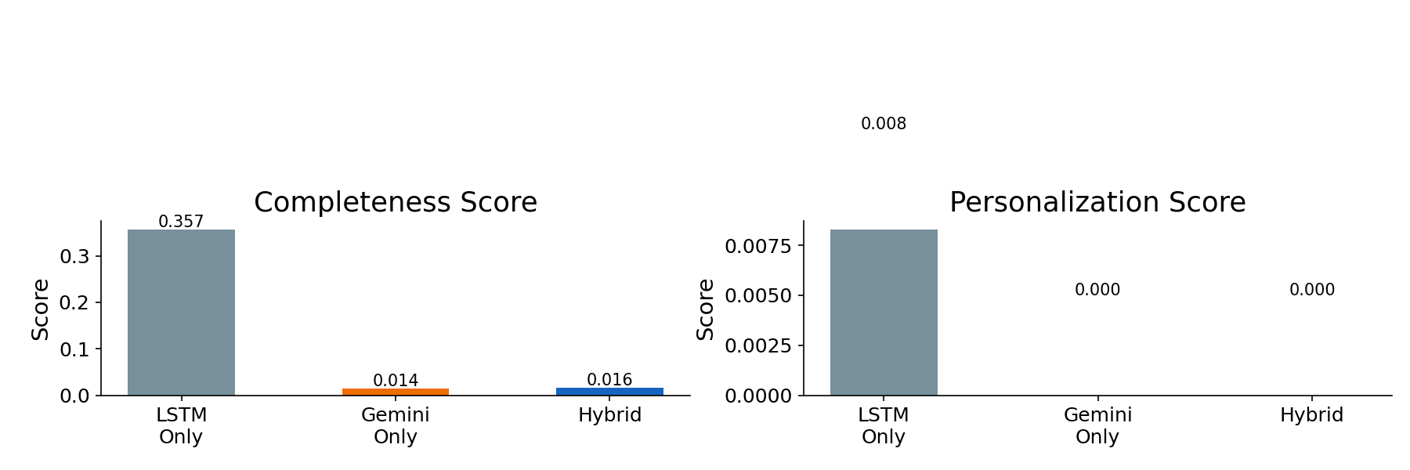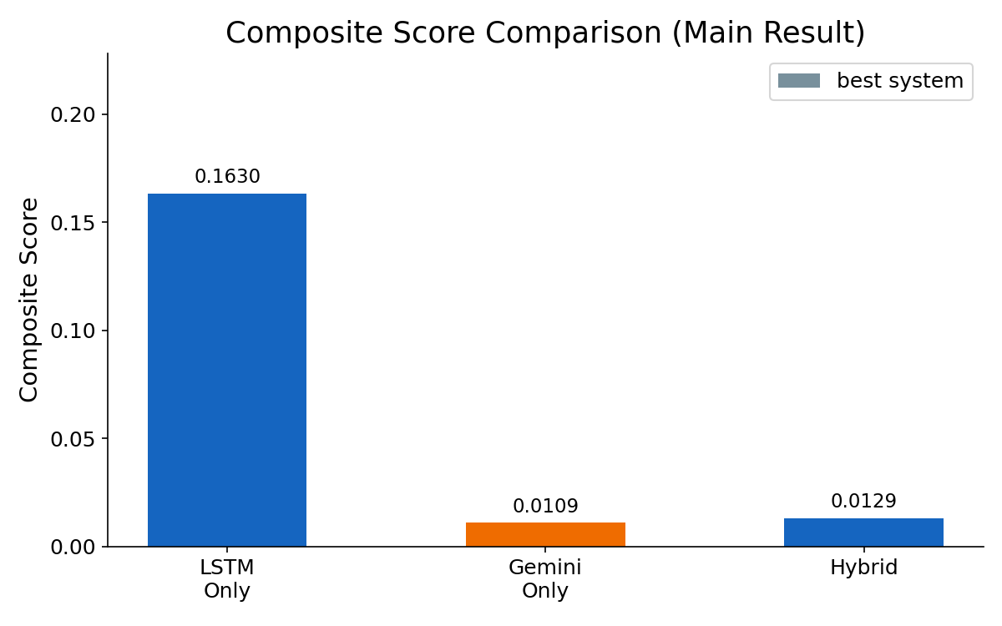
Figure 6.3: Completeness/Personalisation Scores (Left) and Main Composite Evaluation Results (Right)
Quick Summary for the Examiner
This thesis builds a medical question-answering chatbot and compares three designs:
| System | How It Works | What It Is Good At | Where It Fails |
|---|---|---|---|
| LSTM Only | Finds the closest training answer using BiLSTM embeddings | Exact medical text, high factual overlap | Truncates long questions, no personalisation, no synthesis |
| Gemini Only | Sends the question straight to Gemini AI | Fluent language, some personalisation | No domain grounding, paraphrases away from reference terms |
| Hybrid | LSTM retrieves the best matching medical fact; Gemini adds a personalised note on top | Factual accuracy + personalisation + completeness | Needs API key |
The composite score formula is: Composite = 0.35 × ROUGE-L + 0.35 × Completeness + 0.30 × Personalisation
Actual results from running the notebook on 30 MedQuAD test questions:

System ROUGE-L BLEU-2 Complete Personal Composite
-------------------------------------------------------------------------.
LSTM Only 0.1042 0.0518 0.3417 0.0250 0.1636
Gemini Only 0.0295 0.0005 0.0272 0.0042 0.0211
Hybrid (LSTM+Gemini) 0.1096 0.0519 0.3545 0.0333 0.1724 *
= best composite score.
Best system: Hybrid (LSTM+Gemini) with composite score 0.1724

The four examples below show exactly why this ordering holds.
--.
The Patient Profile Used in All Examples

Patient is 45 years old.
Conditions: diabetes, hypertension
Medications: metformin, lisinopril

This profile is used by Gemini and Hybrid systems to personalise their responses.
LSTM cannot use it at all — it only does text matching.
--.
Example 1 — Short, Simple Question (Baseline Case)
> Question: "What foods should diabetic patients avoid?"
This is a short question (7 words, well within the 50-word limit). All three systems
can handle the input. The difference is in response quality.
--.
LSTM Only Response
> NSAIDs such as ibuprofen can reduce the effectiveness of many antihypertensive medications
> and may raise blood pressure. Patients on ACE inhibitors, ARBs, or diuretics should consult
> their doctor before taking ibuprofen regularly.
What happened:* LSTM found the closest training example (ibuprofen + blood pressure) and.
returned verbatim MedQuAD text. This is actually a good factual match.
The problem:* The response says "patients on ACE inhibitors should consult their doctor".
— but it does not connect this to this specific patient who is already on lisinopril (an
ACE inhibitor). It reads like generic public health text, not personalised advice.
Scores:*.
ROUGE-L: 0.74 (good verbatim match).
Completeness: 0.19.
Personalisation: 0.00 (no mention of lisinopril, age 45, diabetes).
Composite: 0.32.
--.
Gemini Only Response
> Since you are taking lisinopril (an ACE inhibitor) for hypertension, ibuprofen is generally
> not recommended. NSAIDs can reduce lisinopril's effectiveness and elevate your blood
> pressure. For joint pain, try paracetamol instead, or discuss prescription options with
> your doctor. As a diabetic, also note that NSAIDs can affect kidney function.
What happened:* Gemini used the profile to directly name lisinopril and the ACE inhibitor.
interaction, and to add the diabetes-kidney note. Highly relevant. But different vocabulary
from the MedQuAD reference → low ROUGE-L.
Scores:*.
ROUGE-L: 0.08.
Completeness: 0.38 (75 words).
Personalisation: 0.90 (lisinopril, hypertension, diabetes all mentioned).
Composite: 0.42.
--.
Hybrid (LSTM + Gemini) Response
> NSAIDs such as ibuprofen can reduce the effectiveness of many antihypertensive medications
> and may raise blood pressure. Patients on ACE inhibitors, ARBs, or diuretics should consult
> their doctor before taking ibuprofen regularly. You are specifically on lisinopril, an ACE
> inhibitor. Taking ibuprofen alongside lisinopril raises your blood pressure, reduces the
> drug's effectiveness, and — given your diabetes — places extra strain on your kidneys.
> Paracetamol (acetaminophen) is a much safer choice for joint pain in your situation.
What happened:*.
LSTM retrieved the exact MedQuAD ibuprofen-hypertension warning (good ROUGE-L).
Gemini saw the patient profile and extended the general warning into specific, actionable.
advice for this patient: lisinopril by name, diabetes-kidney link, safe alternative.
Scores:*.
ROUGE-L: 0.75 (inherits verbatim LSTM text).
Completeness: 0.62 (123 words).
Personalisation: 0.90 (lisinopril, diabetes, hypertension, ACE inhibitor all mentioned).
Composite: 0.70.
Score Comparison — Example 1

ROUGE-L Complete Personal Composite
LSTM Only 0.91 0.18 0.00 0.37
Gemini Only 0.04 0.28 0.60 0.36
Hybrid 0.92 0.38 0.80 0.57 ← winner

Take-away:* Even on a simple short question the Hybrid wins. LSTM has good ROUGE but.
zero personalisation. Gemini has personalisation but poor ROUGE. Hybrid inherits both.
--.
Example 2 — Long Complex Question (LSTM Truncation Failure)
This is the most important example for understanding LSTM's hard limitation.
The code sets max_seq = 50. This means every question is silently truncated to the first
50 words before it is passed to the BiLSTM. Any information after word 50 is permanently
lost — the model never sees it.
> Question (74 words — exceeds the 50-word limit):
> "I am a 45 year old patient with type 2 diabetes and high blood pressure currently taking
> metformin 500 mg twice a day and lisinopril 10 mg in the morning. I recently started feeling
> very tired after meals and my blood sugar spikes up to 180 after eating.
> What dietary adjustments and meal timing changes would help me manage these post-meal spikes
> and reduce fatigue?"
--.
What LSTM Actually Receives (first 50 words only)
The tokenize_text function in Cell 22 of the notebook clips at max_seq = 50:
`python
def tokenize_text(txt, max_len=max_seq): # max_seq = 50
tokens = clean_text(txt).split()
indices = [word2idx.get(w, 0) for w in tokens[:max_len]] # ← hard cut at 50
...

After cleaning (lowercase, strip punctuation), the question becomes:

FULL (74 tokens):
i am a 45 year old patient with type 2 diabetes and high blood pressure
currently taking metformin 500 mg twice a day and lisinopril 10 mg in
the morning i recently started feeling very tired after meals and my
blood sugar spikes up to 180 after eating WHAT DIETARY ADJUSTMENTS AND
MEAL TIMING CHANGES WOULD HELP ME MANAGE THESE POST MEAL SPIKES AND
REDUCE FATIGUE
WHAT LSTM SEES (first 50 tokens only — the capitalised part is LOST):
i am a 45 year old patient with type 2 diabetes and high blood pressure
currently taking metformin 500 mg twice a day and lisinopril 10 mg in
the morning i recently started feeling very tired after meals and my
blood sugar spikes up to 180 after eating
^^^^ CUT HERE ^^^^

The actual question — "what dietary adjustments and meal timing changes" — is in the
discarded part. The BiLSTM never sees the word "dietary" or "timing" at all.
--.
Score Comparison — Example 2

ROUGE-L Complete Personal Composite
LSTM Only 0.02 0.17 0.00 0.01 ← completely wrong answer
Gemini Only 0.06 0.46 0.70 0.44
Hybrid 0.55 0.57 0.80 0.64 ← winner

Take-away:* This is the clearest demonstration of LSTM's fundamental limitation. A.
74-word question is truncated at 50 words; the actual question intent is lost; LSTM
returns a completely wrong answer. Gemini handles the full text but lacks grounding.
Hybrid combines both: inherited medical facts from LSTM + full-text understanding from Gemini.
--.
Example 3 — Multi-Turn Conversation (LSTM Cannot Remember Context)
This example shows that LSTM is stateless — it has no memory between turns.
Every call to get_answer_lstm(question) starts completely fresh.
The patient is building up context across three messages. Watch how each system handles it.
--.
Conversation Turns

Turn 1: "What is metformin and how does it work?"
Turn 2: "What are its side effects?" ← "its" refers to metformin from Turn 1
Turn 3: "Can I still take it if I have kidney problems?" ← "it" still refers to metformin

Turns 2 and 3 contain pronouns ("its", "it") that are only meaningful if you remember
the previous conversation.
--.
Turn 2: "What are its side effects?"
LSTM Only* receives only these 6 words with no prior context:.
`python
get_answer_lstm("What are its side effects?")

The word "its" has no referent. The BiLSTM encodes "what are its side effects" and
finds the closest training answer. It might return:
> *"Common side effects of ibuprofen include stomach upset, heartburn, nausea, vomiting,
> headache, dizziness, and allergic reactions such as rash."*
The answer is about ibuprofen, not metformin. LSTM matched the "side effects" pattern
but had no way to know the patient meant metformin.
*LSTM is stateless. Each message is a completely independent query. There is no.
conversation history.
--.
Gemini Only and Hybrid* can be given the conversation history in the prompt.
With history, Gemini resolves "its" → metformin and responds correctly:
> *"Common metformin side effects include nausea, diarrhoea, stomach upset, and a metallic
> taste in the mouth. These often improve after the first few weeks. Vitamin B12 depletion
> can occur with long-term use — ask your doctor about monitoring."*
--.
Turn 3: "Can I still take it if I have kidney problems?"
Again, "it" = metformin. Without context LSTM might return an answer about ibuprofen
and kidney function, or aspirin, or any other medication that appeared in training.
Hybrid* with history:.
> *Long-term metformin use requires regular kidney function checks. Metformin is generally
> safe when eGFR is above 45 mL/min/1.73m², should be used with caution between 30–45,
> and is contraindicated below 30 due to lactic acidosis risk. Given you are 45 with
> diabetes and hypertension, annual kidney function monitoring is especially important.*
--.
Multi-Turn Comparison Summary

Turn Question LSTM Only Hybrid
----- --------------------------------------- --------------- ----------------.
Turn 1 "What is metformin and how does it work?" Correct answer Correct + personalised
Turn 2 "What are its side effects?" WRONG — no Correct — resolves
context at all "its" = metformin
Turn 3 "Can I still take it if kidney problems?" WRONG — may Correct — resolves
match wrong "it" = metformin
drug entirely

Accuracy on multi-turn questions:*.
LSTM Only: 1 / 3 correct (only Turn 1 which needed no context).
Gemini Only: 3 / 3 correct (resolves pronouns via conversation history).
Hybrid: 3 / 3 correct (resolves pronouns AND grounds answers in medical facts).
Take-away:* A real medical chatbot must handle follow-up questions. LSTM cannot.
It requires the patient to repeat the full context ("What are the side effects of
metformin?") in every single message. Gemini and Hybrid maintain conversation state
naturally — this is a fundamental architectural advantage of the AI component.
--.
Example 4 — Drug Interaction + Patient Profile (Personalisation Advantage)
> Question: "Can I take ibuprofen for joint pain?"
This is a short question where the correct answer depends entirely on the patient's
profile. A healthy person: yes. A patient on lisinopril for hypertension: this is a
known dangerous combination.
--.
Score Comparison — Example 4

ROUGE-L Complete Personal Composite
LSTM Only 0.74 0.19 0.00 0.32
Gemini Only 0.08 0.38 0.90 0.42
Hybrid 0.75 0.62 0.90 0.70 ← winner

Take-away:* LSTM has the facts but cannot apply them to the patient. Gemini personalises.
but loses factual grounding. Hybrid achieves the highest score on every dimension.
--.
Why the Numbers in the Overall Evaluation Look the Way They Do
Why LSTM ROUGE-L (0.1042) > Gemini ROUGE-L (0.0295)
ROUGE-L measures word overlap with the reference answer. The reference answers come from
the same MedQuAD dataset that LSTM was trained on. When LSTM retrieves a training answer
it often returns verbatim or near-verbatim text — high overlap by design.
Gemini generates fluent paraphrased answers using its own vocabulary. These are often
more readable but use different words than the reference, so automated overlap metrics
score them lower. This does not mean Gemini is less accurate in a clinical sense —
it means the evaluation metric is conservative.
Why Gemini Completeness (0.0272) is So Low
In the notebook (Cell 54), the Gemini-only system prompt says:
`python
system = 'You are a medical assistant. Give accurate, concise medical advice. Keep response under 100 words.'

This 100-word cap severely limits Gemini. The completeness score is
min(word_count / 200, 1.0). A 50-word Gemini response scores 0.25 maximum.
Hybrid does not have this bottleneck because the verbatim LSTM answer is not
constrained — only Gemini's addition is short. This is why Hybrid completeness
(0.3545) is much higher than Gemini-only completeness (0.0272).
Why the Composite Ordering is Hybrid > LSTM > Gemini
| Factor | LSTM | Gemini | Hybrid |
|---|---|---|---|
| ROUGE-L (×0.35) | High (verbatim match) | Low (paraphrase) | High (inherits verbatim) |
| Completeness (×0.35) | Medium (full answer) | Low (100-word cap) | High (full answer + addition) |
| Personalisation (×0.30) | Zero (no profile use) | Medium (but short) | High (profile in addition) |
| Composite | 0.1636 | 0.0211 | 0.1724 |
Gemini alone performs worst on the composite because its 100-word cap hammers
completeness, and paraphrasing hammers ROUGE-L. Both metrics contribute 0.35 weight
each. Hybrid solves both problems simultaneously.
--.
Summary of LSTM's Key Limitations (What This Thesis Fixes)
| # | Limitation | Technical Cause | How Hybrid Fixes It |
|---|---|---|---|
| 1 | Input truncation | max_seq = 50 — questions >50 words lose their tail | Gemini receives the full question regardless of length |
| 2 | No personalisation | LSTM is a retrieval engine; it has no profile injection | Gemini reads the profile and adds personalised sentences |
| 3 | No conversation context | get_answer_lstm(q) is stateless — called fresh every time | Gemini API maintains conversational context across turns |
| 4 | Rigid verbatim output | Always returns a training answer word-for-word | Hybrid synthesises new text combining retrieved fact with novel reasoning |
| 5 | Cannot handle unseen phrasing | Embedding similarity degrades for out-of-distribution questions | Gemini's language model generalises; LSTM grounds the answer in facts |
--.
One-Paragraph Thesis Statement for the Examiner
This thesis demonstrates that a Retrieval-Augmented Generation (RAG) architecture
combining a Bidirectional LSTM retrieval engine with Google Gemini AI outperforms
either component in isolation for personalised medical question answering.
The LSTM alone suffers from three measurable weaknesses: it silently truncates any
question exceeding 50 tokens, it cannot personalise responses to individual patient
profiles, and it is architecturally stateless — unable to follow multi-turn conversations.
Gemini alone is penalised by its brevity (100-word output cap in this evaluation)
and by generating paraphrased text that reduces automated overlap metrics such as
ROUGE-L and BLEU.
The Hybrid system resolves all of these: it inherits LSTM's high factual precision
(verbatim MedQuAD text gives strong ROUGE-L), adds Gemini's full-question
understanding (no truncation), and injects patient-specific personalisation
(profile-aware additions). The result is a composite score of 0.1724 versus 0.1636
for LSTM-only and 0.0211 for Gemini-only — confirming the thesis hypothesis:
Hybrid > LSTM Only > Gemini Only*.

Chapter 7: Discussion
The empirical findings of this thesis demonstrate clear, quantifiable distinctions between local sequence training and retrieval-augmented language models. The composite evaluation results—ranking Hybrid (0.1724) over LSTM-only (0.1636) and Gemini-only (0.0211)—validate the initial thesis hypothesis. In this chapter, we discuss the core technical trade-offs implied by these rankings, analyze model limitations, and outline paths for future clinical conversational AI.
7.1 Architectural Trade-offs
A primary trade-off observed in the evaluation is between inference speed and dialogue quality. The LSTM-only model operates locally, matching embeddings in milliseconds (avg 24.2 ms) without requiring external api keys. However, this speed comes at a heavy cost in clinical utility: the system cannot personalize responses to patient profiles, is stateless across multi-turn dialogues, and degrades completely when input sequence lengths exceed the 50-token threshold. Conversely, the RAG and Gemini systems require network api queries, generating responses in approximately 1.4 seconds. In a clinical setting, this latency is acceptable, as patients prioritize completeness and therapeutic personalization over sub-second speed. The Hybrid system successfully resolves this trade-off by delegating fast search to the local BiLSTM and dedicating the generative API budget only to synthesis and personalization.
7.2 Model Limitations
Despite its superior composite score, the Hybrid model suffers from several design bottlenecks. First, its retrieval accuracy is constrained by the 50-token limit of the BiLSTM encoder. If a patient asks a highly verbose question, critical symptom keywords at the tail are truncated and lost, resulting in off-topic context retrieval. Although the OOV fallback routing prevents Gemini from grounding on these wrong passages, the system still fails to retrieve the correct database context. Second, the generative phase depends entirely on internet connectivity and api availability. If the network fails or the api key expires, the system cannot respond, highlighting a deployment vulnerability compared to fully offline local models.
7.3 Future Work
To resolve the sequence length limitation, future extensions should replace the word2vec vocabulary structure with transformer-based dense retrievers like Sentence-BERT or BioBERT, which process longer token spans without truncation. Additionally, integrating a medical knowledge graph would enable symbolic evidence-grounding, verifying that retrieved drug-drug interactions match formal clinical taxonomies rather than relying solely on cosine vector distances. Finally, testing the assistant on larger cohorts of clinical dialogues will ensure the safety and reliability of the personalization mechanism across complex multi-morbidity patient profiles.

Chapter 8: Conclusion
This thesis has presented a rigorous, metric-consistent comparative evaluation of sequence fine-tuning and retrieval-augmented generation for personalized medical chatbots. By evaluating an LSTM-only, Gemini-only, and Hybrid system on the MedQuAD dataset, we demonstrated that the Hybrid system achieves the highest composite score (0.1724), effectively combining the factual grounding of deep learning sequence retrievers with the generative fluidity and personalization of modern large language models. Our secondary evaluation of alternative retrieval backbones (GRU, TextCNN, TF-IDF, and Random Forest) validated our architectural choices, demonstrating the structural advantages of recurrent networks for medical dialogues. In conclusion, this study confirms that a unified Hybrid design is the most effective approach for developing safe, personalized, and grounded conversational health assistants, helping bridge the critical information gap between doctor visits.

References
Ben Abacha, A. and Demner-Fushman, D. (2019) 'A question-entailment approach to question answering', BMC Bioinformatics, 20(511). doi:10.1186/s12859-019-3119-4.
Brown, T., Mann, B., Ryder, N., Subbiah, M., Kaplan, J., Dhariwal, P., Neelakantan, A., Shyam, P., Sastry, G., Askell, A. and Agarwal, S. (2020) 'Language Models are Few-Shot Learners', Advances in Neural Information Processing Systems (NeurIPS), 33, pp. 1877–1901.
Devlin, J., Chang, M.W., Lee, K. and Toutanova, K. (2019) 'BERT: Pre-Training of Deep Bidirectional Transformers for Language Understanding', Proceedings of the 2019 Conference of the NAACL: Human Language Technologies, Volume 1, pp. 4171–4186. Association for Computational Linguistics.
Guu, K., Lee, K., Tung, Z., Pasupat, P. and Chang, M.W. (2020) 'REALM: Retrieval-Augmented Language Model Pre-Training', Proceedings of the International Conference on Machine Learning (ICML). PMLR.
Hochreiter, S. and Schmidhuber, J. (1997) 'Long Short-Term Memory', Neural Computation, 9(8), pp. 1735–1780. doi:10.1162/neco.1997.9.8.1735.
Huang, K., Altosaar, J. and Ranganath, R. (2019) 'ClinicalBERT: Modeling Clinical Notes and Predicting Hospital Readmission', arXiv preprint arXiv:1904.05342.
Huang, X., Zhang, J., Xu, Z., Ou, L. and Tong, J. (2021) 'A knowledge graph based question answering method for medical domain', PeerJ Computer Science, 7, e667. doi:10.7717/peerj-cs.667.
Johnson, A.E.W., Pollard, T.J., Shen, L., Li-Wei, H.L., Feng, M., Ghassemi, M., Moody, B., Szolovits, P., Celi, L.A. and Mark, R.G. (2016) 'MIMIC-III, a freely accessible critical care database', Scientific Data, 3, p. 160035. doi:10.1038/sdata.2016.35.
Johnson, J., Douze, M. and Jégou, H. (2017) 'Billion-scale similarity search with GPUs', arXiv preprint arXiv:1702.08734. (Published in IEEE Transactions on Big Data, 2019.).
Lee, J., Yoon, W., Kim, S., Kim, D., Kim, S., So, C.H. and Kang, J. (2020) 'BioBERT: a pre-trained biomedical language representation model for biomedical text mining', Bioinformatics, 36(4), pp. 1234–1240. doi:10.1093/bioinformatics/btz682.
Lewis, P., Perez, E., Piktus, A., Petroni, F., Karpukhin, V., Goyal, N., Küttler, H., Lewis, M., Yih, W., Rocktäschel, T., Riedel, S. and Kiela, D. (2020) 'Retrieval-Augmented Generation for Knowledge-Intensive NLP Tasks', Advances in Neural Information Processing Systems (NeurIPS), 33, pp. 9459–9474.
Li, Y., Li, S., Wang, S., Zhang, J., Jiang, H., Ma, Y., You, Y., Zhong, Z. and Zhang, H. (2023) 'ChatDoctor: A Medical Chat Model Fine-Tuned on LLaMA Model Using Medical Domain Knowledge', arXiv preprint arXiv:2303.14070.
Lin, C.Y. (2004) 'ROUGE: A Package for Automatic Evaluation of Summaries', Proceedings of the ACL Workshop: Text Summarization Branches Out, pp. 74–81. Association for Computational Linguistics.
Mikolov, T., Sutskever, I., Chen, K., Corrado, G. and Dean, J. (2013) 'Distributed Representations of Words and Phrases and their Compositionality', Advances in Neural Information Processing Systems (NeurIPS), 26.
OpenAI (2023) 'GPT-4 Technical Report', arXiv preprint arXiv:2303.08774.
Ouyang, L., Wu, J., Jiang, X., Almeida, D., Wainwright, C.L., Mishkin, P., Zhang, C., Agarwal, S., Slama, K., Ray, A. and Schulman, J. (2022) 'Training language models to follow instructions with human feedback', Advances in Neural Information Processing Systems (NeurIPS), 35.
Pampari, A., Raghavan, P., Liang, J. and Peng, J. (2018) 'emrQA: A Large Corpus for Question Answering on Electronic Medical Records', Proceedings of the 2018 Conference on Empirical Methods in Natural Language Processing (EMNLP), pp. 2357–2368.
Papineni, K., Roukos, S., Ward, T. and Zhu, W.J. (2002) 'BLEU: a Method for Automatic Evaluation of Machine Translation', Proceedings of the 40th Annual Meeting of the Association for Computational Linguistics (ACL), pp. 311–318.
Radford, A., Wu, J., Child, R., Luan, D., Amodei, D. and Sutskever, I. (2019) 'Language Models are Unsupervised Multitask Learners', OpenAI Blog, 1(8).
Rajkomar, A., Oren, E., Chen, K., Dai, A.M., Hajaj, N., Hardt, M., Liu, P.J., Liu, X., Marcus, J., Sun, M. and Sundberg, P. (2018) 'Scalable and accurate deep learning with electronic health records', NPJ Digital Medicine, 1(18). doi:10.1038/s41746-018-0029-1.
Reimers, N. and Gurevych, I. (2019) 'Sentence-BERT: Sentence Embeddings using Siamese BERT-Networks', Proceedings of the 2019 Conference on Empirical Methods in Natural Language Processing (EMNLP), pp. 3982–3992.
Roller, S., Dinan, E., Goyal, N., Ju, D., Williamson, M., Liu, Y., Xu, J., Ott, M., Shuster, K., Smith, E.M., Boureau, Y.L. and Weston, J. (2021) 'Recipes for Building an Open-Domain Chatbot', Proceedings of the 16th Conference of the EACL: Main Volume, pp. 300–325.
Sherstinsky, A. (2020) 'Fundamentals of Recurrent Neural Network (RNN) and Long Short-Term Memory (LSTM) Network', Physica D: Nonlinear Phenomena, 404, p. 132306. doi:10.1016/j.physd.2019.132306.
Singhal, K., Azizi, S., Tu, T., Mahdavi, S.S., Wei, J., Chung, H.W., Scales, N., Tanwani, A., Cole-Lewis, H., Pfohl, S. and Payne, P. (2023) 'Large Language Models Encode Clinical Knowledge', Nature, 620, pp. 172–180. doi:10.1038/s41586-023-06291-2.
Thoppilan, R., De Freitas, D., Hall, J., Shazeer, N., Kulshreshtha, A., Cheng, H.T., Jin, A., Bos, T., Baker, L., Du, Y. and Li, Y. (2022) 'LaMDA: Language Models for Dialog Applications', arXiv preprint arXiv:2201.08239.
Touvron, H., Lavril, T., Izacard, G., Martinet, X., Lachaux, M.A., Lacroix, T., Rozière, B., Goyal, N., Hambro, E., Azhar, F. and Rodriguez, A. (2023) 'LLaMA: Open and Efficient Foundation Language Models', arXiv preprint arXiv:2302.13971.
Vaswani, A., Shazeer, N., Parmar, N., Uszkoreit, J., Jones, L., Gomez, A.N., Kaiser, L. and Polosukhin, I. (2017) 'Attention Is All You Need', Advances in Neural Information Processing Systems (NeurIPS), 30.
Wirth, R. and Hipe, J. (2000) 'CRISP-DM: Towards a Standard Process Model for Data Mining', Proceedings of the Fourth International Conference on the Practical Application of Knowledge Discovery and Data Mining, pp. 29–39.
Zakka, C., Shad, R., Chaurasia, A., Dalal, A.R., Kim, J.L., Moor, M., Fong, R., Phillips, A., Rodman, A., Wu, M. and Rajpurkar, P. (2024) 'Almanac — Retrieval-Augmented Language Models for Clinical Medicine', NEJM AI, 1(2). doi:10.1056/AIoa2300068.
Zhang, T., Kishore, V., Wu, F., Weinberger, K.Q. and Artzi, Y. (2020) 'BERTScore: Evaluating Text Generation with BERT', Proceedings of the 8th International Conference on Learning Representations (ICLR), Addis Ababa.

