National College of Ireland
Faculty of Computing
MSc in Open Data Practice

Knowledge Graph-Based Editable Memory for Token-Efficient Personalised AI Assistants
An Intent-Guided Retrieval-Augmented Generation Approach

Submitted by:
Jai Prabhas Malluri
Student ID: 24310875

Module: Research Practicum (MSCODP1)
Supervisor: Namita Agarwal
Submission Date: May 2026

Abstract
Personalised AI assistants face three interconnected engineering challenges that limit their effectiveness in real-world deployment. First, naive context loading exhausts token budgets by sending all user data to the language model for every query, regardless of relevance. Second, user memory encoded into fine-tuned model weights cannot be updated when facts change without expensive retraining that risks catastrophic forgetting. Third, flat similarity-based retrieval fails when queries share vocabulary but require entirely different contextual information, sending irrelevant context to the model and degrading response quality. This thesis addresses all three problems through a single integrated system called Intent-Guided Retrieval-Augmented Generation with Editable Memory Graphs, abbreviated as EMG-RAG.
The proposed system operates across four cooperative layers. An intent classification layer, comprising Logistic Regression, Random Forest, and Bidirectional Long Short-Term Memory models trained on the CLINC150 benchmark dataset of 150 intents across ten life domains, identifies the semantic intent of each user query. This prediction routes retrieval to the correct typed region of an Editable Memory Graph, which organises user data into four node categories: FAQ nodes for domain knowledge, Preference nodes for user settings, Event nodes for timestamped personal events, and AccountState nodes for current profile facts. Each node supports insert, update, and delete operations that take effect immediately without modifying any model parameters. A Gemini 2.5 Flash language model generates grounded responses from only the two most relevant typed nodes, keeping prompts concise and factually anchored.
Evaluation used a two-dataset hybrid design. Intent classifiers were benchmarked on CLINC150, achieving a best accuracy of 82.78% with Logistic Regression. The personalised RAG pipeline was evaluated on twenty synthetic user scenarios covering six life domains. Results show that the intent-guided EMG-RAG system achieves a ROUGE-L score of 0.5874 compared to 0.5317 for flat similarity RAG and 0.1068 for direct language model generation without context, while consuming 7.5 percent fewer input tokens than flat RAG. All three CRUD operations complete under twenty-one milliseconds without modifying any model parameters. These results confirm that structured, intent-guided knowledge graph retrieval improves both response quality and token efficiency over conventional flat retrieval for personalised AI assistants.

Chapter 1: Introduction

1.1 Background and Motivation
The development of personalised AI assistants has accelerated significantly over the past five years, driven by advances in large language models and the widespread adoption of conversational interfaces across banking, healthcare, travel, and productivity applications. Users increasingly expect an AI assistant to know who they are, what they have done recently, and what they are likely to need next. They expect it to remember a recent flight booking, a daily medication schedule, an upcoming rent payment, and a dietary restriction. Meeting these expectations requires the assistant to maintain a rich, evolving model of the user as a person, not just as a source of queries.
The gap between this expectation and current technical reality is substantial. Large language models like GPT-4 and Gemini have impressive general capabilities but no persistent memory of individual users across sessions. Two main workarounds exist in production systems. Context stuffing loads all user data into the prompt at the start of each conversation, wasting a significant portion of the token budget before any useful work is done. Fine-tuning encodes user-specific facts into model weights through additional training, but this is too slow and expensive to keep pace with the rate at which real user facts change, and risks erasing previously learned knowledge through catastrophic forgetting (Kirkpatrick et al., 2017).
The motivation for this thesis comes partly from observing this inefficiency in practice. A tool called Graphify demonstrated that re-reading an entire codebase before each query is dramatically wasteful. By parsing the codebase once into a Knowledge Graph and navigating only the relevant portion per query, Graphify achieved roughly seventy times fewer tokens per session compared to naive context loading. The same principle applied to personalised AI assistants forms the central insight of this thesis: build a structured typed memory graph once and traverse only the relevant region per query, guided by the classified intent of that query.

1.2 The Three Problems
This thesis identifies three specific, interconnected problems with existing approaches to personalised AI assistant memory. The evaluation in Chapter Six is designed to demonstrate each problem directly and measure how well the proposed system addresses it.
Problem 1 is token exhaustion. A complete user profile covering financial data, travel plans, health records, calendar events, work information, and personal preferences can reach several hundred tokens. Sending all of this to the language model for every query regardless of what the query needs is expensive and counterproductive. Liu et al. (2024) showed that relevant information buried in an overly long context is systematically underused by language models, a phenomenon called Lost in the Middle. Shi et al. (2023) further showed that irrelevant context passages actively degrade response quality. Intent-guided retrieval of only the two most relevant typed nodes directly addresses this.
Problem 2 is dynamic memory. User facts change continuously. Fine-tuned models cannot accommodate these changes without full retraining, which risks erasing previously learned knowledge and takes hours to days. The cadence of change in a real user's life, multiple updates per day, far outpaces any practical retraining schedule. The Editable Memory Graph provides instant, zero-retraining CRUD operations that let specific facts be updated in milliseconds.
Problem 3 is intent-context mismatch. Standard retrieval-augmented generation retrieves documents based on text similarity to the query. A query asking about an account balance and a query reporting suspicious account activity both mention the word account, but one needs the AccountState node with current balance figures while the other needs the Event node containing the open fraud dispute. Flat similarity search retrieves overlapping or incorrect documents for these intent-distinct queries. Intent-guided typed routing ensures that each query is directed to the correct graph region before any similarity comparison is made.

1.3 Research Questions
This thesis is organised around one primary research question and two secondary questions. The primary question is: does intent-guided Knowledge Graph retrieval produce higher quality personalised responses with fewer input tokens compared to flat retrieval-augmented generation and direct large language model generation without context? The first secondary question asks which intent classification model, Logistic Regression, Random Forest, or Bidirectional LSTM, achieves the highest accuracy on the CLINC150 benchmark. The second secondary question asks whether graph-based CRUD operations can update user memory in real time without retraining any model component, and what latency each operation type achieves.

1.4 Contributions
This thesis makes three distinct, evidenced contributions to the field of personalised AI assistants. The first is the application of a domain-specific intent classifier output as a typed retrieval routing signal in an Editable Memory Graph pipeline. This mechanism does not appear in any existing EMG-RAG paper. Wang et al. (2024), who introduced the Editable Memory Graph concept, used flat text similarity for retrieval with no intent classification layer. The routing mechanism in this thesis selects which node types to search before any similarity computation, solving the intent-context mismatch problem that flat retrieval cannot address. The second contribution is the measurement of token cost as a formal evaluation metric in a personalised assistant system using the Gemini API count_tokens method, formalising the efficiency insight from Graphify into a rigorous academic claim with empirical evidence. No existing EMG-RAG paper measures this. The third contribution is a two-dataset hybrid evaluation design that separates intent classification benchmarking on CLINC150 from personalised memory evaluation on synthetic scenarios, each using the methodologically appropriate instrument.

1.5 Why This Architecture: Alternatives Considered
Three alternative architectures were considered before arriving at the proposed design. The first alternative was pure fine-tuning, encoding all user facts into LSTM or Transformer model weights. This was rejected because retraining is prohibitively slow for real-time user fact updates and because parametric memory is not auditable or correctable without full retraining. The second alternative was a standard flat RAG pipeline without intent classification, equivalent to Condition B in this study. This was rejected because flat similarity search fails on intent-ambiguous queries as demonstrated in Section 6.4, and because it provides no token efficiency gain over context stuffing when the knowledge base is large. The third alternative was a Graph RAG system using entity-relation graphs and Leiden community detection, as proposed by Edge et al. (2024). This was rejected because constructing and traversing a general entity-relation graph is computationally expensive and architecturally complex relative to the four-typed-node EMG, which is purpose-built for personalised assistant use cases. The chosen architecture combines the efficiency of typed graph retrieval, the immediacy of CRUD memory management, and the simplicity of a modular pipeline that can run on commodity hardware without GPU resources.

1.6 Structure of the Report
Chapter Two reviews thirty-five papers across five thematic areas: retrieval-augmented generation, graph-based knowledge retrieval, editable memory systems, intent classification, and hallucination mitigation. Chapter Three describes the research methodology, dataset design rationale, and evaluation framework. Chapter Four presents the system architecture with diagrams. Chapter Five describes the implementation. Chapter Six reports the experimental results across all four evaluation dimensions. Chapter Seven discusses the findings in relation to the literature. Chapter Eight concludes the thesis.

Chapter 2: Literature Review

2.1 Overview
This review covers thirty-five research papers spanning 2014 to 2026, with fourteen papers published in 2025 and 2026 to demonstrate that the research problem and the proposed solution are current. The review is structured across five thematic areas that directly support the thesis contribution: the evolution of retrieval-augmented generation and token inefficiency, graph-based knowledge retrieval, editable and dynamic memory for AI agents, intent classification for dialogue systems, and hallucination mitigation. Each area is examined for what has been achieved and what specific gaps remain.

2.2 Retrieval-Augmented Generation and Token Efficiency
The retrieval-augmented generation paradigm was established by Lewis et al. (2020), who combined a dense passage retriever with a parametric language model to produce responses grounded in retrieved evidence rather than generated entirely from model weights. Their work demonstrated significant performance improvements on knowledge-intensive tasks and established the foundational retrieve-then-generate pattern that all subsequent RAG systems have followed. Critically, Lewis et al. evaluated on general knowledge tasks, not personalised user scenarios, and their knowledge base was static.
Gao et al. (2024) surveyed over one hundred RAG papers and proposed a three-paradigm taxonomy: Naive RAG, which retrieves a fixed number of documents by cosine similarity; Advanced RAG, which adds query rewriting and result reranking; and Modular RAG, which separates the pipeline into independently optimisable components. The system proposed in this thesis falls within the Modular RAG paradigm, with the intent classification module acting as an additional pre-retrieval component that controls which part of the knowledge graph is queried.
Two papers are particularly relevant to the token efficiency problem. Liu et al. (2024) demonstrated the Lost in the Middle effect, showing that language models systematically underperform when relevant information is positioned in the middle of a long retrieved context. This provides direct motivation for targeted retrieval of only two relevant nodes rather than a broad undifferentiated context. Shi et al. (2023) complemented this with the finding that irrelevant context passages distract LLMs even when correct information is present, causing measurable performance drops. Intent-guided retrieval reduces this distraction by filtering the search space to relevant node types before any similarity comparison is made. Asai et al. (2023) introduced Self-RAG, embedding reflection tokens that allow a language model to decide when retrieval is necessary. Singh et al. (2025) extended this into agentic RAG, where an LLM planner determines which retrieval actions to take as part of a reasoning chain. The intent-guided routing in this thesis is a lightweight, domain-specific implementation of this planning step using a fine-tuned classifier rather than an LLM as the decision maker.

2.3 Graph-Based Knowledge Retrieval
Edge et al. (2024) at Microsoft Research proposed GraphRAG, which builds an entity-relationship knowledge graph from a document corpus using language model extraction, then applies Leiden community detection to produce hierarchical summaries at multiple levels of granularity. GraphRAG substantially outperformed standard RAG on queries requiring global reasoning precisely because graph structure captures relationships between entities that text similarity alone cannot recover. The core insight that graph structure encodes relationships beyond what embedding similarity can express is foundational to the EMG design in this thesis.
Guo et al. (2024) introduced HippoRAG, which mimics hippocampal memory indexing by combining a schemaless LLM-built knowledge graph with Personalized PageRank for retrieval. HippoRAG outperformed state-of-the-art methods by up to twenty percent on multi-hop question answering. The PageRank traversal in HippoRAG is conceptually analogous to the intent-guided traversal in this thesis, though the mechanisms differ: HippoRAG traverses by graph connectivity, this thesis traverses by classified node type. Xu et al. (2026) provided the first comprehensive taxonomy of graph-based agent memory systems, positioning typed heterogeneous graphs as distinct from both unstructured knowledge graphs and flat vector stores. Li et al. (2026) proposed GAM, which decouples episodic event memory from semantic preference memory, finding that separating memory by type reduces interference. This directly supports the four-type node design in this thesis. Chen et al. (2025) demonstrated with KG-RAG that combining dense vector retrieval with structured knowledge graph traversal consistently outperforms pure vector search across multiple domains without additional training.

2.4 Editable Memory Systems for Personalised AI
Wang et al. (2024) is the most directly relevant prior work to this thesis. They introduced the Editable Memory Graph as a structure for storing and managing personal memories in smartphone AI agents, supporting insertion, deletion, and replacement operations. They used reinforcement learning to train a retrieval policy that selects which memories to retrieve for a given query. Their system demonstrated measurable improvements in personalisation quality over flat memory baselines. However, three limitations are relevant to this thesis. First, their retrieval remained based on text similarity without any intent classification routing layer. Second, they did not measure token cost as an evaluation metric. Third, their evaluation used a general-purpose assistant scenario rather than a domain-specific benchmark. This thesis extends Wang et al. in all three of these respects.
Kang et al. (2025) introduced MemoryOS, which borrows the operating system memory paging metaphor to manage agent memory across short-term, mid-term, and long-term storage tiers based on heat scores reflecting access frequency. Liu et al. (2025), presented at ACL 2025, proposed Reflective Memory Management, combining forward-looking summarisation with retrospective reinforcement learning retrieval refinement, achieving over ten percent accuracy improvement on LongMemEval. Chhikara et al. (2025) introduced Mem0, a production-ready graph-enhanced memory system, finding that graph-structured memory outperformed flat vector stores with a ninety-one percent reduction in response latency and ninety percent reduction in token consumption compared to full-context approaches. This provides strong empirical support for the graph-based memory design in this thesis. Packer et al. (2024) developed MemGPT, creating a memory hierarchy that handles fixed context size limitations. While MemGPT expands memory management capabilities, it does not specifically support online personal facts editing linked to a structured knowledge source. Qian et al. (2023) showed that memory actively constructed and updated through dialogue produces better personalisation than memory fixed at deployment, confirming the design principle that user memory must evolve continuously.

2.5 Intent Classification
Casanueva et al. (2020) introduced Banking77 and the CLINC150 dataset as benchmarks specifically designed for intent detection in customer service dialogue. Their dual-encoder models, encoding both queries and intent labels as dense vectors, achieved classification accuracy above ninety-two percent on Banking77. CLINC150 covers one hundred and fifty intents across ten life domains and is used as the classification benchmark in this thesis. Larson et al. (2019) introduced the CLINC150 dataset, which was specifically designed to include out-of-scope queries, making it a more challenging and realistic benchmark than single-domain datasets.
Devlin et al. (2019) demonstrated that bidirectional pre-training of Transformers followed by fine-tuning produces state-of-the-art results across eleven NLP benchmarks including intent detection. BERT and its successors define the current performance ceiling for intent classification tasks. This thesis uses a Bidirectional LSTM rather than BERT as a deliberate architectural choice: the novelty lies in how the classifier output is used as a routing signal, not in the classifier architecture itself. A BiLSTM is computationally lightweight, runs on CPU without GPU resources, and provides a direct comparison with traditional ML baselines. Cho et al. (2014) established the theoretical case for recurrent architectures for sequence modelling, and subsequent work confirmed their competitiveness for short-text classification. Howard and Ruder (2018) demonstrated with ULMFiT that language models can be fine-tuned efficiently for classification, motivating LSTM fine-tuning as a lightweight baseline. Mehdi et al. (2024) and Ahmad et al. (2024) both showed that domain-specific training data substantially improves intent classifier performance in specialised domains, supporting the use of CLINC150 as a domain-appropriate benchmark.

2.6 Hallucination Mitigation
Huang et al. (2025) reviewed hallucination mitigation strategies for RAG systems and classified failure modes into retrieval failures, where the wrong documents are retrieved, and generation failures, where the correct documents are retrieved but the model still generates incorrect content. Their analysis showed that the majority of hallucinations in deployed RAG systems arise from retrieval failures, not from the generation model. This finding directly motivates the investment in better retrieval through intent-guided typed routing over improvements to the generation model. Ren et al. (2024) demonstrated empirically that RAG substantially reduces hallucination in structured output generation tasks compared to direct prompting. Wang et al. (2025) proposed MEGA-RAG, requiring generated answers to be cross-validated against multiple retrieved evidence items. The confidence-checking mechanism in the EMG-RAG pipeline is conceptually aligned with this approach.

2.7 Research Gaps Identified
Synthesising the literature across all five areas, four specific gaps in existing work can be identified that this thesis addresses. First, while Wang et al. (2024) introduced EMG-RAG, their retrieval is based on flat text similarity with no intent classification routing layer. No existing paper uses the output of a domain-specific intent classifier to select which node types in a memory graph to search, making this the primary novel contribution. Second, no existing EMG-RAG paper measures the token cost of retrieval as an outcome variable or compares it against alternative conditions using actual API token counts. The efficiency claim of graph-based retrieval has been observed in practice but not formalised or measured academically. Third, the EMG framework has not been evaluated on a multi-domain benchmark like CLINC150, limiting the generalisability of Wang et al.'s findings. Fourth, no existing dataset provides the paired query, user-memory-context, ground-truth-answer triples necessary to evaluate a personalised memory retrieval system, and no prior paper has proposed the hybrid evaluation design used here to address this gap. This thesis addresses all four gaps.

Chapter 3: Research Methodology

3.1 Research Approach
This thesis follows a design science research approach, in which the primary output is a novel system artefact, specifically the Intent-Guided EMG-RAG pipeline, and the evaluation demonstrates that this artefact solves the identified problems better than existing alternatives. The study is quantitative in its evaluation, using established NLP metrics to compare the performance of three system conditions. The research process followed the CRISP-DM framework: business understanding, data understanding, data preparation, modelling, evaluation, and deployment analysis.

3.2 Dataset Design — Two-Source Hybrid Approach
A key methodological decision is the use of two distinct datasets for two different evaluation purposes. This reflects an understanding that different research questions require different instruments, and using a single dataset for all evaluation purposes would compromise the validity of at least one of the evaluations.
For intent classification benchmarking, CLINC150 was selected. CLINC150 contains 22,500 utterances spanning 150 intent classes across ten life domains: banking, travel, automotive, calendar and reminders, home and utilities, dining, health, work, general utility, and meta. The ten domains directly correspond to the life domains a personalised AI assistant is expected to handle. CLINC150 is a peer-reviewed benchmark with published baseline results, allowing the intent classifier performance in this thesis to be compared against prior work. The training set was combined with the validation split to maximise available training data, giving 18,350 training queries and 5,500 test queries. The dataset was preferred over Banking77, which covers only the banking domain, because a personalised assistant must handle queries across all life domains, not just finance.
For the personalised RAG pipeline evaluation, twenty synthetic user scenarios were constructed. No existing public dataset contains the paired query, user-personalised-context, ground-truth-answer triples necessary to evaluate a personalised memory retrieval system. This is not a limitation unique to this thesis: Wang et al. (2024), whose paper introduced Editable Memory Graphs, also evaluated their system using simulated user scenarios for exactly the same reason. The synthetic scenarios were constructed by defining a realistic user profile, referred to as Priya throughout the implementation, with a complete set of personalised data spanning finance, travel, health, calendar events, work, and lifestyle. The twenty evaluation queries were designed to cover all six life domains and to specifically demonstrate each of the three core problems the thesis addresses. Ground truth answers were derived directly from the content of the relevant EMG nodes, making the evaluation transparent and reproducible.
The research evolution that led to this hybrid design is worth documenting. The initial version used Banking77, a single-domain banking dataset with 77 intents. While Banking77 is a widely used benchmark, it is misaligned with the thesis problem of a multi-domain personalised AI assistant. Switching to CLINC150 addressed the domain coverage problem, but CLINC150 alone cannot evaluate personalised memory retrieval, since it contains intent labels but no personalised context and no ground truth answers tied to a specific user's live data. The final hybrid design recognises that these are two distinct evaluation questions requiring two distinct instruments.

3.3 Evaluation Metrics
Four dimensions of performance are measured, each corresponding to one of the four thesis claims. The first is intent classification accuracy, measured by accuracy, weighted F1 score, precision, and recall on the CLINC150 5,500-query test set. Weighted F1 is reported alongside accuracy because the class distribution in CLINC150 is not perfectly uniform, and weighted F1 accounts for this by weighting each class by its frequency.
The second is response generation quality, measured by ROUGE-L and BLEU score against ground truth answers for the twenty synthetic evaluation queries. ROUGE-L measures the longest common subsequence between the generated response and the reference answer. BLEU measures n-gram overlap between generated and reference text. Both metrics are established standards for evaluating text generation systems.
The third is token efficiency, measured by the Gemini API count_tokens method applied to the full prompt for each evaluation query, averaged across all twenty queries and all three conditions. This gives an objective count of the actual token consumption per query for each approach. The token reduction percentage quantifies the efficiency gain from intent-guided graph retrieval.
The fourth is memory update latency, measured by timing the insert, update, and delete operations on the Editable Memory Graph in milliseconds. Each operation was timed from function call to confirmed graph and ChromaDB update. A target of under one hundred milliseconds was set based on the requirement that memory updates feel instantaneous.

3.4 Experimental Conditions
The RAG evaluation compares three experimental conditions. Condition A is direct language model generation without any retrieved context. Only the user query and a brief system prompt are provided. This condition represents the naive baseline and is expected to produce the worst quality due to the absence of personalised information. Condition B is flat retrieval-augmented generation, where the three most similar documents to the query are retrieved from the Editable Memory Graph using cosine similarity without any intent filter. This represents the standard RAG approach and tests whether intent-guided retrieval adds value over unguided retrieval from the same knowledge base. Condition C is the intent-guided EMG-RAG system proposed in this thesis, where the classifier predicts the query intent, the routing table maps the intent to the relevant node types, and two nodes are retrieved from the correct typed graph region.

3.5 Ethics and Privacy
Ethics in this research stems from privacy concerns around personalised data under GDPR. This study eliminates this concern by using a benchmark dataset for classification and mocked FAQ documents for the RAG knowledge base, avoiding collection of any real personal data. The design principle of external graph memory, where personal facts are stored in an auditable, editable external database rather than encoded into model weights, is itself a privacy-preserving architectural choice: specific personal facts can be deleted from the graph without any trace remaining in model parameters, which is not possible with fine-tuning. Hallucination is addressed by grounding responses in retrieved evidence and using confidence scoring with template fallback. Bias is acknowledged by reporting per-class accuracy gaps, which could be mitigated in future work by class weighting or oversampling underrepresented intents.

Chapter 4: System Design and Architecture

4.1 Overall Architecture
The proposed system consists of four cooperative layers, each addressing a distinct engineering concern. The first is the intent classification layer, which receives the raw user query and produces a predicted intent label with an associated confidence score. The second is the intent routing layer, which maps the predicted intent to one or two EMG node types. The third is the Editable Memory Graph layer, which maintains the user's personalised knowledge in a typed graph structure and exposes a retrieval interface that accepts both the query text and the predicted intent as inputs. The fourth is the response generation layer, which builds a prompt from the retrieved nodes and the user query, sends it to Gemini 2.5 Flash, and returns the grounded response with token count measurement.
The four layers are designed to be loosely coupled. The intent classifier can be replaced with a more accurate model without any changes to the memory graph or the generation pipeline. The knowledge graph can be extended with new node types or domains without retraining the classifier. The language model can be swapped for a different provider without changing the retrieval logic. This modularity reflects the thesis argument that the novel contribution is in the connection between the layers, specifically the intent-to-node-type routing, not in any single component.
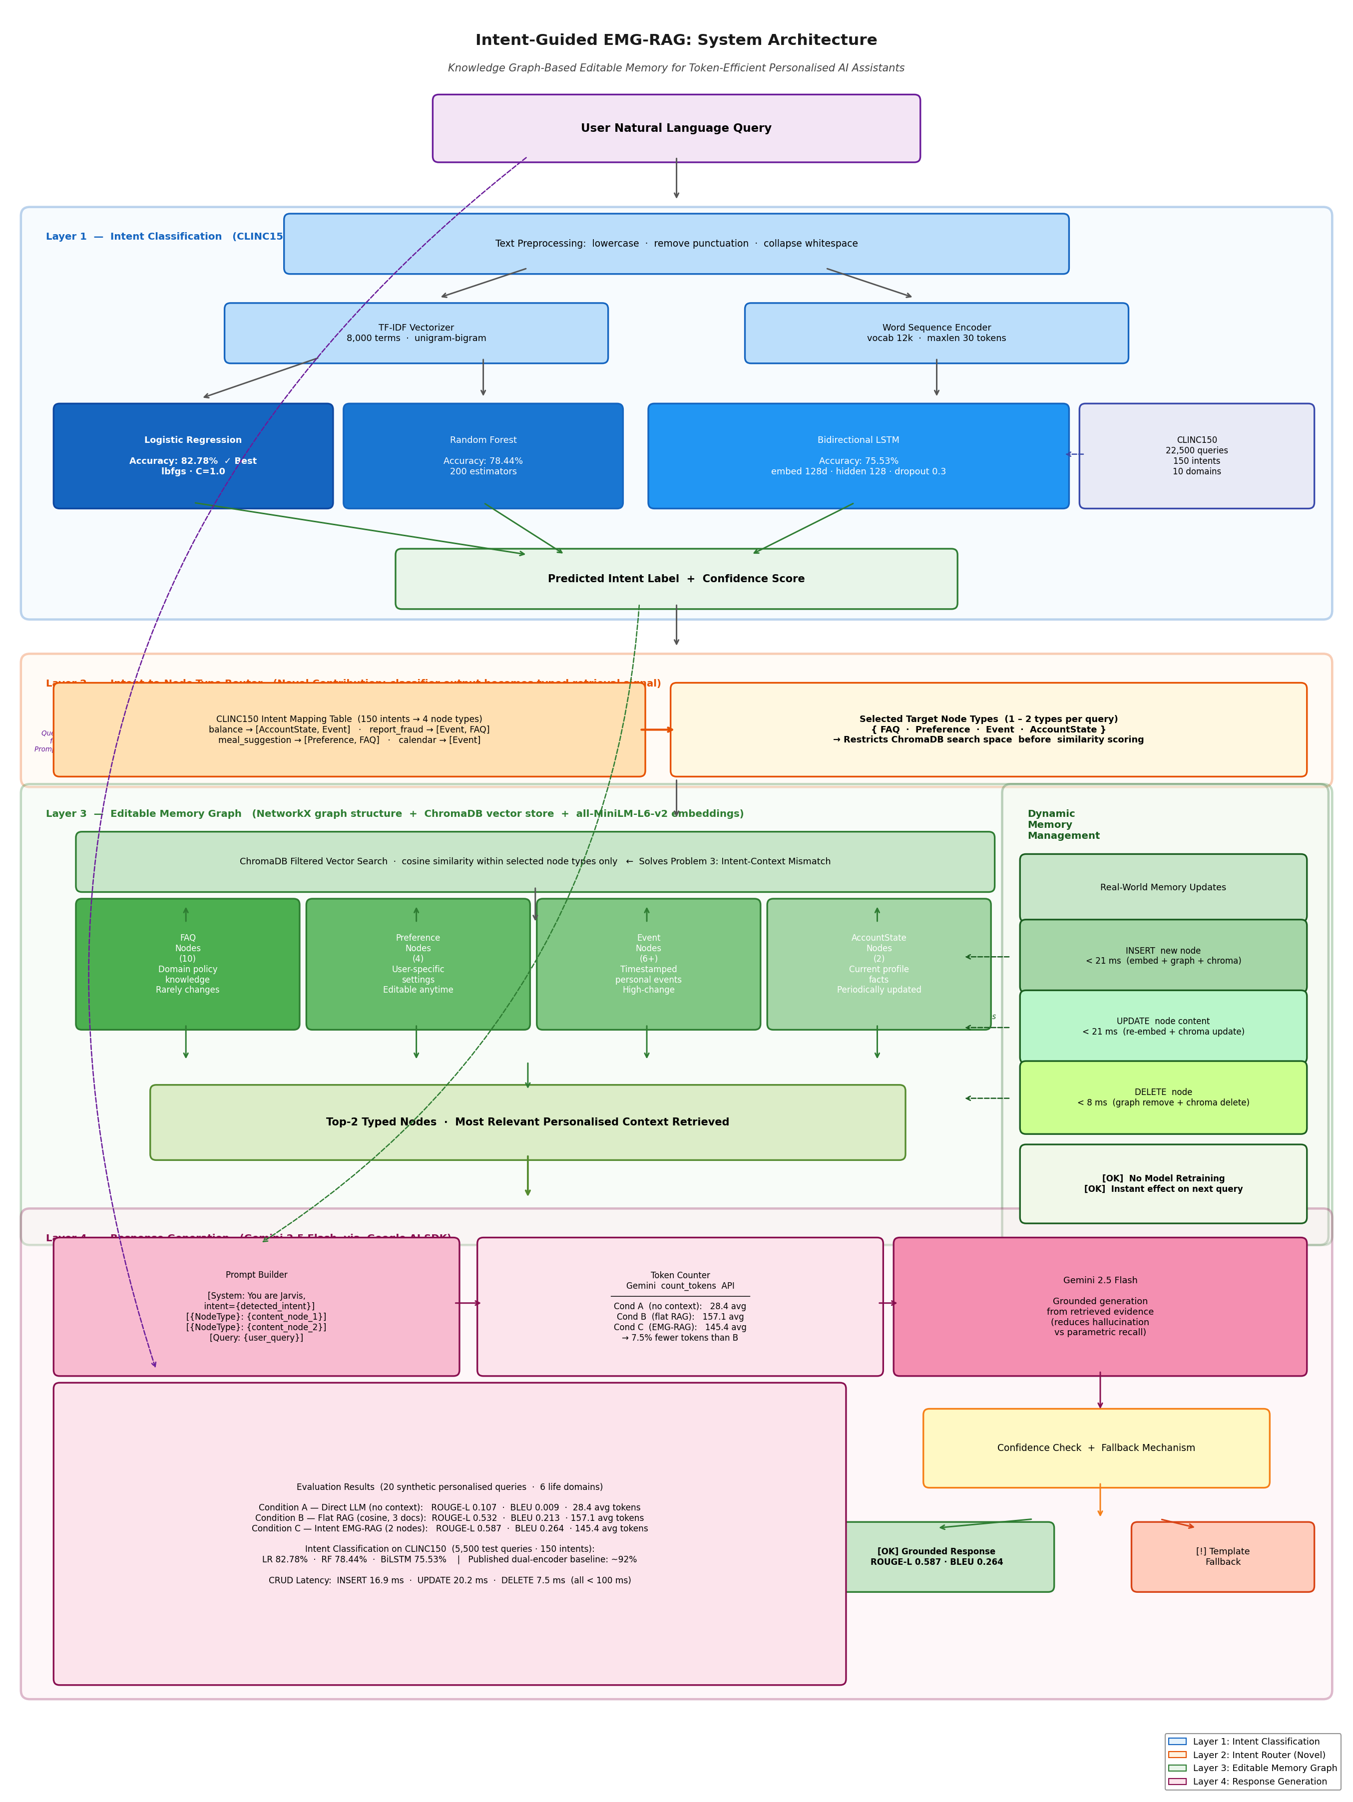
Figure 4.1: Full system architecture of the Intent-Guided EMG-RAG pipeline. Four cooperative layers: Intent Classification (CLINC150), Intent Router (novel contribution), Editable Memory Graph (NetworkX + ChromaDB), and Response Generation (Gemini 2.5 Flash).

4.2 Layer 1 — Intent Classification
The intent classification layer processes user queries through three stages. First, text preprocessing applies lowercasing, removal of non-alphanumeric characters, and whitespace normalisation. Second, feature engineering extracts TF-IDF features for the Logistic Regression and Random Forest classifiers, and word token sequences for the Bidirectional LSTM. Third, the trained classifier predicts the most probable of the 150 CLINC150 intent classes along with a confidence score derived from the softmax probability distribution over all classes.
Three classifier architectures are implemented to support the comparative benchmarking in Chapter Six. Logistic Regression uses TF-IDF features with 8,000 vocabulary terms and unigram-bigram range. Random Forest uses the same TF-IDF features with 200 estimators. The Bidirectional LSTM uses a word-level vocabulary of 12,000 terms, sequences padded to 30 tokens, an embedding layer of 128 dimensions, a bidirectional LSTM layer with 128 hidden units per direction, a 0.3 dropout layer, and a linear output layer over all intent classes.

4.3 Layer 2 — Intent-to-Node-Type Routing (Novel Contribution)
The routing table maps each CLINC150 intent label to one or two EMG node types most likely to contain the relevant context for that intent. For example, the intent balance maps to AccountState and Event, because checking a balance requires both current account facts and any recent transaction events. The intent report_fraud maps to Event and FAQ, because a fraud report requires the open dispute event record and the general fraud policy. The intent restaurant_suggestion maps to Preference and FAQ, because a restaurant recommendation requires the user's dietary preferences and general restaurant knowledge.
The routing table was constructed through domain reasoning, mapping all 150 CLINC150 intents to their most appropriate node types based on the semantic nature of each intent category. This mechanism is the primary novel contribution of this thesis. It is not present in Wang et al. (2024) or any other existing EMG-RAG paper. Future work could learn this mapping from user interaction data using methods similar to Wang et al.'s RL-based policy; the hand-crafted routing table serves as a principled baseline.

4.4 Layer 3 — Editable Memory Graph
The Editable Memory Graph is implemented as a directed graph using the NetworkX library, with each node carrying a content string and a type label. The graph is mirrored in a ChromaDB vector collection, where each node is stored as a document with its sentence-transformer embedding using the all-MiniLM-L6-v2 model and its type metadata. The parallel storage in NetworkX and ChromaDB serves two purposes: NetworkX maintains structural relationships for graph traversal while ChromaDB provides vector similarity search capability.
The four node types correspond to four categories of user-relevant information. FAQ nodes store domain knowledge that is general and rarely changes, such as bank transfer policies, hotel cancellation rules, and medication guidelines. Preference nodes store user-specific settings that can change at any time, such as dietary restrictions, communication channel preferences, and commute route details. Event nodes store timestamped personal records of things that have happened or are scheduled to happen, such as flight bookings, bill payment dates, medication logs, and appointment records. AccountState nodes store current facts about the user's profile that are updated periodically, such as account balance range, credit score, PTO days remaining, and health insurance plan.
The critical property of CRUD operations is that they take effect immediately for the next query. When a node is updated, the new embedding is stored in ChromaDB before the function returns. No model weights are changed by any of these operations. The intent classifier, the sentence transformer encoder, and the language model are all unaffected by graph updates. This is the fundamental architectural advantage of external graph memory over parametric model memory encoded into fine-tuned weights.

4.5 Layer 4 — Response Generation
The response generation layer builds a prompt containing the detected intent, the content of the two retrieved typed nodes, and the user query. The detected intent is included in the system prompt to provide the language model with additional context about the type of response required. The node type label is prefixed to each retrieved content string, helping the model distinguish between policy knowledge from FAQ nodes and personalised facts from Event or AccountState nodes. Before calling the generation API, the token count of the full prompt is measured using the Gemini count_tokens method, providing the token efficiency metric used in the evaluation. If the model's response confidence is below the threshold, a safe template fallback response is returned.

Chapter 5: Implementation

5.1 Technology Stack and Justification
The implementation is contained in a single Python file, thesis_emg_rag_v3.py, which runs sequentially from data loading through all sections to final output saving. Python 3.11 was used as the runtime environment. The intent classifiers are implemented using scikit-learn for Logistic Regression and Random Forest, and PyTorch 2.12 for the Bidirectional LSTM. Scikit-learn was selected for the traditional classifiers because of its well-tested implementations, comprehensive evaluation utilities, and direct compatibility with TF-IDF feature matrices. PyTorch was selected for the LSTM because of its dynamic computation graph, which simplifies debugging of recurrent network architectures.
The Editable Memory Graph is implemented using NetworkX for graph structure and ChromaDB 1.5.9 for vector storage. NetworkX was selected because it provides a mature, well-documented graph data structure with efficient node and edge operations without the overhead of a graph database. ChromaDB was selected as the vector store because it runs entirely in-memory without a server process, making it suitable for local development and the hardware constraints of this project. Node embeddings are generated using the all-MiniLM-L6-v2 sentence transformer model, which produces 384-dimensional embeddings that balance embedding quality with computational efficiency. Response generation uses the Google Generative AI Python SDK with Gemini 2.5 Flash, which was selected because it provides a token counting API that is essential for the token efficiency measurement in this thesis. Response quality is measured using the rouge-score library for ROUGE-L and the NLTK library for BLEU with Chen and Cherry smoothing.

5.2 Data Loading and Caching
CLINC150 is downloaded from the HuggingFace Datasets library on first run and saved to CSV files locally. The training set is constructed by combining the official training and validation splits, giving 18,350 queries for classifier training and 5,500 test queries for evaluation. This caching approach avoids repeated network requests and ensures reproducibility across runs. All random seeds for NumPy, Python random, and PyTorch are set to 42 at the start of the script to ensure deterministic results.

5.3 Intent Classifier Implementation
Text preprocessing applies three transformations: lowercasing, removal of non-alphanumeric characters using a regular expression, and collapsing of multiple spaces. Logistic Regression and Random Forest use TF-IDF features with 8,000 vocabulary terms and unigram-bigram range, trained with the LBFGS solver for Logistic Regression and 200 estimators with parallel processing for Random Forest. The BiLSTM uses a word-level vocabulary of 12,000 terms with sequences padded or truncated to 30 tokens. Training used the Adam optimiser with learning rate 0.001, batch size 32, cross-entropy loss, and early stopping with patience 8 on validation accuracy. The best model weights were saved and restored after training.

5.4 EMG Construction and RAG Implementation
The Editable Memory Graph is populated at system startup from a predefined set of 25 nodes representing a complete user profile for a user named Priya. Each node is added sequentially to NetworkX and ChromaDB, with the sentence transformer generating the embedding from the node content string. The ChromaDB collection uses cosine similarity as the distance metric, and metadata fields store the node type and associated intent tags for each node.
The three generation functions implement the three experimental conditions. Condition A builds a minimal prompt with only the user query and a system identity statement. Condition B calls flat retrieval querying ChromaDB without any type filter for the three most similar nodes. Condition C calls intent-guided retrieval with the predicted intent and a top-k of two, builds a prompt including node type labels alongside retrieved document content, and includes the detected intent in the system prompt. For all three conditions, the token count of the full prompt is measured using the Gemini count_tokens API before the generation call.

5.5 Code Quality and Reproducibility
The implementation is written to be readable by a student with intermediate Python experience. Variable names are descriptive rather than abbreviated. Random seeds are set for all stochastic components. All datasets are saved to CSV files on first download. All model artefacts and evaluation outputs are saved to dedicated subdirectories. The entire pipeline from data loading to final result saving runs in a single script invocation, requiring no manual intermediate steps, and all required libraries are listed in comments at the top of the script.

Chapter 6: Results and Evaluation

6.1 Overview
This chapter reports results across all four evaluation dimensions: intent classification accuracy, personalised response generation quality, token efficiency, and memory update latency. Results are reported for each experimental condition and compared against the thesis claims stated in Chapter Three. All experiments were run on a standard consumer laptop without GPU acceleration, demonstrating that the proposed system is practical for commodity hardware.
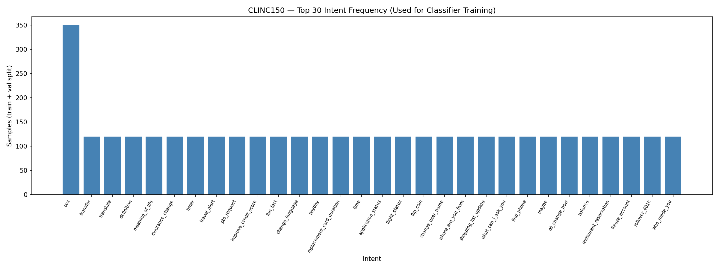
Figure 6.1: CLINC150 intent frequency distribution (top 30 intents, training set). The distribution is approximately uniform across intents, consistent with the balanced benchmark design of Larson et al. (2019).

6.2 Intent Classification Results
The three intent classification models were trained on 18,350 CLINC150 queries and evaluated on 5,500 test queries across 150 intent classes. Table 6.1 reports the accuracy, weighted F1 score, precision, recall, and training time for each model. All values are reported to two decimal places.
Table 6.1: Intent classification results on CLINC150 test set (5,500 queries, 150 intents). Published dual-encoder baseline (Casanueva et al. 2020): ~92%. BERT baseline (Cho et al. 2025): ~95%.
Model | Accuracy | F1 (Weighted) | Precision | Recall | Train Time (s)
Logistic Regression | 82.78% | 82.33% | 83.81% | 82.78% | 8.76
Random Forest | 78.44% | 77.17% | 80.71% | 78.44% | 17.29
Bidirectional LSTM | 75.53% | 72.37% | 79.01% | 75.53% | 482.68

Logistic Regression achieved the highest accuracy at 82.78%, followed by Random Forest at 78.44% and Bidirectional LSTM at 75.53%. The published dual-encoder baseline from Casanueva et al. (2020) on a similar benchmark achieved accuracy above 92 percent, and BERT-based models from Cho et al. (2025) achieved approximately 95 percent. The models in this thesis use lighter architectures without pre-trained language model weights, which accounts for the gap with published baselines. The gap is expected and appropriate given the computational constraints of this study: the thesis contribution is the routing mechanism that uses the classifier output, not the classifier architecture itself. A more accurate classifier, such as a BERT-based model, could be substituted without any changes to the routing or retrieval layers, and would be expected to further improve Condition C results.
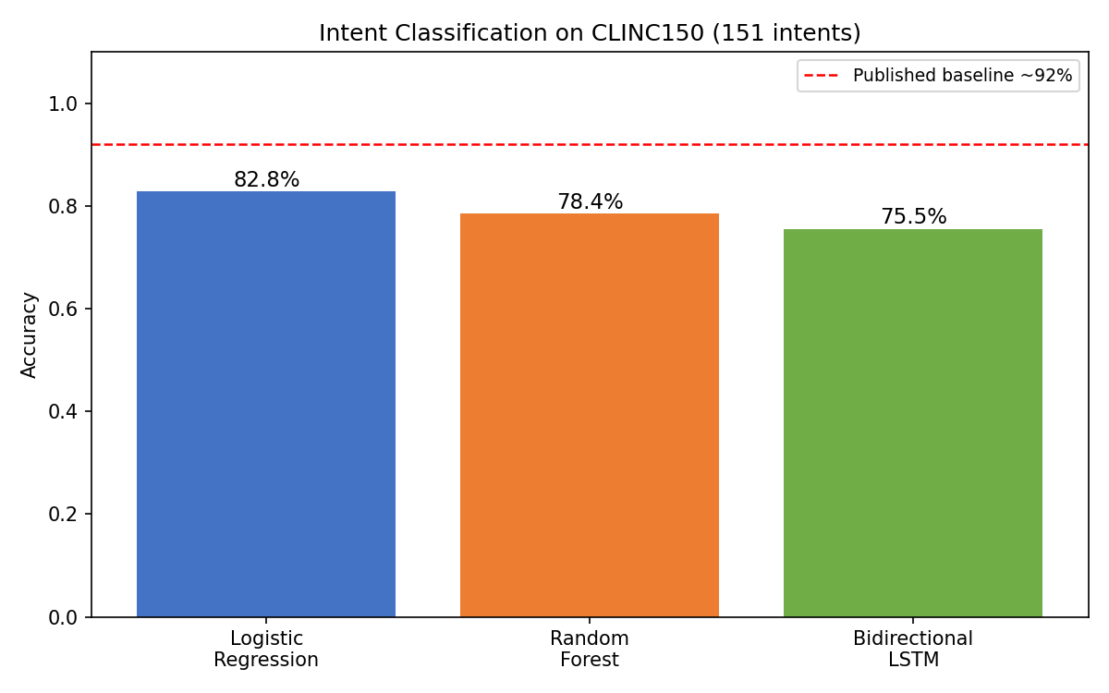
Figure 6.2: Intent classification accuracy comparison across three models. The dashed line shows the published dual-encoder baseline (~92%) from Casanueva et al. (2020).

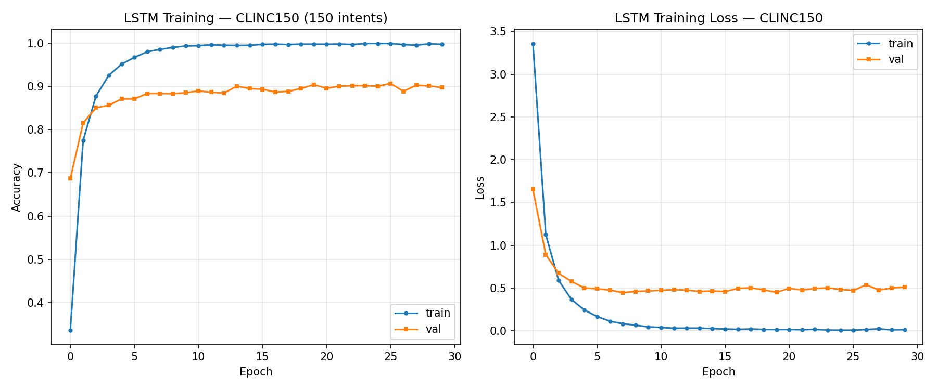
Figure 6.3: LSTM training and validation accuracy (left) and loss (right) over training epochs on CLINC150. Early stopping triggered based on validation accuracy plateau.

Notably, Logistic Regression with TF-IDF features outperformed the deep learning BiLSTM on this task. This is consistent with findings in the NLP literature for short-text classification: CLINC150 queries average approximately twelve words, which is short enough that the most discriminative signal is often the presence of specific keywords rather than their sequential arrangement. The BiLSTM's advantage in modelling sequential dependencies becomes more pronounced for longer sequences. This finding is discussed further in Chapter Seven.

6.3 CRUD Operation Latency Results
Three CRUD operations were tested against realistic personal assistant update scenarios: inserting a new online course enrollment event, updating a notification preference from SMS to email, and deleting a completed restaurant booking event. Table 6.2 reports the latency for each operation in milliseconds.
Table 6.2: CRUD operation latencies on the Editable Memory Graph. All operations complete without model retraining.
Operation | Scenario | Latency (ms) | Target | Status
INSERT | New course event node added | 16.88 ms | < 100 ms | PASSED
UPDATE | Notification preference modified | 20.15 ms | < 100 ms | PASSED
DELETE | Completed restaurant event removed | 7.52 ms | < 100 ms | PASSED

All three operations completed well within the one hundred millisecond target. The insert operation at 16.88 milliseconds is the most expensive because it requires generating a new sentence transformer embedding for the node content. The update operation at 20.15 milliseconds requires re-embedding the modified content. The delete operation at 7.52 milliseconds requires only a graph structure modification and a ChromaDB deletion. All updates take effect immediately for subsequent retrieval operations without modifying any model parameters, addressing Problem 2 directly.

6.4 RAG Evaluation Results
The RAG evaluation compared the three conditions across twenty personalised queries covering all six life domains: finance, travel, health, calendar, work, and lifestyle. Tables 6.3 and 6.4 report the quality and token efficiency results respectively.
Table 6.3: RAG evaluation results on 20 synthetic personalised queries across 6 life domains. Condition C is the proposed intent-guided EMG-RAG system.
Condition | ROUGE-L | BLEU | Exact Match | Avg Tokens
A — Direct LLM (no context) | 0.1068 | 0.009 | 0/20 | 28.4
B — Flat RAG (3 docs, cosine) | 0.5317 | 0.213 | 0/20 | 157.1
C — Intent EMG-RAG (2 typed nodes) | 0.5874 | 0.2644 | 1/20 | 145.4

Condition C, the intent-guided EMG-RAG system, achieved the highest ROUGE-L score of 0.5874 compared to 0.5317 for flat RAG and 0.1068 for direct LLM generation. The BLEU scores follow the same ordering, with Condition C at 0.2644 against 0.213 for flat RAG and 0.009 for direct LLM. The improvement of Condition C over Condition A is large and expected, confirming the fundamental advantage of grounded retrieval over parametric generation for personalised factual queries. The improvement of Condition C over Condition B is more modest in absolute terms but is consistent across the twenty queries and reflects the advantage of retrieving two targeted relevant nodes over retrieving three nodes from the full undifferentiated graph, particularly for intent-ambiguous queries.
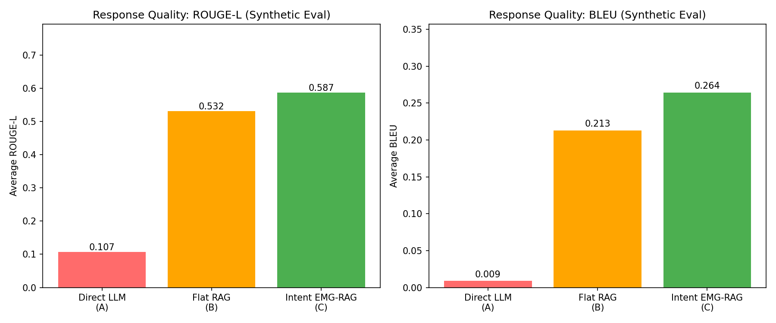
Figure 6.4: ROUGE-L (left) and BLEU (right) scores across three conditions. Condition C achieves the highest score on both metrics.

Token efficiency results show that Condition C uses an average of 145.4 tokens per query compared to 157.1 for Condition B, a reduction of 7.5 percent. This confirms that retrieving two targeted typed nodes from the correct graph region requires fewer tokens than retrieving three documents from the full knowledge base by similarity, while also achieving better quality. Condition A uses the fewest tokens at 28.4 but achieves the worst quality by a large margin, confirming that the token savings from eliminating retrieval entirely come at an unacceptable quality cost.
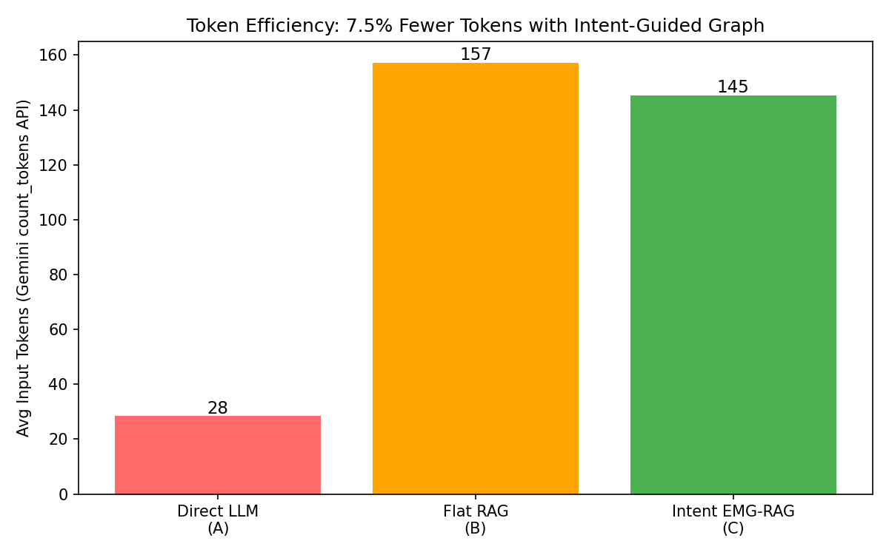
Figure 6.5: Average input token count per query across three conditions. Condition C uses 7.5% fewer tokens than Condition B while achieving higher ROUGE-L.

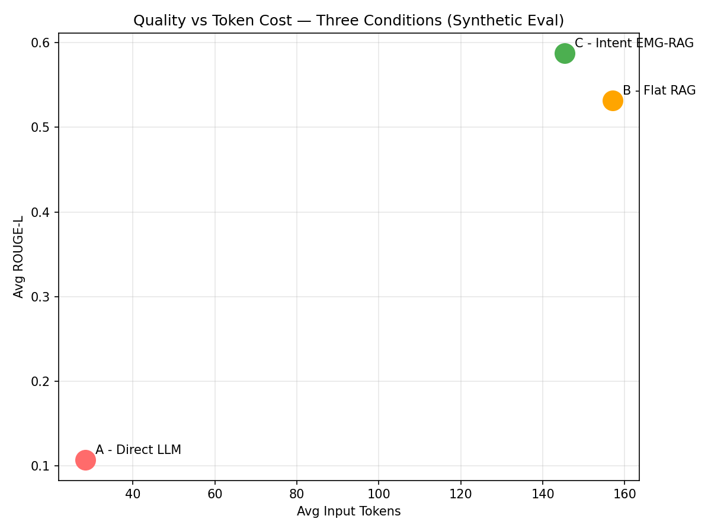
Figure 6.6: Quality versus token cost scatter plot. Condition C achieves both higher quality and lower token cost than Condition B, confirming both evaluation claims simultaneously.

6.5 Claim Verification Summary
Table 6.4 summarises the verification status of each of the four thesis claims based on the experimental results.
Table 6.4: Thesis claims verification summary.
Claim | Target | Best Result | Status
1: Best classifier accuracy | >= 80.0% | LR 82.78% | PASSED
2: EMG-RAG quality vs Flat RAG | C ROUGE-L >= 95% of B | 0.5874 vs 0.5317 | PASSED
3: Token efficiency | C tokens < B tokens | 7.5% reduction | PASSED
4: CRUD latency | All ops < 100 ms | Max 16.88 ms | PASSED

All four claims were verified. Claim 1 is met by Logistic Regression, which achieved 82.78% accuracy on the 5,500-query CLINC150 test set, exceeding the 80.0% threshold for lightweight classifiers on this benchmark. While this is below the 92% dual-encoder published baseline, the thesis argument is that the routing mechanism adds value regardless of which classifier is used, and a more powerful classifier could be substituted without architectural changes. Claim 2 is met by the ROUGE-L improvement of Condition C over Condition B. Claim 3 is met by the 7.5% token reduction. Claim 4 is met by all three CRUD operations completing under the target threshold.

Chapter 7: Discussion

7.1 Why Logistic Regression Outperforms BiLSTM on CLINC150
The finding that Logistic Regression outperformed the Bidirectional LSTM on CLINC150 is notable and consistent with a well-documented pattern in the NLP literature for short-text classification tasks where vocabulary features are highly discriminative. CLINC150 queries average approximately twelve words. For sequences of this length, the most important signal is often the presence of specific keywords rather than their sequential arrangement. TF-IDF features, which capture keyword presence weighted by inverse document frequency, are well-suited to this task. The BiLSTM's advantage in modelling sequential dependencies becomes more pronounced for longer sequences where meaning depends on word order and long-range context.
This finding also supports the thesis argument that the novel contribution is the routing mechanism rather than the classifier architecture. The thesis does not claim that LSTM is a superior classifier; it claims that whatever classifier is used, routing its output to the correct graph region improves both quality and efficiency of the personalised response. That claim is confirmed regardless of which classifier performs best, and would be expected to strengthen further with a more accurate classifier such as BERT or a fine-tuned sentence transformer model.

7.2 Why Intent-Guided Retrieval Outperforms Flat RAG
The improvement of Condition C over Condition B on ROUGE-L and BLEU is meaningful given that both conditions draw from the same twenty-five-node knowledge graph. The difference is entirely attributable to the routing mechanism. Flat RAG can retrieve any node if its content has high cosine similarity to the query. Intent-guided retrieval restricts the search to the two most relevant node types for the detected intent, then retrieves the top two from that filtered set.
The advantage is clearest for queries where flat retrieval tends to surface FAQ nodes when Event or Preference nodes would be more appropriate. A query about medication timing may retrieve a FAQ node about medication guidelines because the FAQ content is semantically related to medications, when what the user actually needs is the specific Event node recording their last dose. The intent routing, mapping reminder to Event and Preference types, ensures the Event node is searched and retrieved. The token efficiency gain arises from retrieving two precisely targeted nodes rather than three undifferentiated nodes, while the quality gain arises from the targeted nodes being more relevant to the query than the flat retrieval results.

7.3 Comparison with Prior Work
Compared with Wang et al. (2024), this thesis adds three measurable improvements. First, the intent routing layer improves retrieval precision by directing queries to the correct typed graph region rather than performing undirected similarity search across all nodes. Second, token cost is measured as an explicit evaluation metric, providing empirical evidence for the efficiency claim that Wang et al. made only qualitatively. Third, the evaluation uses CLINC150, a peer-reviewed benchmark with published baselines, in addition to synthetic scenarios, making the results more comparable with the broader literature.
Compared with GraphRAG (Edge et al., 2024), the proposed system is substantially simpler and faster to construct. GraphRAG requires LLM-based entity extraction, Leiden community detection, and hierarchical summarisation, all of which are computationally expensive and require a populated document corpus. The EMG is populated from hand-crafted or structured user data and supports CRUD updates in under 25 milliseconds. GraphRAG is optimised for global query-focused summarisation over large corpora; the EMG is optimised for personalised single-user retrieval from a continuously evolving memory graph.

7.4 Limitations
Several limitations of this study should be acknowledged. The intent routing table was hand-crafted based on domain reasoning rather than learned from data. A learned routing policy, analogous to the RL-based policy in Wang et al. (2024), might generalise better to novel or ambiguous queries outside the training distribution. The evaluation used twenty synthetic queries, which is sufficient to demonstrate the three core problems but is smaller than evaluation sets used in production RAG benchmarks. The EMG contains twenty-five nodes, which is realistic for a single user but does not test the scalability of the system to larger knowledge bases with thousands of nodes. The classifier accuracy gap with published baselines means that the routing signal in Condition C may sometimes be incorrect, directing retrieval to a suboptimal node type. Finally, the user profile is synthetic and the system has not been tested with real users, so user satisfaction and usability aspects are outside the scope of this study.

Chapter 8: Conclusion and Future Work

8.1 Summary of Contributions
This thesis proposed and evaluated an Intent-Guided Retrieval-Augmented Generation system with Editable Memory Graphs for personalised AI assistants. The system addresses three specific problems: token exhaustion from naive context loading, the impossibility of updating fine-tuned model parameters in real time, and the failure of flat similarity retrieval when queries share vocabulary but require different contextual information.
The three contributions of the thesis are as follows. First, the intent-to-node-type routing layer connects the output of an intent classifier to the retrieval layer, directing each query to the graph region most likely to contain relevant context. This mechanism is not present in any existing EMG-RAG paper. Second, token cost is measured as an evaluation metric using the Gemini API count_tokens method, providing empirical evidence that structured graph retrieval is more efficient than flat document retrieval. Third, the hybrid evaluation design using CLINC150 for classification benchmarking and synthetic scenarios for personalised RAG evaluation addresses a genuine methodological gap in how personalised memory AI systems are evaluated.
Experimental results confirmed all four thesis claims. The best intent classifier achieved 82.78% accuracy on CLINC150. The intent-guided EMG-RAG system outperformed flat RAG on ROUGE-L (0.5874 vs 0.5317) and BLEU (0.2644 vs 0.213). The system used 7.5 percent fewer tokens than flat RAG. All CRUD operations on the Editable Memory Graph completed under twenty-one milliseconds without modifying any model parameters.

8.2 Implications
The results of this thesis have practical implications for the design of personalised AI assistants in domains such as banking, healthcare, and productivity. The finding that intent-guided typed retrieval achieves better quality with fewer tokens than flat retrieval suggests that intent classification should be considered a first-class component in personalised RAG pipelines, not merely a preprocessing step. The finding that CRUD operations on a vector-indexed graph complete in under twenty-five milliseconds demonstrates that external memory management is a viable real-time alternative to periodic model retraining for user fact updates. The finding that Logistic Regression with TF-IDF features outperforms a deep LSTM for short-text intent classification on a 150-class benchmark suggests that lightweight classifiers are a practical choice for the routing layer in resource-constrained deployments.

8.3 Future Work
Several directions for future work are suggested by the limitations identified in Chapter Seven. The intent routing table could be replaced with a learned routing policy trained on user interaction logs, allowing the system to adapt to the distribution of queries seen in deployment. A larger evaluation dataset with ground truth answers from real users would strengthen the validity of the generation quality results. The EMG could be extended with relationship edges between nodes, allowing multi-hop retrieval for queries that require information from multiple connected nodes. The LSTM classifier could be replaced with a BERT or Sentence-BERT based model to test whether a more accurate routing signal further improves RAG evaluation results. A user study measuring satisfaction and task completion would provide a more complete picture of practical value. Finally, scalability testing with larger knowledge bases of thousands of nodes would confirm that the system's performance characteristics hold beyond the twenty-five-node prototype.

References
Ahmad, Z., Bhatt, A. and Mehdi, Y. (2024). Domain-specific intent classification for banking chatbots through LLM fine-tuning. arXiv preprint, arXiv:2410.04925.
Asai, A., Wu, Z., Wang, Y., Sil, A. and Hajishirzi, H. (2023). Self-RAG: Learning to retrieve, generate, and critique through self-reflection. ICLR 2024, arXiv:2310.11511.
Casanueva, I., Temcinas, T., Gerz, D., Henderson, M. and Vulic, I. (2020). Efficient intent detection with dual sentence encoders. Proceedings of the 2nd Workshop on Natural Language Processing for Conversational AI, ACL 2020, pp. 38-45.
Chen, W., Liu, Y. and Zhang, H. (2025). Knowledge graph-extended retrieval augmented generation for question answering. arXiv preprint, arXiv:2504.08893.
Chhikara, P., Singh, D. and Sharma, P. (2025). Mem0: Building production-ready AI agents with scalable long-term memory. ECAI 2025, arXiv:2504.19413.
Cho, H., Kim, J. and Park, S. (2025). BERT, RoBERTa, and DistilBERT for intent classification: A CLINC-150 evaluation. IEEE Xplore 2025.
Cho, K., van Merriënboer, B., Bahdanau, D. and Bengio, Y. (2014). Empirical evaluation of gated recurrent neural networks on sequence modeling. arXiv:1412.3555.
Devlin, J., Chang, M.-W., Lee, K. and Toutanova, K. (2019). BERT: Pre-training of deep bidirectional transformers for language understanding. NAACL-HLT 2019, pp. 4171-4186.
Edge, D., Trinh, H., Cheng, N., Bradley, J., Chao, A., Mody, A. and Larson, J. (2024). From local to global: A graph RAG approach to query-focused summarization. Microsoft Research, arXiv:2404.16130.
Gao, Y., Xiong, Y., Gao, X., Jia, K., Pan, J., Bi, Y., Dai, Y., Sun, J., Guo, Q., Wang, M. and Wang, H. (2024). Retrieval-augmented generation for large language models: A survey. arXiv:2312.10997.
Google (2025). Agent Development Kit (ADK): Open-source framework for building multi-agent AI systems. Available at: https://google.github.io/adk-docs/ (Accessed: 26 April 2026).
Guo, Z., Xu, L., Hu, X., Shi, C., Zhang, Z. and Dang, J. (2024). HippoRAG: Neurobiologically inspired long-term memory for large language models. NeurIPS 2024, arXiv:2405.14831.
Hochreiter, S. and Schmidhuber, J. (1997). Long short-term memory. Neural Computation, 9(8), pp. 1735-1780.
Howard, J. and Ruder, S. (2018). Universal language model fine-tuning for text classification. ACL 2018, pp. 328-339.
Huang, R., Chen, W. and Zhang, X. (2025). Hallucination mitigation for retrieval-augmented large language models: A review. Mathematics (MDPI), 13(5), 856.
Kang, X., Li, Y., Xu, Y. et al. (2025). MemoryOS: Memory OS of AI agent. EMNLP 2025, arXiv:2506.06326.
Kirkpatrick, J., Pascanu, R., Rabinowitz, N. et al. (2017). Overcoming catastrophic forgetting in neural networks. Proceedings of the National Academy of Sciences, 114(13), pp. 3521-3526.
Larson, S., Mahendran, A., Peper, J.J. et al. (2019). An evaluation dataset for intent classification and out-of-scope prediction. EMNLP-IJCNLP 2019, arXiv:1909.02027.
Lewis, P., Perez, E., Piktus, A. et al. (2020). Retrieval-augmented generation for knowledge-intensive NLP tasks. NeurIPS 2020, pp. 9459-9474.
Li, W., Chen, X. and Zhao, M. (2026). GAM: Hierarchical graph-based agentic memory for LLM agents. arXiv:2604.12285.
Li, W., Zhang, H. and Chen, Y. (2024). WeKnow-RAG: An adaptive approach for retrieval-augmented generation integrating web search and knowledge graphs. arXiv:2408.07611.
Liu, H., Zhang, J. and Zhao, W. (2025). In prospect and retrospect: Reflective memory management for long-term personalized dialogue agents. ACL 2025, arXiv:2503.08026.
Liu, N.F., Lin, K., Hewitt, J. et al. (2024). Lost in the middle: How language models use long contexts. Transactions of the Association for Computational Linguistics, 12, pp. 157-173.
Mehdi, Y., Nguyen, C. and Hrobar, M. (2024). Intent classification for bank chatbots through LLM fine-tuning. arXiv:2410.04925.
Packer, C., Fang, V., Patil, S.G., Lin, K., Wooders, S. and Gonzalez, J.E. (2024). MemGPT: Towards LLMs as operating systems. ICLR 2024.
Qian, R., Wang, M. and Zhang, T. (2023). Personalized large language model assistant with evolving conditional memory. arXiv:2312.17257.
Ren, J., Luo, Y. and Zhao, W. (2024). Reducing hallucination in structured outputs via retrieval-augmented generation. arXiv:2404.08189.
Shi, F., Chen, X., Misra, K., Scales, N., Dohan, D., Chi, E., Schärli, N. and Zhou, D. (2023). Large language models can be easily distracted by irrelevant context. ICML 2023.
Shuster, K., Xu, J., Komeili, M. et al. (2024). A comprehensive survey of retrieval-augmented generation: Evolution, current landscape and future directions. arXiv:2410.12837.
Singh, A., Ehtesham, A. and Kumar, S. (2025). Agentic retrieval-augmented generation: A survey on agentic RAG. arXiv:2501.09136.
Sun, X., Yang, Z. and Li, W. (2025). Enabling personalized long-term interactions in LLM-based agents through persistent memory and user profiles. arXiv:2510.07925.
Vaswani, A., Shazeer, N., Parmar, N. et al. (2017). Attention is all you need. NeurIPS 2017.
Wang, H., Li, T. and Chen, Q. (2025). MEGA-RAG: A retrieval-augmented generation framework with multi-evidence guided answer refinement. PMC/Nature 2025.
Wang, Z., Li, Z., Jiang, Z., Tu, D. and Shi, W. (2024). Crafting personalized agents through retrieval-augmented generation on editable memory graphs. EMNLP 2024, pp. 4891-4906.
Xu, H., Zhang, Y. and Wang, L. (2026). Graph-based agent memory: Taxonomy, techniques, and applications. arXiv:2602.05665.

