**G. SUDEEP ARYAN**

**How to Build a Mobile Control Quadcopter Using Arduino (UNO)**

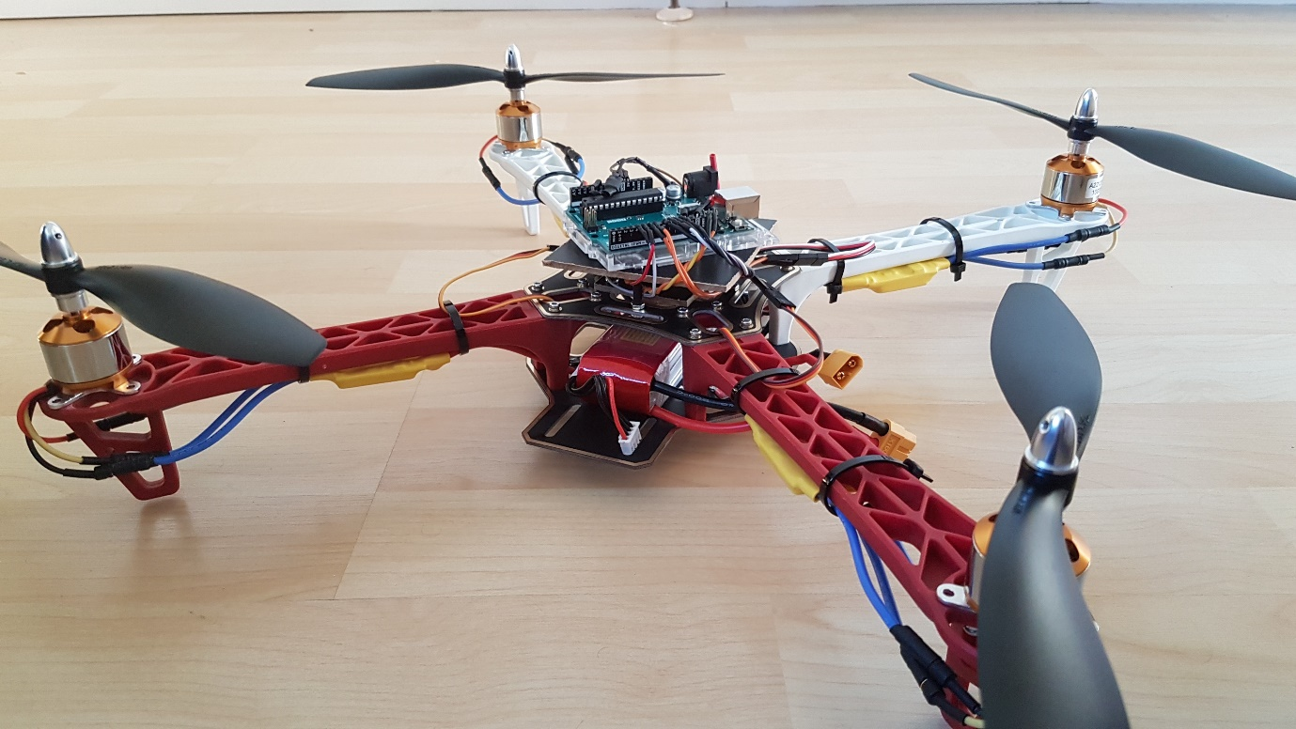

Making a drone these is a simple task these days,but it will cost you so much .So I am going to tell you how to build a quadcopter using Arduino with low cost and also this drone is fully homemade .You don't need to buy any flight controller boards or transmitters.

Before going to project first we should know how a quadcopter works.

The movement of a drone seems quite complicated as it has four motors to enable all movements.

But in reality its quite simple and intuitive drone can move four degrees of freedom which means it can translate in three directions and one rotation

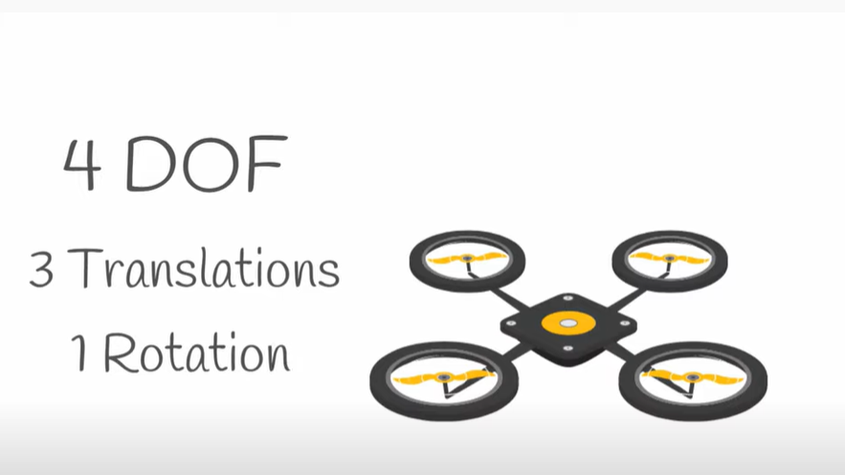

in one as two propellers of a quadcopter rotate in clockwise direction and other two rotate in the counter clockwise direction this generates a zero angular momentum that allows the drone to stay stationary rather than rotating in one direction

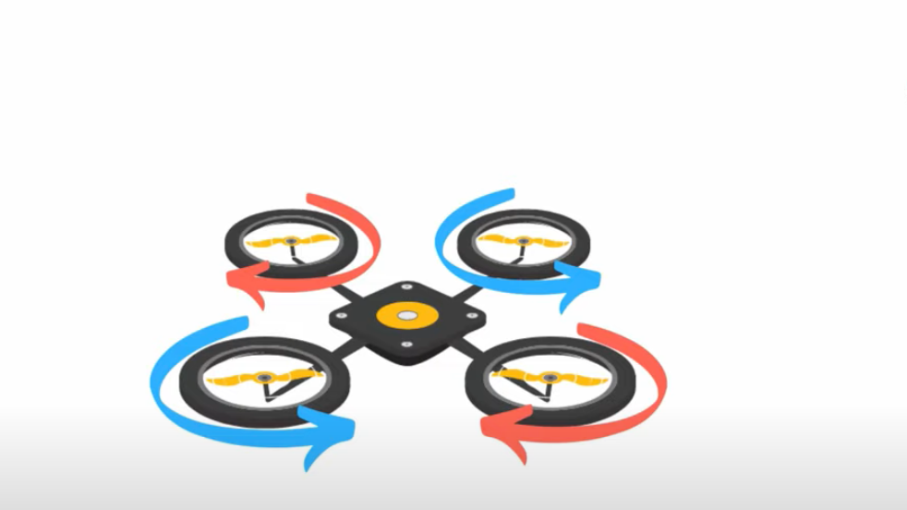

Lets have a look at the first translation movements first we will run all the motor with same speed that will generate the lift greater than the weight of the drone these will cause the drone to move up this is the phase translational movement

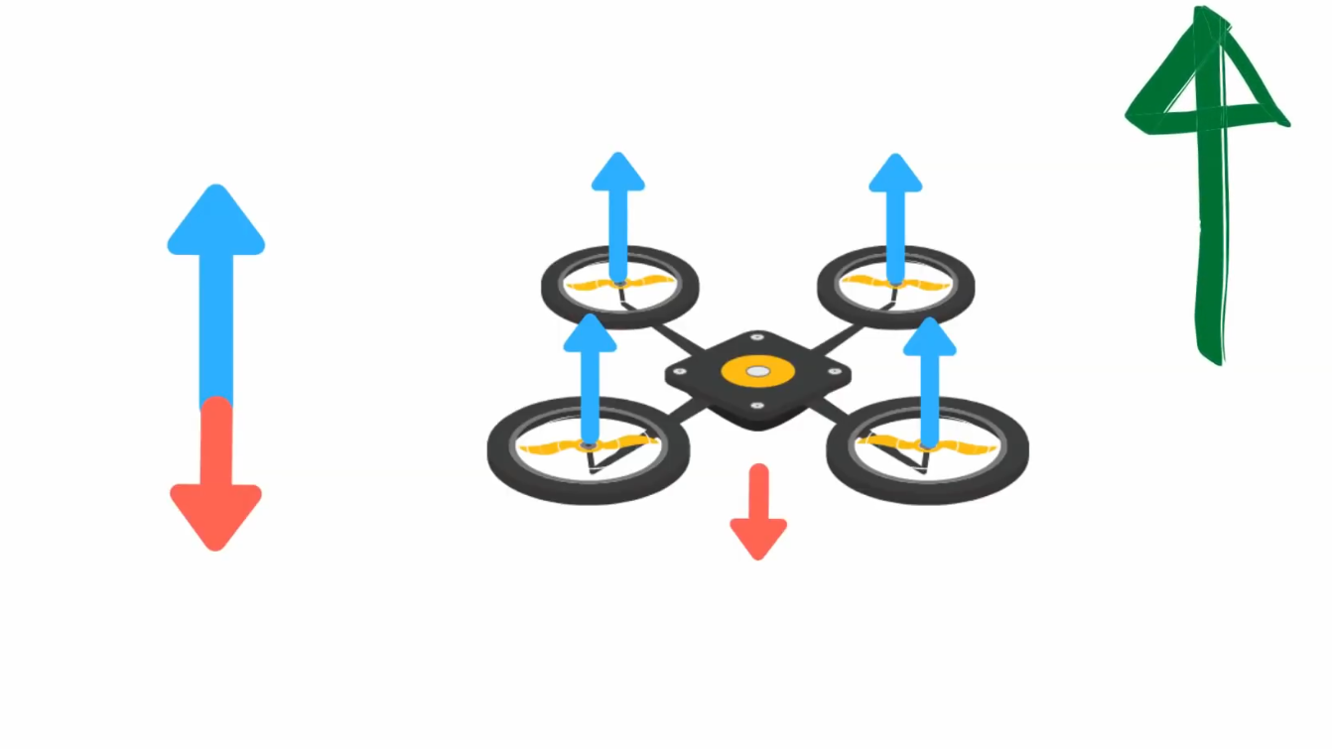

if we want to go down we will decrease the speed of all motor so that the lift is less than the weight of the drone if we want to hover in air we will change the speed of the motors so that the lift is equal to the weight of the drone this will allow the drone to hover above the ground

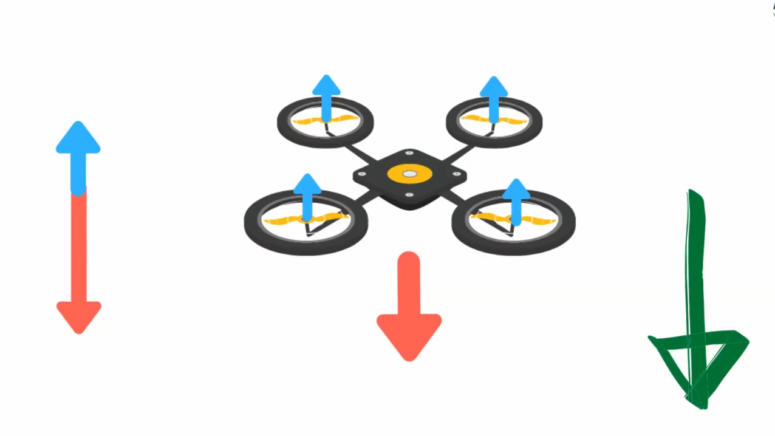

Now coming to second translation we want to move left motors we will reduce the speed of the left motor and increase the speed of the right motors to move towards right we will decrease the speed of the right motors and increase the speed of left motors

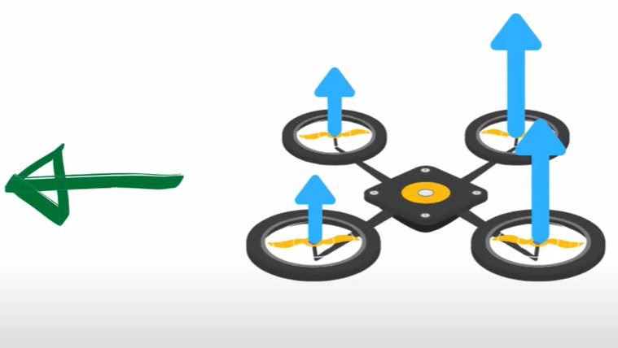

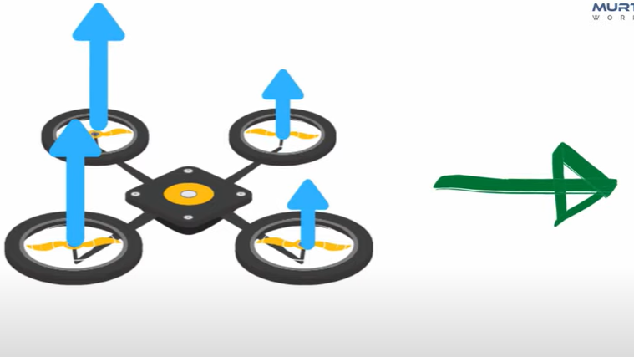

Similarly we can translate in third direction which is moving forward and backward direction by decreasing the speed of the front Motors and increasing the speed of the back motors the drone will move forward

For moving backwards we can decreases the speed of the back motors and increase the speed of the front motors since two motors are rotating clockwise and other two motors are in counter clockwise direction we can use these knowledge to rotate our drone .

to rotate the drone clockwise we will decrease the speed of the motors moving clockwise and increase the speed of the motors moving counter clockwise

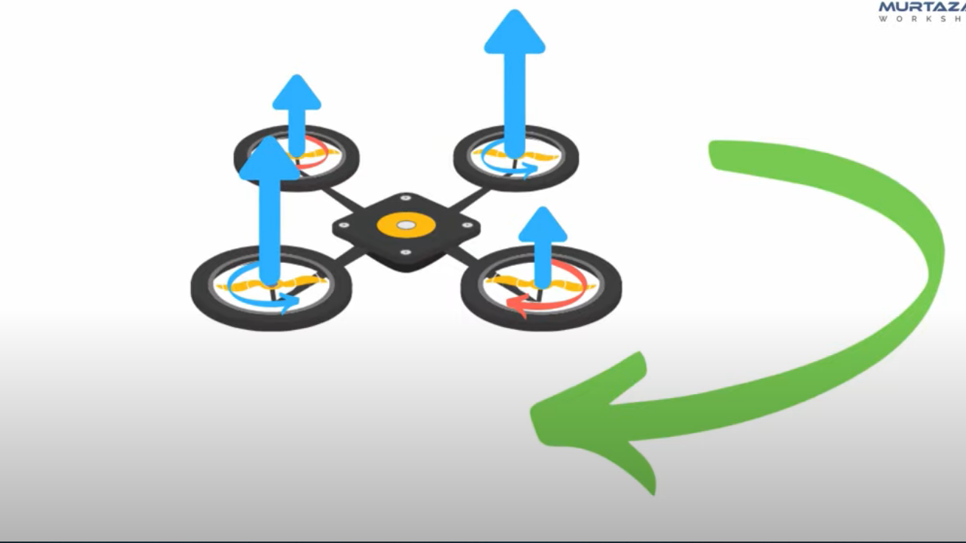

Similarly if we want to rotate counter clock wise we will decrease the speed of the counter clock wise motor and increases the speed of clock wise motors

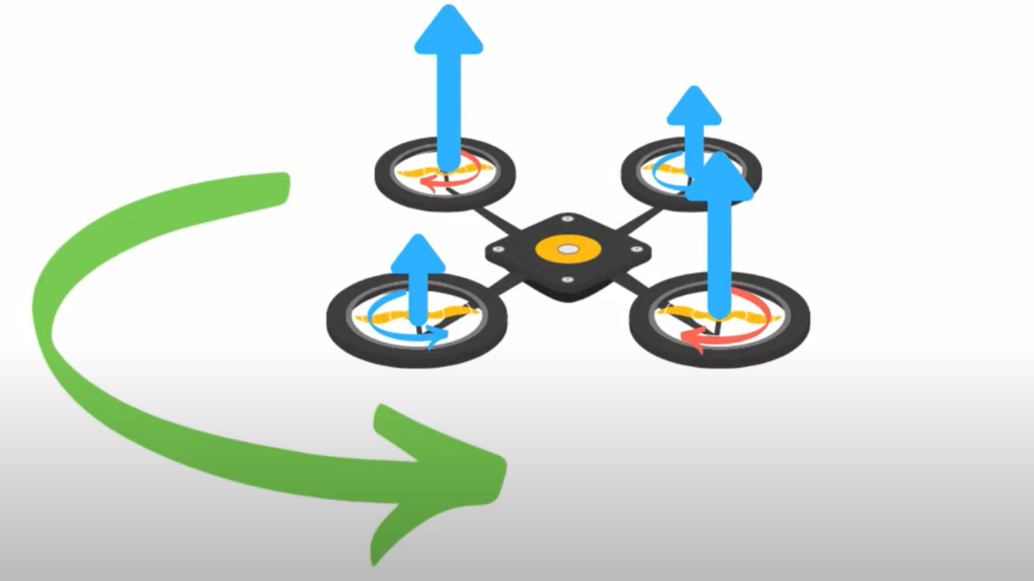

now we understand how the drone flies lets have a look at the drone we will be using for the project.

**We need these items to make the drone,**

* **For the drone-**

**1. Frame**– 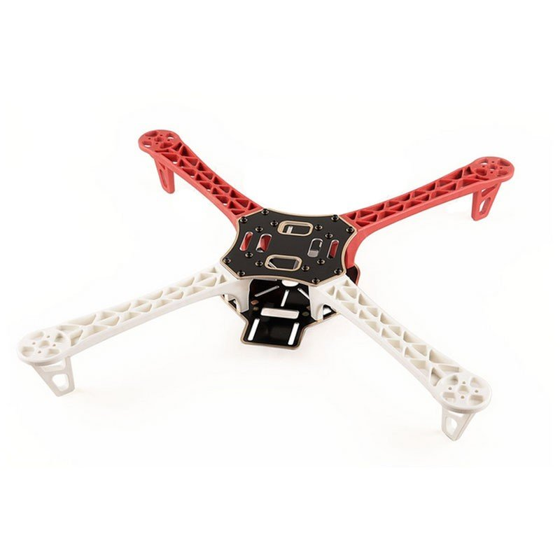The “backbone” of the quadcopter. The frame is what keeps all the parts of the helicopter together. It has to be study, but on the other hand, it also has to be light so that the motors and the batteries don’t struggle to keep it in the air.

**2. Motors**–

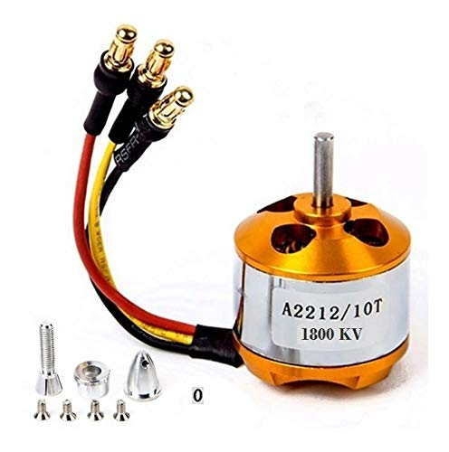

The thrust that allows the Quadcopter to get airborne is provided by Brushless DC motors and each of them is separately controlled by an electronic speed controller or ESC. Four Brushless DC motors are used for a Quadcopter which are fixed with the Frame kit.

**3.ESCs**–

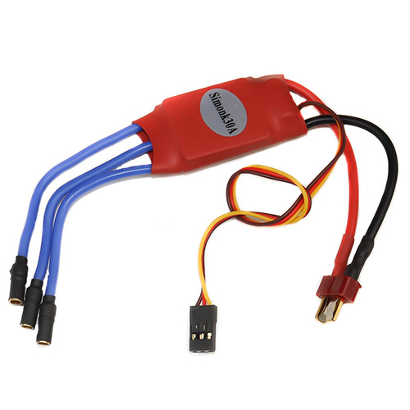

Electronic Speed Controller is like a nerve that delivers the movement information from the brain (flight controller) to the arm or leg muscles (motors). It regulates how much power the motors get, which determines the speed and direction changes of the quadcopter.

**3.Propellers** –

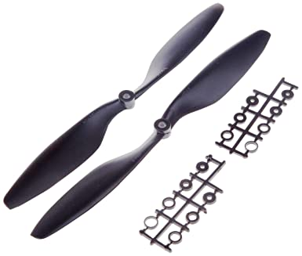

Depending on the type of a quad, you can use 9 to 10 or 11-inch props (for stable, aerial photography flights), or 5-inch racing props for less thrust but more speed. Now we are using 10-inch propeller.

## **Battery**– Depending on your setup maximum voltage level, you can choose from 7.4, 11.1V,14.8V,18.5V or even 22.2V batteries. You will need a 11.1V battery. You could go with the 22.2 V if you are building a racing quad and you want the motors to spin a lot faster. Now we are using 6S 22.2V 3500mAh RC Lipo Battery 35C 70C.

**Arduino board(UNO)**

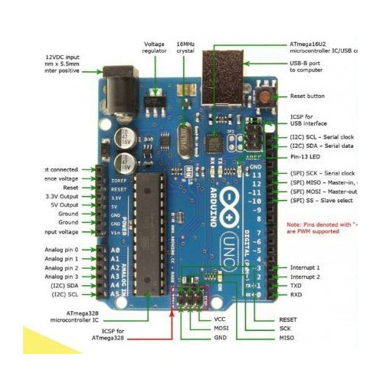

Bluetooth module:-

**It manages the communication channel of the wireless part**. The Bluetooth modules can transmit and receives the data wirelessly by using two devices.

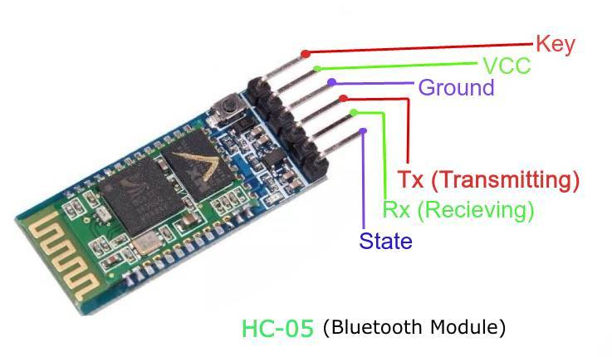

**IMU (MPU 6050)** – A board that is basically (depending on your choice) a sum of various sensors that help your quad know where it is and how to level itself. But we are not using these because IMU is inbuilt for these frame.

**SOFTWARE**:-

The type of software which I used for the quadcopter is Arduino. <https://www.arduino.cc/en/software.> Download and install the app in your desktop so that you can compile and run the program.

**CODE**:

#include<Servo.h>

Servo myservo1;

Servo myservo2;

Servo myservo3;

Servo myservo4;

int FR_SERVO = 11;

int FL_SERVO = 10;

int BR_SERVO = 6;

int BL_SERVO = 5;

int throttle = 0;

void setup()

{

myservo1.attach(FR_SERVO);

myservo1.write(10);

delay(3000);

myservo2.attach(FL_SERVO);

myservo1.write(10);

delay(3000);

myservo3.attach(BR_SERVO);

myservo1.write(10);

delay(3000);

myservo4.attach(BL_SERVO);

myservo1.write(10);

delay(3000);

Serial.begin(9600);

Serial.println("Setup Initializing...");

/* if ((myservo.attached(FR_SERVO)== HIGH)&&(myservo.attached(FL_SERVO)== HIGH)&&(myservo.attached(BR_SERVO)== HIGH)&&(myservo.attached(BL_SERVO)== HIGH))

{

Serial.println("All Servos are connected, READY TO GO...");

}

else

{

Serial.println("Servos are not connected");

}

*/

}

void loop()

{

if (Serial.available())

{

char c =Serial.read();

Serial.println(c);

if(c=='1')

{

myservo1.write(40);

myservo2.write(40);

myservo3.write(40);

myservo4.write(40);

delay(15);

Serial.println("Servo angle = 40 degrees");

}

else if(c=='2')

{

myservo1.write(45);

myservo2.write(45);

myservo3.write(45);

myservo4.write(45);

delay(15);

Serial.println("Servo angle = 45 degrees");

}

else if(c=='3')

{

myservo1.write(50);

myservo2.write(50);

myservo3.write(50);

myservo4.write(50);

delay(15);

Serial.println("Servo angle = 50 degrees");

}

else if(c=='4')

{

myservo1.write(55);

myservo2.write(55);

myservo3.write(55);

myservo4.write(55);

delay(15);

Serial.println("Servo angle = 55 degrees");

}

else if(c=='5')

{

myservo1.write(60);

myservo2.write(60);

myservo3.write(60);

myservo4.write(60);

delay(15);

Serial.println("Servo angle = 60 degrees");

}

else if(c=='6')

{

myservo1.write(65);

myservo2.write(65);

myservo3.write(65);

myservo4.write(65);

delay(15);

Serial.println("Servo angle = 65 degrees");

}

else if(c=='7')

{

myservo1.write(85);

myservo2.write(85);

myservo3.write(85);

myservo4.write(85);

delay(15);

Serial.println("Servo angle = 85 degrees");

}

else if(c=='8')

{

myservo1.write(100);

myservo2.write(100);

myservo3.write(100);

myservo4.write(100);

delay(15);

Serial.println("Servo angle = 100 degrees");

}

else if(c=='9')

{

myservo1.write(115);

myservo2.write(115);

myservo3.write(115);

myservo4.write(115);

delay(15);

Serial.println("Servo angle = 115 degrees");

}

else if(c=='q')

{

myservo1.write(130);

myservo2.write(130);

myservo3.write(130);

myservo4.write(130);

delay(15);

Serial.println("Servo angle = 130 degrees");

}

else if(c=='0')

{

myservo1.write(0);

myservo2.write(0);

myservo3.write(0);

myservo4.write(0);

delay(15);

Serial.println("Servo angle = 0 degrees");

}

else

{

Serial.println("Nothing");

}

}

}