Create a well-documented DOCX or PDF file in your repository, including:

* 1. Screenshots of your GUI layout with your name, student ID, and date.

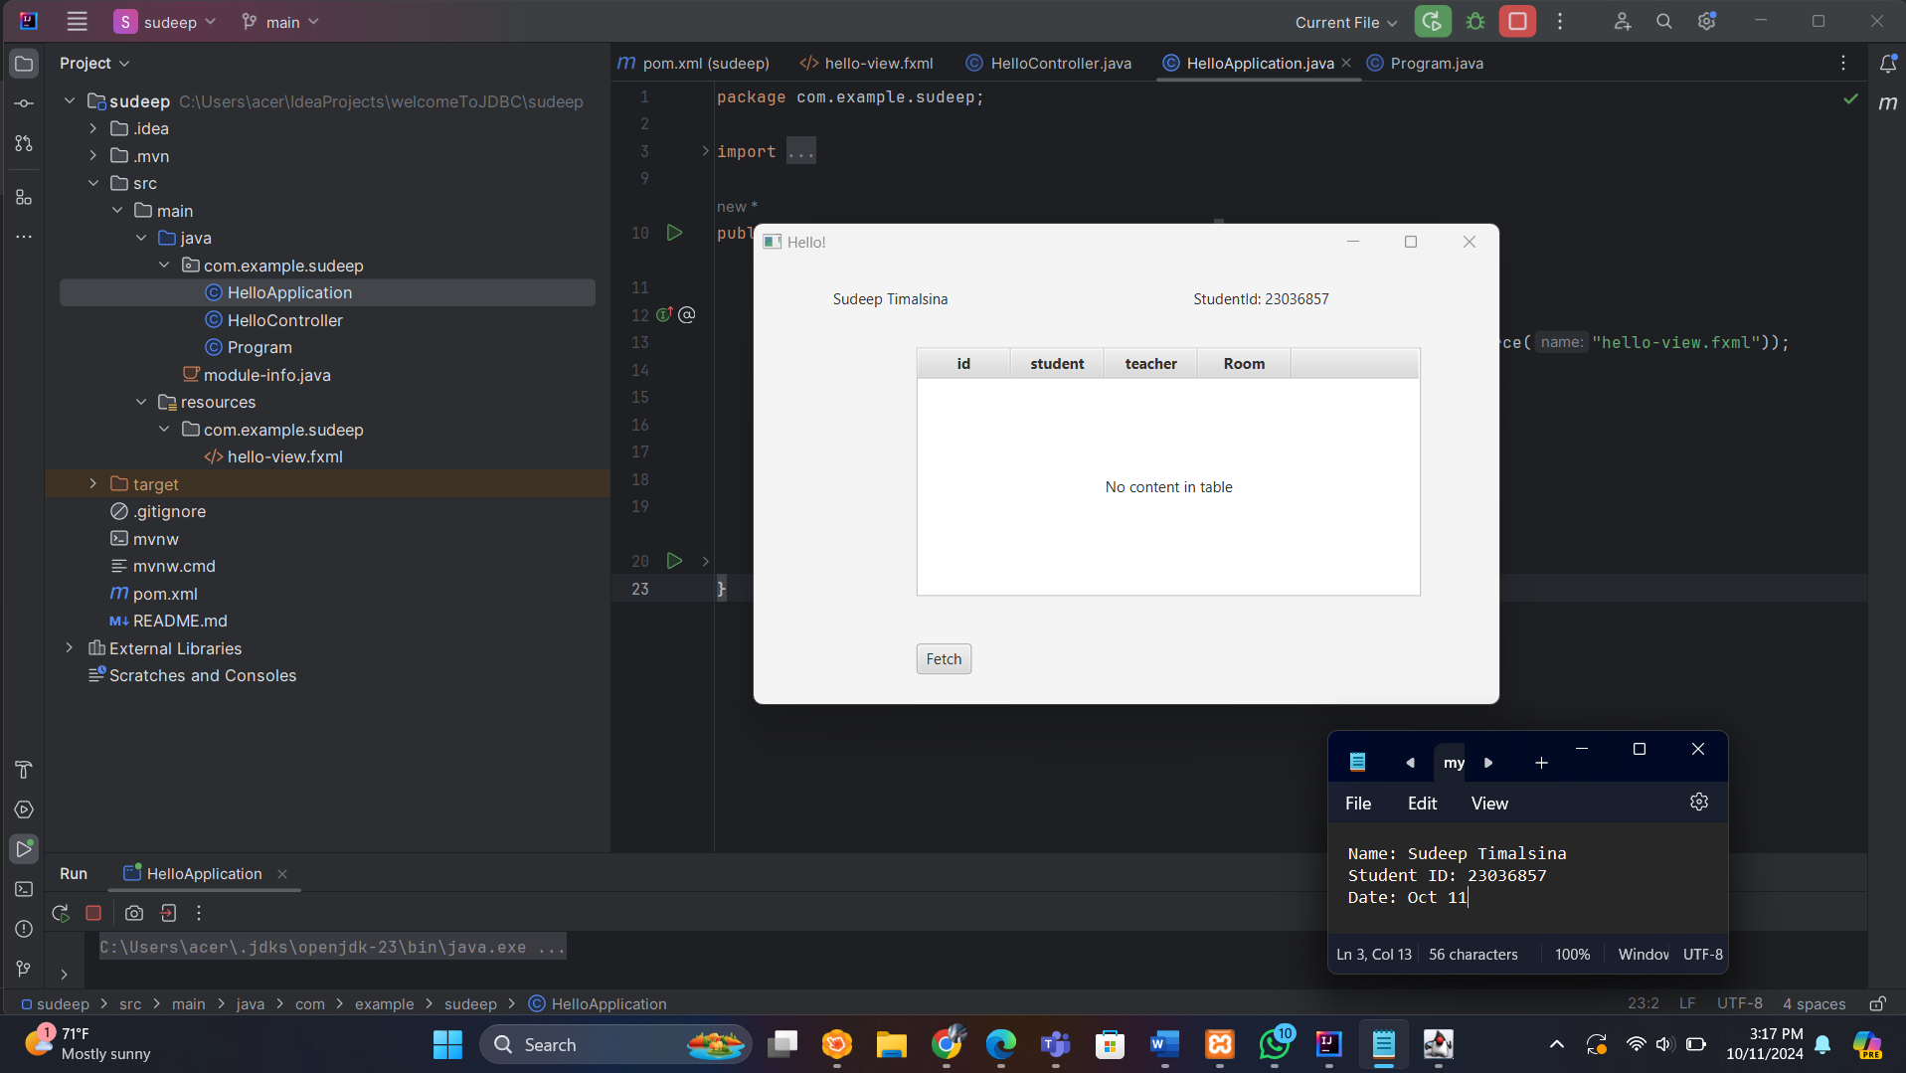

* 1. Screenshots of your database table structure and sample data.

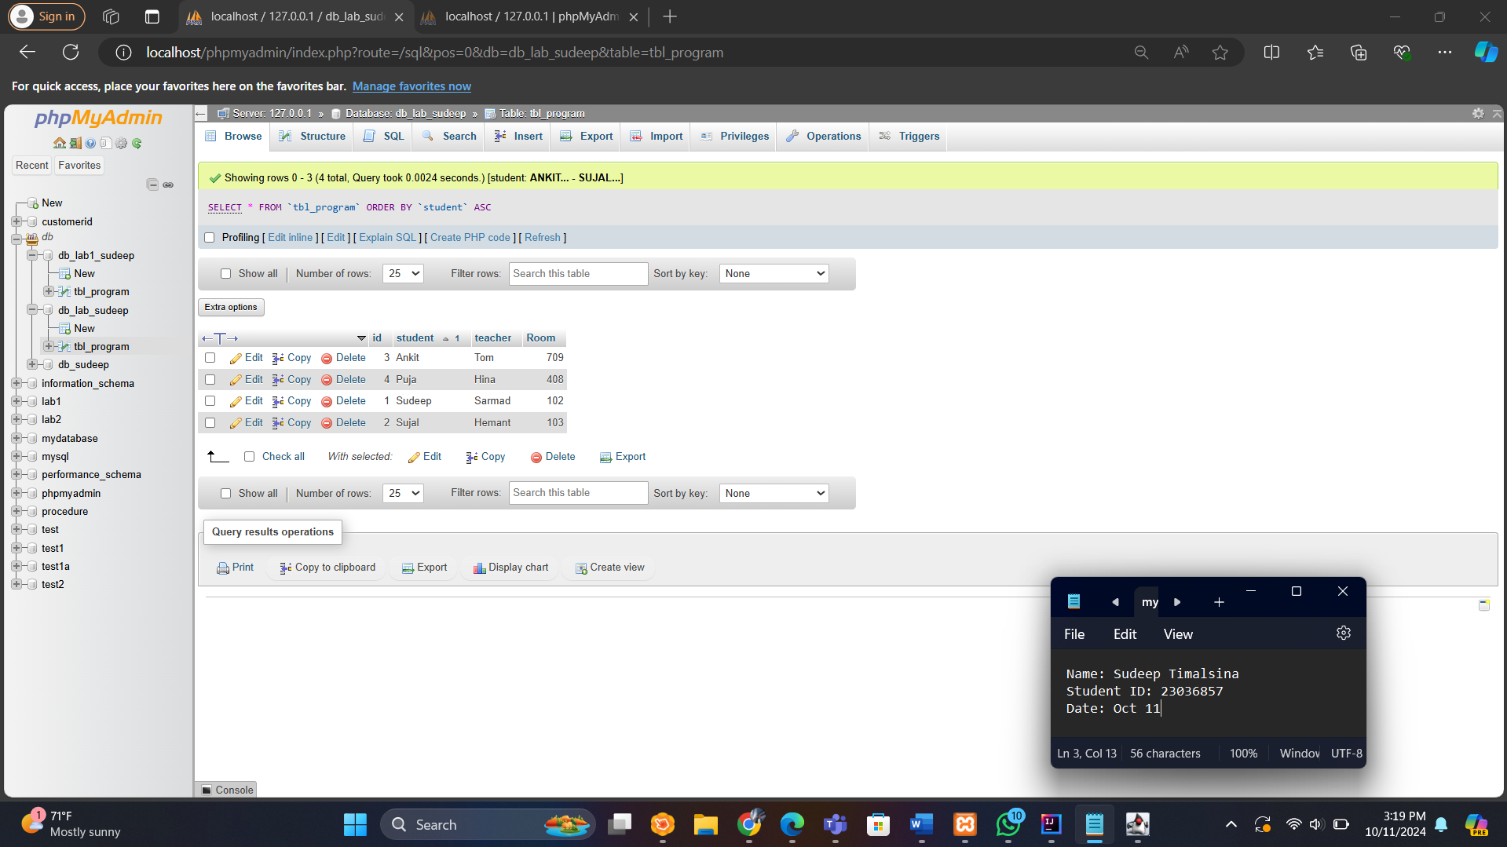

* 1. Screenshots of relevant portions of your code.

Connecting to the database and populating the data in GUI

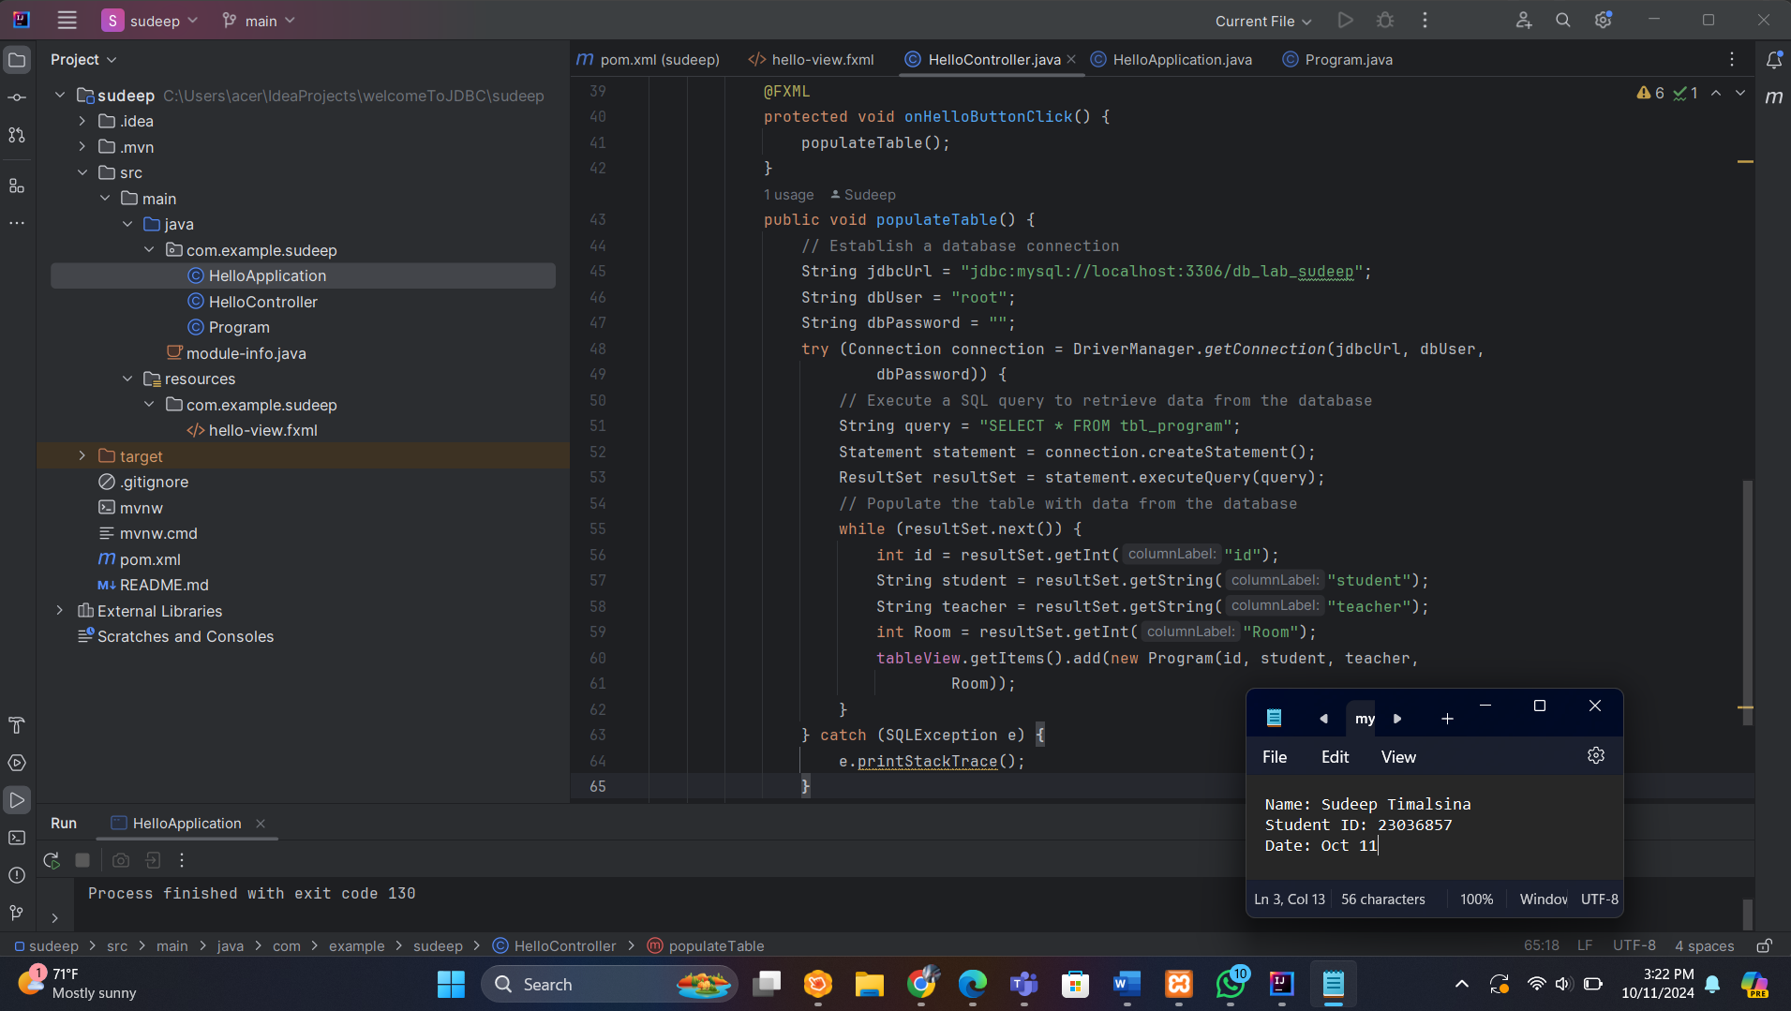

Importing the required dependencies(JDBC)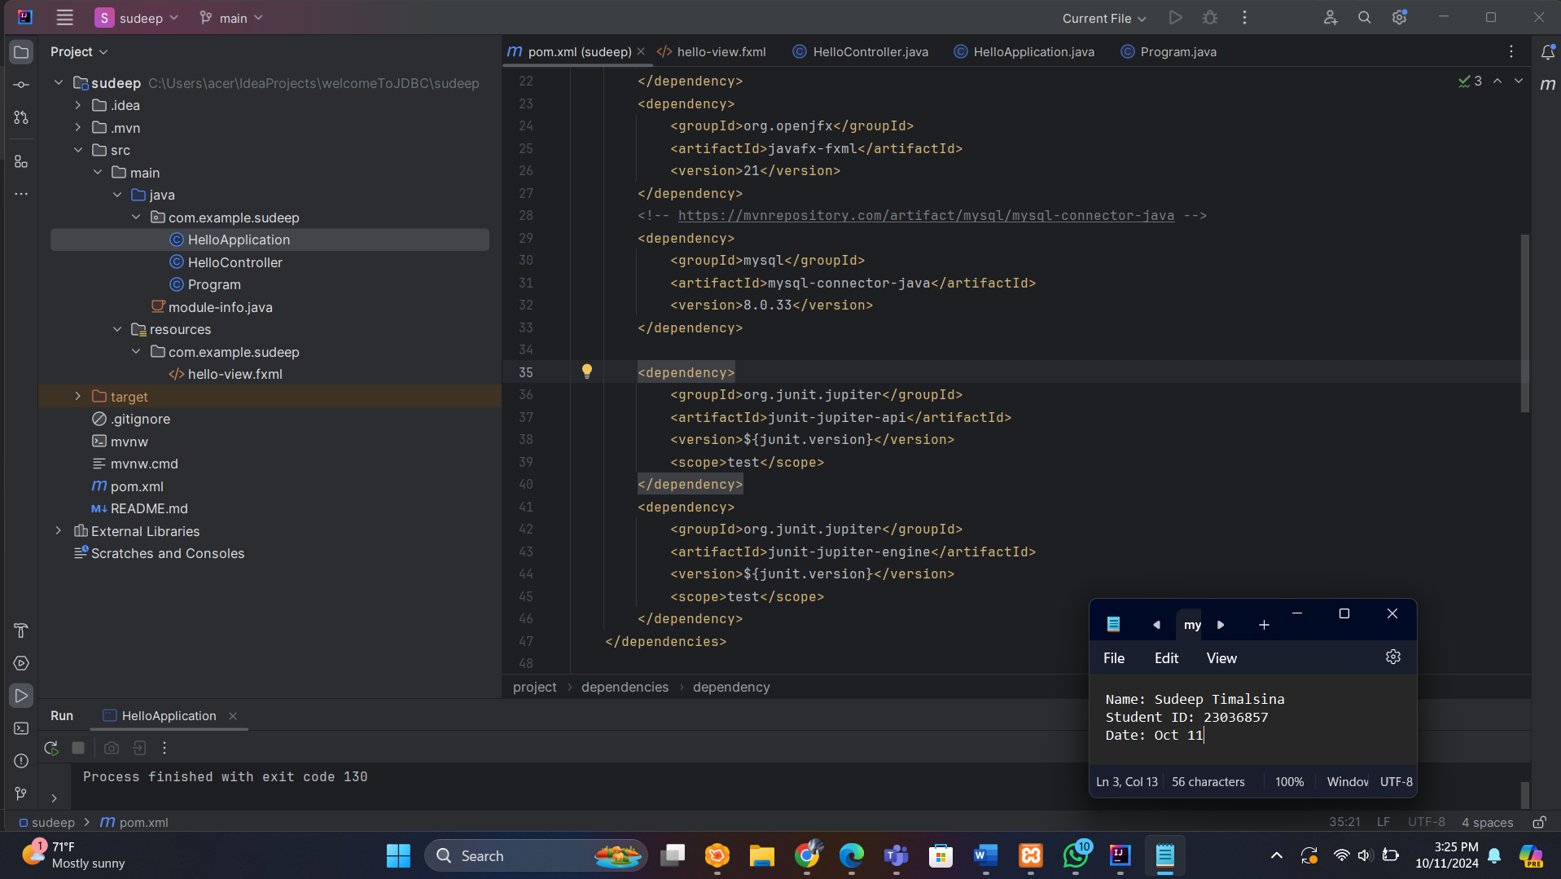

GIT HUB CODE

https://github.com/Sudeepdo/Programming