AI-Assisted Enterprise Migrations
Why the Next Decade of Cloud Transformation Will Be Intelligence-Driven, Not Infrastructure-Driven
By Sudeept Srivastava
Enterprise cloud migration has evolved from a technical infrastructure exercise into a strategic business transformation initiative. Yet despite a decade of platform maturity, most migration programs still run on manual discovery, static assessment reports, spreadsheets, and human judgment. That approach strains badly once an organization is managing thousands of workloads across hybrid, multi-cloud, and virtualized estates.
The evidence that it strains is not anecdotal. McKinsey’s survey of roughly 450 CIOs and IT decision-makers found that 75% of cloud migrations ran over budget and 38% were delayed by a quarter or more, with the firm projecting around $100 billion in wasted migration spend industry-wide. Gartner has found that 83% of data migration projects either fail outright or exceed their budgets and schedules. CloudBees’ 2025 DevOps Migration Index, surveying more than 300 enterprise IT leaders, found average migration projects running 18% over budget — roughly $315,000 of overrun per enterprise — while 94% reported system performance that was the same or slower after migrating.
These are not technology failures. They are information failures. And information failures are precisely what artificial intelligence is suited to address — not by automating more tasks, but by giving architects and product teams continuous intelligence, predictive insight, and data-grounded recommendations across the entire migration lifecycle.

Why Current Migration Approaches Break Down
Most migration failures are not caused by platform limitations. They are caused by incomplete information and delayed decision-making. Before making a single migration decision, an architect must understand application dependencies, infrastructure health, utilization patterns, business criticality, licensing constraints, networking, security posture, compliance obligations, and operational readiness. Gathering and correlating that manually is slow, and it goes stale the moment it is finished.
The industry data points to exactly this bottleneck. Dependency mapping and skills gaps are repeatedly cited as the leading causes of migration delay, and unclear application dependencies rank as the single most-cited migration challenge in recent aggregated surveys. A static assessment describes the estate on the day it was run. Enterprise estates do not hold still.

From Automation to Intelligence
Traditional migration platforms answer a narrow question: what can I migrate? AI-assisted platforms answer higher-order ones. Which workload should move first? What operational risk exists in this estate today? Which dependencies carry the highest probability of failure? Which modernization path creates the most business value?
That is the shift — from workflow automation to continuous decision intelligence. Automation executes what you already decided. Intelligence improves what you decide.

Traditional vs. AI-Assisted Migration
The distinction becomes concrete when the two approaches are compared across the migration lifecycle:
Dimension | Traditional Migration | AI-Assisted Migration
Discovery | One-time inventory scan; point-in-time snapshot | Continuous correlation into a living knowledge graph
Readiness | Static assessment report, valid on the day it ran | Dynamic readiness scores that update with drift and incidents
Sequencing | Human judgment, spreadsheets, negotiation | Risk-and-value-optimized wave recommendations
Dependencies | Manually mapped; unknowns surface during cutover | Inferred from telemetry before execution
Execution | Runbook-driven; issues found after impact | Real-time anomaly detection with adaptive correction
Learning | Post-mortem documents rarely reused | Outcomes feed back into the next recommendation
Failure mode | Discovered late, at highest cost | Predicted early, at lowest cost

The AI-Assisted Enterprise Migration Framework
The framework below organizes AI-assisted migration into five interlocking stages, each resting on a reliability-first data foundation.
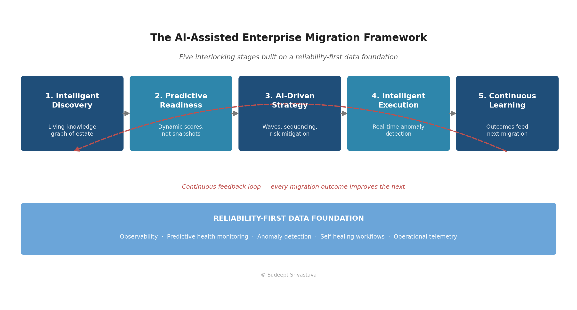
Figure 1: The AI-Assisted Enterprise Migration Framework

1. Intelligent Discovery
Continuously correlate infrastructure inventory, application topology, telemetry, configuration data, dependency graphs, and performance history into a living enterprise knowledge graph — one that reflects the estate as it is now, not as it was during the assessment window.

2. Predictive Readiness
Generate dynamic readiness scores from historical health, capacity trends, operational incidents, and configuration drift, replacing the one-time assessment with a signal that stays current.

3. AI-Driven Migration Strategy
Recommend landing zones, modernization options, migration waves, sequencing, and risk mitigations weighted by both technical and business priorities — making the tradeoffs explicit rather than implicit.

4. Intelligent Execution
Monitor migration events in real time, detect anomalies as they emerge, recommend corrective action, and minimize customer impact through adaptive orchestration rather than fixed runbooks.

5. Continuous Learning
Improve future recommendations by learning from migration outcomes, rollbacks, incidents, customer feedback, and post-migration performance. This is the stage most organizations skip, and it is the one that compounds.

A Reliability-First Foundation
AI recommendations are only as good as the operational data beneath them. Mature reliability engineering — observability, predictive health monitoring, anomaly detection, self-healing workflows, and operational telemetry — is what makes AI-assisted migration trustworthy rather than speculative.
This has a strategic implication that is easy to miss: organizations investing in reliability engineering today are simultaneously building the data platform that intelligent migration will require tomorrow. The two initiatives are usually funded separately. They should not be.

The Enterprise Migration Maturity Model
Organizations do not jump from manual migration to autonomous migration. They progress through identifiable stages, and knowing which one you occupy determines what to invest in next.
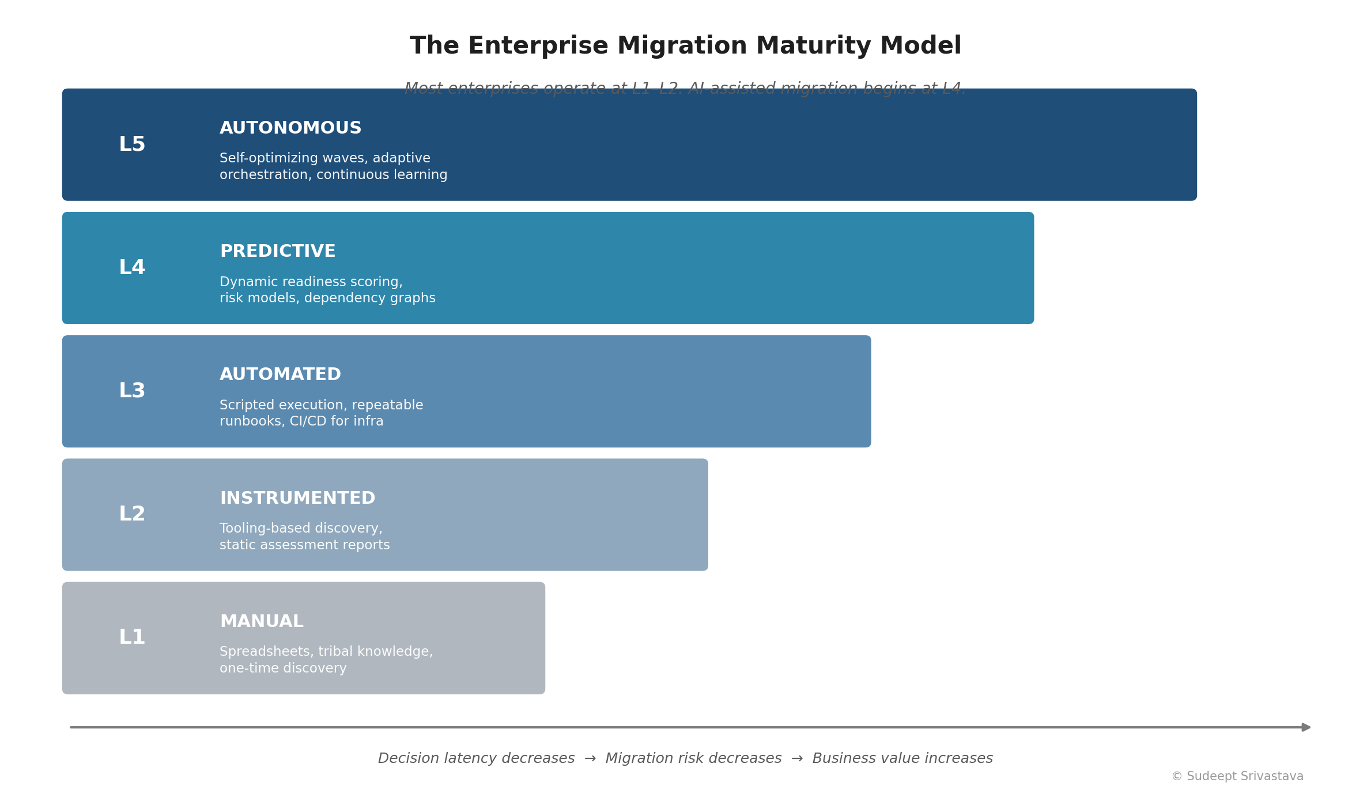
Figure 2: The Enterprise Migration Maturity Model
The practical value of the model is diagnostic. An organization at L2 that buys an autonomous migration platform will not get L5 outcomes — it will get L5 recommendations grounded in L2 data. The prerequisite for intelligence is instrumentation. Most enterprises today sit at L1–L2; AI-assisted migration meaningfully begins at L4, and the path there runs through reliability engineering rather than through migration tooling.

What This Looks Like in Practice
Three generalized patterns — composites drawn from common enterprise scenarios rather than any single organization — illustrate where intelligence changes outcomes.

Case Pattern 1: The Dependency That Surfaced Too Late
A financial services organization plans a wave-based migration of several hundred workloads. Discovery is tool-assisted but point-in-time. Midway through wave three, a batch settlement process fails because an undocumented dependency on an on-premises scheduling service was never mapped — it appeared in no CMDB and no architecture diagram, because it had been added during an incident two years earlier.
What intelligence changes: continuous telemetry correlation infers the dependency from observed traffic patterns rather than relying on documentation. The dependency surfaces during planning, when the cost of addressing it is a sequencing change, rather than during cutover, when the cost is a failed settlement run.

Case Pattern 2: The Readiness Score That Went Stale
A manufacturer completes a formal readiness assessment, then begins a migration program that runs eighteen months. By month twelve, the assessment reflects an estate that no longer exists — capacity has shifted, several hosts have degraded, and configuration drift has accumulated. Waves are sequenced against year-old assumptions.
What intelligence changes: readiness is a continuously recomputed score rather than a document. Workloads whose risk profile has deteriorated are automatically resequenced; workloads that have stabilized move earlier. The plan tracks reality instead of diverging from it.

Case Pattern 3: Lift-and-Shift That Delivered Nothing
A retailer migrates a large virtualized estate on schedule and declares success. Twelve months later, cloud spend is materially above forecast and application performance is unchanged — the pattern CloudBees found in 94% of surveyed enterprises. The migration moved workloads without changing anything about how they run.
What intelligence changes: modernization-path recommendation is part of the migration decision rather than a follow-on project. Each workload is evaluated not only for whether it can move, but for what it should become — with the business case attached to the recommendation.

Business Value
- Reduce migration planning effort through intelligent recommendations rather than manual correlation.
- Surface hidden dependencies before execution, when remediation is cheap.
- Improve migration success rates by predicting operational risk instead of discovering it.
- Optimize sequencing against combined business and technical priorities.
- Accelerate modernization while reducing downtime and operational cost.
- Compound organizational learning across every migration wave.

The Next Five to Ten Years
Where this goes next is not speculation — the direction is already visible in analyst forecasts and in how infrastructure teams are being restructured.
Through 2028: intelligence becomes ambient.
Gartner projects that 33% of enterprise software applications will include agentic AI by 2028, up from less than 1% in 2024, and that at least 15% of day-to-day work decisions will be made autonomously in the same timeframe. For migration, this means recommendation engines stop being a separate product category and become a default property of the platforms enterprises already run.
Through 2029: infrastructure operations restructure around agents.
Gartner forecasts that 70% of enterprises will deploy agentic AI as part of IT infrastructure operations by 2029, up from under 5% in 2025. The role change is the substantive part: infrastructure teams shift from operators who execute tasks to supervisors who govern systems. Migration programs will be staffed accordingly — fewer people running runbooks, more people setting policy and adjudicating exceptions.
The counter-trend worth taking seriously.
The same analysts forecasting adoption are forecasting failure. Gartner expects over 40% of agentic AI projects to be canceled by the end of 2027 due to escalating costs, unclear value, or inadequate risk controls — and predicts that by 2027, 40% of enterprises will demote or decommission autonomous agents because governance gaps surfaced only after production incidents. This is the single most important planning input in this article. The organizations that succeed will not be the ones that adopt fastest; they will be the ones that instrument first, govern deliberately, and grant autonomy in proportion to demonstrated reliability.
Beyond 2030: migration stops being a project.
The logical endpoint of continuous discovery, continuous readiness, and continuous learning is that migration ceases to be a discrete program with a start and end date. Workload placement becomes an ongoing optimization — evaluated continuously against cost, performance, compliance, and risk, with movement occurring when the model justifies it. The enterprises that reach that state will have done so not by buying an autonomous platform, but by building the reliability foundation that makes autonomy safe.

Closing
The next generation of migration platforms will function less like project management tools and more like trusted advisors — combining infrastructure telemetry, application intelligence, business context, and reliability signals to recommend the optimal path for every workload.
But the sequencing matters more than the ambition. Intelligence built on poor operational data produces confident, wrong recommendations at scale, and the governance failures analysts are already forecasting will land hardest on organizations that skipped the foundation. The enterprises that win the next decade of migration will be the ones that treated reliability engineering as the prerequisite it is — and then let intelligence compound on top of it.

About the Author
Sudeept Srivastava is a product and platform leader specializing in enterprise cloud platforms, AI-driven infrastructure operations, reliability engineering, and large-scale enterprise modernization. His work focuses on autonomous operations, predictive infrastructure intelligence, and the intersection of AI, cloud reliability, and enterprise transformation. He has represented his work at global technology conferences and writes on the future of intelligent infrastructure.

References
- McKinsey & Company — survey of ~450 CIOs and IT decision-makers on cloud migration cost and schedule performance (75% over budget; ~$100B projected wasted spend).
- Gartner — finding that 83% of data migration projects fail or exceed budget and schedule.
- CloudBees — DevOps Migration Index, November 2025 (survey of 300+ enterprise IT leaders; 18% average budget overrun; 94% same-or-slower post-migration performance).
- Gartner — agentic AI forecasts: 33% of enterprise applications and 15% of daily work decisions by 2028.
- Gartner — forecast that 70% of enterprises will deploy agentic AI in IT infrastructure operations by 2029.
- Gartner — forecast that over 40% of agentic AI projects will be canceled by end of 2027; 40% of enterprises will demote or decommission agents by 2027 due to governance gaps.
- Flexera — State of the Cloud Report (cloud cost management and dependency-mapping challenges).
Note: figures are cited from publicly published analyst research and industry surveys. Readers should consult the original publications for full methodology and sample sizes.

