Smart Aquarium (AquiClean Module) Using
Internet of Things(IOT)

-Sudeeptha Mouni Ganji

"To Help Users keep connected to their Aquarium tank at all times to have a healthier tank by helping them to keep track of stats in the absence of user through the Internet."

Introduction:
Fishes need fresh and clean water to survive and lead healthy lives. Additionally, they also need food to be fed at regular intervals. They also require optimum water levels along with proper temperatures for survival. However, when fishes are placed in large and small aquariums, they often do not meet these required conditions.
This occurs because aquarium owners are often unaware of when the water has reached a level where it needs to be changed. All this results in the bad health and untimely death of the fishes.
The present Existing Aquariums Require a day-today monitoring and a human time to keep track of all the above conditions.
Proposed System:
- To solve the above problems, we have designed an AquiClean module that could perform the following functions:
- Measures the turbidity of the aquarium water and switch on the water filter when turbidity levels are beyond optimum range.
- Checks the water temperature and switch on the water heater when the temperature is too low.
- Senses the water levels and displays a message when the water levels are too low.
- Automatically feeds the fishes at regular interval through an automatic feeding system.
- With this proposed system, it does not require a daily human time and the automatic care of the aquarium is taken care by the proposed module.

ARCHITECTURE CUM CIRCUIT DIAGRAM:
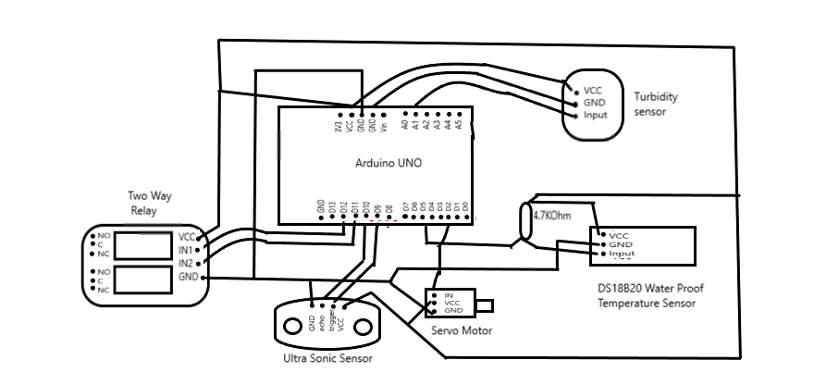

Components :
To achieve the proposed solution, we have used a combination of Arduino UNO, servo motor, DS18 B20(waterproof temperature sensor), turbidity sensor, ultrasonic sensor, relay switch and LCD display and their functionalities have been achieved using embedded C in Arduino IDE. The values obtained from the module are fed to the user’s mobile device through the Blynk App.

Arduino UNO board: A micro controller board which has 14 digital IO pins, 6 analog pins, a power jack, a reset button and USB connection pin. Programs can be loaded on to it form the easy to use Arduino computer program. Arduino boards are able to read inputs-depth, temperature, turbidity etc and turn them into outputs- activating a motor, displaying a message etc.
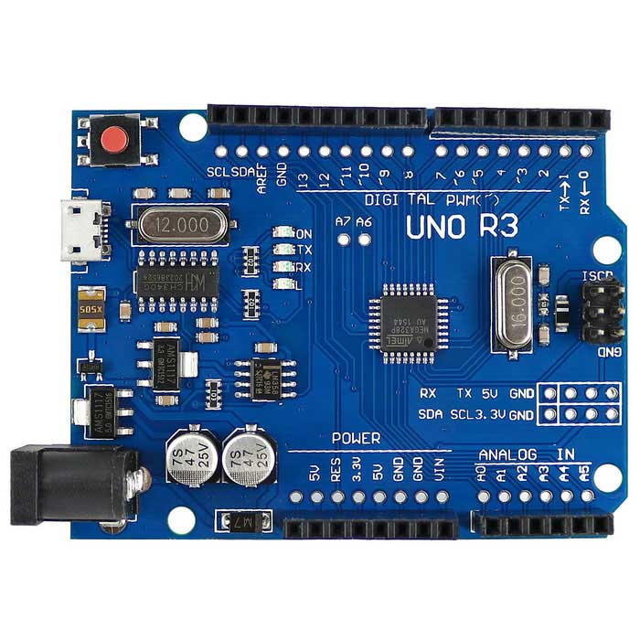

Sensors used:
Servo motor: A servo motor is a rotary actuator that allows for precise control of angular or linear position, velocity and acceleration. It consists of a suitable motor coupled to a sensor for position feedback. It is often used in a closed loop control system.
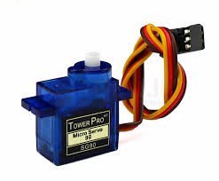

DS 18B20 (Waterproof temperature sensor): The sealed digital temperature probe lets you precisely measure temperatures in wet environments with a simple 1-wire interface. It needs to be connected from a central microprocessor. It measures a temperature range of -55⁰ C to 125⁰ C with an accuracy of + 0.5⁰ C.
Turbidity sensor: Turbidity is a quantitative measure of the suspended particles in a fluid. Turbidity sensor measures the amount of light that is scattered by the suspended particles in the water. As the amount of total suspended particles increases, the water's turbidity levels increase.
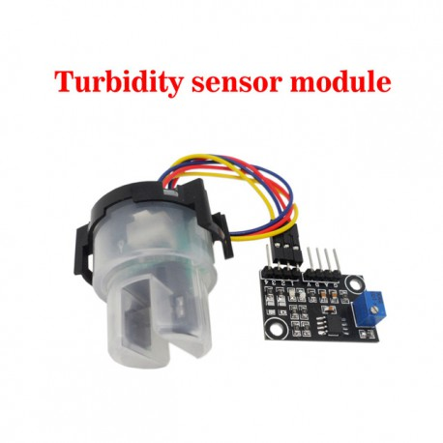
Ultrasonic sensor: It measures distance by using ultrasonic waves. The sensor head emits an ultrasonic wave and receives the wave reflected back from the target. It measures the distance to the target by measuring the time between emission and reception.
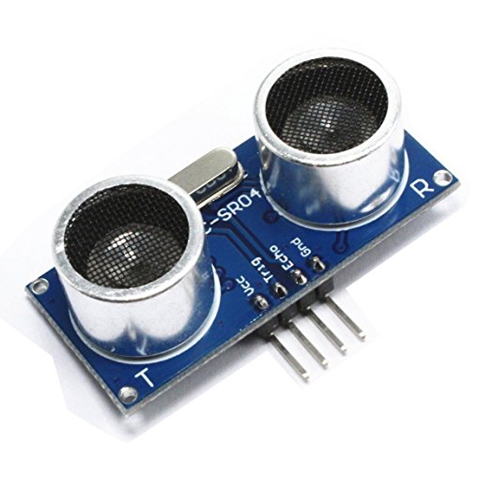
Relay Switch: Relays are switches that open and close circuits electromechanically or electronically. Relays control one electrical circuit by opening and closing contacts in another circuit. Many relays use an electromagnet to mechanically operate a switch, but other operating principles are also used.
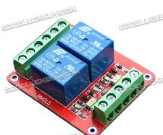

USB Cable: To Dump the code from Computer to Arduino Uno, we use USB cable which transfer data in the form of 0's and 1's.
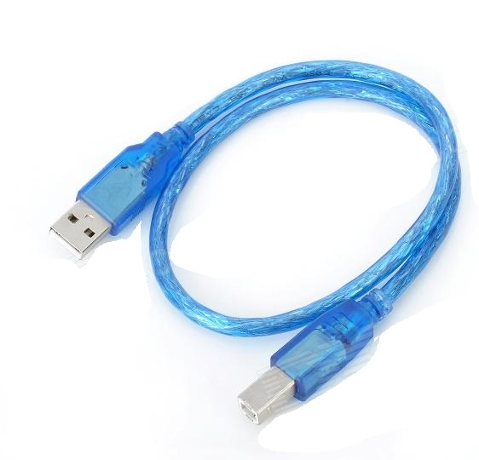
LCD Display: The Liquid Crystal Display is used to display various values and textual information. The LiquidCrystal library is used to control the LCD display. It has 16 pins interface. It can manipulate several interface pins at once to control the display.

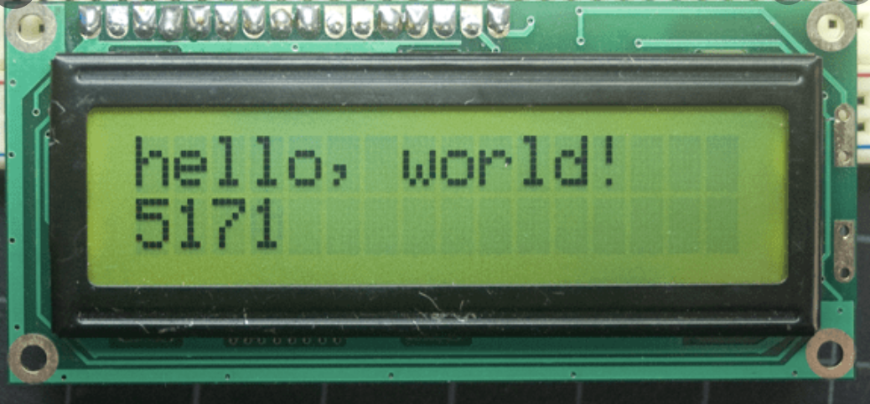

Coding:
Embedded C is a set of language extensions for the C programming language to address commonality issues that exist between C extensions for different embedded systems. It uses most of the syntax and semantics of standard C.

Libraries Used:
- Servo Library
- Ultrasonic Library
- Turbidity Library

Working:
- The AquiClean module uses a turbidity sensor to measure the turbidity levels of the water. It is connected to a filter which is switched on when the turbidity levels are high using a relay switch.
- The DS 18B20 is a waterproof temperature sensor which is connected to a heater using a relay switch. The heater is switched on when the water temperature gets too low.
- The ultrasonic sensor floats on the water surface and is used to measure the levels of the water. As the water levels below a required minimum point, it displays a message through the LCD display.
- A servo motor is used to control the cap of the feeding bowl to feed the fishes at a regular interval.
- All the changes and current values can be observed by the aquarium owner through the Blynk app

Conclusion:
Thus, by using the AquiClean module the problems which are faced by aquarium users can be solved by automating the process of water cleaning and feeding while maintaining optimum water levels and temperature. This reduces the consumption of human time and efforts required for maintaining an aquarium and making it easier to use in every home.

Future Enhancements:
- On a large scale, the AquiClean module can be used in artificial ponds for water maintenance and feeding the fishes.
- It can be further used to keep track of the changes in water temperature and turbidity to predict the soil type in ponds.
- The AquiClean module can also be used to check the water quality of large water bodies.
- The AquiClean module can be used to predict when the water will get Murky by keeping track of the time period between water changing

