GENDER IDENTIFICATION OF AUTHOR FROM TEXT

In this project as per your request we have used author profiling and gender text data to train Random Forest Machine Learning algorithms. This trained model can be applied on any text document to predict weather Document Author is same or different or what is the author gender.

To train model we are using below gender text data

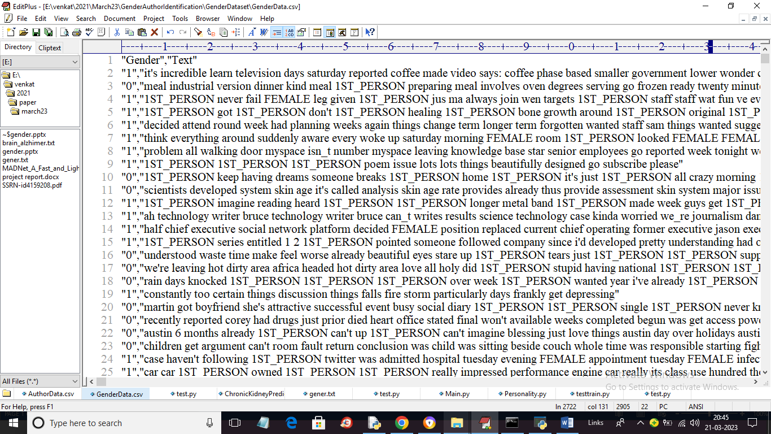

In above dataset screen 0 means Male and 1 means Female and then we can see text data and below is the Author dataset

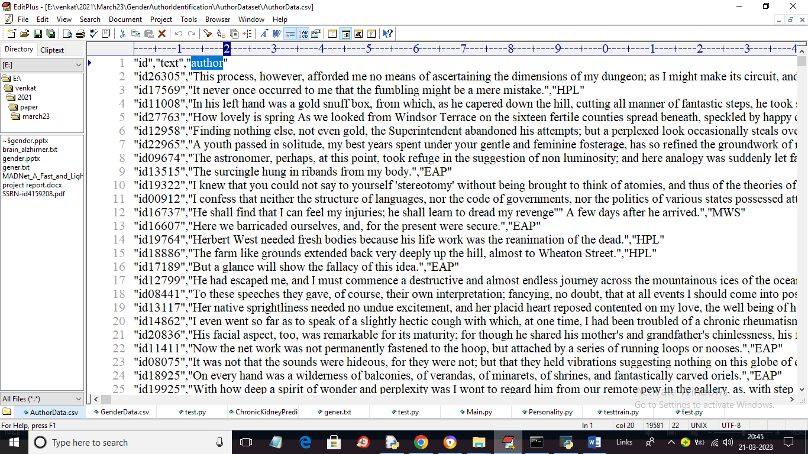

In above author dataset we are having columns called ID, Document text and the name of author. So by using above dataset we will train model.

SCREEN SHOTS

To run project double click on ‘run.bat’ file to get below screen

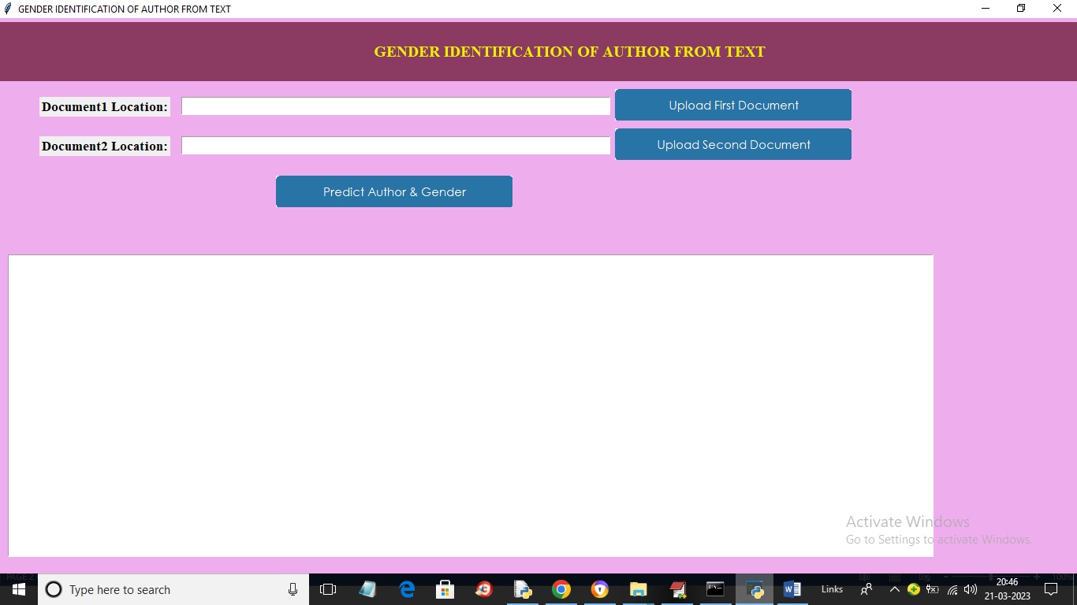

In above screen click on ‘Upload First Document’ button to upload document1 like below screen

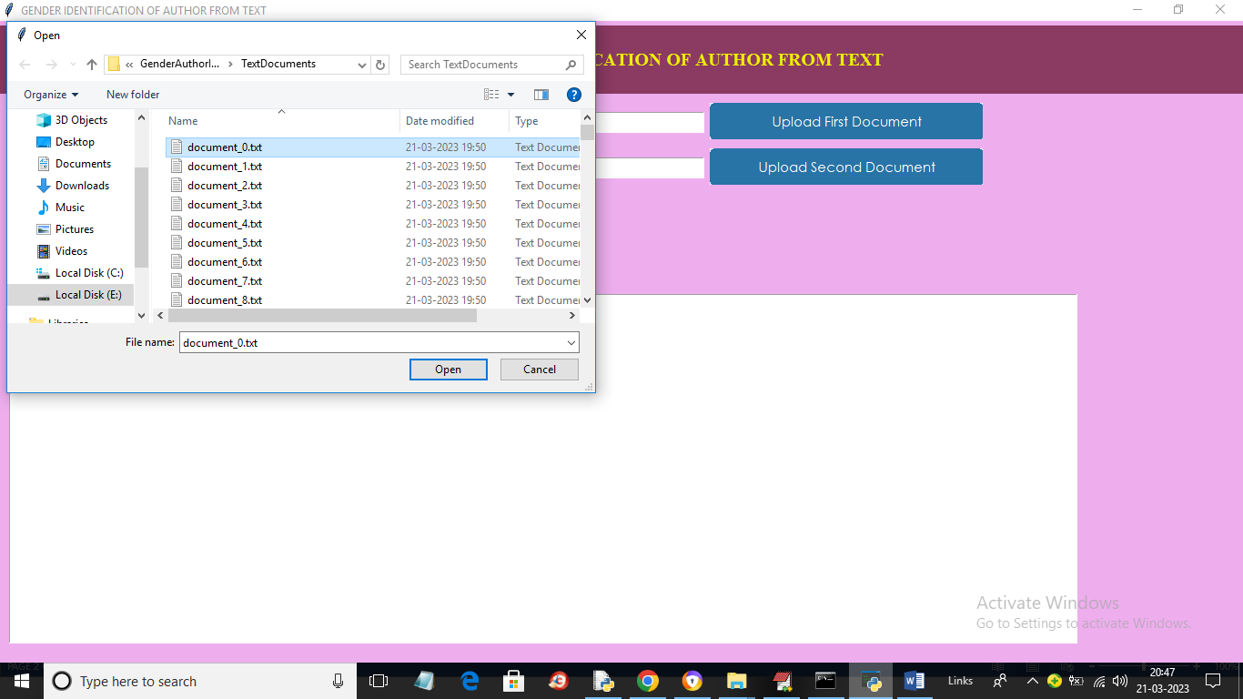

In above screen selecting and uploading document_0.txt and then click on ‘Open’ button to load document and get below output

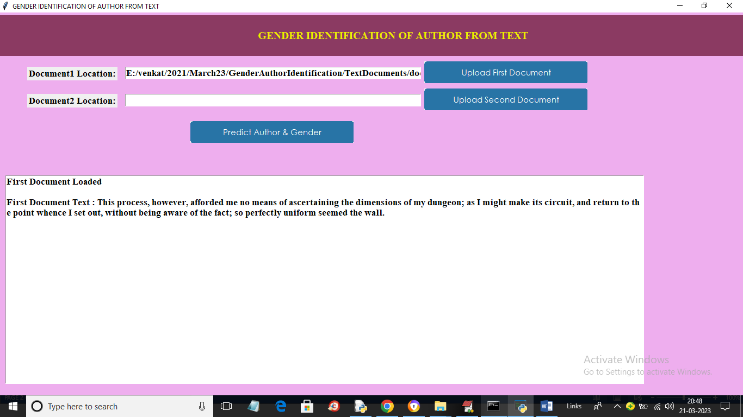

In above screen we can see first document text loaded and now click on ‘Upload Second Document’ button to upload second document and get below screen

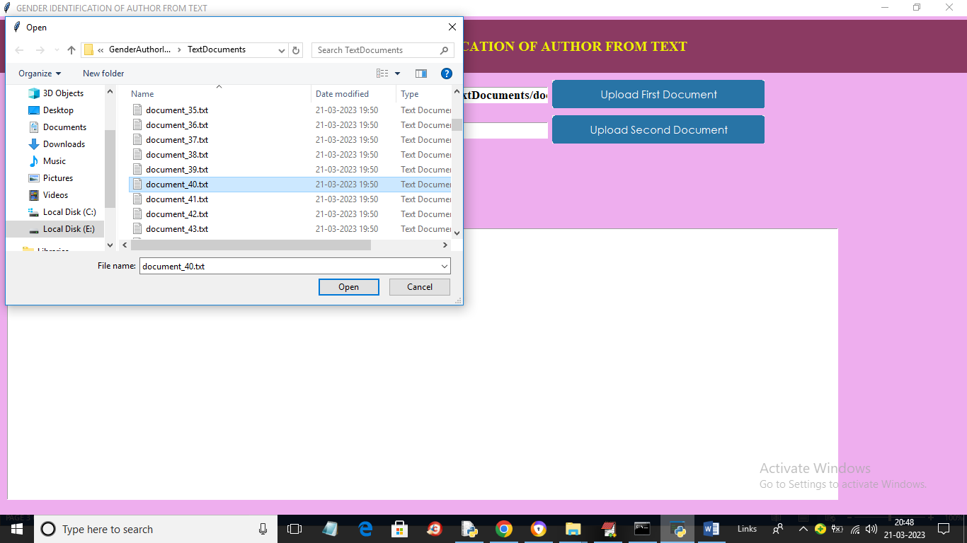

In above screen selecting and uploading document40.txt and then click on ‘Open’ button to load dataset and get below output

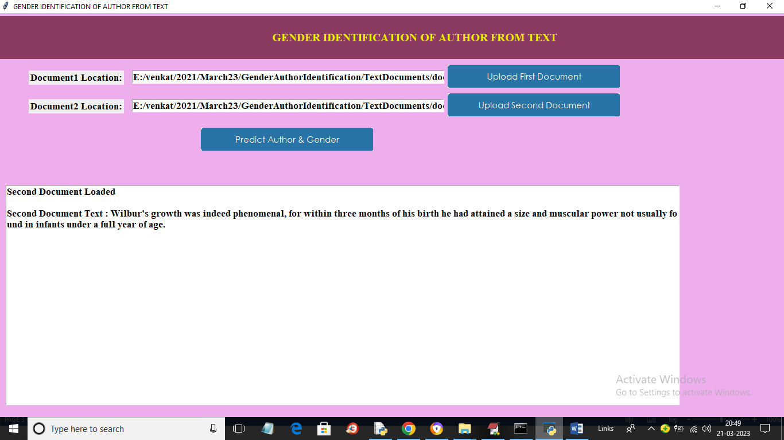

In above screen both documents loaded and now click on ‘Predict Author & Gender’ button to get below output

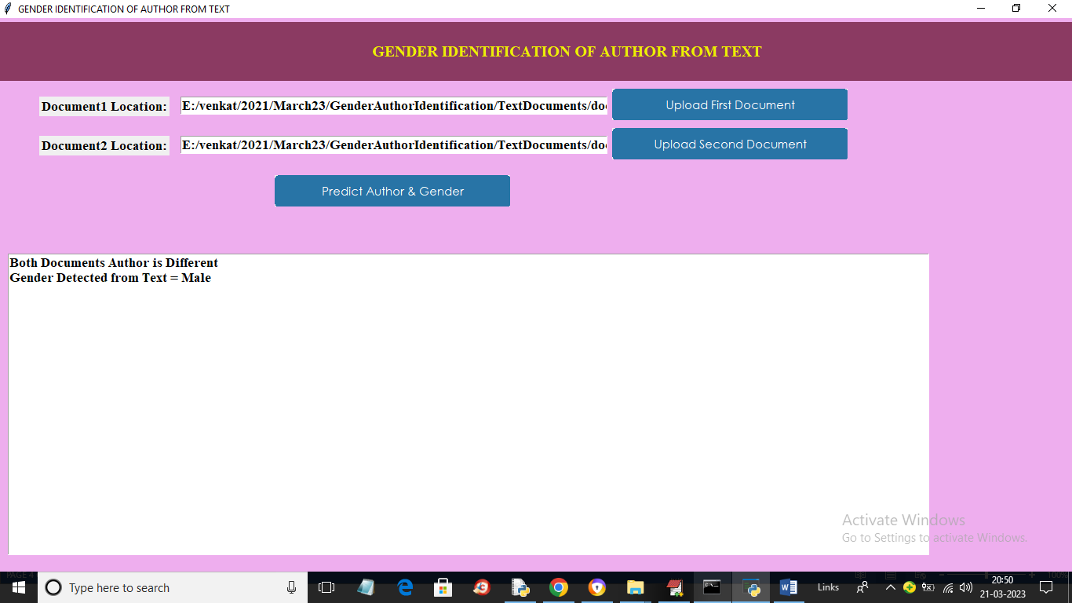

In above screen in text area we can see document author is different and gender is male and similarly you can upload any document and test the application. Below is another output

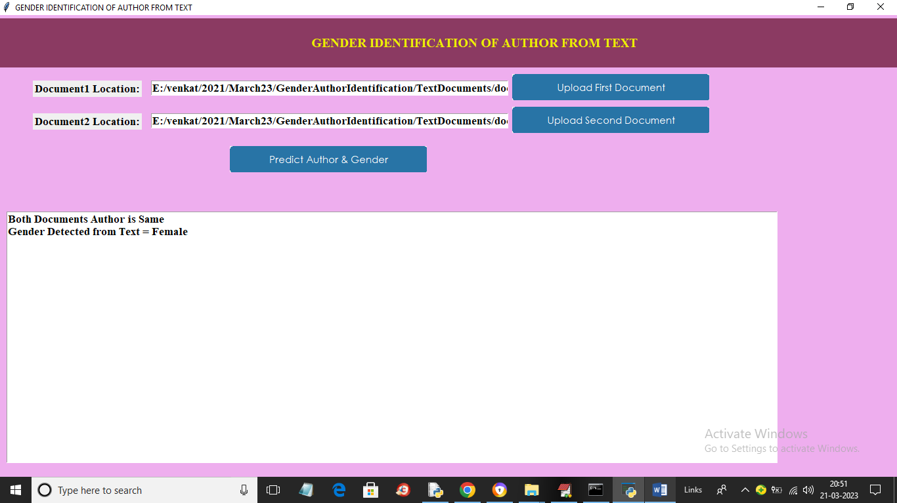

In above screen author is same and gender is different for new selected documents whose names you can see in first and second text fields

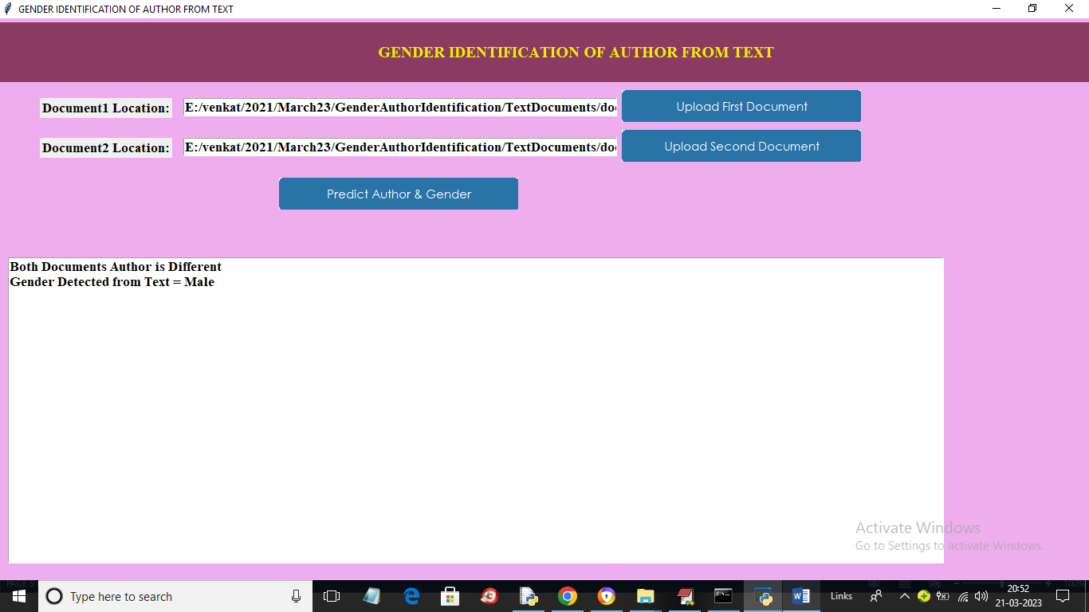

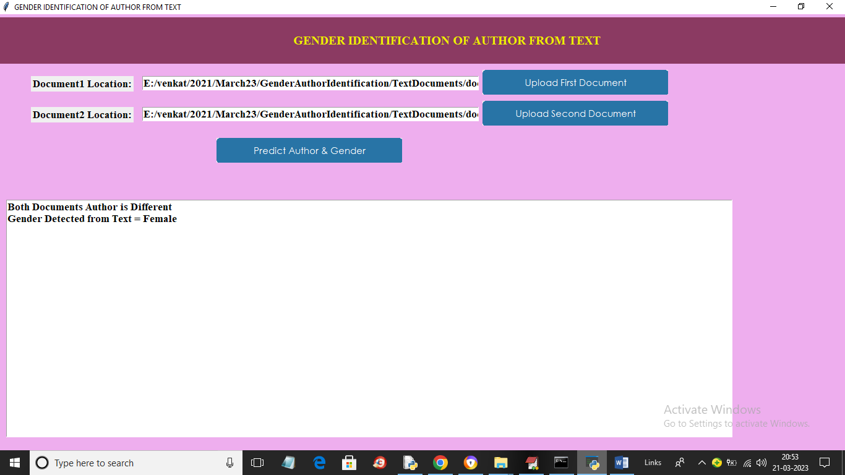

In above screens you can see different genders with same and different authors