Genetic Multi-Objective and Multi-Agent-Driven Adaptive Resource Allocation Framework for Cloud Radio Access Networks
Cloud computing benefitting each network application with high speed, heavy storage and computation power and 5G is one of the technology which is getting heavy support from cloud for high connectivity and heavy computation. Cloud will utilize virtualization technique to allocate resources to Radio Access Network based on user demands and if demand high then more resources will be allocated and if less then allocation resource will be reduced.
Above resource allocation will get failed when users are dynamic in nature which means user demand for resources constantly increased or decreased and to overcome from this issue author of this paper employing Combination of Multi Agent and Centralized Resource allocation as Hybrid allocation whose primary objective is to minimize the unfulfilleduser demand and to provide the maximum amountof resources utilization while maintaining theconstraint.
Hybrid allocation first priority is to minimize the unfulfilleduser demand as given and second priorityis to reduce the total amount of wasted resources at eachresource allocation time. The wasted resource can be reducedby allocating proper amount of resources in each VBS whileensuring that the user requirement is satisfied. Thirdpriority is to ensure a fair resource allocation among all theVBS agents. Apart from that, our forth priority is to balancebetween system efficiency as well as user satisfaction bymaximizing the amount of saved resources at the BBU pooleach allocation time.
The fifth generation (5G) mobile network is designed to facilitate high data rates with massiveconnectivity with the benefit of small cell technology. The cloud radio access network (C-RAN) is apromising mobile network architecture that can meet the ever-increasing resource demand of a growingnumber of users. In C-RAN, base station functionalities are separated into baseband units (BBUs) andremote radio heads (RRHs), with BBUs centralized and virtualized via cloud computing. However, thisarchitecture introduces new challenges in efficiently allocating resources to dynamic users. This paper aimsto design a resource allocation scheme that improves system efficiency and satisfies dynamic user demandsin C-RAN. Proposed hybrid resource allocation approach that combines centralized control and multi-agent-based decision-making. The centralized controller, located within the BBU pool, collaborates withvirtual base stations (VBSs) acting as multi-agent system (MAS) agents. The resource allocation solutionis derived by jointly considering the real-time resource requests from agents and the historical demandestimates generated by the centralized controller. Through simulation-based evaluation, proposed scheme with conventional random and fixed resource allocation methods. The results demonstrateimproved performance in terms of resource utilization, reduced unfulfilled demand, and fairness among VBSagents. The proposed combined resource allocation strategy effectively meets dynamic user requirementswhile maintaining system efficiency in C-RAN. Our work highlights the importance of integrating historicaldemand trends with real-time agent requests for improved long-term resource planning.
Propose Hybrid Resource allocation divided in to following modules
- Designeda C-RAN environment to formulateour resource allocation problem for both multi-agent andcentralized systems.
- Designed a combined resource allocation schemewhere the centralized controller and multiple VBSagents take part in allocating resources based on userdemand. The main objective is to allocate computationalresources to each VBS such that the allocation solutionmeets the user requirements for a longer duration.We have discussed our priorities that wewant to considerfor resource allocation and designed our algorithmaccordingly.
- Utilize the historical data for user demandduring different time of the day to estimate therequired resources before next reallocation timeslot.By varying the time-slots, we show the impactof the duration of time-slot on resource allocationperformance.
- Evaluate the performance of our proposed mechanismthrough an extensive simulation study and by comparingthe performance with other resource allocationschemes. Propose algorithm compared using number of unfilled demand due to limited available resources.
Hybrid Resource Allocation Algorithm Description
Each resource allocation time-slot t, thecontroller has the current resource demand received fromeach VBS agent and the past resource demands from H.At first, the controller computes the maximum resourcedemand h1tmax,i from the historical demands, where 1t = tb−ta defines the time duration between two resource allocationtime-slots. For each of the VBS agents, the max demandd1tmax,i is calculated. As mentioned, each VBS agent can be allocated theresource based on maximum demand only when the condition8t ≤ Bmax is satisfied. When this condition is not met,the controller allocates resources to each VBS based on anestimation from the historical data. To do that, the requiredresource estimation is calculated for a specific time intervalwhich is the duration between two consecutive resourceallocation time-slots. Using the historical data of resource
In paper author has not used any multi-objective function to reduce resource allocation wastage so in extension work we have modified propose Hybrid model with Genetic Multi-objective algorithm which is known for optimizing given task based on fitness function. This algorithm continuously evaluate available resources with current demand and then calculate fitness value. Resource with high fitness will be selected for current demand allocation and this process continues till no more optimization left. This process of continuous evaluation make multi-objective algorithm better and efficient. Multi-objective algorithm concurrently optimizing several goals, such as minimizing execution time, cost, energy consumption, and resource wastage, while maximizing resource utilization and load distribution.
Modules Information
To implement this project we have designed following modules
- New User Registration Here: using this module user can register with the application
- User Login: using this module user can login to system
- Generate Demand Data: author has generated his own simulation data but not publish on internet so we have generated few resources and demand simulation data randomly
- Fixed Allocation: all available resources and demand request data will be input to existing Fixed algorithm to allocate resources and then calculate number of unfilled demand request
- Hybrid Allocation: all available resources and demand request data will be input to proposeHybrid algorithm to allocate resources and then calculate number of unfilled demand request
- Multi-objective Allocation: all available resources and demand request data will be input to extension Genetic Multi-objective algorithm to allocate resources and then calculate number of unfilled demand request.
- Graph: using this module will plot number of unfilled demand request from different algorithms such as existing, propose and extension.
SCREEN SHOTS
To run project install python 3.7.2 and then install all packages given in requirements.txt file and then install MYSQL and then copy content from ‘database.txt’ file and paste in MYSQL console to create database.
Now double click on ‘run.bat’ file to start python web server and then will get below page
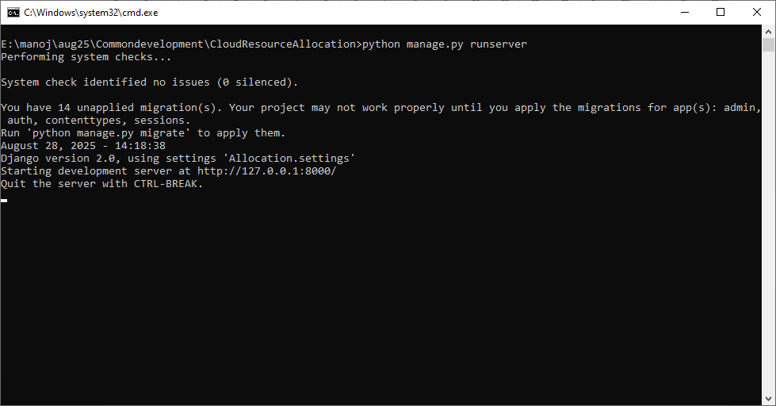
In above screen python web server started and now open browser and enter URL as http://127.0.0.1:8000/index.html and then press enter key to get below page
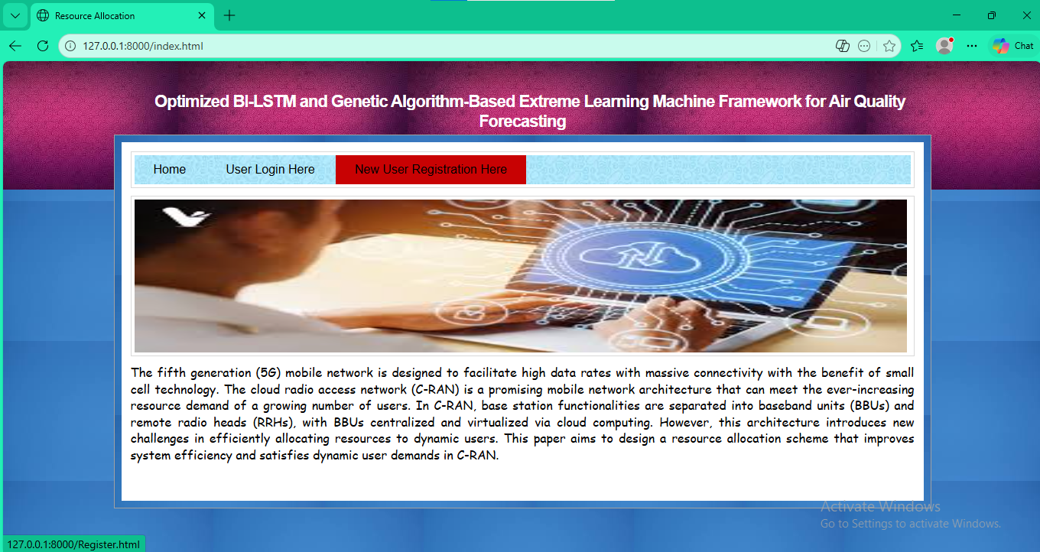
In above screen click on ‘New User Register’ link to get below page

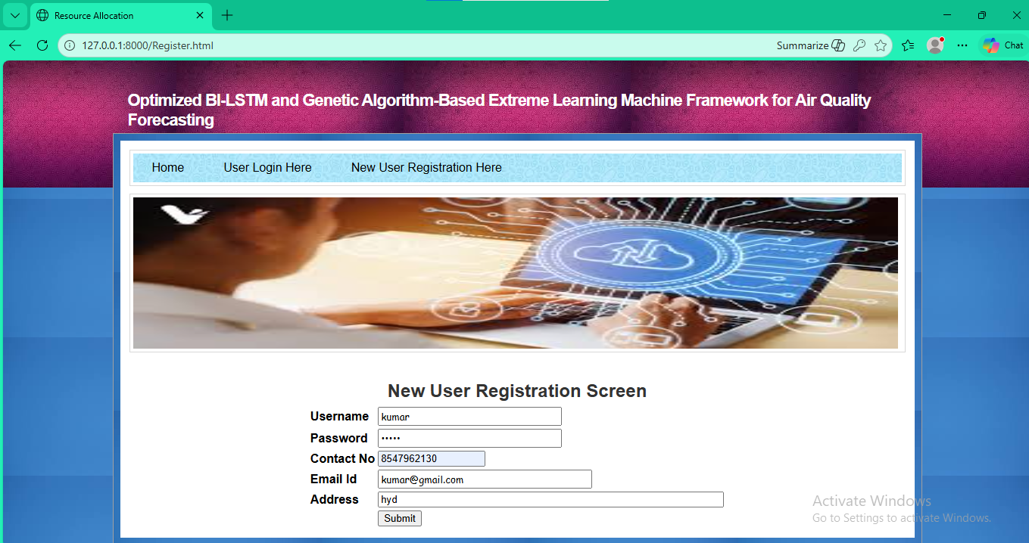
In above screen user is entering sign up details and then press button to get below page

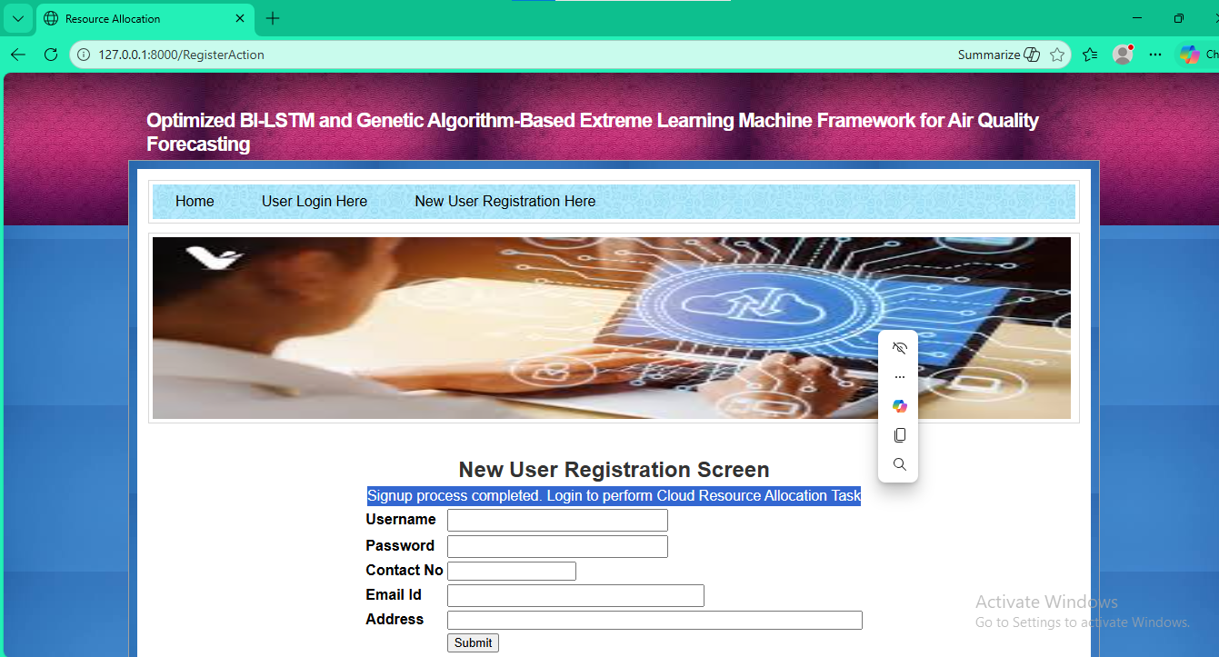
In above screen user sign up completed and now click on ‘User Login’ link to get below page
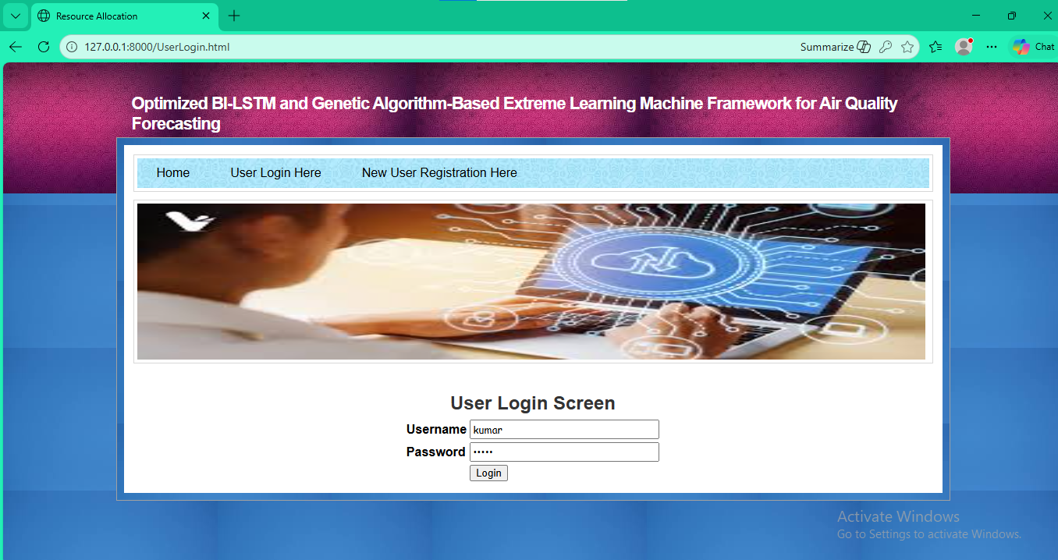
In above screen user is login and after login will get below page

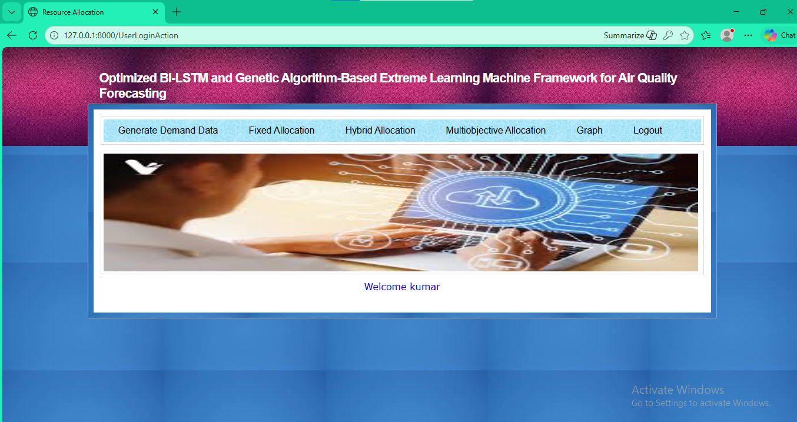
In above screen click on ‘Generate Demand Data’ link to generate simulation data and then will get below page

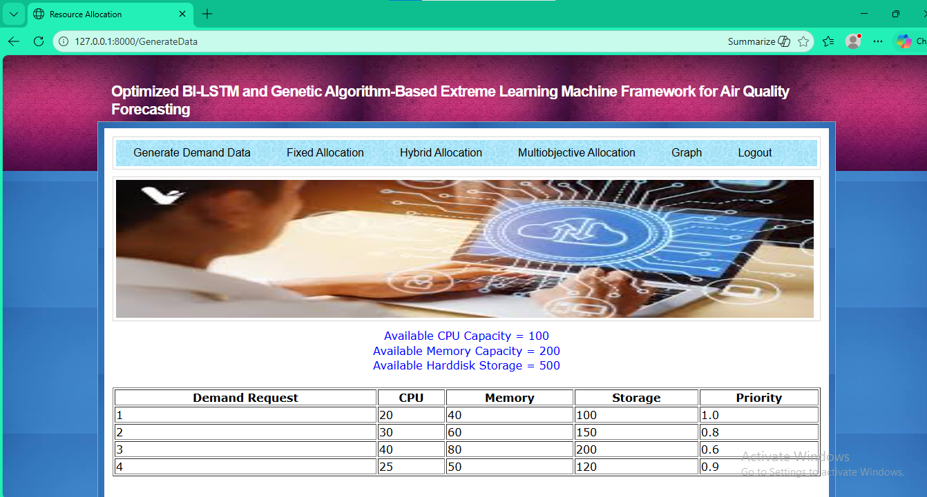
In above screen in blue text can see available resources size and in table format can see simulation data with different request demand which required different size of request along with priority. Now click on ‘Fixed Allocation’ link to allocate resources to above demand and then calculate unfilled demand

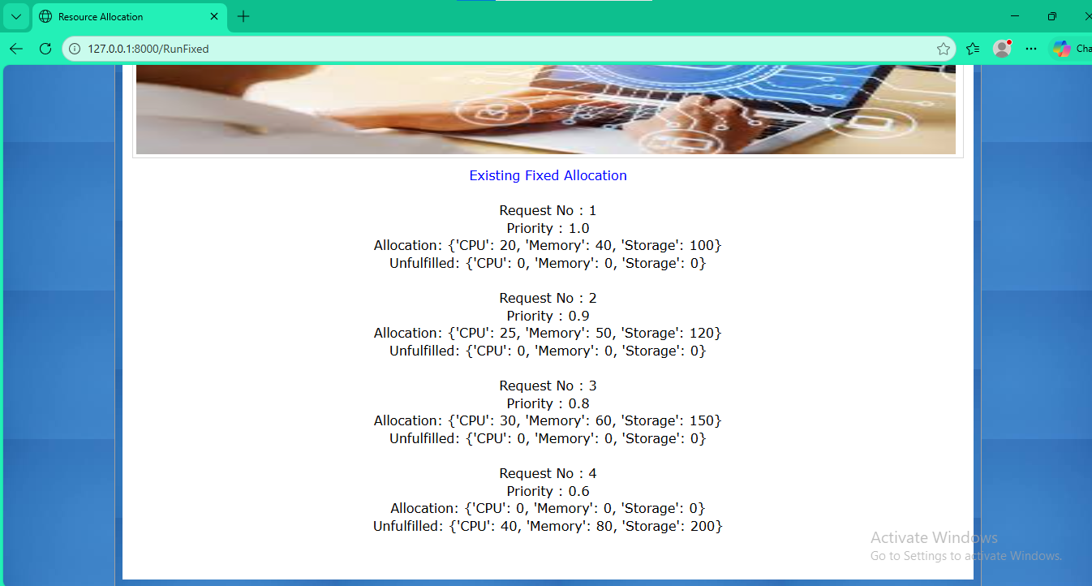
In above screen first 3 task successfully allocated and then fixed algorithm unable to find resources so last task remain unassigned and can see unfilled resource size of CPU is 40. Now click on ‘Hybrid Allocation’ to allocate using propose hybrid algorithm

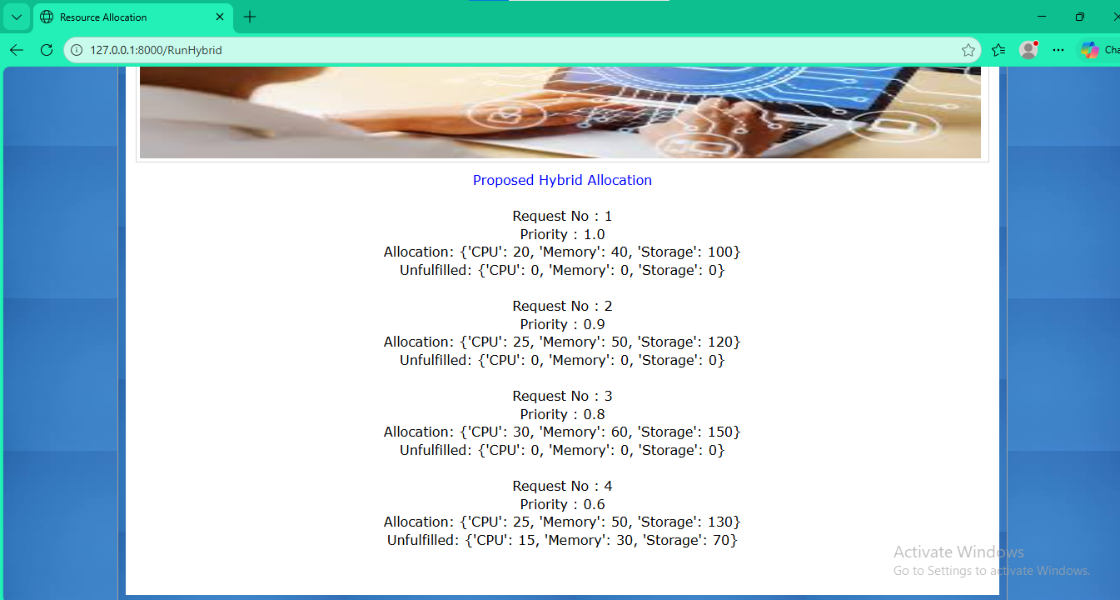
In above screen propose algorithm unfilled CPU is 15 but existing was 40 and now click on ‘Multi-objective Allocation’ link to allocate resource using extension technique and then will get below page

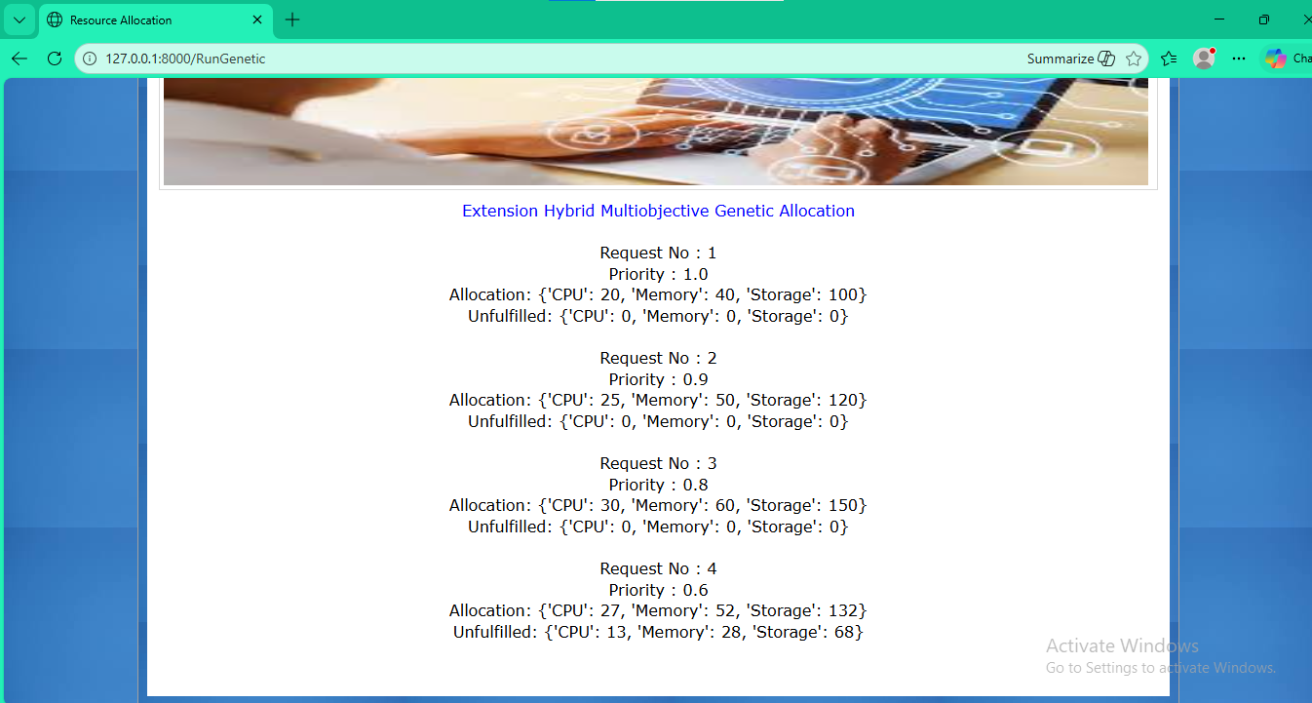
In above screen with extension technique last demand unfilled CPU size is 13 where propose was 15. Now click on ‘Graph’ link to get all algorithm performance graph

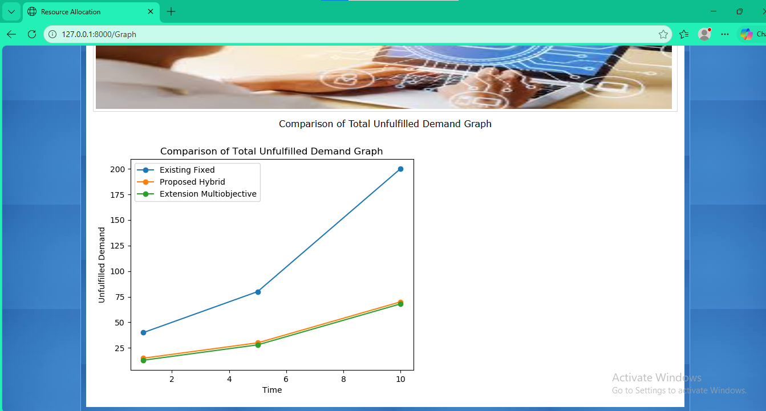
In above graph x-axis represents Time and y-axis represents ‘Unfilled demand count’. In above graph blue line represents Existing Fixed algorithm allocation and orange line represents Propose Hybrid allocation and then green line represents extension multi-objective allocation. In all algorithm extension unfilled demand is lesser than propose and existing algorithms.

