
A
Practical Assignment
On
Modern Operating System Design
Master of Computer Application - I Sem

RUNGTA INTERNATIONAL SKILLS UNIVERSITY

SESSION: 2025-26

Submitted By:-
Subject teacher name:- Sudeep Sarkar
Mr. Lakshman Sahu ERP :- RU-25-11468

RUNGTA INTERNATIONAL SKILLS UNIVERSITY,CG
SCHOOL OF INFORMATION TECHNOLOGY

INDEX

S.No | Topic | Date | Signature
01 | Write a Python program to display Operating System name, version, and  architecture using the platform library.
02 | Write a Python program to show Disk Partitions and Usage.
03 | Write a Python program to display total  memory, used memory, and available memory using the psutil library.
04 | Write a Python program to list the top 5 running processes (process name + PID)
05 | Write a Python program to display Monitor Network Statistics (Bytes  Sent/Received).
06 | Implement First Come First Serve (FCFS) CPU scheduling in Python.
07 | Implement Round Robin Scheduling with different time quantum.
08 | Implement Priority Scheduling and show waiting time vs turnaround time.
09 | Implement Page Replacement Algorithms: FIFO, LRU.
10 | Extend LRU with a prediction model (predict next reference using past data).
11 | Write a Python program to simulate memory allocation (First Fit, Best Fit, Worst Fit).
12 | Implement Optimal Page Replacement Technique
13 | Implement Disk Scheduling Algorithms: FCFS, SSTF.
14 | Write a program to monitor file access patterns and suggest cache strategy.
15 | Simulate Container as a Scheduler.
16 | Write a program to implement Banker’s Algorithm (Deadlock Avoidance)
17 | Write a program to implement Deadlock Prevention Techniques
18 | Simulate resource allocation and scheduling using Docker.
19 | Simulate Virtual File System

Experiment-01

Aim : Write a Python program to display Operating System name, version, and architecture using the platform library.

Code:
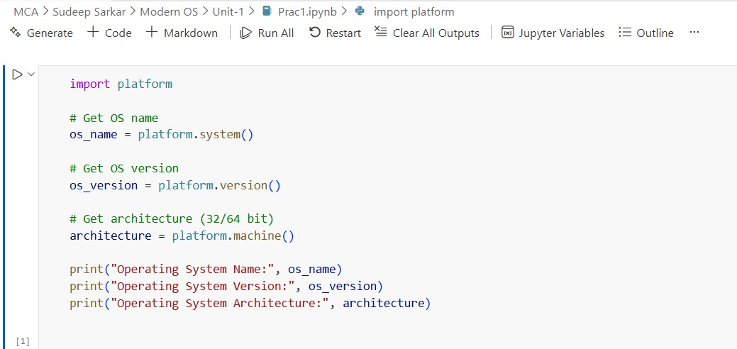

Output :-

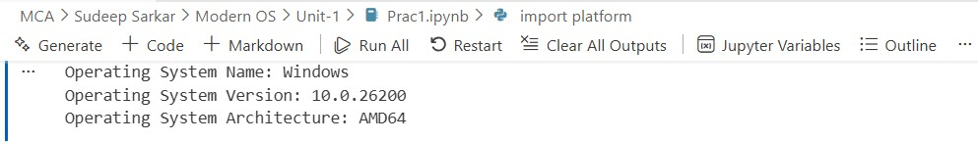

Experiment-2
Aim: Write a Python program to show Disk Partitions and Usage.

Code
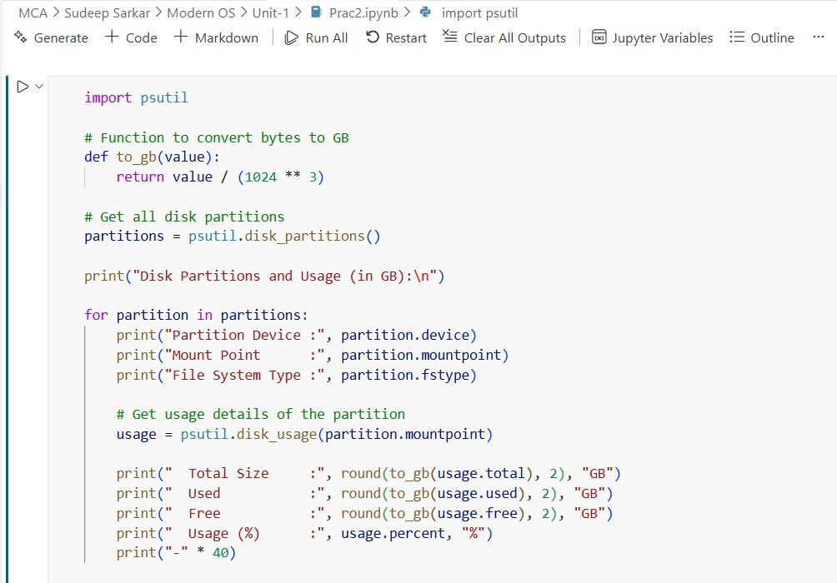

Output :-
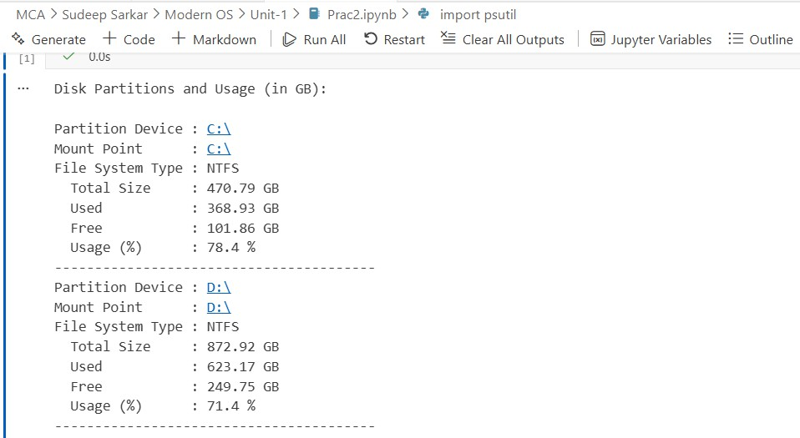

Experiment – 03

Aim: Write a Python program to display total memory, used memory, and available memory using the psutil library.

Code:
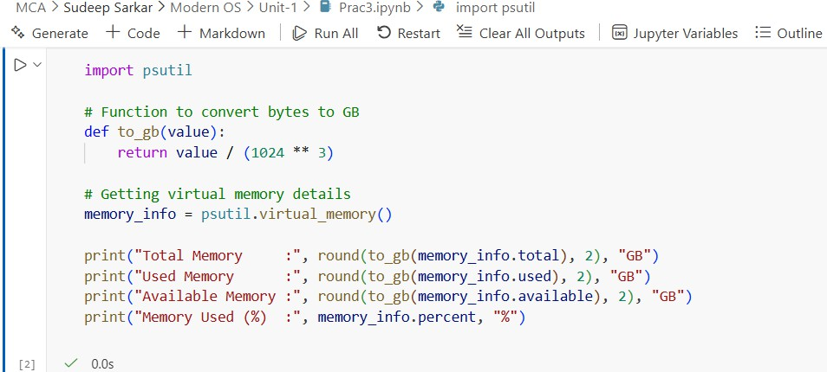

Output :-
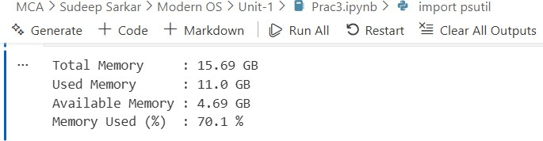

Experiment-04

Aim : Write a Python program to list the top 5 running processes (process name + PID).

Code:
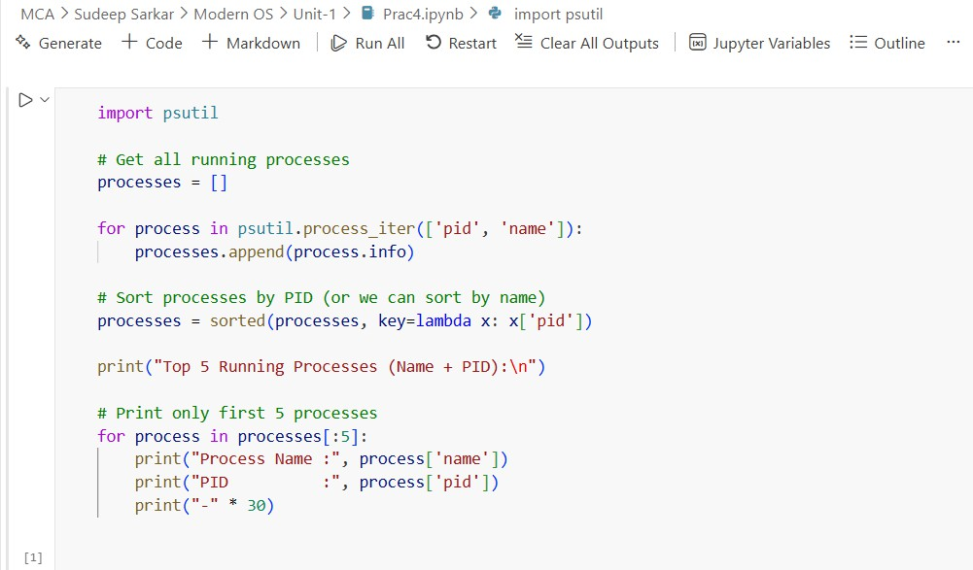

Output :-
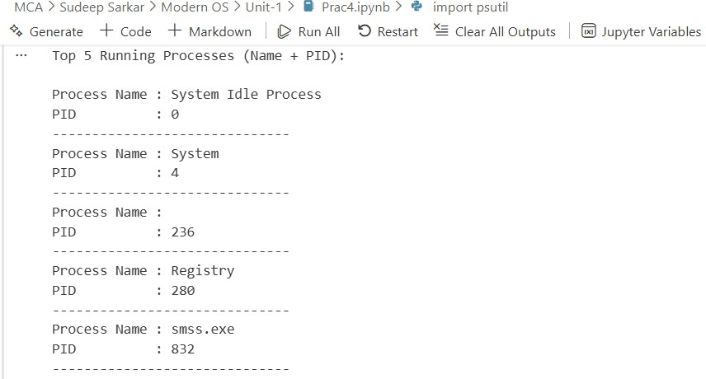

Experiment-05

Aim : Write a Python program to display Monitor Network Statistics (Bytes Sent/Received).
Code:
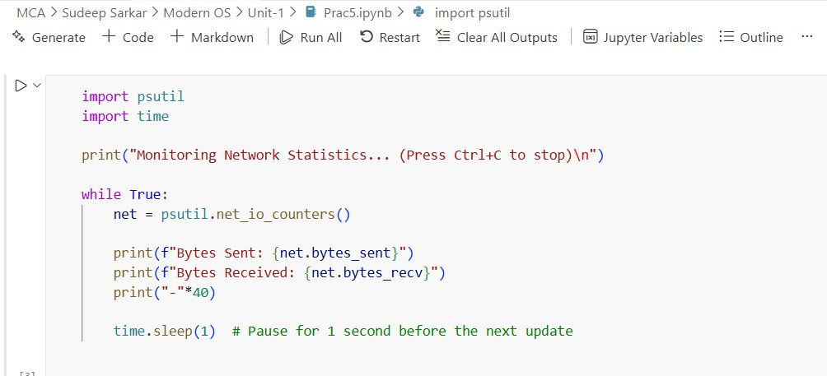

Output :-
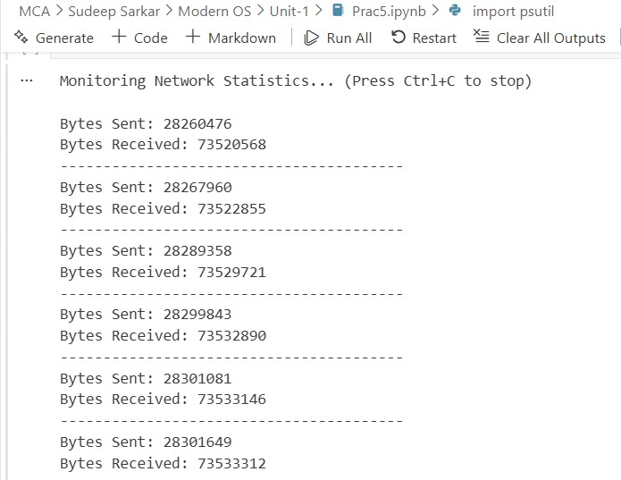

Experiment-06

Aim : Implement First Come First Serve (FCFS) CPU scheduling in Python.

Code
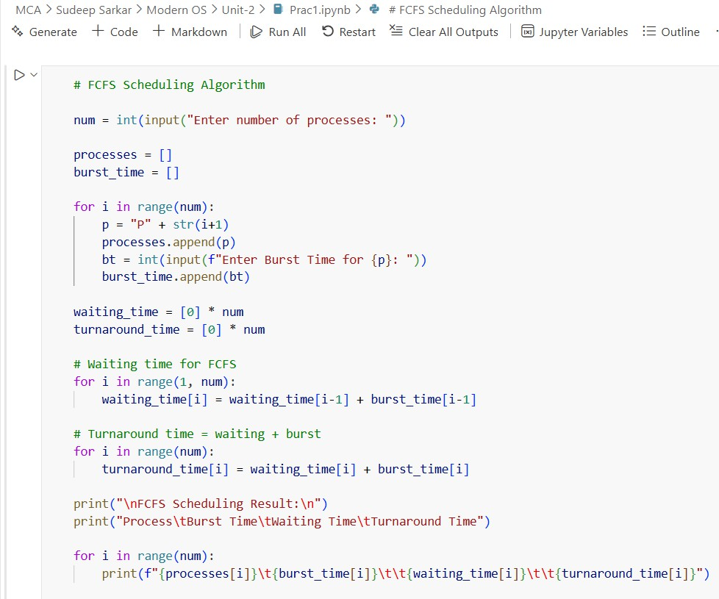
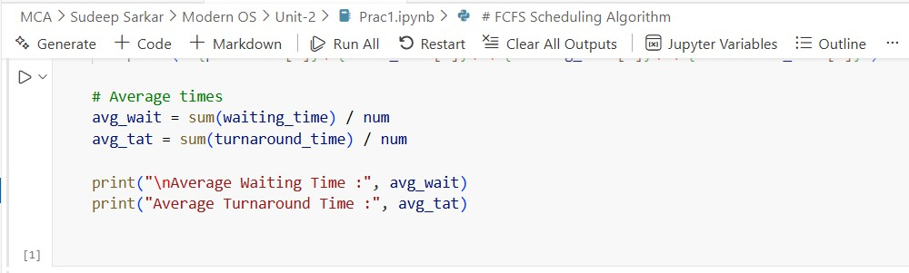
Output :-
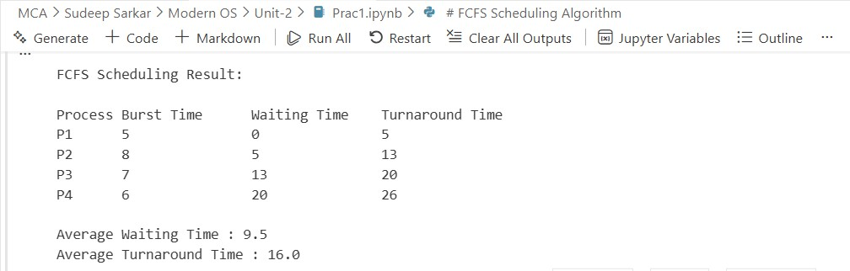

Experiment-07

Aim : Implement Round Robin Scheduling with different time quantum.

Code:
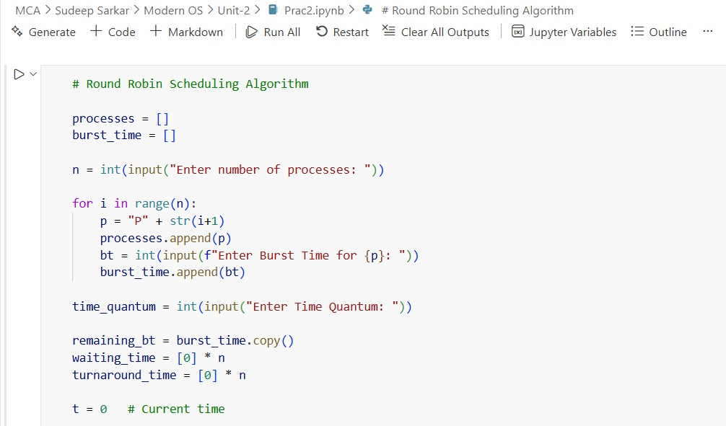

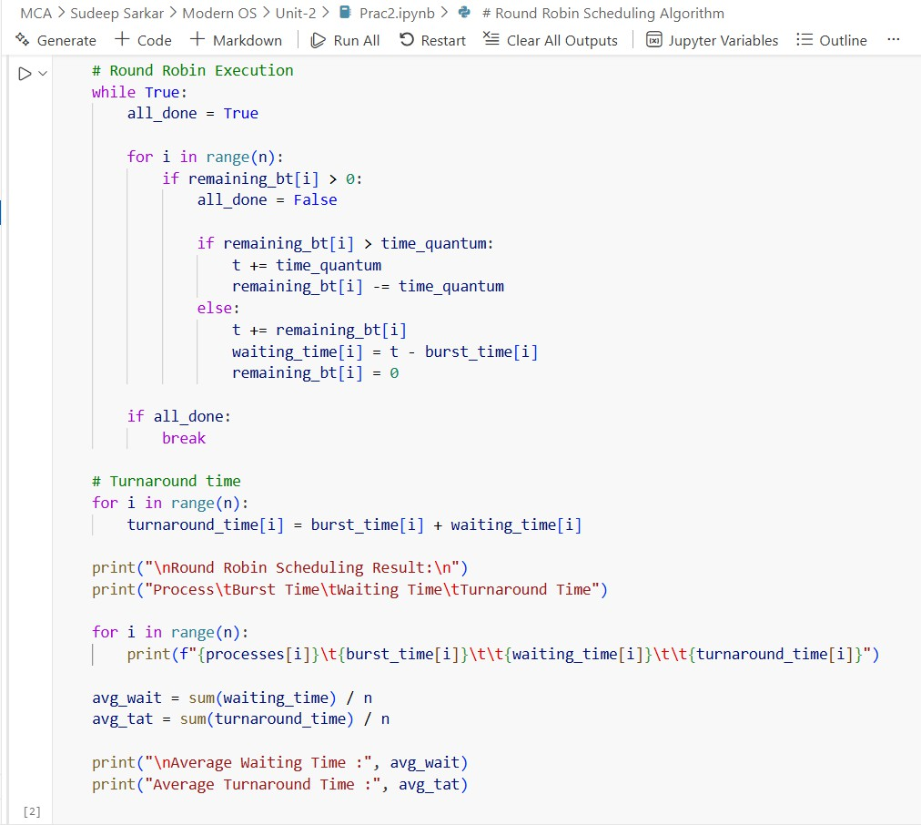

Output :-
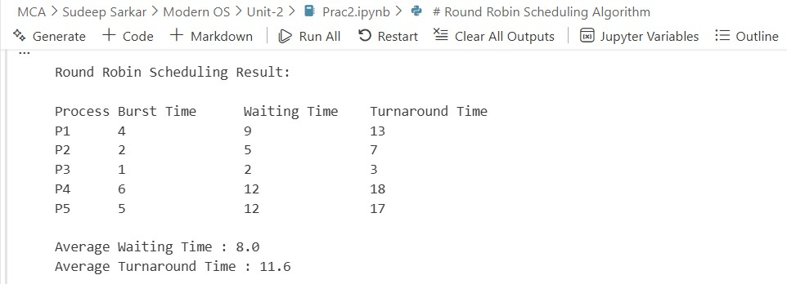

Experiment-08

Aim : Implement Priority Scheduling and show waiting time vs turnaround time.
Code:
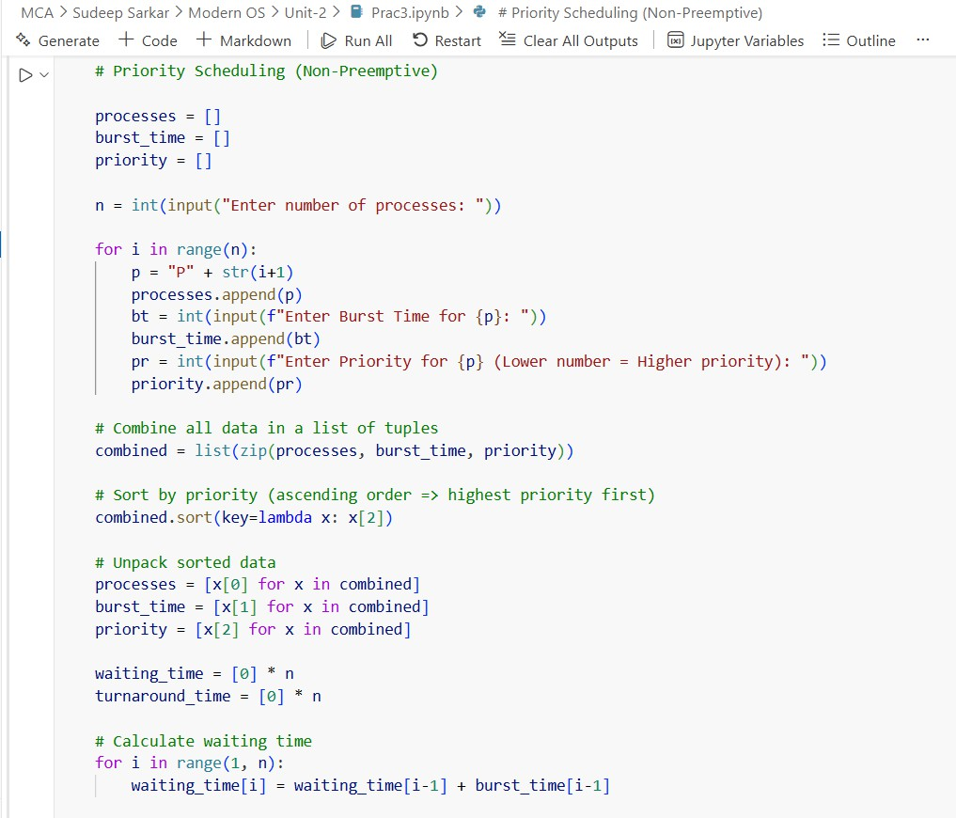
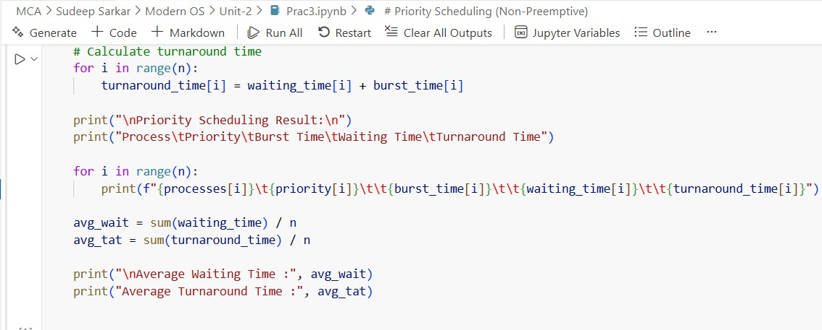

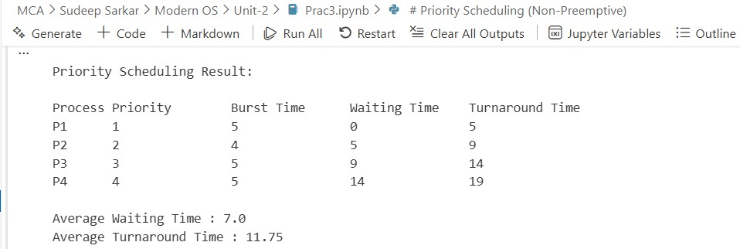
Output :-

Experiment-09

Aim: Implement Page Replacement Algorithms: FIFO, LRU.

Code:
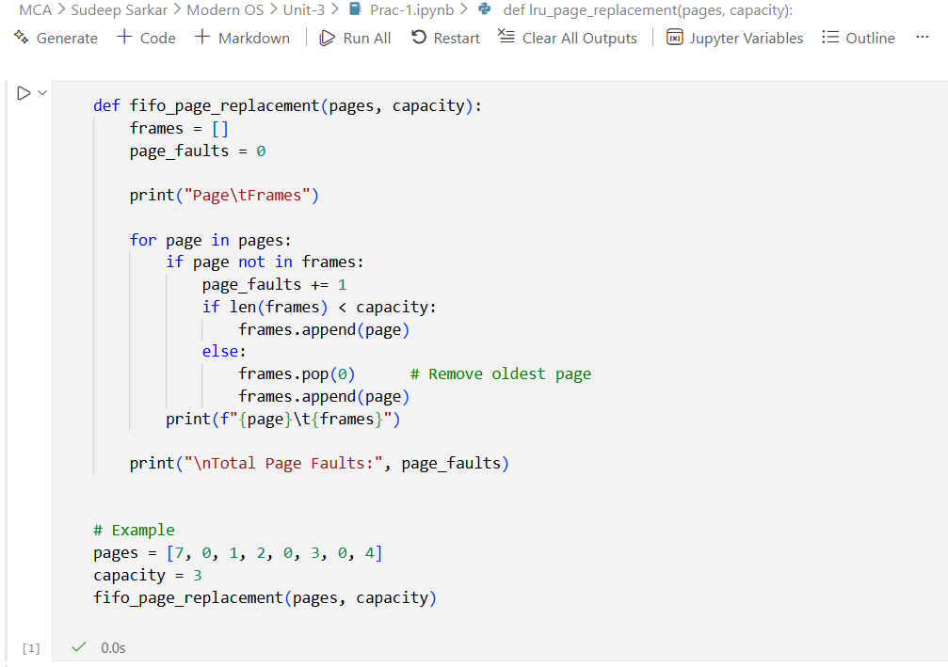

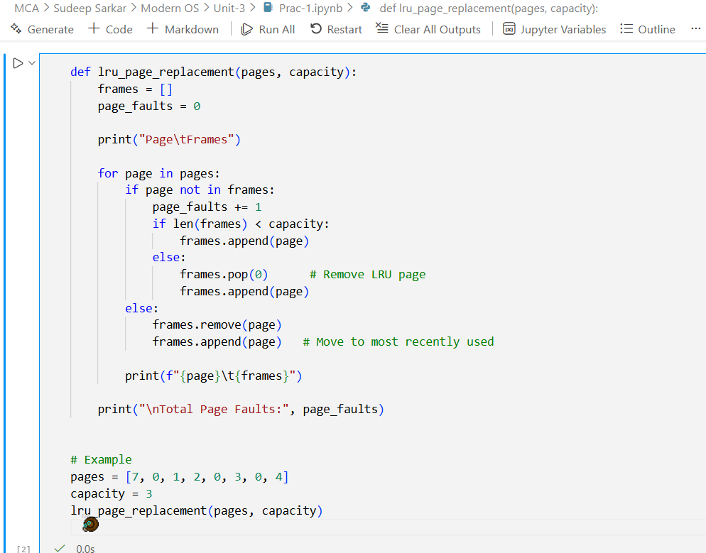
Output:
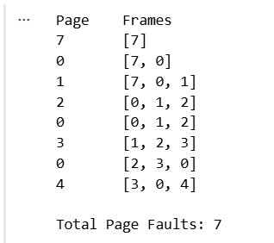
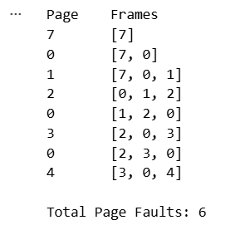

Experiment-10

Aim:- Extend LRU with a prediction model (predict next reference using past data).

Code:-
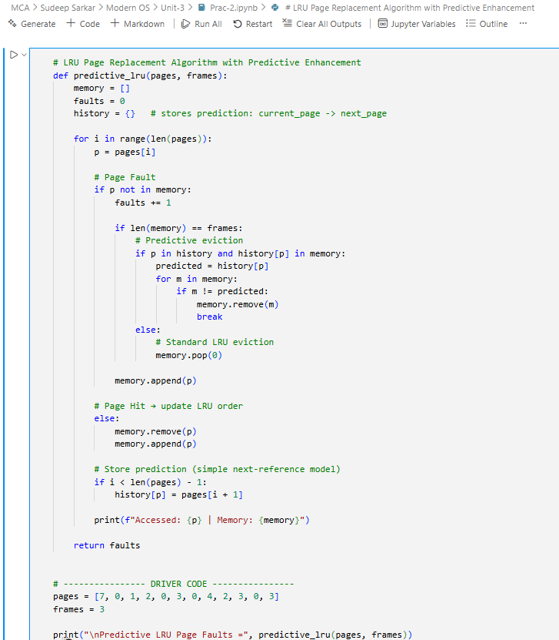

Output:
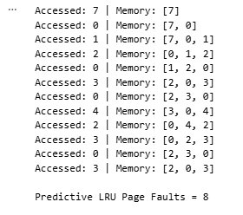

Experiment-11

Aim:- Write a Python program to simulate memory allocation (First Fit, Best Fit, Worst Fit).

Code:-
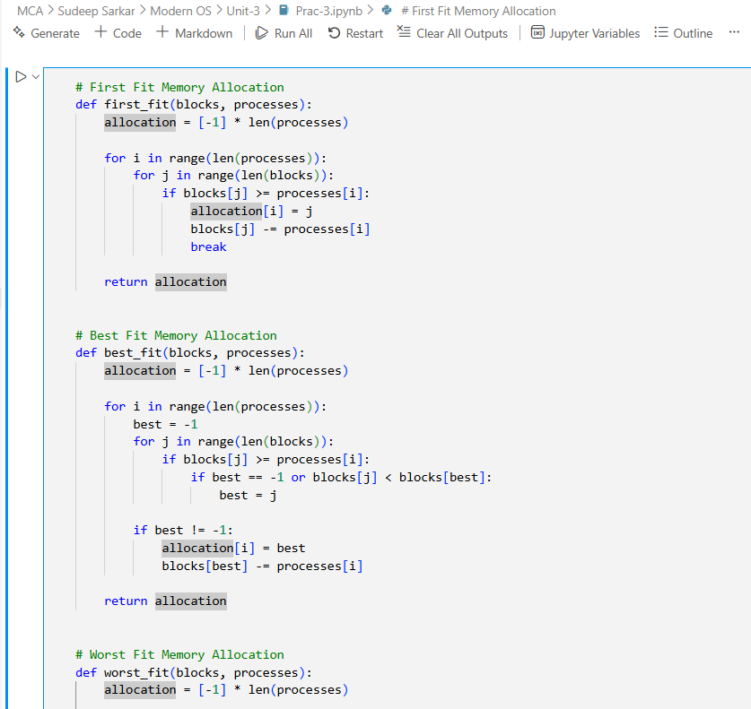
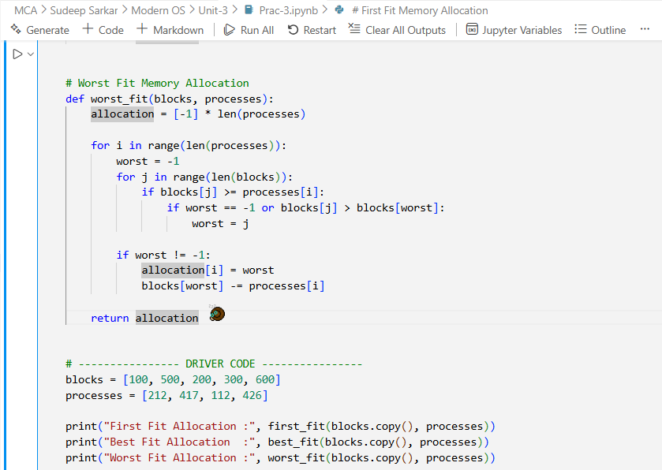

Output:
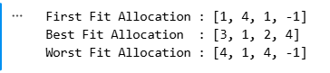

Experiment-12

Aim:- Implement Optimal Page Replacement Technique

Code:-
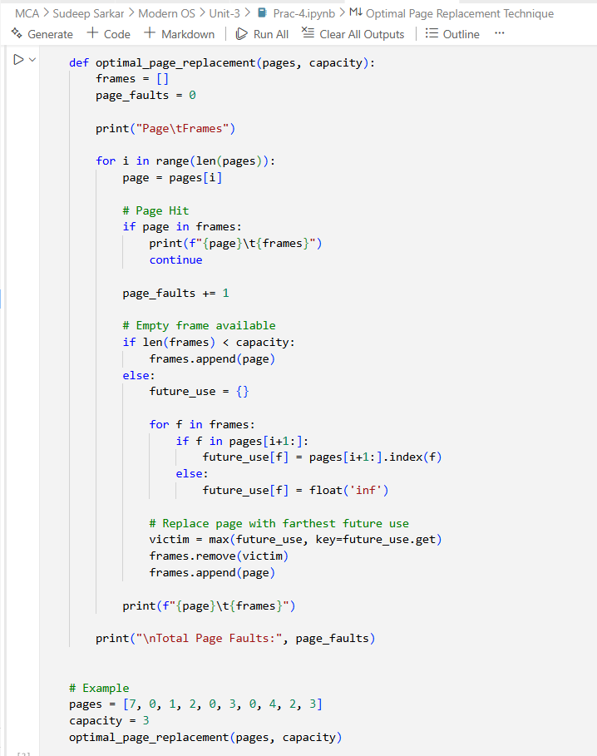

Output:
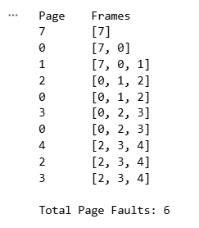

Experiment-13

Aim:- Implement Disk Scheduling Algorithms: FCFS, SSTF.

Code:-
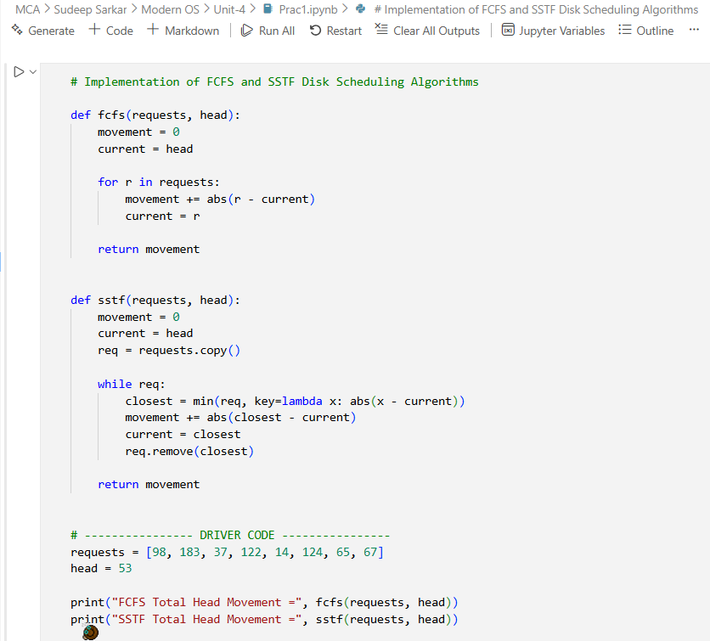

Output:
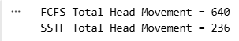

Experiment-14

Aim:- Write a program to monitor file access patterns and suggest cache strategy.

Code:-
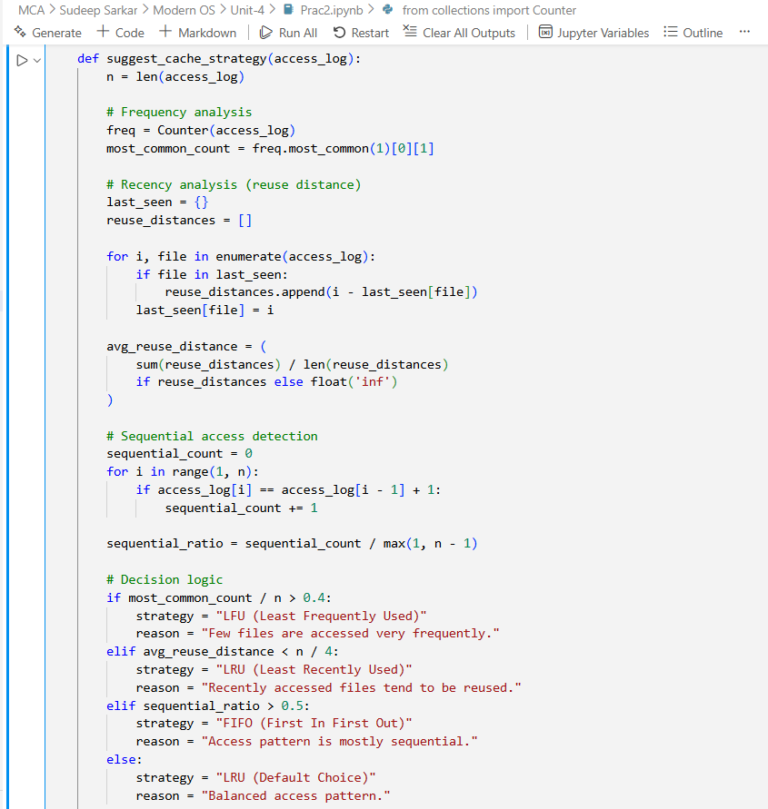
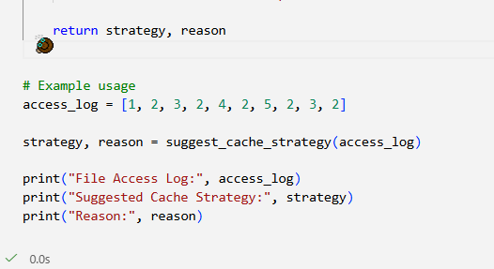

Output:
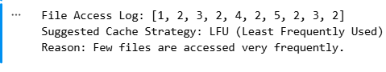

Experiment-15

Aim:- Simulate Container as a Scheduler.

Code:-
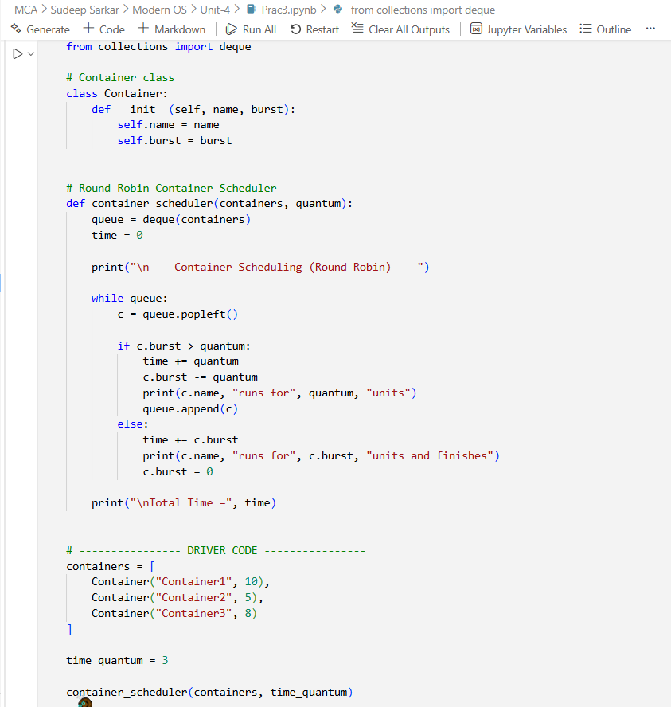

Output:
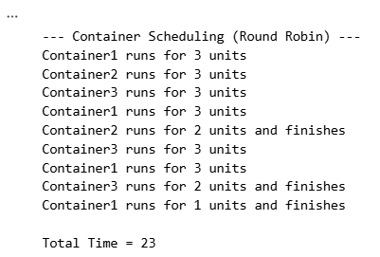

Experiment-16

Aim:- Write a program to implement Banker’s Algorithm (Deadlock Avoidance)

Code:-
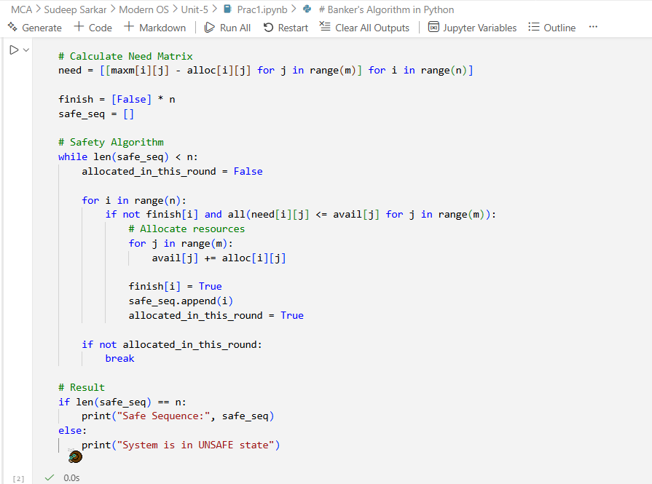

Output:
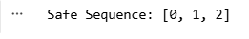

Experiment-17
Aim:- Write a program to implement Deadlock Prevention Techniques

Code:-
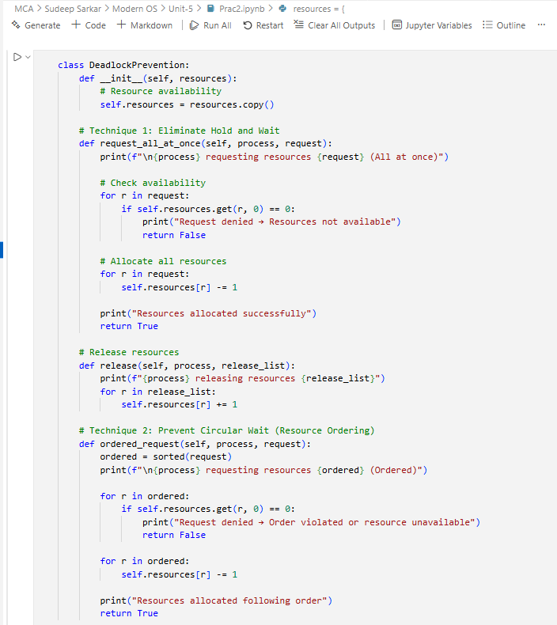
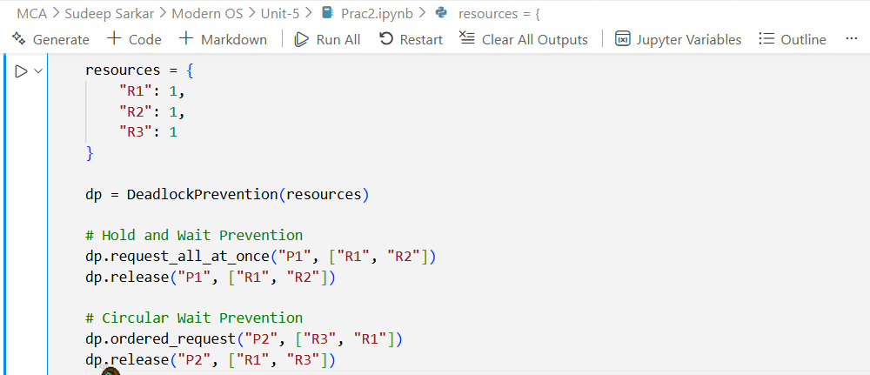

Output:
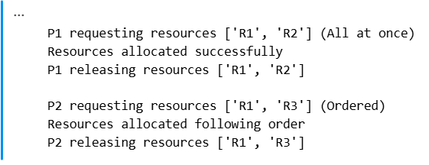

Experiment-18

Aim:- Simulate resource allocation and scheduling using Docker.

Code:-
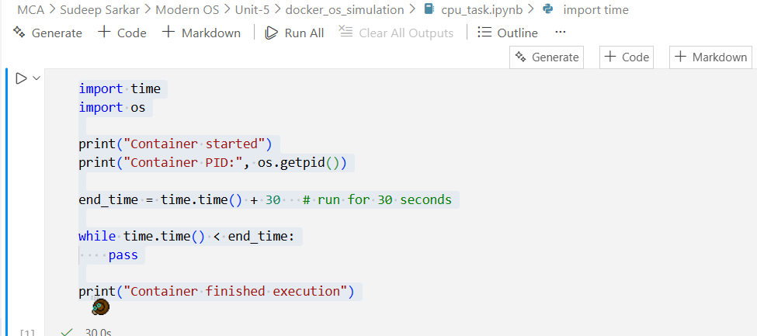
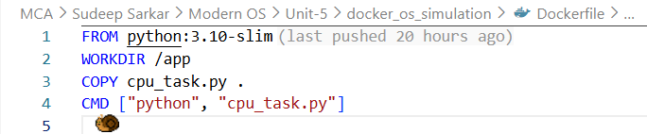

Output:
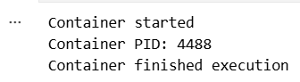
Experiment-19

Aim:- Simulate Virtual File System.

Code:-
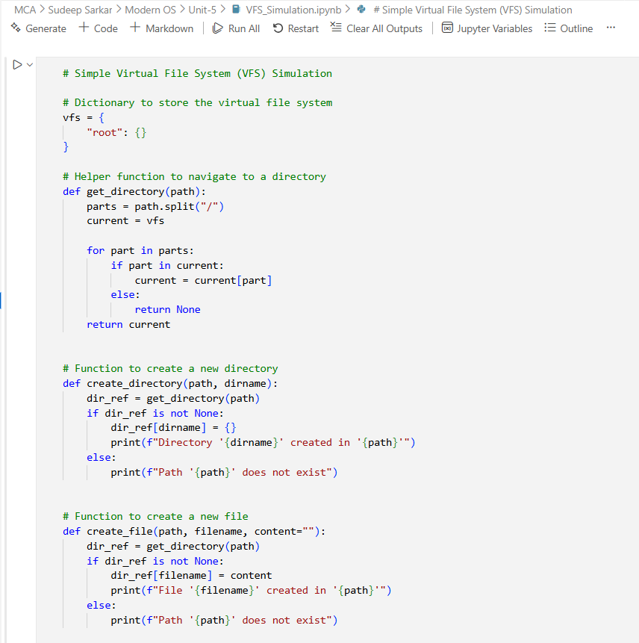
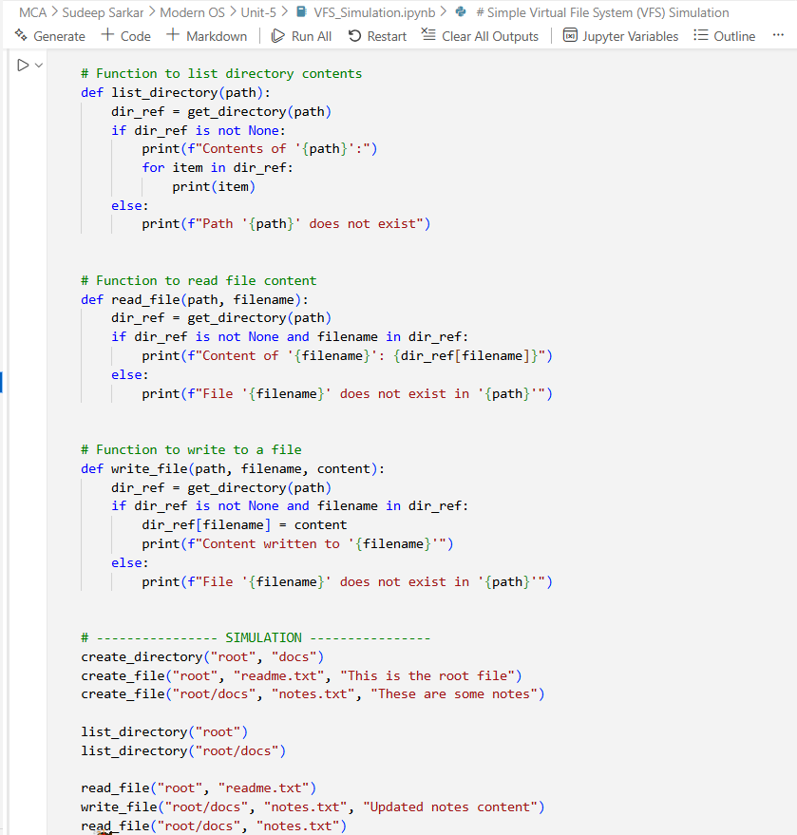

Output:
