
A
Practical Assignment
On
Python Programming Lab Records
Master of Computer Application -I Sem

RUNGTA INTERNATIONAL SKILLS UNIVERSITY

SESSION: 2025-26

Submitted By:-
Subject teacher name :- Sudeep Sarkar
Ms. Kavita Kanwar ERP :- RU-25-11468

RUNGTA INTERNATIONAL SKILLS UNIVERSITY,CG
SCHOOL OF INFORMATION TECHNOLOGY

INDEX
S.No | Name of Practical | Submission Date | Remarks
 | Write a program to check whether the year is leap or not
 | Write a program to count no. of vowels in a string.
 | Write a program to reverse a number.
 | Write a program to find mean, median and mode of given number.
 | Write a Python program to reverse only the vowels in a given string, keeping other characters in their original positions.
 | Create a script that takes an integer and displays its binary, octal and hexadecimal representations neatly formatted.
 | Given a list of items (possible with duplicates), write a program that removes duplicates and displays that sorted list.
 | Accept a list of students and their marks as tuples. Display the name of the student with the highest marks.
 | Read data from a CSV file containing employee details (name, department, salary) and display the average salary by department.
Write a python program using math module to calculate:

- Square root of a number
- Factorial of a number
- Power of a number
( take input from the user )
 | Write a python program to find the area and circumference of a circle using math module, take input from the user.
 | Create a list of student and select CR randomly, then shuffle the list and print it.
 | Write a python program to generate a random password of 12 characters using UPPERCASE, lowercase, digits and special symbols(!, @, #, $, *). Password should start with Capital letter or digits.
 | Create a package named shapes that contains two modules: circle.py and rectangle.py. Each module should compute area and perimeter of the shape. Write the complete directory structure and sample code.
Write a program that asks the user for an index and prints the element at that index from a predefined list. Handle:

- IndexError (index out of range)
- TypeError (if user enters a non-integer index)
- Print the specific exception message using except Exception as e.
 | Implement a supervised learning model to classify flowers in the Iris dataset using decision tree classifier. Print the accuracy of the model.
 | Use Support Vector Machine (SVM) on the breast cancer datasets to classify malignant vs benign tumors.
 | Perform Principal Component Analysis (PCA) on the digits dataset and reduce the dimension to 2. Print the explained variance ratio.
 | Apply K-Means clustering on the Iris Dataset and print cluster label

Practical-1
Aim: Write a program to check whether the year is leap or not
Code :-
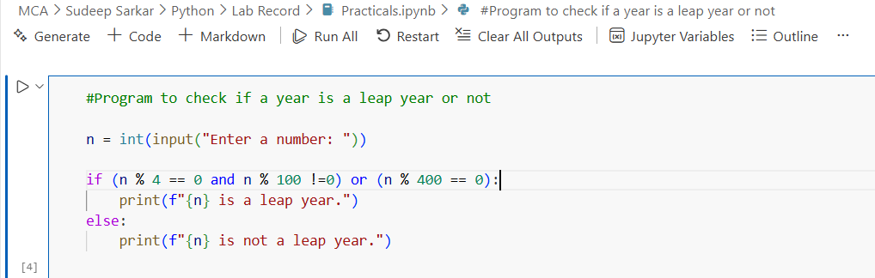

Output :-

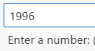
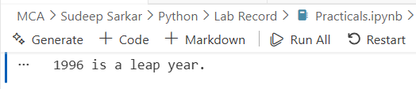

Practical-2

Aim: Write a program to count no. of vowels in a string.
Code :-

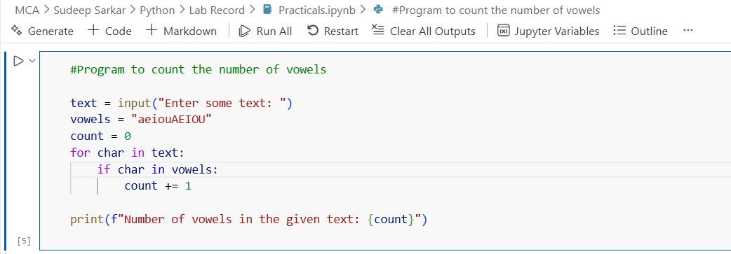

Output :-

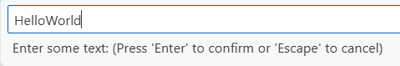

Practical-3
Aim: Write a program to reverse a number.
Code :-

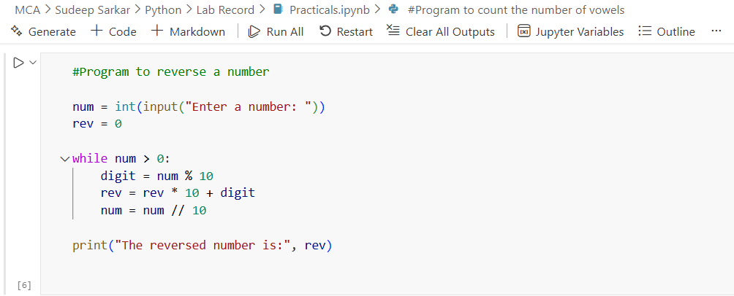

Output :-

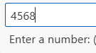
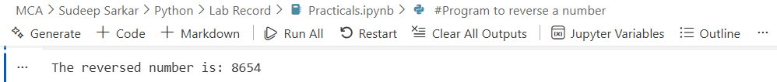

Practical-4
Aim: Write a program to find mean, median and mode of given number.
Code :-

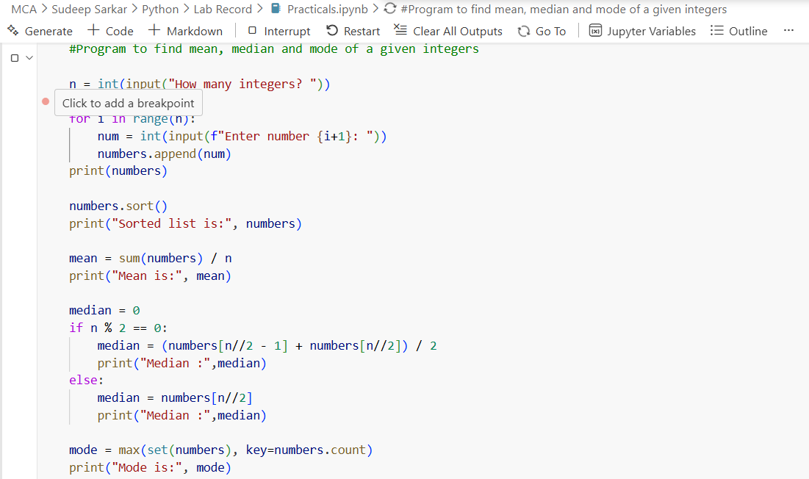

Output :-
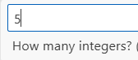
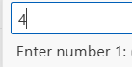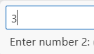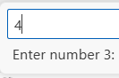
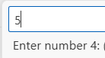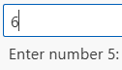
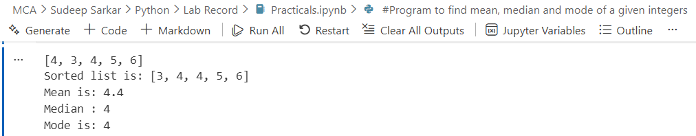Practical-5
Aim: Write a Python program to reverse only the vowels in a given string, keeping other characters in their original positions.
Code :-

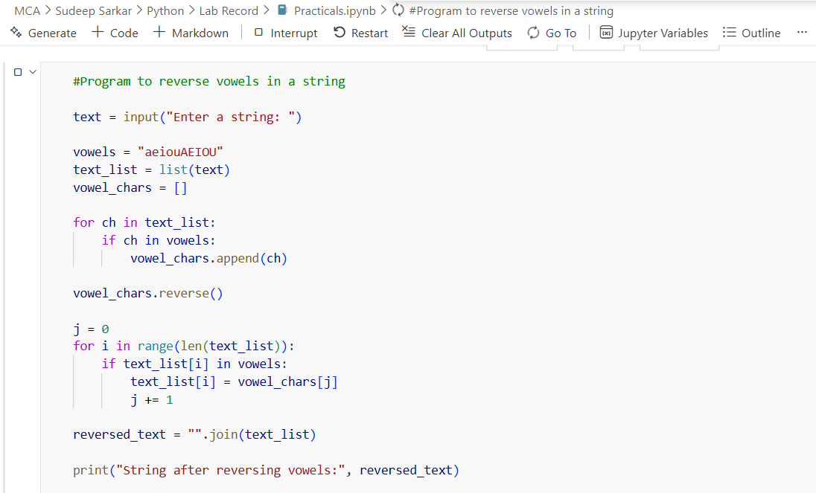

Output :-

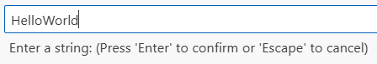
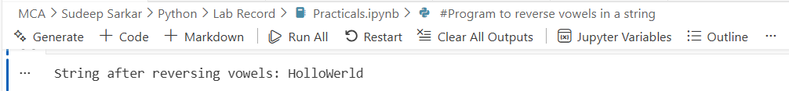

Practical-6
Aim: Create a script that takes an integer and displays its binary, octal and hexadecimal representations neatly formatted.

Code :

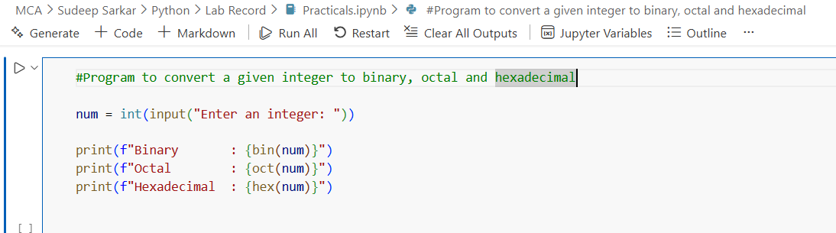

Output :

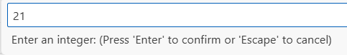

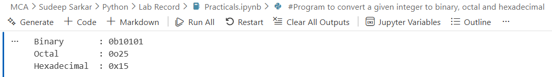

Practical-7

Aim: Given a list of items (possibly with duplicates), write a program that removes duplicates and displays that sorted list.
Code :-
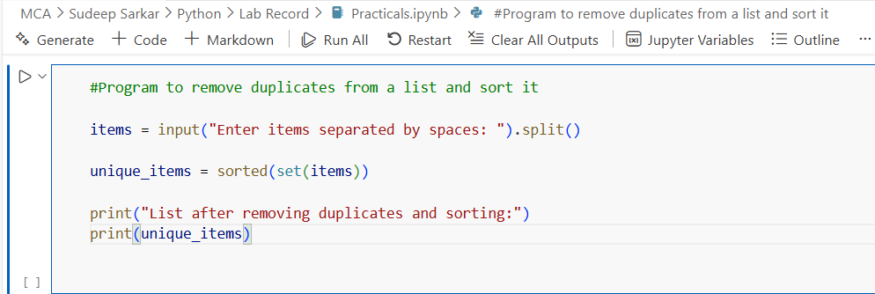

Output :
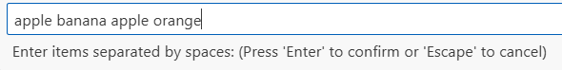

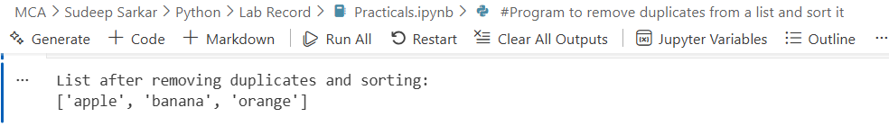

Practical-8
Aim: Accept a list of students and their marks as tuples. Display the name of the student with the highest marks.
Code :-
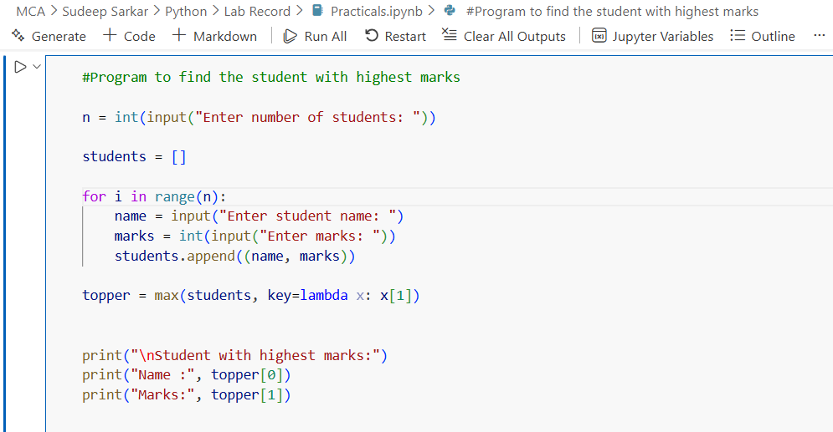

Output :-

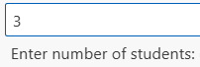

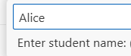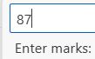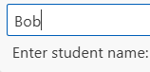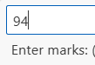

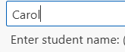

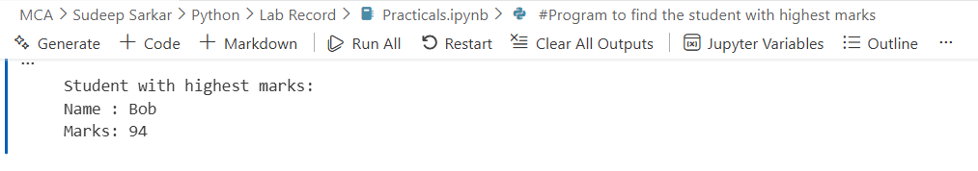
Practical-9
Aim : Read data from a CSV file containing employee details (name, department, salary) and display the average salary by department.
Code :-

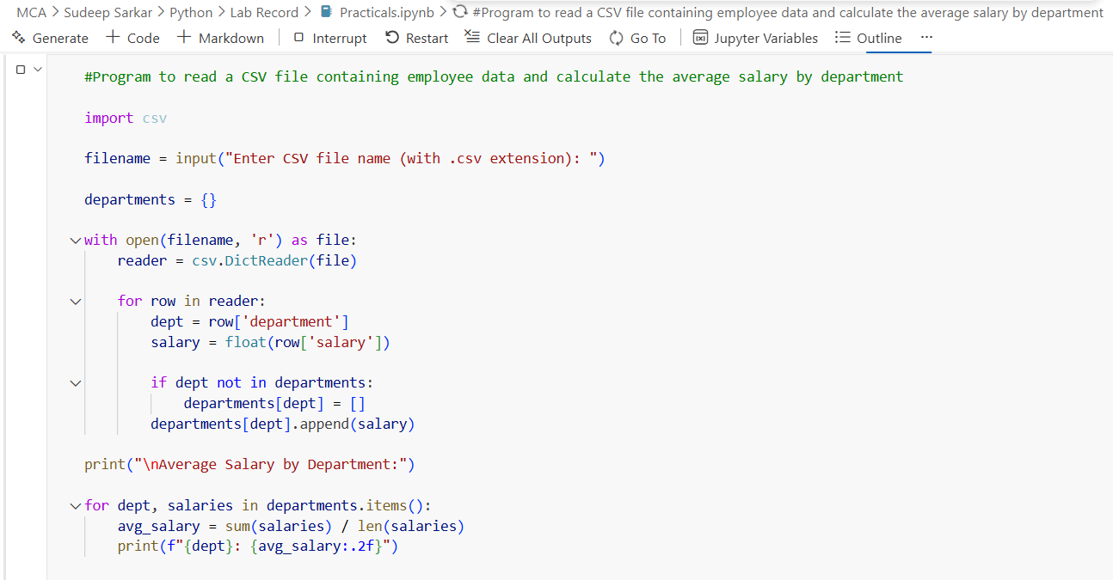

Output :-

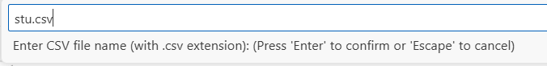

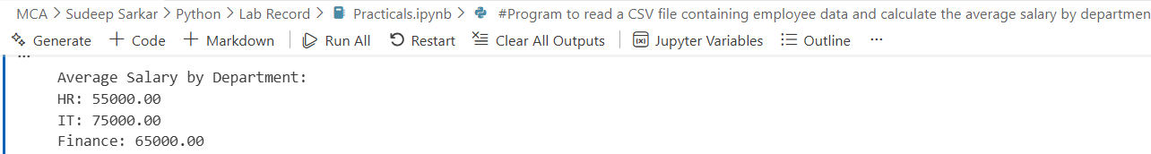

Practical-10

Aim:- Write a python program using math module to calculate:
a) square root of a number
b) factorial of a number
c) power of a number
(take input from the user)

Code :
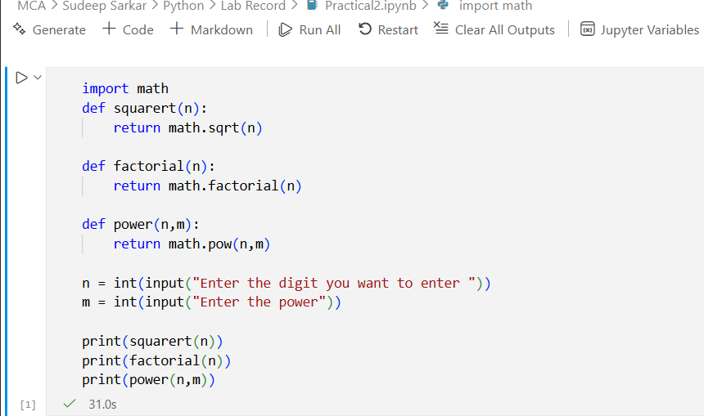

Output :
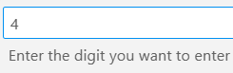
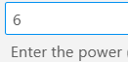
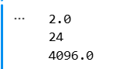

Practical-11

Aim:- Write a python program to find the area and circumference of a circle using math module, take input from the user

Code:-
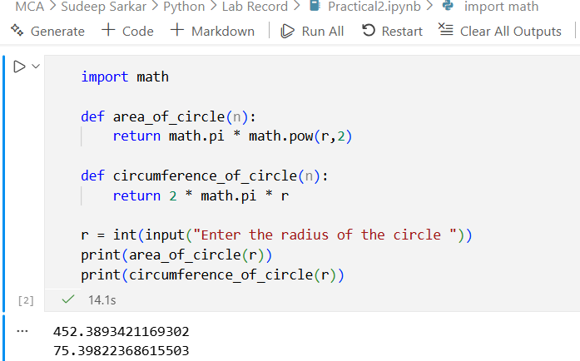

Output:
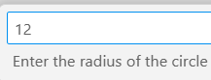


Practical-12

Aim:- Create a list of student and select CR randomly, then shuffle the list and print it.

Code:-
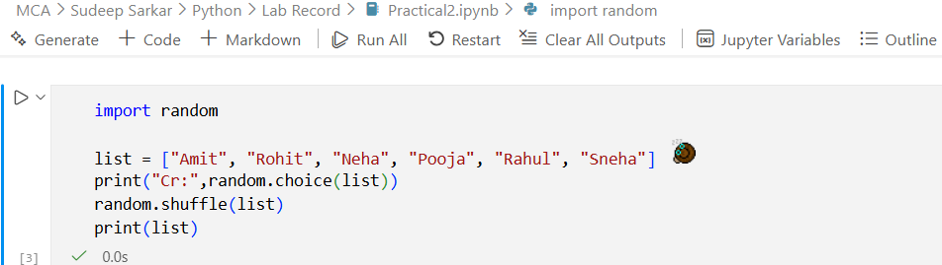

Output:
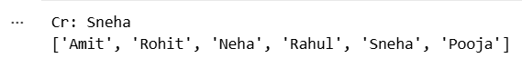

Practical-13

Aim:- Write a python program to generate a random password of 12 characters using UPPERCASE, lowercase, digits and special symbols(!, @, #, $, *). Password should start with Capital letter or digits.

Code:-
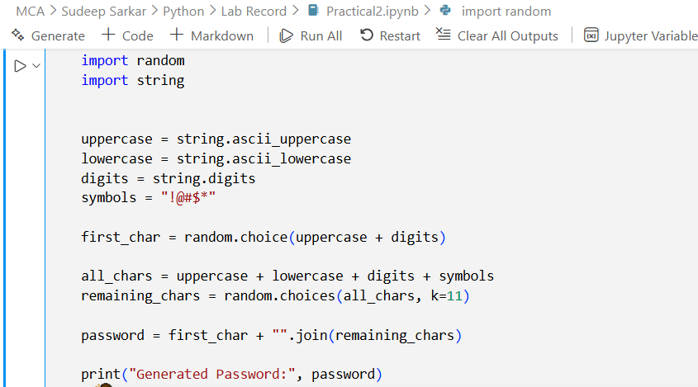

Output:
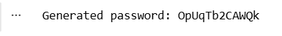

Practical-14

Aim:- Create a package named shapes that contains two modules: circle.py and rectangle.py. Each module should compute area and perimeter of the shape. Write the complete directory structure and sample code.

Module 1(circle.py):

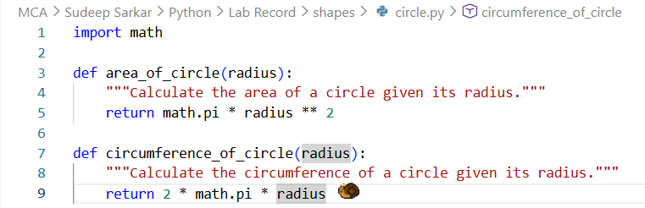

Module 2(rectangle.py):

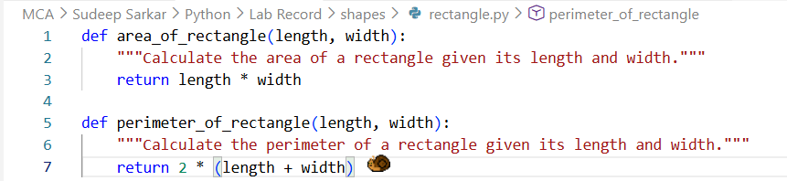

Directory Sample:

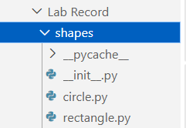

Code:
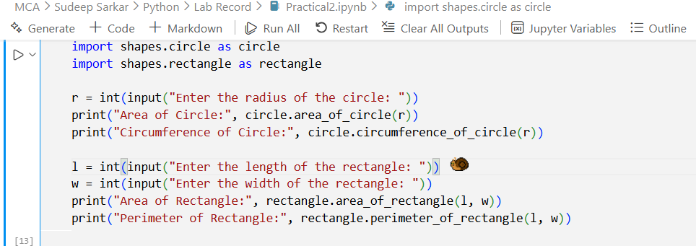

Output:
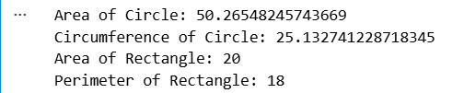

Practical-15

Aim:- Write a program that asks the user for an index and prints the element at that index from a predefined list.
Handle:
- IndexError (index out of range)
- TypeError (if user enters a non-integer index)
- Print the specific exception message using except Exception as e.

Code:-

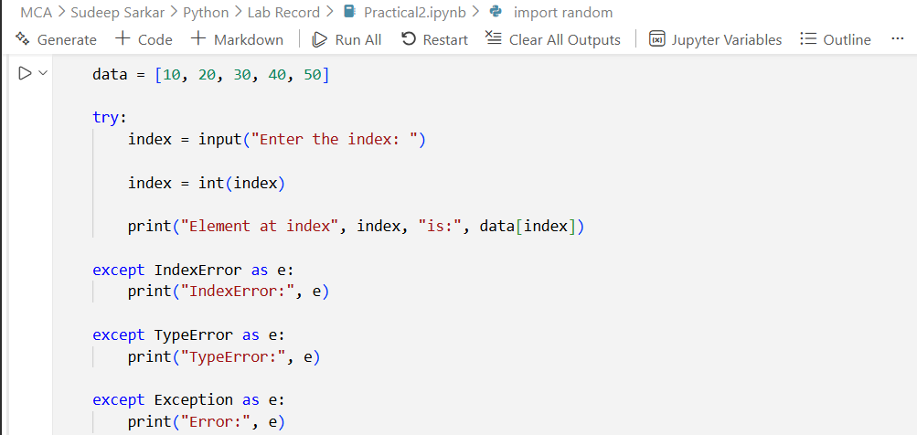

Output:
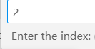
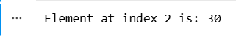

Practical-16

Aim:- Implement a supervised learning model to classify flowers in the Iris dataset using Decision Tree Classifier. Print the accuracy of the model.

Code:-
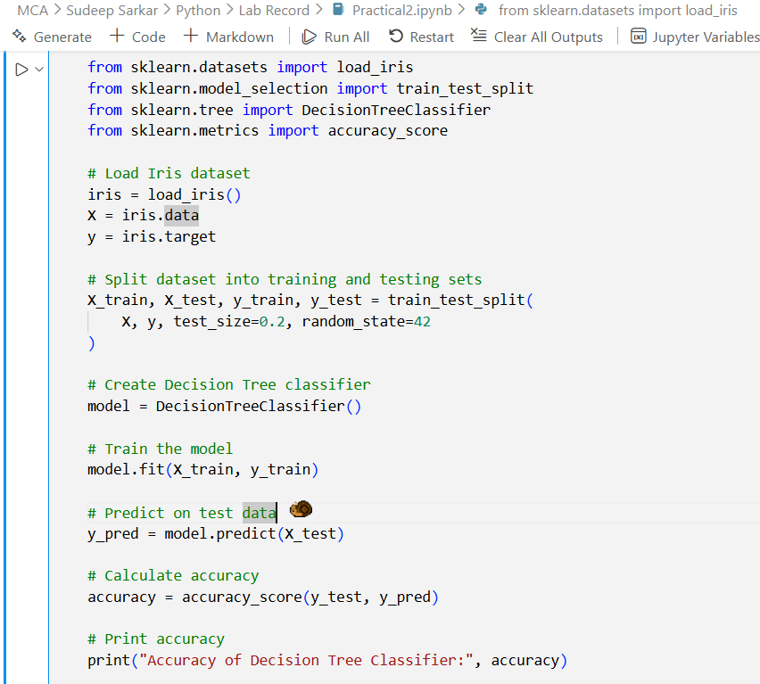

Output:
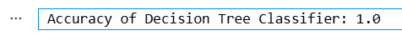

Practical-17

Aim:- Use Support Vector Machine (SVM) on the Breast Cancer datasets to classify malignant vs benign tumors.

Code:
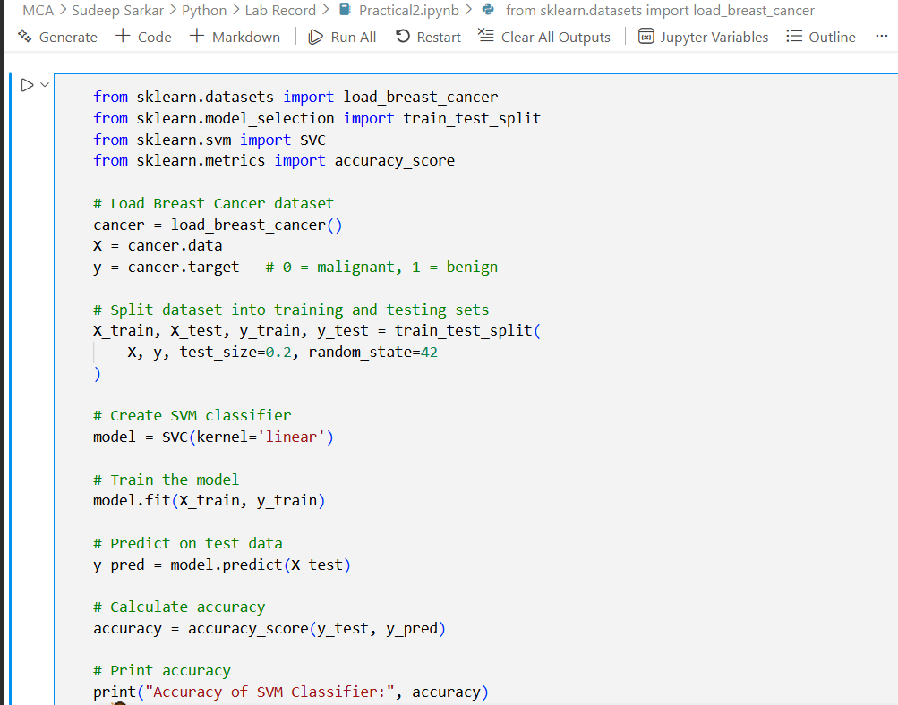

Output:
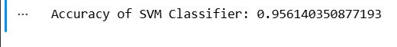

Practical-18

Aim:- Perform Principal Component Analysis (PCA)on the Digits dataset and reduce the dimension to 2. Print the explained variance ratio

Code:
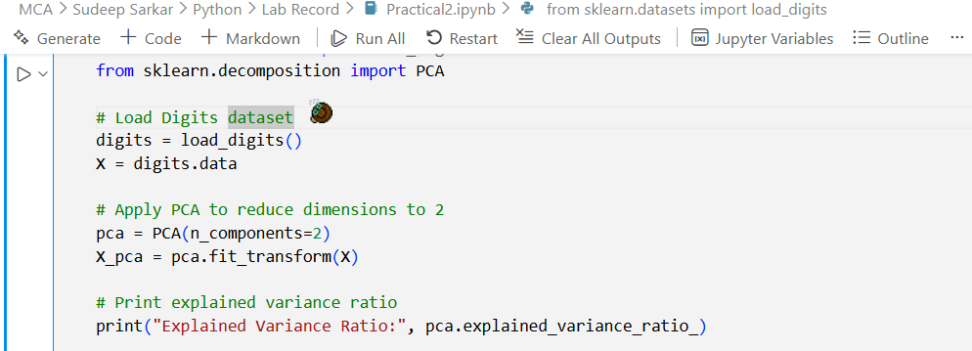

Output:

Practical-19

Aim:- Apply K-Means clustering on the Iris Dataset and print cluster labels.

Code:-
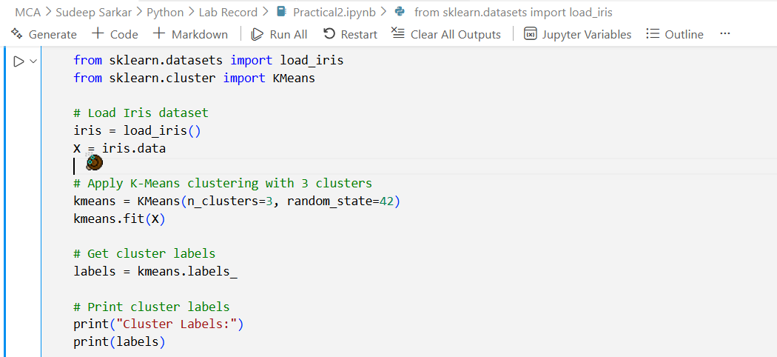

Output:
