**Tables**

Table: Crime Report

Primary key: ReportID

|  |  |  |
| --- | --- | --- |
| **Field** | **Type** | **Description** |
| ReportID | INT | Unique identifier for the report |
| UserID | INT | ID of the user who submitted the report |
| DateReported | DATETIME | Date and time the report was submitted |
| Location | VARCHAR (100) | Location of the incident |

Table: Multimedia Evidence

Primary key: EvidenceID

|  |  |  |
| --- | --- | --- |
| **Field** | **Type** | **Description** |
| EvidenceID | INT | Unique identifier for the evidence |
| ReportID | INT | ID of the associated criminal report |
| Type | VARCHAR(50) | Type of evidence (e.g., photo, video) |
| FileName | VARCHAR(100) | Name of the file |
| FilePath | VARCHAR(255) | Path to the file location |
| UploadedBy | INT | ID of the user who uploaded the evidence |
| UploadDate | DATETIME | Date and time the evidence was uploaded |

Table: Social Media

Primary key: SMID

|  |  |  |
| --- | --- | --- |
| **Field** | **Type** | **Description** |
| SMID | INT | Unique identifier for the social media feed |
| AdminID | INT | ID of the admin who posted the feed |
| Content | TEXT | Text content of the feed |
| ImageURL | VARCHAR(255) | URL of any image attached to the feed |
| VideoURL | VARCHAR(255) | URL of any video attached to the feed |
| PostedAt | DATETIME | Date and time when the feed was posted |

Table: Reaction

Primary key: RID

|  |  |  |
| --- | --- | --- |
| **Field** | **Type** | **Description** |
| RID | INT | Unique identifier for the reaction |
| FeedID | INT | ID of the social media feed the reaction is for |
| UserID | INT | ID of the user who reacted to the feed |
| Reaction | VARCHAR(20) | Reaction |
| ReactedAt | DATETIME | Date and time when the reaction was made |

UML Diagrams

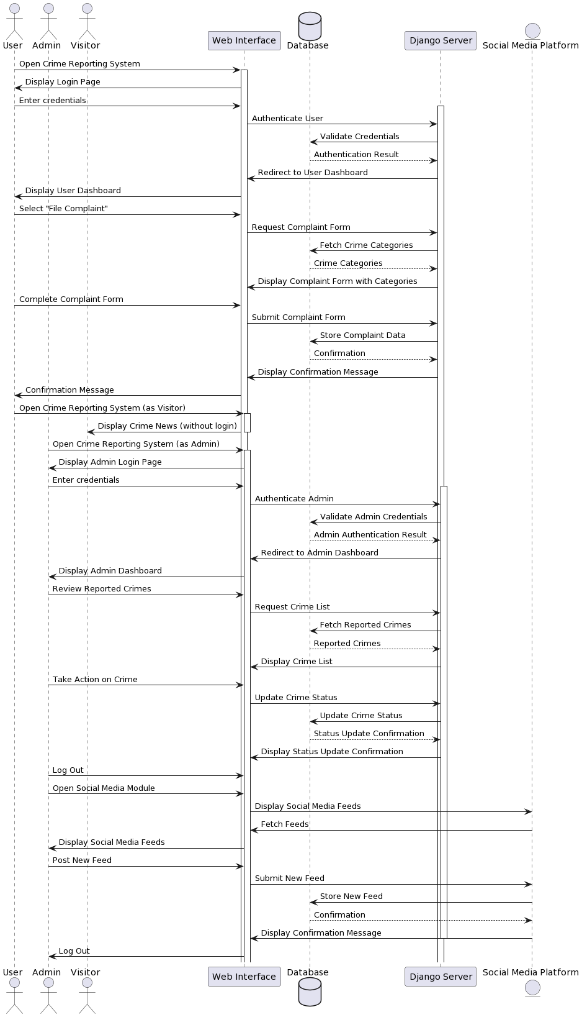

State diagram

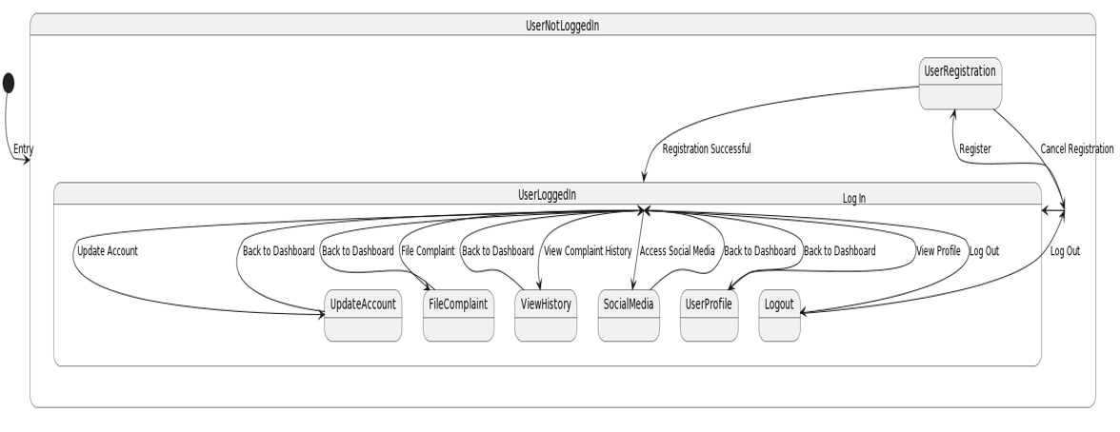

Object diagram

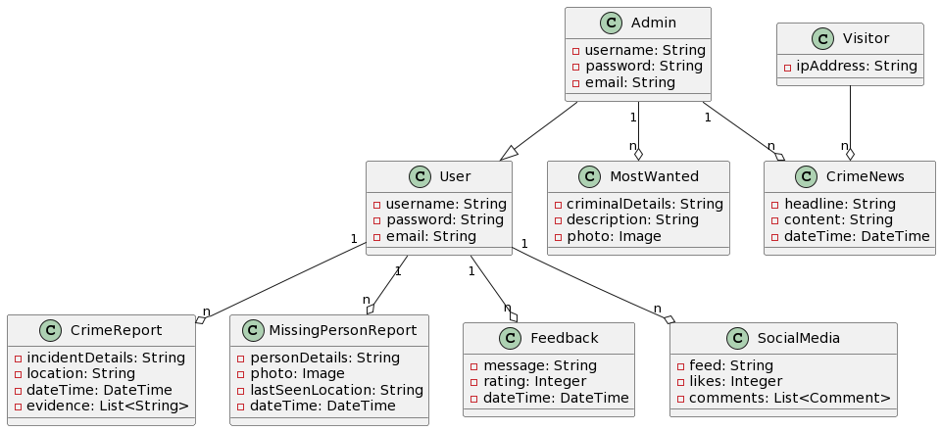

Component diagram

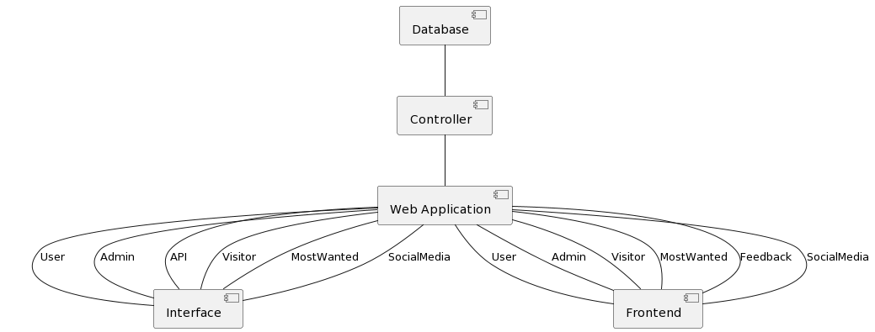

Class diagram

