Treasure Hunt Game Report
1. Introduction
This report discusses the development and functionality of the Treasure Hunt Game implemented in C. The objective of the game is for the player to find treasures while avoiding traps in a grid-based map. The player can save their progress and load a saved game to continue playing.
2. Game Description
The Treasure Hunt game is a grid-based adventure game. The player is given a grid (5x5)and must move around to find treasures ('T') and avoid traps ('X'). The game is designed to track the player's position and collected treasures while allowing for saving and loading of the game state.
3. Functions Used in the Game
3.1 placeItems()
The placeItems function places a specific number of treasures ('T') and traps ('X') randomly on the grid. It ensures that the items are placed in empty cells, and no items overlap.
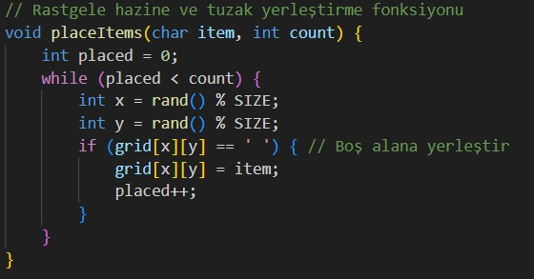
3.2 initializeGame()
This function initializes the game grid with 'P' representing the player, '?' representing unknown cells, 'T' for treasures, and 'X' for traps. It initializes a 5x5 grid and places theplayer at position (0,0). 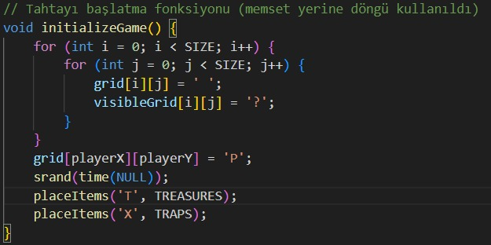
3.3 printBoard()
This function prints the game board (visibleGrid) on the screen, displaying the current state to the player. Additionally, it prints the number of treasures collected by the player (collectedTreasures).
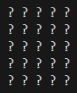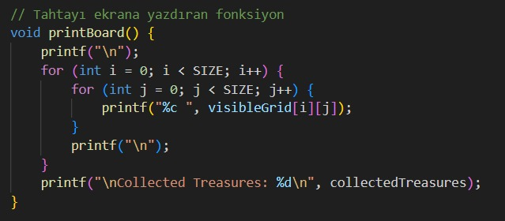
3.4 countNearby()
This function counts how many times a specific item (e.g., treasure or trap) appears in the 8 surrounding cells of the player's current position (playerX, playerY) and returns this value.
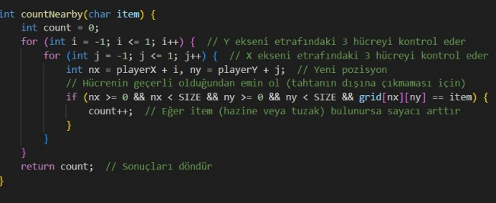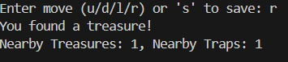
3.5 movePlayer()
This function allows the player to move based on the directional input. During the movement, the player's position on the game board (grid and visibleGrid) is updated, and events such as treasures or traps are handled..
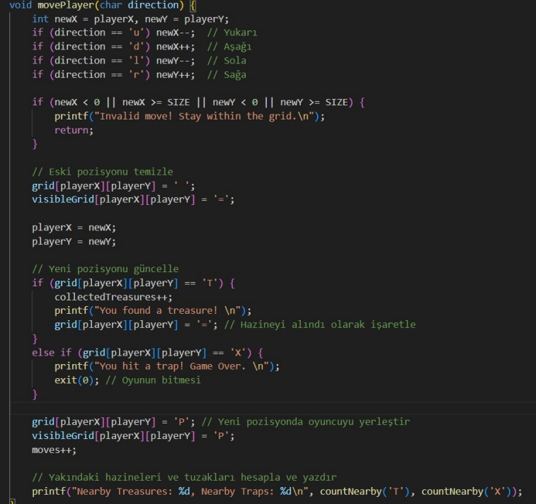
3.6 saveGame()
This function saves the current game state to a file. The player’s name, position, collected treasures, and game grid are written to a file named 'game_save.txt'. If the game cannot be saved, it will print an error message.
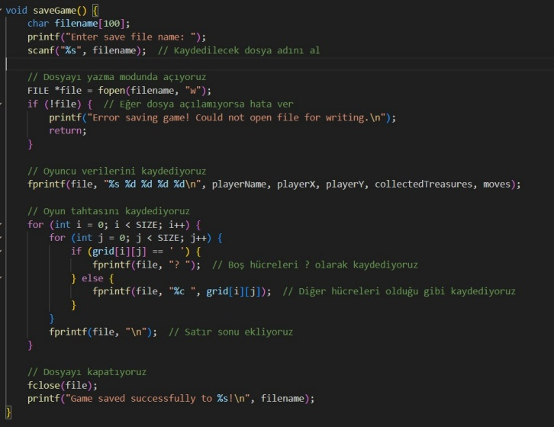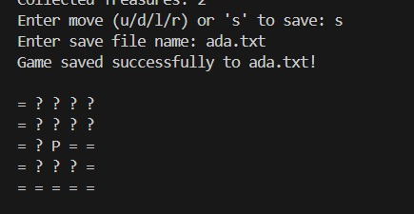
3.7 loadGame()
This function loads a saved game from a file. It reads the player's saved position, the number of treasures collected, and the game board (grid) state from the file. It also verifies that the player loading the game is the correct one (based on their name). If everything is valid, the game state is loaded, and the visible grid is updated to reflect the player's position and the known areas.
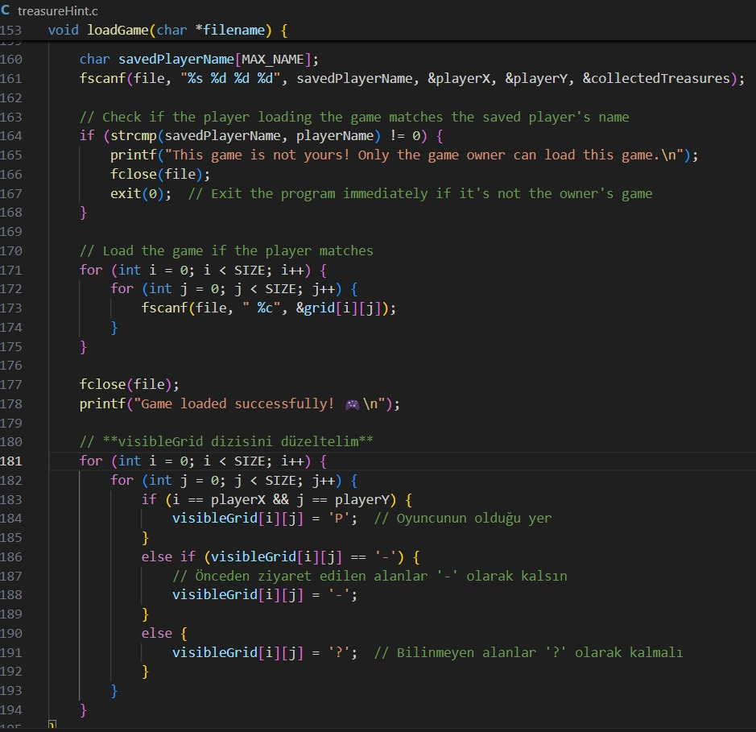
3.8 updateLeaderboard()
This function updates the leaderboard by appending the current player's name and their move count
to a file (leaderboard.txt). It stores the player's performance in a persistent leaderboard file, allowing
for tracking of the player's progress over time.
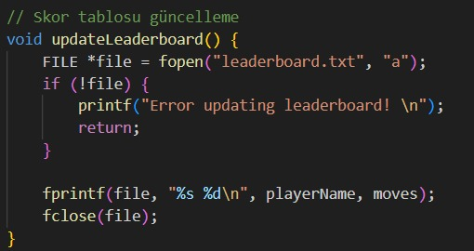

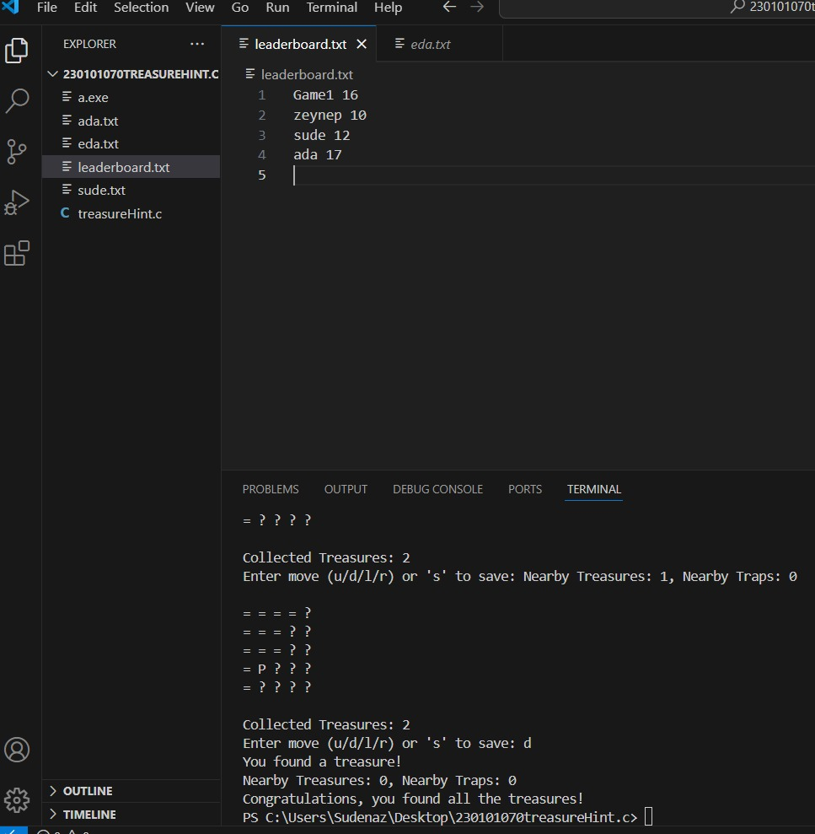
Leaderboard.txt dosyasında game1, zeynep, sude, ada oyunu kazandıkları ve ayrıca kaydettikleri için tabloda ve klasörde yer alıyorlar,fakat şuan eda oyunu kazanamadığı için liderlik tablosunda yazılmıyor ama dosyasını kaydettiği için klasörde yer alıyor. Ayrıca Game1 oyununu kaydetmediği için klasörü yoktur.
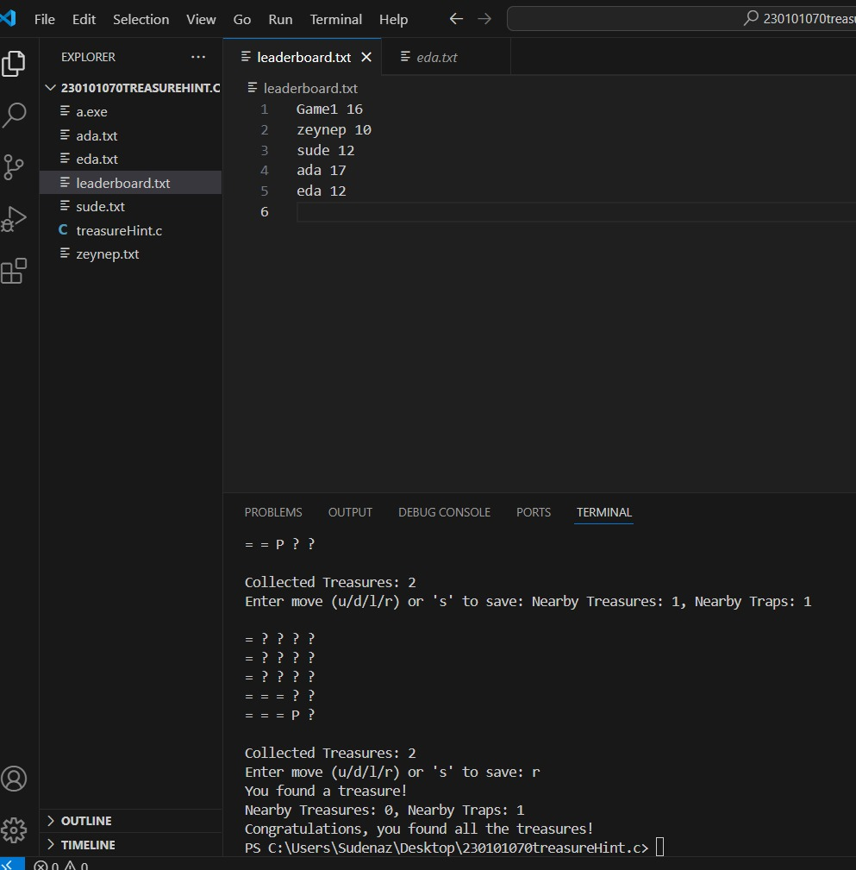
Eda tekrar oynadı ve oyunu kazandığı için liderler tablosunda yer alıyor.
3.9 displayLeaderboard()
This function reads and displays the leaderboard from a file (leaderboard.txt). It shows a list of
players and their corresponding scores (number of moves) in a readable format.
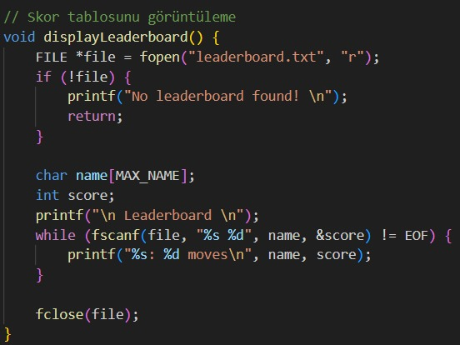

3.10 gameLoop()
This function serves as the main game loop, managing the game's flow. It continuously asks for user
input to move the player or save the game. The loop runs until the player collects all the treasures, at
which point the game ends and the leaderboard is updated.
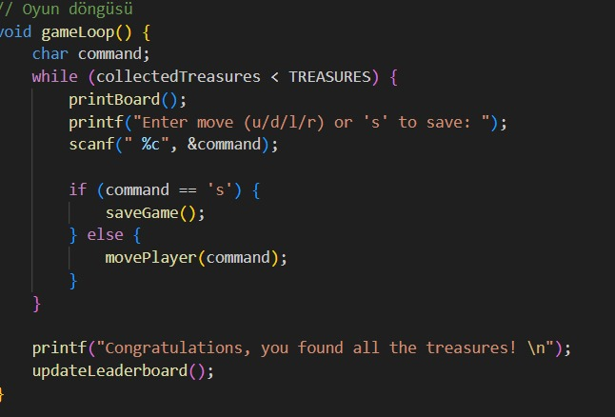
3.11 main()
The main function serves as the entry point of the game. It processes command-line arguments to
set up the game, either by starting a new game, loading a saved game, or displaying the leaderboard.
The function determines what action to take based on the provided arguments and initiates the
appropriate game logic.
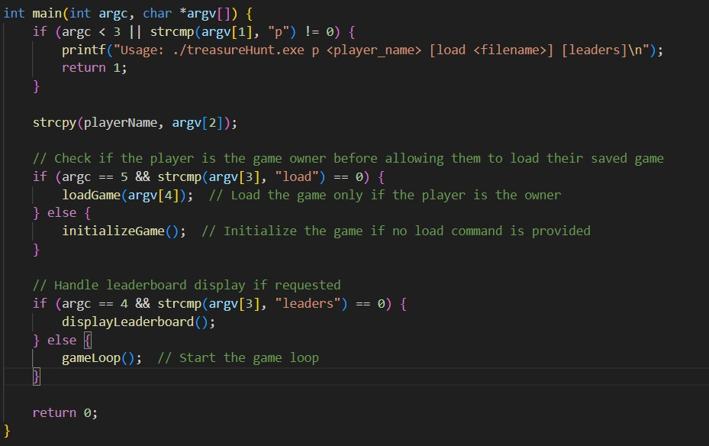
TO SUM UP
The Treasure Hunt game is a fun and interactive grid-based game that allows players to explore a map, find treasures, and avoid traps. The game incorporates features such as saving and loading progress, as well as displaying a leaderboard to track the best players.

