But, How Do I Calculate umasks?

The octal umasks are calculated via the bitwise AND of the unary complement of the argument using bitwise NOT. The octal notations are as follows:

* **Octal value** : Permission
* 7 : read, write and execute
* **6** : read and write
* **5** : read and execute
* **4** : read only
* **3** : write and execute
* **2** : write only
* **1** : execute only
* **0** : no permissions

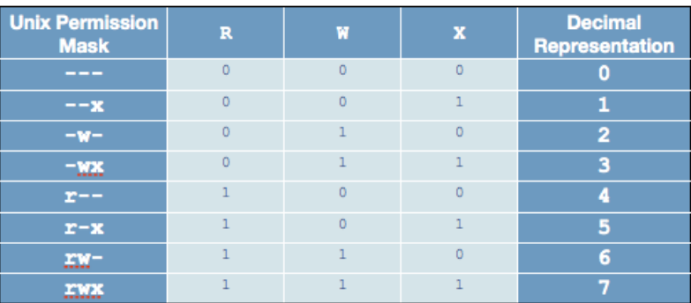

* 666 777

Now, you can use above table to calculate file permission. For example, if umask is set to 077, the permission can be calculated as follows:

|  |  |  |
| --- | --- | --- |
| **Bit** | **Targeted at** | **File permission** |
| 0 | Owner | read, write and execute |
| 7 | Group | No permissions |
| 7 | Others | No permissions |

To set the umask 077 type the following command at shell prompt:  
$ umask 077   
$ mkdir dir1  
$ touch file  
$ ls -ld dir1 file  
Sample outputs:

drwx------ 2 vivek vivek 4096 2011-03-04 02:05 dir1

-rw------- 1 vivek vivek 0 2011-03-04 02:05 file

Task: Calculating The Final Permission For FILES

You can simply subtract the umask from the base permissions to determine the final permission for file as follows:  
666 – 022 = 644

* File base permissions : 666
* umask value : 022
* subtract to get permissions of new file (666-022) : 644 (rw-r–r–)

Task: Calculating The Final Permission For DIRECTORIES

You can simply subtract the umask from the base permissions to determine the final permission for directory as follows:  
777 – 022 = 755

* Directory base permissions : 777
* umask value : 022
* Subtract to get permissions of new directory (777-022) : 755 (rwxr-xr-x)

<https://www.computernetworkingnotes.com/linux-tutorials/how-to-change-default-umask-permission-in-linux.html>

<https://linuxhandbook.com/suid-sgid-sticky-bit/>

