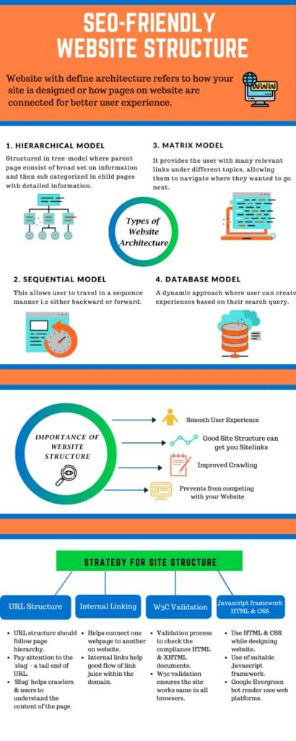

**What are the types of website structure?**

* **Hierarchical Model**

The hierarchical model in website structures is the most commonly used one since it is very easy to understand. Also called the tree model, this website structure is used by websites containing a large pool of information distributed amongst many pages. The hierarchical model uses a home page, main category pages, subpages, and child pages within subpages to distribute the website structure.

This model also uses internal links to connect child pages, subpages, and category pages in order to convey the hierarchy of the pages to the search engine algorithms. The simple to-down approach helps websites in clearly conveying the importance of the pages within a website, as well as the relevance of the content within.

* **Sequential Model**

Also called the linear model, this one is the most suited for websites with a basic structure with not too many pages. Not all websites require multiple pages to convey information. The sequential model is most commonly used by small businesses.

If a website does not require subcategories or child pages, this model is the best fit. This model usually has a main page, a home page, or a landing page. This is followed by a small number of basic parent pages that lead to the relevant call to action for the users. Usually, this model takes the users on a predefined sequential journey on a website in a straight line.

* **Matrix Model**

The matrix model is more commonly known as the webbed model for website structures. It is named after the visual it creates for a website structure, which is a web of landing pages. This model interconnects all the parent pages with the subpages and main page so everything can be accessed by the user in minimal clicks.

Best suited for eCommerce websites, this model can seamlessly connect product pages with retail pages and payment gateways. The goal of this model is to create an environment for the user to access whatever pages they want to with a minimum amount of clicks via internal links. While it may look like a lack of structure to many, that is almost the point. It makes it a user experience the website however they want to based on their needs, even if they change their mind midway through.

* **Database Model**

The database model takes almost the opposite approach to the hierarchical model, and shapes the website from the bottom-up. The model uses taxonomies and metadata to define the structure of the website. This helps in allowing the users to create their own unique website experience as they go along the internal pages. The information that appears on the website is specific to you, and from there onwards, data is pulled from a database that guides your journey on the website. This model is usually used by search engines like Google and even bank websites.

**What is the importance of Website structure?**

* **A smooth user experience**

If your website is appealing and informative and has hassle-free navigation, users will want to spend more time on it, increasing the [dwell-time](https://www.infidigit.com/blog/dwell-time/) and decreasing the bounce time. This will, in turn, indicates to Google that your website is an excellent result to be displayed for a search query and can boost your rankings.

* **Good site structure can get you sitelinks**

[Sitelinks](https://www.infidigit.com/blog/sitelinks/) on a SERP show your website’s important pages. These are of a great [SEO](https://www.infidigit.com/seo-search-engine-optimization/) advantage and can improve [clickthrough rate](https://www.infidigit.com/blog/click-through-rate/), better your brand’s reputation and help you rank better on SERPs. Google awards sitelinks to websites with excellent site structure. Currently, you cannot add a sitelink on your own.

* **Improved Crawling**

A properly designed website structure with good [internal linking](https://www.infidigit.com/blog/internal-linking/) will help not only users but also crawlers that [crawl](https://www.infidigit.com/blog/crawling-and-indexing/) your website by letting them discover important pages.

* **Prevents from competing with your website**

Sometimes, you may have different blog posts written around the same topic. If your site is designed correctly, it can help you avoid having competing webpages and [keyword cannibalization](https://www.infidigit.com/blog/keyword-cannibalization/).

**How to have a good website structure?**

Hierarchical structures based on parent and child pages are generally considered a good website structure. Some of its elements include:

* **Homepage**

The homepage of your website can be referred to as a central place from where the whole website is navigated. It’s important for your homepage to include links to all important pages of your website and guide the users to information that they need.

* **Navigation**

Navigation or the menu of your website helps visitors understand your website structure**.**Therefore, categorise all the pages systematically so that the users can easily identify the information they are looking for. The best way to create good navigation is by using short phrases and simple language for the content.

* **Categories**

Categories and subcategories play a crucial role in creating an adequate website structure**.** Make sure to craft different categories for different types of content. Group similar content together and create a category and further add a sub-category if required. For instance, if you sell books, you can create categories for different genres of books.

* **Individual Pages**

Individual pages and blogs must be organised properly on your website so that the desired audience can effortlessly find the content they are searching for. The finest way to structure information on individual pages is with the use of [meta tags](https://www.infidigit.com/blog/meta-tags/), breadcrumb trails, and contextual links.

* **Breadcrumbs**

A [breadcrumb](https://www.infidigit.com/blog/breadcrumbs/) trail helps add navigation to the posts and pages on your website. A breadcrumb trail consists of clickable links that provide your website structure to users and also help them view different posts present on the website. Breadcrumbs provide a great way to improve the user experience of your website.

* **Tags**

Tags serve the purpose of grouping together similar content present on your website. Tags are quite similar to the categories present on your website. The only difference between categories and tags is that categories are further divisible into sub-categories. However, tags can not be subdivided and work only by grouping together similar content.

**How to design an SEO-friendly website structure?**

* **Strategize before you start**

The best way to do things is to plan before executing them. Grab a paper and pen, and draw a rough sketch of how your website should look. You can list down various important pages, categories and product pages. This can help you get a better understanding of your website’s skeletal system. If you are starting a new website, it is good to consider implementing various [SEO techniques](https://www.infidigit.com/blog/on-page-seo/) at the designing stage itself. Choosing the right website model is important here. A flat site structure where all pages are just one click away from your home page can sound easy to implement.

. **Website Symmetry is important**

If you eliminate the colors, fonts, kernel, graphics and images from a website, a good website structure is what remains. And maintaining symmetry in the structure can be satisfying to the user. Keep your category count between 2 to 7 and try to add an equal number of sub-categories in each category. Symmetricity will prevent your website from looking uneven.

* **URL structure**

The [URL structure](https://www.infidigit.com/blog/url-structure/) should follow the page hierarchy. If you already have a good website structure, this won’t be much of an issue. However, pay close attention to the ‘slug’. A slug refers to the tail end of the URL. Using a readable name in the slug instead of the ID number of the page helps crawlers and users to better read and understand the content of the page.

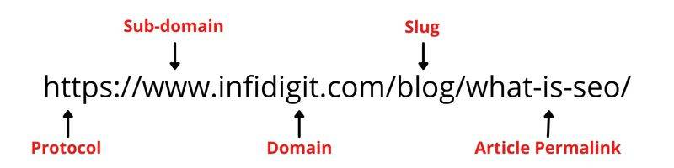

* **Internal Linking**

Internal linking is a crucial SEO technique which helps you connect one webpage to another on your website. This enhances the [user experience](https://www.infidigit.com/blog/category/user-experience/) as important pages are accessible with fewer clicks. Implementing a good internal linking strategy can help with a good flow of link juice within the domain. Thus, your website can rank better on the SERP.

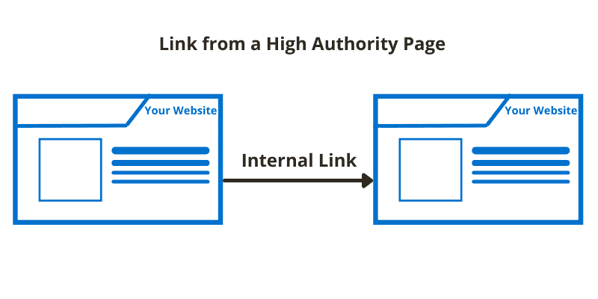

* **W3C Validation**

The World Wide Web Consortium (W3C) validation is a process to check the compliance of the HTML and XHTML documents of your website to well-formed markup. W3C validation ensures that the site works the same in all browsers.

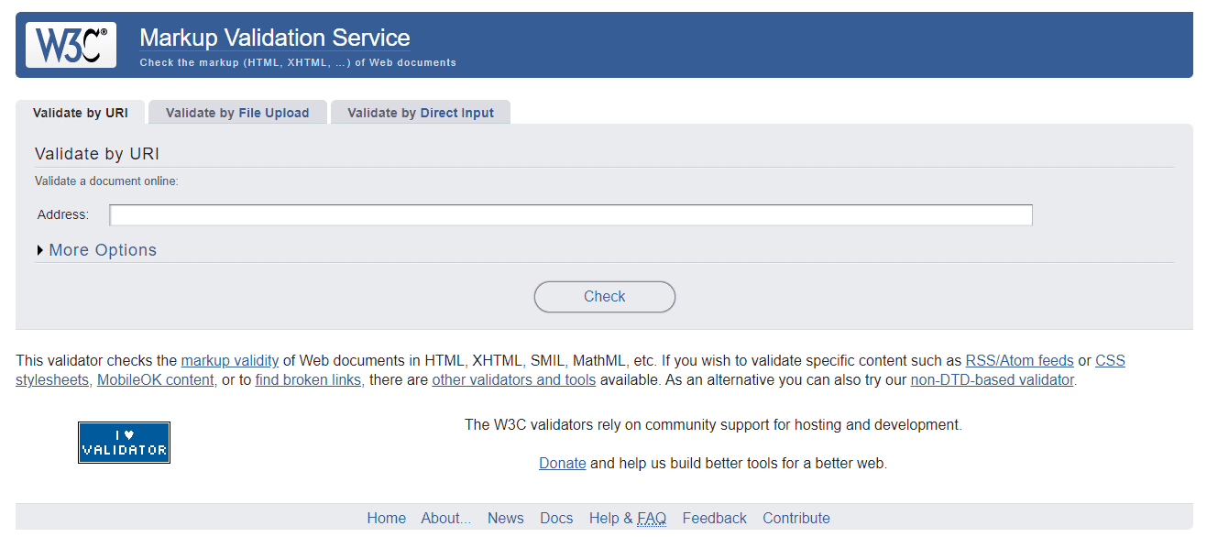

* **Use suitable JavaScript framework along with HTML and CSS**

When designing your website, using HTML and CSS are the safest methods. However, using JavaScript can make your site appealing to the users. You need to use a suitable JavaScript framework for your website. With the introduction of the Google Evergreen bot, the crawler can now render more than 1000 web platform features that it could not earlier, making SEO easier.

## ****Step-by-step guide to building a solid site structure****

<https://seranking.com/blog/website-structure/>

<https://bettermode.com/blog/online-community-seo-branding>

<https://www.investisdigital.com/blog/link-building/how-use-google-analytics-successful-link-building>

