This document gives summary of implementation point by point. I have implemented each point as per specification document.

Point 1: Table declaration

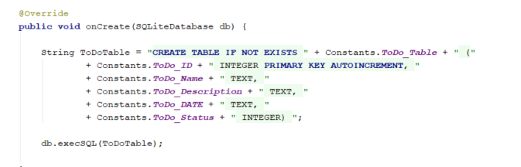

Point 2 : Extending of AppCompactActivity

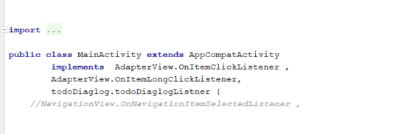

Point 3 : ListView

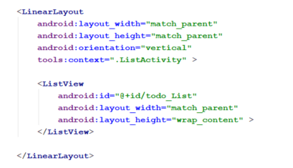

Point 4 : List item with Textviews and imageview

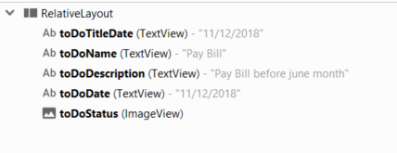

Point 5 : Sorting of List



Point 6 : Two MenuBars for Add and Switch between Completed List and incomplete tasks.

Same button icon toggles and you can switch between complete list and incomplete list.

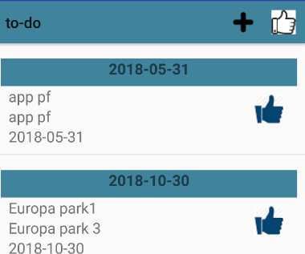

Point 7 : Add New Task

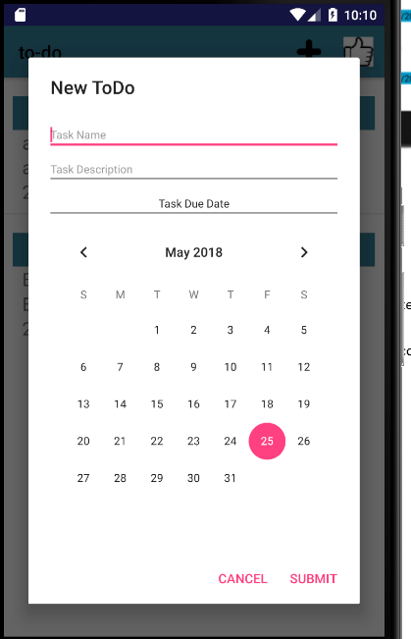

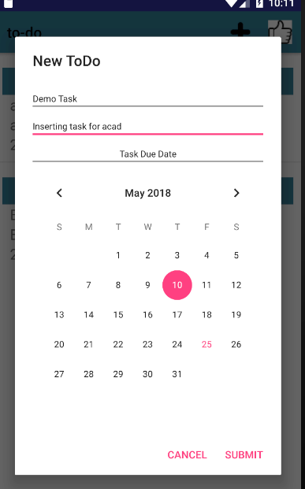

Point 8 : Screen After insertion of task

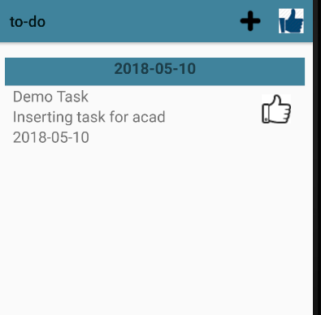

Point 9 : On clicking of item you will get dialog to modify data.

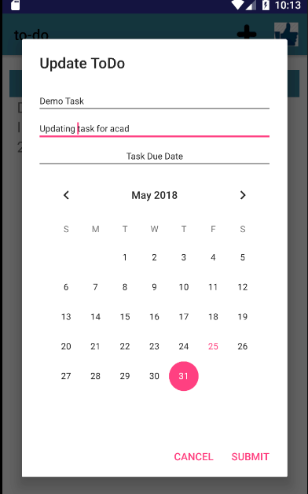

Point 10 : Press Submit after modification

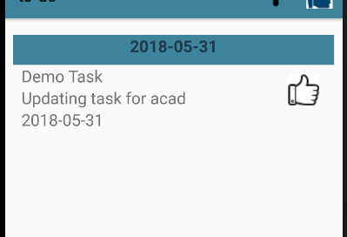

Point 11 : Long Click on incomplete task and task status is changed to complete task. Press Complete task icon to see complete tasks in list view and the icon of button switched to icon incomplete picture.

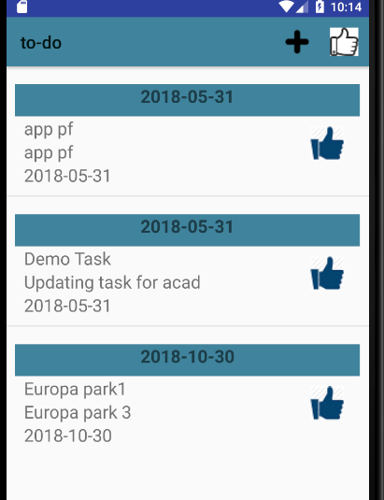

Point 12 : long click on complete task it deletes task from list.

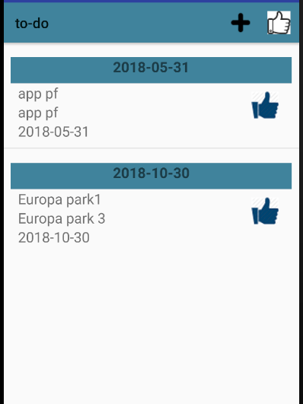

Point 13: Simple error handler

