PES UNIVERSITY, BENGALURU
Department of Computer Science and Engineering
SOFTWARE ENGINEERING MINI-PROJECT
SOFTWARE REQUIREMENTS SPECIFICATION
Snake Game
A Graphics-Based / Console-Based Snake Game
Project ID: <Project ID>
Team: <Team Name>
Team Members: <Names / SRNs>
Document Version: 1.0
Status: Initial Submission
Date: 06 September 2026

Revision History
Version | Date | Reason for Change | Author
1.0 | 06-09-2026 | Initial SRS baseline for Snake Game | <Team Name>
Document status: This document is the requirements baseline. Architecture, design, code and final test references should be updated later as those artifacts are completed.

Table of Contents
• 1 Introduction
• 1.1 Purpose
• 1.2 Intended Audience and Reading Suggestions
• 1.3 Product Scope
• 1.4 References
• 2 Overall Description
• 2.1 Product Perspective
• 2.2 Product Functions
• 2.3 User Classes and Characteristics
• 2.4 Operating Environment
• 2.5 Design and Implementation Constraints
• 2.6 Assumptions and Dependencies
• 3 External Interface Requirements
• 3.1 User Interfaces
• 3.2 Software Interfaces
• 3.3 Hardware Interfaces
• 3.4 Communications Interfaces
• 4 Analysis Models
• 4.1 Use Case Model
• 4.2 Context/Data Flow Model
• 4.3 Logical Data Model
• 5 System Features
• 5.1 Game Initialization and Controls
• 5.2 Food, Scoring and Growth
• 5.3 Collision and Game Over
• 5.4 Pause, Restart and Exit
• 5.5 Difficulty and High Score
• 6 Other Nonfunctional Requirements
• 6.1 Performance
• 6.2 Safety
• 6.3 Security
• 6.4 Software Quality Attributes
• 6.5 Business Rules
• 7 Other Requirements
• 7.1 Data Requirements
• 7.2 Logging Requirements
• 7.3 Deployment and Operations
• 7.4 Privacy and Legal
• Appendix A Glossary
• Appendix B Field Layouts
• Appendix C Test Requirements
• Appendix D RTM
• Appendix E Compliance Checklist

1 Introduction

1.1 Purpose
This Software Requirements Specification (SRS) defines the functional and non-functional requirements of the Snake Game. It establishes the requirements baseline that will guide design, implementation, testing and validation.
The system allows a player to control a snake on a bounded game board, collect food, increase the snake's length and score, and continue playing until a collision occurs. The game also supports common controls such as pause, restart, exit and high-score display.

1.2 Intended Audience and Reading Suggestions
This SRS is intended for students, developers, testers, instructors and project evaluators. Sections 1–2 introduce the purpose and context; Section 3 defines interfaces; Section 4 presents analysis models; Section 5 defines detailed functional requirements; Sections 6–7 define quality, security and operational requirements; the appendices provide terminology, data, tests and traceability.

1.3 Product Scope
The Snake Game is a standalone single-player game. Its main purpose is to provide simple, responsive gameplay in which the player controls a continuously moving snake, collects food, earns points and avoids collisions.
The project may be implemented as a graphical application or a console-based application. The core requirements remain the same, while the visual representation can differ.

1.4 References
Reference | Use
Course Software Engineering SRS Template | Structure, required sections and documentation expectations.
Project statement: Snake Game | Defines the core project idea: a Snake game using graphics or a console interface.
Team implementation repository | Source code, design and test artifacts to be added during later SDLC stages.

2 Overall Description

2.1 Product Perspective
The Snake Game is a new, self-contained software system. It receives player commands through the keyboard, updates the game state at regular intervals, checks food and collisions, and displays the resulting state. A local file may be used to preserve the high score.
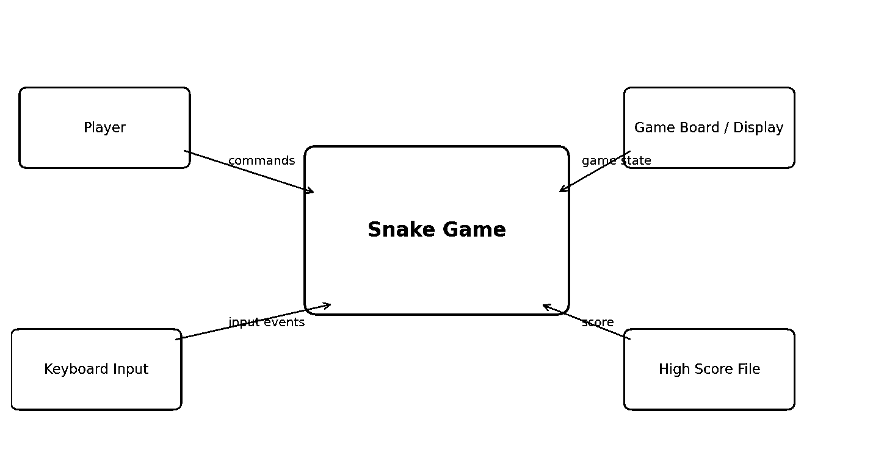
Figure 1. High-level logical system context.
The context diagram shows the Player and keyboard supplying commands to the Snake Game. The game sends the current state to the display and may read/write the high score locally.

2.2 Product Functions
• Start a new game and initialize the snake, food and score.
• Accept keyboard commands for changing the snake direction.
• Move the snake continuously at a configured update rate.
• Generate food at valid positions on the game board.
• Detect food collection and grow the snake.
• Increase and display the player's score.
• Detect boundary and self-collision.
• Display Game Over and the final score.
• Pause and resume gameplay.
• Restart the game after Game Over.
• Increase movement speed as the score reaches configured thresholds.
• Save and display the highest score.
• Allow the player to exit safely.

2.3 User Classes and Characteristics
User Class | Characteristics | Main Capabilities
Player | Primary user; basic computer knowledge. | Start/control game, eat food, view score, pause, restart, view high score, exit.
Developer | Builds and maintains the application. | Implement game logic, UI, input, storage and tests.
Tester / Evaluator | Validates requirements and behavior. | Execute test cases, inspect outputs and verify SRS compliance.

2.4 Operating Environment
The target environment is a standard desktop or laptop computer running Windows, Linux or macOS. A graphical version requires a supported graphics/game library; a console version requires a terminal or command prompt. A keyboard and display are required.

2.5 Design and Implementation Constraints
• The game shall support keyboard-based controls.
• The board dimensions and movement speed shall be configurable.
• The application should run locally without requiring internet access.
• The implementation shall keep game logic, input handling, display and score storage reasonably modular.
• Requirement IDs shall remain unique so that later testing can be traced back to the SRS.

2.6 Assumptions and Dependencies
• The player has access to a standard keyboard and display.
• The player understands the basic objective of Snake.
• A supported programming language/runtime and, if required, graphics library are available.
• The high-score file, if used, is stored in a location where the application has appropriate access.
• Exact controls, board size and scoring values may be finalized during implementation without changing the overall requirements.

3 External Interface Requirements

3.1 User Interfaces
• The system shall display the game board, snake, food and current score.
• The system shall display clear instructions for controls and game states.
• The system shall display a clear Game Over message and options to restart or exit.
• If pause is supported, the paused state shall be visibly distinguishable from active gameplay.
• The interface shall remain understandable in either graphical or console form.

3.2 Software Interfaces
Interface | Input | Output | Purpose
Game/Input Module | Keyboard events | Direction command | Control the snake.
Game Logic Module | Current state + command | Updated state | Movement, food and collision processing.
Display/UI Module | Updated game state | Rendered board/text | Present the game to the player.
High Score Storage | Score value | Stored/retrieved score | Preserve highest score locally.

3.3 Hardware Interfaces
The system shall use a standard keyboard for input and a monitor/display for output. No specialized hardware is required.

3.4 Communications Interfaces
The basic game does not require network communication. If the implementation remains standalone, all game processing and high-score storage are local.

4 Analysis Models

4.1 Use Case Model
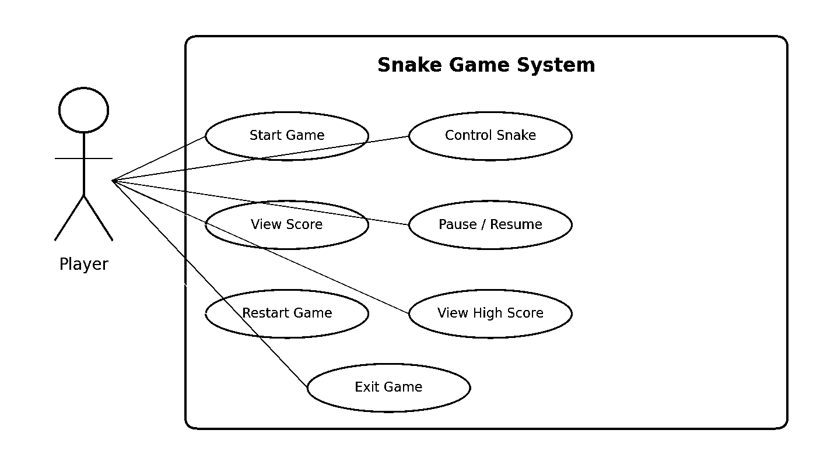
Figure 2. Primary use-case model.
Primary use cases: UC-01 Start Game; UC-02 Control Snake; UC-03 View Score; UC-04 Pause/Resume; UC-05 Restart Game; UC-06 View High Score; UC-07 Exit Game. Collision detection, food collection and score updates are internal behaviors supporting these use cases.

4.2 Context/Data Flow Model
The Player provides keyboard commands. The game validates the command, updates the snake position, checks food and collisions, updates score/length and sends the resulting state to the display. The high-score store is updated when a new high score is achieved.

4.3 Logical Data Model
Entity / Data | Key Fields | Relationships / Purpose
GameSession | session_id, status, score, speed | Represents one active or completed game.
Snake | position, direction, length | Belongs to a game session; position changes every update.
SnakeSegment | x, y, sequence | Stores the ordered body coordinates.
Food | x, y, value | One or more food records associated with a game session.
HighScore | score, timestamp | Stores the highest achieved score.
GameConfig | board_width, board_height, speed, growth | Stores configurable gameplay values.
For a simple implementation these may be represented by program variables/classes rather than a relational database. The logical model is included to clearly identify the information managed by the system.

5 System Features
Each feature below is independently testable and contains a short stimulus/response sequence followed by uniquely identified functional requirements.

5.1 Game Initialization and Controls
Description and Priority: High. The player must be able to start a game and control the snake.
Stimulus/Response Sequences
• Player selects Start → system initializes board, snake, food and score.
• Player presses a valid direction key → system records the new direction.
• Player attempts an immediate reverse direction → system ignores the unsafe reversal.
• Invalid key input → system ignores the input without changing the game state.
REQ-GC-01 — The system shall allow the player to start a new game. (Priority: High)
REQ-GC-02 — The system shall initialize the snake at a valid starting position. (Priority: High)
REQ-GC-03 — The system shall initialize the score to the configured starting value. (Priority: High)
REQ-GC-04 — The system shall accept the configured keyboard controls for snake movement. (Priority: High)
REQ-GC-05 — The system shall prevent an immediate 180-degree reversal when the snake has more than one segment. (Priority: High)
REQ-GC-06 — The system shall ignore unsupported keyboard input without changing the active game state. (Priority: Medium)

5.2 Food, Scoring and Growth
Description and Priority: High. Food collection is the main mechanism for increasing score and snake length.
• Snake reaches food → system detects collection.
• Food collected → system increases score and snake length.
• System generates replacement food at a valid location.
REQ-FS-01 — The system shall generate food within the playable board area. (Priority: High)
REQ-FS-02 — The system shall detect when the snake head occupies the food position. (Priority: High)
REQ-FS-03 — The system shall increase the score by the configured food value when food is collected. (Priority: High)
REQ-FS-04 — The system shall increase snake length after food is collected. (Priority: High)
REQ-FS-05 — The system shall generate replacement food after successful food collection. (Priority: High)
REQ-FS-06 — The system shall not place food outside the board or on an occupied snake segment. (Priority: Medium)

5.3 Collision and Game Over
Description and Priority: High. Collision detection determines when the game ends.
• Snake reaches a boundary → system detects boundary collision.
• Snake head reaches its body → system detects self-collision.
• Collision detected → system stops active movement and displays Game Over.
REQ-CO-01 — The system shall detect collision between the snake and each game boundary. (Priority: High)
REQ-CO-02 — The system shall detect collision between the snake head and its body. (Priority: High)
REQ-CO-03 — The system shall change the game state to Game Over after a terminal collision. (Priority: High)
REQ-CO-04 — The system shall stop normal snake movement after Game Over. (Priority: High)
REQ-CO-05 — The system shall display the final score when the game ends. (Priority: High)

5.4 Pause, Restart and Exit
Description and Priority: Medium/High. These controls manage the game lifecycle.
• Player selects Pause → system stops movement while retaining the current state.
• Player selects Resume → system continues from the retained state.
• Player selects Restart after Game Over → system creates a fresh game.
• Player selects Exit → system closes safely.
REQ-LR-01 — The system shall allow the player to pause an active game. (Priority: Medium)
REQ-LR-02 — The system shall stop automatic snake movement while paused. (Priority: High)
REQ-LR-03 — The system shall resume the game from its previous state after Resume. (Priority: Medium)
REQ-LR-04 — The system shall allow the player to restart after Game Over. (Priority: High)
REQ-LR-05 — The system shall allow the player to exit the game safely. (Priority: Medium)

5.5 Difficulty and High Score
Description and Priority: Medium. The game may become faster as the player's score increases and shall maintain a high score when storage is enabled.
REQ-DH-01 — The system shall increase snake movement speed when configured score thresholds are reached. (Priority: Medium)
REQ-DH-02 — The system shall display the current score during active gameplay. (Priority: High)
REQ-DH-03 — The system shall compare the final score with the stored high score. (Priority: Medium)
REQ-DH-04 — The system shall save a new high score when the final score exceeds the previous high score. (Priority: Medium)
REQ-DH-05 — The system shall display the stored high score on the start or Game Over screen. (Priority: Medium)

6 Other Nonfunctional Requirements

6.1 Performance Requirements
• The game should process normal keyboard input without noticeable delay.
• The game loop shall maintain a stable configured update rate during normal gameplay.
• High-score read/write operations shall not noticeably interrupt gameplay.
• Performance shall be verified on the declared target student computer.

6.2 Safety Requirements
• Unexpected input shall not cause the application to enter an invalid game state.
• The game shall stop movement cleanly when Game Over occurs.
• Unexpected errors shall be handled without exposing internal stack traces to the player.
• Invalid high-score data shall be rejected or replaced safely.

6.3 Security Requirements
• Input shall be validated against the set of supported game commands.
• High-score data shall be validated before being used by the game.
• Out-of-range board coordinates shall not be accepted for snake or food positions.
• The application shall not execute arbitrary commands from keyboard input or stored score data.
• If configuration files are used, only expected numeric/string formats shall be accepted.

6.4 Software Quality Attributes
Attribute | Requirement / Verification Approach
Maintainability | Game logic, input, display and score handling should be separated into clear functions/modules.
Testability | Each functional requirement shall map to at least one test case.
Reliability | Normal gameplay shall not crash during the defined test duration.
Usability | Controls, score and game status shall be easy to understand.
Portability | The application shall run in the declared target environment.
Extensibility | Board size, speed, scoring and controls should be configurable without rewriting unrelated logic.
Correctness | Score, snake length, food position and collision state shall remain consistent.

6.5 Business Rules
• BR-01: A score is increased only when the snake successfully collects food.
• BR-02: Food must always remain inside the playable area.
• BR-03: A terminal collision ends the active game.
• BR-04: A paused game shall not update snake position until resumed.
• BR-05: A new high score is stored only when it exceeds the previous high score.
• BR-06: Unsupported input shall not change the game state.

7 Other Requirements

7.1 Data Requirements
The system may use in-memory data structures for active gameplay and a small local file for the high score. No database is required for the basic version.

7.2 Logging Requirements
• The application may log important events such as game start, Game Over and high-score update for debugging.
• Logs shall not contain unnecessary personal information.
• Debug logging should be disableable in the final release.

7.3 Deployment and Operations
• The project shall include instructions for installing required dependencies.
• The game shall have a documented run command or executable launch method.
• Configuration values such as board size and speed should be documented.
• The final project should include source code and test evidence in the team repository.

7.4 Privacy and Legal
• The game shall not require personal information for normal gameplay.
• Only locally generated gameplay information such as scores may be stored.
• Third-party libraries, if used, shall be compatible with the project's licensing requirements.

Appendix A: Glossary
Term | Definition
SRS | Software Requirements Specification.
UI | User Interface.
FR | Functional Requirement; describes what the system shall do.
NFR | Non-Functional Requirement; describes quality or operational expectations.
Game Loop | Repeated cycle that reads input, updates the game state and displays the result.
Snake Segment | One body unit/coordinate belonging to the snake.
Food | Collectible object that increases score and snake length.
Collision | Condition in which the snake hits a boundary or its own body.
High Score | Highest score recorded by the game.
RTM | Requirements Traceability Matrix; connects requirements to design/code/tests.

Appendix B: Field Layouts
These fields describe the logical information managed by the game. They may be implemented as variables, classes or file fields depending on the chosen programming approach.
Entity | Field | Type | Range / Format | Mandatory | Description
GameSession | session_id | Integer/String | Unique | Y | Identifies one game session.
GameSession | status | Enum | READY/RUNNING/PAUSED/GAME_OVER | Y | Current game state.
GameSession | score | Integer | 0 or greater | Y | Current score.
Snake | direction | Enum | UP/DOWN/LEFT/RIGHT | Y | Current movement direction.
SnakeSegment | x | Integer | 0..board_width-1 | Y | Horizontal board coordinate.
SnakeSegment | y | Integer | 0..board_height-1 | Y | Vertical board coordinate.
Food | x | Integer | 0..board_width-1 | Y | Food horizontal coordinate.
Food | y | Integer | 0..board_height-1 | Y | Food vertical coordinate.
Food | value | Integer | Positive | Y | Points awarded for collection.
HighScore | score | Integer | 0 or greater | Y | Highest recorded score.
GameConfig | board_width | Integer | Positive | Y | Board width.
GameConfig | board_height | Integer | Positive | Y | Board height.
GameConfig | speed | Integer | Positive | Y | Movement/update setting.

Appendix C: Test Requirements
Test ID | Test Area | Requirement(s) | Expected Result
TC-001 | Start Game | REQ-GC-01 | Game starts with initialized board, snake, food and score.
TC-002 | Keyboard Control | REQ-GC-04 | Valid direction key changes movement direction.
TC-003 | Reverse Prevention | REQ-GC-05 | Immediate opposite direction is ignored.
TC-004 | Food Generation | REQ-FS-01, REQ-FS-06 | Food is inside board and not on snake.
TC-005 | Food Collection | REQ-FS-02, REQ-FS-03, REQ-FS-04 | Food is removed, score increases and snake grows.
TC-006 | Boundary Collision | REQ-CO-01 | Boundary hit produces Game Over.
TC-007 | Self Collision | REQ-CO-02 | Head/body collision produces Game Over.
TC-008 | Game Over | REQ-CO-03, REQ-CO-04, REQ-CO-05 | Movement stops and final score is shown.
TC-009 | Pause/Resume | REQ-LR-01, REQ-LR-02, REQ-LR-03 | State is retained during pause and continues after resume.
TC-010 | Restart | REQ-LR-04 | Restart creates a fresh game state.
TC-011 | Exit | REQ-LR-05 | Application closes safely.
TC-012 | Difficulty | REQ-DH-01 | Speed changes at configured score threshold.
TC-013 | High Score | REQ-DH-03, REQ-DH-04, REQ-DH-05 | New high score is stored and displayed.
TC-014 | Invalid Input | SG-SR-001 | Unsupported input does not change game state.
TC-015 | Invalid Data | SG-SR-002, SG-SR-004 | Invalid stored score/coordinates are rejected safely.

Appendix D: Requirements Traceability Matrix
Requirement ID | Brief Description | Module / Design Reference | Test | Status (N/P/A)
REQ-GC-01 | The system shall allow the player to start a new game. | Input/Game Initialization | TC-001 | N
REQ-GC-02 | The system shall initialize the snake at a valid starting position. | Input/Game Initialization | TBD | N
REQ-GC-03 | The system shall initialize the score to the configured starting value. | Input/Game Initialization | TBD | N
REQ-GC-04 | The system shall accept the configured keyboard controls for snake movement. | Input/Game Initialization | TC-002 | N
REQ-GC-05 | The system shall prevent an immediate 180-degree reversal when the snake has more than one segment. | Input/Game Initialization | TC-003 | N
REQ-GC-06 | The system shall ignore unsupported keyboard input without changing the active game state. | Input/Game Initialization | TBD | N
REQ-FS-01 | The system shall generate food within the playable board area. | Food & Score Manager | TC-004 | N
REQ-FS-02 | The system shall detect when the snake head occupies the food position. | Food & Score Manager | TC-005 | N
REQ-FS-03 | The system shall increase the score by the configured food value when food is collected. | Food & Score Manager | TC-005 | N
REQ-FS-04 | The system shall increase snake length after food is collected. | Food & Score Manager | TC-005 | N
REQ-FS-05 | The system shall generate replacement food after successful food collection. | Food & Score Manager | TBD | N
REQ-FS-06 | The system shall not place food outside the board or on an occupied snake segment. | Food & Score Manager | TC-004 | N
REQ-CO-01 | The system shall detect collision between the snake and each game boundary. | Collision Manager | TC-006 | N
REQ-CO-02 | The system shall detect collision between the snake head and its body. | Collision Manager | TC-007 | N
REQ-CO-03 | The system shall change the game state to Game Over after a terminal collision. | Collision Manager | TC-008 | N
REQ-CO-04 | The system shall stop normal snake movement after Game Over. | Collision Manager | TC-008 | N
REQ-CO-05 | The system shall display the final score when the game ends. | Collision Manager | TC-008 | N
REQ-LR-01 | The system shall allow the player to pause an active game. | Game State Manager | TC-009 | N
REQ-LR-02 | The system shall stop automatic snake movement while paused. | Game State Manager | TC-009 | N
REQ-LR-03 | The system shall resume the game from its previous state after Resume. | Game State Manager | TC-009 | N
REQ-LR-04 | The system shall allow the player to restart after Game Over. | Game State Manager | TC-010 | N
REQ-LR-05 | The system shall allow the player to exit the game safely. | Game State Manager | TC-011 | N
REQ-DH-01 | The system shall increase snake movement speed when configured score thresholds are reached. | Difficulty/High Score Manager | TC-012 | N
REQ-DH-02 | The system shall display the current score during active gameplay. | Difficulty/High Score Manager | TBD | N
REQ-DH-03 | The system shall compare the final score with the stored high score. | Difficulty/High Score Manager | TC-013 | N
REQ-DH-04 | The system shall save a new high score when the final score exceeds the previous high score. | Difficulty/High Score Manager | TC-013 | N
REQ-DH-05 | The system shall display the stored high score on the start or Game Over screen. | Difficulty/High Score Manager | TC-013 | N
SG-NF-01 | Responsive keyboard input | Overall Game | TC-NF-001 | N
SG-NF-02 | Stable gameplay | Overall Game | TC-NF-002 | N
SG-NF-03 | Clear and usable interface | UI | TC-NF-003 | N
SG-NF-04 | Target-environment portability | Deployment | TC-NF-004 | N
SG-NF-05 | Maintainable modular code | Architecture | TC-NF-005 | N
SG-SR-001 | Validate supported keyboard input | Input Validation | TC-014 | N
SG-SR-002 | Validate high-score data | Data Validation | TC-015 | N
SG-SR-003 | Accept only valid numeric high scores | High Score Manager | TC-013 | N
SG-SR-004 | Reject out-of-range coordinates | Game Logic | TC-015 | N
SG-SR-005 | Recover safely from unexpected state errors | Game Manager | TC-NF-002 | N

Appendix E: Compliance Checklist
Check | Status | Evidence
Project scope covered | PASS | Snake gameplay, controls, food, score, growth and collision are covered.
SRS structure covered | PASS | Introduction, overall description, interfaces, models, features, NFRs and appendices included.
Unique functional requirement IDs | PASS | REQ-GC, REQ-FS, REQ-CO, REQ-LR and REQ-DH identifiers used.
Invalid/error handling | PASS | Unsupported input, invalid coordinates and invalid high-score data are addressed.
User classes | PASS | Player, Developer and Tester/Evaluator defined.
Operating environment | PASS | Desktop/laptop, keyboard and display environment defined.
External interfaces | PASS | Input, game logic, display and high-score interfaces described.
Analysis models | PASS | Use-case, context/data flow and logical data model included.
System features | PASS | Five independently testable feature groups included.
Non-functional requirements | PASS | Performance, safety, security and quality attributes included.
Security objectives/requirements | PASS | Security goals and five security requirements included.
Testability | PASS | Functional requirements mapped to test cases in Appendices C–D.
RTM | PASS | Requirements are connected to modules and tests; later design/code references can be updated.
No fabricated implementation evidence | PASS | Initial status is marked N; later P/A statuses should be changed only after actual implementation/testing.

Implementation Note
This document is a requirements baseline, not proof that the game has already been implemented or tested. After coding, the team should update the RTM with actual architecture/design/code references and change test status from N (Not started) to P (Pass) or A (Accepted) only when real evidence exists.

