**Outstanding-01**

**Sudhasmita Swain**

**-Create a Resource Group by name (rg01).**

* Go to Home > Resource Group > Add and complete all the configurations > Review+Create

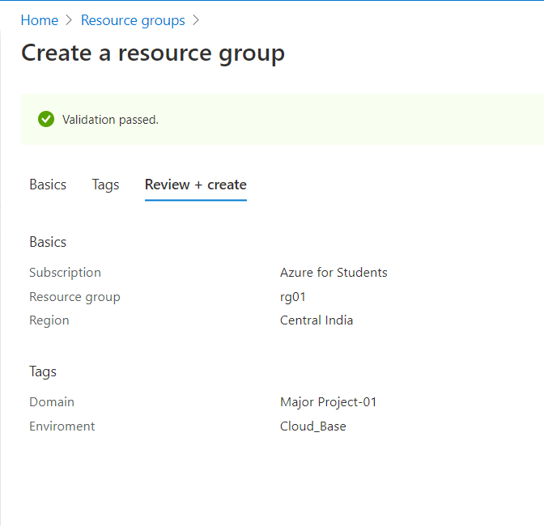

**-Create two virtual network using two different address spaces .**

* Go to Home > Virtual Network > Add > Set the configurations > Review + Create
* Vnet-01

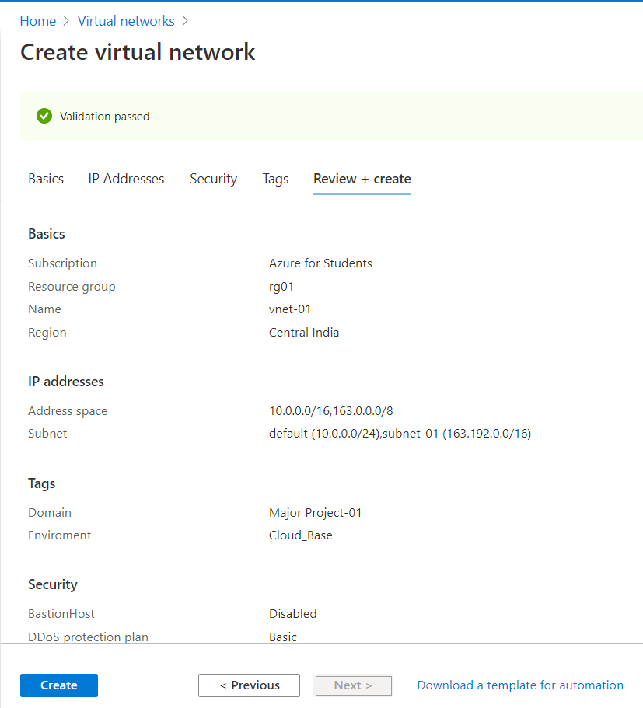

* Vnet-02

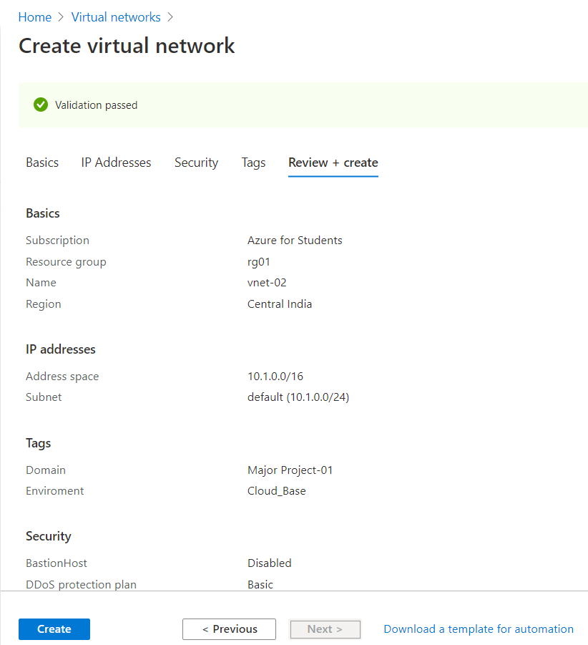

**-Create two virtual machines (one Linux and one Windows) in each created virtual networks respectively.**

* **VM for Windows**

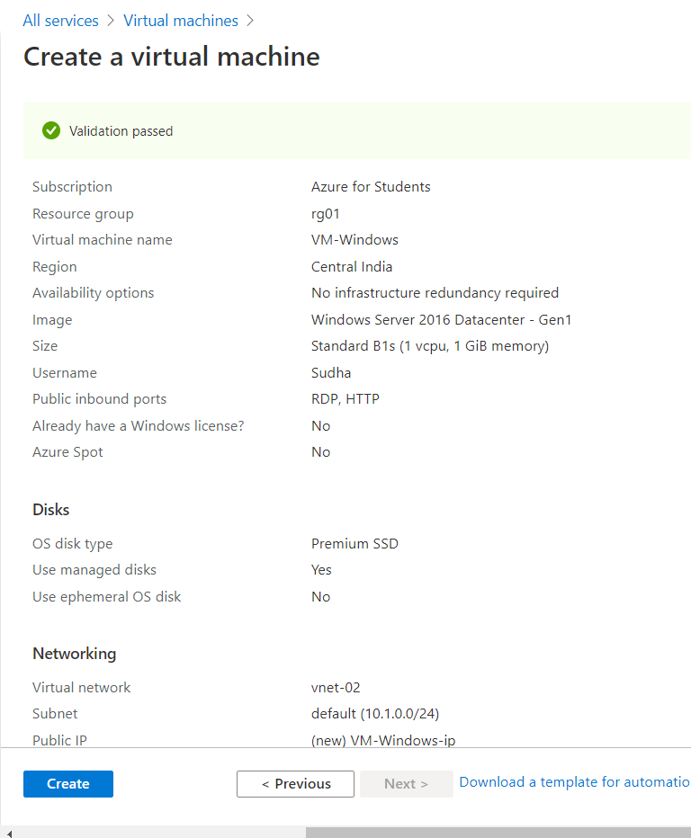

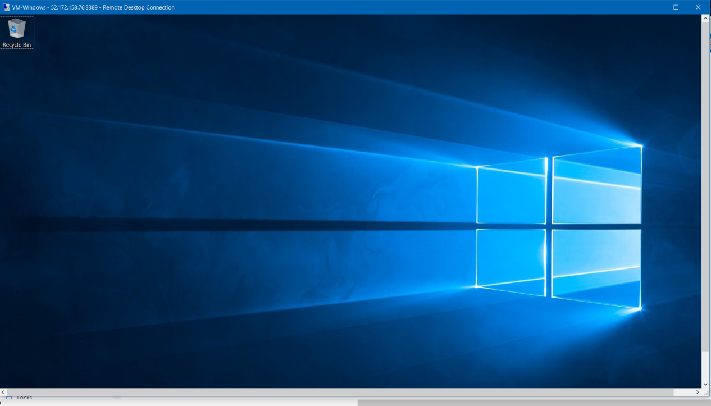

* **VM for Linux**
* Go to Virtual machine > + add and set the configuration. Here we are creating Linux VM by using SSH(22) protocol.
* While configuring it, you will see an **Administrator account (** user credentials) add putty client to generate the public-private key.
* In SSH public key we update the public key and set other configurations by default.

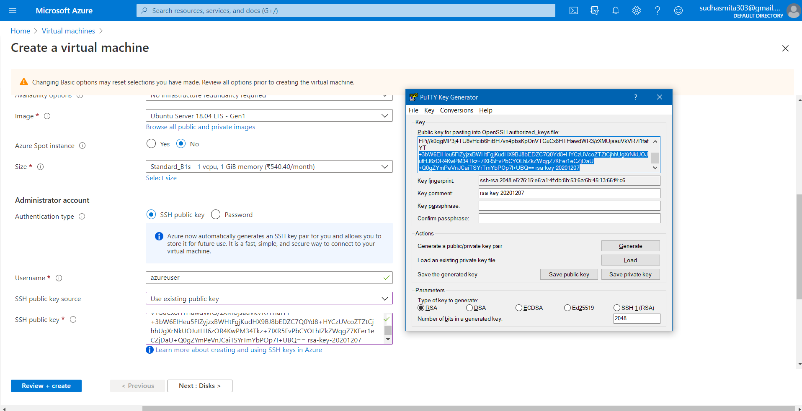

* Then Review + Create.

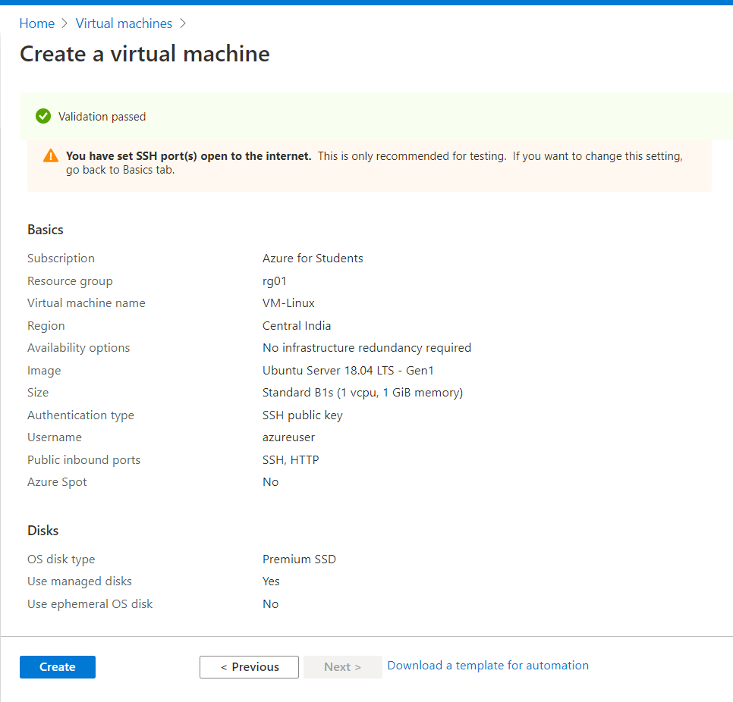

* Now open the PuTTY configuration to link your Linux server.
* First configure your Linux VM ip.

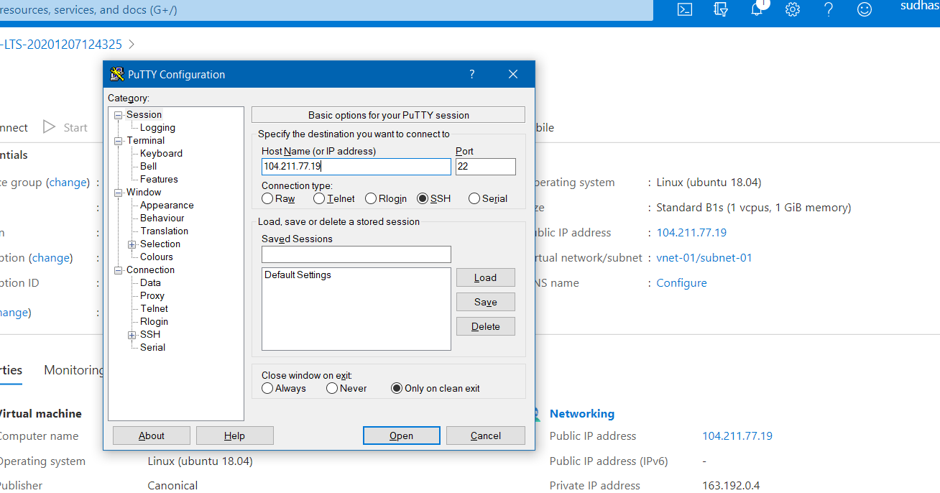

* Now the private key to specify the server belongs to that ip.

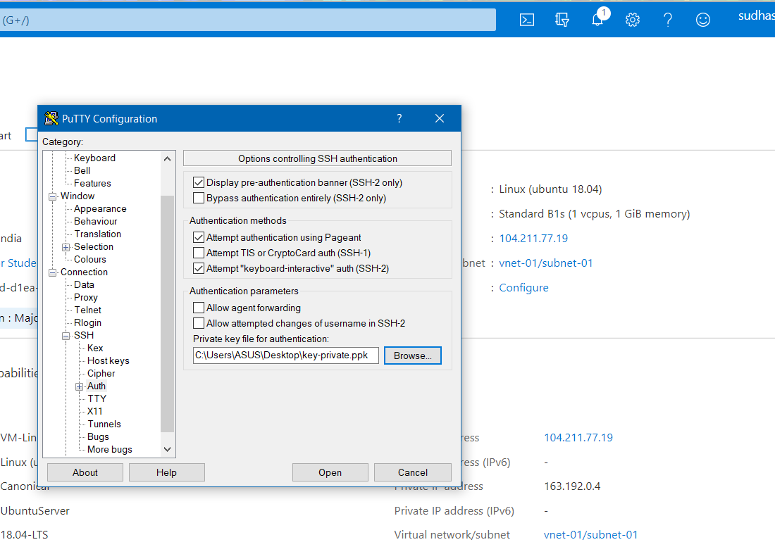

* After this it will redirect to VM Linux server.
* Enter the user name you have given at the time of configuration.
* Now, you can access the terminal of the Linux.

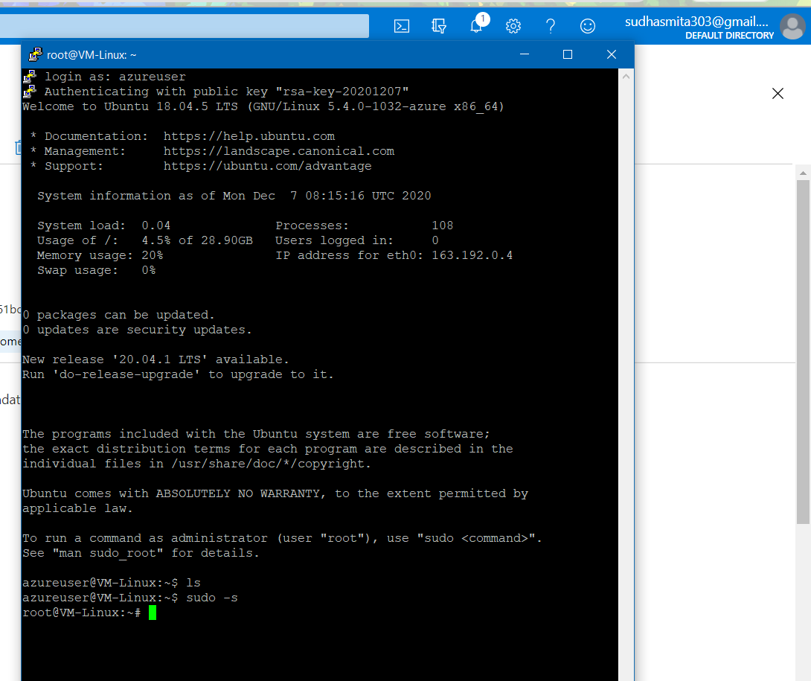

**-Create Blob storage along with the below file share:-**

**~Create a file share(share01) and mount on the Windows VM’s.**

* File-share (share01)

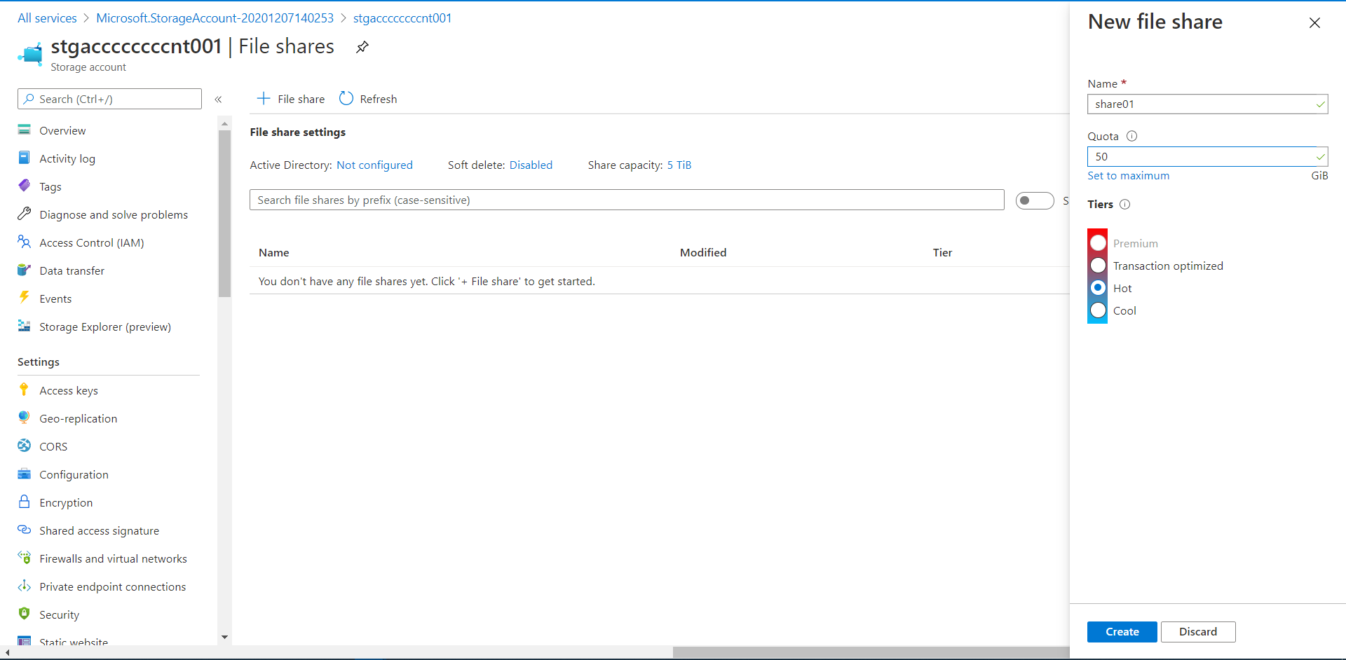

* Connect the share file
* Choose the Drive letter
* Then you’ll get an auto generated code for the selected drive
* Copy the code and run it on our VM(windows)’s power-shell.
* After mount it on VM a share-drive will generate in VM.

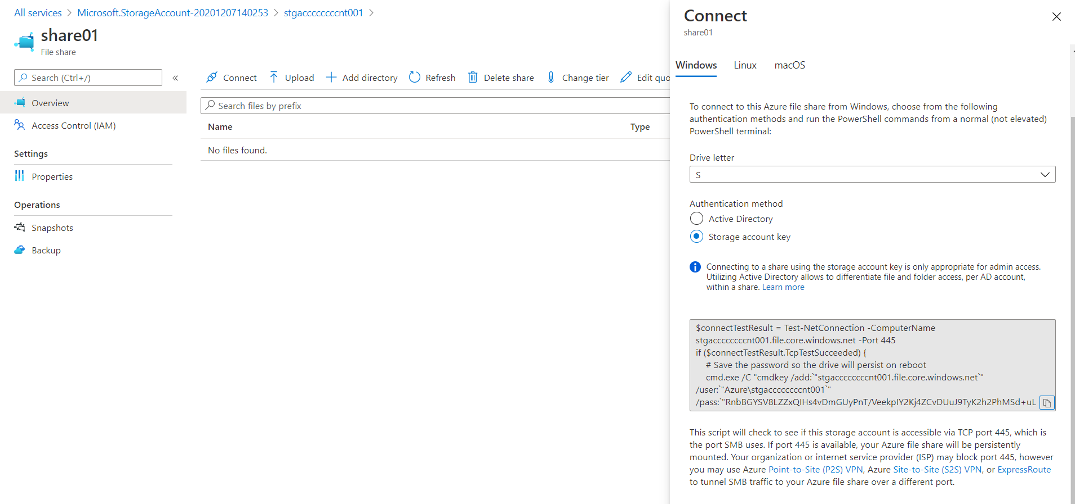

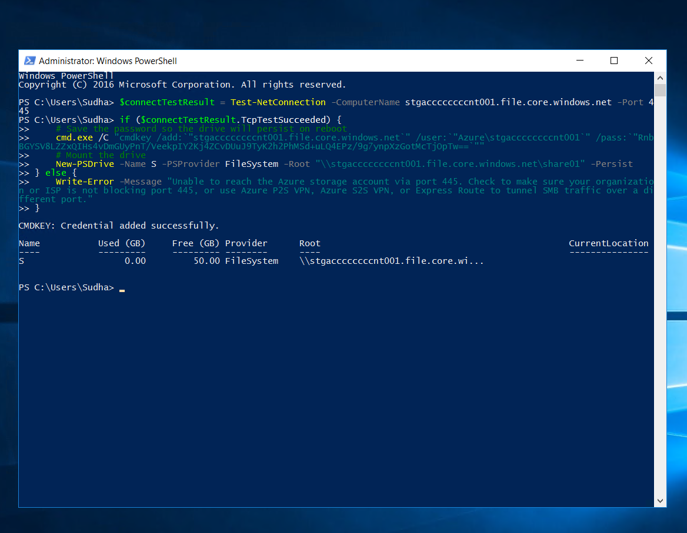

* File on S-storage of VM

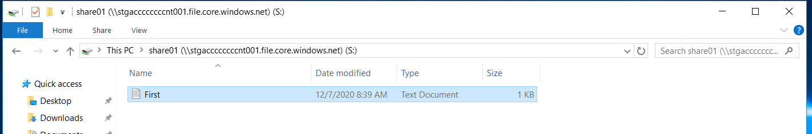

* Create a text file on VM share drive . Then it’ll Auto-upload on cloud.

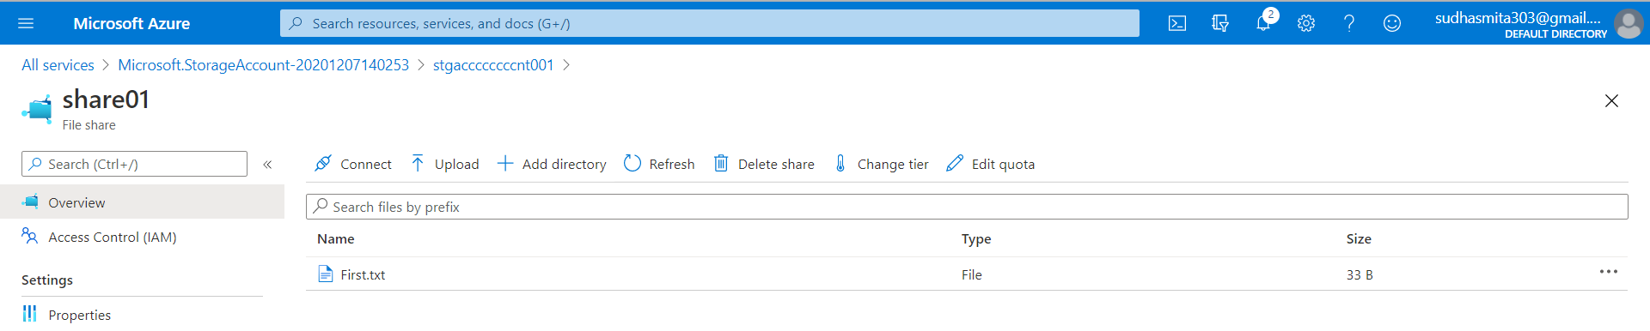

**-Create a Network security group and attach it to the respective Subnets of (Linux and Windows) VM.**

* It has already been created while creating the VMs.
* NSG of Windows

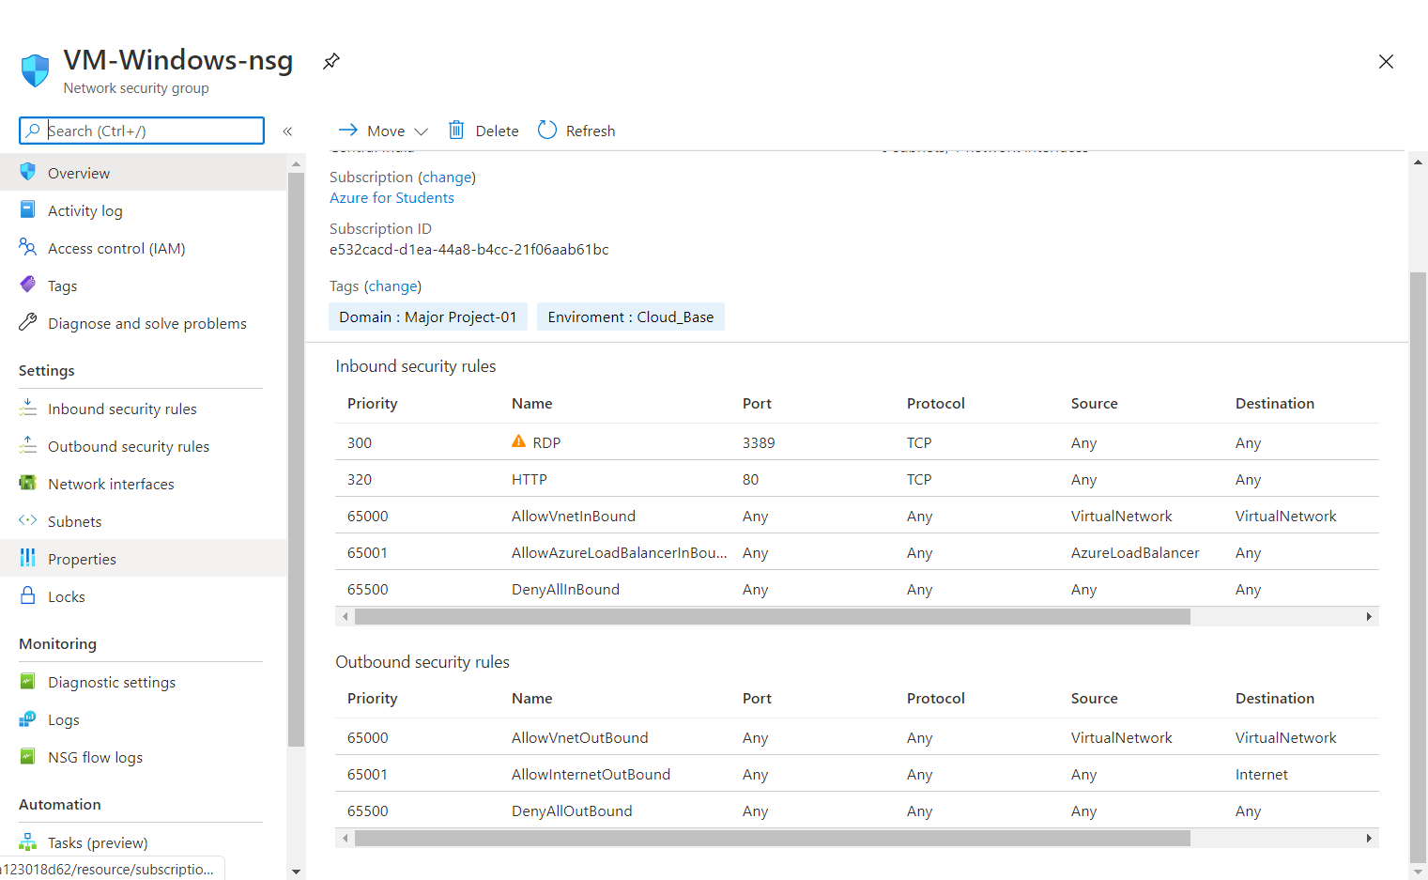

* NSG of Linux

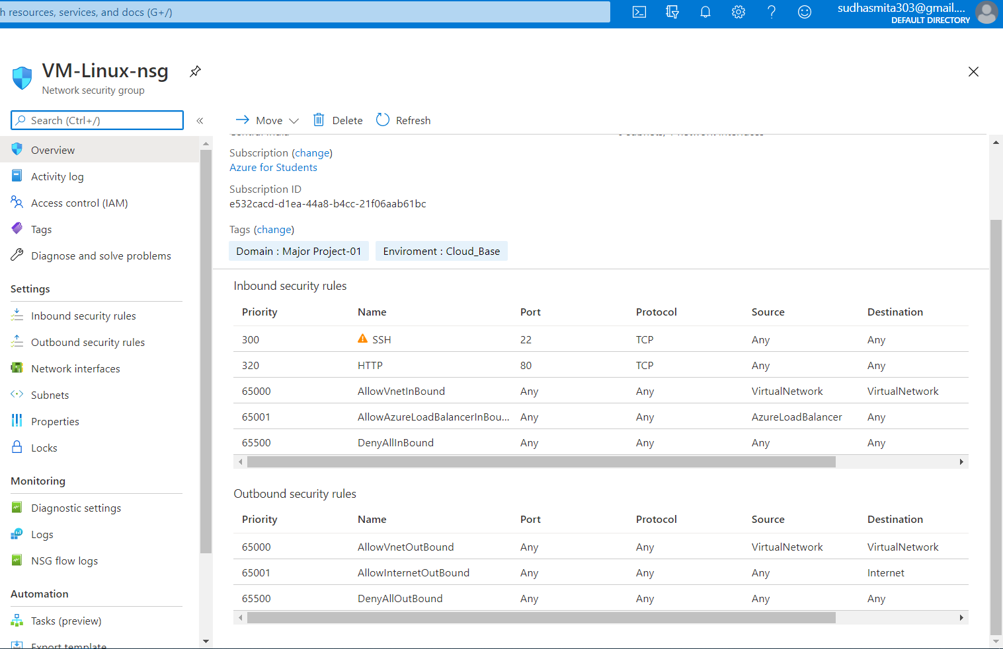

**-Configure an inbound security port rule to allow (RDP & SSH).**

* Go to NSG > Add inbound port rule for the respective NSGs.
* Inbound port rule to allow RDP



* Inbound port rule to allow SSH



**- Create Peering between the two Virtual Networks.**

* Go to vnet-01 > Peerings > Set all the Configuration

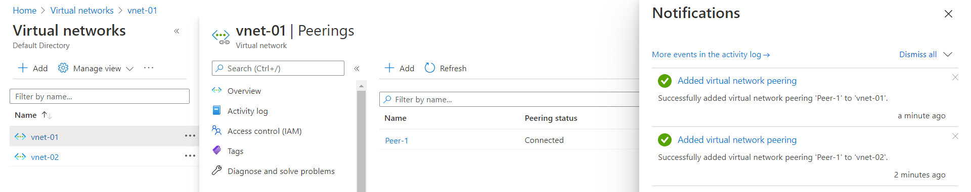

**- Create a Recovery Services vault (Rsv-001) in the Resource Group (rg01).**

* **Recovery Service Vault** :- A **RSV** is a management entity that stores recovery points created over time and provides an interface to perform backup related operations.
* These include taking on-demand backups, performing restores, and creating backup policies.
* Rsv-001

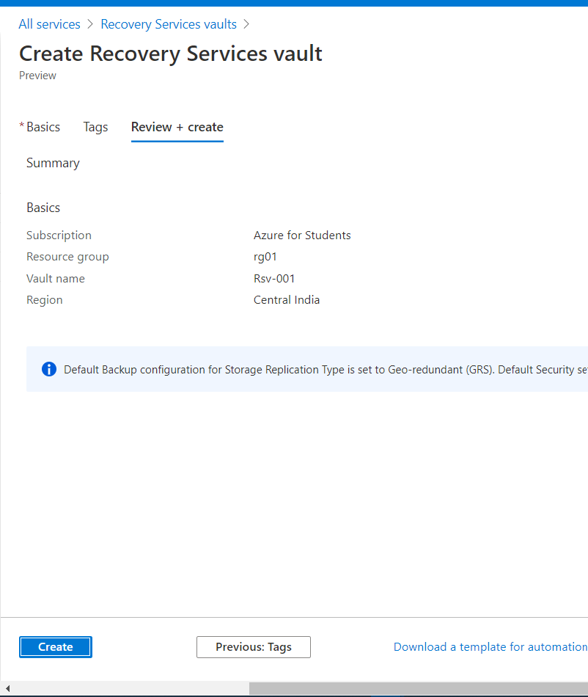

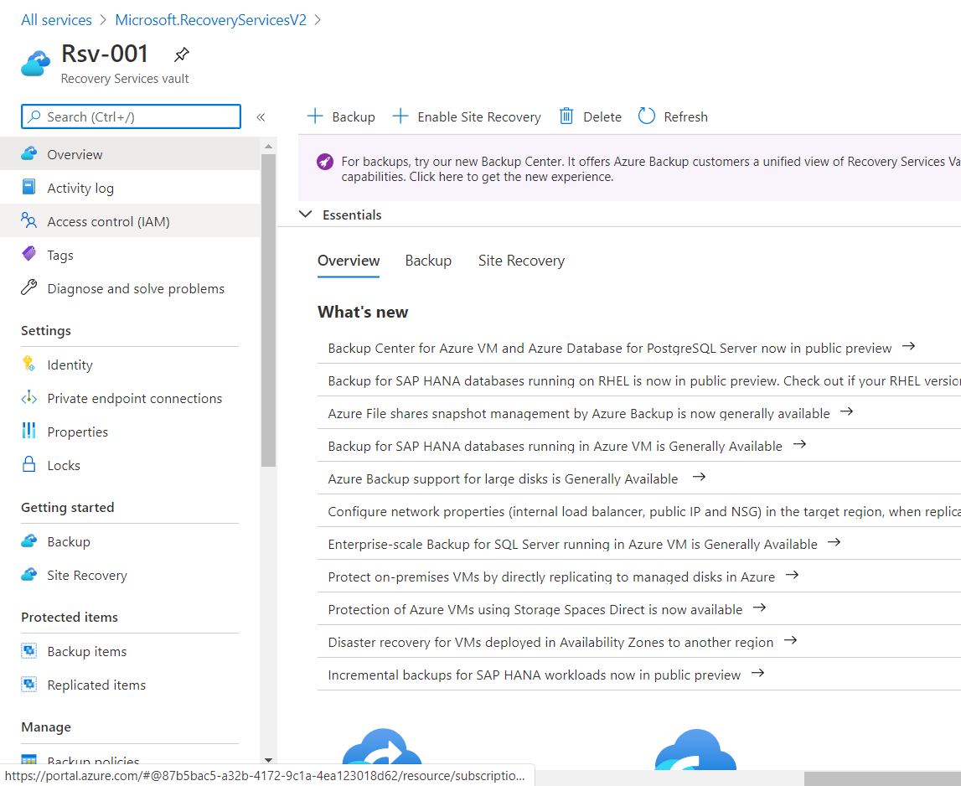

**- Define Custom policy for Window VM Backup.**

* Go to VM > Policies > Assign policy
* Here Policy hasn’t started yet.Cause it takes some time to activate after creating the policy.

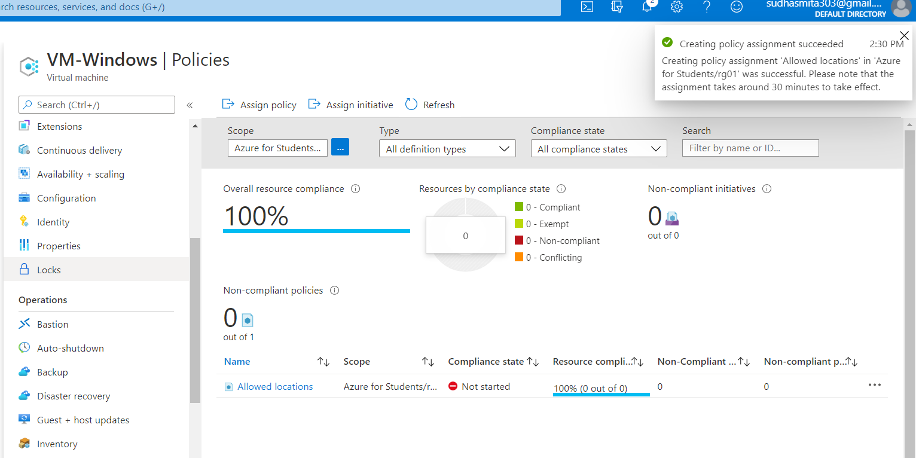

* Policy has started .

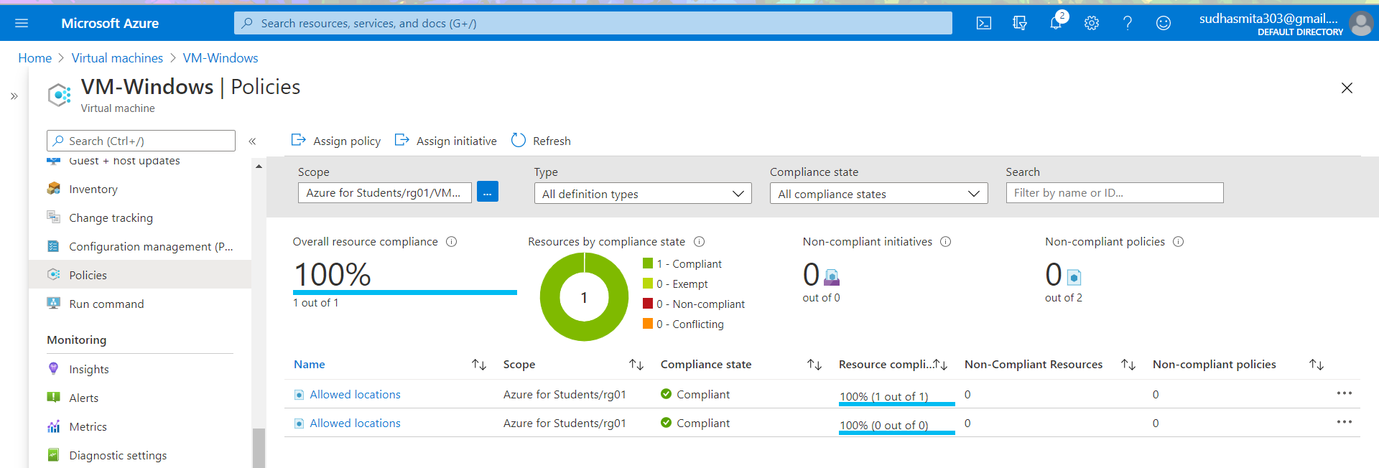

**- Setup Backup for the Virtual Machine (Windows) and ensure backup is completed successfully.**

* Backup in progress.

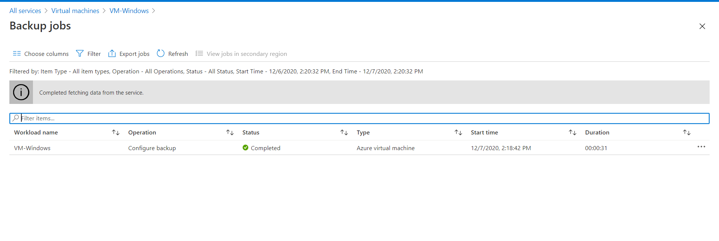

* Backup successful.

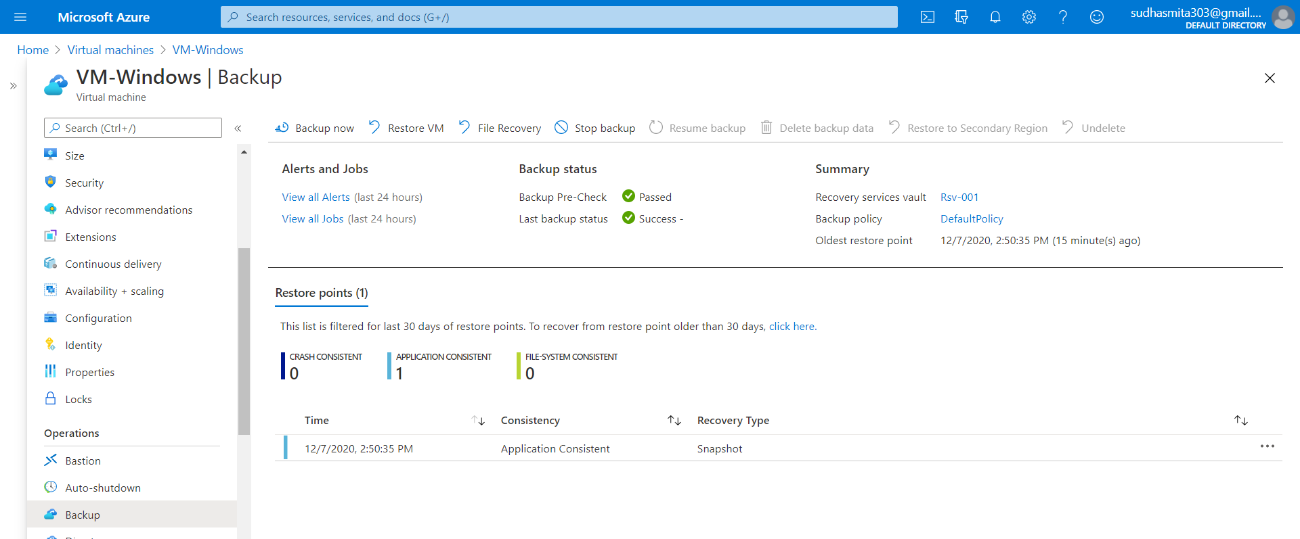

**- Restore new VM from the backup and delete the older VM.**

* Restore VM-Windows

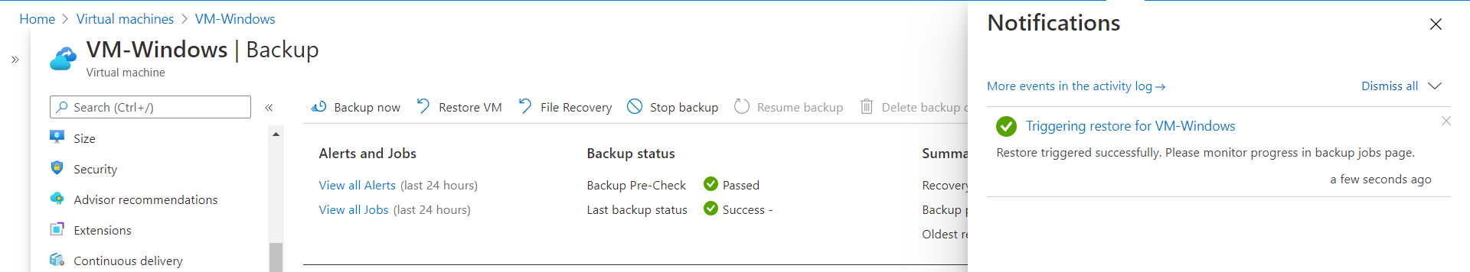

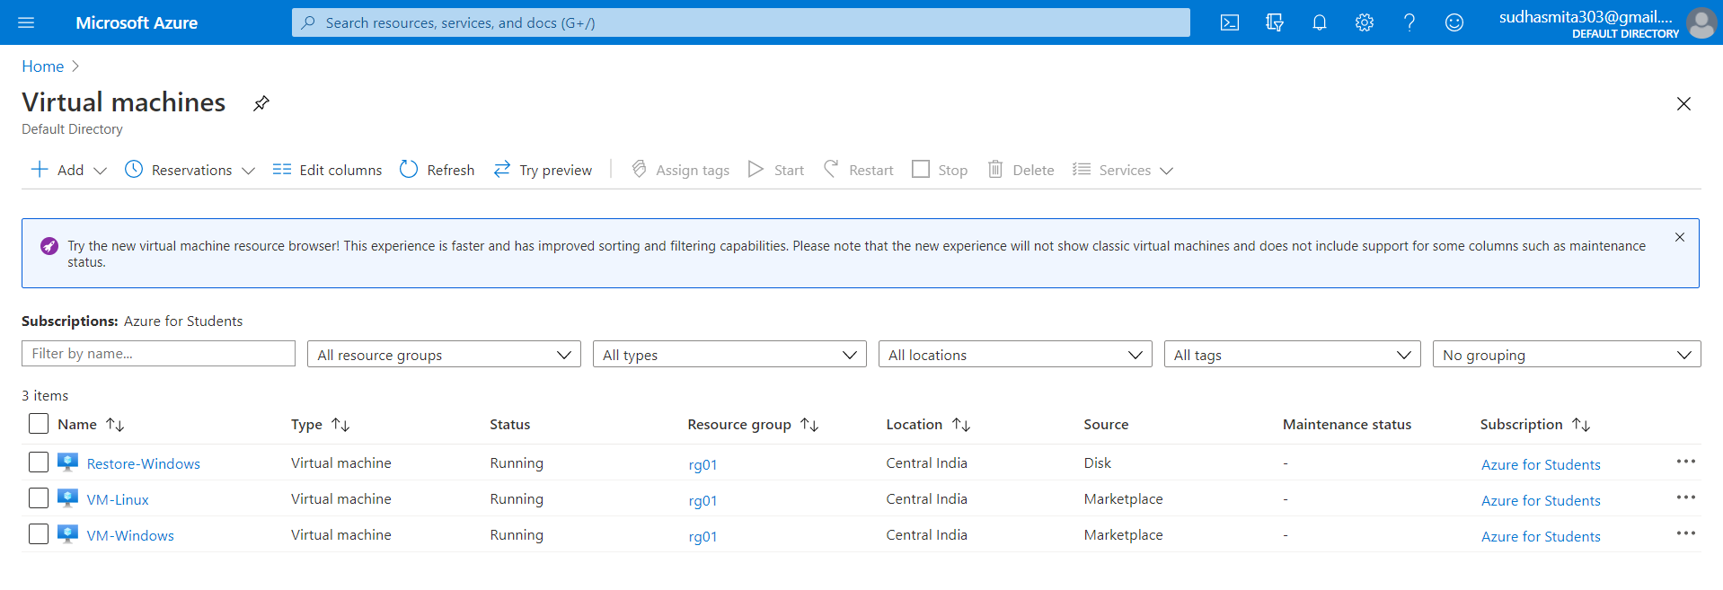

* New Restored VM(Restore-VM-01) of VM-Windows

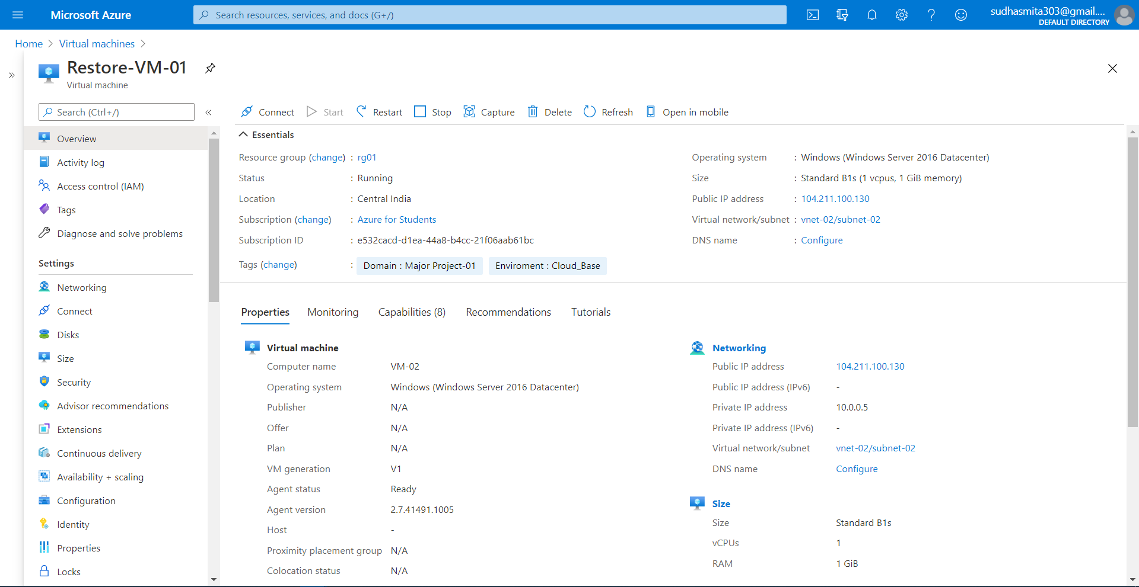

* After deleting the older VM

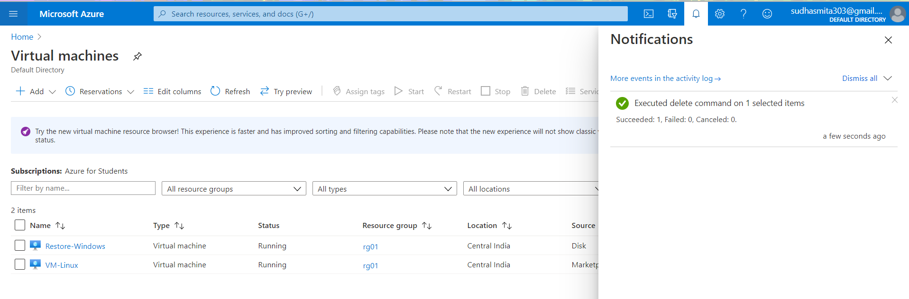

**- Apply a lock on the (rg01) and test if you are allowed to delete any resource.**

* Applied lock in Resource group (rg01),which is editable.

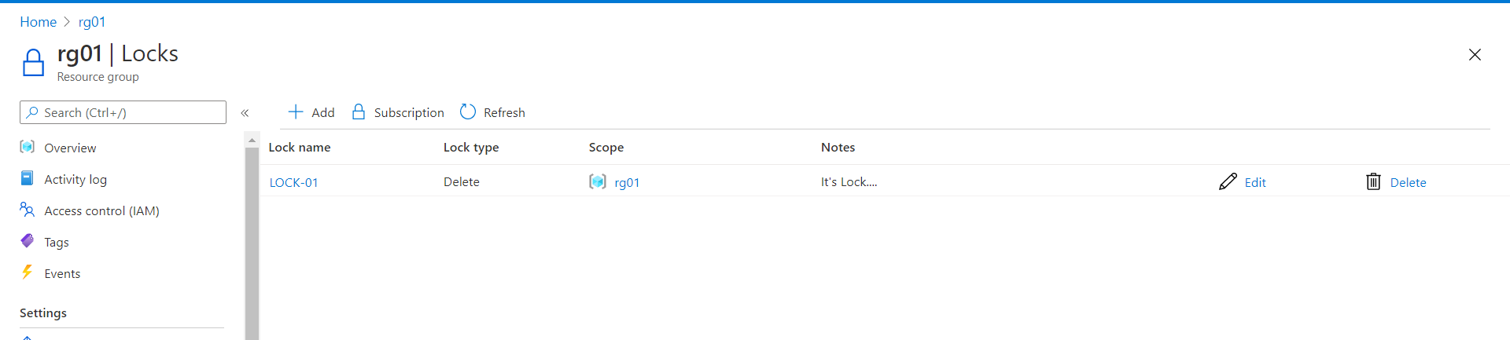

* Trying to delete Resource.

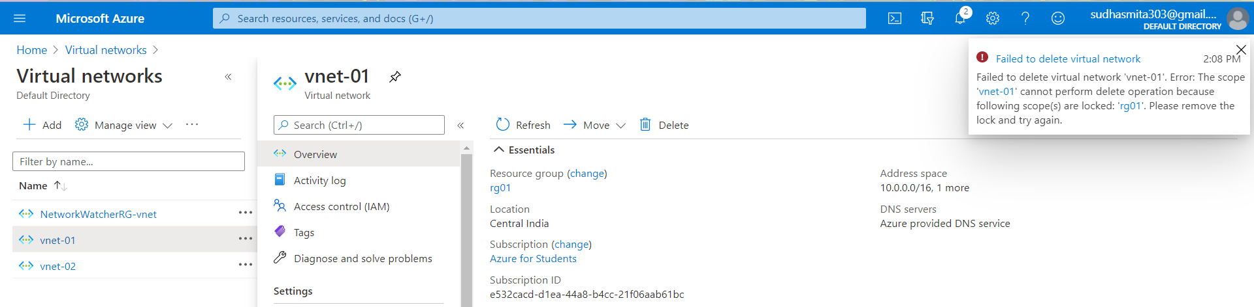

* We can’t delete any resources ,which are under the Resource Group(rg01).

**- Remove the Lock and delete all the resources after completion of your practical.**

* After removing the lock from the Resource Group we can delete any resources .

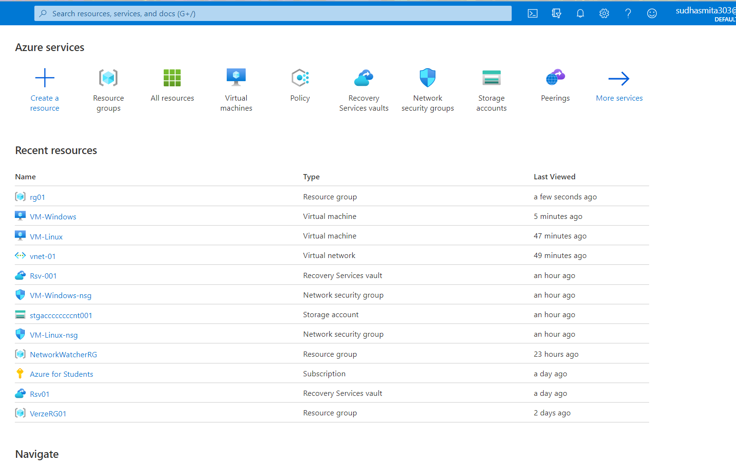

* Above is all the resources under rg01.
* Deletion successful.

