**Outstanding-02**

**Sudhasmita Swain**

**-Create two Resource Groups by name (rg001) and (rg002)**

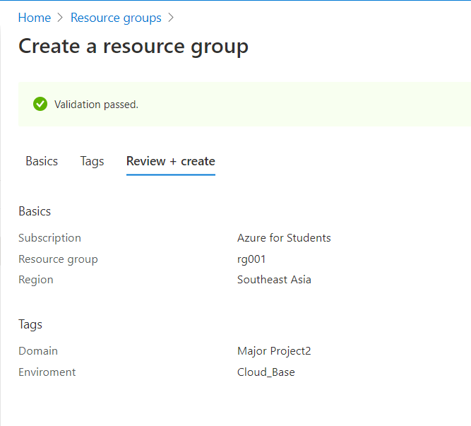

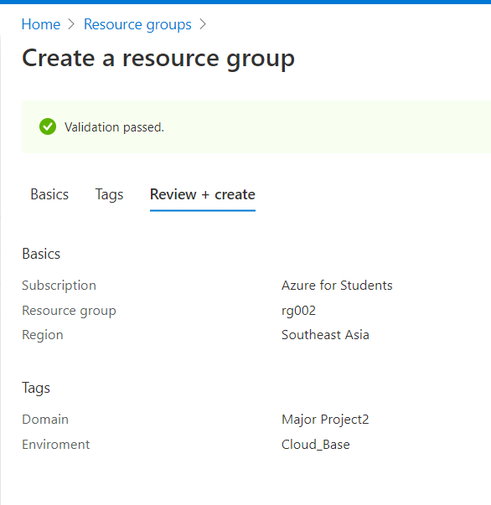

* We have created two resource groups under the name of rg001 and rg002.

**-Create two virtual networks (vnet01) and (vnet02) in the above resource-groups respectively.**

* vnet01

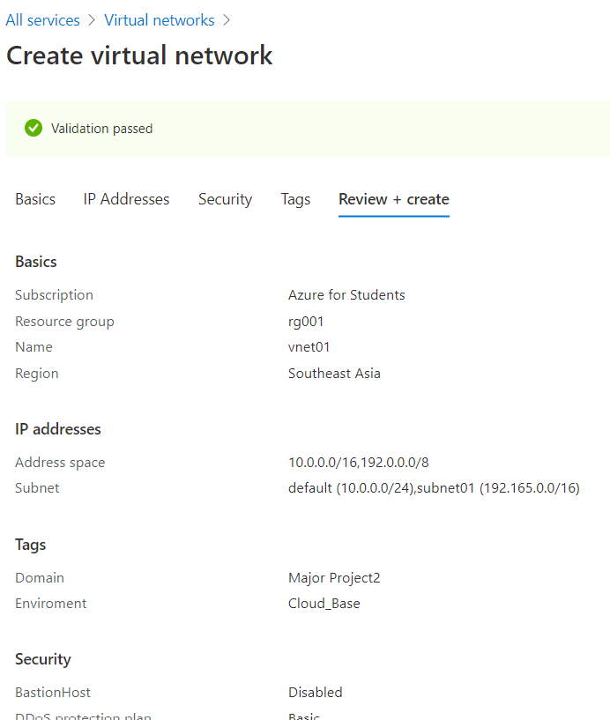

* vnet02

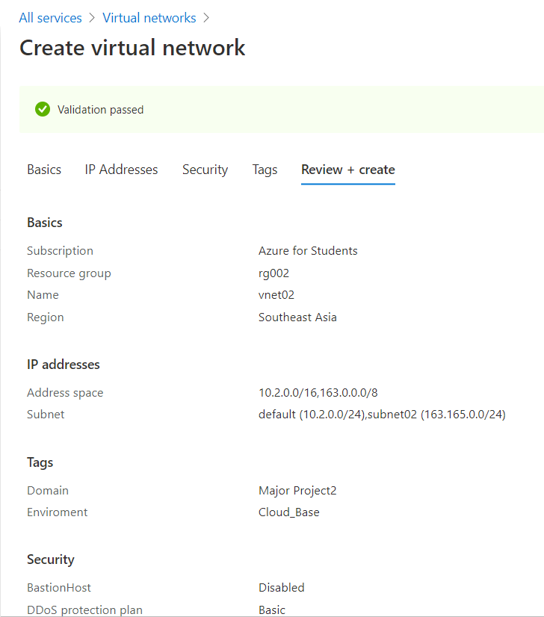

**-Create two Storage Accounts and only exposed these storage accounts to the above created vnets only.**

* stgaccnt01

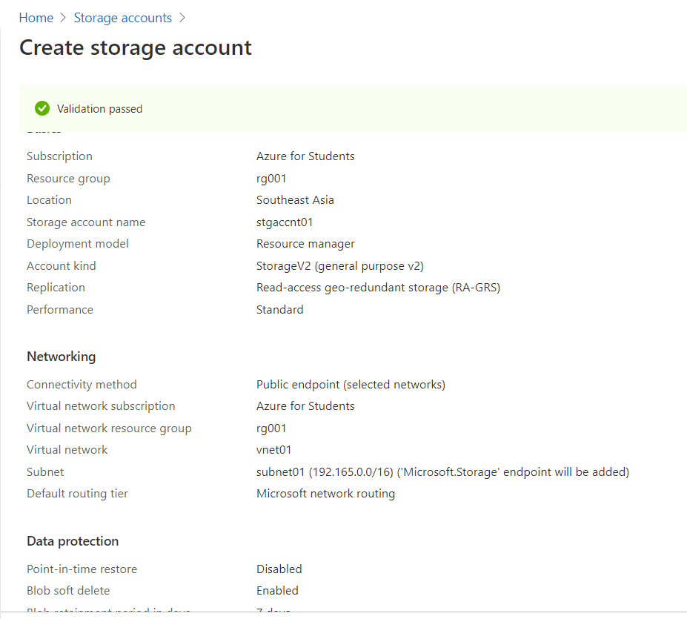

* stgaccnt02

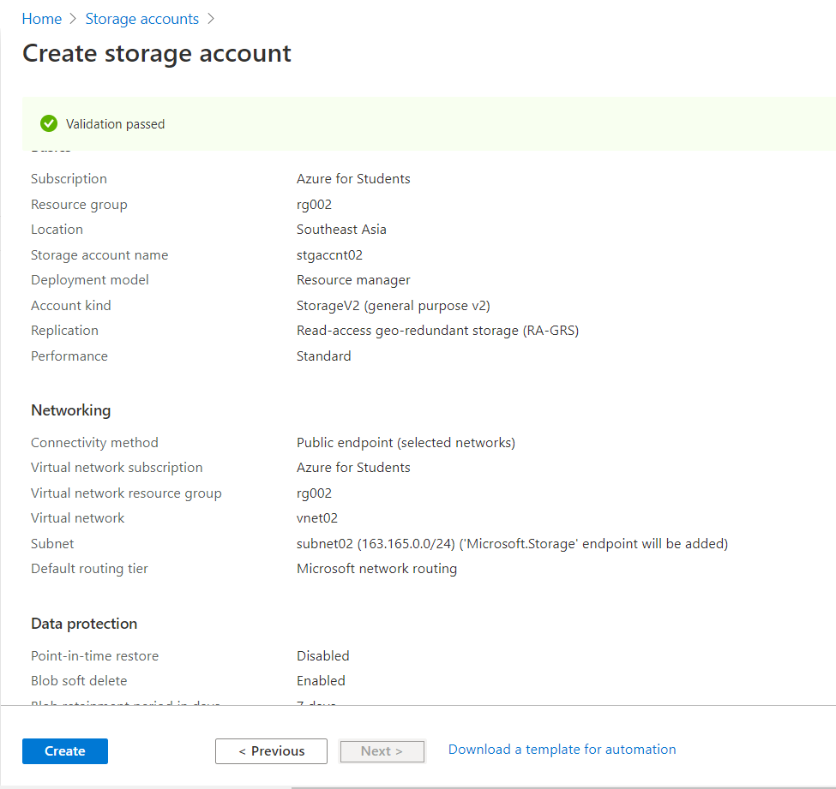

**-Create two users (user01 and user02) in azure active Directory**

* Go to Default Directory > Users > add users and Configure it.
* Let say user-1 is user01 and User-2 is user02 .
* A

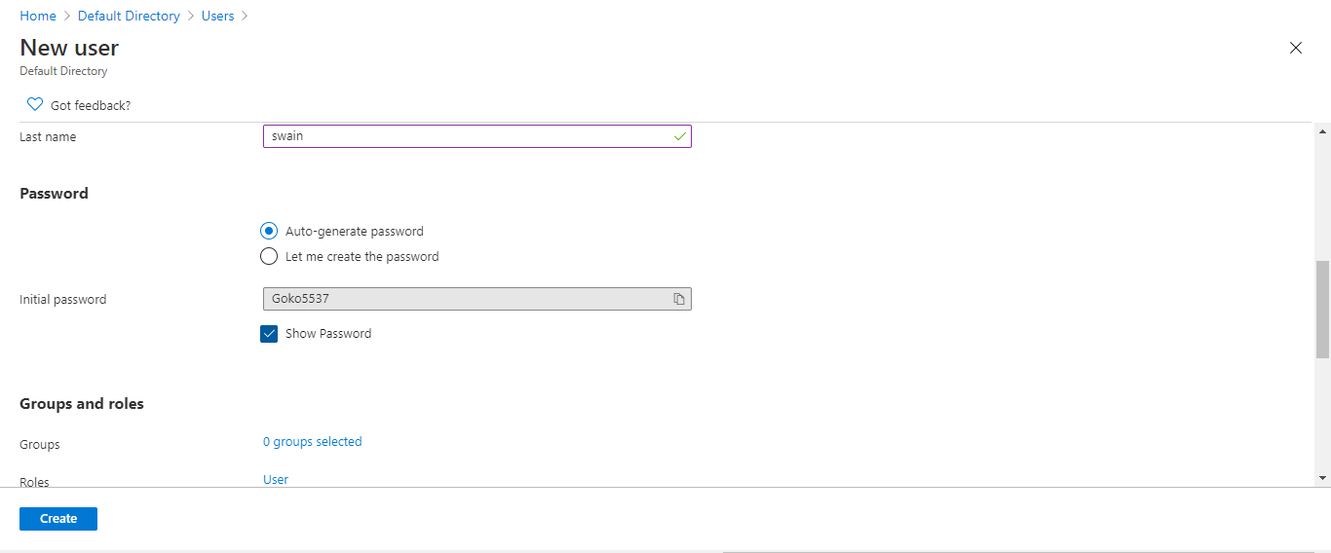

* **B**



* It generates the one time password which can be changed at the time of log in.
* User01

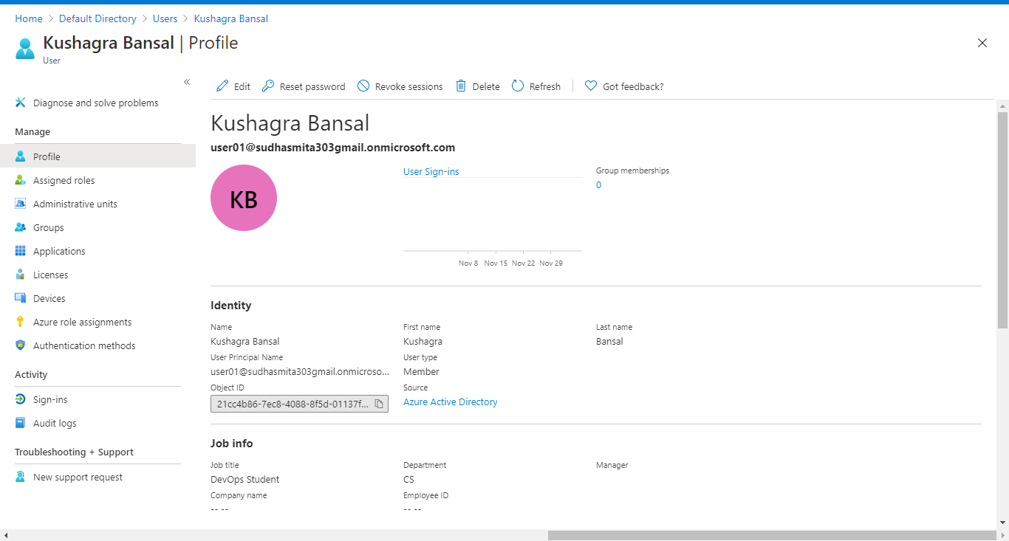

* User02

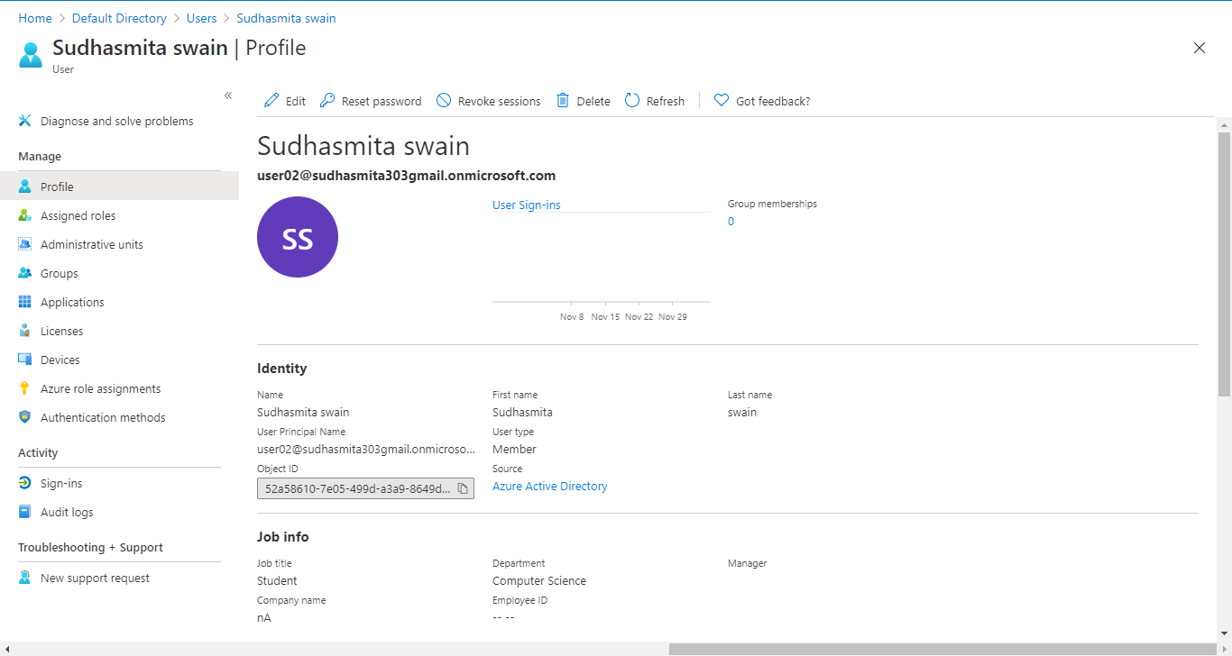

* Go to the top right, Click on the profile option and login with the generated mail i.e

1. [User01@sudhasmita303gmail.ommicrosoft.com](mailto:User01@sudhasmita303gmail.ommicrosoft.com)
2. [User02@sudhasmita303gmail.ommicrosoft.com](mailto:User02@sudhasmita303gmail.ommicrosoft.com)

**-Check whether you’re able to login with any of the one newly created user.**

* After following the above steps and retyping the password you will redirect to the user created by you.
* After login you’ll see like if you click your profile.

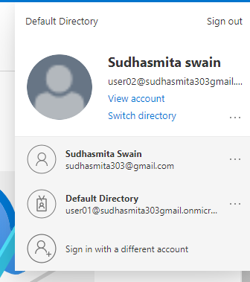

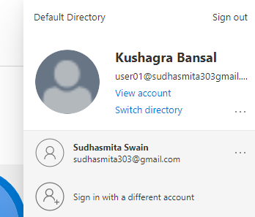

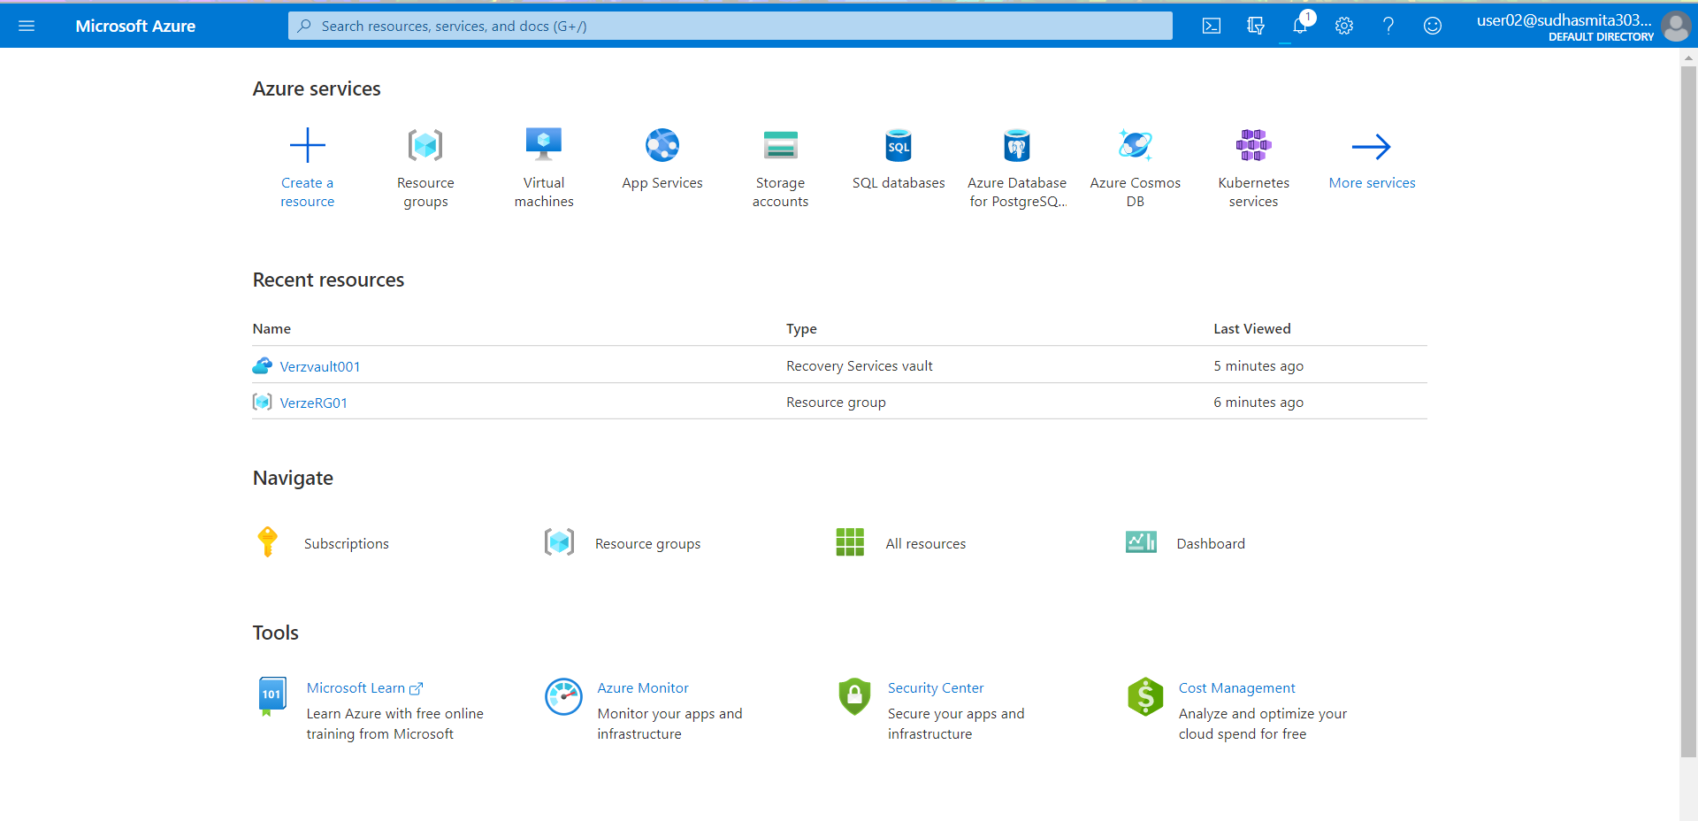



**-Give above user’s access to the storage account with the contributor role.**

* Go to subscription > Access Control(IAM) > Give the Contributor Role

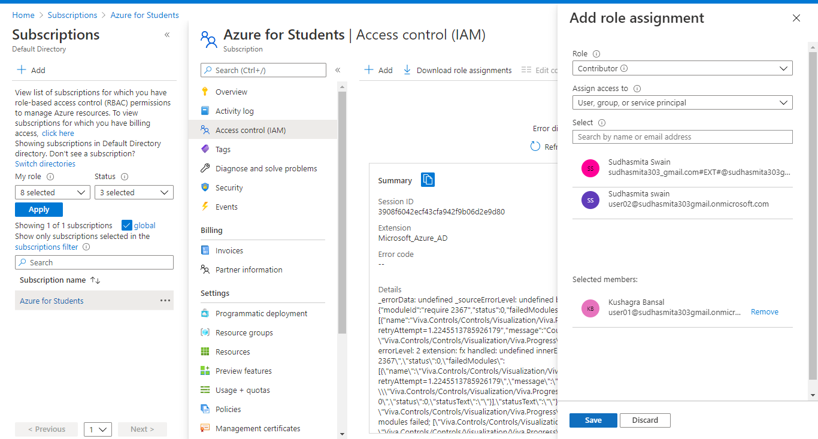

* Now go to the user01 and user02 you’ll see the assigned role.
* User02 mentioned below.

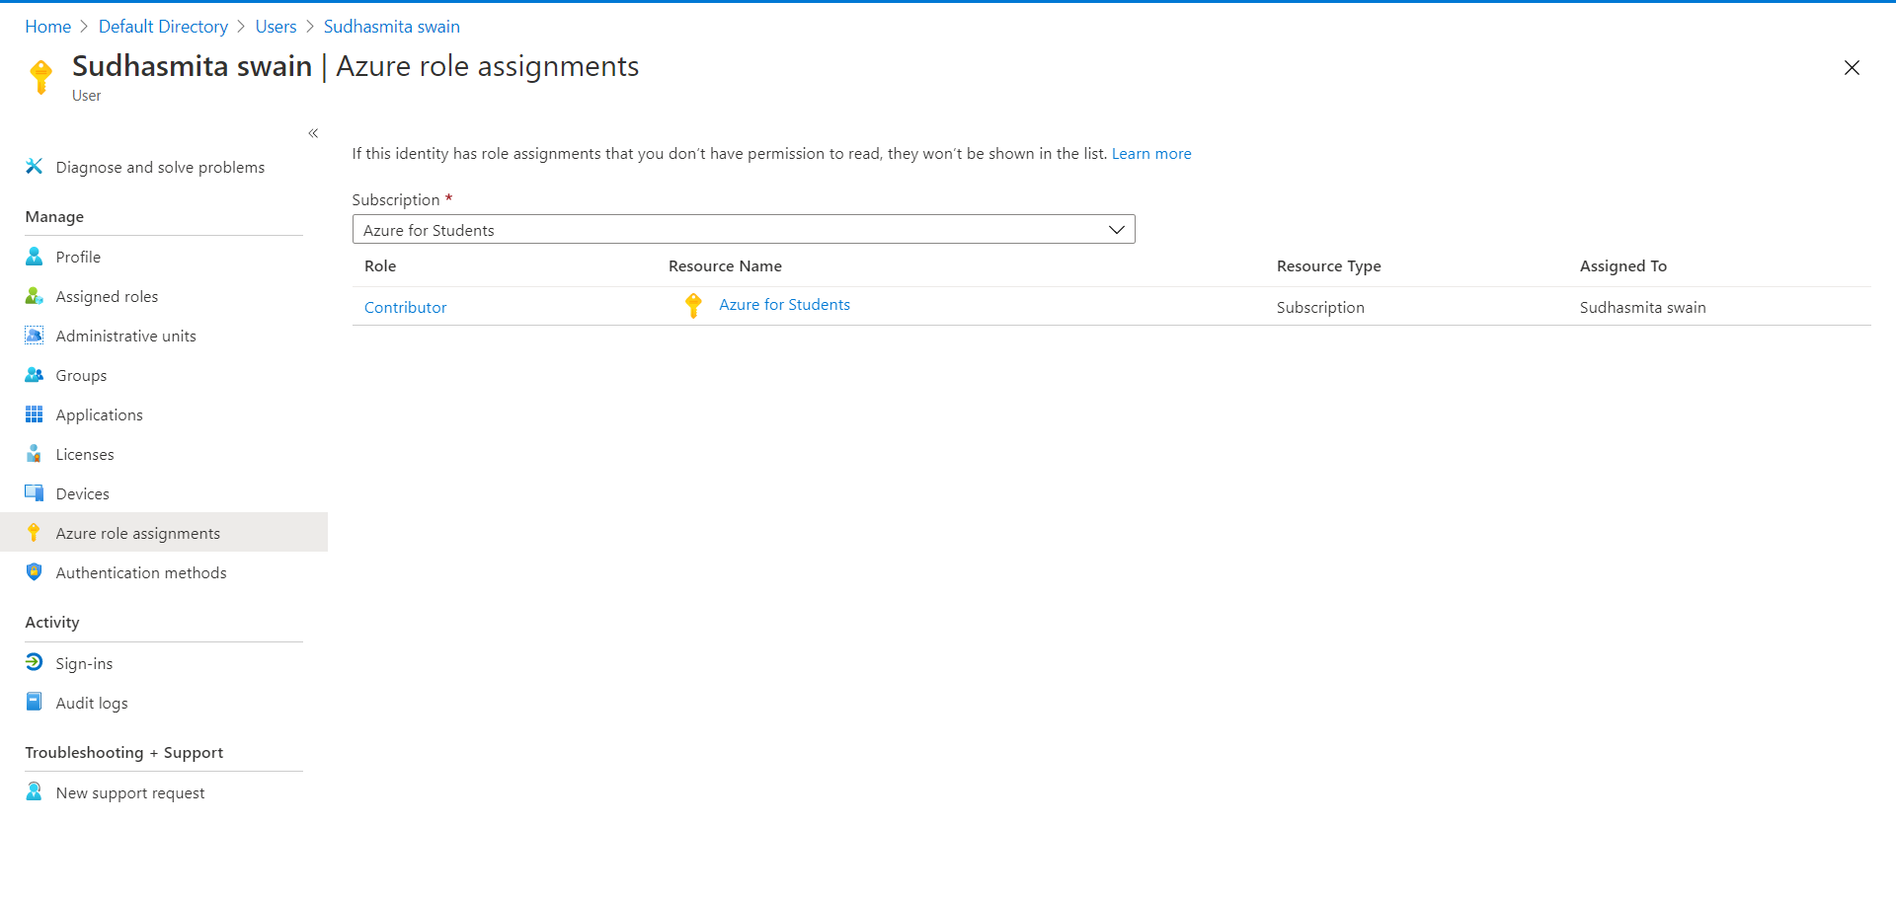



**-Create an Azure Policy to allow only certain locations (Southeast Asia) for the resource group , try to create a resource in any other locations and check the policy evaluation.**

* Azure Policy has not started

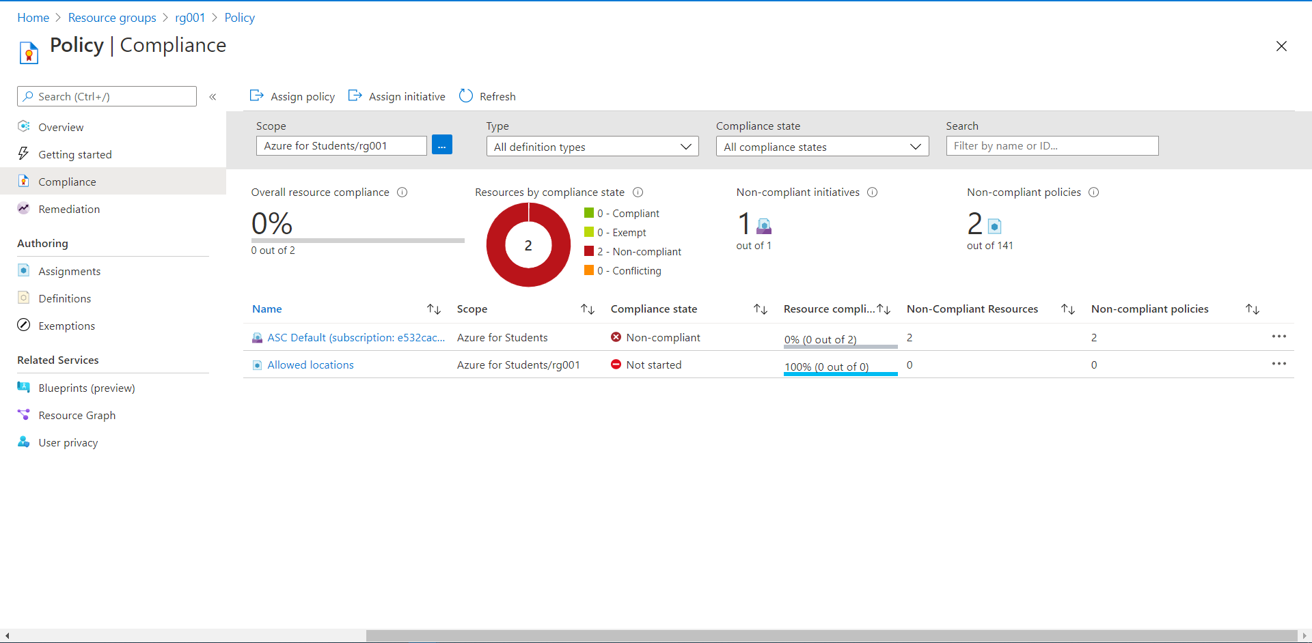

* Wait for a few minute and refresh it and policy disable will change to compliant.
* Azure Policy has started

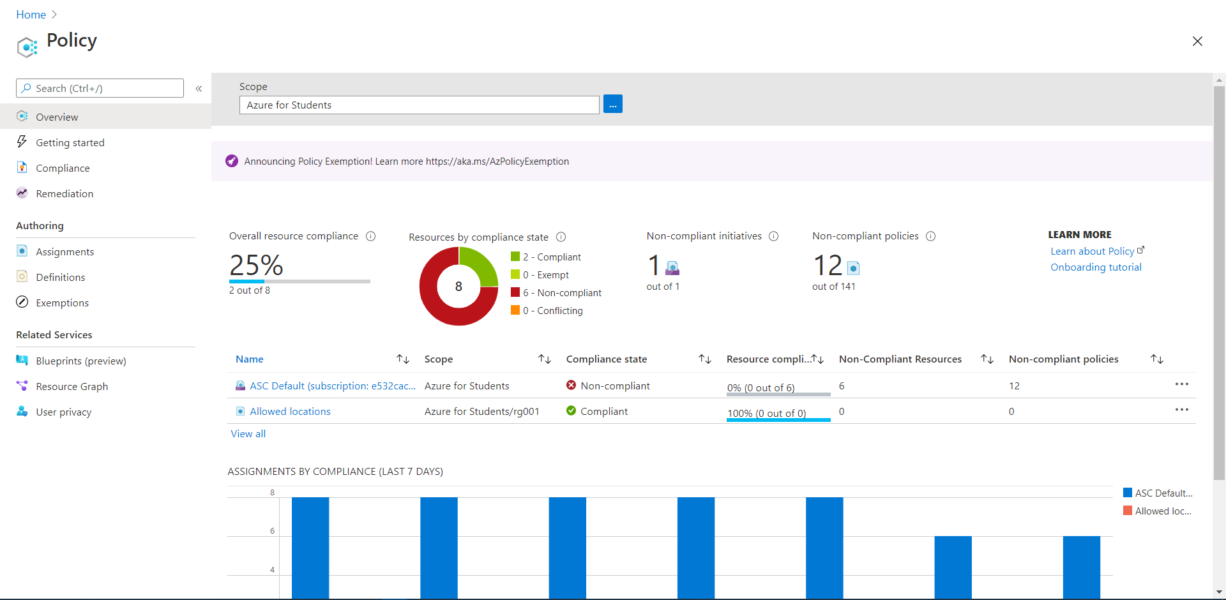

* We can not create any resources in any other location.As you can see I have taken the location WEST US2.

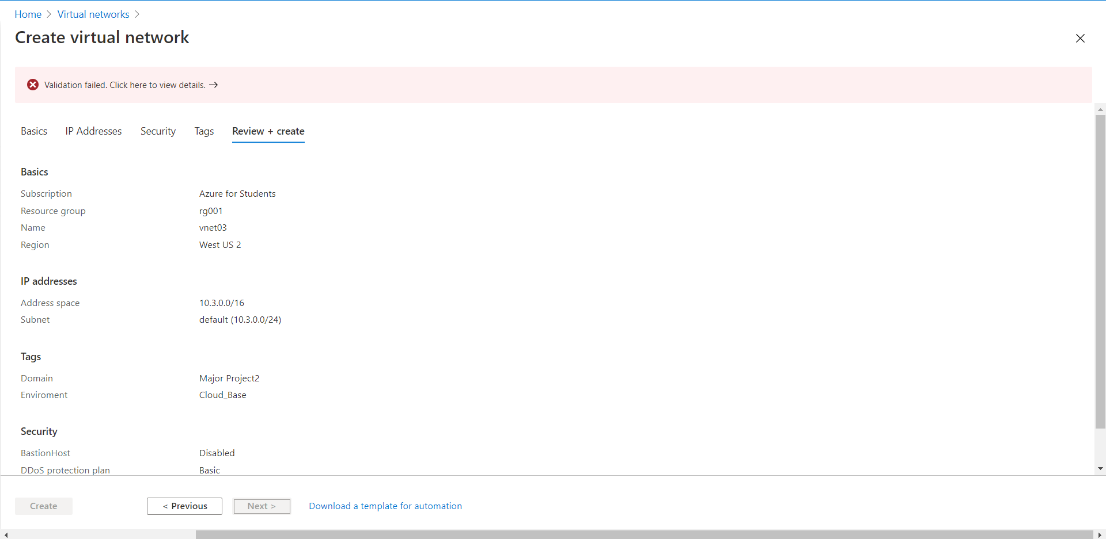



**- Set up Ingress and Egress metrics for both the above created storage Account.**

* Go to Metrics > Add new Charts
* Ingress Metrics

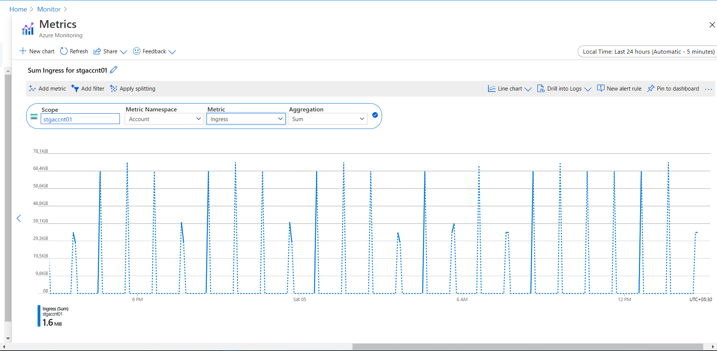

* Egress Metrics

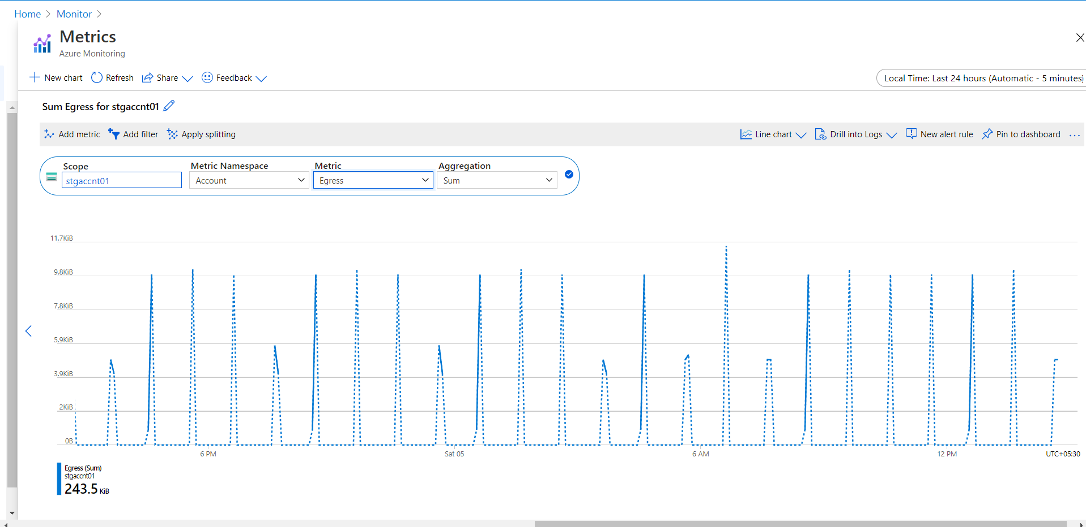

**-Create action group (Verzactgrp) Group for the above alert with your email id.**

* Go to monitor > Manage Action > Add Action
* Action group created

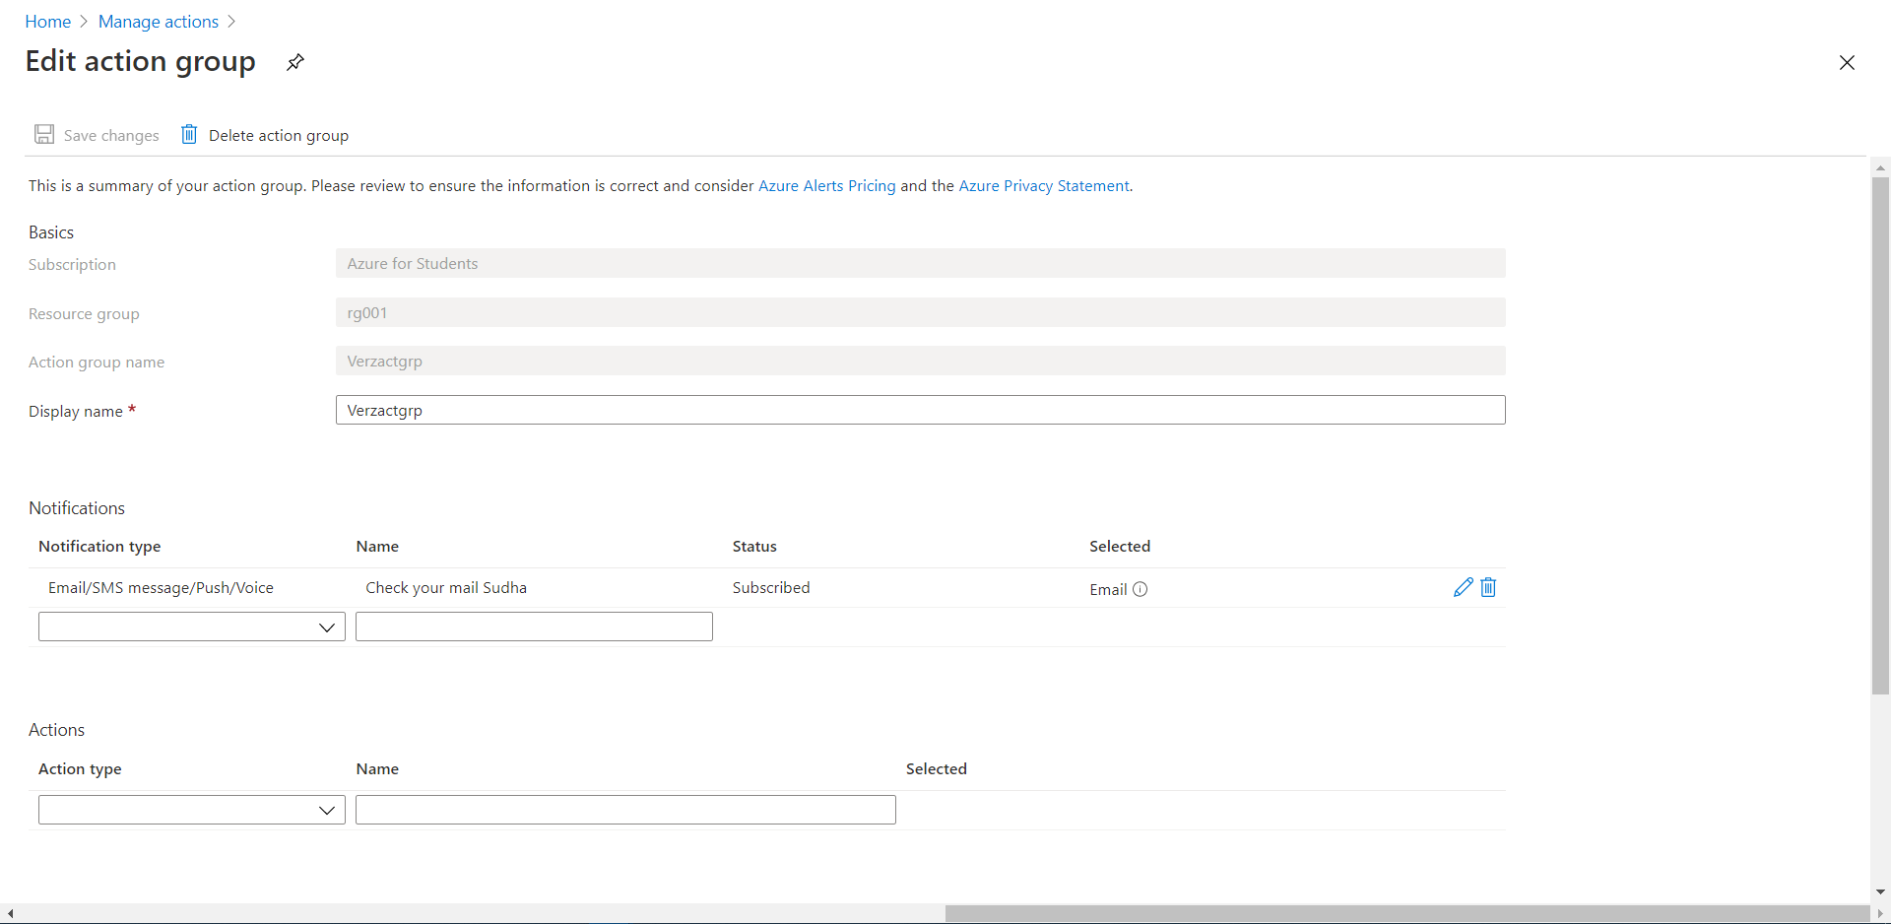

* Created alert with sudhasmita303@gmail.com



**-Check if you’re receiving alert.**

