**Outstanding-03**

**Sudhasmita Swain**

1. **Resource Group:-**

* **Resource groups**: A resource group is a logical container into which **Azure resources** like web apps, databases, and storage accounts are deployed and managed.
* **Resources**: Resources are instances of services that you create,like virtual machine,storage,or SQL databases.
* Creating a resource group is the first most important thing to do before starting deploying anytime in azure.

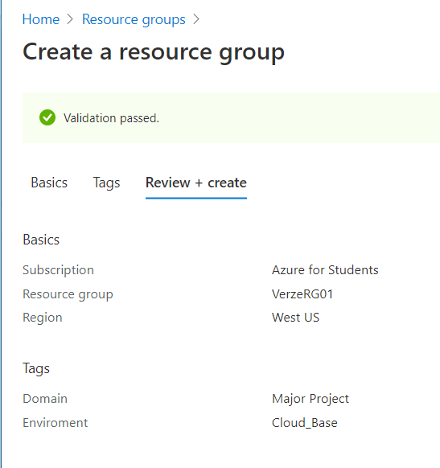

1. **Virtual Network :-**

* **Azure Virtual Network** (**VNet**) is the fundamental building block for your private **network in Azure.**
* A **virtual network** is a **network** where all devices, servers, **virtual** machines, and data centers that are connected are done so through software and wireless technology.
* Results in secure communication among each other, the internet, and on-premises **networks**.

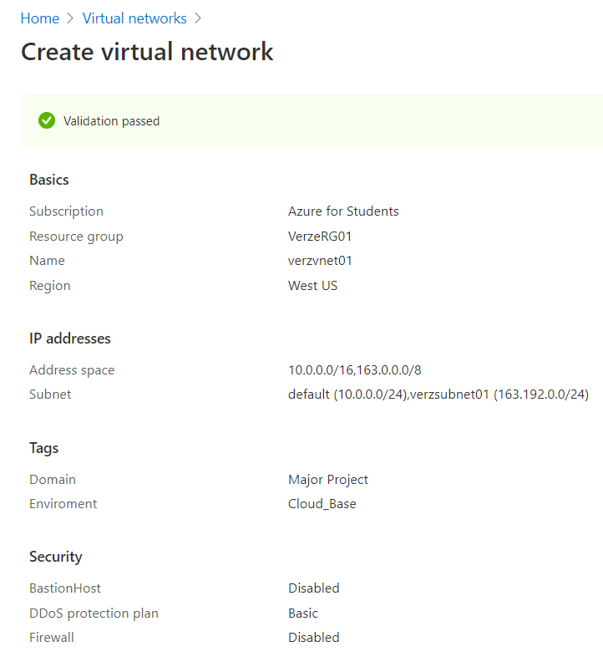

**SUBNET:-**

* **A Subnet** is a range of IP addresses in the VNet.
* It enables you to segment the virtual network into one or more sub-networks and allocate a portion of the virtual network’s address space to each subnet.
* Each **NIC** in a **VM** is connected one subnet in one **VNet.**
* **NICs** connected to **subnets(**same or different**)** within a **VNet** can communicate with each other without any extra configuration.

1. **Virtual Machine:-**

* A **virtual machine** (VM) is a virtual environment that functions as a virtual computer system with its own CPU, memory, network interface, and storage, created on a physical hardware system (located off- or on-premises).

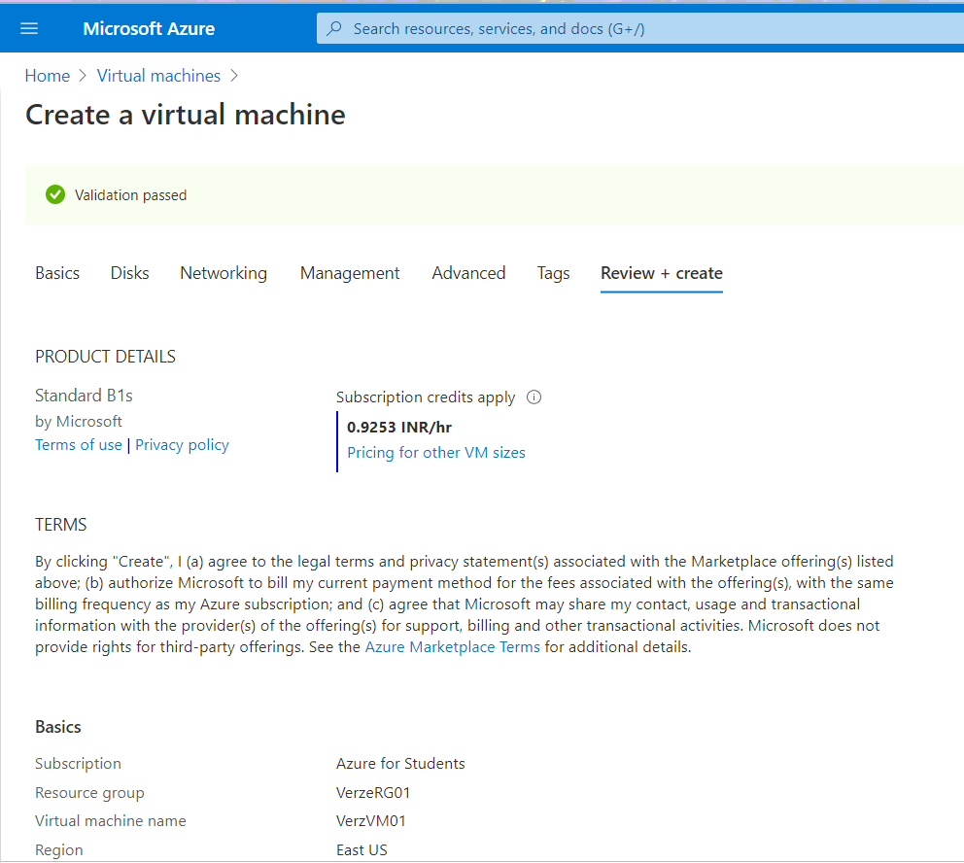

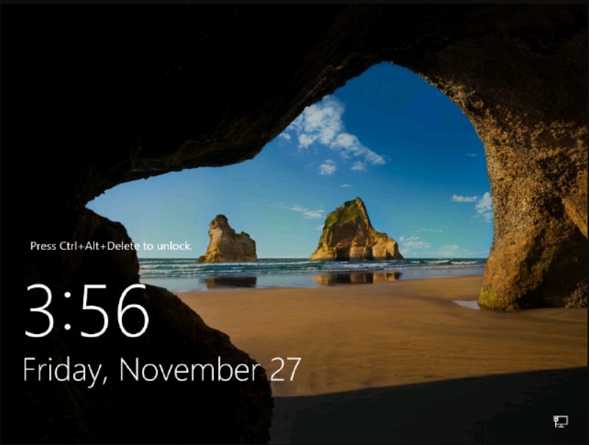

1. **Storage-Account:-**

* An **Azure Storage** **account** contains all of your Azure Storage data objects:**blobs**, **files**, **queues**, **tables** and **disk**.
* Azure Storage offers several types of storage accounts.Each type supports different features and has its own pricing model.
* The storage account provides a unique name-space for your Storage Data that is accessible from anywhere in the world over HTTP or HTTPS.
* Data in Azure Storage account is durable and highly available, secure, and massively scalable.

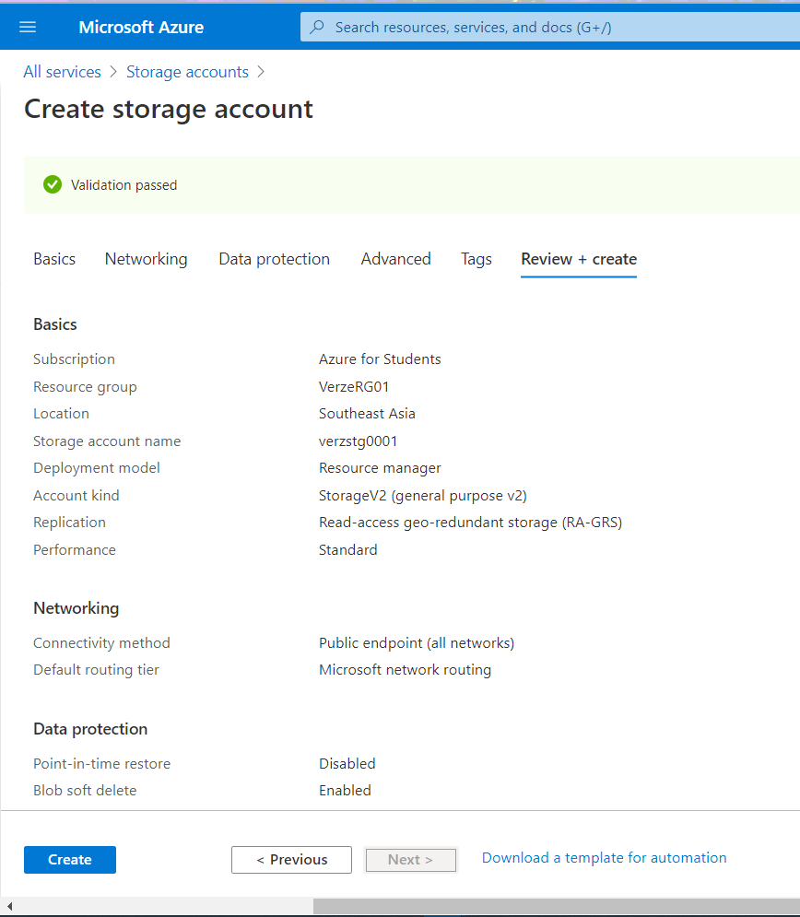

**File-Share Storage:-**

* File Storage accounts provide a premium performance tier for Azure file shares.
* This storage account kind supports files but not block blobs, append blobs, page blobs, tables, or queues.
* File Storage account offer unique performance dedicated characteristics such as IOPS bursting.

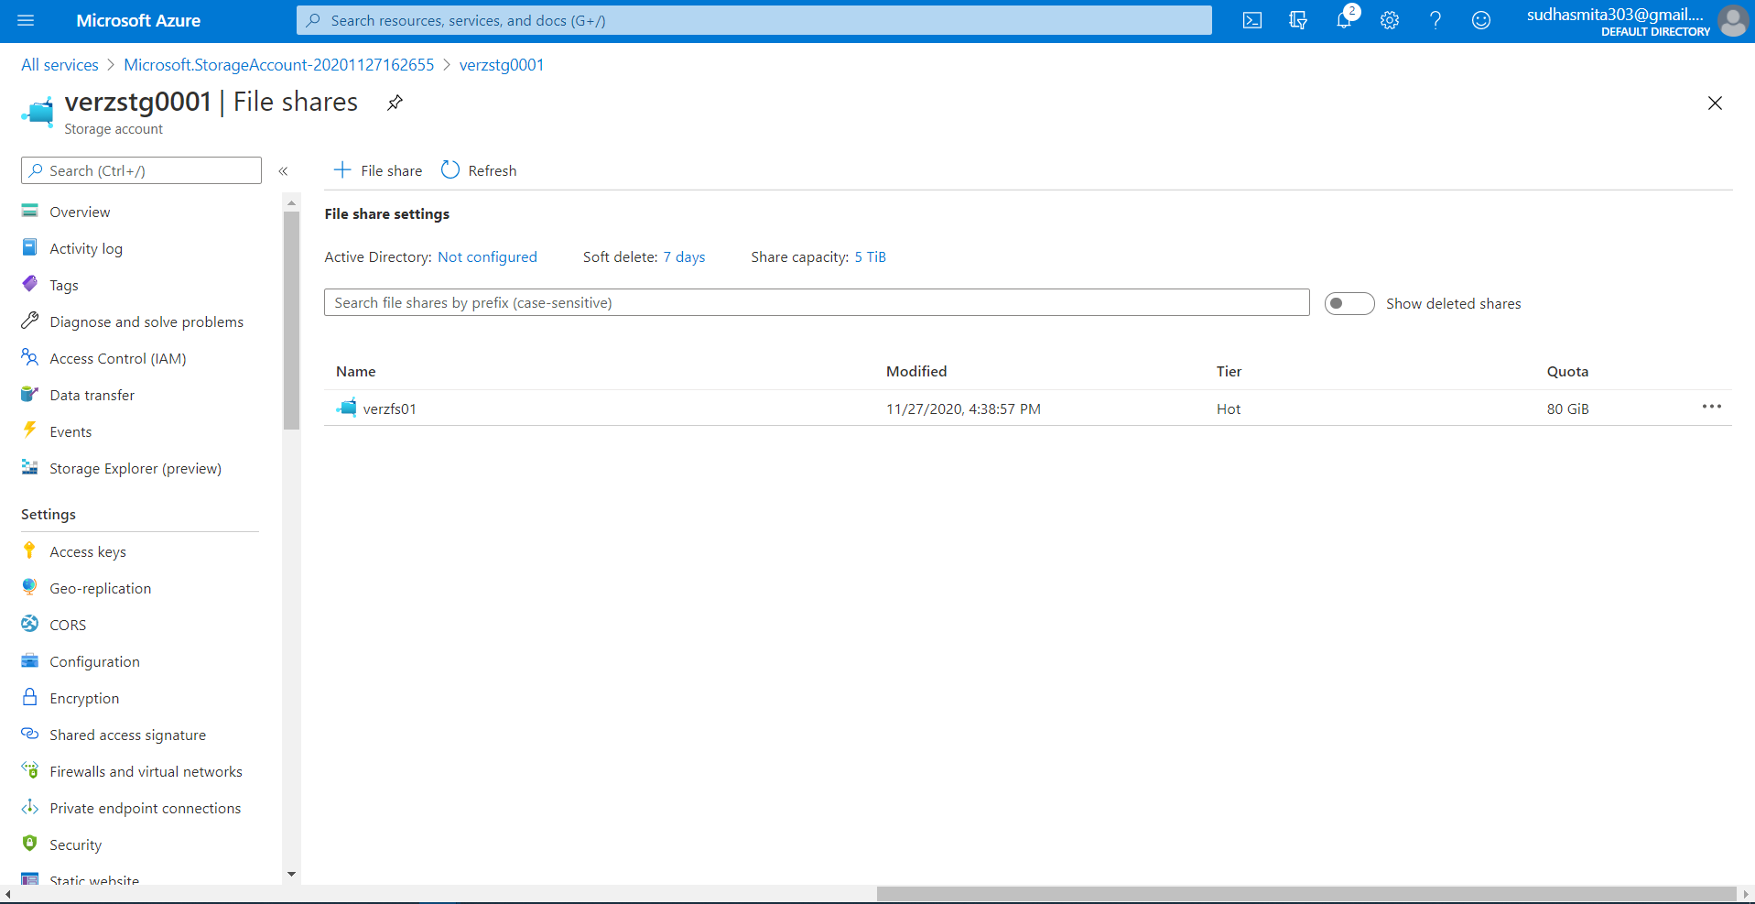

* **Mount on the VM[VerzVM01]:-**

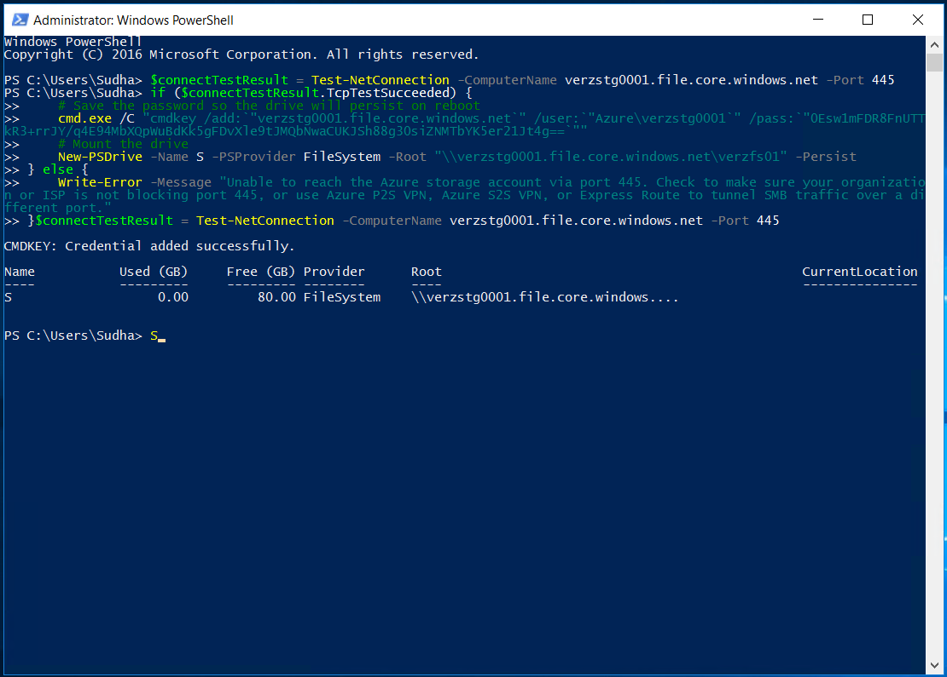

* **S-Storage file on VM**

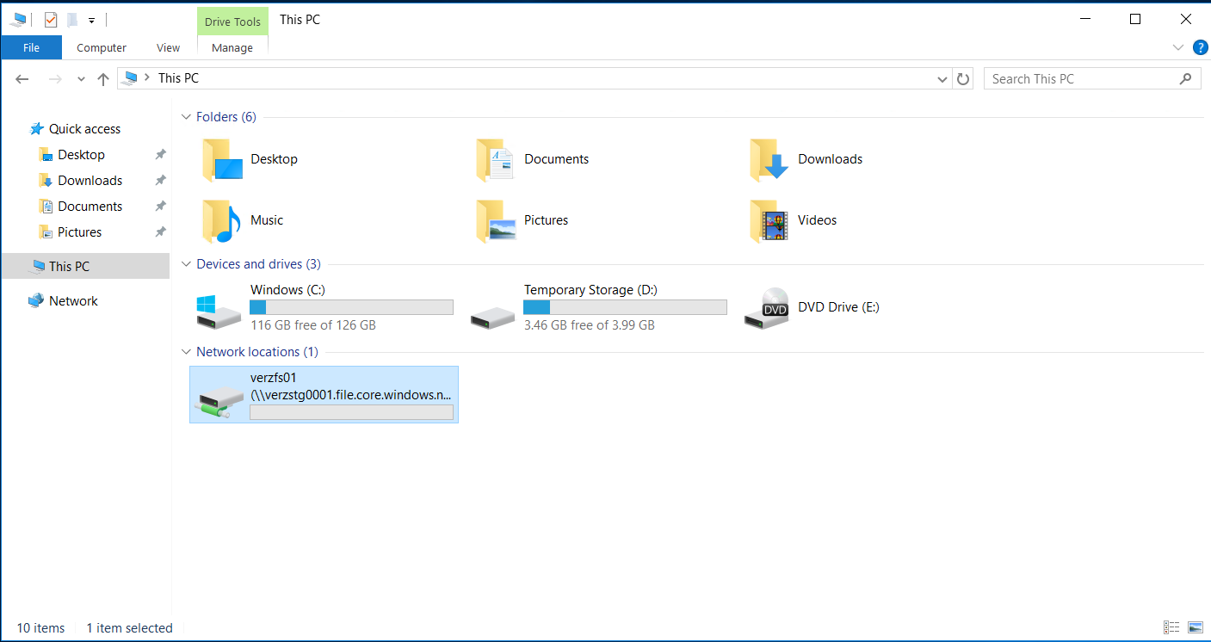

* **Text File on Azure Cloud Storage After creating it on S-Storage of Virtual Machine**

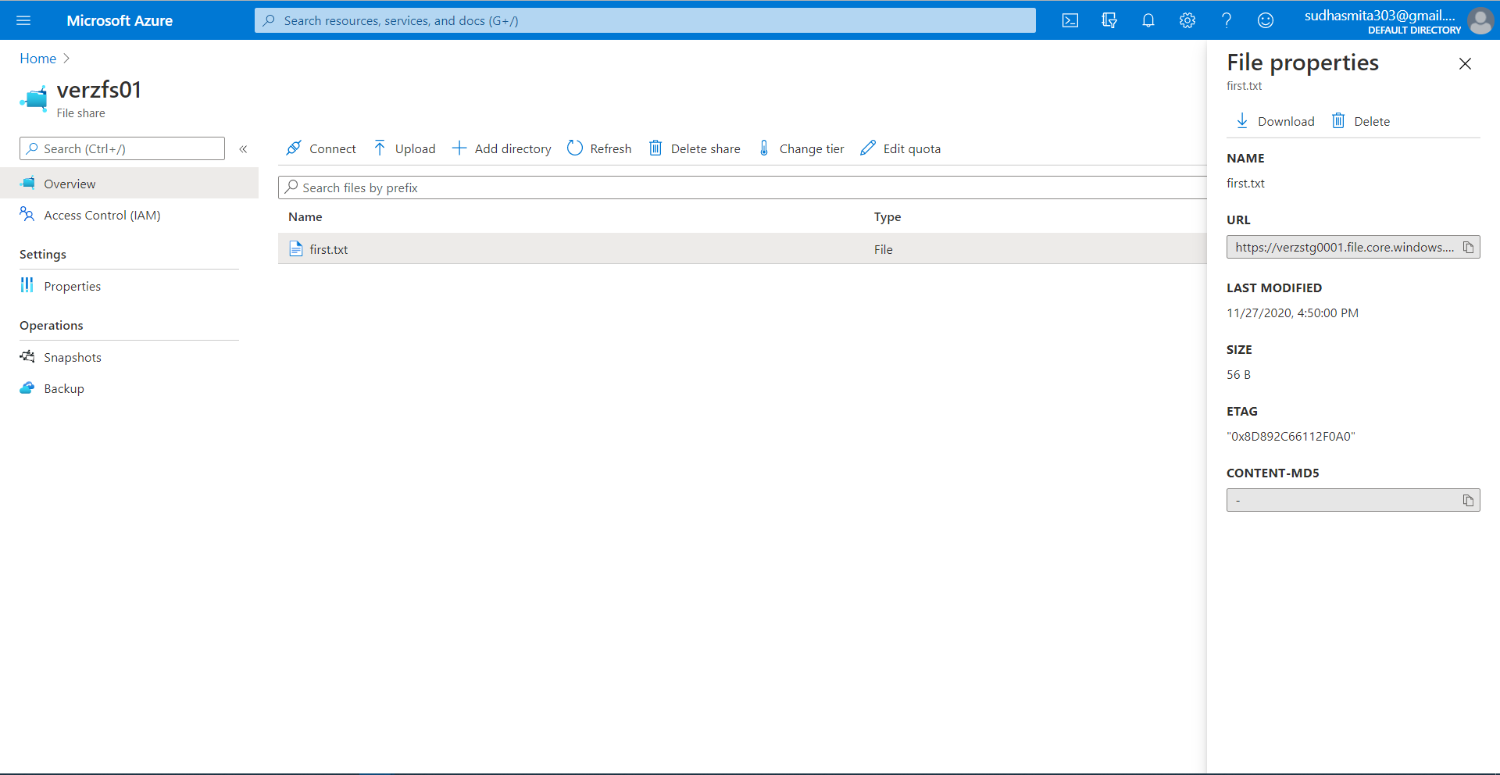

1. **Network Security Group:-**

* **Network Security Groups** provide control over **network** traffic flowing in and out of your services running in **Azure**.
* **Network Security Groups** can also be applied to a Subnet in a Virtual Network thus they provide an efficient mechanism to administer access control rule updates across multiple VMs.
* A **Network Security Group** contains security rules that allow or deny inbound network traffic to, or outbound network traffic from, several types of **Azure** resources

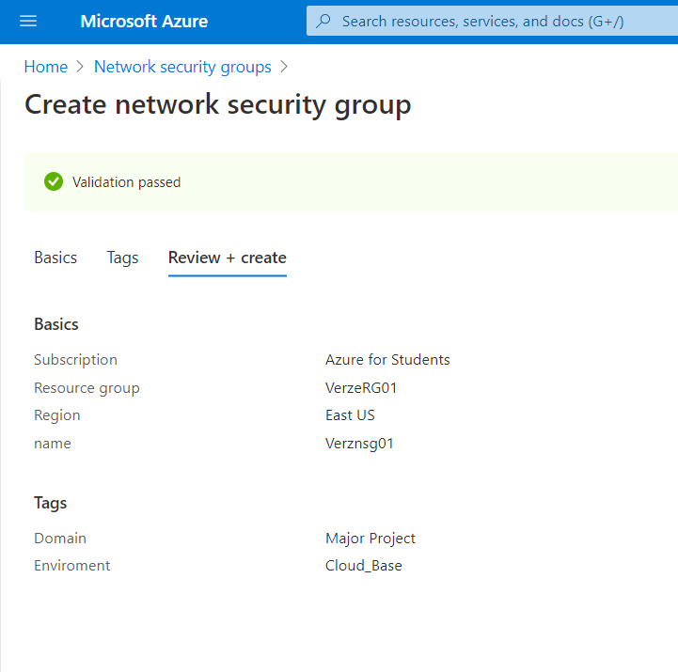

**Inbound and Outbound Rules:-**

* A network security group contains **Rules** that allow or deny **inbound** network traffic to,or **outbound** network traffic from, several types of **Azure** resources. For each **rule**, you can specify source and **destination**, **port**, and **protocol**.
* The below Screen Shot represents an inbound security port rule that allow RDP and an outbound security port rule deny Internet access.

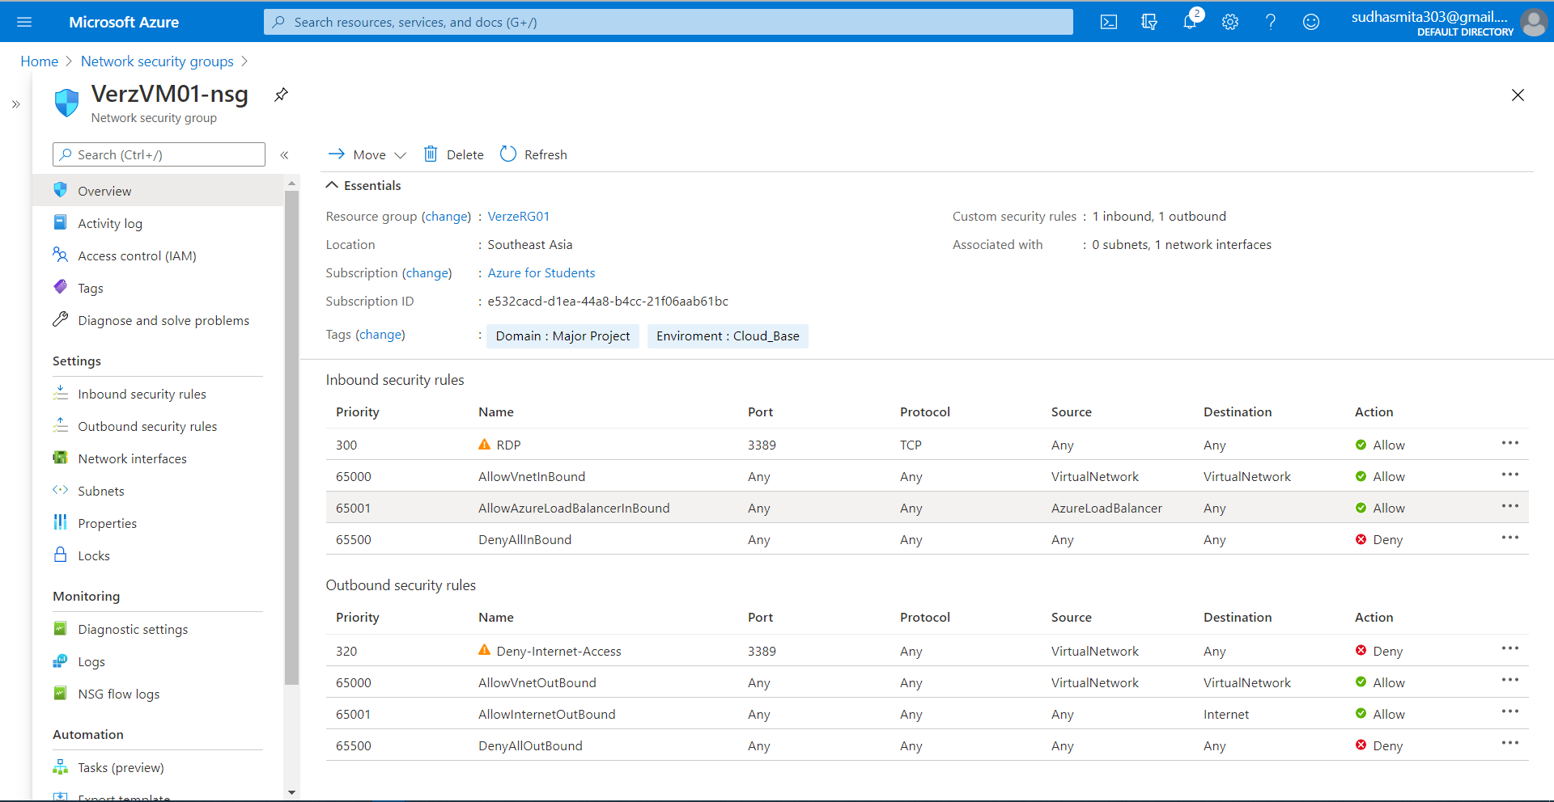

1. **Azure Policy :-**

* **Azure policy** establishes conventions for resources. Policy describes resource compliance conditions and the effect to take if a condition is met.
* It helps us **manage and prevent IT issues** with policy definitions that enforces rules and effects for our resources.
* In Azure policy the business rules,described in JSON format, are known as P**olicy** definitions.
* Allowed only certain locations[Southeast Asia].
* Policy not started

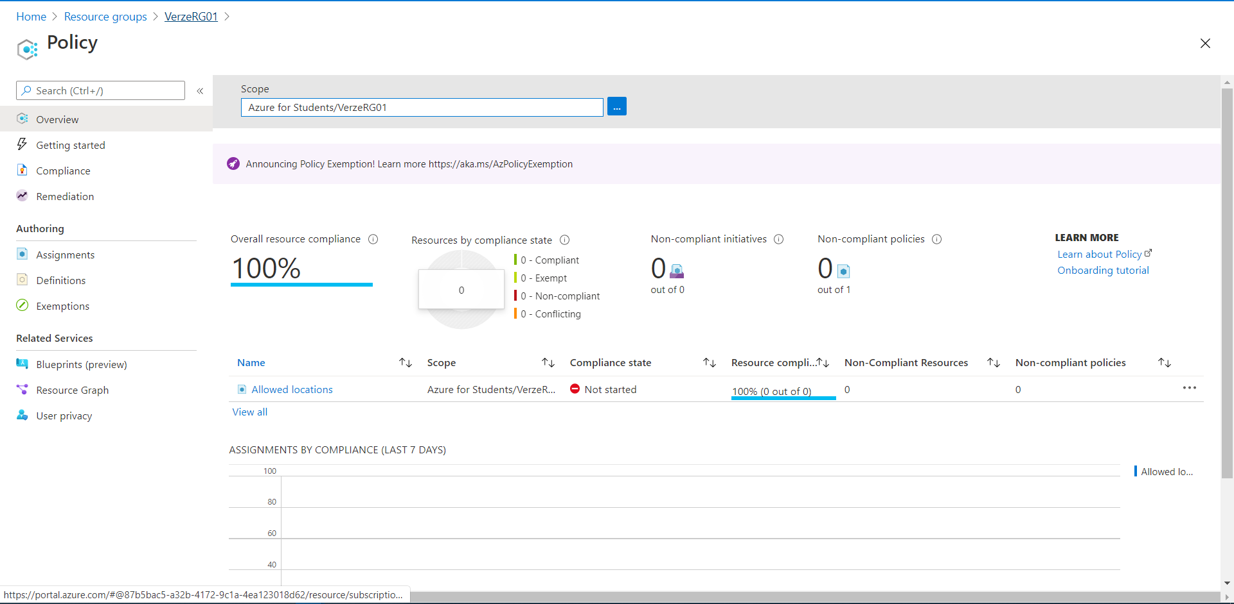

* Policy Started

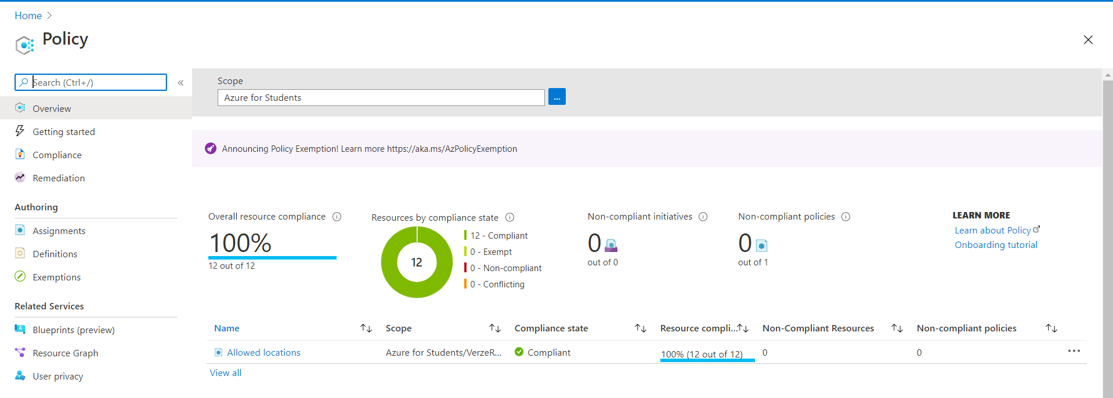

* We can’t create a resource in any other location.It restricts the available Locations for new resources.

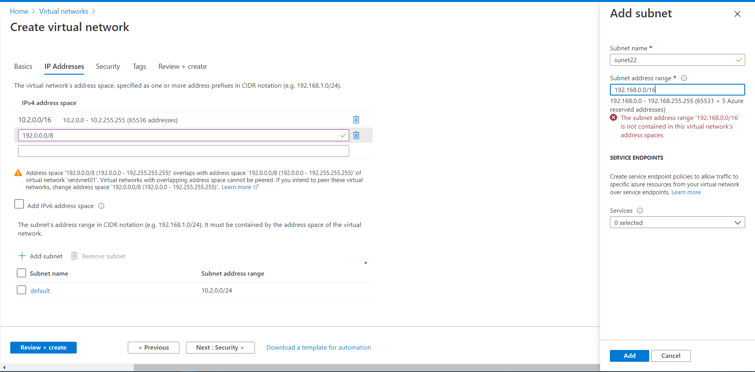

1. **Applying lock on Resource Group :-**

* Lock applied on Resource Group[VerzeRG01]

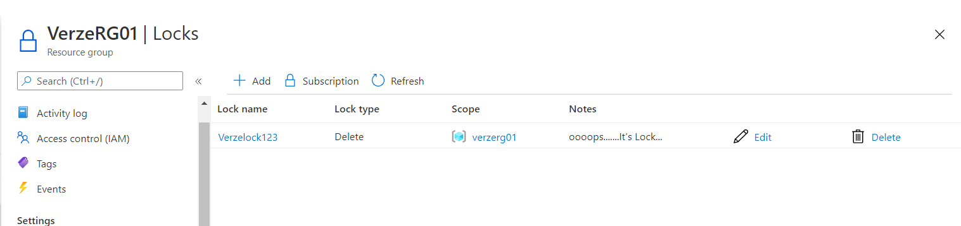

* Not able to delete any resource under this Resource Group [VerzeRG01].

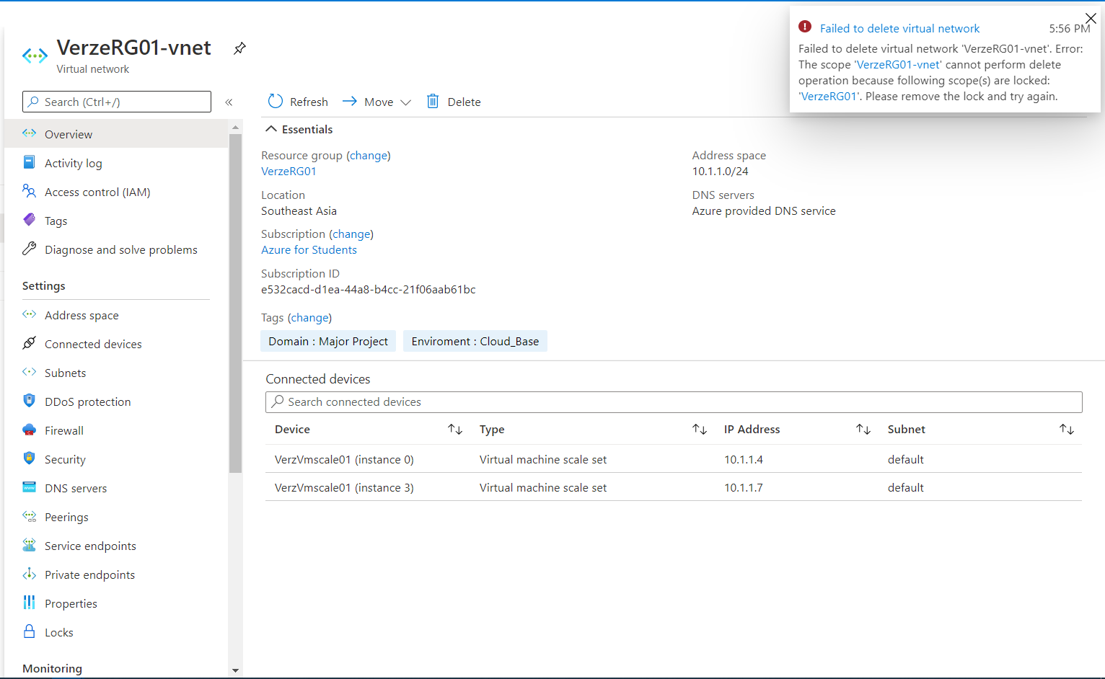



1. **Setup CPU Threshold alert for the VM :-**

* Dynamic Threshold on VM CPU percentage metrics.
* An alert will be created for the VM with a value that exceeds the threshold.

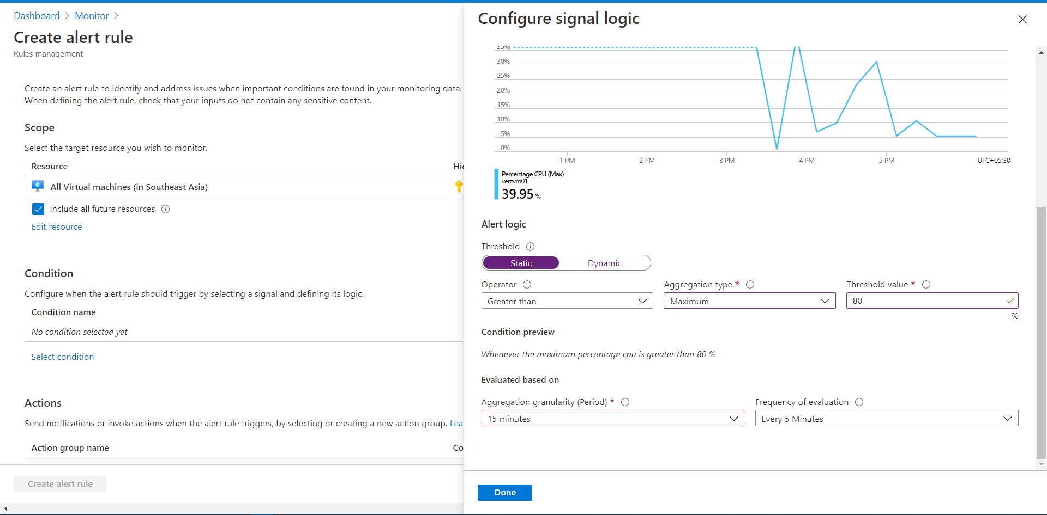

* Dashboard

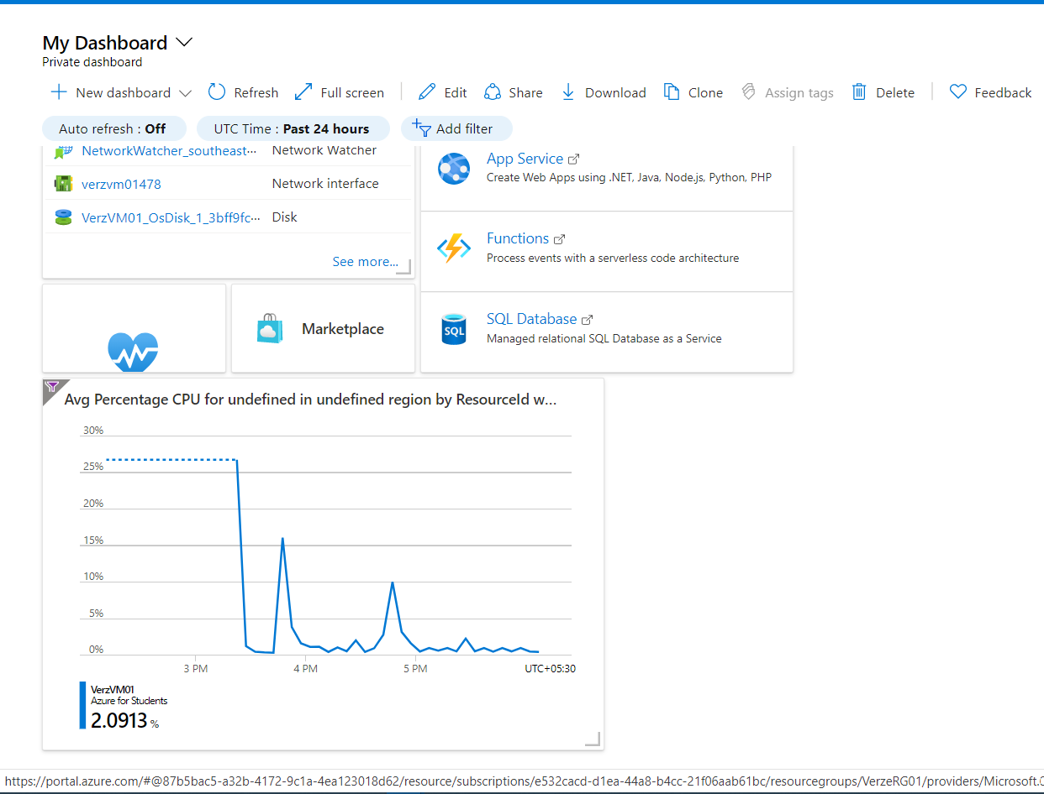

* Metrics Monitor

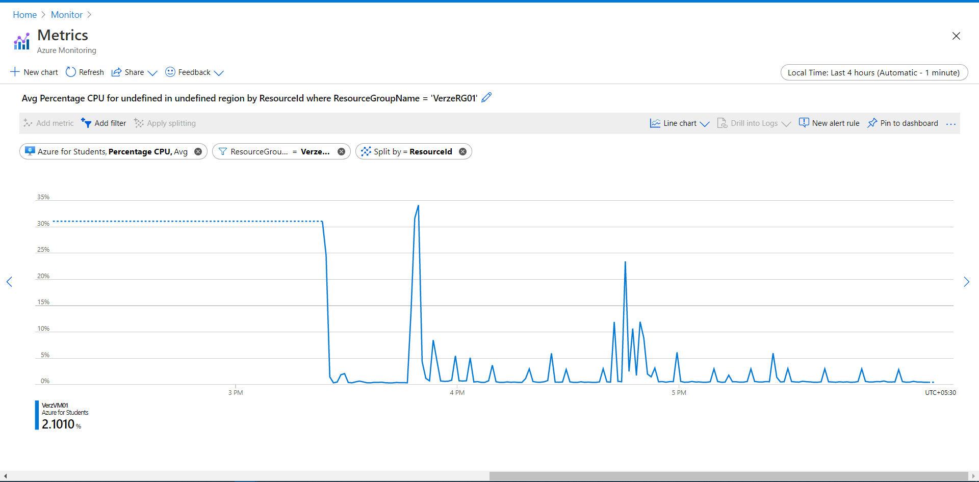

* Alert Logic



* Condition

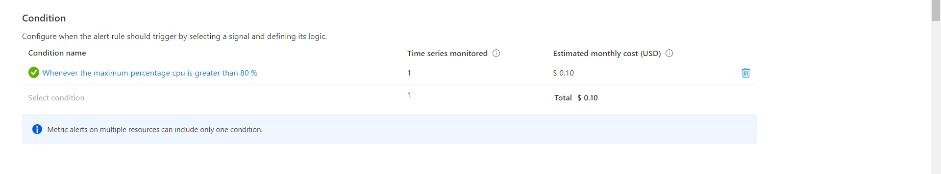

* Action Group:-

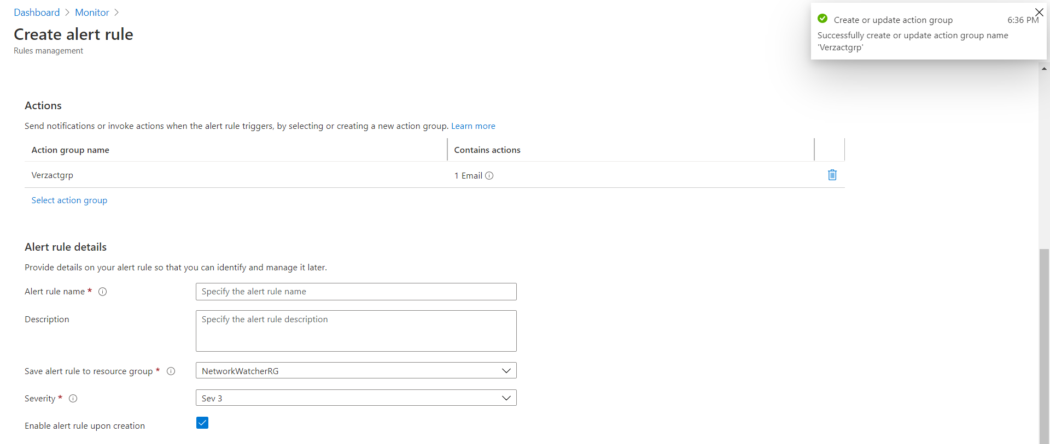



1. **Check receiving alert for the VM :-**

* Recovery Service Vault is a storage entity in Azure that houses data.The data is typically copies of data,or configuration information for VMs,workloads, or workstations.
* Recovery service vaults suport system center DPM,windows server,Azure Backup Server, more.

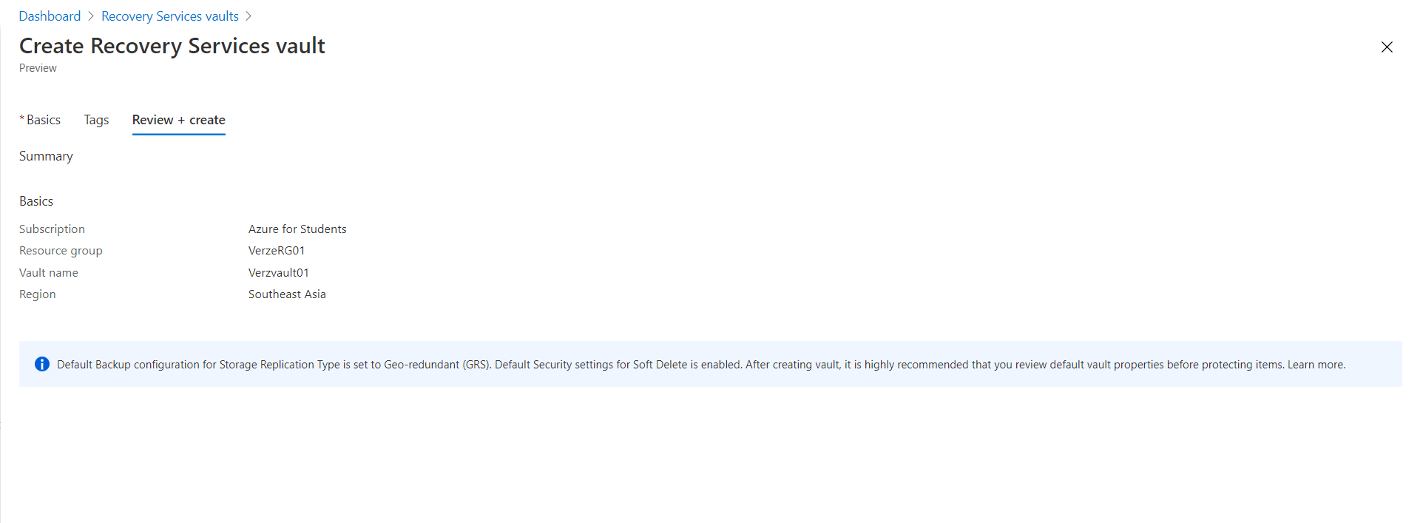

1. **Backup for VM :-**

* **Azure Backup Service** provides simple, secure, cost-effective solutions to backup your data and recover it from the Microsoft Azure Cloud.

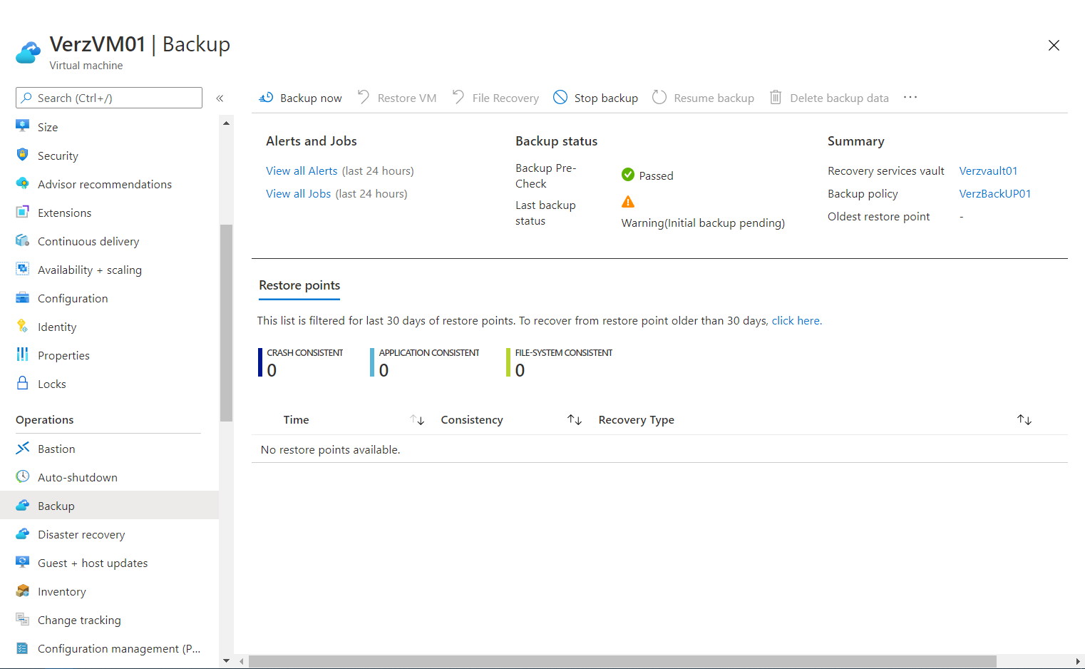

* Successfully completed the backup process.

