

CS565 .Net Programming-Fall 2015

Professor Wiselin Mathuram

**Final Report 2**

by

Yarram, Sudha (143077)

Submission Date: December 5, 2015 3.00pm PST

Assignment1: Add to Numbers:

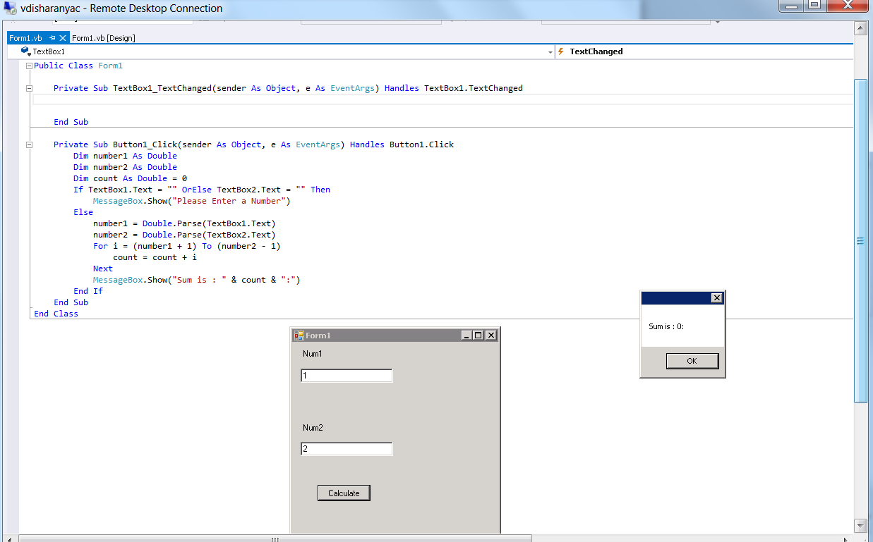

Assignment2: Calculator:

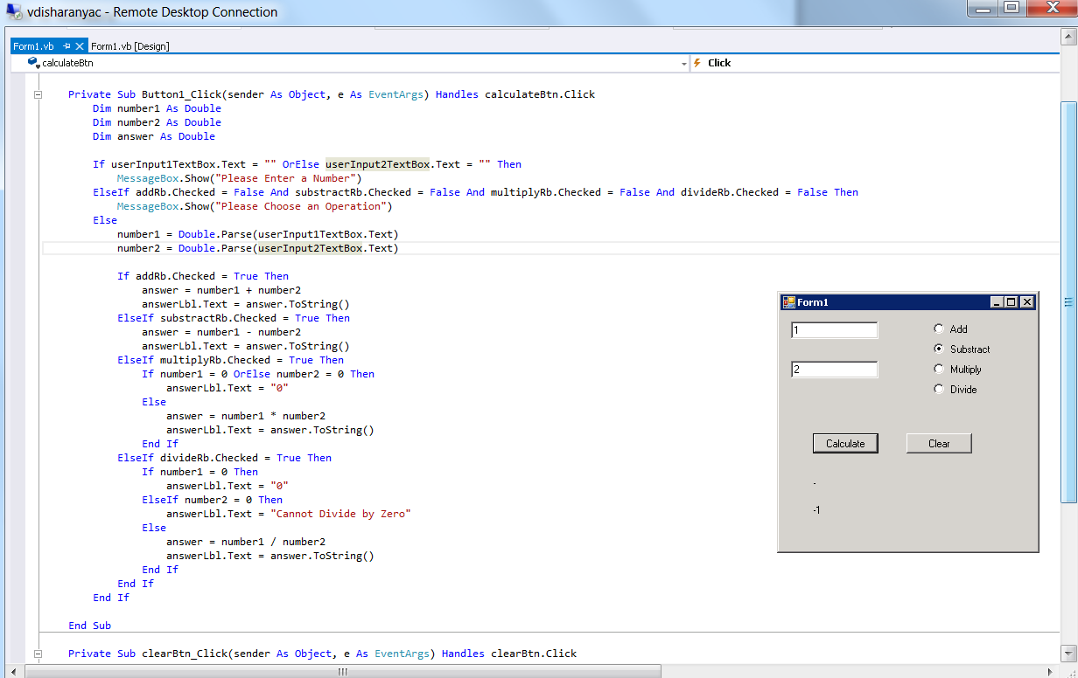

Assignment 3:

String Manipulation

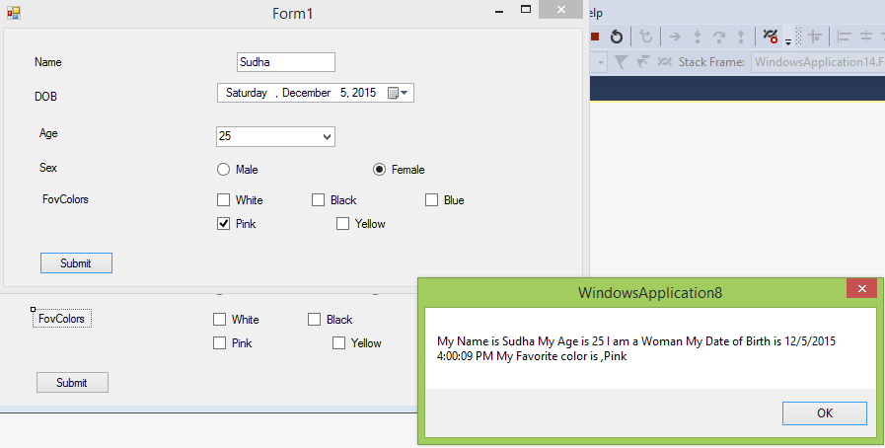

**Code**:

Public Class Form1

Dim DOB As String

Dim Sex As String

Dim Color As String

Private Sub Label2_Click(sender As Object, e As EventArgs) Handles Label2.Click

End Sub

Private Sub RadioButton1_CheckedChanged(sender As Object, e As EventArgs) Handles RadioButton1.CheckedChanged

sex = "Man"

End Sub

Private Sub RadioButton2_CheckedChanged(sender As Object, e As EventArgs) Handles RadioButton2.CheckedChanged

sex = "Woman"

End Sub

Private Sub CheckBox1_CheckedChanged(sender As Object, e As EventArgs) Handles CheckBox1.CheckedChanged

If InStr(Color, "white") Then

Else

Color = Color + "white"

End If

End Sub

Private Sub CheckBox2_CheckedChanged(sender As Object, e As EventArgs) Handles CheckBox2.CheckedChanged

If InStr(Color, "Black") Then

Else

Color = Color + ",Black"

End If

End Sub

Private Sub CheckBox3_CheckedChanged(sender As Object, e As EventArgs) Handles CheckBox3.CheckedChanged

If InStr(Color, "Blue") Then

Else

Color = Color + ",Blue"

End If

End Sub

Private Sub CheckBox4_CheckedChanged(sender As Object, e As EventArgs) Handles CheckBox4.CheckedChanged

Color = Color + ",Pink"

End Sub

Private Sub CheckBox5_CheckedChanged(sender As Object, e As EventArgs) Handles CheckBox5.CheckedChanged

Color = Color + ",Yellow"

End Sub

Private Sub Button1_Click(sender As Object, e As EventArgs) Handles Button1.Click

Try

MsgBox("My Name is " + TextBox1.Text + " My Age is " + ComboBox1.Text + " I am a " + Sex + " My Date of Birth is " + DateTimePicker1.Value + " My Favorite color is " + Color)

Catch ex As Exception

End Try

End Sub

Private Sub TextBox1_TextChanged(sender As Object, e As EventArgs) Handles TextBox1.TextChanged

End Sub

End Class