

CS565 .Net Programming-Fall 2015

Professor Wiselin Mathuram

**Final Report 2**

by

Yarram, Sudha (143077)

Submission Date: December 5, 2015 3.00pm PST

Assignment1: Add to Numbers:

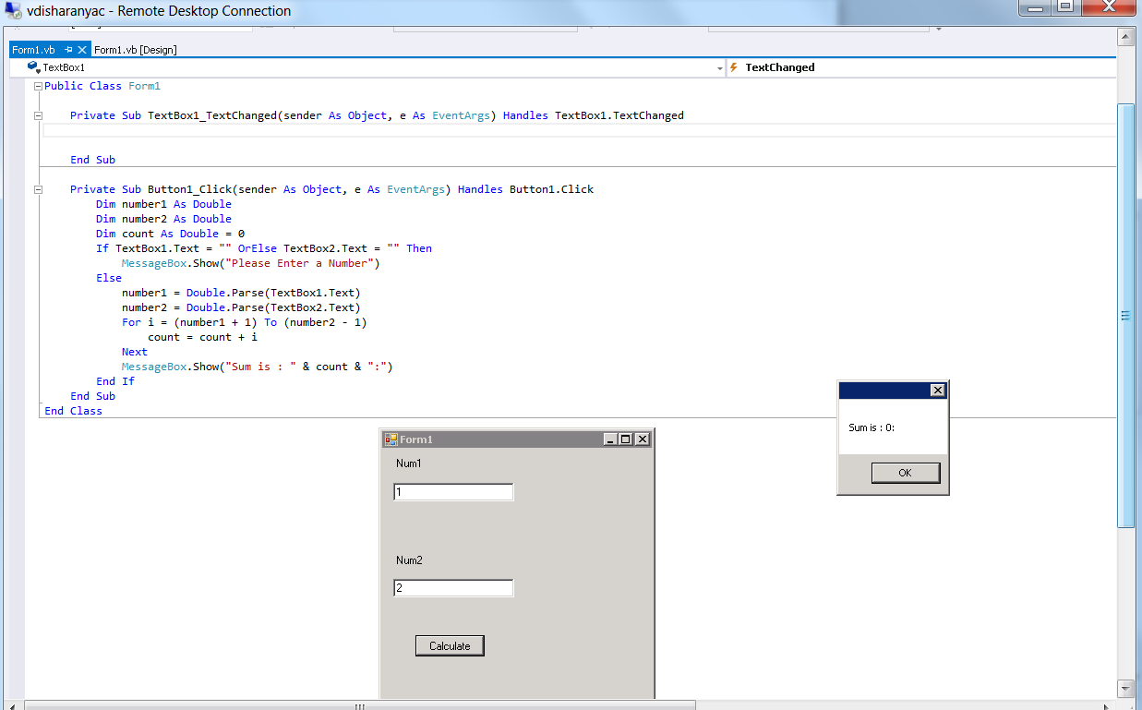

Assignment2: Calculator:

