Generating randomn new number.
function myRandomInts(quantity, max){
const arr = []
while(arr.length < quantity){
var candidateInt = Math.floor(Math.random() * max) + 1
if(arr.indexOf(candidateInt) === -1) arr.push(candidateInt)
}
return(arr)
}myRandomInts(6, 20) // [13, 9, 3, 8, 6, 12]

The most mystifying part of this is probably where we check to see if our current candidate integer is already in the array:
if(arr.indexOf(candidateInt) === -1)

How to send mail

https://www.geeksforgeeks.org/how-to-send-an-email-from-javascript/

<!DOCTYPE html>
<html>

<head>
<title>Send Mail</title>
<script src="https://smtpjs.com/v3/smtp.js">
</script>

</head>

<body>
<form method="post">
<input type="button" value="Send Email" onclick="sendEmail()" />
</form>

<script type="text/javascript">
function sendEmail() {
Email.send({
Host: "smtp.gmail.com",
Username: "sender@email_address.com",
Password: "Enter your password",
To: 'receiver@email_address.com',
From: "sender@email_address.com",
Subject: "Sending Email using javascript",
Body: "Well that was easy!!",
})
.then(function (message) {
alert("mail sent successfully")
});
}
</script>
</body>

</html>

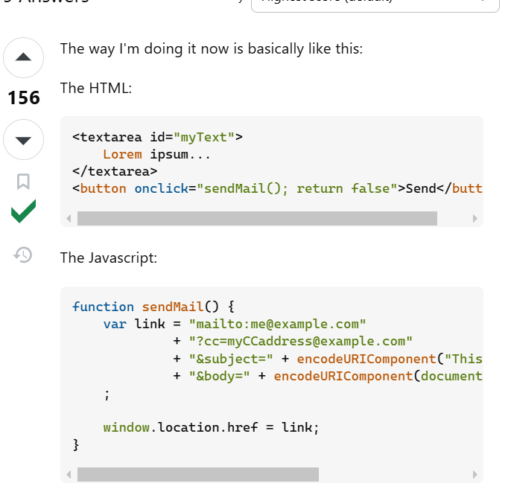

<textarea id="myText">
Lorem ipsum...
</textarea>
<button onclick="sendMail(); return false">Send</button>

function sendMail() {
var link = "mailto:me@example.com"
+ "?cc=myCCaddress@example.com"
+ "&subject=" + encodeURIComponent("This is my subject")
+ "&body=" + encodeURIComponent(document.getElementById('myText').value)
;

window.location.href = link;
}

var link = "mailto:me@example.com"
+ "?cc=myCCaddress@example.com"
+ "&subject=" + encodeURIComponent("This is my subject")
+ "&body=" + encodeURIComponent(document.getElementById('myText').value)
;

window.location.href = link;

https://dev.to/manthanank/building-an-otp-verification-system-using-html-css-and-javascript-2dlk

