Website

Vs Code

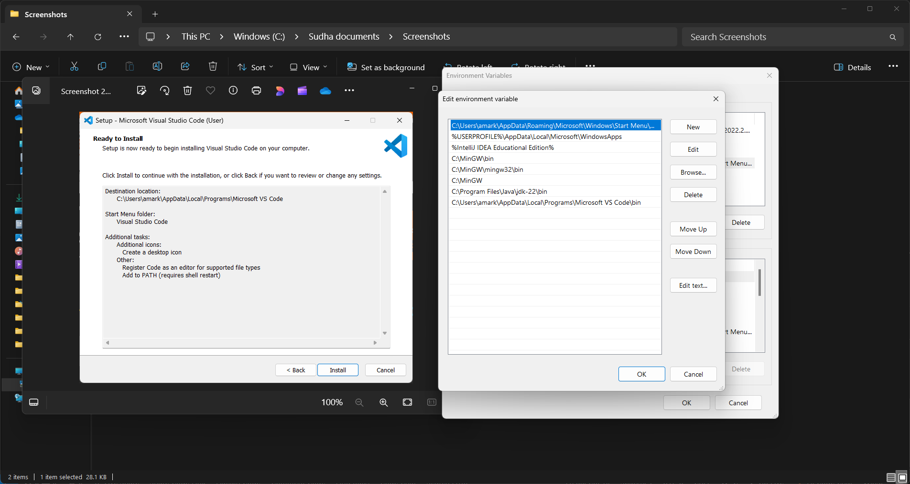

Mingw

comment
<!--comment-->

alt =” ” in img mean alternative text when img do not get loaded

name="" in input type radio it is just like category having inputs of one type used for selecting only one out of given options

for ="" in label and id="" in input should be same for identification that input is taken for which label

