**CPME 272 Assignment #1 Ansible**

**Submitted by**: Team Falcon

Group Members:

* Anvitha Shubhaveer Jain
* Chaitrali Deshmukh.
* Saylee Vyawahare
* Sudha Amarnath

**Introduction**

Following are the steps done in this assignment:

* Client and Server connection using Ansible
* Install and configure Ansible on Client
* Install Apache2 Webserver
* Display HTML page on Browser on port 80
* Un-deploy the HTML page and Apache2 on Server
* GitHub submission link

1. ***Client and Server connection using Ansible***

In this assignment we have used two different machines to connect and act as a server and client. A VM is configured as a client and an AWS EC2 instance as a web server. Ubuntu is the operating system used on both the machines.

1. ***Install and configure Ansible on Client***

Ansible is installed and configured on the VM machine.

Commands used are:-

sudo apt-get install ansible

Hosts file is defined to use awsserver as webservers   
nslookup awsserver // used to check server name of associated IP

ansible webservers -m ping

If there is ‘success message’, it means ansible is configured and can ping the web server.

1. ***Install Apache2 on server***

On AWS EC2 instance we are installing Apache2 webserver. To do so run playbook named ‘**install_apache2.yml’.**

Commands used are:-

ansible -m command -a "dpkg-query -W apache2" webservers

ansible -m command -a "ls -lrt /var/www/html" webservers

ansible-playbook playbook/install_apache2.yml

ansible -m command -a "dpkg-query -W apache2" webservers

ansible -m command -a "systemctl status apache2.service" webservers

If there is a ‘success message’, then apache web server is installed successfully.

1. ***Display HTML page on Browser on port 80***

After installing apache2 web server, deploy html page named ‘index.html’ having content ‘Hello World’. By default html port is 80. Then run the playbook ‘deploy.yml’, to deploy the html file in /var/www/html directory on server and run the html page on browser displaying “HelloWorld!”.

Commands used are

ansible-playbook playbook/deploy.yml

ansible -m command -a "cat /var/www/html/index.html" webservers

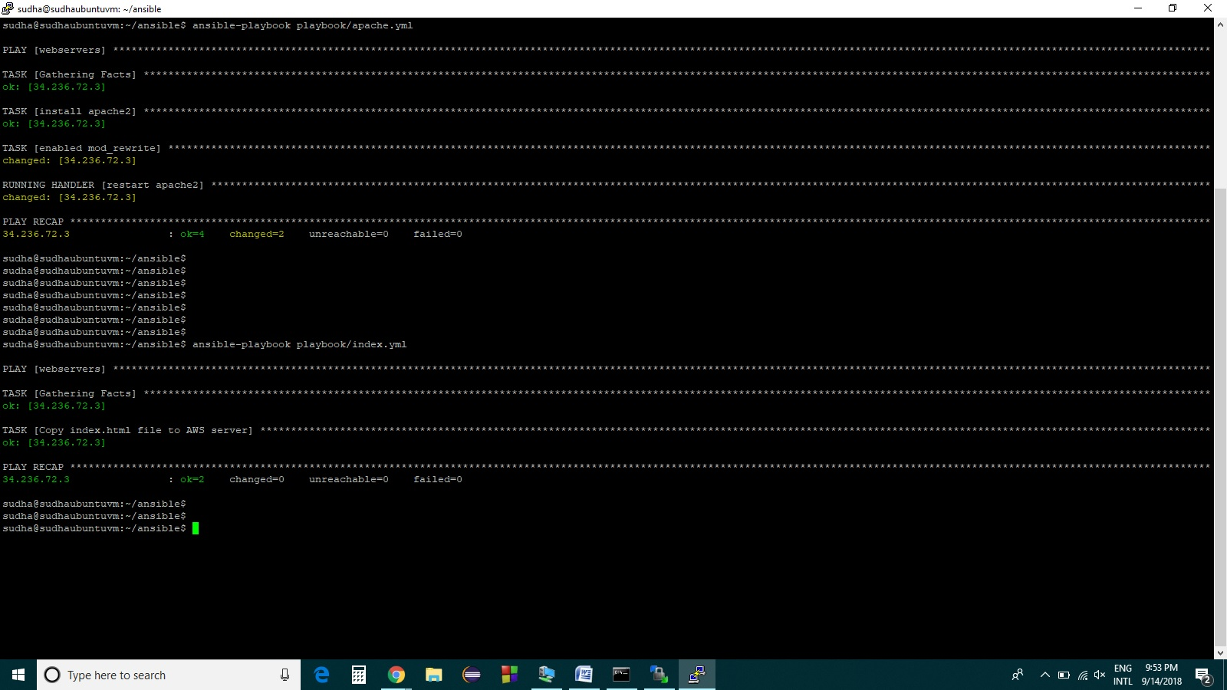

Apache2 server is installed and html page is deployed as shown below.

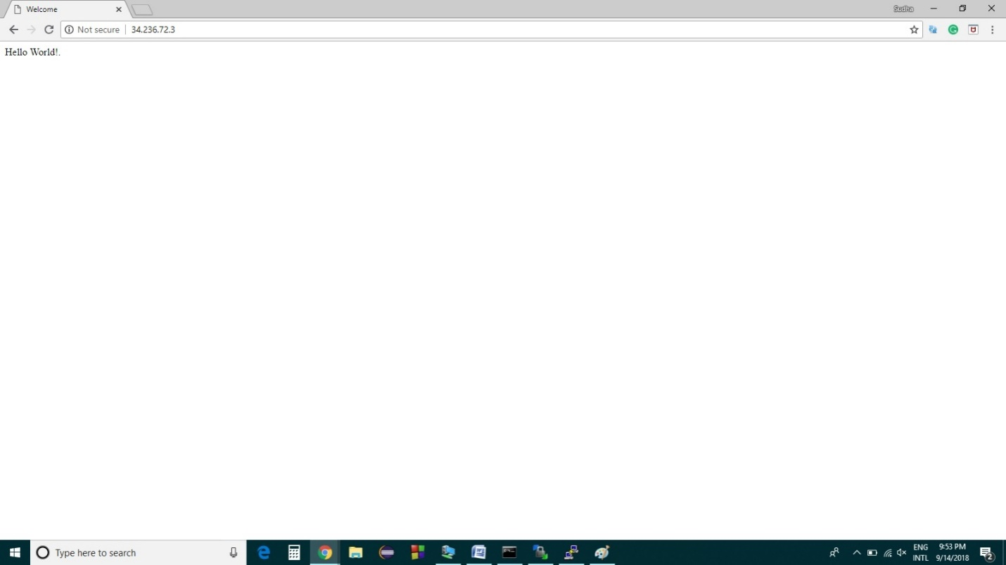

“**Hello World!.**” - Displayed on browser

1. ***Undeploy the HTML page and stop/uninstall Apache2 on Server.***

To Undeploy, we need to delete all the *.html files from directory /var/www/html/ in the server and then stop the apache2 service. To perform this we run the playbooks namely **‘undeploy.yml’ and then ‘uninstall_apache2.yml’ to finally uninstall the apache2 package.**

**Commands used are:-**

ansible-playbook playbook/undeploy.yml

ansible -m command -a "ls -lrt /var/www/html" webservers

ansible -m command -a "systemctl status apache2.service" webservers

ansible-playbook playbook/uninstall_apache2.yml

ansible -m command -a "dpkg-query -W apache2" webservers

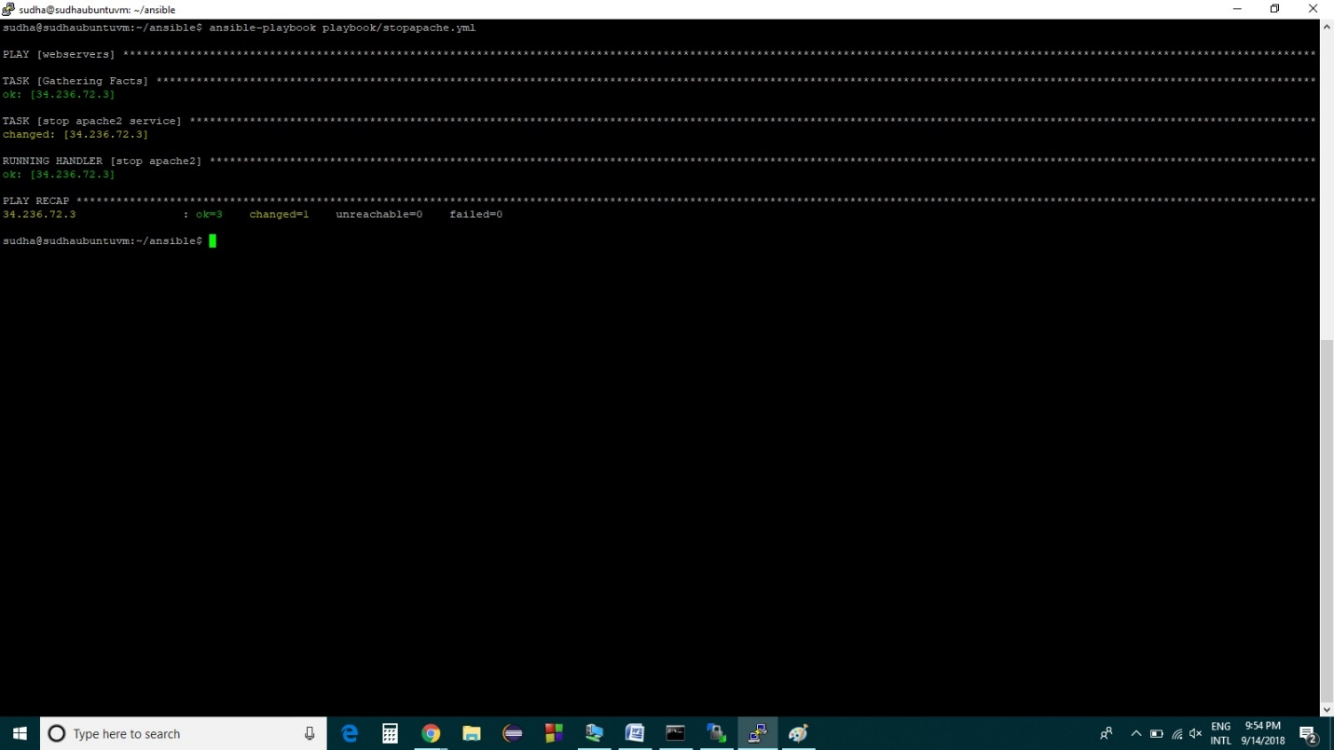

1. ***GitHub submission link***

To fetch the code and playbooks (.yml) files please check the GitHub link.

<https://github.com/FALCON-SJSU/ansible.git>

Following link shows the screen shots and working output of all the above commands for this assignment.

<https://github.com/FALCON-SJSU/ansible/blob/master/ansible/commands>