**Create AWS EC2 instances:**

* **Jenkins server**
* **Staging**
* **Prodution1**
* **Prodution2**

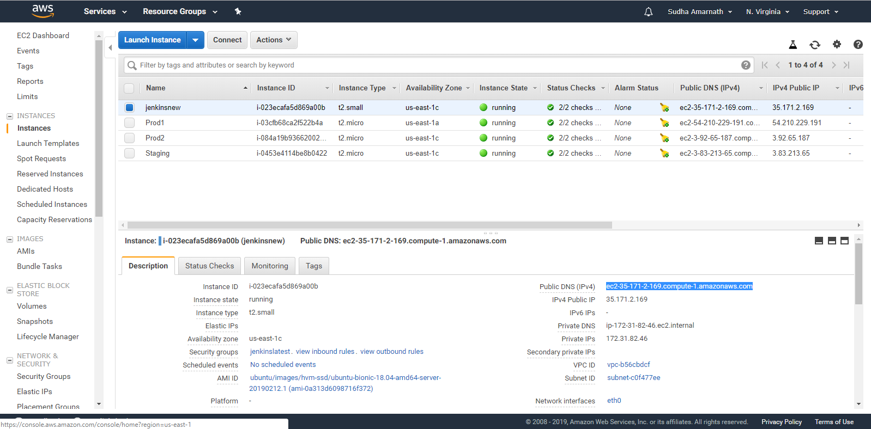

**Installation steps:**

* **Follow the steps to Install CodeDeploy agent on all the EC2 instances**

<https://docs.aws.amazon.com/codedeploy/latest/userguide/codedeploy-agent-operations-install-ubuntu.html>

* **Install Java JDK8**
* **On Jenkins server EC2 instance install Jenkins, maven and check active status for Jenkins, CodeDeploy agent.**

**On Jenkins server EC2Instance the CodeDeploy agent , Jenkins server status are active and are up and running.**

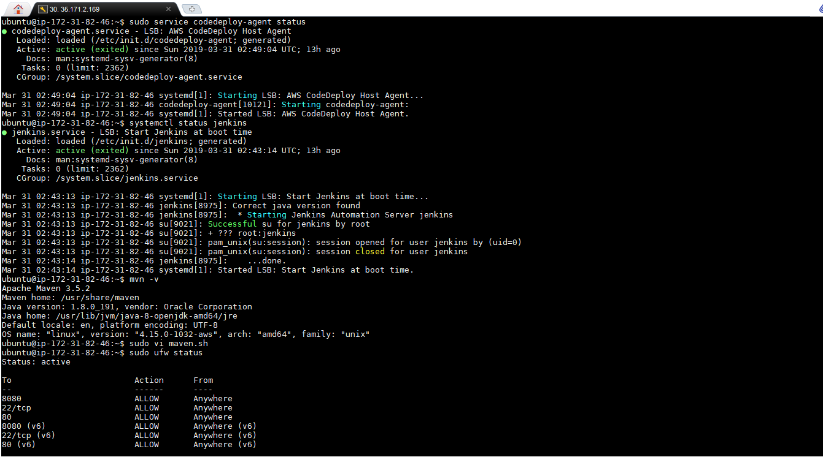

**Open Jenkins on** [**http://35.171.2.169:8080**](http://35.171.2.169:8080)**. Set up Build environment with AWS CICD Pipeline.**

**Latest Builds successful**

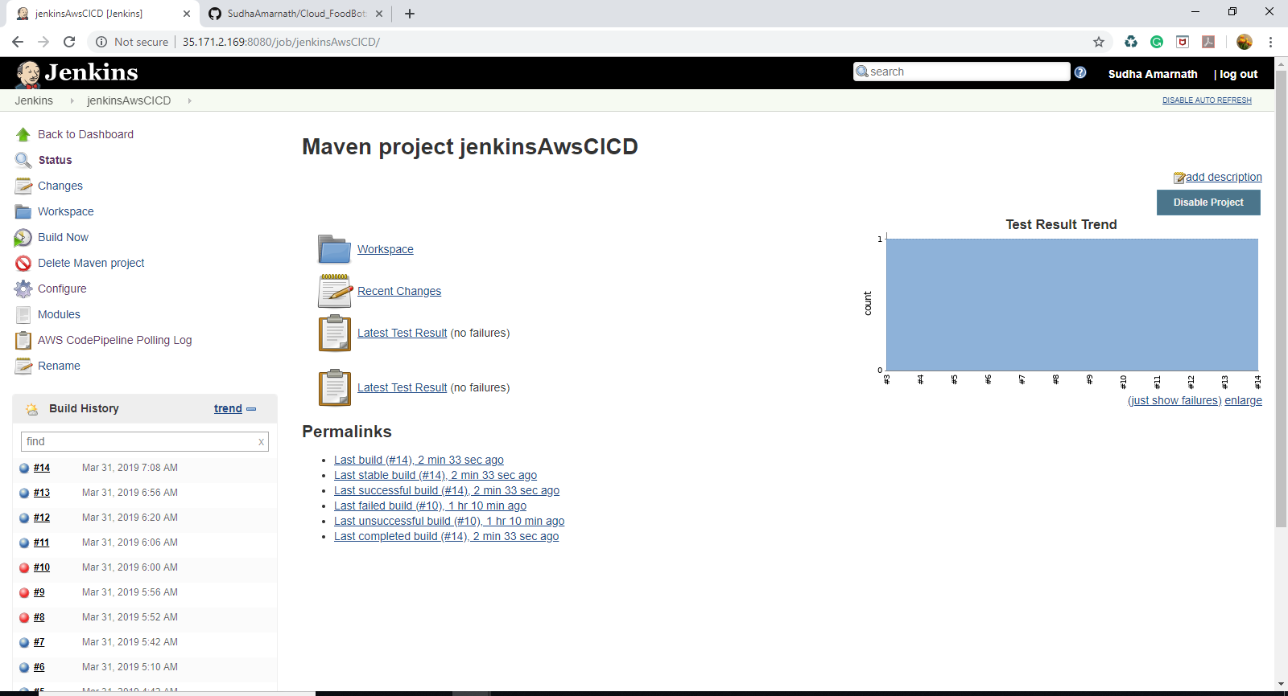

**The source artifacts are received from aws codepipeline to Jenkins. Jenkins runs the build.**

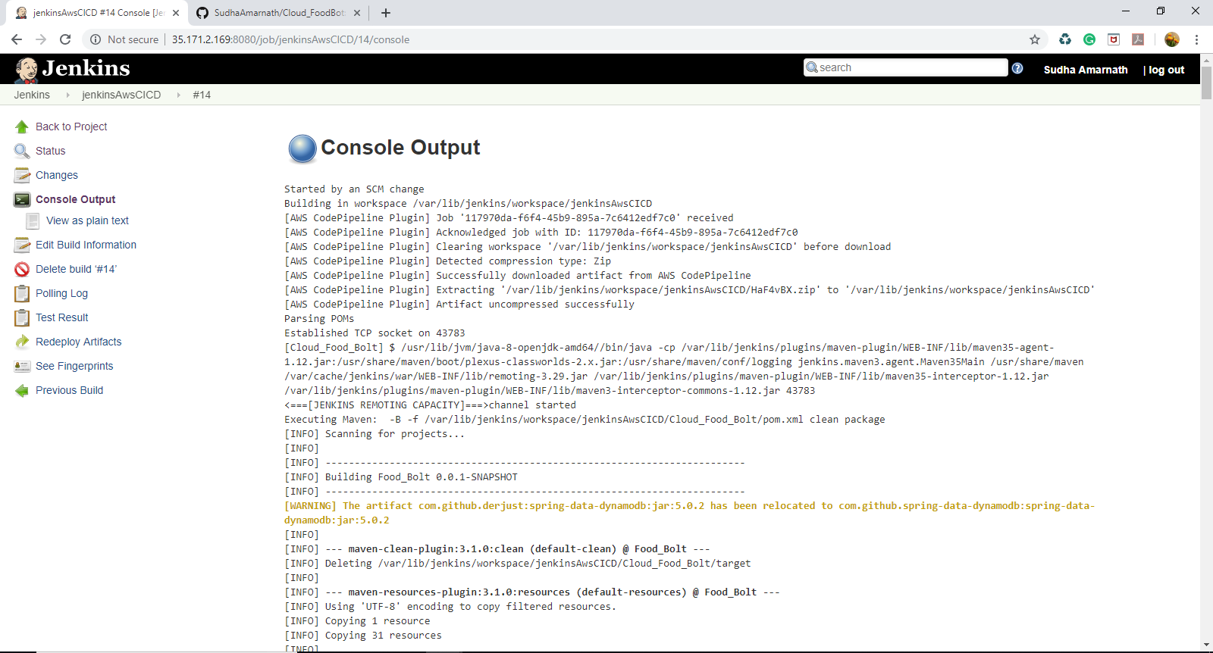

**Once the build is successful the build artifacts are sent from Jenkins to code pipeline**

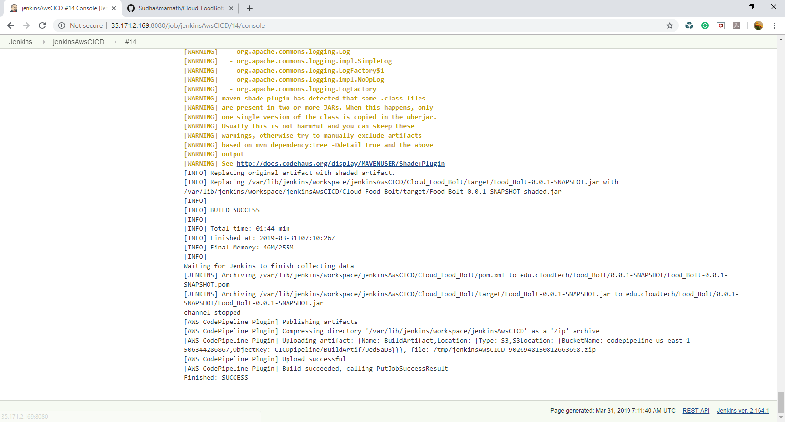

**Github Webhooks for the project**

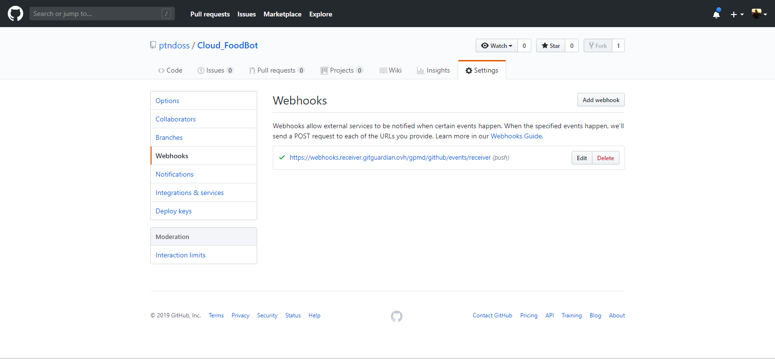

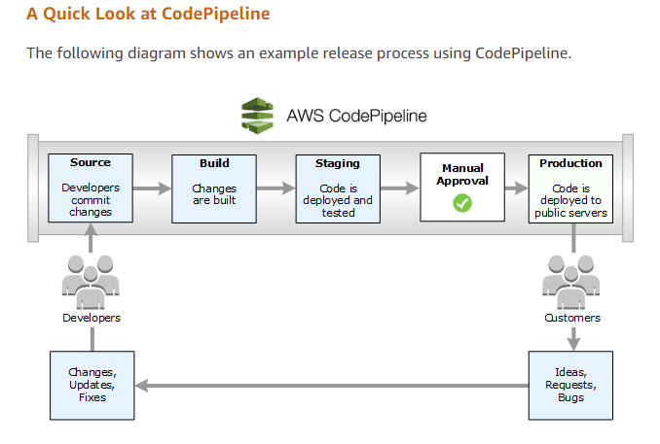

**Succesuful execution of all the above stages in AWS CodePipeline**

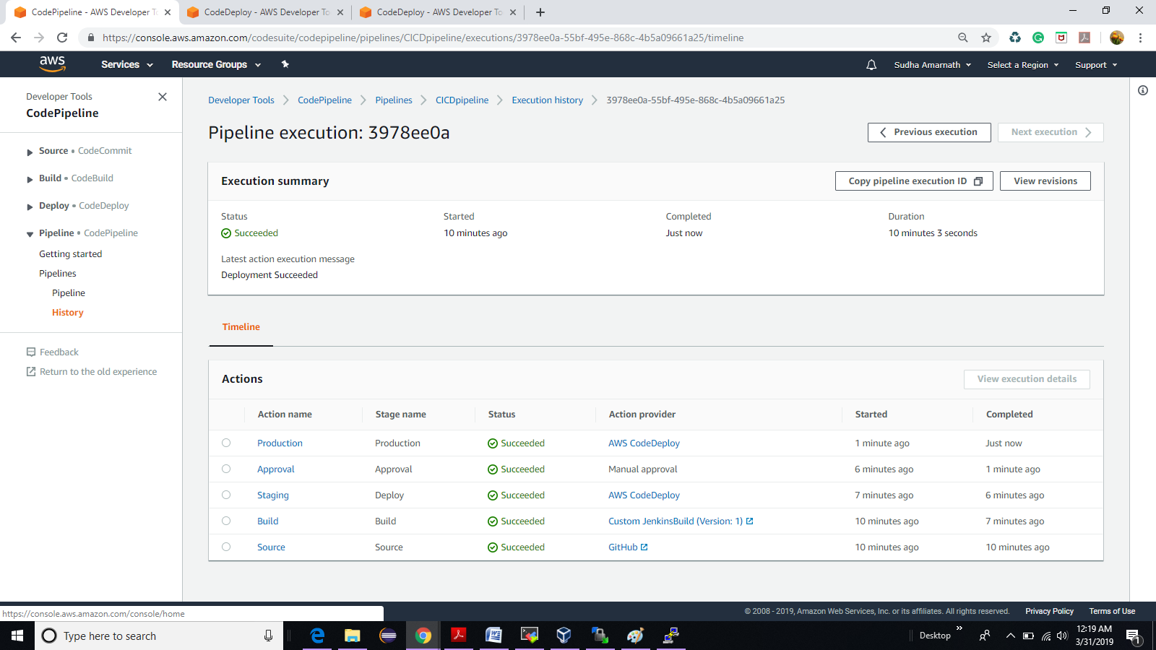

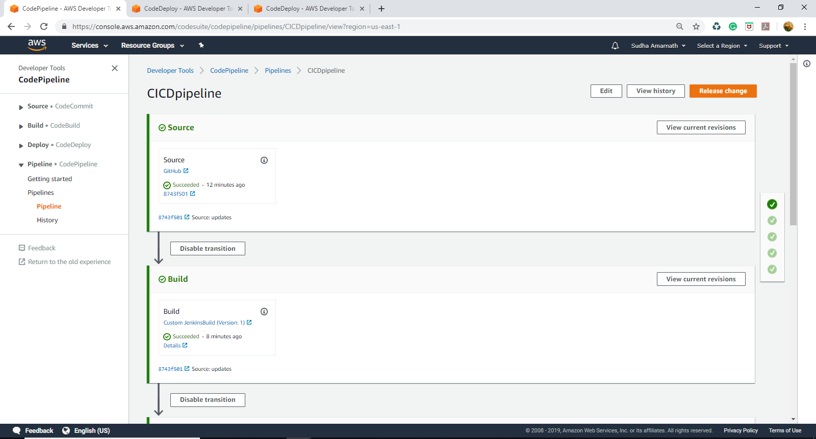

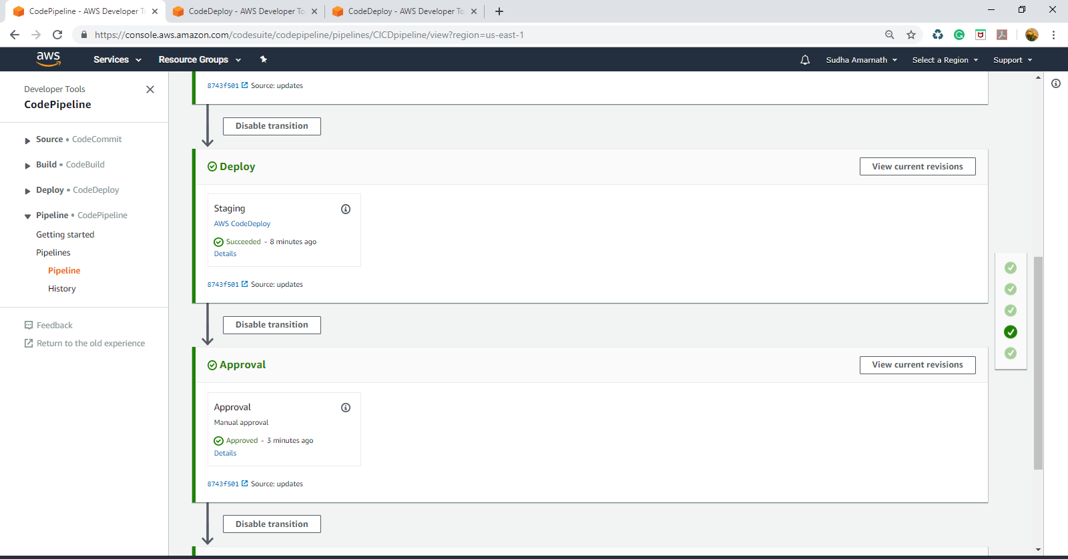

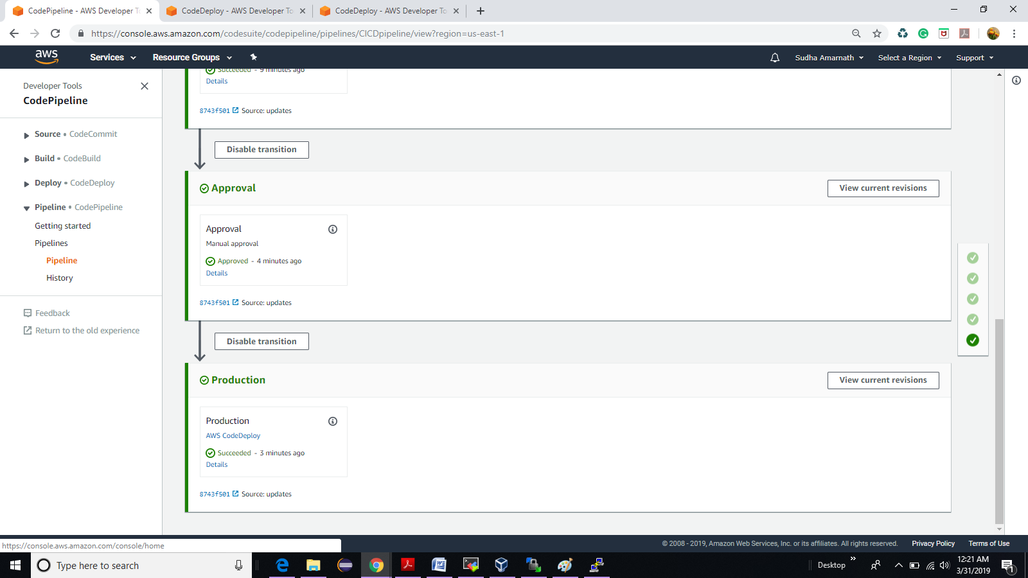

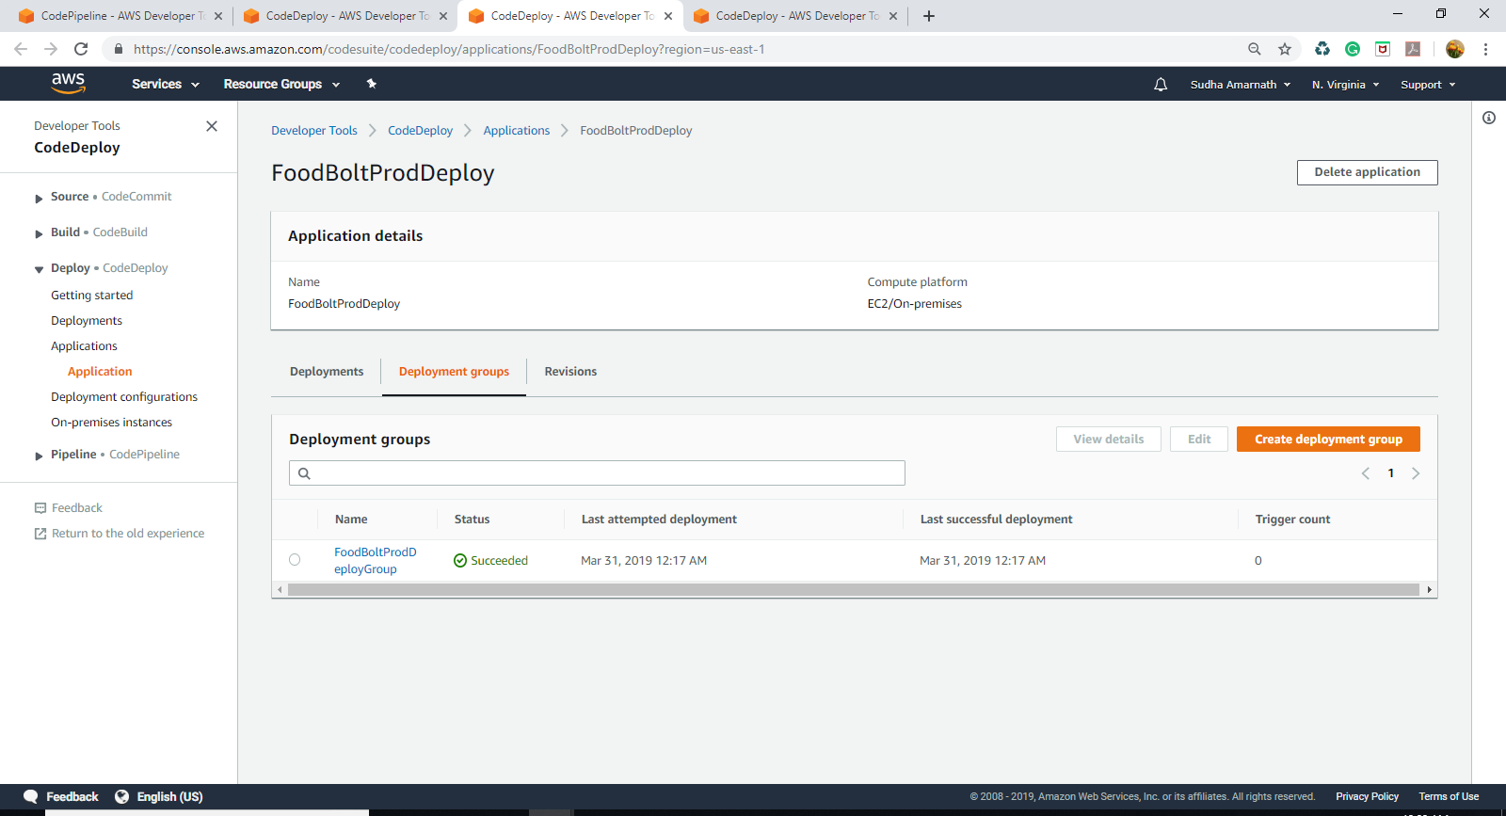

**Deploy logs**

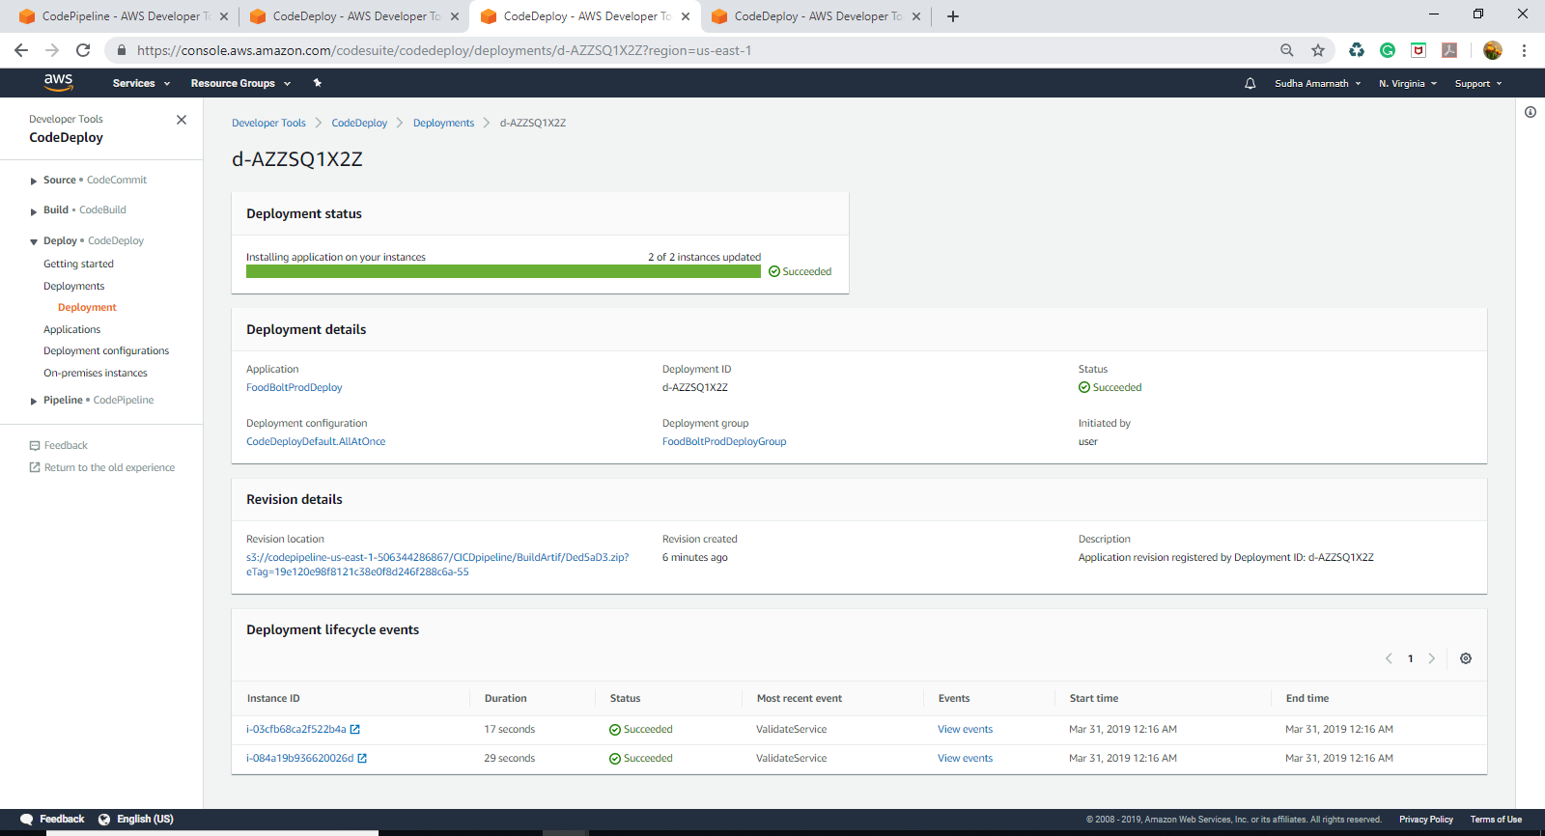

**Events in EC2 instance code deployment**

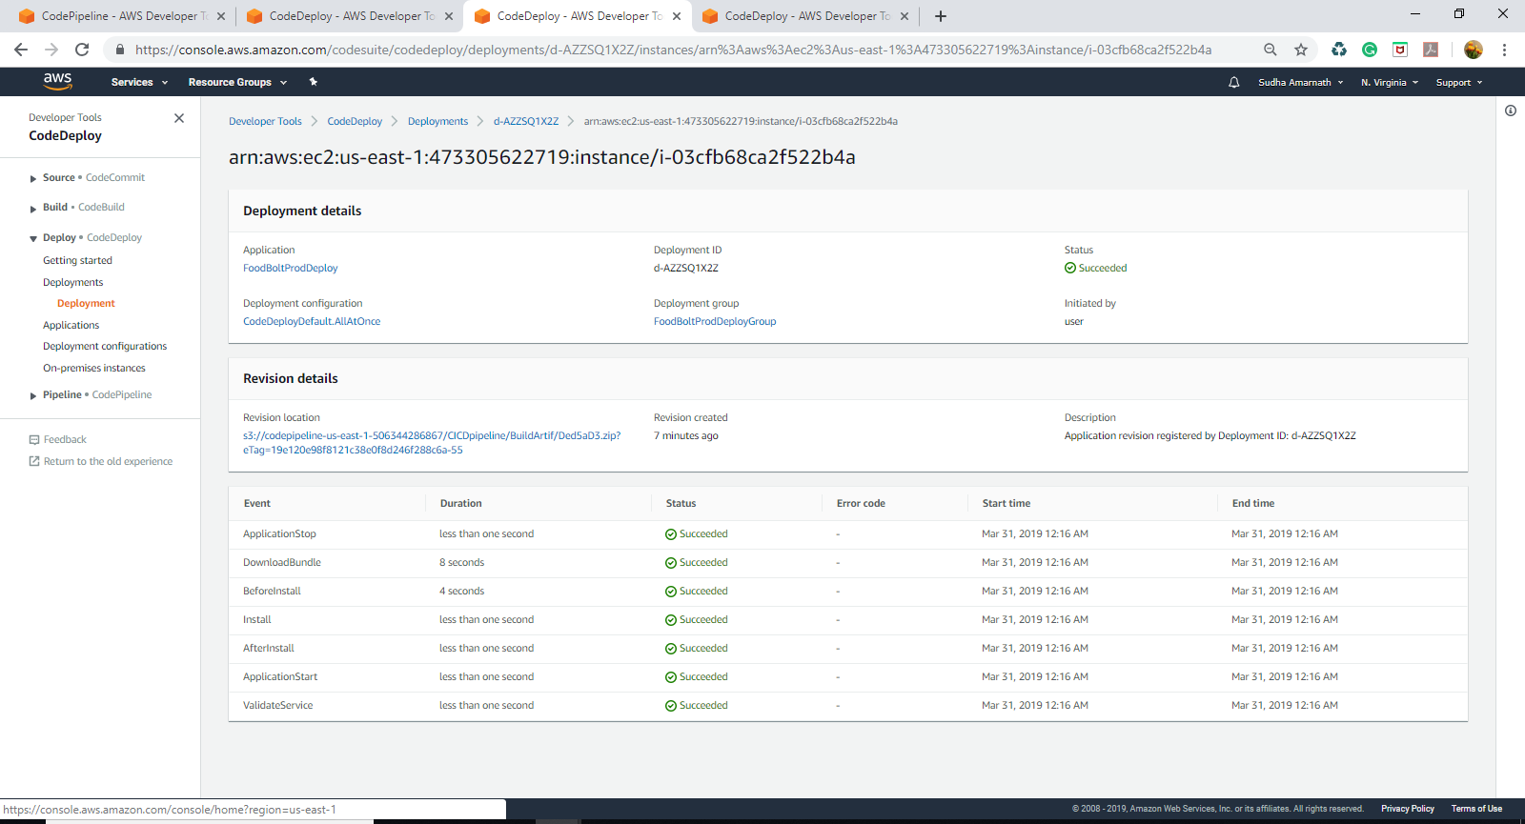

**EC2 instances. Checking for Prod2 instance DNS working for the Project.**

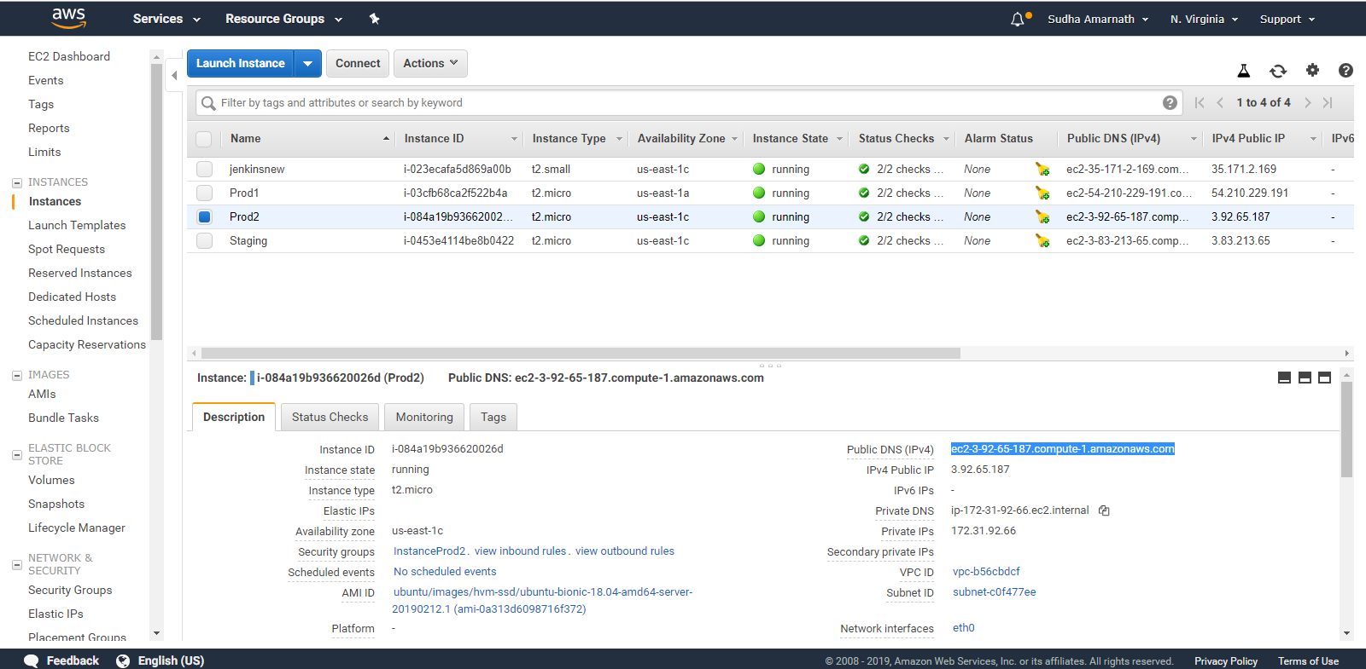

**Project deployment from Production environment (Prod2)**

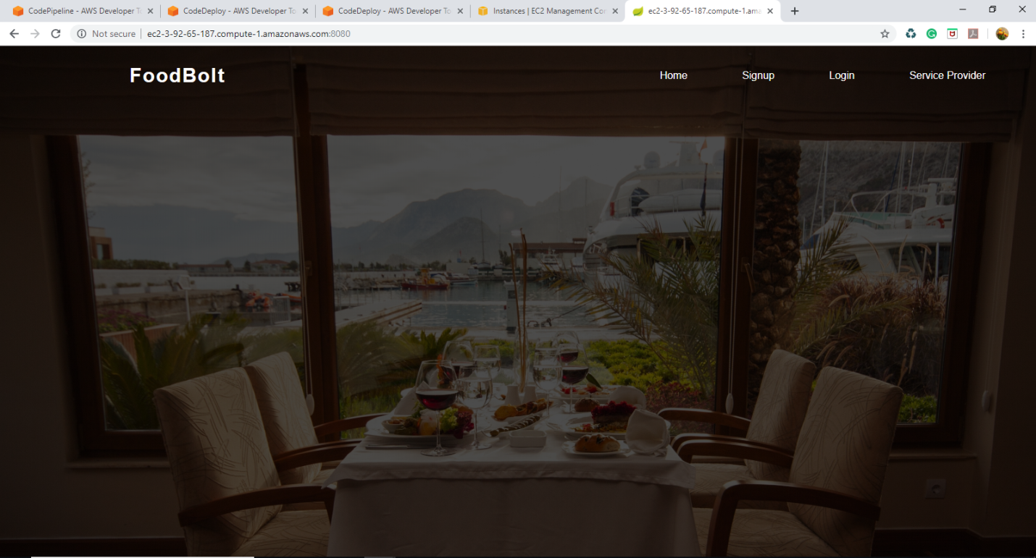

**Automation of the continuous integration is done in the YAML script**

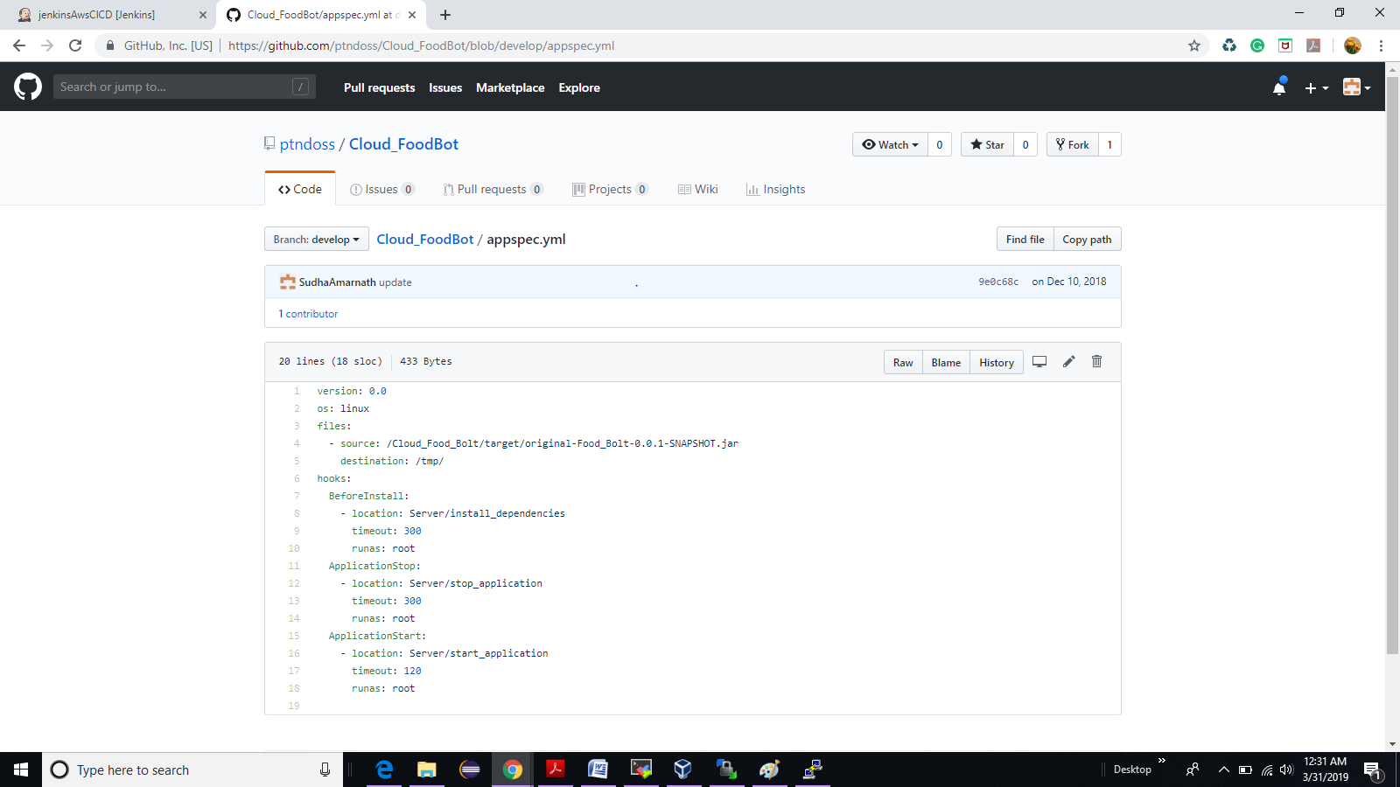

**install_dependencies**

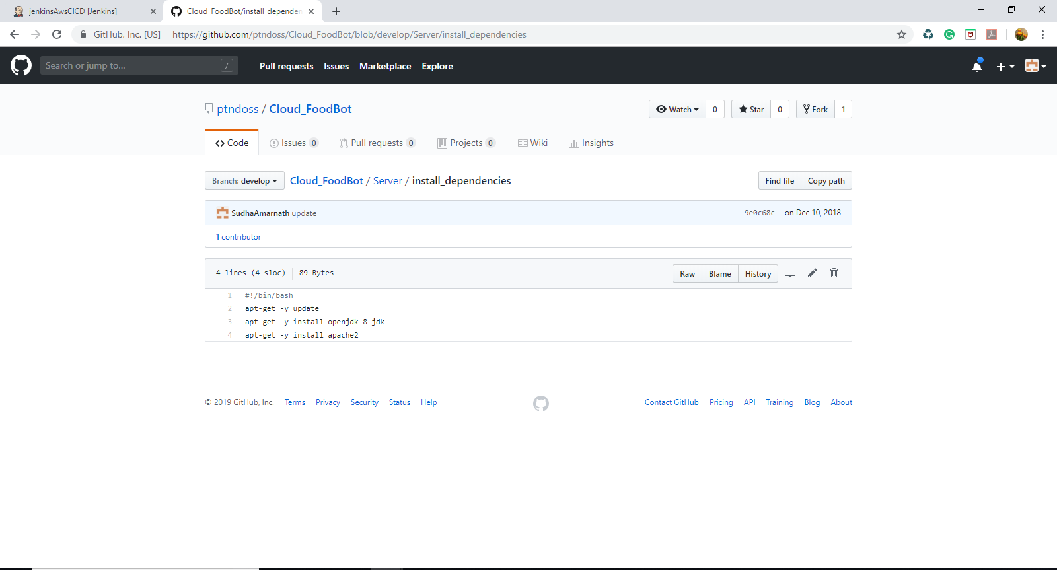

**start_application**

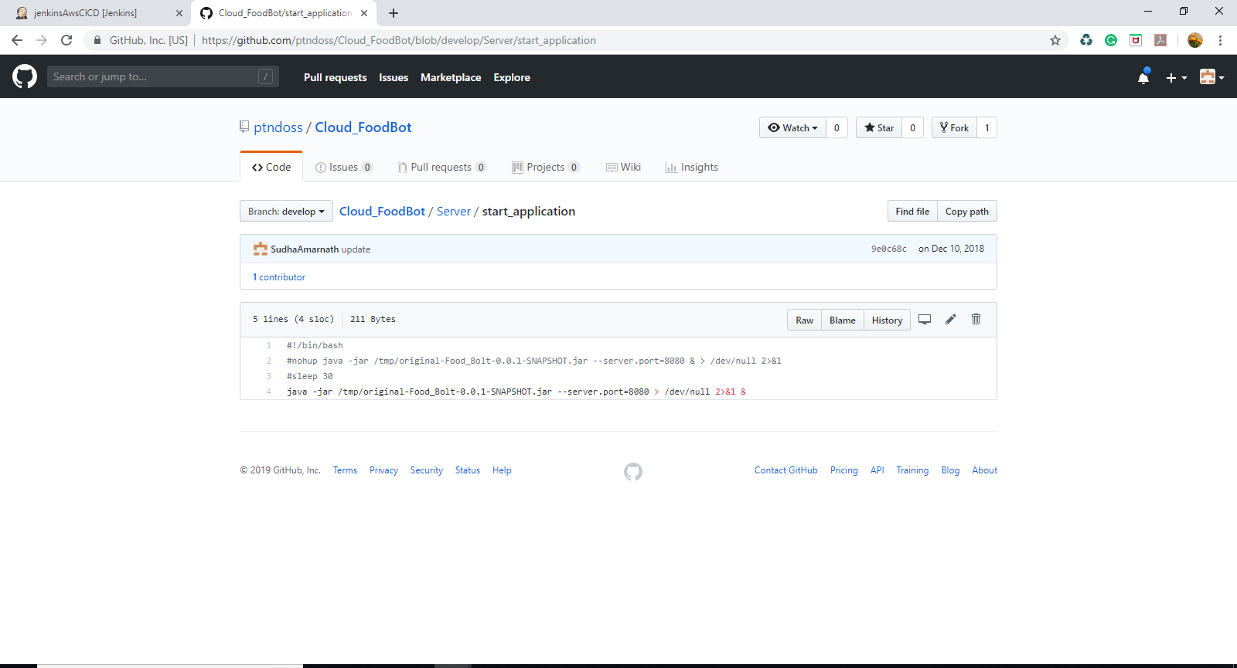

**stop_application**

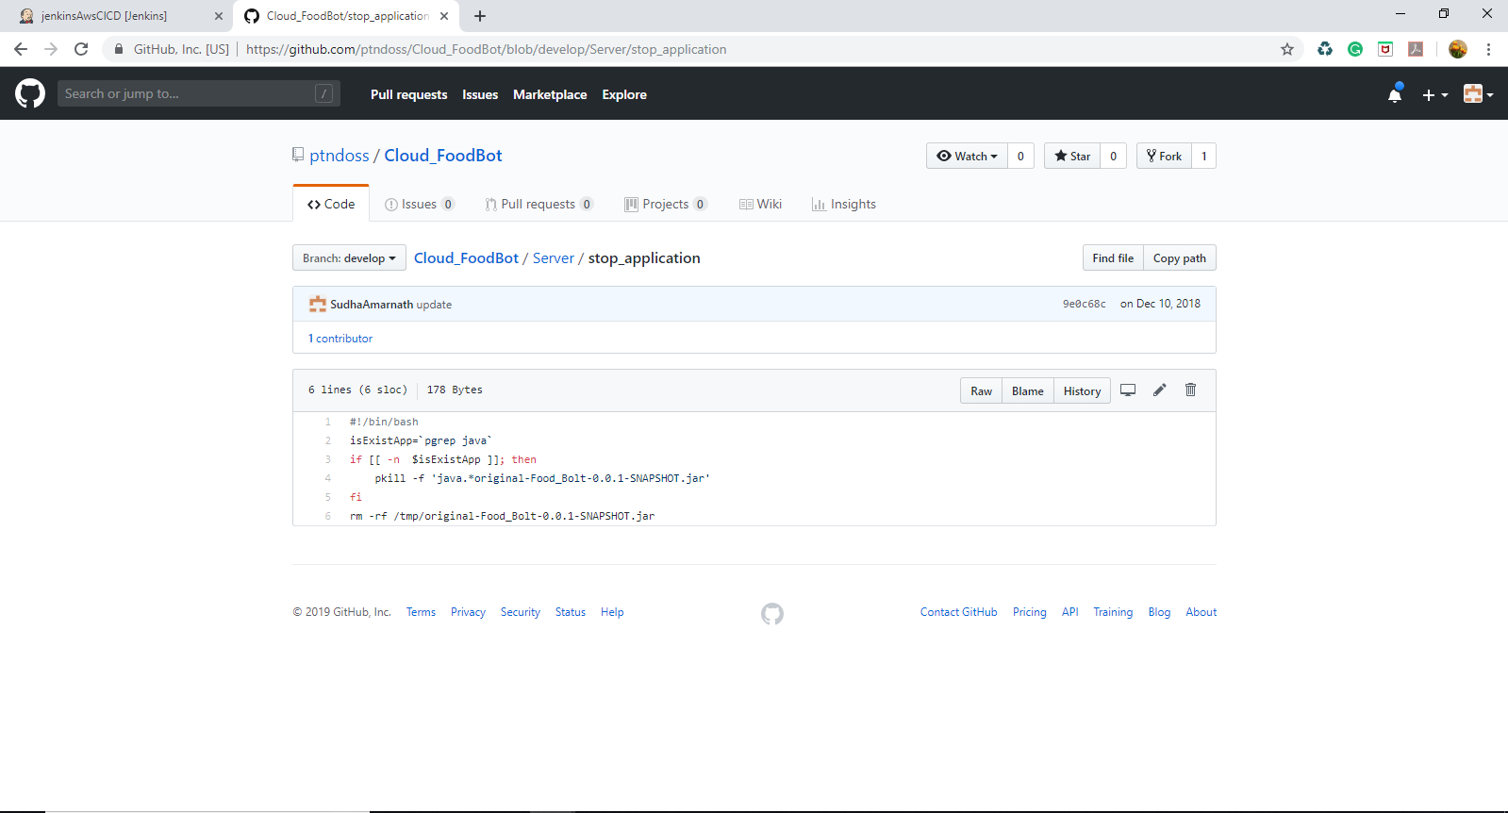

**Github link** - <https://github.com/ptndoss/Cloud_FoodBot/tree/develop>

